2023-01-0330
DME-PROPANE IGNITION DELAY TIME MEASUREMENTS AT MIXING CONTROLLED COMPRESSION IGNITION ENGINE-RELEVANT CONDITIONS
Zuhayr Pasha Mohammed, Ramees Khaleel Rahman, Michael Pierro, Justin Urso, Subith Vasu
University Of Central Florida, Orlando, FL 32816

Abstract
The blend of dimethyl ether (DME, CH₃OCH₃) and propane (C₃H₈) is a potentially renewable fuel mixture that has the potential to replace diesel in compression ignition engines. The combination can potentially reduce particulate and greenhouse gas emissions compared to a conventional diesel engine operating under similar conditions. However, detailed conceptual and simulation studies must be conducted before adopting a new fuel on a compression ignition engine. For these simulations, accurate chemical kinetic models are necessary. However, the validity of chemical kinetic mechanisms in the literature is unknown for mixing controlled compression ignition (MCCI) engine operating conditions. Hence, in this work, we studied the ignition of dimethyl ether (DME) and propane blends in a shock tube at MCCI engine conditions. Ignition delay time (IDT) data was collected behind the reflected shock for DME-propane mixtures for heavy-duty compression ignition (CI) engine parameters. Undiluted experiments spanning temperatures of 700 to 1100 K and pressures of 55 to 84 bar for various blends (100% CH₃OCH₃/ 0% C₃H_{8,} 100% C₃H₈/ 0% CH₃OCH₃, 60% CH₃OCH₃/ 40% C₃H₈) of DME and propane were combusted in synthetic air (21% O₂/ 79% N₂). Some experiments were conducted at higher pressures (90-120 bar) to understand model performance at these conditions. Comparisons of IDT were made with the predictions of recent chemical kinetic mechanisms for DME-propane mixture, including the Aramco3.0, NUIG, and Dames et al. mechanisms. All mechanisms overpredicted IDT compared to experimental values. Sensitivity analysis was conducted with Dames et al. model, and critical reactions sensitive to IDT of DME-propane mixture near 100 bar are outlined.
Introduction
The transportation sector is the second-largest energy consumer in the U.S., with roughly 28 quadrillion BTUs being consumed in 2019 [1]. The increasing energy demand and rising global temperatures drive the industry to find alternatives to petrol and diesel fuels that are significant producers of greenhouse gases. An alternative fuel that promises to replace these commonly used fuels is liquified petroleum gas (LPG) [2], which mainly consists of propane (~80-100 %). Propane is an attractive alternative to the current fuels due to the existing infrastructure [3] for its constituents and its large energy content (propane's LHV is 46.4 MJ/kg) [4], which surpasses both petrol (43.2 MJ/kg) [5] and diesel (42.5 MJ/kg) [4]. Despite its high LHV, propane needs to be blended with some fuel that can enhance its autoignition characteristics [6]. One such biofuel is dimethyl ether (DME) (LHV of 28.43 MJ/kg) [4].

There have been several studies on the oxidation of propane and DME, which are summarized in Table 1.

Table 1. Different works in literature for IDT measurements for propane and DME mixtures.
Fuel | Additive | T (K) | P (atm) | Measurement
C₃H₈ |  | 980-1400 | 6-60 | IDT[7]
C₃H₈ | H₂ | 1000-1600 | 1.2-10 | IDT[8]
C₃H₈ | H₂ | 1000-1600 | 1.2-10 | IDT[9]
C₃H₈ | DME | 1100-1500 | 20 | IDT[10]
C₃H₈ |  | 1800-2600 | 5 | IDT[11]
n-C₄H₁₀ | DME | 1200-1600 | 1.2-5.3 | IDT[12]
LPG | DME | 1100-1500 | 5-15 | IDT[13]
C₃H₈ | DME | 550-2000 | 10-50 | IDT[6]
DME |  | 630-1450 | 2-25 | IDT[14]
DME |  | 697-1239 | 22-23 | IDT[15]
DME |  | 1175-1900 | 1.6-6.6 | IDT[16]
n-C₄H₁₀ | DME | 650-1400 | 2-10 | IDT[17]
Most of the studies are focused on ignition delay time measurements, although soot yield at temperatures of 1800-2600 K and 5 atm have been provided for propane [11]. For propane-DME blends, IDTs have been reported up to pressures of 50 atm [6]. Compression ignition engines operate at a pressure range of 30-70 bar [18], while heavy-duty compression engines operate at much higher pressures (~100 bar). There is a lack of information on the ignition delay times of propane-DME mixtures at higher pressure relevant to the combustion of heavy-duty engines, and there are few studies that provide in situ, time-resolved measurements of key intermediate species. Figures 1 and 2 show simulated IDTs for oxidation of neat DME and neat propane, respectively, using Hu et al. [10] and either the Aramco 3.0 [19] or Dames et al. [6] models at 90 atm. The IDTs obtained from both models differ considerably at temperatures less than 1000 K, indicating a need for model improvement. Additionally, the fuel and oxidizer are not premixed in an MCCI engine and can encounter a wide range of equivalence ratios ranging from very lean (<0.2) to very rich (>2.0) [20]. The chemical kinetic models developed for CFD simulations of MCCI engines should be able to capture all these conditions. In order to validate chemical kinetic mechanisms generated for propane-DME chemistry, high-pressure measurements are needed for the fuel's IDT at a wide range of equivalence ratios and temperatures that an MCCI engine encounters during its operation. The shock tube reactor is ideal for generating such a high-pressure environment as they have been used for studying combustion since the 1940s [21]. Shock tube experiments assume homogeneous distributed quiescent gas behind the reflected shock, with test times on the order of a few milliseconds. This allows experimental data from shock tube experiments to be compared to kinetic model predictions under constant internal energy and volume assumptions [21].
IDT measurements of DME-propane were done in this work for blends at 60, 80, and 90, 120 bar, at 700-1125 K, for Φ=1.0 and Φ=0.38. Results were compared with DME-propane models from literature, and a sensitivity analysis was conducted at 89 atm. Based on the sensitivity analysis, we outline important reactions that could impact the predictions of IDT for DME-propane mixtures at MCCI engine conditions.

Figure 1. Simulation results show discrepancies in IDT predictions for neat DME oxidation at equivalence ratio 1.0 and 90 atm using literature mechanisms.
Figure 2. Simulation results show discrepancies in IDT predictions for neat propane oxidation at an equivalence ratio of 1.0 using literature mechanisms at 90 atm.
Materials and Methods
This study was conducted at the University of Central Florida (UCF)'s High-Pressure Extended Range Shock Tube for Advanced Research (HiPER-STAR) facility [22, 23]. This newly built facility is capable of high-pressure experiments reaching up to 1000 atm. In general, shock tubes are considered ideal devices for replicating combustion test conditions (temperature, T_{5,} and pressure, P₅ in shock tube reference) in a controlled environment. Some of our previous works provide details of shock tube utilization for IDT measurements [24-33]. PCB (113B26) piezoelectric pressure transducers record the pressure traces during the experiments. The test location is located 1 cm away from the end wall in the test section of the shock tube. Six axially spaced pressure transducers are connected to Agilent 53220A time interval counters on the driven side. The arrival of the incident shock triggers these timer counters, and the time difference is used to calculate the shock velocity. The uncertainty is 20% of IDTs, which is from the shock velocity measured by the timer counters, which influences temperature [22].
Before experiments, the driven section of the shock tube is vacuumed using a combination of Agilent dual-stage rotary vane pumps (DS 102) and a Kurt J. Lesker TRIVAC B two-stage rotary vane pump (D8B), and an Agilent turbomolecular pump (TwisTorr 305 FS), ensuring there are no impurities in the shock tube before the introduction of the test mixture. Neodymium nickel-coated magnetic stirrers are used to ensure the homogeneity of the mixture, which is prepared in a separate high-pressure mixing tank.
All mixtures were diluted in air, synthetically made in-house using ultra-high purity oxygen (O₂) and ultra-high purity nitrogen (N₂), both supplied from Nexair and guaranteed to be 99.999% pure. Simulations to predict IDT were conducted in Cantera [34], and sensitivity analysis was carried out using Chemkin-Pro [35] to locate any discrepancies between the experimental data and mechanisms. The reactor model used for both Chemkin-Pro and Cantera was a closed 0-D homogenous batch reactor using a constraint volume problem type. The undiluted mixture constituents and test conditions can be found in Table 2. The 60% DME, and 40% propane (61.1:38.9% by mass) mixture ratio was chosen based on previous literature where it was recommended to use propane content lower than 40%_{mass} in compression ignition engines [18]. Few experiments were performed in the pressure range of 90-120 bar and had a temperature range of 900-1100 K with mixtures containing 50% DME and 50% propane (of the fuel mole fraction) and at an equivalence ratio of ϕ=0.38.
Mixture # | Mixture | φ | C₃H₈ | CH₃OCH₃ | O₂ | N₂ | P₅ (bar)
1 | Neat propane | 1 | 4.03 | 0 | 20.16 | 75.81 | 60, 80
2 | Neat DME | 1 | 0 | 6.54 | 19.63 | 73.82 | 60, 80
3 | 60/40 - DME/Propane | 1 | 2.10 | 3.14 | 19.91 | 74.85 | 60, 80
4 | 50/50 - DME/propane | 0.38 | 1.00 | 1.00 | 20.58 | 77.42 | 90, 120
Table 2. Mixture compositions and conditions tested.
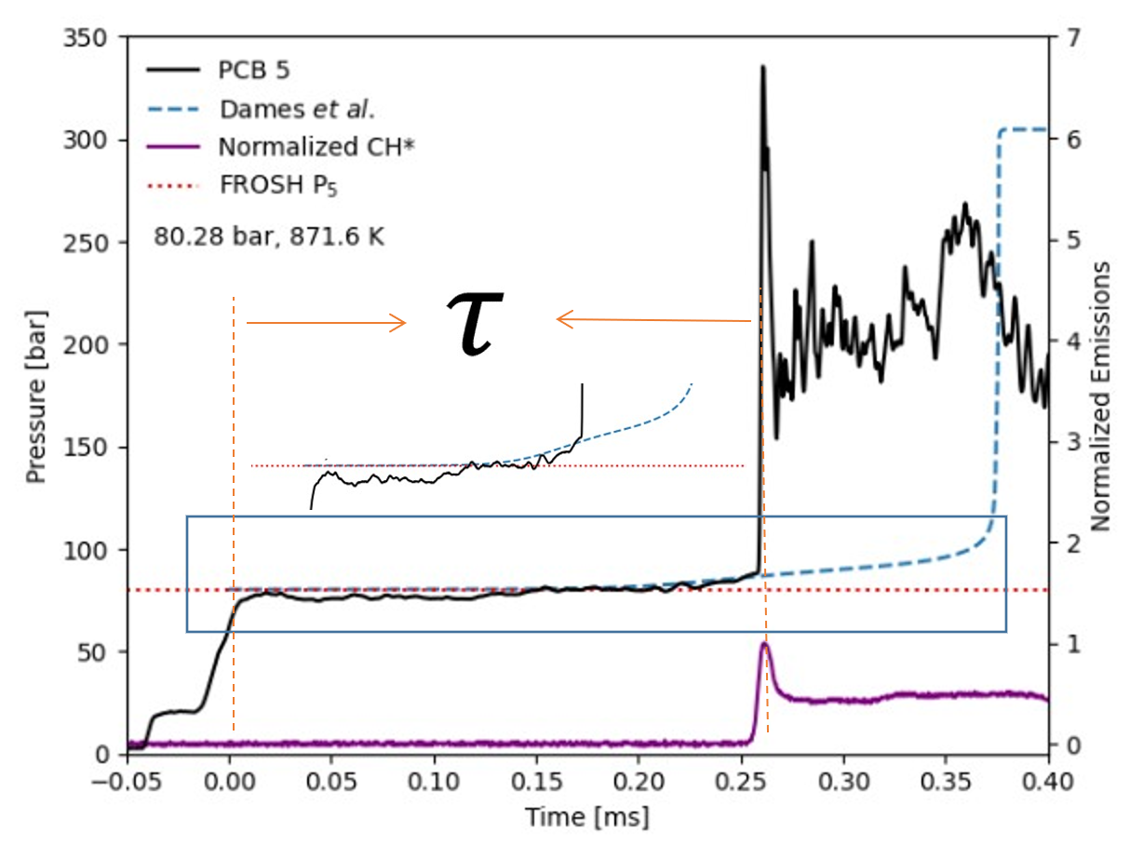
Figure 3. Definition of IDT τ) during shock tube experiments. The conditions shown are for 80.4 bar and 871 K for 60/40 DME/Propane blend. Dashed lines show simulated pressure traces obtained using the Dames et al. [6] mechanism.
The IDTs were captured using an OH* (306 nm) and CH* radical chemiluminescent emission detector via window ports at the test location. Calculating IDTs is different for each experimental group, but it is important to maintain consistency when comparing the IDT data obtained from experiments with other works and simulations. Here, IDTs are calculated from the experimental time-zero, which is considered when the core of the reflected shock passes by the test section to the time when OH* attains a peak value (τ in figure 3) [19].
Shock tube experiments assume homogeneous distributed quiescent gas behind the reflected shock, with test times on the order of a few milliseconds. This allows experimental data from shock tube experiments to be compared to kinetic model predictions under constant internal energy and volume assumptions [21]. Since the experiments are during the microsecond time scale, the heat loss process is negligible; this justifies the adiabatic assumption for modeling [21]. The chemical kinetic mechanisms used in this work are Aramco3.0 [19], NUIG [36], and Dames et al. [6]. Most of the analysis in this work was carried out with the Dames et al. [6] model, as it is well-validated for DME-propane mixtures for pressures up to 20 bar.
Results and Discussion
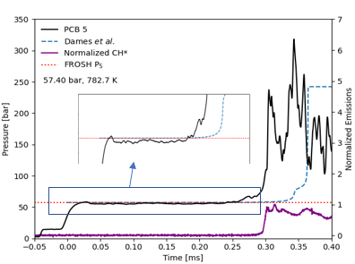
Figure 4. Example experimental trace showing an increase in the pressure before ignition. The conditions shown are for 57.4 bar and 782 K for neat DME. Dashed lines show simulated pressure traces obtained using the Dames et al. [6] mechanism.
Figures 3 and 4 are examples of experimental OH* and CH* emissions and pressure traces during the oxidation of DME-propane mixtures. Of note, both pressure traces show an increase just before ignition that is also captured by the model. The initial rise in pressure, noticeable from Figures 3 and 4, can be attributed to a characteristic of DME. In Figures 3 & 4, the P₅ and T₅ are calculated using normal shock equations (Rankine–Hugoniot–equations), which use the incident shock velocity and set driven conditions [37]. This is to reach the initial conditions needed for achieving the targeted T₅ and P₅ found by FROSH [38]. The driven gas used was composed of helium and nitrogen, and the mixing time of the tank was one hour. From Table 3, a prominent reaction for DME, is DME reacting with OH (R7), which occurs after a chain of reactions in the first stage of DME decomposition. DME undergoes H-abstraction with O₂ to produce a radical and HO₂ (R1). The radical proceeds to react with O₂ to form RO₂ (R2), which undergoes isomerization to form QOOH (R3). This then reacts with O₂ to form OOQOOH (R4). OOQOOH then decomposes to form HPMF + OH (R5). HPMF then decomposes to form another OH (R6). Since one DME produces two OH radicals (R4 and R5), it is considered chain branching. These reactions dominate at lower temperatures, contributing to the increase of pressure before ignition [39]. Since these reactions are part of the Dames et al. [6] mechanism, the model also predicts this pressure rise (see figure 4).
Table 3. First-stage reactions of DME.
DME+O₂=R+HO₂ | R1
R+O₂=RO₂ | R2
RO2 = QOOH | R3
QOOH+O₂=OOQOOH | R4
OOQOOH = HPMF + OH | R5
HPMF = OH + OCHOCH₂O | R6
DME + OH = R+H₂O | R7
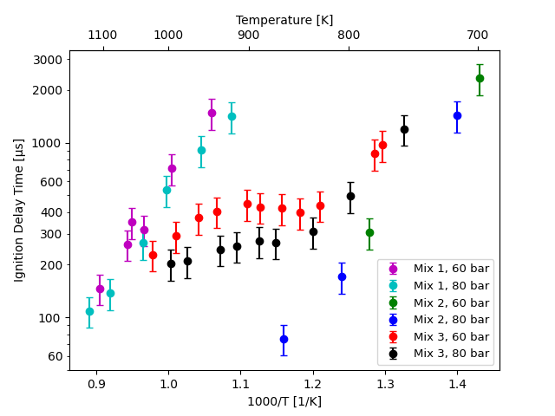
Figure 5. Experimental ignition delay times for various DME mixtures studied in this work at 60 bar and 80 bar at an equivalence ratio of 1.
Figure 5 shows the ignition delay times observed near 60 and 80 bar for various mixtures studied in this work. As expected, the neat propane mixture is the slowest to ignite, while the neat DME mixture ignites the fastest. Small pressure dependency was observed for neat propane ignition delay times. With higher pressures, ignition is faster for a 100% propane mixture. The experiments do not show significant pressure dependency for neat DME at the conditions studied. For the 60/40 blend of DME in propane mixture, ignition delay times were observed to be faster than neat propane mixture and slower than neat DME mixture. At 60 bar, the ignition delay time reduces with an increase in temperature until 827 K. Further increase in temperature increases the ignition delay time until ~900 K, beyond which IDT reduces again. This negative temperature coefficient (NTC) behavior for IDT has been observed for DME mixtures in Dames et al. [6]. However, at 80 bar, the NTC behavior is not as significant as in lower pressures (60 bar), although it still exists. For the mixtures of 100% DME and C₃H₈, NTC regions could not be experimentally reached. For DME, instantaneous ignition occurred at higher temperatures, while for propane, remote ignition occurred at lower temperatures. As mentioned earlier, DME and propane complement each other very well, allowing for a broad temperature range between 754 – 1022K at 60 and 80 bar- a much wider range for testing in comparison to the neat mixtures.
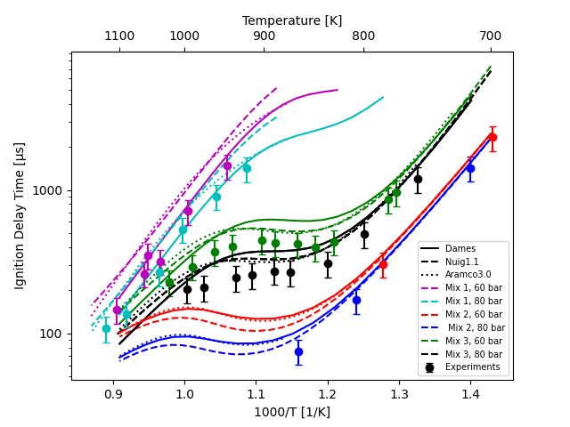
Figure 6. Comparison of experiments and model predictions (NUIG [36] and Dames et al. [6] mechanisms) for ignition delay times of DME-propane mixtures at 60 and 80 bar at an equivalence ratio of 1.
Figure 6 shows the comparison of experimental IDTs with predictions (NUIG [36], Dames et al. [6], and Aramco3.0 [19] ). In general, all three models capture the trend in IDTs for all DME-propane mixtures. For a 100% DME blend, the IDTs predictions are within the experimental uncertainty at both 60 and 80 bar at lower temperatures. At lower temperatures for neat DME mixtures, the model predictions at 60 and 80 bar converge, showing that there is significantly lower pressure dependency. This is concurrent with our experimental observation. As temperature increases, the models diverge, showing higher pressure dependency at high temperatures. All three mechanisms predicted low-temperature IDTs for neat DME accurately. However, as temperature increases, deviations are observed, with experimental IDTs being faster than predicted values. For neat propane at 60 bar and 80 bar, the Dames et al. [6]. mechanism predicts the experimental IDTs with much better accuracy than the NUIG [36] and Aramco3.0 mechanism. For the 60/40 blend of DME-propane, all mechanisms overpredict the IDTs, with the NUIG [36] and Aramco3.0 [19] model being closer to experiments at lower temperatures. Additionally, the trend of decreasing pressure dependency when lowering the temperature, as in a neat DME mixture, is still retained even after blending with 40% propane. The models predict more significant NTC behavior than is experimentally observed. The most accurate model is the Dames et al. [6] at higher temperatures. The NTC behavior for the 80 bar experiments is different from that of 60 bar. Instead of a large rise before falling, the trend is flatter and quickly trends downward at approximately 950K. At lower temperatures, before the NTC region, the NUIG [36] mechanism is the most accurate where the values are within the experimental uncertainty. In the NTC region, the most accurate mechanism is Aramco3.0 [19]. However, at higher temperatures, near the end of the NTC region, the experimental data has a much smaller slope when compared to the predictions of mechanisms where they curve out and then plateau. In this region, the most accurate mechanism is the Dames et al. [6] model.
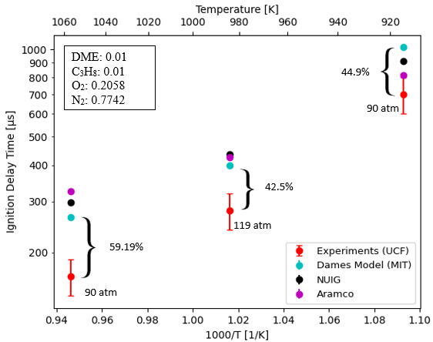
Figure 7. Experimental results obtained for IDTs compared with simulation results for DME-propane mixture at ~90 and ~120 bar. See text for mechanisms.
Figure 7 shows the ignition delay times obtained during the experiments conducted at 90 and 120 bar, along with the comparisons with recent mechanisms from the literature. The IDTs obtained during experiments are much faster than the predicted ones obtained with reaction mechanisms from the literature. Clearly, as pressure increases, the deviations from the models are also more prominent. The Aramco3.0 [19] mechanism predicts the slowest ignition at higher temperatures, and as temperatures decrease, accuracy increases, while the Dames et al. [6] mechanism predicts the fastest ignition at two points. The prediction by the NUIG [36]mechanism is in between Aramco3.0 [19] and Dames et al. model [6] for two points. For 119 atm, Aramco and NUIG [36] predict similar IDTs, but the Dames et al. [6] model has the best prediction. In terms of deviation from the model, the closest prediction is by Dames et al. [6]. The model shows a deviation of ~59% with experimental results at high temperatures. At lower temperatures, a deviation of ~44.9% is observed. This indicates that the present models on DME/propene blends available in the literature are inadequate in modeling high-pressure ignition scenarios which are typical in heavy-duty engines.
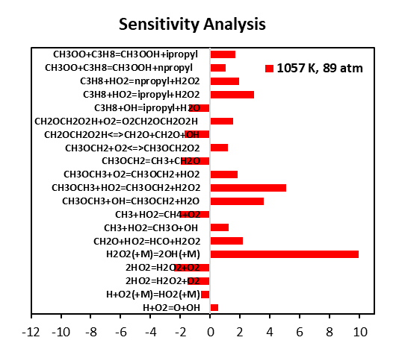
Figure 8. Sensitivity analysis using the Dames et al. [6] mechanism at the time when half of the DME in the mixture is consumed (1057 K and 89 atm).
A sensitivity analysis was conducted using the Dames et al. [6] model to understand the discrepancies between the model and experiments. Sensitivity analysis was conducted for the high-temperature case (1057 K and 89 atm), which exhibited the maximum deviation from experiments. The results for the top 20 reactions at the time when 50 % of DME was consumed are shown in Figure 8. The most sensitive reaction is H₂O₂ (+M) = 2OH (+M). This reaction is well studied in the literature, and the rate is well established. However, the second most sensitive reaction was CH₃OCH₂ + HO₂ = CH₃OCH₂ + H₂O_{2,} which is the H-abstraction from DME by HO₂ radical. This is because the mixture under investigation has 50 % propane in the fuel, and propane undergoes H-abstraction at high temperatures to produce the C₃H₇ radical. The C₃H₇ produced then reacts with oxygen to produce HO₂ radicals. The larger amount of HO₂ in the reaction pool makes this H-abstraction by HO₂ one of the most sensitive reactions for the DME/propane mixture. The rate constant for this reaction is from the theoretical work by Mendes et al. [40] and has an estimated uncertainty of a factor of 2.5. Other sensitive reactions include H-abstraction by OH and O2. These rates were estimated by Curran and Fisher [41] and are prone to significant uncertainties [41]. The IDT for this mixture is also sensitive to a few pressure-dependent reactions of DME intermediates like CH₂OCH₂O₂H + O₂ = O₂CH₂OCH₂O₂H and CH₃OCH₂ + O₂ = CH₃OCH₂O₂. Both rates are from Burke et al. [42], which utilized many assumptions to derive these rates using the theoretical calculations from Yamada et al. [43] and the high-pressure rate from Li et al. [44].
To understand the effect of sensitive reactions, the reaction CH₃OCH₂ + HO₂ = CH₃OCH₂ + H₂O₂ was modified within its uncertainty, and A-factor was multiplied by 2.5 times. The resulting IDT predictions are shown in Figures 9 and 10. The agreement has improved considerably, indicating that further analysis is required for the sensitive reactions outlined in this work.
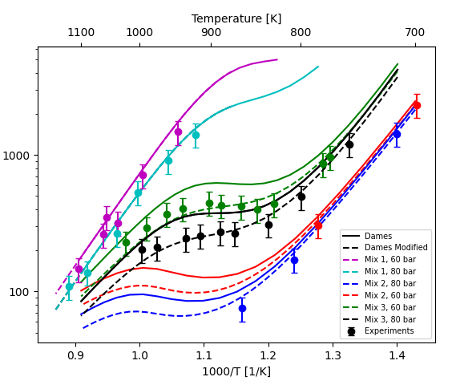
Figure 9. Comparison of experimental results with the predictions by the Dames et al. [6] model and the modified version of the Dames et al. [6] model for IDTs of DME-propane mixtures (60 and 80 bar) at an equivalence ratio of 1.
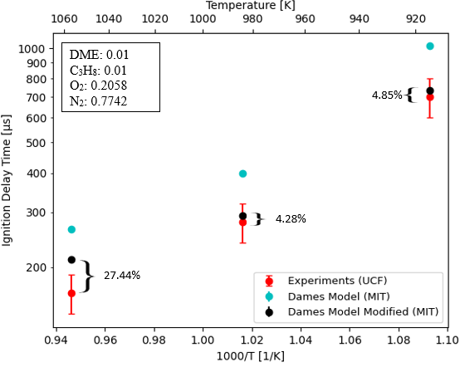
Figure 10 Comparison of experimental results with the predictions of the Dames et al. [6] mechanism and the modified version for IDTs of DME-propane mixtures at 90-120 bar.
Conclusions
IDTs for mixtures of DME-propane were measured at conditions relevant to mixing controlled compression ignition engines (60-120 bar and 700-1100 K). Undiluted experiments, spanning temperatures of 700 to 1100 K and pressures near 60 and 80 bar for various blends (100% CH₃OCH₃, 100% C₃H₈, 60% CH₃OCH₃ | 40% C₃H₈) of DME and propane were combusted in synthetic air (21% O₂ | 79% N₂). In order to understand the effect of higher pressures, some experiments were conducted near 90 and 120 atm. NTC behavior was observed with a 60/40 blend of DME with propane. At higher pressures (80 bar), NTC was less prominent than at lower pressures (60 bar). Against the experimental IDT data, comparisons are made with predictions of recent chemical kinetic mechanisms for the DME-propane mixture, including the Aramco3.0 [19], NUIG [36], and Dames et al. [6] mechanisms. Models were able to capture the general trend in experimental IDTs for 60 and 80-bar cases. However, when compared to experimental results, none of the models could fully predict the behavior across the entire region of interest. For 90 and 120 atm cases, significant deviations from experiments were observed for model predictions. All mechanisms overpredict IDTs compared to experimental values. Sensitivity analysis was conducted with the Dames et al. [6] mechanism, and critical reactions sensitive to IDT of DME-propane mixture near 90 atm were outlined. Future work will involve collecting data for additional mixtures and experimental conditions (pressure, temperature) as well as probing intermediates and products using laser absorption techniques during the ignition process for additional insights into this promising fuel blend chemistry.
References
[1] E.-E. I. Administration, "Annual Energy Outlook 2020," 2020. [Online]. Available: https://www.eia.gov/outlooks/aeo/pdf/aeo2020.pdf.
[2] C. Bae and J. Kim, "Alternative fuels for internal combustion engines," Proceedings of the Combustion Institute, vol. 36, no. 3, pp. 3389-3413, 2017.
[3] J. Baker, R. Khaleel Rahman, E. M. Ninnemann, and S. Vasu, "Ammonia Hydrogen Ignition Measurements for Clean Aircraft Propulsion," in AIAA SCITECH 2022 Forum, 2022, p. 0817.
[4] S. H. Park and C. S. Lee, "Applicability of dimethyl ether (DME) in a compression ignition engine as an alternative fuel," Energy Conversion and Management, vol. 86, pp. 848-863, 2014.
[5] H. Stichnothe and A. Azapagic, "Bioethanol from waste: Life cycle estimation of the greenhouse gas saving potential," Resources, Conservation and Recycling, vol. 53, no. 11, pp. 624-630, 2009.
[6] E. E. Dames, A. S. Rosen, B. W. Weber, C. W. Gao, C.-J. Sung, and W. H. Green, "A detailed combined experimental and theoretical study on dimethyl ether/propane blended oxidation," Combustion and Flame, vol. 168, pp. 310-330, 2016.
[7] K.-Y. Lam, Z. Hong, D. Davidson, and R. Hanson, "Shock tube ignition delay time measurements in propane/O2/argon mixtures at near-constant-volume conditions," Proceedings of the Combustion Institute, vol. 33, no. 1, pp. 251-258, 2011.
[8] X. Man, C. Tang, L. Wei, L. Pan, and Z. Huang, "Measurements and kinetic study on ignition delay times of propane/hydrogen in argon diluted oxygen," international journal of hydrogen energy, vol. 38, no. 5, pp. 2523-2530, 2013.
[9] C. Tang, X. Man, L. Wei, L. Pan, and Z. Huang, "Further study on the ignition delay times of propane–hydrogen–oxygen–argon mixtures: Effect of equivalence ratio," Combustion and flame, vol. 160, no. 11, pp. 2283-2290, 2013.
[10] E. Hu, Z. Zhang, L. Pan, J. Zhang, and Z. Huang, "Experimental and modeling study on ignition delay times of dimethyl ether/propane/oxygen/argon mixtures at 20 bar," Energy & fuels, vol. 27, no. 7, pp. 4007-4013, 2013.
[11] G. Agafonov, V. Smirnov, and P. Vlasov, "A Shock-Tube and Modeling Study of Soot Formation During Pyrolysis of Propane, Propane/Toluene and Rich Propane/Oxygen Mixtures," Combustion science and technology, vol. 182, no. 11-12, pp. 1645-1671, 2010.
[12] E. Hu, X. Jiang, Z. Huang, J. Zhang, Z. Zhang, and X. Man, "Experimental and kinetic studies on ignition delay times of dimethyl ether/n-butane/O2/Ar mixtures," Energy & fuels, vol. 27, no. 1, pp. 530-536, 2013.
[13] L. Xu, L. Ouyang, Z. Geng, H. Li, Z. Huang, and X. Lu, "Experimental and Kinetic Study on Ignition Delay Times of Liquified Petroleum Gas/Dimethyl Ether Blends in a Shock Tube," Energy & Fuels, vol. 28, no. 11, pp. 7168-7177, 2014/11/20 2014, doi: 10.1021/ef5014133.
[14] N. Zettervall, C. Fureby, and E. J. Nilsson, "Reduced Chemical Kinetic Reaction Mechanism for Dimethyl Ether-Air Combustion," Fuels, vol. 2, no. 3, pp. 323-344, 2021.
[15] Z. Li, W. Wang, Z. Huang, and M. A. Oehlschlaeger, "Dimethyl ether autoignition at engine-relevant conditions," Energy & fuels, vol. 27, no. 5, pp. 2811-2817, 2013.
[16] R. Cook, D. Davidson, and R. Hanson, "Shock tube measurements of ignition delay times and OH time-histories in dimethyl ether oxidation," Proceedings of the Combustion Institute, vol. 32, no. 1, pp. 189-196, 2009.
[17] X. Jiang, Z. Tian, Y. Zhang, and Z. Huang, "Shock tube measurement and simulation of DME/n-butane/air mixtures: Effect of blending in the NTC region," Fuel, vol. 203, pp. 316-329, 2017.
[18] S. Kajitani, C. Chen, M. Oguma, M. Alam, and K. Rhee, "Direct injection diesel engine operated with propane-DME blended fuel," SAE Technical Paper, 0148-7191, 1998.
[19] C.-W. Zhou et al., "An experimental and chemical kinetic modeling study of 1,3-butadiene combustion: Ignition delay time and laminar flame speed measurements," Combustion and Flame, vol. 197, pp. 423-438, 2018/11/01/ 2018, doi: https://doi.org/10.1016/j.combustflame.2018.08.006.
[20] S. L. Kokjohn, "Reactivity controlled compression ignition (RCCI) combustion," The University of Wisconsin-Madison, 2012.
[21] E. Ninnemann et al., "New insights into the shock tube ignition of H2/O2 at low to moderate temperatures using high-speed end-wall imaging," Combustion and Flame, vol. 187, pp. 11-21, 2018.
[22] J. J. Urso et al., "Characterization of a new ultra-high pressure shock tube facility for combustion and propulsion studies," Review of Scientific Instruments, vol. 93, no. 6, p. 063905, 2022, doi: 10.1063/5.0084047.
[23] M. Pierro et al., "High-Fuel Loading Ignition Delay Time Characterization of Hydrogen/Natural Gas/Ammonia at Gas Turbine-Relevant Conditions Inside a High-Pressure Shock Tube," in ASME Turbo Expo 2022: Turbomachinery Technical Conference and Exposition, 2022, vol. Volume 3B: Combustion, Fuels, and Emissions, V03BT04A002, doi: 10.1115/gt2022-82069. [Online]. Available: https://doi.org/10.1115/GT2022-82069
[24] R. K. Rahman, S. Barak, S. W. Wagnon, G. Kukkadapu, W. J. Pitz, and S. S. Vasu, "Shock tube investigation of high-temperature, extremely-rich oxidation of several co-optima biofuels for spark-ignition engines," Combustion and Flame, vol. 236, p. 111794, 2022.
[25] A. R. Laich et al., "High-pressure shock tube study of ethanol oxidation: Ignition delay time and CO time-history measurements," Combustion and Flame, vol. 212, pp. 486-499, 2020.
[26] J. B. Baker et al., "Experimental Ignition Delay Time Measurements and Chemical Kinetics Modeling of Hydrogen/Ammonia/Natural Gas Fuels," Journal of Engineering for Gas Turbines and Power, vol. 145, no. 4, 2022, doi: 10.1115/1.4055721.
[27] E. Ninnemann et al., "Reflected shock-initiated ignition probed via simultaneous lateral and endwall high-speed imaging with a transparent, cylindrical test-section," Combustion and Flame, vol. 224, pp. 43-53, 2021/02/01/ 2021, doi: https://doi.org/10.1016/j.combustflame.2020.08.017.
[28] S. Neupane et al., "DMMP pyrolysis and oxidation studies at high temperature inside a shock tube using laser absorption measurements of CO," Combustion and Flame, vol. 214, pp. 14-24, 2020/04/01/ 2020, doi: https://doi.org/10.1016/j.combustflame.2019.12.014.
[29] Z. E. Loparo, E. Ninnemann, Q. Ru, K. L. Vodopyanov, and S. S. Vasu, "Broadband mid-infrared optical parametric oscillator for dynamic high-temperature multi-species measurements in reacting systems," Optics Letters, vol. 45, no. 2, pp. 491-494, 2020/01/15 2020, doi: 10.1364/OL.382308.
[30] S. Barak et al., "Measuring the effectiveness of high-performance Co-Optima biofuels on suppressing soot formation at high temperature," Proceedings of the National Academy of Sciences, vol. 117, no. 7, pp. 3451-3460, 2020, doi: 10.1073/pnas.1920223117.
[31] F. Arafin, A. Laich, E. Ninnemann, R. Greene, R. K. Rahman, and S. S. Vasu, "Influence of the double bond position in combustion chemistry of methyl butene isomers: A shock tube and laser absorption study," International Journal of Chemical Kinetics, vol. 52, no. 11, pp. 739-751, 2020, doi: https://doi.org/10.1002/kin.21396.
[32] S. Panigrahy et al., "An experimental and detailed kinetic modeling study of the pyrolysis and oxidation of allene and propyne over a wide range of conditions," Combustion and Flame, vol. 233, p. 111578, 2021/11/01/ 2021, doi: https://doi.org/10.1016/j.combustflame.2021.111578.
[33] K. Zhang et al., "An experimental, theoretical, and modeling study of the ignition behavior of cyclopentanone," Proceedings of the Combustion Institute, vol. 37, no. 1, pp. 657-665, 2019/01/01/ 2019, doi: https://doi.org/10.1016/j.proci.2018.06.097.
[34] Cantera: An Object-oriented Software Toolkit for Chemical Kinetics, Thermodynamics, and Transport Processes. (2022). https://www.cantera.org.
[35] R. J. Kee, F. M. Rupley, and J. A. Miller, "Chemkin-II: A Fortran chemical kinetics package for the analysis of gas-phase chemical kinetics," Sandia National Lab.(SNL-CA), Livermore, CA (United States), 1989.
[36] Y. Wu et al., "Understanding the antagonistic effect of methanol as a component in surrogate fuel models: A case study of methanol/n-heptane mixtures," Combustion and Flame, vol. 226, pp. 229-242, 2021.
[37] A. G. Gaydon and I. R. Hurle, The shock tube in high-temperature chemical physics. Reinhold Publishing Corporation, 1963.
[38] PyRGFROSH: A frozen shock solver for ideal and real gas equations of state. (2022). [Online]. Available: https://vasulab.github.io/PyRGFROSH
[39] T. Wada, A. Sudholt, H. Pitsch, and N. Peters, "Analysis of first stage ignition delay times of dimethyl ether in a laminar flow reactor," Combustion Theory and Modelling, vol. 17, no. 5, pp. 906-936, 2013.
[40] J. Mendes, C.-W. Zhou, and H. J. Curran, "Rate Constant Calculations of H-Atom Abstraction Reactions from Ethers by HȮ2 Radicals," The Journal of Physical Chemistry A, vol. 118, no. 8, pp. 1300-1308, 2014/02/27 2014, doi: 10.1021/jp412496g.
[41] H. J. Curran, S. L. Fischer, and F. L. Dryer, "The reaction kinetics of dimethyl ether. II: Low-temperature oxidation in flow reactors," International Journal of Chemical Kinetics, https://doi.org/10.1002/1097-4601(2000)32:12<741::AID-KIN2>3.0.CO;2-9 vol. 32, no. 12, pp. 741-759, 2000/01/01 2000, doi: https://doi.org/10.1002/1097-4601(2000)32:12<741::AID-KIN2>3.0.CO;2-9.
[42] U. Burke et al., "An ignition delay and kinetic modeling study of methane, dimethyl ether, and their mixtures at high pressures," Combustion and Flame, vol. 162, no. 2, pp. 315-330, 2015/02/01/ 2015, doi: https://doi.org/10.1016/j.combustflame.2014.08.014.
[43] T. Yamada, J. W. Bozzelli, and T. H. Lay, "Comparisons of CBS-q and G2 calculations on thermodynamic properties, transition states, and kinetics of dimethyl-ether + O2 reaction system," International Journal of Chemical Kinetics, https://doi.org/10.1002/(SICI)1097-4601(2000)32:7<435::AID-KIN6>3.0.CO;2-4 vol. 32, no. 7, pp. 435-452, 2000/01/01 2000, doi: https://doi.org/10.1002/(SICI)1097-4601(2000)32:7<435::AID-KIN6>3.0.CO;2-4.
[44] Q. S. Li, Y. Zhang, and S. Zhang, "Dual Level Direct ab Initio and Density-Functional Theory Dynamics Study on the Unimolecular Decomposition of CH3OCH2 Radical," The Journal of Physical Chemistry A, vol. 108, no. 11, pp. 2014-2019, 2004/03/01 2004, doi: 10.1021/jp037154w.

Contact Information
- Prof. Subith Vasu, Mechanical and Aerospace Engineering, University of Central Florida, Orlando, FL 32816, subith@ucf.edu

Acknowledgments
This material is based upon work supported by the U.S. Department of Energy’s Office of Energy Efficiency and Renewable Energy (EERE) under Award Number DE-EE0009879. Partial support from the University of Central Florida is also acknowledged.
Disclaimer: This report was prepared as an account of work sponsored by an agency of the United States Government. Neither the United States Government nor any agency thereof, nor any of their employees, makes any warranty, express or implied, or assumes any legal liability or responsibility for the accuracy, completeness, or usefulness of any information, apparatus, product, or process disclosed, or represents that its use would not infringe privately owned rights. Reference herein to any specific commercial product, process, or service by trade name, trademark, manufacturer, or otherwise does not necessarily constitute or imply its endorsement, recommendation, or favoring by the United States Government or any agency thereof. The views and opinions of authors expressed herein do not necessarily state or reflect those of the United States Government or any agency thereof.
Definitions/Abbreviations
BTU | British Thermal Unit
LPG | Liquified petroleum gas
LHV | Lower heating value
DME | Dimethyl ether
IDT | Ignition delay time
C₃H₈ | Propane
K | Kelvin
MJ | Mega joules
NTC | negative temperature coefficient
HPMF | Hydroperoxymethyl Formate (C₂H₄O₄)

Appendix: Mixture and IDT information

Table 4:summary of neat DME mixture data (C₂H₆O/O₂/N₂ = 6.6/19.6/73.8)
T₅ | P₅ | IDT
(K) | (atm) | (µs)
699 | 60 | 2334
782 | 58 | 306
714 | 86 | 1431
807 | 82 | 171
863 | 84 | 75
915 | 84 | 59

Table 5: Summary of neat C₃H₈ mixture data(C₃H₈/O₂/N₂ = 4/20.2/75.8)
T₅ | P₅ | IDT
(K) | (atm) | (µs)
944 | 60 | 1480
995 | 60 | 714
1035 | 62 | 319
1054 | 64 | 351
1059 | 62 | 262
1105 | 61 | 147
920 | 79 | 1415
957 | 79 | 907
1003 | 82 | 534
1036 | 80 | 266
1089 | 83 | 137.5
1124 | 84 | 108.9

Table 6: Summary of neat C₃H₈/DME blend data (C₃H₈/CH₃OCH₃/O₂/N₂ = 2.1/3.14/19.91/74.85)
T₅ | P₅ | IDT
(K) | (atm) | (µs)
771 | 60 | 967
778 | 55 | 864
827 | 61 | 438
846 | 60 | 398
864 | 59 | 421
887 | 59 | 428
902 | 57 | 447
937 | 59 | 405
960 | 59 | 371
989 | 59 | 293
1022 | 58 | 229
754 | 82 | 1200
799 | 81 | 493
833 | 80 | 309
871 | 80 | 268
888 | 77 | 272
914 | 79 | 257
933 | 78 | 245
974 | 80 | 210
997 | 80 | 203

Table 7: Summary of experimental IDTs for DME/C3H8 (DME/C3H8/O2/N2= 1/1/20.58/77.42) at phi =
T₅ | P₅ | IDT
(K) | (atm) | (µs)
984 | 119 | 280
1057 | 89 | 166
915 | 87 | 701

