Lighting for Health and Wellness Recommendations in Offices: A Circadian Lighting Pilot Project in Chicago, IL

Sarah Safranek¹, Jessica Collier¹, Jess Baker², John Jacobsen², Andrea Wilkerson¹
¹Pacific Northwest National Laboratory
²Schuler Shook

Introduction
In 2019 Cook County initiated a request for proposals for a pilot project aimed at designing and specifying an advanced tunable lighting system for government offices in Chicago, Illinois. The primary goal of the project was to replace the existing tubular LED (TLED) lighting system with a lighting system that supported the circadian rhythms and wellbeing their office employees. A secondary goal was to evaluate the potential impacts of the new lighting system, informing Cook County’s internal workplace design standards. This Circadian Lighting Pilot Project focused on two floors of the George W. Dunne Cook County Administration Building, occupied by the transportation department.
Schuler Shook, a Chicago-based lighting design firm, was awarded the Circadian Lighting Pilot Project in October 2019 and invited Pacific Northwest National Laboratory (PNNL) to contribute as a research partner. Based on the initial project goals, Schuler Shook and PNNL established design objectives that would enable a human factors study in the office spaces, investigating the benefits and drawbacks of using a tunable LED lighting system to meet existing recommendations for lighting and health. This year-long study was designed to further understanding of how electric lighting attributes, such as intensity and spectrum, can affect how office occupants feel and behave at work while accounting for meditating variables such as lifestyle factors (e.g., diet and exercise routines), stress levels, or job satisfaction. Experimental conditions were designed to meet circadian lighting recommendations made by the International WELL Building InstituteTM (IWBI) and UL for office spaces while also considering Illuminating Engineering Society (IES) recommendations and meeting International Energy Conservation Code (IECC) requirements.
Schuler Shook was responsible for the design of the lighting system that provided the desired experimental conditions, including overseeing installation and commissioning. Due to the global pandemic, the Circadian Pilot Project was concluded after the design development phase. Despite the unexpected conclusion, the project provided a unique collaboration between PNNL and Schuler Shook that highlights the challenges of designing to meet current light and health recommendations with available LED luminaire and control system technologies. The following report details the lighting design process through design development, with summaries of the relevant circadian lighting metrics, simulation tools, energy considerations, and research plan for the Circadian Lighting Pilot Project.

Background
The 35-story George W. Dunne office building was the workplace for roughly 2000 county employees prior to the pandemic. It was designed by Skidmore, Owings & Merrill in 1963 and completed in 1965, the building was historically known as the Brunswick Building and was the tallest reinforced concrete structure of its time. The building was among the early works of noted structural engineer Fazlur Khan and pioneered the tube-within-a-tube structural system. Combined with a waffle slab design, the results were column-free interiors and the iconic “waffle iron” façade. Office floors were typical, each with 20,000 square foot floor plates. The building, centrally located within Chicago’s downtown business district and adjacent to other government buildings, became county-owned in 1997. The 23rd and 24th floors, currently occupied by the transportation department, were dedicated for the Circadian Pilot Project.
While the building offered its own set of unique constraints, the project team noted many familiar challenges often found in modern workplaces during a visit to the project site. The main open offices of each floor were situated on the north and south sides, with private offices and meeting rooms primarily occupying the east and west perimeters of the building. Despite the roughly 7 ft tall windows along the entire perimeter of each floor, the downtown Chicago office tower was situated between tall neighboring towers. This caused varied access to daylight for employees, depending on their location in the building. All windows in the open and private office spaces also had a white manually operated vertical blinds. Figure 1 shows a schematic floorplan with the space type distribution of the 23rd floor as well as the current furniture layout in the open office spaces.
Walls had been recently painted lighter neutral tones, with medium grey-blue accent finishes found on interior and meeting room walls. A 2 ft by 2 ft lay-in acoustical ceiling tile grid created ceiling heights of 8.75 ft, while some ceiling conditions dropped to a low 8 ft due to structural and mechanical constraints. The open office workstations used cubicles with 5 ft tall, neutrally colored partitions. Workstations in both open and private offices were oriented by employees to predominantly face the interior circulation zones, with their backs and computer monitors towards the perimeter glazing, as seen in Figure 1 and Figure 2. Darker desk finishes, like those seen in Figure 2, were observed in the private office spaces.
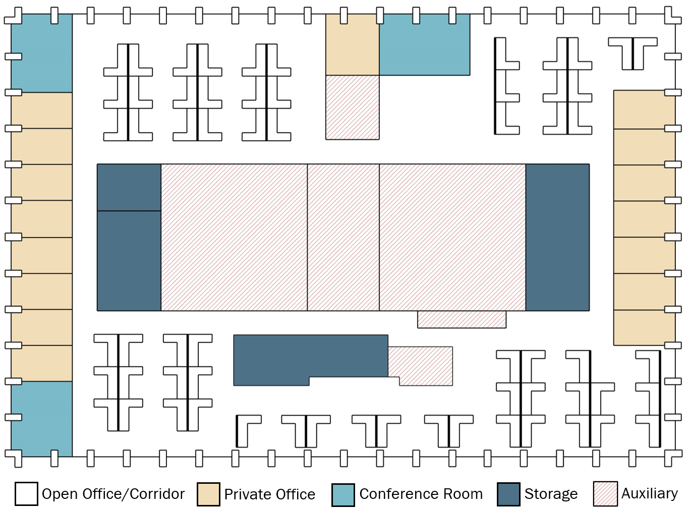
Figure 1. Schematic floorplan of the 23rd floor including existing furniture layout and space type distribution.

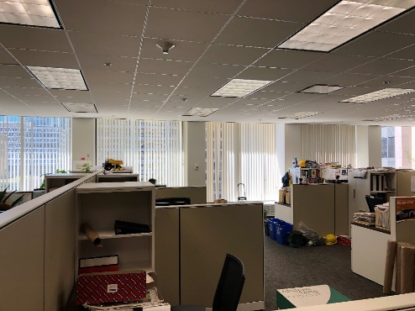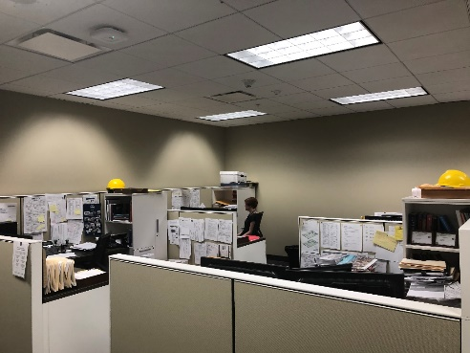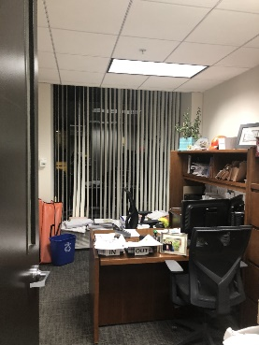
Figure 2. Existing furniture and electric lighting layout for the 23rd floor open office (left, center) and private offices (right).
The existing lighting system of the two office floors consisted of 2 ft by 4 ft parabolic reflector fluorescent troffers retrofitted with TLED lamps in a correlated color temperature (CCT) of 4000 K. The luminaires were arranged in a grid with 8 ft spacing in both the open office and private offices. This arrangement resulted in consistently high horizontal illuminance levels over 600 lux on desk work planes, well exceeding IES recommendations for office tasks, though not unusual for a traditional work environment. Vertical illumination levels varied widely depending on the location in the office, with an average of about 200 lux, ranging from 60 to 330 lux.
Cook County initiated this project to further understand how lighting could better support the well-being of its employees and planned to use the results to inform their internal lighting standards, and make a broader contribution to office lighting research. The design team was charged not only to develop an advanced tunable lighting system that would demonstrate a sustainable, evidence-based lighting design for the Circadian Lighting Pilot Project, but also turn the county’s typical office space into a modern, appealing workplace for current and perspective employees. Although initiated as a lighting focused project, JLK Architects and WMA Engineering were included in the design team to address any architectural or engineering modifications needed to achieve the project’s human-centered and sustainability goals. PNNL spearheaded development of the yearlong research study to understand employee response to different lighting conditions.
In order to create a design standard for happy, healthy, and motivated employees, not only did Cook County and the design team want to provide a circadian supportive design that was environmentally conscious with a modern lighting design. As a result, that the design team sought to find tunable luminaires that provided comfortable source brightness, delivered light levels that were not noticeably high, and that provided warm color temperatures appropriate to the interior environment could also be achieved in the design. In addition, the lighting design team aimed to embrace modern LED technology, avoiding dated luminaire form-factors, such as troffers.
The pilot evaluation required an advanced lighting system to seamlessly study the potential electric lighting effects on the occupants as well as their preferences. The design team approached the project with the goal of creating a visually appealing lighting system that would meet industry standards for glare, circadian entrainment, appropriate task illumination levels, and color quality, as well as optimizing user control and minimizing energy use. As a result, the system would be tasked with meeting numerous current lighting industry standards and recommendations for visual and non-visual health, such as the WELL Building Standard, LEED, and the 2018 IECC requirements.

State of the Industry

Circadian Lighting Metrics
Emerging evidence from the medical research community has linked lighting to physiological responses including circadian synchronization, mood, and acute alerting effects. Research over the past 20 years has demonstrated that these responses have spectral sensitivities that differ from the visual system, leading to new circadian metrics to quantify the potential effects of light. The three most common circadian metrics are: equivalent melanopic lux (EML, units of m-lux), circadian stimulus (CS, unitless), and the more recent melanopic equivalent daylight illuminance (M-EDI, units of lux). These metrics weight the spectrum of light using different weighting functions and incorporate light intensity as a scaling factor. The EML and M-EDI metrics are based on the melanopic response of the intrinsically photosensitive retinal ganglion cells (Lucas, Peirson et al. 2014) with a peak response at 480 nm, with the only difference being the reference source of equal energy and D65, respectively. It is possible to convert between EML and M-EDI using a scalar multiplier (EML ≈ M-EDI x 1.103). The CS metric is the calculated effectiveness of light at suppressing melatonin, using a more complex model of human phototransduction, including data from human melatonin suppression experiments combined with estimates of rod and cone photoreceptor responses, with this model most recently updated in 2021 (Rea and Figueiro 2018, Rea, Nagare et al. 2021). EML was adopted in a slightly modified form to align with SI unit requirements by the International Commission on Illumination (CIE) (2018). More recently, the CIE endorsed M-EDI. CS has not yet been adopted by CIE or the Illuminating Engineering Society (IES).

Design Recommendations
There are currently two organizations with documented recommendations for designing lighting to account for the human circadian system in offices: IWBI and UL. The IWBI WELL building recommendation framework consists of design features that cover multiple aspects of the built environment including water, materials, thermal comfort, and light (IWBI 2020). Points can be earned toward WELL Certification by demonstrating various features have been met. In particular, up to 3 points can be earned through the Circadian Lighting Design feature by demonstrating that electric lighting can be used to deliver varying thresholds of EML to all workstations in regularly occupied spaces for at least 4 hours. UL Design Guideline 24480 (UL 2019) focuses on how circadian-effective lighting designs for offices are to be accomplished and field verified, using CS as the primary metric. The WELL and UL recommendations are summarized in Table 1 and meeting both sets of recommendations was a priority in the Circadian Lighting Pilot Project.
At the time that the project was initiated, WELL v2 2019 Q2 and UL Design Guideline 24480 were the relevant documents for designing to circadian lighting recommendations and metrics however, the WELL Circadian Lighting Design feature and recommendations have since been updated along with the CS metric. The 3-point EML threshold in WELL v2 2021 Q4, the current version of WELL v2 at the time of this report, has been increased by 15% to reflect new recommendations made for healthy daytime, evening, and night-time indoor light exposure (Brown 2020). Although this higher EML recommendation did not exist until after the Circadian Pilot Project concluded, it has been included in Table 1 as it will be discussed in the later sections of this report.

Table 1. WELL and UL Circadian Lighting Design Recommendations. WELL recommendations for EML were updated after the start of the Circadian Lighting Pilot Project.
Document | Recommendation | Viewing Locations | Measurement Height Above Finished Floor (ft) | Minimum Duration (hrs)
WELL v2 2019 Q2 | 1 point: EML ≥ 150 [136 M-EDI] OR CS ≥ 0.3  3 points: EML ≥ 240 [218 M-EDI] | 100% | 4 | 4  9 a.m. – 1 p.m.
WELL v2 2021 Q4 | 1 point: EML ≥ 150 [136 M-EDI]  3 points: EML ≥ 275 [250 M-EDI] | 100% | 4 | 4  Beginning by noon
UL Design Guideline 24480 (2019) | CS ≥ 0.3 | N/A | 3 - 4 | 2  7 a.m. – 4 p.m.

In addition to the existing recommendations for circadian lighting metrics, typical IES recommendations for glare control, color rendering, and task illumination were incorporated into the lighting design for the office spaces. These included metrics like horizontal/vertical illuminance, illuminance/luminance uniformity ratios, and visual comfort probability (VCP).

Design Process

Design of Experimental Conditions
The design and research teams worked closely to ensure that the lighting for the Circadian Lighting Pilot Project could also be used for a detailed human factors study. Although the human factors study was not completed due to the global pandemic, planning was nearly complete for a year-long experimental period comparing four lighting conditions to the baseline TLED lighting condition across the two office floors. In addition to evaluating occupant preference and satisfaction of the new lighting system, data regarding occupant health, lifestyle, environmental satisfaction, job satisfaction, and life changes were included to address the holistic nature of the client’s goals. While lighting can play a role in fostering an environment for happy, healthy, and motivated employees, other factors like individual stress level, satisfaction with job duties and management, and thermal comfort can also impact someone’s overall perception of their work environment, as illustrated in Figure 3 (Collier, Abboushi et al. 2020).
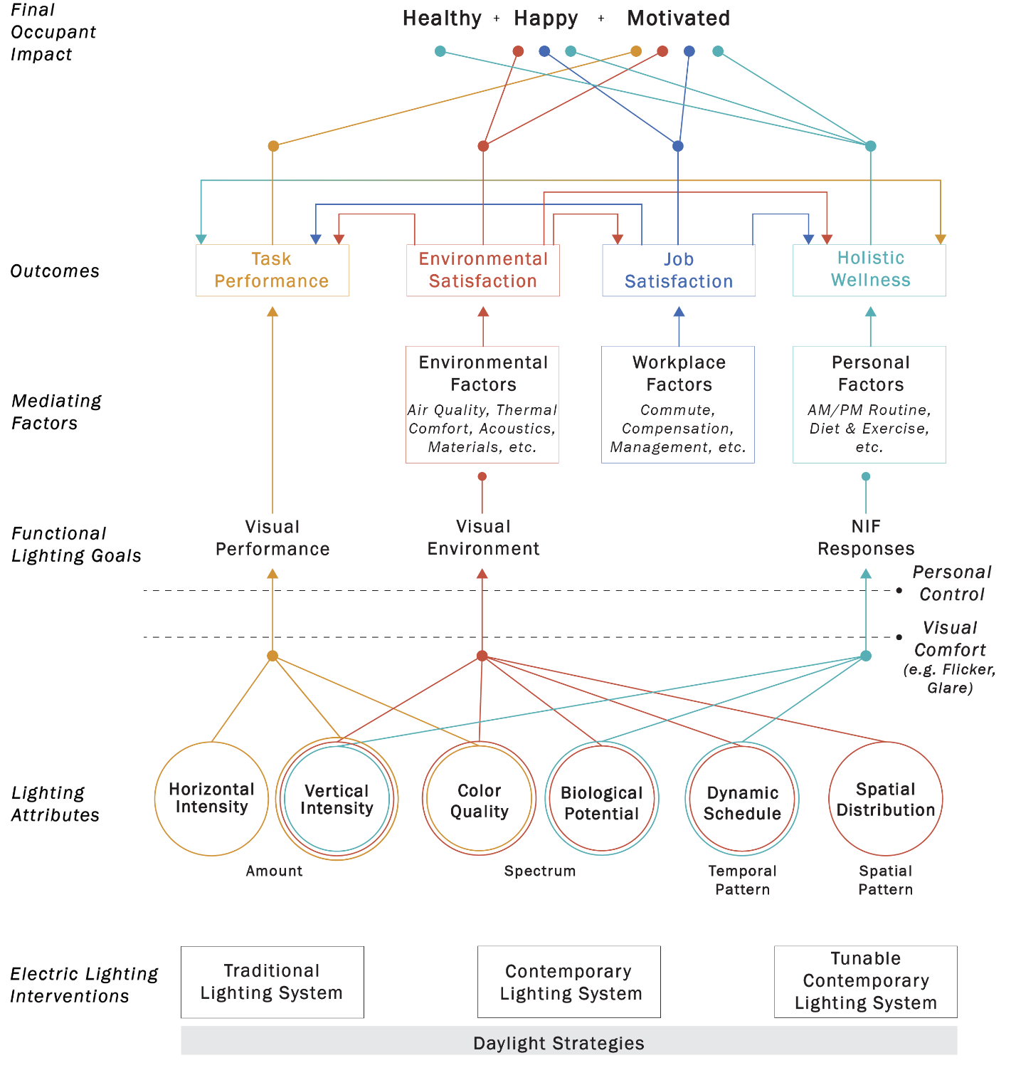
Figure 3. Theory of change diagram connecting technology specific, electric lighting interventions and related attributes to occupant health, happiness and motivation via functional lighting goals (visual performance, visual environment and NIF responses) and outcomes (task performance, environmental satisfaction, job satisfaction and holistic wellness). The relationships create color-coded pathways that explain how the lighting interventions support outcomes that will lead to the final occupant impact. The dotted lines connected to personal control and visual comfort express additional lighting qualities to be considered, along with other external mediating factors (environmental, workplace, or lifestyle factors), when evaluating how a lighting intervention can influence occupant’s well-being. It is assumed that daylight strategies have been considered, such as side lighting with blinds or shades, and that the electric lighting interventions build on those strategies to achieve the functional lighting goals.

The four lighting conditions were designed to feature different attributes that, based on relevant research and recommendations, were hypothesized to contribute to environmental satisfaction and physiological well-being. Each lighting condition lasting six weeks was to appear twice on each floor throughout a year timeframe to account for seasonal changes and variable daylight availability. The first, baseline condition was a static CCT lighting condition meeting existing IES recommendations for task performance and visual quality. The second condition added white tuning to the baseline condition to evaluate the response to visual cueing and environmental satisfaction associated with automated tunable lighting in the workplace. The last two lighting conditions met WELL and UL health and well-being design recommendations but differ in their approach. One lighting condition was designed to meet the recommendations using a static CCT at maximum output for the entire day, and the other lighting condition utilized color tuning, specifically high CCTs, to deliver the stimulus more efficiently. Additionally, the last lighting condition would only deliver light intended to support occupant well-being for 4 hours a day and would return to a lower intensity output for the rest of the day. The last lighting condition satisfied the recommendations in the most energy efficiency manner, however, more research is required to understand outcomes associated with the duration and timing of exposure. The lighting conditions are summarized in Table 2 To seamlessly switch the specific intensity, color, and duration characteristics of the experimental lighting conditions every six weeks, a tunable lighting system was required.
Table 2. Four experimental lighting conditions planned for the Circadian Lighting Pilot Project. A baseline control condition is compared to three intervention conditions that may or may not satisfy light and health recommendations by varying the light level and CCT delivered to occupants.
 | Lighting Conditions
 | Baseline,  Visual Only | Dynamic,  Visual Only | Static,  Wellness | Dynamic, Wellness
Meet Light and Health Recommendations | No | No | Yes | Yes
Light Level | IES recommended light levels | IES recommended light levels | High intensity | High intensity 4 hours per day
Color Tuning | Static CCT | Dynamic CCT | Static CCT | Dynamic CCT

Throughout the human factors study, data collection was to include several standardized surveys including the Patient Reported Outcomes Measurement Information System (PROMIS) Sleep Disturbance and Sleep Related Impairments questionnaires to assess daytime sleepiness and nighttime sleep disturbances as well as the Warwick-Edinburgh Mental Wellbeing Scale (WEMWBS) to assess mood and perceived stress. In addition, the research team developed shorter questionnaires known as Ecological Momentary Assessments (EMAs) to capture “in the moment” responses to a small number of questions regarding elements of the indoor environment such as satisfaction with different aspects of the lighting conditions, temperature, or noise. Lastly, participants were to be prompted with EMAs regarding their alertness, mood, and motivation to complete their current task.

Lighting Design
Once the experimental lighting conditions were established, a balancing act was required to meet the circadian lighting design goals of the project while complying with code and industry recommendations for glare control, color rendering, and task illumination levels. Due to inconsistent daylight penetration within the project space because of adjacent buildings, as well as Chicago’s large number of dark, overcast winter days, the project team sought to design the electric lighting system capable of complying with the applicable lighting recommendations without the benefit of daylight contributions. Although this was understood to be a ‘worst case scenario’ in terms of lighting power, it was also anticipated implementation of daylight responsive controls and intensity setbacks during the periods where circadian lighting metrics were not a priority would reduce actual energy consumption from the connected load baseline.
The WELL v2 2019 Q2 and UL Design Guideline 24480 circadian lighting recommendations call for vertical light levels at occupant eye-level that are higher than what is achieved when solely meeting IES recommendations for horizontal work plane illuminance (Safranek, Collier et al. 2020). As a result, the design team looked to utilize a direct/indirect lighting distribution with separate control of the direct and indirect components. With glare control being an important consideration for occupant comfort, the indirect illumination, as well as wall illumination, was key to increasing overall light levels while decreasing visible lens brightness and balancing contrast ratios to meet IES recommendations.
Due to the limited ceiling heights, Lambertian downlight distributions caused high illumination levels at the task plane when meeting the vertical illumination targets needed for also meeting circadian lighting metrics, while Lambertian uplight distributions caused non-uniform illumination of the ceiling surface. As a result, distributions with greater high-angle output (i.e. ‘batwing’), like that shown in Figure 4, were studied for both direct and indirect components to increase illumination at the eye and hopefully decrease energy consumption. Linear luminaires were arranged in a rectangular pattern over each double wide section of cubicle workstations as shown in Figure 5, allowing illumination to be optimally placed for seated employees’ primary vertical view orientations. Luminaire spacing was unable to be maximized for energy efficiency, as a denser luminaire layout allowed recommendations for glare, uniformity and vertical intensity at the eye to be achieved. In addition to the open office linear pendant, coordinating wall wash, undercabinet task light, and wall mounted uplight were desired. Determining a suitable luminaire family that provided the necessary optics became challenging, especially with the critical role of spectral tuning.
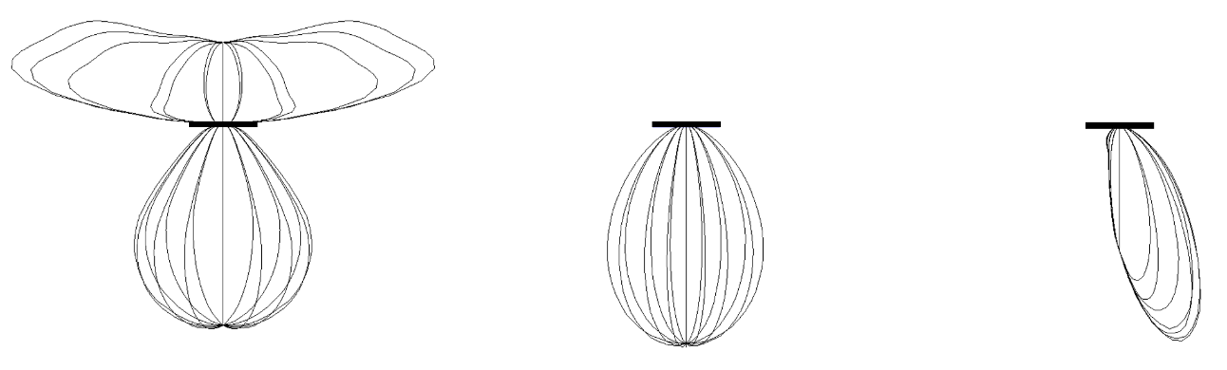
Figure 4. Examples of the photometric distribution of the luminaires selected for the project.
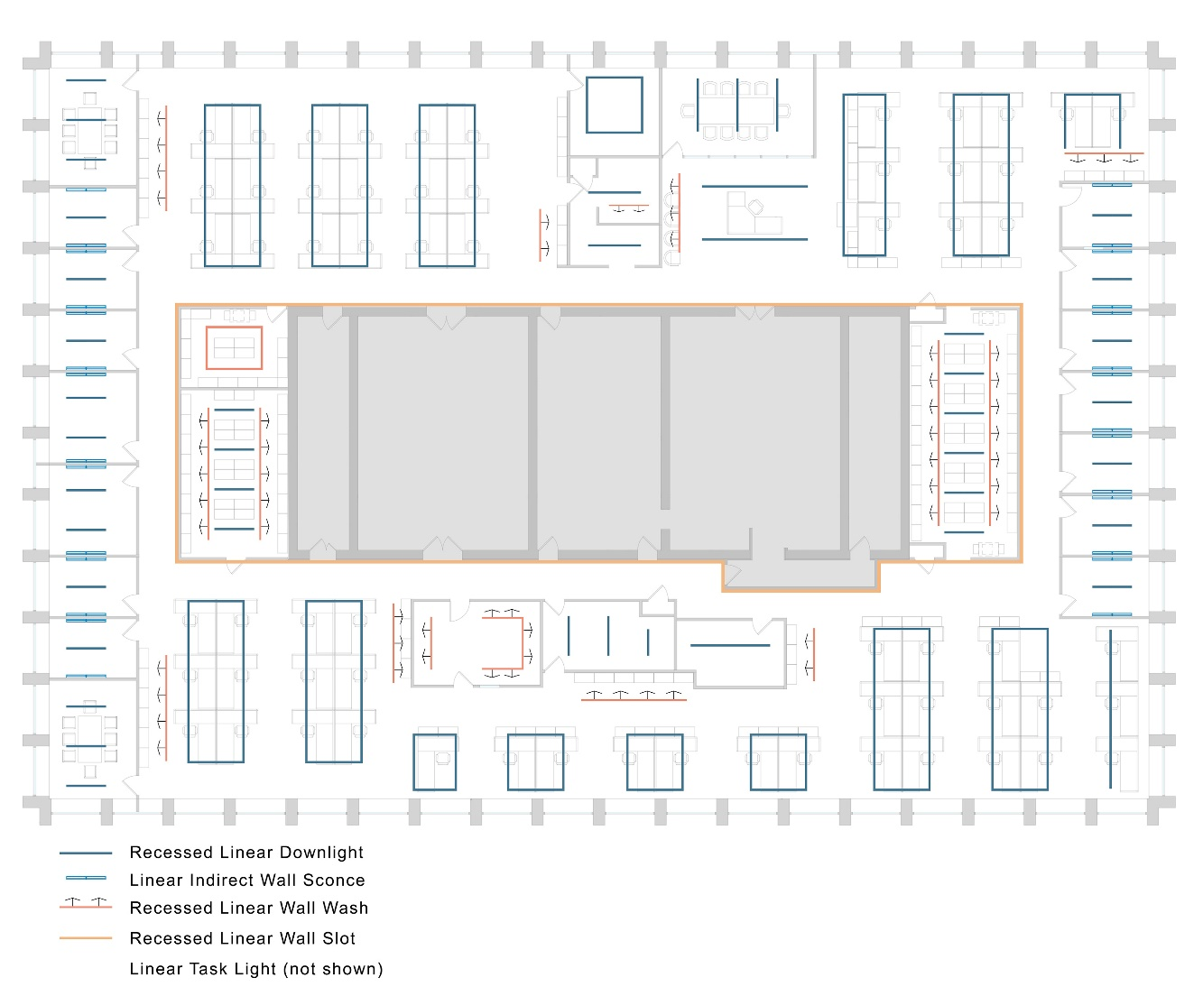
Figure 5. Lighting layout on the 23rd floor.
While the intensity of light is key to meeting the circadian lighting metric thresholds recommended by WELL and UL, the spectral characteristics of the source also play an influential role. The initial proof of concept calculations were conducted with static white sources in a CCT range of approximately 3000 K to 3500 K that were considered standard for commercial interiors. Further, the design team investigated spectrally optimized sources to provide more flexibility in balancing circadian lighting metric recommendations with energy efficiency while maintaining color and visual quality. To optimize the spectra delivered by the system and study its effects, the team initially explored tunable lighting systems with three or more spectral channels. While initially optimistic, the designers realized they would have to make a trade-off after tirelessly searching for products. Multi-primary systems that can vary the spectrum independent of chromaticity did not have the optics necessary to create a non-Lambertian distribution. Conversely, products with the necessary optical distribution to meet circadian metrics and code only had two primaries, a warm and cool phosphor-converted LED, with chromaticity inherently deviating from the blackbody locus resulting in lower color rendering fidelity. Even these two-channel tunable products with the desired optics were difficult to find. As a third option, some lighting products alter source spectra to specifically account for circadian metrics. Unfortunately, these products provided too limited of spectral flexibility for the experimental conditions needed for the study which required slow, visible changes in the color appearance of the light source throughout the day for biophilic and cueing considerations. Additionally, finding the desired optical distributions for these products remained a hurdle, particularly in a linear form factor.
After extensive searching from the design team, a 4 in wide and 1 in tall profile linear luminaire was selected. This luminaire also had a wall wash distribution and could be modified for wall mounting and undercabinet lighting. It was available with a 2-channel tunable white system (2700 K to 6500 K) and injection model optics that provided edge-lighting of a nominal 4 in wide acrylic lens, allowing for high vertical illumination levels that still met IES recommended values for glare mitigation.
While industry recommendations for circadian lighting metrics and glare were achieved, lighting levels on the horizontal task surface were still two to three times higher than the recommendations from the IES. In addition, the increased vertical surface and ceiling illumination, which were both needed for an effective and comfortable lighting system, also created a significant challenge to comply with the energy code, let alone optimized energy performance metrics from sustainability guidelines such as LEED.
To determine how much of a factor the lower ceiling height was on the effectiveness of the lighting system, the team began to investigate architectural modifications to find solutions to address the high intensity horizontal levels. As a result, the team explored the possibility of an exposed ceiling approach on the 24th floor. This new investigation would also allow for the study a very common modern office design of taller open office spaces with exposed ceiling decks and address the obtrusively low mounting height of the currently proposed direct-indirect linear lighting system. The exposed scheme gained the space three feet in additional ceiling height (11 ft to 11.75 ft), allowing luminaires to be mounted at a more visually appealing location. However, the waffle slab structure of the building caused much of the indirect illumination scheme to be less effective than the existing drop ceiling tile solution. Using the same lighting layout, the exposed ceiling approach required higher wattage luminaires to be used to meet the same melanopic values to account for the variable ceiling surface and increased distance, though ceiling uniformity ultimately did improve. Each scheme was presented to Cook County as a possibility for the study, and it was determined that both schemes would be studied in conjunction – one varying the layout for the two floors. This also would allow for a valuable surveying of employee preference of the two schemes. While the ceiling height gained the lighting scheme more visual comfort and pleasing esthetics for the occupants were anticipated, both lighting schemes still struggled with high energy consumption and high horizontal task plane lighting levels.
While the primary focus of the lighting design was meeting the various metrics at the office workstations, it was important to the team to consider the balance of illumination levels for supporting spaces such as storage rooms, break rooms, elevator lobbies, and restrooms in order to manage contrast and adaptation. Maintaining consistent lighting levels to minimize stark contrast with the adjacent private and open office areas meant much higher energy consumption in areas such as storage, many of which have lower lighting power density (LPD) allowances. This tension between managing light level adjacencies and energy code compliance was identified as a topic to be coordinated and resolved before the project could complete the subsequent construction documents phase.

Lighting Simulations

Simulation Software Tools and Methods
Schuler Shook used Lighting Analysts’ AGi32 software to conduct lighting calculations for the study of photopic and melanopic light levels throughout the office spaces. AGi32 is one of the most commonly used lighting design software tools to predict photopic quantities in common architectural applications. Traditional radiosity-based lighting simulation tools, like AGi32, assume light sources to be of equal energy across the visible spectrum, and non-luminous architectural surfaces are assigned a single reflectance value with a flat spectral reflectance distribution. For visualization purposes, luminous and non-luminous surfaces can be assigned red, green, and blue (RGB) color values, and a color bleeding technique is used to depict interreflection of colored surfaces (AGi32 2020). This is a coarse visual representation of what is experienced in a real environment and photometric values calculated using this method may be inflated due to the misrepresentation of energy transfer during interreflections. Currently, additional steps are necessary to use AGi32 simulation methods to calculate spectrally dependent metrics like EML or CS.
During design development, the 23rd floor was used to study all typical space types in both conditions of an open ceiling and the existing drop tile ceiling. Horizontal illuminance calculations were conducted using points on the floor with 2 ft spacing as well as on each task plane, 2.5 ft above finished floor (AFF), with 1 ft spacing. A maintenance light loss factor (LLF) of 0.8 was used in all simulations, consistent with typical lighting project calculations for long term system installations.
Both glare and melanopic potential were studied in AGi32 utilizing vertically oriented calculations points. Calculations were conducted using a continuous point grid with 2 ft spacing, 4 ft AFF, with the calculation points oriented vertically. Multiple vertical calculation grids were placed so that the points were oriented towards each cardinal direction, simulating employee’s primary and peripheral fields of view. To estimate the EML using AGi32, calculations applied an additional LLF based on the melanopic to photopic (M/P) ratio data obtained from lighting manufacturers. The use of consistent vertical calculation grids made it apparent that the vertical light levels necessary to avoid discomfort glare as defined by the IES conflicted with necessary levels for EML and CS at the eye. Lighting Analysts’ companion software, Photometric Toolbox, was also utilized to study luminance angles of each proposed luminaire option to assess glare potential.
PNNL conducted a second set of lighting simulations for several of the spaces on the 23rd floor including the open office, private office, and storage spaces. These simulations were conducted in Adaptative Lighting for Alertness (ALFA), a relatively new simulation tool that allows for high resolution spectral simulations of architectural environments. ALFA uses 81 bins to represent the spectral characteristics of room surfaces and light sources for calculating the intensity and spectrum of light at horizontal or vertical calculation points. This makes it possible to estimate spectrally dependent metrics like EML or CS at the eye of potential occupants. It is important to note that ALFA has not been formally validated in academic literature however, it expands on the capabilities of Radiance, a popular lighting toolkit that uses a raytracing method to simulate daylight and electric lighting in 3 spectral bins.
The following sections explore the AGi32 and ALFA simulation results to investigate how different simulation methods and CCT conditions influence the prediction of relevant lighting metrics in different spaces.

Open Office Simulations – Comparison of Software Tools and Methods
For comparing software tools and calculated metrics, one AGi32 simulation and four ALFA simulations were conducted using the same lighting and architectural layouts for the 23rd floor open office spaces. The AGi32 simulations follow the procedure used by Schuler Shook during the development of the lighting design described in the previous section.
In AGi32, average reflectance values were assigned to room surfaces, based on the materials observed during a site visit to the existing Cook County Office spaces. These materials and corresponding (photopic) reflectance values are listed in Table 3. Material definitions for the ALFA simulations are more detailed, using 81-bin spectral reflectance distributions (SRD) for all surfaces. Multiple reflectance values can be calculated using these SRDs for different portions of the visible spectrum; melanopic reflectance corresponds to the average reflectance within the bounds of the melanopic sensitivity function and photopic reflectance corresponds to reflectance within the bounds of the photopic sensitivity function. The M/P ratio compares these average reflectance values per surface. A summary of the average reflectance values as well as the M/P ratio of each surface is shown in Table 3. Note, the AGi32 and ALFA simulations had the same photopic reflectance values however, the average melanopic reflectance values differ given the full SRDs in ALFA include variations in material reflectance (and color) across the visible spectrum. Most of the surfaces used to simulate the Cook County office spaces are spectrally neutral, with an M/P ratio close to 1.00. The tan wall paint, however, is an example of a surface material that does not reflect short-wavelength energy compared to mid- or long-wavelength energy.
Table 3. Summary of the average photopic and melanopic reflectance values and M/P ratios for all surface materials included in the 23rd floor spaces. The AGi32 simulation used the average photopic reflectance value to represent each surface material while the four ALFA colored lighting conditions used the full spectral reflectance distribution from 380 to 780 nm. Material melanopic and M/P values are also included.
Surfaces | Melanopic Reflectance | Photopic Reflectance | Material M/P
Ceiling | 77% | 82% | 0.94
Desktops | 6% | 10% | 0.65
Desk Cabinets | 80% | 83% | 0.97
Desk Partitions | 48% | 58% | 0.82
Floor | 21% | 22% | 0.98
Glazing* | 46% | 45% | 1.01
Interior Doors | 9% | 9% | 1.03
Interior Glass* | 89% | 88% | 1.01
Wall Paint (Blue) | 23% | 22% | 1.08
Wall Paint (Tan) | 68% | 78% | 0.87
Wall Paint (White) | 76% | 78% | 0.97
*Values correspond to average transmittance of material

The same photometric files were used in AGi32 and ALFA to represent the four luminaire types specified in the open office spaces. Full light source SPDs, displayed in Figure 4, represent the different colored lighting conditions planned for the office space and can be simulated using 5 nm increments in ALFA. Four SPD conditions, from 3000 K to 5000 K, were simulated in ALFA and for the remainder of this report, these SPDs will be described using the nominal CCT values.
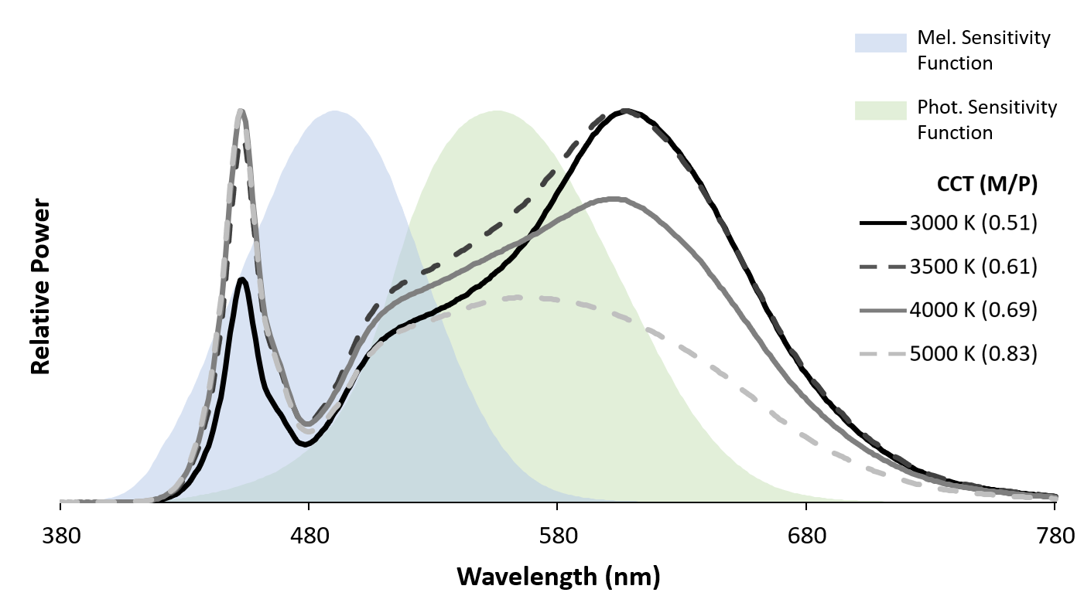
Figure 6. Relative spectral power distributions of luminaires used in ALFA simulations. The four colored lighting conditions that were specified for the Cook County office space are plotted and labeled using the corresponding CCT values. The M/P ratio for each CCT condition is included in parentheses. The melanopic and photopic sensitivity functions are plotted for predicting the melanopsin-driven and visual responses to light.
It cannot be assumed that daylight would contribute consistent levels of EML or CS during the daytime hours, particularly for those workstations further away from the exterior windows and so daylight was not considered in the lighting simulations. It is likely that any daylight contributions would be limited by factors like desk orientation, partition height, deployment of the manual shading system, and obstructions from neighboring towers. Additionally, it is not currently possible to conduct annual or climate-based spectral simulations of daylight.
For ALFA simulations of the open office spaces on the 23rd floor, 62 workstations were assigned one horizontal and one vertical calculation point. Horizontal calculation points were placed atop the desks, which were assumed to be 2.5 ft AFF. Vertical calculation points were placed 4 ft AFF, representing the field of view of a person sitting at each workstation facing towards the desk partition. An example of the placement of the horizontal and vertical calculation points are included in Figure 7. Computer monitors were not included in any of the simulated conditions. Both AGi32 and ALFA were used to estimate average horizontal illuminance at each workstation and ALFA was used to estimate vertical EML and CS. The results of these simulations are plotted in Figure 8 and reference lines are included to indicate which workstations are above the metric thresholds recommended by IES, WELL v2, and UL Design Guideline 24480.

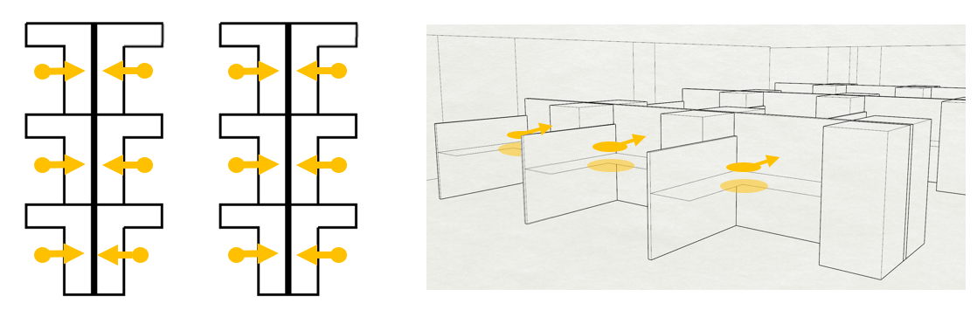
Figure 7. Layout of horizontal and vertical calculation points used in ALFA simulations of the open office spaces. One horizontal and one vertical calculation point was placed at workstation. Vertical calculation points were oriented toward the desk partition, representing the view of an occupant sitting at the workstation.

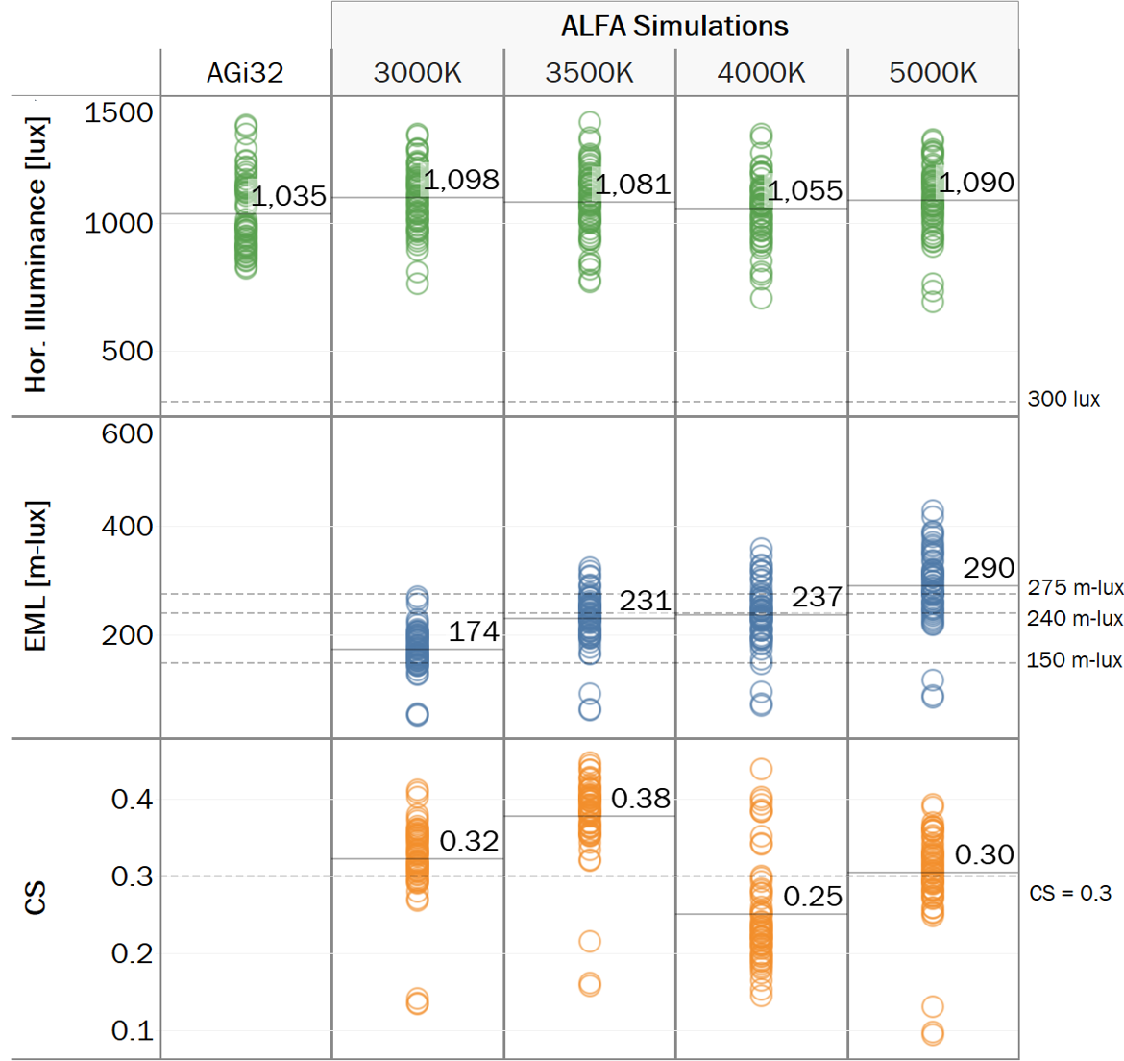
Figure 8. AGi32 and ALFA simulation predicted horizontal illuminance, vertical EML, and vertical CS for 62 workstations in the open office spaces. Each datapoint represents an individual workstation from the 23rd floor open office spaces. Reference lines are included to compare the simulation results against the relevant IES, WELL, and UL recommended thresholds for each metric.
The estimated average horizontal illuminance for all workstations was between 1000 and 1100 lx for both the AGi32 and ALFA simulations, with general agreement between the two simulation software tools. The small differences observed between the AGi32 and ALFA results may be due to the calculation methods (radiosity and raytracing respectively) used to simulate the propagation of light throughout the built environment. Changing the CCT conditions of the luminaires in the ALFA simulations did not have any notable influence on estimated horizontal illuminance, although the small differences (3% between conditions) can likely be attributed to the differences in SPD within the bounds of the photopic sensitivity function. Average EML was estimated to be between 172 and 396 m-lux with EML values increasing as the CCT value of the lighting condition increased. A different pattern occurs when estimating CS; average CS varies between 0.25 and 0.43 with the 4000 K condition resulting in the lowest CS values.
While this report will primarily focus on ALFA estimates of vertical illuminance, EML, and CS, it is valuable to compare how different simulation/calculation methods may impact these metrics. As detailed previously in this section, vertical calculation girds were used in AGi32 to the simulate the four CCT conditions during design development. Despite similar estimates of horizontal illuminance between AGi32 and ALFA, there are notable differences between estimates of vertical illuminance. Determining the source of these differences is outside the scope of this project but it is important to acknowledge how other metrics like EML or CS might also be affected.
Figure 9 shows a small subset of workstations in the southwest corner of the open office space, comparing AGi32 and ALFA simulation results for vertical viewing positions under the 4000 K lighting condition. AGi32 estimates of vertical illuminance range from 533 to 597 lx while ALFA estimates are generally less, ranging from 391 to 442 lx (note, these estimates are 2.5-4 times greater than what is recommended by IES). Without spectral simulation tools, it is possible to estimate EML at the eye of a potential occupant by multiplying vertical illuminance by the M/P ratio of the light source or by inputting the M/P ratio as an additional loss factor in AGi32. Similarly, CS can be estimated by inputting the vertical illuminance at the eye and full SPD of the light source using the calculation procedure outlined by UL Design Guideline 24480.
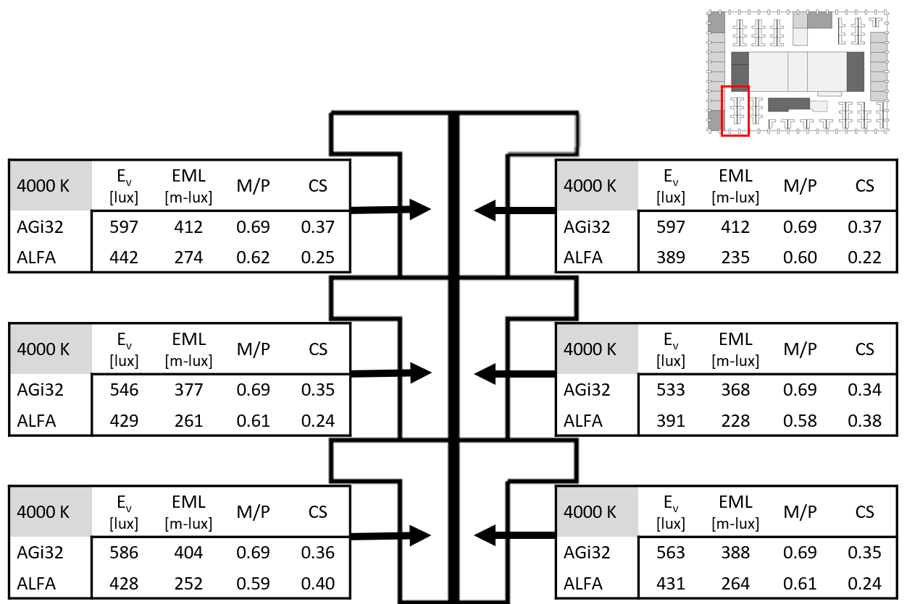
Figure 9. Comparison of results using AGi32 and ALFA to simulate six workstations for the 4000 K lighting condition. AGi32 was used to estimate vertical illuminance at six workstations which was then used to estimate EML and CS using the calculation methods provided by WELL and UL Design Guideline 24480. ALFA was used to estimate vertical illuminance and EML at the same workstations. ALFA predictions of SPD at the eye were used to estimate CS using the method provided by UL Design Guideline 24480.
The differences in vertical illuminance resulting from the AGi32 and ALFA simulations can also be observed in estimates of EML; AGi32 provides higher estimates of EML than ALFA. AGi32 estimates of EML at the six workstations for the 4000 K lighting condition are well above the WELL recommended thresholds of 150 m-lux and 240 m-lux. When simulated in ALFA, all of the workstations remain above 225 m-lux however, two workstations no longer meet the higher EML threshold. AGi32 estimates of CS also meet existing recommendations as all workstations are 0.35 CS or greater. The ALFA simulation results in much different values for CS with four of the six workstations falling below the 0.3 recommended threshold and as low as 0.22 CS.
Some of these differences can be explained by comparing the M/P value predicted for each viewing position (also included in Figure 9). AGi32 estimates of M/P match the light source (0.69) and does not account for any shifts in the spectrum of light as it moves from the luminaires throughout the built environment. The M/P values resulting from ALFA display this shift, with values that are less than the light source, ranging from 0.58 to 0.62. Understanding the spectrum of light at the occupant viewing location is particularly important for calculating CS as is particularly sensitive to small changes in SPDs around 3500 K.
The location of the workstations within the open office space influenced the resulting horizontal illuminance, with large variations observed between workstations for individual simulation conditions. In AGi32, the horizontal illuminance values estimated for the task plane ranged from 822 lx to 1382 lx depending on the location of the workstation. ALFA had a larger range in results estimated for same workstations; the 4000 K condition resulted in horizontal illuminance ranging from 706 lx to 1356 lx. This variation between workstations is also observed for the EML and CS values, which were also impacted by the orientation of the vertical calculation points. This is particularly evident for 3 workstations located in the southeast corner of the 23rd floor, oriented such that the occupant would be facing the window. These positions did not receive much reflected light from the electric lighting system given most of it was transmitted through the glazing material. As a result, EML and CS values at these workstations were notably less for all simulated conditions compared to other workstations throughout the open office, making it difficult to meet the circadian lighting metric recommendations.
For all simulated conditions, average horizontal illuminance in the open office space was estimated to be more than three times greater than what the IES recommends for visual tasks (300 lx). At several workstations, the estimated horizontal illuminance was nearly 1400 lx, which is almost five times the IES recommended value. Despite high light levels, none of the CCT conditions considered for the open office space were able to meet the 150 or 240 m-lux EML thresholds recommended by the WELL v2 2019 Q2 Circadian Lighting Design feature at all workstations. Similarly, there are no simulated conditions would meet 0.3 CS at all workstations, as is recommended by UL Design Guideline 24480.
If the same comparison was done, excluding the three workstations in the southeast corner of the open office space, the 3500 K, 4000 K, and 5000 K conditions would meet 150 m-lux at all workstations but would still fail to meet 240 m-lux at six or more workstations. Of these lighting conditions, 3500 K is the only condition that would also meet 0.3 CS. As discussed in Section XX, the 3-point EML threshold has been updated to 275 m-lux since the conclusion of the Circadian Lighting Pilot Project. Even excluding the three workstations in the southeast corner, 18 or more workstations would fail to meet this higher EML threshold.
The original design for the Circadian Lighting Pilot Project was completed before the new EML threshold was established but ALFA spectral simulations can help to identify the workstations that need further optimization to meet circadian lighting metrics. It is also worth noting that the results presented in this section are based on the environmental factors and initial light levels instead of maintained levels over time. It is expected that measured results would initially deviate from the simulations. With no ability to control cleanliness of workstations, occupant viewing height/direction, and daylight intensity and spectral exposure, results should conservatively meet circadian lighting metrics to allow for further tuning to the actual environment.

Private Office Simulations – Comparison of Occupant View Direction
Although most private offices had similar furnishings, use of each individual office space varied amongst the employees. To investigate the outcomes associated with view direction, surface reflectance, and influence of task lighting, six private offices were created varying the occupant’s primary view direction (i.e., facing the interior of the room, window (excluding daylight), white interior wall, or dark wood bookcase). In addition, three of the six rooms assume a bookcase or storage cabinet is attached to the desk, while the other three have a free-standing bookcase. The three offices with an attached bookcase include an additional surface mounted undercabinet task light. The architectural lighting is the same across all six offices, consisting of a recessed linear luminaire in the center of the room and two wall mounted indirect luminaires mounted one foot below the ceiling with an asymmetric distribution spreading light across the ceiling and work surface. A summary of simulation conditions is shown in Figure 10.

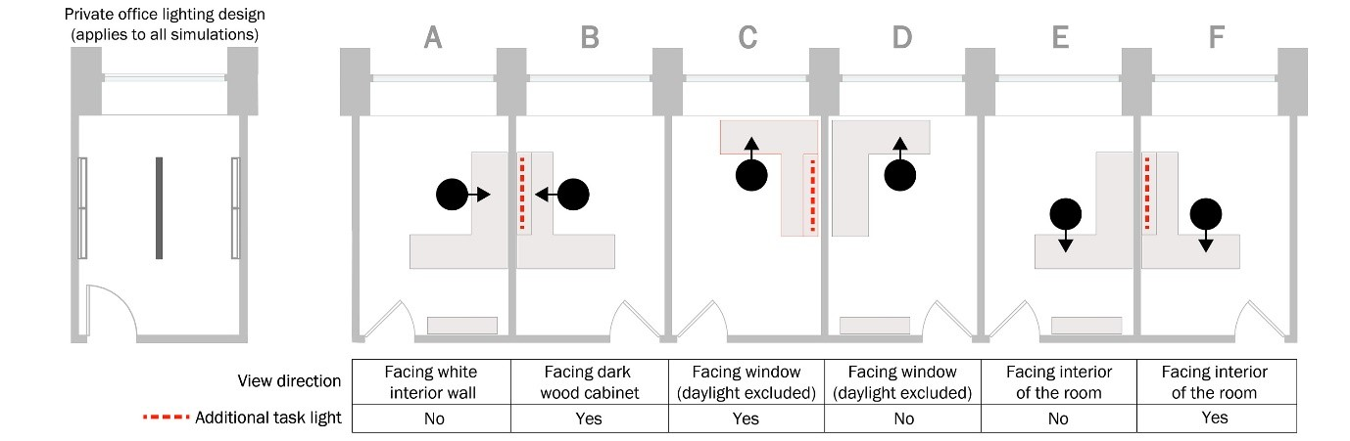
Figure 10. Simulation conditions for six private offices. As use of private office spaces varied by employee, six different office arrangements were produced to explore the effects of view directions and supplemental task lighting on horizontal and vertical illuminance levels. The lighting layout on the left applies to all six offices, while three of the six include an additional undercabinet task light.

Horizontal illuminance was simulated on the desk surface in front of the occupant 2.5 ft AFF. Across all six offices and tunable options, the range was between 600 and 1178 lx with an average horizontal illuminance of 839 lx. The largest source of variation between the offices is due to the relationship between the location of the occupant’s workstation and the direct luminaire in the center of the room. Layouts B, E, and F consistently have the highest illuminance measurements across the tunable conditions, simply because the measurement points are the closest to center of the room. As daylight was excluded from the simulations, both layouts facing the perimeter windows (C and D) consistently have the lowest illuminance, due to the lack of reflected light and position of the measurement point relative to the luminaires. Even at the low end of the range, the values are consistent with the light levels provided by the existing lighting system.
Horizontal and vertical contribution from the supplemental task light was most noticeable in office layout B, as shown in the summary Table 4. This is expected, as the occupant is directly facing the cabinet with the supplemental task light in this layout. Compared to office layout A, layout B with the task light provides an additional 60 to 130 lx at the occupant’s eyes. There is no noticeable difference caused by task light contribution when the occupant is facing the interior of the room with the task light beside them (F), nor when the occupant is facing the window with the task light beside them (C).
Table 4. Private office ALFA simulation results for horizontal and vertical illuminance. Work plane illuminance was simulated 2.5 ft AFF and vertical illuminance at the eye was simulated 4 ft AFF assuming a primary view direction for the office occupant.
 | Work plane Illuminance |  |  |  |  | Vertical Illuminance
 | 3000 K | 3500 K | 4000 K | 5000 K |  | 3000 K | 3500 K | 4000 K | 5000 K
A | 796 | 710 | 931 | 843 |  | 261 | 279 | 262 | 292
B | 1016 | 1178 | 933 | 883 |  | 341 | 358 | 324 | 421
C | 600 | 669 | 624 | 666 |  | 87 | 89 | 84 | 81
D | 813 | 687 | 733 | 697 |  | 71 | 99 | 93 | 94
E | 872 | 1024 | 936 | 889 |  | 375 | 395 | 496 | 424
F | 873 | 903 | 1000 | 850 |  | 474 | 372 | 389 | 362

Daylight contribution is often discussed as a way to increase vertical light levels to meet design recommendations, however, the vertical view positions facing the window only receive between 71 and 99 lx. This would be higher if daylight was considered, however the amount will vary throughout the day and year. When the occupant is facing the interior of the room in office layouts E and F, more than three times the amount of light is provided at the eye compared to layouts C and D, where the occupant is facing the window. Many employees in this office preferred to face the interior of the space with their backs to the windows, and the simulation results suggest that facing this direction can maximize electric light delivered to the occupants’ eyes. When the occupant is facing the window or the wall, as in office layouts A, C, and D, most of the electric light is behind the occupant, as shown in Figure 11.
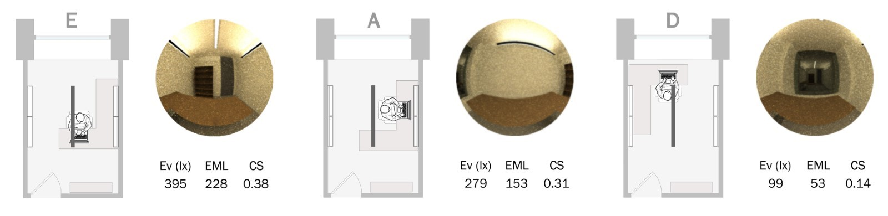
Figure 11. Comparison of different view directions at 3500 K in the private offices. Electric light contribution is maximized for this lighting layout when the occupant is facing the interior of the room (E) and is minimized when the occupant is facing the window (D). Although the size of the private office can limit furniture placement, both daylight and electric light could be leveraged in office layout A.

Of the 24 private office simulations across the tunable lighting range, 15 scenarios satisfy the 1-point WELL EML recommendation of 150 m-lux, 5 scenario satisfies the original 3-point recommendation of 240 m-lux, and 4 scenarios satisfy the updated 3-point recommendation of 275 m-lux. Figure 12 shows that no lighting conditions meet any design recommendations when the occupants are facing the windows. Between both layouts, the maximum EML and CS are 69 m-lux and 0.15, respectively. In the other four office layouts, the conditions only satisfy the 1-point EML and CS WELL recommendations at 3500 K. Occupants in office layouts B, E, and F all receive an EML of 150 m-lux or greater regardless of the color temperature and view direction. Results for CS are similar, however none of the office layouts satisfy the recommendation of 0.3 or greater at 4000 K. Office layouts E and F have the highest metric values overall, with an average EML of 250 m-lux and an average CS of 0.33.
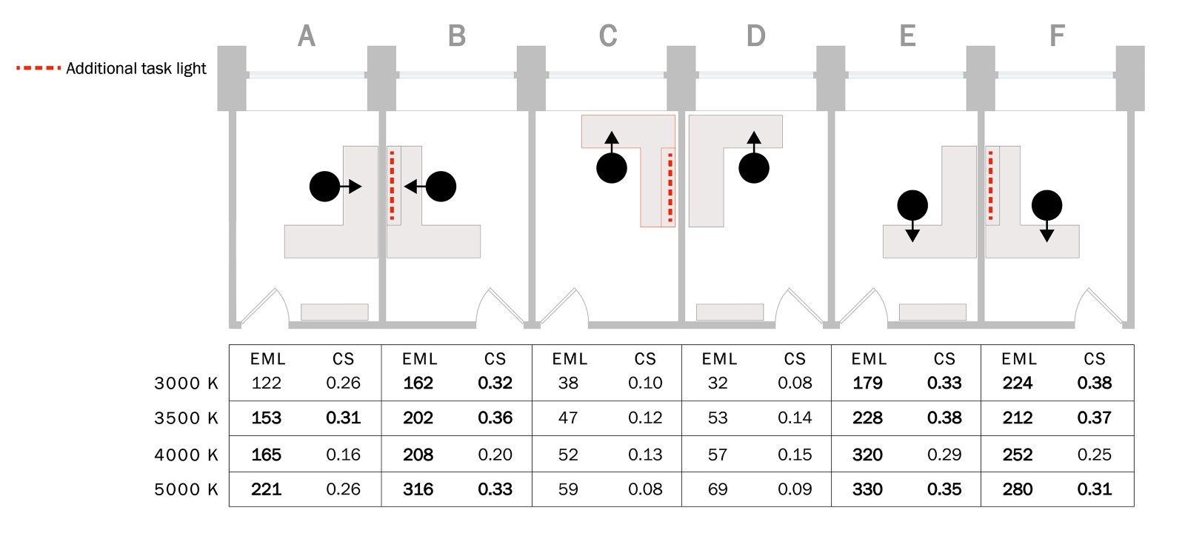
Figure 12. Summary of light and health metric results for the private office simulations. Layouts B, E, and F meet the 1recommended design targets in all cases except for 4000 K, where CS is below 0.3. The two layouts facing the window (C and D) have the lowest metric values, which are all well below the recommended design targets.

Storage Space Simulation Comparisons
The Department of Transportation office employees often referenced large paper drawing sets, so the office space included several filing and work areas where employees accessed and viewed stored drawings. While there were no primary workstations located in these spaces, employees could spend considerable time in these spaces during the day. Additionally, these spaces were adjacent to open office areas, so the same luminaires were used to provide a cohesive visual environment. This included asymmetric wall wash luminaires that illuminated the vertical surfaces of the filing cabinets around the perimeter of the room, as well as direct recessed luminaires that provided task plane illuminance on tables along the center of the room.
The simulations show that the average illuminance delivered to the task plane (30” AFF) in the storage rooms was just over 1000 lux. Although this is much greater than IES visual recommendations for storage areas, the value is only slightly lower than the other office spaces by design to avoid creating high contrast transitions between adjacent spaces and due to the potential for employees to spend considerable time in these spaces. Figure 13 shows the simulated horizontal illuminance at 3500 K, ranging from 680 to 1553 lx. In each room, the horizontal uniformity at the task plane is 1.2:1 average to minimum, however, the vertical uniformity at standing eye height is over 2:1 average to minimum. This is typical for office interiors, but it draws attention to the complexity of delivering consistent vertical illuminance to moving occupants compared to horizontal illuminance. According to the simulation results, when an occupant is standing in the same spot facing the work tables in the center of the room or turned around facing the filing cabinets around the perimeter of the room, the vertical illuminance simulated at the standing eye position (63.5” AFF) ranges from over 650 lx to below 300 lx.
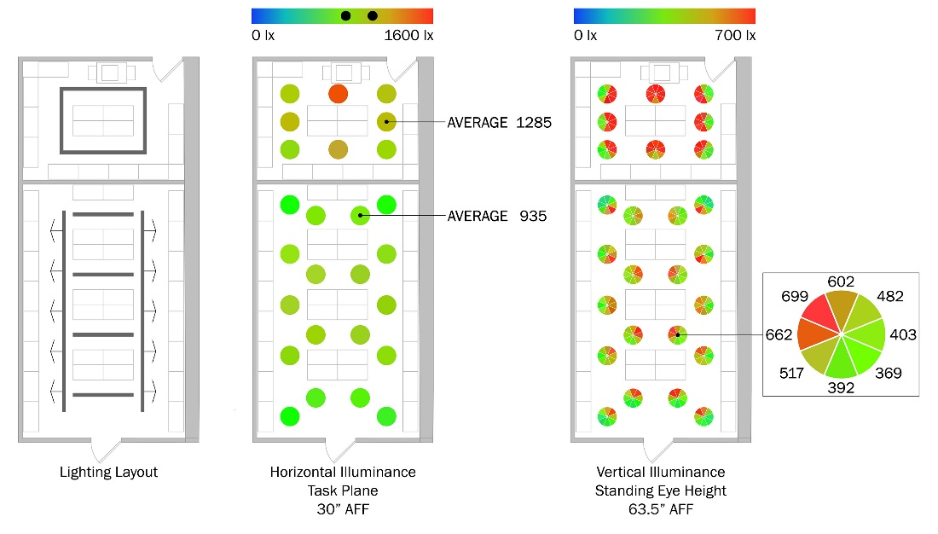
Figure 13. Simulation results for two storage rooms. The lighting consisted of asymmetric wall wash luminaires around the perimeter and recessed linear direct luminaires in the center of the room. Horizontal illuminance on the task plane in each room is relatively uniform, while the vertical illuminance measured at standing eye height can vary greatly if the occupant is facing the tables in the middle of the room or the filing cabinets around the perimeter.

Energy Implications
Energy conservation was a critical design goal set by Cook County for the Circadian Lighting Pilot Project, especially since implementation of results would be incorporated into their workplace standards. As a permanently installed system, the project design would be required to meet local energy code requirements. In addition, while the lighting system design was not specifically targeting a LEED certification, it was planned that the final workplace standard recommendations would want to aim for high levels of sustainability goals based on the results of the study. However, preliminary design results indicated that circadian lighting goals contributed to higher energy use than a non-circadian supportive design.
In 2019, the city of Chicago adopted new building codes based on the International Building Code and other model construction codes published by the International Code Council in alignment with other major cities in the US. The city is one year away from completing a seven-year construction code modernization effort that focused on increasing consistency and alignment of construction codes to promote sustainable and energy efficient design practices as well as reduce the administrative load on users. The first phase of the modernization effort focused on updating the existing Chicago Electrical Code, and the second phase expanded those efforts to the core construction codes which now include energy conservation measures that are based on the 2018 International Energy Conservation Code (IECC).
The design team studied compliance under the IECC-2018 energy code which provides requirements for lighting system controls and maximum power allowances. There are two paths for compliance: the Building Area Method or the Space-by-Space Method. Generally, using the Space-by-Space method may provide greater flexibility given the specificity of each listed space type. Although the Building Area Method is more straightforward, utilizing the Space-by-Space Method will often slightly increase the maximum power allowance depending on the specific space type allocation, as well as provide additional allowances for specific applications. In this case, the Building Area Method allows 11,643 W for the 23rd floor, while the Space-by-Space Method allows 11,643 W, just 54 W more than the Building Area Method.
At the conclusion of the Design Development phase, the total connected load on the 23rd floor was 15,853 W, or 4,210 W above code compliance. The 2018 IECC Space-by-Space method does allow for tradeoff between space types, like ASHRAE/ANSI/IES Standard 90.1, and also provides flexibility to designers using furniture mounted supplemental task lighting as well as decorative lighting when it is controlled separately from the general lighting. The summary provided in Table 5 shows that the design had roughly 300 W to spare in the conference rooms, but was above the allowable wattage in all other space types. Although Standard 90.1 is not applicable by Chicago codes, as a point of comparison, the 2018 IECC wattage allowances are higher than Standard 90.1 2019 in all space types.
Table 5. IECC 2018 interior wattage allowance and connected load for the 23rd floor. The total allowable wattage is slightly higher for the Space-by-Space Method, however the designed connected load not considering any decorative wattage allowances exceeded the allowance by 4,210 W.
Space Types | 2018 IECC Allowance (W/sq ft) | Area  (sq ft) | Allowable Wattage  (W) | Connected Load  Floor 23  (W)
Corridor | 0.66 | 2206 | 1456 | 2501
Storage room | 0.46 | 831 | 382 | 886
Enclosed office | 0.93 | 2075 | 1930 | 2342
Open plan Office | 0.81 | 7719 | 6252 | 8539
Lounge/breakroom | 0.62 | 304 | 188 | 339
Copy/print room | 0.56 | 355 | 199 | 283
Conference/meeting/multipurpose room | 1.07 | 793 | 849 | 570
Lobby | 1.0 | 387 | 387 | 393
Total Interior Allowance,  Space-by-Space |  | 14670 | 11643
Total Interior Connected Load |  |  |  | 15853
Total Interior Allowance,  Building Area Method | 0.79 | 14670 | 11589

Although all of the project spaces exhibited illuminances higher than the IES target levels used to establish the energy code LPD, the impact of providing circadian illumination was particularly acute for these two space types. If the project had continued, the design team most likely would have decided to reduce luminaire lumen packages in the support spaces and the corridors to create a WELL compliant but less consistent circadian supportive space for the occupants. The evaluation of the installation could have provided valuable information related to occupant outcomes and energy consumption that would help further streamline the design and application for the County’s workplace standards.
Apart from interest in light and health, a key adoption criterion for solid-state lighting systems has been the vast energy savings gained over fluorescent or other incumbent technologies. For example, the fluorescent lighting system installed in this office previously had an LPD of 1.37 W/ sq ft. When the system was replaced with TLEDs, the LPD dropped to 0.64 W/ sq ft. The LPD for the 23rd floor redesign stood at 1.08 W/ sq ft, which is a 64% increase from the TLED retrofit scenario, and only a 20% decrease from the fluorescent baseline. In this case, the increase in connected load is a result of attempting to meet the suggested design guidelines discussed in this document; if only redesigning for visual acuity and aesthetics the design might look differently entirely.
The design recommendations offer a suggested minimum duration to reduce annual energy consumption and deliver energy-intensive stimulus during certain hours of the day. The WELL Building Standard suggests a minimum duration of 4 hours per day in the morning or early afternoon, and the UL Design Guideline suggests a minimum duration of 2 hours per day, anytime between the hours of 7 a.m. and 4 p.m. Considering these scenarios, annual energy calculations were completed assuming the lighting system operated for 3,120 hours per year (12 hours per day, 5 days per week, 52 weeks per year).
The first calculation creates a baseline, representing the scenarios where the lighting system is operating at full output in order to support occupant well-being. The second creates an additional baseline at a dimmed level appropriate for visual tasks. The visual baseline was determined using simulations in the open office spaces with an additional applied light loss factor. At 40% output, the lighting system provided 414 lx on average and was considered an appropriate task plane light level for the tasks completed by the occupants. A linear dimming curve is assumed for this analysis, therefore 40% of the connected load is used to estimate annual energy consumption. The third calculation represents the WELL scenario, where the energy intensive lighting operates for 4 hours a day and then dims to the visual baseline for the remainder of the day. The last calculation represents the UL scenario, where the energy-intensive lighting operates for 2 hours a day.
As shown in Table 6, the annual energy usage for the visual baseline was 19,783,920 kWh. Providing high intensity stimulus for just 2-4 hours a day as suggested in the design recommendations increases energy consumption by 25-50%. If high intensity stimulus is delivered all day, the annual energy usage increases by 150%, totaling just under 50 million kWh.
Table 6. Comparison of four potential operating scenarios. For all scenarios, it is assumed that the lighting system operates for 3,120 hours per year. Compared to the visual task baseline scenario operating at 40% system output for the entire year, increasing the intensity to support occupant well-being will also increase annual energy consumption between 25 and 150%.
Operating Scenario | Annual Operating Hours |  |  | Annual Energy Usage (kWh) | % Increase from Visual Baseline
Operating Scenario | 100% Output | 40% Output | Total | Annual Energy Usage (kWh) | % Increase from Visual Baseline
High Intensity Baseline | 3120 | 0 | 3120 | 49,461,360 | 150
WELL | 1040 | 2080 | 3120 | 29,676,400 | 50
UL | 520 | 2600 | 3210 | 24,730,160 | 25
Visual Task Baseline | 0 | 3120 | 3120 | 19,783,920 | --

Conclusion
This report detailed lighting design process through design development, with summaries of the relevant circadian lighting metrics, simulation tools, energy considerations, and research plan for the Circadian Lighting Pilot Project. Due to the global pandemic, the Circadian Pilot Project was concluded after the design development phase however, several key results and lessons emerged from the Circadian Lighting Pilot Project, as summarized below.

Key Results:
- Delivering the necessary vertical light level at the eye of occupants while also minimizing glare is difficult to accomplish with currently available luminaire optics and color tuning options. Multi-primary lighting systems are limited by the optics necessary to create non-Lambertian distributions. Conversely, luminaires with the desired optical distributions are generally limited to two primaries.
- Designing to meet recommended thresholds of EML and CS throughout the open office spaces in this project resulted in horizontal and vertical illuminance levels three to five times greater than IES recommendations for visual tasks. The predicted light levels conflict with IES recommendations for avoiding discomfort glare.
- It was not possible to meet EML or CS thresholds recommended by WELL v2 2019 Q2 or UL Design Guideline 24480 at 100% of the workstations in the open office space. For several CCT conditions, it was possible to achieve the minimal EML threshold (150 m-lux) and CS threshold (0.3) at 95% of workstations.
- The orientation and location of the workstations influenced whether or not EML or CS thresholds were met. An analysis in the private office spaces demonstrated it was possible to meet all WELL and UL recommendations (including the updated WELL v2 2021 Q4 recommendation) by optimizing the location and orientation of the workstation relative to the electric lighting system, window, and room surfaces.
- Workstations oriented toward the windows along the perimeter of the open and private offices had more light transmitted through the glazing material than reflected back into the space, resulting in notably lower levels of vertical illuminance, EML, and CS than workstations oriented toward the interior of the building. It is difficult to determine how much daylight will contribute to vertical illuminance, EML and CS at these locations throughout the day or year.
- Lighting simulation methods and software tools that do not account for the spectral characteristics of light sources and room surfaces are limited in their ability to estimate the spectrum of light, and subsequently EML and CS, at the vertical viewing positions.
- In each room, the horizontal uniformity at the task plane is 1.2:1 average to minimum, however, the vertical uniformity at standing eye height is over 2:1 average to minimum. While this is not necessarily unusual for office interiors, it draws attention to the complexity of delivering consistent vertical illuminance to moving occupants compared to horizontal illuminance.
- Preliminary design results from this study indicated that designing to meet circadian lighting metric recommendations resulted in higher energy use than existing codes recommend for meeting visual tasks.

References
(2018). CIE SYSTEM FOR METROLOGY OF OPTICAL RADIATION FOR IPRGC-INFLUENCED RESPONSES TO LIGHT, International Commission on Illumination (CIE).
AGi32. (2020). "Color bleed - concepts." Retrieved December 1, 2020, from https://docs.agi32.com/AGi32/Content/multi_use_forms/Color_Bleed_-_Concepts.htm.
Brown, T. B., G.; Cajochen, C.; Czeisler, C.; Hanifin, J.; Lockley, S.; Lucas, R.; Munch, M.; O'Hagan, J.; Peirson, S.; Price, L.; Roenneberg, T.; Schlangen, L.; Skene, D.; Spitschan, M.; Vetter, C.; Zee, P.; Wright Jr., K. (2020). " Recommendations for Healthy Daytime, Evening, and Night-Time Indoor Light Exposure." Preprints.
Collier, J. M., B. K. Abboushi and R. G. Davis (2020). Evolving theories of change: Rethinking of the effects of office lighting on occupants. Conference: Proceedings of the 2020 Illuminating Engineering Society Annual Conference, August 24-28; August 31- September 4, 2020, Virtual. United States: Medium: X.
IWBI (2020). WELL v2™. https://v2.wellcertified.com/en/wellv2/overview, The International WELL Building Institute.
Lucas, R. J., S. N. Peirson, D. M. Berson, T. M. Brown, H. M. Cooper, C. A. Czeisler, M. G. Figueiro, P. D. Gamlin, S. W. Lockley, J. B. O'Hagan, L. L. A. Price, I. Provencio, D. J. Skene and G. C. Brainard (2014). "Measuring and using light in the melanopsin age." Trends in Neurosciences 37(1): 1-9.
Rea, M. S. and M. G. Figueiro (2018). "Light as a circadian stimulus for architectural lighting." Lighting Research & Technology 50(4): 497-510.
Rea, M. S., R. Nagare and M. G. Figueiro (2021). "Modeling Circadian Phototransduction: Quantitative Predictions of Psychophysical Data." Frontiers in Neuroscience 15(44).
Safranek, S., J. M. Collier, A. Wilkerson and R. G. Davis (2020). "Energy impact of human health and wellness lighting recommendations for office and classroom applications." Energy and Buildings 226: 110365.
UL (2019). Recommended Practice and Design Guideline for Promoting Circadian Entrainment with Light for Day-Active People.

CL-500A Konica Minolta Illuminance Spectrophotometer (10002008) calibrated Aug. 30, 2018.
The M/P ratio compares the melanopic content of a light source to the photopic content by weighting the light source SPD by the respective spectral weighting functions.

