Development of A Water Source Heat Pump Hardware-in-the-Loop (HIL) Testing Facility for Smart Building Applications

Caleb Calfa Zhiyao Yang, PhD Yangyang Fu, PhD
ASHRAE Student Member ASHRAE Member ASHRAE Member

Zhelun Chen, PhD Zheng O’Neill, PhD, PE Jin Wen, PhD
Associate ASHRAE Member ASHRAE Fellow ASHRAE Member

ABSTRACT
Over the last decade, the global fight against climate change through electrification has led to an increase in research on building heating, ventilation, and air conditioning (HVAC) systems that utilize intelligent control algorithms to provide demand-side grid service while maintaining the thermal comfort of building occupants. As the pivotal point between building electricity consumption and indoor thermal comfort, high-efficiency electrical heat pumps are at the center of these emerging studies, and various grid-interactive and occupant-comfort control algorithms have been developed for them. The impact of these algorithms on the heat pump operation and performance under different weather, building load, and grid requests calls for investigation and verification via experimental tests with actual heat pumps integrated with real-time building and grid responses. This study presents a Water-Source Heat Pump Hardware-in-The-Loop (HIL) Test Facility developed with the capability to perform such tests. The hardware configuration for this test facility introduces a hydronic system that emulates the conditions for the heat pump water-side, and a duct system that emulates conditions for the heat pump airside. Both data acquisition and emulator control are implemented through the National Instruments (NI) LabVIEW software running on an NI PXI platform. The HIL mechanism based on the hardware-software integration that allows the testbed to communicate with a generic simulation environment is also discussed. Currently, the test facility setup includes a single heat pump and virtual building model in EnergyPlus coupled with an occupant behavioral model in MATLAB. Preliminary test results of the current setup demonstrate the building load emulator’s ability to track the simulated zone temperature with an RSME below 0.12°C. An uncertainty analysis based on sensor accuracies shows that the heat pump coefficient of performance (COP) can be measured with a relative uncertainty of 9.5% in cooling and 3.1% in heating. Apart from the current testing on a single heat pump, the test facility also provides the flexibility to include additional heat pumps to form a heat pump cluster, as well as coupling the heat pump with active thermal storage to provide enhanced demand flexibility.

1. INTRODUCTION
Global climate change drives the current push for electrification in various aspects of human activities such as built environment and transportation. Switching to electric power sets the infrastructure in place for increased adoption of cleaner sources of energy. On the other hand, the intermittent nature of renewable energy sources such as wind and solar coupled with the increase in electrical demand could impose significant stress on our power grid. Therefore, active and real-time response to the fluctuation of power generation and transmission on the demand-side is crucial to improve resilience of the grid, and enable the increased penetration of renewable energy. Since buildings consume more than 40% of all U.S. energy, 30% of which can be attributed to space heating and cooling, a primary focus of this field has become the development and optimization of building HVAC systems and controls to provide grid flexibility (Baldwin et al. 2015). High-efficiency electric heat pumps in particular are considered ideal tools for demand response in buildings (Fischer and Madani 2017; Lee et al. 2020; Péan et al. 2019). However, there are a limited number of published experimental studies within academia investigating the use of heat pumps for demand response compared with the amount of research done using simulation (Péan et al. 2019). In general, experimental testing is more costly in terms of set up and run time, and depending on the scale of the systems being tested, sometimes not feasible. Hardware-in-the-Loop (HIL) testing is a good compromise between a simulation environment and full-scale field testing and has the potential to be very useful in furthering our understanding of heat pump operation within the context of the smart grid. A short list of published experimental facilities that utilize a real heat pump to investigate demand side grid service is shown in Table 1. From this, it can be seen that air-source (AHSP), water-source (WSHP), and ground-source (GSHP) heat pumps, operating in either heating or cooling mode, with either single-speed or variable-speed compressors and fans have all been investigated servicing either real or emulated thermal zones.

Table 1. Experimental Test Studies of Heat Pump for Demand Response
References | Heat Pump Type |  |  | Mode |  |  | Speed Control |  |  | Building Thermal Zones
References | ASHP | WSHP | GSHP |  | Heating | Cooling |  | Single Stage | Variable Speed | Real | Emulated
(Meng et al. 2021) | X |  |  |  | X | X |  | X |  |  | X
(Kim et al. 2015) |  | X |  |  |  | X |  |  | X |  | X
(Vanhoudt et al. 2014) |  | X |  |  | X |  |  | X |  |  | X
(Jiang et al. 2020) | X |  |  |  |  | X |  |  | X |  | X
(Fiorentini et al. 2017) | X |  |  |  | X | X |  |  | X | X
(Moreno et al. 2014) |  | X |  |  | X | X |  | X |  |  | X
(Bünning et al. 2020) |  |  | X |  | X | X |  |  | X |  | X

The scope of experimental studies that can be investigated using a particular test setup depends on the testbed configuration, type of heat pump, and building thermal zones. For example, a testbed utilizing a heat pump capable of continuously modulating its fan or compressor speed provides more flexibility to execute load modulating than a single-speed heat pump with only on/off controls. Also, depending on the testbed equipment, an investigation may be limited to just one heat pump mode of operation. The testbed presented in (Kim et al. 2015) for instance, utilizes a boiler to heat up an indoor thermal zone, however, with no way to cool said zone, it is limited to only testing heat pumps operating in cooling mode. Testbeds emulating building thermal zones are capable of testing a range of different building types under various weather conditions regardless of the climate and location of the testbed. On the other hand, a testbed with a fully functioning building (Fiorentini et al. 2017) is limited by its construction materials, physical layout, and the environment in which it is situated in. The water-source heat pump (WSHP) hardware-in-the-loop (HIL) testbed presented in this paper has been developed with the capability of integrating multiple simulations with fast-response high accuracy hardware to enable comprehensive investigation of a WSHP operating in either heating or cooling mode. The paper is separated into four sections. The first section gives an overview of the testbed experimental setup. This includes the hardware configuration and data acquisition system (DAQ) with a description of the data communication between its emulating equipment and simulated HIL environment, as well as the control of the load emulator coil. The second section discusses the results from an uncertainty analysis of the testbed measurements. The third section presents preliminary results from a test case emulating a small office building located in Atlanta, GA. Finally, conclusions, future work and potential improvements to the testbed are presented.
2. Experimental Setup
2.1. HIL Environment Communication
The testbed is capable of communicating with any simulated environment as long as it can properly interface with NI LabVIEW. Currently we are utilizing a virtual building model developed in the MATLAB/Simulink environment that couples an EnergyPlus (E+) zone load simulation with an occupant behavioral simulation (Chen 2021). The E+ model is designed to represent a small office building that is separated into five thermal zones and conforms to ASHRAE guideline 90.1-2004. A Functional Mockup Unit (FMU) has been developed to represent this E+ model in Simulink. This allows LabVIEW to interface with the model’s various inputs and outputs through an application programming interface (API) that already exists between MATLAB and LabVIEW. With this connection established, communication between the physical testbed and simulated environment becomes possible because the emulator control is implemented through LabVIEW. The data flow for this communication is presented in Figure 1.

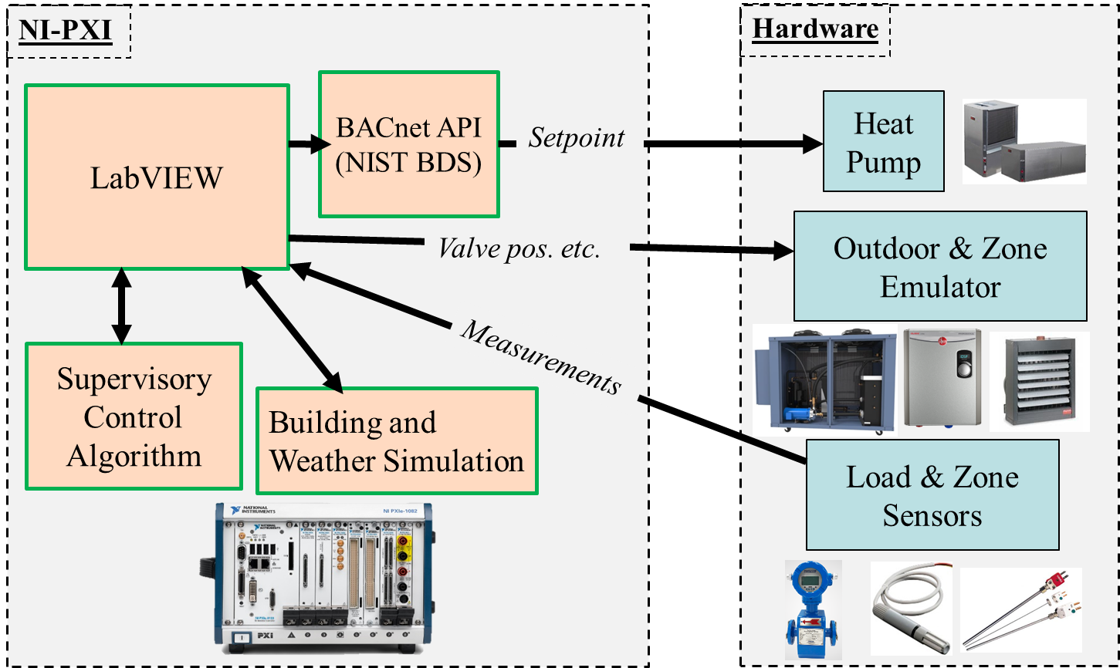

Figure 1 The data flow communication between the testbed and the HIL environment.

Currently, the simulated environment has only been setup to model the indoor thermal zone parameters. Therefore, the model inputs are limited to the supply air volumetric flowrate, the supply air temperature, and the supply air relative humidity. Based on these inputs, the virtual building model subsequently communicates the resulting average thermal zone temperature and relative humidity, which is then emulated using the load emulator coil and steam humidifier spray, respectively.
2.2. Hardware Configuration
A full plumbing schematic of this testbed is presented in Figure 2. A Trane 2-ton (7 kW) variable speed WSHP is the focal point of the facility which can be separated into two subsystems, one being the airside duct system and the other being the waterside hydronic system. Photographs of both of these subsystems and the heat pump are also shown in Figure 3.

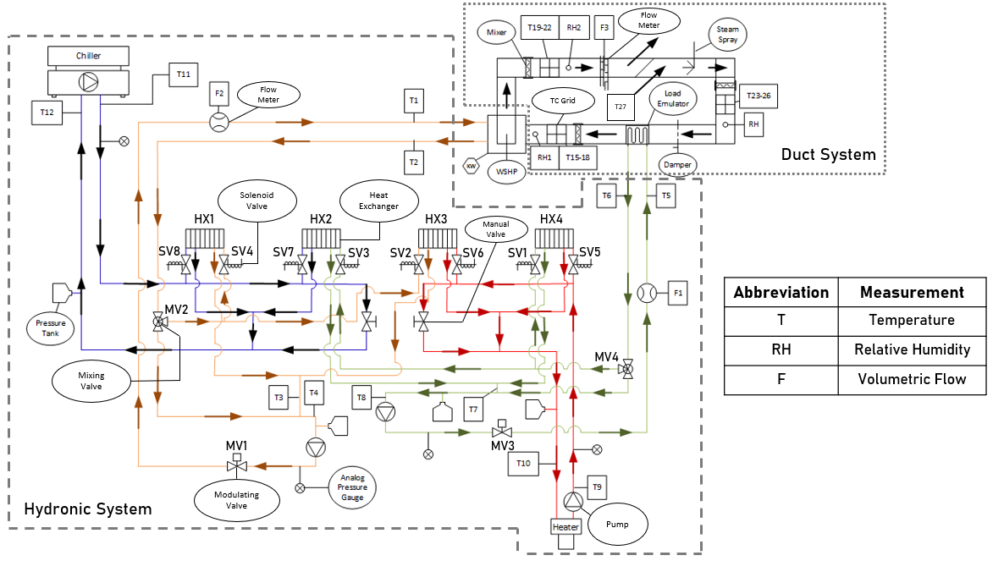
Figure 2 A plumbing schematic of the WSHP HIL testbed.

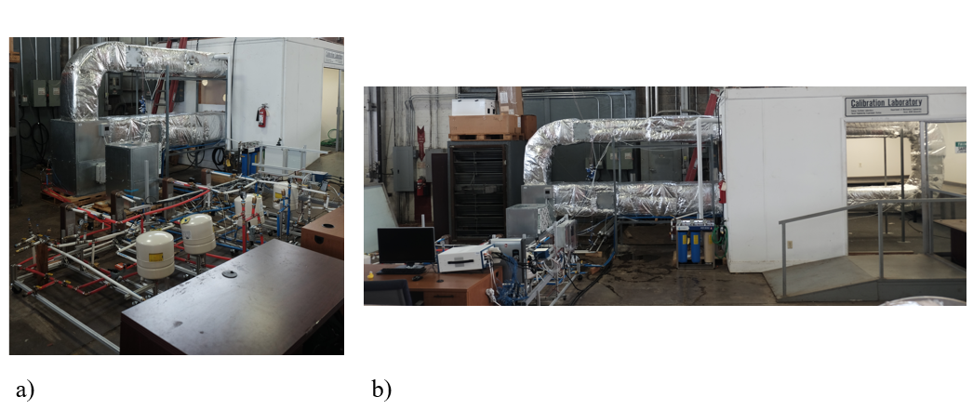
Hydronic System
Heat Pump
Duct System

Figure 3 (a) A photograph of the testbed waterside hydronic system (b) and the airside duct system.

The function of the hydronic system is to control the heat pump waterside inlet temperature (T1) and flow rate (F2). It also provides conditioned water to the load emulator coil in order to control the sensible air temperature returning to the heat pump (T15-18). Its main components consist of three external water circulation pumps, an 8-ton (28 kW) outdoor chiller unit, an 18-kW (61500-BTUH) tankless water heater, four water to water heat exchangers, and a series of solenoids, mixing valves, and modulating valves. On the other hand, the airside duct system operates by utilizing the pressure differential created by the heat pump blower fan to suck in ambient lab air (T27). This air is conditioned to its desired humidity (RH1) and temperature set points by utilizing a steam spray and boiler assembly as well as the load emulator coil. A manual damper is used to either restrict or increase the air flow rate depending on the building application being tested. Overall, the system is capable of providing conditioned water within a temperature range of 10 to 55 °C (50 to 131 °F) at flow rates up to 5 gpm. It is also capable of injecting up to 50 lbs. of steam per hour, and can provide a total airside heating load up to 17 kW (58000 BTUH) and cooling load up to 12 kW (41000 BTUH).
2.3. DAQ System
Both the data acquisition and system control are done by utilizing a National Instruments (NI) PXI server and NI LabVIEW software. The various sensors, listed in detail in Table 2, interface with LabVIEW through two field-programmable gate array (FGPA) circuit boards housed within the PXI.

Table 2. WSHP HIL Testbed Sensors
Brand Name | Sensor Type | Measurement | Manufacturer Accuracy
T-Type Thermocouple | Temperature Sensor | Temperature | ± 1 °C/ 1.8 °F
RTD | Temperature Sensor | Temperature | ± 0.15 °C/ 0.27 °F
Picomag Flow Meter | Flow Meter | Volumetric Flow Rate | ± 0.8% of reading
Electra-flo-g5 | Flow Meter | Air Velocity | ± 3% of reading
Vaisala HMDW110 | Humidity Sensor | Relative Humidity | ± 2% RH for 0 < RH < 90%
Vaisala HMDW110 | Humidity Sensor | Relative Humidity | ± 3% RH for 90 < RH < 100%
WattNode BACnet | Electric Power Meter | Power | ± 0.5% of reading

The supply (T1) and return (T2) water temperatures are measured using a pair Resistance Temperature Devices (RTDs), while the remaining temperatures of interest within the hydronic system are each measured using a single T-Type thermocouple (TC). The flow rates are measured using the Picomag Flow Meters shown in Table 2. On the other hand, the duct system uses the Electra-flo-g5 air station to measure airside volumetric flow rate, and three Vaisala HMDW110 humidity sensors to measure the relative humidity at different locations within the duct. Air temperature is also measured at three locations using three TC grids, respectively. Each grid is comprised of 16 equally spaced thermocouples ($T_{n}$). However, due to equipment constraints, the 16 thermocouples are joined together into four thermopiles for each grid. Therefore, T19-26 while being read as single temperature measurements in the DAQ system, are actually an average of four different thermocouple measurements. Those four measurements corresponding to a single TC grid are then later averaged within the LabVIEW software. This gives us the ability to see in real time if there is any temperature stratification present within a TC grid. It also results in a lower measurement uncertainty, which will be discussed in more detail in the analysis below.
2.4. Load Emulator Control Logic
The logic that determines how the load emulator coil operates to match the WSHP return air temperature (T15-18) with the simulated average zone temperature is presented in Figure 4. First, whether the load emulator needs to provide heating or cooling is determined based on how the return and ambient lab air (T27) temperatures compare to the simulation. During the entire testing period, the modulation valve, MV3, is actuated to either open or close via PID control in order to match the return air temperature with the simulated zone temperature. If the position of the valve returns either a fully open or fully closed position signal, the mixing valve, MV4, is modulated to either increase or decrease the water temperature entering the load emulator (T8).

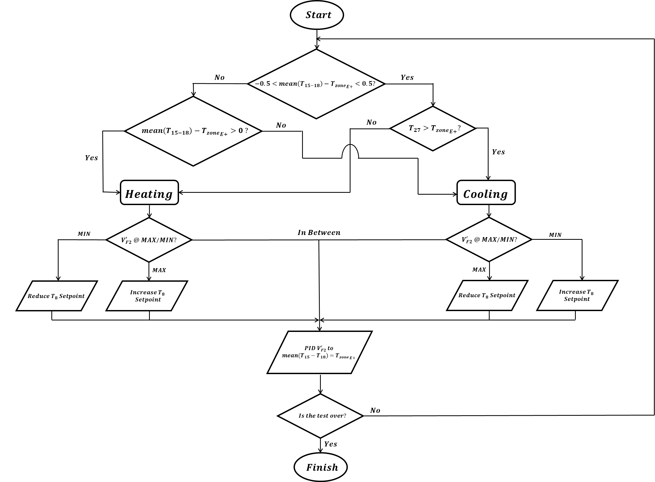

Figure 4 The control logic of the load emulator coil
3) uncertainty analysis
A propagation of uncertainty analysis is performed based on the sensor manufacturer accuracies outlined in Table 2. This was done to get an initial estimate of the error that exists when measuring the loads across both heat pump heat exchangers as well as the WSHP Coefficient of Performance (COP). The analysis is done using the standard methodology outlined in ASME PTC 19.1-2005 (ASME 2018) for both a heating and cooling design condition specified in the Trane catalogue provided with the WSHP. The procedure assumes that all errors are independent of each other and follow a normal or Gaussian distribution. This allows us to use the following computation to solve for uncertainty:

$$d=f\left(a,b,c\right)$$ | (1)
$$u_{d}=\sqrt{{\left(\frac{∂f}{∂a}\right)}^{2}u_{a}^{2}+{\left(\frac{∂f}{∂b}\right)}^{2}u_{b}^{2}+{\left(\frac{∂f}{∂c}\right)}^{2}u_{c}^{2}}$$ | (2)

The results for this analysis are shown in Table 3. $Q_{air}^{'}$ measures the load across the air to refrigerant heat exchanger, and in cooling mode, can be separated into a sensible (${Q_{air}^{'}}_{sens}$) and latent (${Q_{air}^{'}}_{lat}$) component. On the other hand, $Q_{water}^{'}$ measures the load across the heat pump water to refrigerant heat exchanger. The analytical relationships used during this analysis between the various load calculations and the measured readings are also presented in Table 3. The key assumptions made when establishing these relationships is that air behaves as an ideal gas with a constant density and specific heat throughout the duct system. Water is assumed to be incompressible and also has a constant specific heat throughout the hydronic system. Lastly, the uncertainty due to fluid density and specific heat is negligible (Mills 2016; Moran 2008).

Table 3. Uncertainty Analysis Results
Measurement | Design Condition | Analytical Relationship | Absolute Uncertainty | Relative Uncertainty
TC Grid | NA | $$\frac{\sum_{n=1}^{16}{T_{n}}}{16}$$ | ± 0.0625 °C/ 0.1125 °F | NA
$${Q_{air}^{'}}_{sens}$$ | Cooling | $$ρ_{air}Av_{F3}c_{p_{air}}({T_{air}}_{ret}-{T_{air}}_{sup})$$ | ± 181 W/ 618 BTUH | ± 3.1%
$${Q_{air}^{'}}_{sens}$$ | Heating | NA | ± 276 W/ 943 BTUH | ± 3.0%
$${Q_{air}^{'}}_{lat}$$ | Cooling | $$ρ_{air}V_{F3}^{'}(w_{ret}-w_{sup})h_{fg}$$ | ± 712 W/ 2432 BTUH | ± 37.3%
$${Q_{air}^{'}}_{lat}$$ | Heating | NA | NA | NA
$$Q_{air}^{'}$$ | Cooling | $${Q_{air}^{'}}_{sens}+{Q_{air}^{'}}_{lat}$$ | ± 735 W/ 2510 BTUH | ± 9.5%
$$Q_{air}^{'}$$ | Heating | $$ρ_{air}Av_{F3}c_{p_{air}}({T_{air}}_{sup}-{T_{air}}_{ret})$$ | ± 276 W/ 943 BTUH | ± 3.0%
$${Q'}_{water}$$ | Cooling | $$ρ_{water}V_{F2}^{'}c_{p_{water}}(T_{1}-T_{2})$$ | ± 288 W/ 984 BTUH | ± 3.2%
$${Q'}_{water}$$ | Heating | $$ρ_{water}V_{F2}^{'}c_{p_{water}}(T_{2}-T_{1})$$ | ± 286 W/ 977 BTUH | ± 3.6%
COP | Cooling | $Q_{air}^{'}$ / $Power_{WSHP}$ | ± 0.7 | ± 9.5%
COP | Heating | $Q_{air}^{'}$ / $Power_{WSHP}$ | ± 0.2 | ± 3.1%

The results show that the largest uncertainty value can be attributed to the measurement of $Q_{air_{lat}}^{'}$ in the cooling design condition. This is due to the high uncertainty of relative humidity measurements.
In the future, we also, plan to run a secondary air velocity check using a pitot static traverse near each thermocouple grid, respectively. This will allow us to get a better understanding of the flow characteristics within the duct system, which the Electra-flo-g5 air station may not fully capture.
4) Preliminary tESTING RESULTS
A preliminary test case was run using the WSHP to service a single thermal zone within the virtual building simulation framework described in Section 2.1 during a hot summer day in Atlanta, GA. The test was run for a total of 3 hours corresponding to the timestamp of 8:00 AM to 11:00 AM within E+. For this study, we focus primarily on the testbed’s ability to emulate the average zone temperature output from the simulation environment. The emulation of this parameter is a good measure the testbed’s HIL capabilities. Figure 5a presents how well the measured WSHP return air temperature (T15-18) was able to track the simulated average zone temperature during this test run. Disregarding the first 30-40 minutes after the simulation was initialized, the emulated return air temperature was able to successfully mimic the average zone temperature within an RSME value of 0.12 °C.
Figure 5b shows the WSHP’s corresponding measured electrical power profile during this same preliminary test run. After the simulation was initialized, the heat pump compressor turned on and ramped up to its maximum speed in order to cool the simulated thermal zone. It held at this speed for the remainder of the test before being shut off around the 230-minute mark. It should be noted that there is a slight step change that occurs in the heat pump power after 210 minutes. At this time, the inlet water temperature setpoint (T1) was manually decreased, which subsequently caused the heat pump refrigerant head pressure to also decrease, and with it, the operating load.

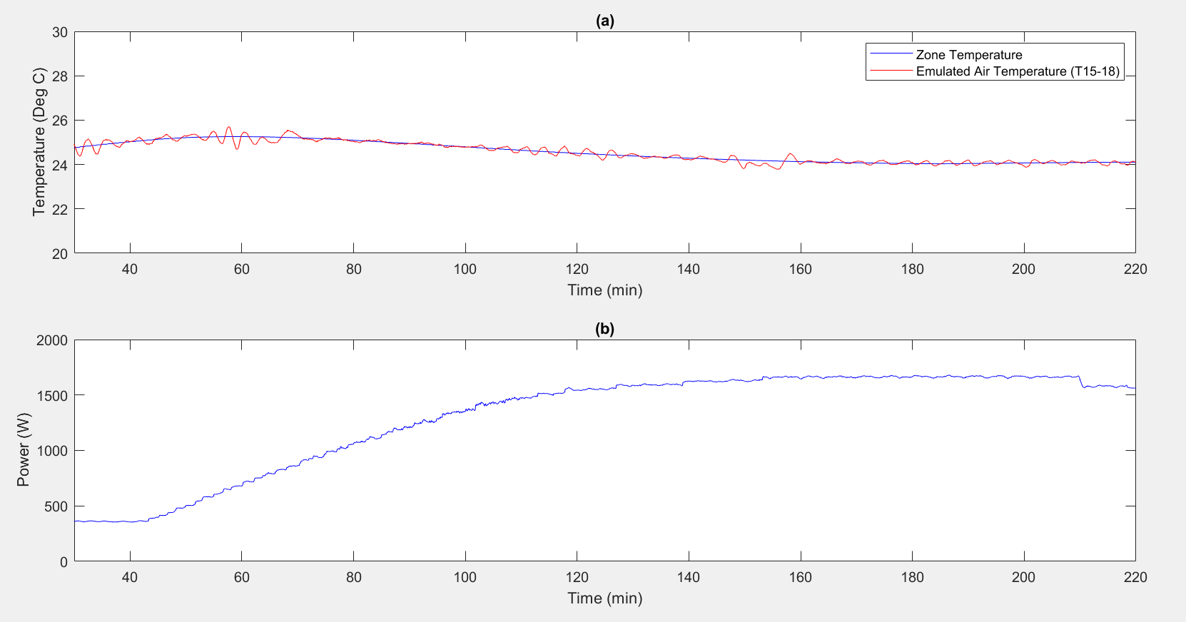

Figure 5 (a) The measured return air temperature (T15-18) and average zone temperature output from the E+ simulation with (b) the corresponding WSHP electrical demand power profile recorded during the same preliminary test case.
5) cONCLUSIONS
This testbed provides the capability to measure how a real WSHP will perform when subjected to a variety of loading conditions and external disturbances. This could be anything from different climate zones, weather patterns, occupancy behavior, to some variety of supervisory control. We plan to use this facility to better understand the behavior of a heat pump operating within the context of a smart grid. While this has become an increasingly popular research topic over the last decade, we feel that there still remains a gap between simulation results and actual heat pump behavior, which we hope this testbed will help to fill.
In the near future, we plan to add both a second WSHP that is capable of servicing its own thermal zone, as well as an active thermal storage system (e.g., PCM tank, water tank connected to solar thermal collector, etc.) to the current setup. With these additions, we will be able to investigate some level of dual heat pump control servicing either two thermal zones, respectively, or working together to service a single thermal zone. We will also be able to further explore heat pump operation when coupled with an active thermal storage tank.

Acknowledgment AND DISCLAimER
The research reported in this paper was partially supported by the Building Technologies Office of the U.S. Department of Energy through the Emerging Technologies program under the award number DE-EE0009153. The views and opinions of the authors expressed herein do not necessarily state or reflect those of the United States Government or any agency thereof.

NOMENCLATURE
$A$ = Area
$ρ$ = Density
$c_{p}$ = Specific heat
$h_{fg}$ = Heat of vaporization
$V'$ = Volumetric flow rate
$Q'$ = Heat transfer
$v$ = Volumetric flow rate
$w$ = Humidity ratio
$u$ = Uncertainty

rEFERENCES
ASME. (2018). Test Uncertainty (Vol. PTC 19.1): ASME.
Baldwin, S., G. Bindewald, A. Brown, C. Chen, K. Cheung, C. Clark, J. Cresko, M. Crozat, J. Daniels, and J. Edmonds. (2015). Quadrennial technology review: an assessment of energy technologies and research opportunities: DOE.
Bünning, F., J. Warrington, P. Heer, R. S. Smith, and J. Lygeros. 2020. Frequency regulation with heat pumps using robust MPC with affine policies. IFAC-PapersOnLine, 53(2), 13210-13215.
Chen, Z. W., Jin; Bushby, Steven T.; Lo, L. James; O’Neill, Zheng; Payne, W. Vance; Pertzborn, Amanda; Calfa, Caleb; Fu, Yangyang; Grajewski, Gabriel; Li, Yicheng; Yang, Zhiyao. 2021. Development of a Hardware-in-the-loop Testbed for Laboratory Performance Verification of Flexible Building Equipment in Typical Commercial Buildings. Paper submitted to the 2022 ASHRAE Annual Conference, Toronto, Canada.
Fiorentini, M., J. Wall, Z. Ma, J. H. Braslavsky, and P. Cooper. 2017. Hybrid model predictive control of a residential HVAC system with on-site thermal energy generation and storage. Applied Energy, 187, 465-479.
Fischer, D., and H. Madani. 2017. On heat pumps in smart grids: A review. Renewable and Sustainable Energy Reviews, 70, 342-357.
Jiang, Z., J. Cai, and P. S. Moses. 2020. Smoothing control of solar photovoltaic generation using building thermal loads. Applied Energy, 277, 115523.
Kim, Y.-J., E. Fuentes, and L. K. Norford. 2015. Experimental study of grid frequency regulation ancillary service of a variable speed heat pump. IEEE Transactions on Power Systems, 31(4), 3090-3099.
Lee, Z. E., Q. Sun, Z. Ma, J. Wang, J. S. MacDonald, and K. Max Zhang. 2020. Providing grid services with heat pumps: A review. Journal of Engineering for Sustainable Buildings and Cities, 1(1), 011007.
Meng, Q., X. Ren, W. Wang, C. Xiong, Y. Li, Y. Xi, and L. Yang. 2021. Reduction in on-off operations of an air source heat pump with active thermal storage and demand response: An experimental case study. Journal of Energy Storage, 36, 102401.
Mills, A. F. C., C.F.M. (2016). Heat Transfer (3rd ed.). San Diego, CA 92130: Temporal Publishing, LLC.
Moran, M. J. S., Howard N. (2008). Fundamentals of Engineering Thermodynamics (6th ed., pp. 819). 111 River Street, Hoboken, NJ 07030-5774: John Wiley & Sons, Inc. .
Moreno, P., A. Castell, C. Sole, G. Zsembinszki, and L. F. Cabeza. 2014. PCM thermal energy storage tanks in heat pump system for space cooling. Energy and buildings, 82, 399-405.
Péan, T. Q., J. Salom, and R. Costa-Castelló. 2019. Review of control strategies for improving the energy flexibility provided by heat pump systems in buildings. Journal of Process Control, 74, 35-49.
Vanhoudt, D., D. Geysen, B. Claessens, F. Leemans, L. Jespers, and J. Van Bael. 2014. An actively controlled residential heat pump: Potential on peak shaving and maximization of self-consumption of renewable energy. Renewable Energy, 63, 531-543.

