Long-term thermal aging of parylene conformal coatings under high humidity and its effects on tin whisker mitigation

Preeth Sivakumar¹, Surbhi Mahajan Du², Matt Selter², Imani Ballard², John Daye², and
Junghyun Cho^{1,3}
- Department of Mechanical Engineering, State University of New York (SUNY) at Binghamton, NY 13902
- Honeywell FM&T∗, Kansas City National Security Campus, Kansas City, MO 64147
- Materials Science and Engineering Program, State University of New York (SUNY) at Binghamton, NY 13902
Abstract
Usage of pure tin (Sn) or Sn-rich alloy in electronics industry is growing, which makes them more susceptible to the spontaneous growth of tin whiskers. The risk of having these whiskers can be dramatically mitigated by applying a conformal coating provided that it not only possesses excellent mechanical and adhesion properties but also maintains these properties throughout their service. Parylene C is commonly used as a conformal coating because of its favorable mechanical and physical properties, as well as superior conformal coverage. The purpose of this paper is to investigate the degradation of parylene C coating during the thermal aging in high humidity environment (85°C/85% relative humidity for up to 5000hrs) and its effect on the tin whisker mitigation capacity. It was observed that during aging at high temperature and high humidity (HTHH) environment, the oxidation occurs at early times, followed by bond scission, resulting in the loss of strength of the coating. Thinner parylene coating (12.5-μm-thick) had better coating adhesion on the silane-treated tin surface, so provided the better protection for tin whisker penetration than the thicker counterpart (25-μm-thick). After 2500hrs of aging, due to the degradation of the silane agent at the tin/parylene interface, the adhesion of the parylene coating was significantly weakened on the tin surface, which resulted in extensive corrosion of the tin solderpads. The loss of adhesion of the coating, along with the corrosion of the tin surface facilitated the tin whisker nucleation at the interface while the loss of mechanical strength and the brittleness made the coating easily penetrated by the growing whiskers. Tin whiskers with a smaller diameter were buckled and grew along the delaminated region while those with a larger diameter penetrated and continued to grow through the coating. Hence, the effectiveness of the parylene coatings on tin whisker mitigation is significantly reduced under long exposure to such high temperature and high humidity.

Keywords:
Parylene, Tin whisker mitigation, Coating degradation, Adhesion, Long-term HTHH

- Introduction
The use of lead (Pb) in electronics is restricted due to the legislation passed by the European Directive on restrictions of hazardous substances [1]. Due to this limitation, industries are shifting towards the use of pure tin and other high tin based lead-free alloys. However, the use of pure tin or tin rich alloy results in the spontaneous growth of needle-like tin whiskers [2]. Tin whiskers can reach to hundreds of microns in length and up to 10 microns in diameter.[3] These whiskers can bridge with the adjacent component/lead that would result in the short circuit of the electronic device. Electrical short made from the growth of tin whiskers will result in the intermittent or permanent failure of the device [4,5]. The potential mechanisms for the growth of tin whisker is generally believed to be an act of releasing the compressive stress in the tin layer. Sources of stress in the tin layer include residual stress from plating, intermetallic compound and oxide/corrosion product formation, mechanically induced external stress, and thermal treatment [3,6]. While the potential mechanisms for the formation of tin whiskers were identified, there seemed to be no universal solution to get rid of these whiskers. As a result, the formation of these whiskers has been mitigated by using several metallurgical techniques with limited success [7].
Conformal coating can, however, provide a more effective way to mitigate the tin whisker growth [8]. This is because the conformal coatings can protect the electronics assembly from corrosive and chemical materials, minimize the environmental stress on the circuit boards[9] and also, effectively contain or eliminate the tin whisker growth due to its complete coverage over the tin surface [10]. These conformal coatings should be mechanically adaptable to resist the metallic whisker nucleation and growth while providing enough toughness to avoid cracking ahead of the growing tin whiskers [11]. Importantly, the delamination of conformal coating would provide a space for tin whisker activities that will ultimately result in the vertical growth of tin whisker and its penetration through the coating. Hence, the adhesion strength of the conformal coating to tin surface also plays an important role [12]. An effective conformal coating should have all these mechanical and adhesion characteristics along with the associated degradation mechanisms because these coatings will be exposed to extreme environmental conditions over a long period of time [13].
Parylene C has a semicrystalline nature (45% of crystallinity) and has shown the potential as an effective conformal coating [14]. Parylene C is an organic coating free from solvents, catalysts, and plasticizers with a deposition layer thickness controlled down to 500 Å [15,16]. The bulk resistivity of parylene C conformal coating is advantageously high because of its purity, low moisture absorption, and lack of trace ionic impurities. Parylene have exceptional properties such as being stress free, truly conformal deposition, chemical inertness, bio-acceptability, and optical transparency (index of refraction 1.6) [17]. Several researchers have studied the effectiveness of parylene conformal coating in mitigating the growth of tin whisker up to several days. Thomas et. al reported that 0.4mil – 0.5mil (~10.2µm – ~12.7µm) of parylene coating on the bright tin showed no growth of tin whisker till 401 days in laboratory environment but an additional 347 days at 25°C/97%RH resulted in the penetration of whisker and odd shaped eruptions through the parylene coating [18]. In another research, the same author claimed that no whisker activity was found on the 0.8mil – 1.0mil (20.3µm – 25.4µm) parylene coated samples till 278 hours at ambient temperature but additional 366 days at 50°C/50% RH showed whisker penetration [19]. However, Sungwon et.al. reported that ~20µm thick parylene coated sample, which were exposed to a sequential exposure to temperature cycle (100 cycles), elevated temperature and humidity conditions (50°C/50%RH), and mixed flowing gas (H₂S, Cl₂, NO₂, SO₂ for 48hours) showed no whisker activity on the parylene coated samples [20]. Another study by William fox et. al. reported that parylene coating of thickness 0.5 mil (12.7 µm) on bright tin-plated copper C110 and alloy 42 showed no whisker activity till 5.5 years when exposed at 50°C/50%RH [21]. Most of the studies infer that the whisker mitigation (at earlier timings) by parylene was because of its mechanical properties, but none of the work explains the reason for the whisker penetration through the coating. Further, the long-term whisker mitigation mechanism of the parylene coating at high temperature and high humidity is yet to be established.
Because of the deposition process of the parylene coating, it adheres to any given substrate physically, but not chemically. This results in the poor adhesion strength of the coating on the inorganic substrates. Methacryloxypropyltrimethoxysilane (MPS) is generally used as an adhesion promotor for coating parylene coating on the inorganic surface. [22–24] MPS comprises of a hydrolyzable alkoxy group bonded to the silicon atom and allows formation of a covalent metal – o – siloxane bond by hydrolyzing the metal surface. The o-chloro-p-xylene di-radical which is generated in vapor deposition process reacts with the acrylate group of the siloxane side chain to form a covalent bond [25].
In this paper, the parylene coating (with two different thicknesses – 12.5µm and 25µm) was applied on MPS silane treated coupon with a solderpad containing copper plated with tin and were exposed to high temperature and high humidity (HTHH – 85°C/85%RH) environment for 5000 hrs. The chemical, mechanical and adhesion degradation of the coating was investigated at different time intervals (500hrs, 1000hrs, 2500hrs, 4000hrs and 5000hrs) and its relations with the whisker mitigation property is discussed in detail.

- Experimental techniques
  - Deposition of Parylene
Coupons with bright tin plated solder pads were cleaned using an Aquastorm inline cleaner [26]. Methacryloxypropyl trimethoxysilane (MPS) coupling agent was then applied on the surface of the coupon in dry conditions by evaporation. For this, coupons were supported above a silane reservoir in a closed chamber, and the reservoir was heated to 100°C to achieve > 5 torr vapor pressure. Alternatively, vacuum can be applied until silane evaporation is observed. The substrate temperature was maintained at 160 to 220 ºC for 40 to 60 minutes to promote reaction.
Then the coupon with a silane layer was coated with parylene C via vapor phase deposition by Parylene Deposition System. Parylene-C dimer (di-chloro-di-para-xylylene) was used as a precursor. Parylene-C dimer was first vaporized using the conditions 150°C at 1 Torr. At this stage the parylene is still in its dimer form (di-para-xylene). Then the parylene-C dimer was decomposed to its monomeric form (para-xylene) at 650 °C and 0.5 Torr. Spontaneous deposition of monomers on the silane treated coupons and further polymerization was performed at room temperature. Nominal thicknesses of 12.5µm and 25µm of parylene-C coating were used on the coupons for this study.

  - High-Temperature, High-Humidity Test (HTHH)
All the parylene C coated coupons along with the uncoated coupons were placed inside the Thermotron temperature & humidity chamber for 5000hrs for accelerated aging of tin plated solderpads. The temperature and humidity of the chamber was set at 85°C and 85% relative humidity, respectively. The coupons were taken out at regular time intervals (0hr, 500hrs, 1000hrs, 2500hrs, 4000hrs and 5000hrs) for the investigation of coating properties and tin whisker activities at each time.

  - Characterization of Parylene Coating and Tin Whisker Growth
    - Fourier transform Infrared spectroscopy (FT-IR)
Comparative chemical characterizations were performed on the aged parylene coating by IR spectroscopy (Perkin Elmer Spectrum 100) in an attenuated total reflectance (ATR) mode from the wavenumbers ranging from 550 cm⁻¹ to 4000 cm⁻¹. The change in chemical structures during the aging of the parylene coating was by observing the dominant absorbance peaks from the top surface of the parylene coating. Parylene coating was manually peeled from the surface of the solderpad and FT-IR (ATR) investigation was performed on the surface of the solderpad to understand the degradation behavior of the silane agent at the interface. During aging there is very less variation in the H bonded to the ring peak (at 823cm⁻¹)[27]. Hence, the absorbance peaks at each aging time were normalized by peak at 822cm⁻¹.

    - Indentation testing
Nanoindentation testing was performed using a Hysitron TriboIndenter, with a Berkovich tip, on time zero and aged thin parylene coatings (12.5µm) on coupon. The built-in quasi-static mode in the TriboIndenter was used with a peak load of 1500μN. The testing was done in three segments consisting of loading at the rate of 150µN/sec, holding at 1500µN for 30 seconds, and unloading at the rate of 150µN/sec. Five indentations were conducted on different regions of the coating for each measurement.
In addition, micro indentation testing of time zero and aged parylene coatings (25µm) on coupon were performed using a Vickers hardness tester (Wilson® Tukon™ 1102 machine). 10gf (0.098N) load was used for measuring the hardness of the coatings. For samples at each time step, five indentations were conducted on different regions of the coating.

    - Adhesion test
Cross-cut tape peel test was used to evaluate the adhesion property of parylene coating on MPS treated tin surface at each time step. Aged parylene coating was first cut by a blade, which penetrates all the way to the substrate with a lattice pattern of small squares. The adhesive tape was then used to peel off the coatings. To identify the adhesion property of the coating, the delamination percent was calculated based on Eq. (1) [12,13].

$Delamination \%= \frac{Number of peeled-off squares}{Total number of squares}×100$ . (1)

The average delamination percent out of two samples for each coating was used in this study.

    - Corrosion analysis
Optical microscopy (Zeiss Axio Imager M1m) was utilized for corrosion analysis on the solderpads of coated coupons. Initial checks were made using OM to confirm and evaluate corrosion protection behavior at each time during HTHH aging. For the coated coupons, the focusing was made on tin surface which was visible through the transparent parylene coating layer. The obtained optical images were then analyzed using image analysis code in MATLAB. The RGB images were converted into the binary images and then based on the number of darker pixels, the percentage of corroded region was calculated.

    - Tin whisker observation
SEM (Zeiss Supra 55 FE-SEM) was used for examining the top surface of the parylene coated coupons at the various time steps to investigate the penetration of protrusions (whiskers and eruptions) through the parylene or damage to the coating, if any, at those time steps. During the investigation, the accelerating voltage and working distance was maintained at 8kV and 8mm, respectively. Secondary electron detector was used to investigate the surface feature during the SEM investigation.
The interface between the tin and the coating was studied at different aging time by cross-sectional investigation. Samples with parylene coated solderpads were epoxy molded and then mechanically polished using different silicon carbide paper in the order of 120, 320, 400, 600, 800, and 1200grit size. Once the desired location of investigation is reached, then the further cross-sectioning was done by room-temperature microtome using Leica Ultramicrotome machine. Trim-knife was used initially to remove the damages or abrasion marks due to the polishing and then 35° diamond knife was used to cut the samples very finely. The cross-sectional assessments were also facilitated through high-resolution FE-SEM. EDX (EDAX, Pegasus EDS) was utilized for confirming confirmation as well as phase identification in cross-sectional samples.
At longer aging times, the parylene coating was poorly adhered to the tin layer on the solderpads. For this coupon, parylene coating was manually peeled and then the whisker activity was investigated on the tin surface and the inner surface of the parylene coating (surface facing the tin layer) using FE-SEM.

- Results and discussion
  - Chemical degradation
    - Degradation of Parylene C coating
The parylene chemistry and oxidation status was evaluated using the FT-IR spectra that are sensitive to the dipole moments associated with the vibrational characteristics of some chemical bonds), as shown in figure 1. All the FT-IR spectra were normalized to the peak at 822 cm⁻¹. The spectra of film aged for 1000hrs (at 85°C/85%RH) showed an increase in the intensity of the C=O peak (at 1724cm⁻¹ and 1675 cm⁻¹). These peaks are attributed to the carbonyl peaks [27,28], indicating the oxidation of parylene coating at earlier time. After 2500hrs, the C=O peak at 1675 cm⁻¹ disappeared and the C=O peak at 1724 cm⁻¹ diminished drastically, indicating the coating degradation due to the bond scission. Drastic decrease in the intensity of the peaks at 1048cm⁻¹ and 874cm⁻¹ was observed in 5000hrs aged spectra when compared to the 4000hrs aged spectra. These peaks correspond to the aromatic Cl peaks [29], indicating the extensive degradation in the parylene bonds.
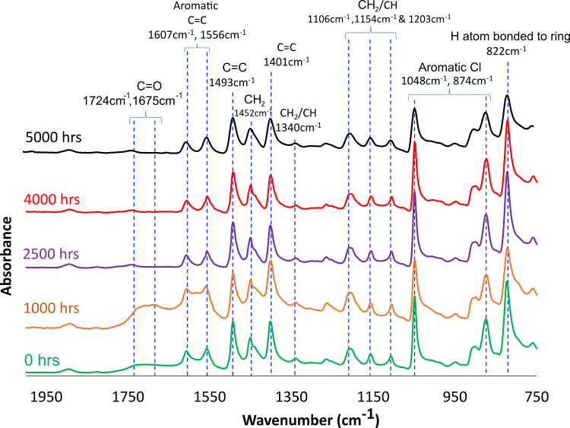
Fig 1: FT-IR spectra of aged parylene coating between the wavenumber 750cm⁻¹ and 2000cm⁻¹

    - Degradation of MPS silane agent at the interface
The FT-IR of the MPS silane agent before its application to the tin surface is given in the appendix section (figure A.1). The parylene coating was manually peeled and then the FT-IR spectra was obtained from the surface of the solderpad (figure 2). The presence of peaks between 1300cm⁻¹ and 1670cm⁻¹ (corresponding to the parylene coating [27]) at 0 hr indicates the presence of trace amount of parylene on the solderpad. It suggests the strong bond between the tin surface and the parylene coating because the coating was not cleanly delaminated during the manual peeling. The peaks at 1079cm⁻¹, 813cm⁻¹ and 689cm⁻¹ corresponding to the Si-O-Si, Si-CH₃ and Si-O peaks, respectively, belong to the silane agent [30,31]. The peaks at 2945cm⁻¹ and 2841 cm⁻¹ correspond to CH peaks in both parylene and silane agent. [30,31] The presence of all the peaks at 0 hr indicates that during the peeling of the coating, the delamination might have occurred at the silane/parylene interface and also partially through the parylene coating as given in figure 3a. After 1000hrs, all the peaks between 1300cm⁻¹ and 1670cm⁻¹ (corresponding to the parylene coating) and CH peaks (at 2945cm⁻¹ and 2841 cm⁻¹) decreased drastically but Si-O-Si peak at 1079cm⁻¹ is still present. This indicates that the peeling might have occurred at the bonding between the parylene and silane agent due to the bond getting weakened between them (figure 3b). After 2500hrs, the intensity of the Si-O-Si peak continues to decrease, and the intensity of Si-O peak (at 689 cm⁻¹) increases and becomes broader. It may suggest the degradation of the silane agent due to excessive oxidation of the silane at the interface. After 4000hrs and 5000hrs, all the peaks vanish from the surface of the tin layer, indicating the clear bonk breakage at the interface between the silane agent and the tin surface. During this long time exposure, the peel line might be similar to the schematic represented in figure 3c.
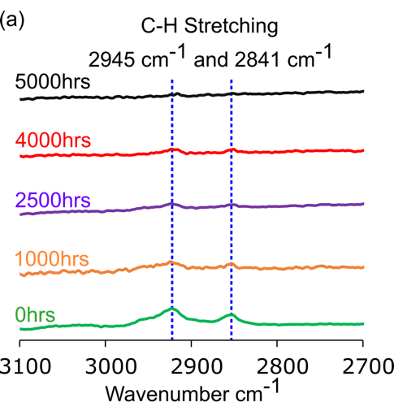
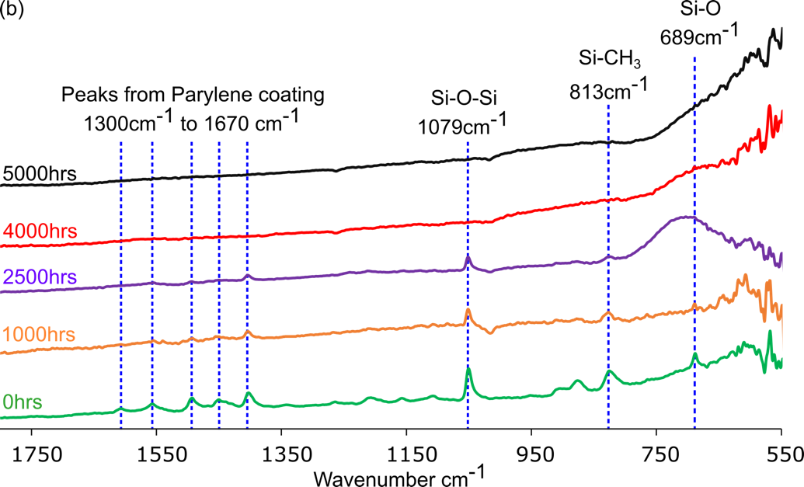
Fig 2: FT-IR spectra of aged parylene coating between the wavenumber (a) 2700cm⁻¹ and 3100cm⁻¹ and (b) 550cm⁻¹ and 1800cm⁻¹

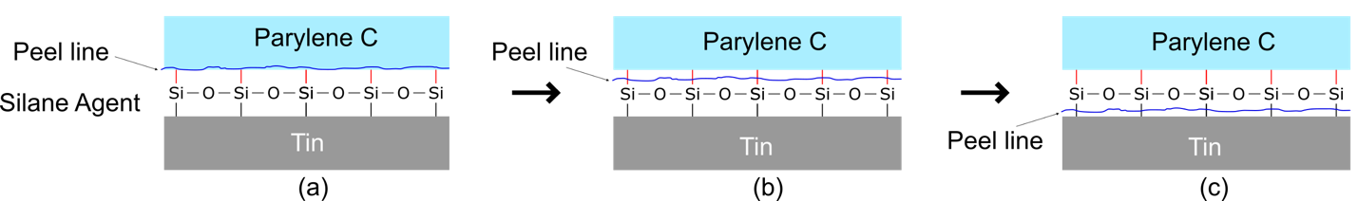
Fig 3: Representation of the peel line during FT-IR investigation at the interface (a) Strong bond between the parylene and tin; (b) Weak bond between the parylene and silane agent; (c) Peeling of silane from tin surface due to silane degradation

  - Mechanical degradation
Nanoindentation technique was used to investigate the mechanical degradation of the thin (12.5µm) parylene coating. The change in the hardness and elastic modulus with aging time is given in figure 4. After 300hrs, the hardness and modulus of the thinner parylene coating increased ~2 times and ~3 times, respectively. This can be related to the oxidation in the coating at earlier times. The hardness and modulus of the coating were then almost maintained till 2500hrs although the modulus was a bit fluctuated. Between 2500hrs and 5000hrs, noticeable reduction of the hardness (by ~23.9%) and modulus (by ~39.8%) values was observed. The decreased mechanical properties of the parylene coating at higher aging time were due to the degradation of the coating through the bond scission.

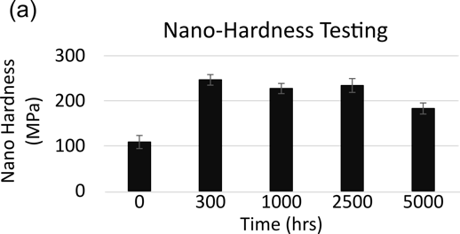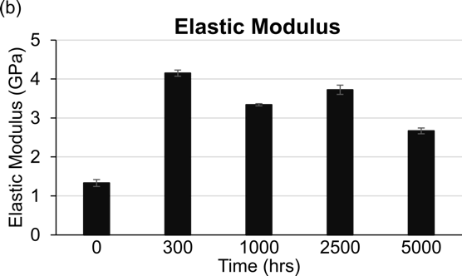
Fig 4: Nanoindentation results of thin parylene coating (thickness – 12.5µm) (a) nano-hardness and (b) elastic modulus

Vickers microhardness tester was also used to investigate the change in hardness of the thick parylene coating (25µm) during long-term aging at 85°C/85%RH (figure 5). Similar to the thin parylene coating, the hardness of the thicker parylene coating also increased (due to oxidation) till 1000hrs of aging. The hardness of the coating was maintained till 4000hrs. At 5000hrs, the hardness of the thick parylene coating decreased by approximately 28.3%, when compared to 4000hrs. This was again due to the degradation of the coating through bond scission. Based on the nanoindentation and micro-indentation results, it can be inferred that the extensive degradation in the mechanical properties of the parylene coating at 85°C/85%RH is after 4000hrs.

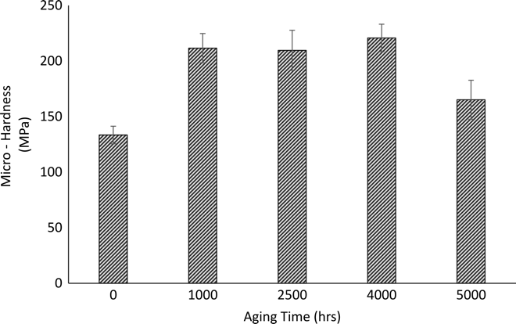
Fig 5: Microhardness of thicker parylene coating (thickness – 25µm) tested using a micro-indenter

  - Adhesion degradation
Adhesion properties of both thicknesses of the parylene coatings at different aging times were evaluated using cross-cut tape peel test (figure 6). This test provides a qualitative way for characterizing the adhesion properties of the coating. For the thinner parylene case (12.5 μm-thick), the peeled-off percent of the parylene coating on the MPS treated tin surface was 0 % at 0hr. On the other hand, the thicker parylene coating (25 μm-thick) on the MPS treated tin surface had a 35.85% of delamination at 0 hr. This was due to the fact that the residual stress of the parylene conformal coating influences the adhesion strength between the coating and the substrate. Singh et. al. reported that, in the presence of residual stress, the adhesion strength of the coating decreases with an increase in the coating thickness [32]. Hence, the thicker parylene coating with a higher residual stress has less adhesion strength than the thinner parylene coating at t=0 hr. Peeled-off delamination percent of the thinner parylene coating was maintained at 0% till 1000 hrs, but it was at 72.5% for the thicker parylene coating for the same duration. After 2500hrs, more than 91% delamination was observed on the thicker parylene coating, whereas complete delamination was observed for thinner parylene coating. This indicates that the silane agent degraded after 2500hrs due to excess oxidation (as shown in the above FT-IR data), which made the coating almost completely or completely peeled off from tin surface. After 5000hrs at 85°C/85%RH, the parylene coating with both the thicknesses showed 100% delamination indicating the parylene coatings were easily peeled off from tin surface during the tape peel test.

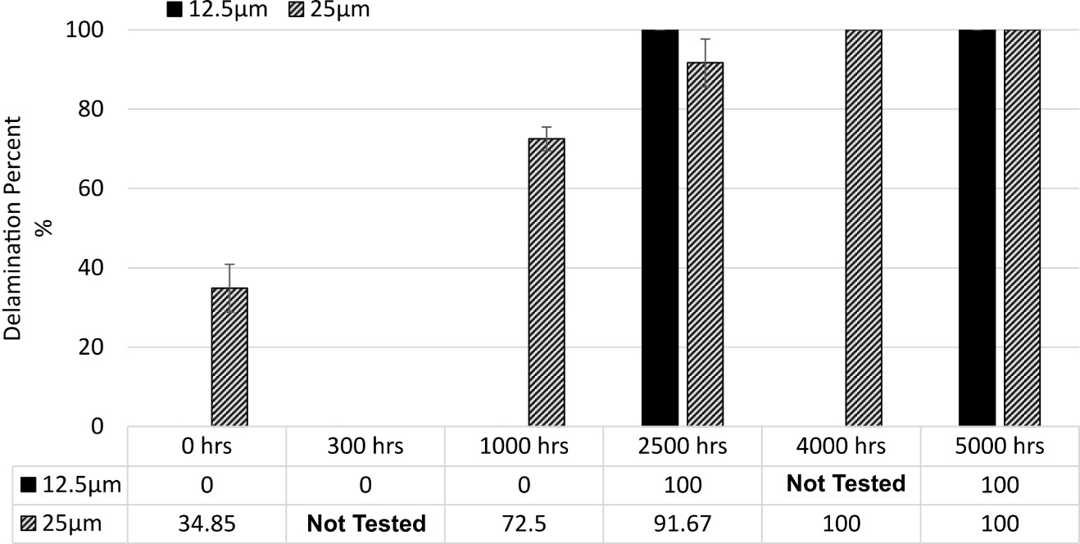
Fig 6: Delamination percent from the tape peel tests for parylene coatings exposed during the long-term aging at 85°C/85%RH

  - Corrosion protection of parylene coating
Corrosion on the tin layer is one of the important attributes in the formation of tin whiskers. The excessive localized corrosion can produce non-uniform oxide growth that imposes additional differential stress states on the tin layer. The Pilling–Bedworth ratio (PBR) for SnO₂ and SnO on tin metal is given as 1.31 and 1.26, respectively. As a consequence, the formation of SnO₂ results in +31% volume expansion [29]. This would result in the formation of higher number/density of tin whiskers, as a means of stress relief in the tin layer [34]. Hence, the duration of corrosion protection behavior of parylene coating on tin plated solderpad is very crusial during long-term aging at high temperature and high humidity.
The corrosion protection behavior of the parylene coatings on the MPS-treated tin surface during different aging times is given in figure 7 (for thin parylene coating) and figure 8 (for thick parylene coating). It can be seen that, up to 1000 hrs of aging, islands of corroded regions (dark regions) were observed on the tin surface coated with the parylene coating (both thick and thin). However, after 2500hrs of aging, the entire solderpad was mostly corroded for the coating with both the thicknesses. This was due to the fact that, for both coatings, the interfacial integrity was relatively maintained up to 1000hrs, especially for the thin parylene coating that showed 0% delamination for the tape peel test. Hence, the moisture reached to the surface of the tin mostly by penetrating through the parylene coating. After 2500hrs, the adhesion strength of the parylene coatings were significantly reduced (100% for thin parylene coating and >90% for thick parylene coating). Poor adhesion of the parylene coating facilitated the moisture to reach to the tin surface by its penetration through the coating-tin interface, as well as through the coating. This resulted in almost the complete corrosion of the tin layer at 2500hrs that became the complete corrosion of the tin layer at 5000hrs.

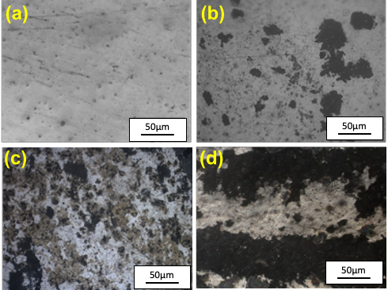
Fig 7: Corrosion behavior on tin surface coated with thin parylene coating (12.5µm) during aging at 85ºC/85%RH after (a) 0hrs; (b) 1000hrs; (c) 2500hrs and (d) 5000hrs

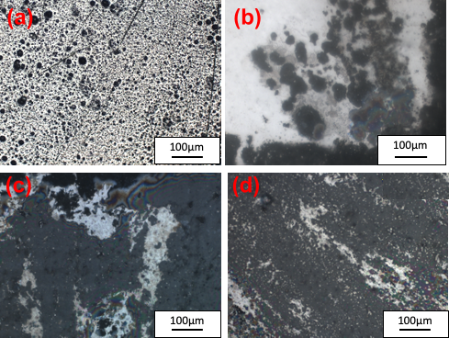
Fig 8: Corrosion behavior on tin surface coated with thick parylene coating (25µm) during aging at 85°C/85%RH after (a) 0hrs; (b) 1000hrs; (c) 2500hrs and (d) 5000hrs

  - Tin whisker growth under parylene coating
SEM survey was done to investigate the presence of tin whisker/dome at the top of the parylene coating. It can be seen from figure 9 that on an uncoated tin surface the whiskers start to appear after aging for 1000hrs at 85°C/85%RH. The number and length of the whiskers grow with additional aging time. As shown in figure 10a, the solderpad coated with the thin parylene coating did not show any tin whisker activity till 2500hrs. However, after 2500hrs, many dome formations were observed on the surface of the thick parylene coating (figure 11a). This can arise from the push from the growing tin whiskers beneath the coating. But after 5000hrs, tin whiskers have penetrated through both the thin and thick parylene coating (figure 10b and 11b). It can be seen from figure 9, 10 and 11 that, after 5000hrs, the diameter of the whisker penetrated through the thick parylene coating was larger than the whisker penetrated through the thin coating, or on uncoated solderpad. It indicates that when a whisker comes in contact with the parylene coating and if the whisker cannot penetrate through the coating, then there might be a possibility of the lateral growth of the whisker through its buckling due to the strength of the coating. The mechanism would be similar to the formation of the hillock structure as mentioned by Jadhav et al. [2].

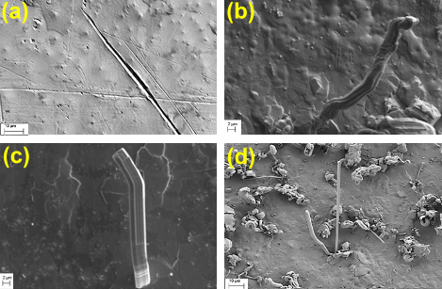
Fig 9: Tin whisker behavior uncoated tin surface during aging at 85ºC/85%RH after (a) 0hr; (b) 1000hrs; (c) 2500hrs and (d) 5000hrs

Fig 10: Whisker mitigation behavior of thin parylene coating (12.5µm) during aging at 85ºC/85%RH after (a) 2500hrs and (b) 5000hrs (Yellow arrow indicating whisker penetration)

Fig 11: Whisker mitigation behavior of thick parylene coating (25µm) during aging at 85ºC/85%RH after (a) 2500hrs and (b) 5000hrs (Red arrow indicating dome formation and Yellow arrow indicating whisker penetration)

Cross sectional SEM views were prepared to investigate the whisker activity at the tin/parylene interface. After 5000hrs of aging, multiple whiskers were penetrating through the thin parylene coating, where microcracks radiate from the corners of the growing whisker tips and grow towards the topside of the parylene coating (figure 12). Almost all the whiskers were penetrating through the thin parylene coating. For the thick parylene coating (figure 13), a thin whisker (~5µm in diameter) buckled after reaching a certain height and continued to grow in the lateral direction because of the higher buckling force from the coating and the lower adhesion strength of the thick parylene coating.

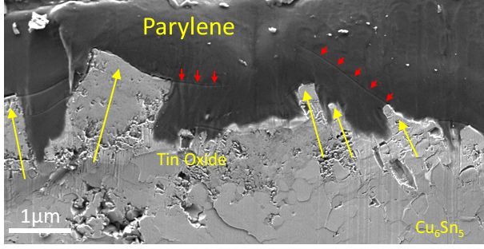
Fig 12: Tin/Parylene (12.5µm) interface after 5000hrs at 85ºC/85%RH (Yellow arrows indicating many whiskers penetrating through coating and red arrow indicating the microcrack developed from the tip of whisker)

Fig 13: Tin/Parylene (25µm) interface after 5000hrs at 85ºC/85%RH

To investigate the whisker activity at the interface of the poorly adhered parylene coating, the coating was manually peeled from the solder pad of the 4000 hr aged sample and SEM imaging was taken from the inner part of the surface of parylene coating facing tin and from the top surface of the tin solderpad after parylene was peeled off (figure 14). It can be seen from figure 14b that the parylene coating had a lot of microcracks around the whisker and that the whisker with a larger diameter seemed to have penetrated the coating while the smaller diameter ones have buckled and grown in the lateral direction. This was confirmed from the image of tin surface (figure 14c) that the whisker with a larger diameter had broken because it penetrated through the coating and broke when the coating was peeled. But another whisker with a smaller diameter buckled and continued to grow at the interfacial gap between the coating and tin surface.

Fig 14: (a) SEM image showing the solderpad after the manual peeling of thick parylene coating (25µm) and the portion of inner surface of the parylene coating folded to face-up from the coated coupon aged at 85°C/85%RH for 4000hrs (b) Whiskers remaining at the inner surface of the parylene coating seen from the folded region (c) Surface of Sn from solderpad after parylene was peeled off

  - Tin whisker mitigation strategies by conformal coating
There has been the relationship reported between the length and diameter of the whisker and the force required to buckle the whisker (F_{b}), which is given by [10].
$F_{b}=\frac{π^{3}E_{w}d_{w}^{4}}{32L^{2}}$ . (2)
$where$ $E_{w}$ is the modulus of the tin whisker, $d_{w}$ is the diameter of the whisker and L is the length of the whisker. Based on Eq. (2), when the length is constant, the force required to buckle the whisker is higher when the diameter is larger (figure 15 and 16).
A whisker that has a flat tip grows and penetrates all the way through the conformal coating, which would act like a rigid flat punch indenting all its way through the polymer coating. For the theoretical analysis purpose, it is assumed that the film does not delaminate from the surface. The load-depth profile, based on the flat punch theory, can be applied to the tin whisker penetration through the coating and is given by the equation (3) [35].

$F_{p}= \frac{2E_{c}}{1-ν^{2}} \frac{d_{w}}{2} L_{w}f\left(\frac{d_{w}}{2t_{o}},ν\right)$ . (3)

In this equation, $F_{p}$ is the penetration force, and $ν$ is the Poisson’s ratio of the parylene coating , which is 0.4 [36]. $E_{c}$ is the elastic modulus of the coating, $t_{o}$is the initial thickness of the film, f is the normalized dimensionless function, which can be obtained by equation (4) [35].

$f=1.03 exp\left(-\frac{d_{w}}{10t_{o}}\right)+\frac{π}{2}\frac{{\left(1-ν\right)}^{2}}{1-2ν}\frac{d_{w}}{2t_{o}}\left[1-exp\left(-\frac{d_{w}}{2t_{o}}\right)\right]$ . (4)

The force $F_{p}$ at which $L_{w}=t_{o}$ can be labelled as the puncture force because at that force the whisker would have completely penetrated the coating thickness. Based on the equations (2), (3) and (4), the relationship between the buckling force ($F_{b}$) and puncture force ($F_{p}$) can be calculated. If $F_{p}>F_{b}$, then the whisker would penetrate through the coating, whereas, if $F_{b}>F_{p}$, then the whisker would buckle and grow along the lateral direction. The length at which $F_{b}>F_{p}$ can be labelled as the critical length to buckle the whisker.
Figure 15 and figure 16 shows the relationship between the buckling force and puncture force for a fixed diameter of the whiskers. Elastic modulus of the parylene coating after 5000hrs (obtained from nanoindentation technique – figure 4b) was used for this calculation. Theoretical analysis of the whisker penetration activity for the thinner parylene coated solderpad after aged for 5000hrs was done with the whiskers of three different diameters ($d_{w}=$ 4.80µm, 1.61µm and 0.65µm). Based on the figure 12, all the whiskers were penetrated into the parylene coating without buckling. It can be seen from the figure 15 that, for a whisker with the diameter of 4.80µm and 1.61µm to be buckled by the parylene coating, the length of the whisker should be larger than 9.5µm and 2.1µm, respectively. It can also be seen that for the smallest whisker diameter from figure 12 ($d_{w}=$ 0.65µm), it needed to be longer than ~0.45µm in order to buckle. For the areas with good adherent coating as shown in figure 12, all whiskers tend to penetrate through the coating because they do not have an enough space to grow long enough and mechanical properties of the parylene are degraded after the 5000 hr aging.

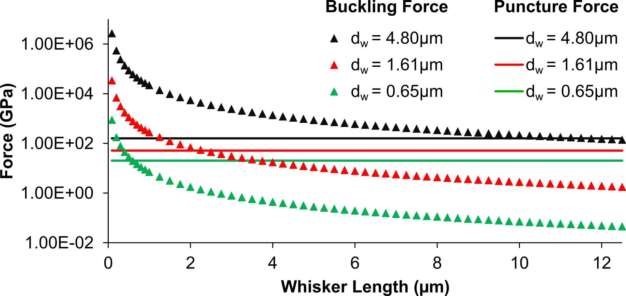
Fig 15: Relationship between the buckling force with respect to the length of the whisker (for thinner parylene coating)

A theoretical analysis of the whisker penetration activity for the thicker parylene coated solderpad aged for 5000hrs was done with three different whiskers: (i) completely penetrated whisker of diameter, $d_{w}=20.18µm$ (figure 11b); (ii) partially penetrated whisker (broken during the manual peeling) with a diameter of 2.17µm (figure 14b); and (iii) whisker buckled after initial growth with diameter 0.86 µm (figure 14c).
As shown in figure 16, for the whisker with the diameter of 20.18µm, $F_{b}>F_{p}$ even with a 25µm long whisker, which leads to the complete penetration of the whisker through the parylene coating. The critical length of the whisker with the 2.17µm diameter for buckling was ~2.5µm, which made the whisker penetrate the coating before buckling since the gap between the parylene coating and tin surface might not be large enough to grow it into the critical length. It may also have resulted in the formation of the dome on the coating surface. For the whisker with a diameter of 0.86µm, the critical length for buckling was very small. If the whisker grew longer than this critical length, it would result in the buckling or lateral growth of the whisker at the interface with no penetration.

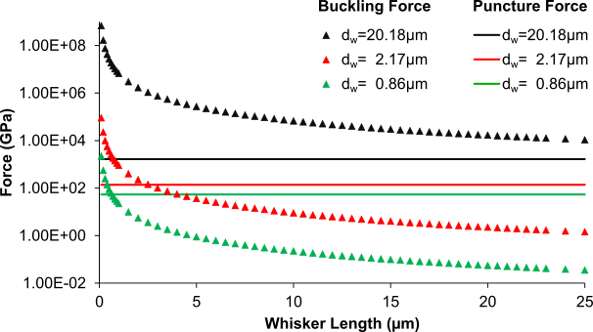
Fig 16: Relationship between the buckling force with respect to the length of the whisker (for thicker parylene coating)

The schematic representation of the whisker mitigation behavior by parylene coating (two different thicknesses) is given in figure 17. In the case of the thin parylene coating, due to its comparatively higher adhesion strength, the oxidation was slower because the moisture reached the tin surface only by penetrating through the coating layer. This resulted in lesser corrosion thereby causing the delay in the nucleation of whiskers. After 1000hrs, the adhesion strength of the thin parylene coating is still good; therefore, the no/almost no whisker activities at this time. After 2500hrs, the silane agent degrades and lowers the adhesion strength of the coating. This results in the absorption of excess moisture at the interface through the coating layer, causing to increase the oxidation on the tin layer. This created the formation of nucleation sites and growth of thick whiskers. These whiskers penetrate the parylene coating that is accompanied by microcracks in front of its advancing tip. Because of the formation and growth of the tin whiskers through the coating, the dome formation was observed in the thin parylene coating case. The resultant microcracks will aid the growth of the tin whisker since the coating becomes more compliant. After 5000hrs, the mechanical properties of the coating were degraded which would accelerate the penetration and growth of all the whiskers through the coating. Many of the whiskers completely penetrate through the coating.
Fig 17: Proposed model of the whisker growth under ‘brittle’ parylene coating with different thicknesses over time: (a) thin parylene; (b) thicker parylene.

In the case of the thicker parylene coating, where the adhesion of the parylene coating on the tin surface was poor from time zero, more corrosion was observed on the surface of Sn, even at earlier times, because of the moisture penetration not only through the coating but also along the parylene/tin interface. Extensive corrosion on the surface of tin can result in nucleation and growth of the tin whiskers at earlier times. Between 1000hrs and 2500hrs, the whiskers started growing at the interface while the adhesion strength of the coating was becoming poor, but the mechanical integrity of the coating was yet to be degraded. Hence, when the whiskers grew in length and came in contact with the inner surface (surface facing the tin layer) of the parylene coating, the whiskers either penetrated through the coating or were buckled by the coating. The former case occurred for those with a larger diameter, which is also followed by the formation of microcracks around the growing whisker tip. The latter case, on the other hand, occurred with those with a smaller diameter, which continuously grew along the interfacial gap created between the tin and parylene coating.
In order to prevent the whisker penetration, it is important to minimize the degradation in mechanical properties of the coating, as well as to avoid the crack formation from the embrittlement resulting from the aging exposure to air and moisture. It is also essential to maintain good adhesion of the coating, which will ensure less tin whisker activities on the tin surface under a conformally adhered coating. The controlled delamination during the tin whisker growth can be beneficial by buckling the tin whiskers to enclose them under the coating; however, the resultant open space may trigger more whisker activities that will form the larger diameter whiskers, which will penetrate through the coating more easily. Therefore, it suggests that there should be a room for further development of conformal coating whose whisker mitigation capacity will be dependent upon its chemical/mechanical stability and adhesion strength. In addition, the thickness of the coating will be another important factor as it not only determines the time for complete penetration of the whisker, but also influences important factors such as poor adhesion that will result in more tin whisker activities.

- Conclusion
This work investigated the degradation of the parylene coating (with two different thicknesses – 12.5µm and 25µm) and its effects on tin whisker mitigation during the long-term aging at 85°C/85%RH up to 5000hrs. The parylene coating provides good mechanical properties compared to other coatings, but the polymer network begins to be degraded and its adhesion to tin surface particularly becomes weakened under such conditions. As a result, the effectiveness of the parylene coating on tin whisker protection is dramatically reduced.
Adhesion strength of the parylene coating over the MPS treated tin surface was completely degraded after 2500hrs due to the degradation and oxidation of the silane agent at the interface. This resulted in the complete corrosion of the tin surface after 2500hrs of aging at 85°C/85%RH. Because of the degradation of mechanical properties of the parylene coating, many tin whiskers penetrated completely through the thin parylene coating after 5000hrs. Because of the poor adhesion strength and degradation of the mechanical properties of the thicker parylene coating, the whiskers with a smaller diameter were buckled and grew along the interface while those with a larger diameter penetrated through the coating. Therefore, the thicker parylene coatings did not necessarily show more protection from tin whisker penetration.
Based upon this observation, it is of importance to maintain the mechanical integrity of the parylene coating and its adhesion to tin surface when exposed to high humidity and high temperature to be able to provide enough protection for tin whisker growth. Further, the parylene coating thickness needs to be limited to the level, below which the coating adhesion can be assured.

- Acknowledgement
This work was supported by the US Department of Energy [grant number DE-NA0002839]. SEM work (Zeiss Supra 55 FE-SEM) was done at Analytical Diagnostics Laboratory (ADL) of Binghamton University.

- Reference
[1] European Parliament, Council of the European Union, Commision delegated directive (EU) 2015/863 of 31 March 2015 amending Annex II to Directive 2011/65/EU of the European Parliament and of the Council as regards the list of restricted substances, Off. J. Eur. Union. L137 (2015) 10–12.
[2] N. Jadhav, E. Buchovecky, E. Chason, A. Bower, Real-time SEM/FIB studies of whisker growth and surface modification, Jom. 62 (2010) 30–37. https://doi.org/10.1007/s11837-010-0105-8.
[3] B.Z. Lee, D.N. Lee, Spontaneous growth mechanism of tin whiskers, Acta Mater. 46 (1998) 3701–3714. https://doi.org/10.1016/S1359-6454(98)00045-7.
[4] B.D. Dunn, Whisker formation on electronic materials, Circuit World. 2 (1976) 32–40. https://doi.org/10.1108/eb043543.
[5] S. Ganesan, M. Pecht G., Lead Free Electronics Transition, John Wiley & Sons., 2006.
[6] K.N. Tu, Spontaneous Tin Whisker Growth: Mechanism and Prevention, Springer Ser. Mater. Sci. 117 (2007) 153–181. https://doi.org/10.1007/978-0-387-38892-2_6.
[7] B.S. Majumdar, I. Dutta, S. Bhassyvasantha, S. Das Mahapatra, Recent Advances in Mitigation of Whiskers from Electroplated Tin, Jom. 72 (2019) 906–917. https://doi.org/10.1007/s11837-019-03933-7.
[8] S. Maganty, Enhanced conformal coatings for tin whisker mitigation, PhD dissertation, Binghamton University, 2017.
[9] A.-A.F. Abbas, C.M. Greene, K. Srihari, D. Santos, G. Pandiarajan, Impact of Conformal Coating Material on the Long-Term Reliability of Ball Grid Array Solder Joints, Procedia Manuf. 38 (2019) 1138–1142. https://doi.org/10.1016/j.promfg.2020.01.202.
[10] K. Mahan, Y. Sun, B. Han, S. Han, M. Osterman, Adhesion and puncture strength of polyurethane coating used to mitigate tin whisker growth, J. Electron. Packag. Trans. ASME. 136 (2014) 1–7. https://doi.org/10.1115/1.4026922.
[11] T. Kato, C.A. Handwerker, J. Bath, E. Chason, N. Jadhav, Major Driving Forces and Growth Mechanisms for Tin Whiskers, Mitigating Tin Whisker Risks. (2016) 21–42. https://doi.org/10.1002/9781119011965.ch2.
[12] F. Dong, S.J. Meschter, J. Cho, Improved adhesion of polyurethane-based coatings to tin surface, J. Mater. Sci. Mater. Electron. 30 (2019) 7268–7279. https://doi.org/10.1007/s10854-019-01040-6.
[13] F. Dong, S.J. Meschter, S. Nozaki, T. Ohshima, T. Makino, J. Cho, Effect of coating adhesion and degradation on tin whisker mitigation of polyurethane-based conformal coatings, Polym. Degrad. Stab. 166 (2019) 219–229. https://doi.org/10.1016/j.polymdegradstab.2019.05.019.
[14] A. Kahouli, A. Sylvestre, L. Ortega, F. Jomni, B. Yangui, M. Maillard, B. Berge, J.C. Robert, J. Legrand, Structural and dielectric study of parylene C thin films, Appl. Phys. Lett. 94 (2009). https://doi.org/10.1063/1.3114404.
[15] W. Chun, N. Chou, S. Cho, S. Yang, S. Kim, Evaluation of sub-micrometer parylene C films as an insulation layer using electrochemical impedance spectroscopy, Prog. Org. Coatings. 77 (2014) 537–547. https://doi.org/10.1016/j.porgcoat.2013.11.020.
[16] E. Song, R. Li, X. Jin, H. Du, Y. Huang, J. Zhang, Y. Xia, H. Fang, Y.K. Lee, K.J. Yu, J.K. Chang, Y. Mei, M.A. Alam, Y. Huang, J.A. Rogers, Ultrathin Trilayer Assemblies as Long-Lived Barriers against Water and Ion Penetration in Flexible Bioelectronic Systems, ACS Nano. (2018). https://doi.org/10.1021/acsnano.8b05552.
[17] T. Haggren, A. Shah, A. Autere, J.P. Kakko, V. Dhaka, M. Kim, T. Huhtio, Z. Sun, H. Lipsanen, Nanowire encapsulation with polymer for electrical isolation and enhanced optical properties, Nano Res. 10 (2017) 2657–2666. https://doi.org/10.1007/s12274-017-1468-8.
[18] T. Woodrow, D. Ph, Evaluation of Conformal Coatings as a Tin Whisker Mitigation Strategy, Part II, (2007).
[19] T.A. Woodrow, E.A. Ledbury, Evaluation of Conformal Coatings as a Tin Whisker Mitigation Strategy, IPC/JEDEC 8th Int. Conf. Lead-Free Electron. Components Assem. San Jose, CA, April 18-20. (2005) 191–215.
[20] S. Han, M. Osterman, S. Meschter, M. Pecht, Evaluation of effectiveness of conformal coatings as tin whisker mitigation, J. Electron. Mater. 41 (2012) 2508–2518. https://doi.org/10.1007/s11664-012-2179-2.
[21] L. Woody, W. Fox, Tin whisker risk management by conformal coating, SMT Surf. Mt. Technol. Mag. 29 (2014) 40–58.
[22] C.J. Mitchell, G.R. Yang, J.J. Senkevich, Adhesion aspects of poly(p-xylylene) to SiO2 surfaces using γ-methacryloxypropyltrimethoxysilane as an adhesion promoter, J. Adhes. Sci. Technol. 20 (2006) 1637–1647. https://doi.org/10.1163/156856106778884217.
[23] M. Cieślik, K. Engvall, J. Pan, A. Kotarba, Silane-parylene coating for improving corrosion resistance of stainless steel 316L implant material, Corros. Sci. 53 (2011) 296–301. https://doi.org/10.1016/j.corsci.2010.09.034.
[24] S. Youssefian, N. Rahbar, Nano-scale adhesion in multilayered drug eluting stents, J. Mech. Behav. Biomed. Mater. 18 (2013) 1–11. https://doi.org/10.1016/j.jmbbm.2012.11.001.
[25] C.P. Tan, H.G. Craighead, Surface engineering and patterning using parylene for biological applications, Materials (Basel). 3 (2010) 1803–1832. https://doi.org/10.3390/ma3031803.
[26] K. Cho, T. Pearson, D. Hillman, R. Wilcoxon, QUALIFICATION OF HIGH DENSITY CONNECTOR SOLUTIONS FOR MILITARY AND AVIONIC ENVIRONMENTS, (2019) 299–305.
[27] D.J. Monk, H.S. Toh, J. Wertz, Oxidative degradation of parylene C (Poly (monochloro-para-xylylene)) thin films on bulk micromachined piezoresistive silicon pressure sensors, Sensors Mater. 9 (1997) 307–319.
[28] R. Caldwell, M.G. Street, R. Sharma, P. Takmakov, B. Baker, L. Rieth, Characterization of Parylene-C degradation mechanisms: In vitro reactive accelerated aging model compared to multiyear in vivo implantation, Biomaterials. 232 (2020) 119731. https://doi.org/10.1016/j.biomaterials.2019.119731.
[29] T.H. Trân, D. Debarnot, E. Richaud, Thermal oxidative stability of polyanilines, Polym. Test. 81 (1980) 2103–2119. https://doi.org/10.1016/j.polymertesting.2019.106187.
[30] L.S. Zaremba, W.H. Smoleński, Study of the reaction of γ – methacryloxypropyltrimethoxysilane (γ – MPS) with slate surfaces, J. Mater. Sci. 34 (1999) 3867–3873. https://doi.org/10.1023/A:1004666621479.
[31] Z. Guo, T. Pereira, O. Choi, Y. Wang, H.T. Hahn, Surface functionalized alumina nanoparticle filled polymeric nanocomposites with enhanced mechanical properties, J. Mater. Chem. 16 (2006) 2800–2808. https://doi.org/10.1039/b603020c.
[32] R. Singh, S. Schruefer, S. Wilson, J. Gibmeier, R. Vassen, Influence of coating thickness on residual stress and adhesion-strength of cold-sprayed Inconel 718 coatings, Surf. Coatings Technol. 350 (2018) 64–73. https://doi.org/10.1016/j.surfcoat.2018.06.080.
[33] B. Horváth, T. Shinohara, B. Illés, Corrosion properties of tin-copper alloy coatings in aspect of tin whisker growth, J. Alloys Compd. 577 (2013) 439–444. https://doi.org/10.1016/j.jallcom.2013.06.092.
[34] P. Zhang, Y. Zhang, Z. Sun, Spontaneous Growth of Metal Whiskers on Surfaces of Solids: A Review, J. Mater. Sci. Technol. 31 (2015) 675–698. https://doi.org/10.1016/j.jmst.2015.04.001.
[35] Y. Cao, D. Ma, D. Raabe, The use of flat punch indentation to determine the viscoelastic properties in the time and frequency domains of a soft layer bonded to a rigid substrate, Acta Biomater. 5 (2009) 240–248. https://doi.org/10.1016/j.actbio.2008.07.020.
[36] T.A. Harder, T. Yao, Q. He, C. Shih, Y. Tai, Residual stress in thin-film parylene-C, in: MEMS 2002 IEEE Int. Conf. Fifteenth IEEE Int. Conf. Micro Electro Mech. Syst. (Cat. No.02CH37266), Las Vegas, NV, USA, 2002: pp. 435–438. https://doi.org/10.1109/MEMSYS.2002.984296.

Appendix:

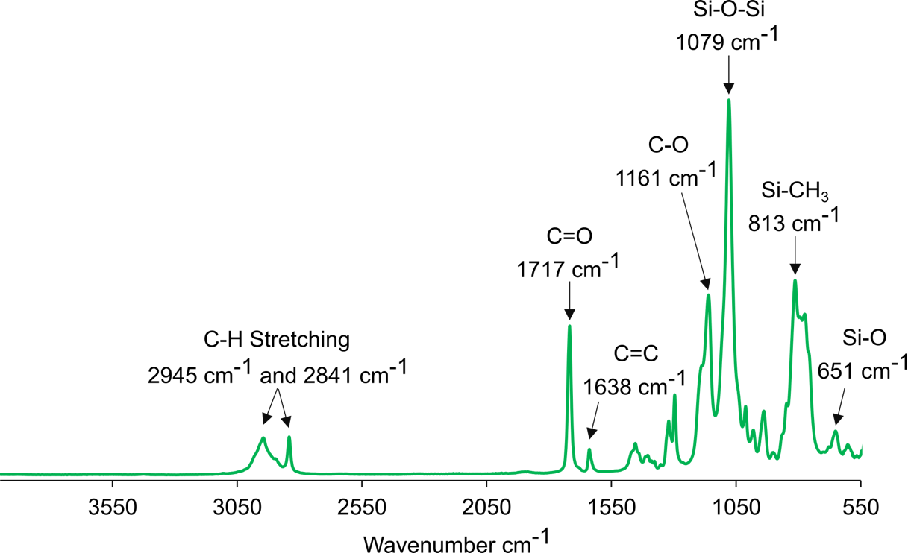
Fig. A.1: FTIR spectra of the MPS coupling agent before coating

∗ Honeywell Federal Manufacturing & Technologies, LLC operates the Kansas City National Security Campus for the United States Department of Energy / National Nuclear Security Administration under Contract Number DE-NA0002839

