Adoption of perennial energy crops in the US Midwest: Causal and Heterogeneous Determinants
Pan Yang^{1,2}, Ximing Cai^{1,2*}, Carrie Leibensperger^{1,2}, Madhu Khanna^{2,3}
¹Department of Civil and Environmental Engineering, University of Illinois at Urbana-Champaign, Urbana, IL, United States of America
²DOE Center for Advanced Bioenergy and Bioproducts Innovation, University of Illinois at Urbana-Champaign, Urbana, IL, United States of America
³Department of Agricultural and Consumer Economics, University of Illinois at Urbana-Champaign, Urbana, IL, United States of America

*Corresponding author: (xmcai@illinois.edu)

Highlights
- Farmer’s likely adoption of perennial energy crops is surveyed
- A causal-relationship structure is identified from the survey data
- Economic factors are found to have the highest priority as the driver of land-use decisions
- Four types of farmers with different responses to land-use factors are classified

Abstract
The success of a bioenergy policy relies largely on the wide adoption of perennial energy crops at the farm-scale. This study uses survey data to examine potential adoption decisions by farmers in the US Midwest and the causal effect of various direct and indirect influencing factors and heterogeneous preferences of farmers. A Bayesian network (BN) model is developed to delineate the causal-relationship between farmers adoption decisions and the various factors influencing them. We find a dominating role of economic factors and a non-negligible impact of non-economic factors, such as the perceived environmental benefits and extent of familiarity with perennial energy crops. To examine the effect of heterogeneity in farmer preferences, we classify the surveyed farmers into four categories based on their attitudes toward the economic, social, and environmental dimensions of perennial energy crops. We identify statistically significant between-group differences in the responses of the four types of farmers to various influencing factors. Our findings contribute to disentangling the complicated motivations that will influence perennial energy crop adoption decisions and provide implications for more targeted policy development that considers the heterogeneous drivers of farmer decisions about land use.

Keywords: perennial energy crop, Bayesian network, land-use behavior, survey analysis, cellulosic biofuel.

- Introduction
Biofuels from biomass are expected to play an increasingly important role in meeting the growing global energy demand in a sustainable manner. Among the different types of biofuels, cellulosic biofuels that use dedicated energy crops such as perennial grasses as feedstocks are especially promising. Compared to conventional grain-based biofuels, cellulosic biofuels have lower life-cycle greenhouse gas (GHG) emissions, lower water quality impacts, and are likely to compete less with food crop production [1–4]. The Renewable Fuel Standard (RFS) in the United States (US) aimed to promote the production of 36 billion gallons of biofuel each year, of which 16 billion gallons was to be produced from cellulosic feedstocks, by the year 2022 [5]. Despite the government mandate, cellulosic biofuel production has lagged behind. In 2019, the total cellulosic biofuel production in the US was 0.42 billion gallons, far below 8.5 billion gallons [6], the statutory production under the RFS.
Accelerating cellulosic biofuel production requires efforts from multiple stakeholders, e.g., farmers/producers, biorefineries, local communities, government and non-government organizations, and consumers [7]. One of the key challenges is inducing a change in land use from the current food-crop dominated land use to one with a diversified crop pattern including perennial energy crops. To facilitate this transition we need improved understanding of the drivers of farmers land-use decisions, especially those relating to perennial energy crop adoption. Based on economic theories and analyses, previous studies have shown that adoption of perennial energy crops could be affected by the profitability and risks of these crops, farmer attitudes toward risks and potential losses, the availability of risk mitigation tools such as insurances and cost-share subsidies and other factors[8–10], .
There are a few studies using surveys to examine empirical evidence of the drivers of farmer decisions to adopt perennial energy crops. These studies show that adoption will be affected not only by economic factors but also by social and environmental factors [11–13]. For example, Khanna et al. [14] surveyed farmers willingness to adopt energy crops under different contract conditions using a choice experiment approach. Their results suggest that farmers are more willing to allocate land for energy crop production if they have low discount rates and if the energy crops have low upfront establishment costs and do not require additional crop-specific investment. Based on a survey of lower Michigan farmers, Skevas et al. [15,16] classified farmers into four types based on their attitudes toward energy crops and included the classified farmer types in their probit model to explain farmer willingness to adopt energy crops. Their model suggests farmer decisions are affected by the marginal land rent rate, farmer typology, and farmers concerns about planting energy crops. Other influencing factors identified in previous survey studies include expected return of perennial energy crop, contract by biorefinery, contract length, farmland ownership, and education level [11,13,14,17,18].
While previous studies identify the factors that affect farmers adoption of perennial energy crops, they provide limited understanding of how and why these factors have an impact. We hypothesize that farmers land-use decisions follow a hierarchical causal-relationship structure, via which farmers preferences affect their decisions directly or indirectly through the mediation of some intermediate variables such as awareness and attitude [19,20]. Without appropriate characterization of the causal-relationship structure, understanding of the impact of various factors on farmers’ perennial energy crop adoption can be distorted [19,21,22]. The causal-relationship embedded in the data might be affected by collinearity when using traditional algorithms such as mixed logit regression or probit model, and this can lead to biased parameter estimations and confounded model structures [23,24].
In addition, previous studies on farm-scale biofuel crop adoption have largely overlooked farmers heterogeneous sensitivities to incentives that are usually identified in other agricultural decision analyses [25–27]. Multiple studies have successfully classified farmers into distinctive groups based on their socio-economic background [18,28] and attitudes toward bioenergy crops [16,29]. But according to our knowledge, only one study, Fewell et al. [18], has attempted to use a latent class model to identify the distinct sensitivities of two types (crop farmer and farmer–stockman, who has interests in both crop and livestock) of farmers to various incentives. There is still a significant lack of understanding of how the heterogeneity among farmers, with respect to not only the economic aspects but also the aspects related to their social and environmental concerns (e.g., attitudes toward environment) and their personal identities (e.g., education level and source of information), could make a difference in their perennial energy crop adoption decisions. Such a knowledge gap presents a barrier to the design of more targeted policies to induce adoption.
In this study, we design a survey to understand the socio-economic drivers of US Midwestern farmers’ perennial energy crop adoption decisions. Using the survey responses as well as empirical justification and validated theories, we develop a Bayesian Network (BN) model to represent the causal-relationship structure for the way various factors affect the willingness of farmers to adopt perennial energy crops. Following that, we classify Midwestern farmers into different groups with distinct economic, social, and environmental considerations. Based on the derived causal-relationship structure and farmers’ heterogeneity classification, we address the following questions: i) what are the major factors (economic, social, environmental) that will influence adoption by different types of farmers with unique perspectives toward perennial bioenergy crops, and ii) what are the implications of these differences for the design of targeted policy development for perennial energy crop adoption?
In the rest of this paper, we introduce the survey design and survey analysis methods in section 2, present the results of the BN model and farmers’ heterogeneous responses to various economic, social, and environmental factors in section 3, and conclude this paper with some final remarks and policy implications in section 4.
- Methods
The procedures adopted in this paper are shown in Figure 1. After the design, distribution, and result collection of the survey (section 2.1), farmers’ response data are first used to develop a Bayesian Network (BN) model (section 2.2). The BN model identifies the causal-relationship structure for the mechanism by which various economic, social, and environmental factors impact farmers adoption of perennial energy crop. We then use the trained BN model to generate Monte Carlo samples for conditional probability inferencing and mutual information calculation; results from both indices represent the sensitivity of farmer decisions to individual influences of each factor (section 2.2). The survey data are also processed by the principal component analysis (PCA) to identify a set of lumped variables that simplify the representation of farmers attitudes toward various aspects of perennial energy crops (section 2.3). Finally, we cluster the surveyed farmers into distinctive types based on those lumped variables and combine the farmer typology with the BN model to identify if farmer sensitivities to incentives vary among different farmer types (section 2.3).
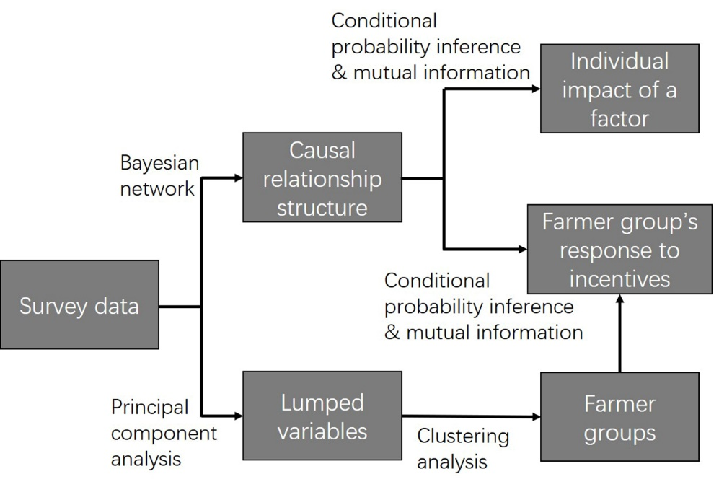
Figure 1. Flow chart for identifying Midwestern farmers’ heterogeneous rule of perennial energy crop adoption
<Figure 1>
  - Farmer Survey
The survey is designed for farmers in the Midwestern states that are expected to be major perennial energy crop producers in the US [30]. Because there are currently not many lands growing perennial energy crops in the Midwest, we take an alternative approach to ask farmer adoption decision preferences under various financial scenarios. The survey includes five sets of questions (Table 1) on: i) background information, ii) farmers’ communication with other stakeholders, iii) farmer behaviors, iv) perennial energy crops, and v) a set of scenarios designed to have farmer responses under the various financial conditions. Survey questions in the five categories are converted to variables shown in Table 1. We then label the variables into two types of codes: i) binary coding with ‘1’ for ‘no’ and ‘2’ for ‘yes’, and ii) ordinal coding starts from ‘1’ (most negative) to the total number of levels (most positive).
In particular, for calculating info_use, we ask the farmers whether certain sources of information contribute to their land management objectives. In total, seven information sources are included in the survey: other farmers, farmers’ associations, government agencies, social media, farm media, academia, and industry. A farmer’s info_use is categorized as ‘low’, ‘medium’, or ‘high’ according to the rule specified in Table 1. There is a set of questions in the survey regarding farmer perceptions of importance of six environmental issues [see Table S1 in the supporting information (SI) for the full list of environmental issues]. We ask the farmers to rate the importance of these environmental issues in 5 scales and convert their responses into 3 scales. We then take the average value of the six items as the imp_env variable in Table 1 and label it as not important (1-1.49), neutral (1.5-2.49), and important (2.5-3).
We include two more sets of questions in the survey regarding farmers’ agreement in 5 scales to claims relating to benefits and concerns of perennial energy crops (see Table S2 in the SI for a full list of claims about perennial energy crops). Again, we convert the responses into 3 scales and calculate the average values of the two sets of questions into the variables benefit and concern in Table 1, which are labeled as disagree (1-1.49), neutral (1.5-2.49), and agree (2.5-3). In order to identify the impacts of economic, social, and environmental factors involved in these matrices of questions separately, we further split them into four variables: bne_eco (economic benefits), bne_env (environmental benefits), con_eco (economic concerns, mostly related to uncertainties and lack of market for perennial biomass), and con_soc (social concerns) in Table 1. See Table S2 in the SI for the list of claims included in the four variables. The scales and labels of the four variables are identical to that of benefit and concern. Finally, for max_fam, we ask farmers about their degree of familiarity with three types of perennial energy crops (Miscanthus, switchgrass, energy sorghum) and take the maximum value of the three familiarity measures to represent the farmer’s maximum level of familiarity with perennial energy crops.
The last section of the survey is 4 sets of scenario-based questions that asks farmer willingness to growing perennial energy crop under some specified financial scenarios (an example of the scenario is shown in Figure 2). On top of the scenario questionnaire, basic perennial energy crop characteristics, including its lifespan and yield (Figure S1 in the SI), as well as some explanation of the scenario settings (Figure S2 in the SI), are provided to ensure well-informed responses to the questions.
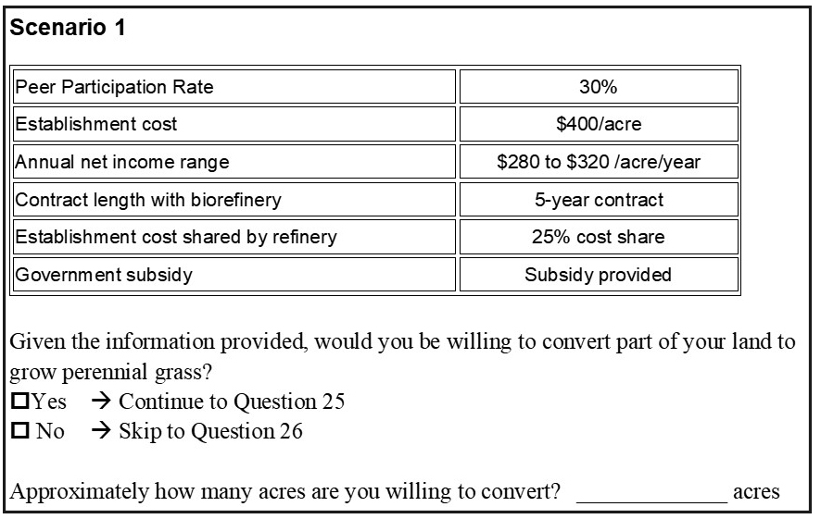
Figure 2. An example of the scenario-based question
<Figure 2>

Table 1. Variables generated from survey responses and their levels
Variable |  | Meaning | Levels
Background information | age | Age of farmer | ≤44 years, 45-64 years, and ≥ 65 years
Background information | gender | Gender of farmer | male, female
Background information | edu | Farmer education level | high school or less, vocational school/technical school, and college or higher
Background information | risk | Farmer attitude toward risk | unwilling to take risks, neutral, and willing to take risks
Background information | farm_size | Farm size | ≤500 acres, 501-999 acres, and ≥1000 acres
Background information | rented_ratio | Portion of rented land | 0%, 0.1-49.9%, and ≥50%
Background information | farm_inc | percentage of income from agricultural business | ≤39%, 40-79%, and ≥80%
Background information | crop_ins | Participation in crop insurance plans | not participated, participated
Background information | lql | Percentage of low-quality land | 0%, 0.1-29.9%, and ≥30%
Interaction variables | com_sup | Community support of energy crop | not supportive, neutral, and supportive
Interaction variables | peer_ec | Peer perennial grass adoption rate | ≤10%, 11-20%, and ≥20%
Interaction variables | info_use | Number of information sources | ‘low’ (≤2), ‘medium’ (3-4), and ‘high’ (≥5)
Interaction variables | gov_prog | Participation in government conservation programs | not participated, participated
Behavior variables | obj_eco | Land management objective is economic return | not important, neutral, and important
Behavior variables | obj_rur | Land management objective is maintaining rural lifestyle | not important, neutral, and important
Behavior variables | obj_env | Land management objective is environmental protection | not important, neutral, and important
Behavior variables | obj_rec | Land management objective is recreation opportunities | not important, neutral, and important
Behavior variables | obj_land | Land management objective is protecting land quality | not important, neutral, and important
Behavior variables | imp_env | Importance of environment in land management | not important, neutral, and important
Perennial grass related variables | benefit | Farmer perceived overall benefit from perennial grass | disagree, neutral, and agree
Perennial grass related variables | bne_eco | Farmer perceived economic benefit from perennial grass | disagree, neutral, and agree
Perennial grass related variables | bne_env | Farmer perceived environmental benefit from perennial grass | disagree, neutral, and agree
Perennial grass related variables | concern | Farmer’s overall concern with perennial grass | disagree, neutral, and agree
Perennial grass related variables | con_eco | Farmer’s economic related concern with perennial grass | disagree, neutral, and agree
Perennial grass related variables | con_soc | Farmer’s social related concern with perennial grass | disagree, neutral, and agree
Perennial grass related variables | max_fam | Farmer’s familiarity with perennial grass | not familiar, neutral, familiar
Scenario-based questions | SC_par_rate | Peer perennial grass adoption rate in the scenario | 0%, 30%, 60%
Scenario-based questions | SC_Cost | Implementation cost of perennial grass in the scenario | $400/acre, $800/acre, and $1,200/acre
Scenario-based questions | SC_rev_mean | Average profit of perennial grass in the scenario | $100/acre, $200/acre, and $300/acre
Scenario-based questions | SC_rev_range | Range of profit of perennial grass in the scenario | $40/acre, $80/acre, and $120/acre
Scenario-based questions | SC_Contract | Provision of contract in the scenario | contract, no contract
Scenario-based questions | SC_cost_share | Cost sharing for the perennial grass implementation cost in the scenario | 0%, 25%, 50%, and 75%
Scenario-based questions | SC_Subsidy | Provision of government subsidy in the scenario | subsidy, no subsidy
Scenario-based questions | SC_will | Farmer willingness to adopt perennial grass in the scenario | willing, unwilling
Scenario-based questions | SC_ratio | The portion of land that farmer is willing to convert to perennial grass in the scenario (conversion ratio) | 0, 0.1-5%, 5.1-10%, 10.1-15%, and >15%

The scenarios are controlled by the first seven variables in the scenario-based questions (Table 1), which have been identified to be important by previous literature [14,18]. Each of the seven variables includes two or more levels (Table 1), and their values are benchmarked by either literature value or farmers’ status-quo to make sure the scenarios are realistic to the farmers. For example, the establishment cost (SC_Cost) of perennial energy crops has three levels: $400/acre, $800/acre, and $1,200/acre, which covers the range of establishment costs of perennial energy crops in the literature [8,31,32]. The three levels of average net income (SC_Rev_mean) ($100/acre, $200/acre, and $300/acre) are benchmarked by the expected corn and soybean production net incomes ($100/acre - $197/acre) in 2019 [33]. After the description of each scenario, the farmer is asked for two questions: i) a binary choice of whether they are willing to plant perennial energy crop on their farm (SC_Will), and ii) a blank for farmers to fill in the acres of land they are willing to plant. We transform the acreage into a percentage of their total land operation and categorize it into five levels shown in Table 1 (SC_Ratio).
In order to investigate farmer sensitivities to changes in the seven scenario variables under various conditions, it is important to get their responses to randomized combinations of these variables. One possible solution is to randomly select scenarios based on all possible combinations of the seven variables, but it would be logistically difficult. Instead, we run a fractional factorial design [34] to generate 36 unique scenarios that effectively represent variations in each of the seven scenario variables. We then randomly select four scenario-based questions from those 36 pre-set scenarios pool for each survey.
The survey was sent to 2,500 farmers from the Farm Market ID [35] dataset in late 2019 and early 2020. The 2500 farmers are identified by stratified random sampling of the Farm Market ID database based on farm size to ensure coverage of farmers managing small and large acreages. For the non-respondents, we sent a mailed reminder two weeks later after the survey was sent out. Finally, we obtained 242 responses, resulting in an overall response rate of 9.7%. Since 17 farmers returned their survey with most of the questions unanswered we had 225 valid surveys. Unanswered questions are occasionally identified in the rest of the 255 surveys (with less than 4% questions unanswered), which is acceptable given the BN model’s ability to deal with missing data [36]. As each farmer is asked for 4 scenario-based questions, the final effective sample size after some further screening is 889.
  - Bayesian network
Bayesian network (BN) is selected for its ability to represent the causal-relationship structure, perform easy conditional inferencing (for identifying farmers’ heterogeneous sensitivities to influencing factors), and deal with incomplete datasets (our survey data have about 4% missing values). BN is a probabilistic graphical model that represents a set of variables and their conditional dependencies via a directed acyclic graph [37]. A BN typically consists of a set of directed links from one variable to another, where the direction of the link could be considered as the causality from the cause to the consequence. With an efficient searching algorithm, a BN can be learned from data to represent the causal-relationship structure, and the derived BN can be easily applied for conditional inferencing through the chain rule of conditional probabilities or Monte Carlo analysis [37].
Compared to traditional econometrics methods, BN is not restricted to a fixed form of equations, hence it is more flexible in representing complex relationships. This is especially important if there exists collinearity among explaining variables, or if the explanation of farmers’ decisions involves a hierarchical causal-relationship structure [19,21,22]. Without in-depth knowledge about farmer decision making, the econometrics regression results can only indicate factors with statistically significant correlations with perennial energy crop adoption, but with no specific judgment whether such correlations are justified, why they exist [21], and to what extent they affect farmer’s behaviors on perennial grass adoption. Compared to other flexible machine learning models such as deep learning neural networks, BN is a more suitable option for this study as it does not have excessively large data demand. Incomplete datasets can be easily dealt with within BN by using the expectation-maximization algorithm [38], which offers an approximation approach to calculate the likelihood function of an incomplete dataset by iteratively improved guesses of missing values.
The above advantages of BN make it a useful tool for understanding human behavior rules from survey data. It has been successfully applied to analyzing farmer land-use decisions [39,40], farm practice adoption [20], and pro-environmental behaviors [41]. However, to the best of our knowledge, this is the first time that BN is applied to understanding potential adoption of perennial energy crops by farmers.
Here a model selection expectation-maximization (MS-EM) algorithm [42] is used to derive the BN structure from the survey data introduced above. The algorithm searches the model structure with the minimum Bayesian information criterion (BIC) value [43]. However, in practice, the BN structure learned from survey data usually requires necessary editing based on expert knowledge [44,45]. This is because the searching algorithms only provide a locally optimal structure, and survey data typically involve a high level of uncertainty. We adopt a hybrid approach that uses the BN structure learned from MS-EM as a backbone and slightly refine it based on common knowledge. We then determine the parameters of the manually edited BN structure using the regular expectation-maximization algorithm [38]. Finally, we validate the BN structure and parameters using a leave-one-out cross-validation [46]. The validation statistics are selected as the classification accuracies of the trained BN model in predicting two target variables SC_Will and SC_Ratio.
The learned BN model is then applied to estimate farmers’ probability of adopting perennial energy crops under various conditions via statistical inferencing. This is done by calculating the conditional probability of a target variable given some influencing variables (here referred to as evidence) p(target|evidence). In this study, we first generate a large sample (10⁷) of all variables in the BN through Monte Carlo, and then calculate p(target|evidence) as the corresponding conditional frequency in the Monte Carlo samples. Two variables of particular interest (as the target variables) are the willingness to adopt perennial grass (SC_Will) and the portion of land allocated to perennial grass (SC_Ratio).
We also investigate farmer sensitivities to changes in an influencing factor through the trained BN. More specifically, the sensitivity of a target variable given variations of another variable is calculated as the mutual information (MI) of the two variables [47]:
$MI\left(T,S\right)=H\left(T\right)-H\left(T | S\right)=\sum_{t}{\sum_{s}{p\left(t,s\right)\log_{2}\left[\frac{p(t,s)}{p\left(t\right)p(s)}\right]}}$ (1)
where T represents the target variable (SC_Will or SC_Ratio), S the influencing variable under investigation, t and s the states of T and S respectively, H() the information entropy, and p() the probability whose value is estimated based on the Monte Carlo samples generated from the investigated BN. The value of MI(T, S) suggests to what degree the state of T is affected by S. A larger value of MI(T, S) means a higher degree of influence. The R package ‘bnlearn’ [48] is used for training and inferencing BN.
  - Farmer classification
The MI index in equation (1) can be further applied to calculate farmers’ individualized sensitivities to changes in incentives by specifying a set of variables Φ that characterize a farmer as additional conditions (all the factors in the BN except the target variable T, scenario-based variables, and the investigated variable S), i.e., MI(T,S|Φ). Knowing MI(T,S|Φ) for different farmers would lead to an improved understanding of farmer decision-making. It also enables more targeted policy designs to promote perennial energy crops. However, involving a large number of individual farmers will cause difficulty in the interpretation of MI(T,S|Φ) and its relationship with the influencing factors, given the uncertainties involved in its estimation, as well as the large number of variables involved in Φ. This study simplifies the interpretation by clustering the surveyed farmers into relatively homogeneous groups and focusing on the between-group differences in MI(T,S|Φ).
Following Skevas et al. [16], farmer classification involves two steps: i) a dimension reduction step to enable a parsimonious and interpretable representation of the large number of attitude-related claims, and ii) a clustering step to assign the surveyed farmers into clusters. The principal component analysis is used for step i), and k-means for step ii). Data from the 225 valid surveys are used in farmer classification. Occasional missing values in the data are filled using a separate BN trained with responses to all questions regarding attitudes toward energy crops (see Table 4 for a list of these questions).
PCA uses an orthogonal linear transformation to transform a set of variables into another set of uncorrelated variables (also known as principal components) with the same dimension [49]. It is usually used as a dimension reduction method because the first few principal components can represent a large portion of variances in the original data. No explicit rule exists for determining the final number of principal components, but the choice is typically a balance of the level of complexity (i.e., number of principal components) and the total variances that these principal components represent. Along with the generation of principal components, a set of factor loadings are calculated as the correlations between initial variables and principal components [49]. We interpret the physical meanings of a principal component through the variables with high absolute factor loadings.
K-means is a nonhierarchical clustering method that iteratively searches the locations of a pre-specified number of cluster centers in the high dimensional space defined by the input variables (here are the principal components determined through PCA). A farmer is then assigned to its nearest cluster center in this high-dimensional space [50]. The number of clusters can be determined empirically by plotting the within-cluster variance with the number of clusters, and the elbow of the curve will be selected [51].
We then calculate each farmer’s sensitivities to the factors investigated in the BN as described in section 2.2 through MI(T,S|Φ). The statistics of MI indices of farmers belonging to a cluster can be used to understand the policy implications of farmer typology, i.e., whether different types of farmers would have distinct responses to incentives. We also apply the logit regression [52] to predict each cluster’s membership based on a set of background information collected from the survey in section 2.1. The logit regression model enables possible physical interpretation of farmers’ cluster memberships through the identification of statistically significant predictors. Logit regression instead of the BN model is selected in this step for two reasons: i) the relatively small sample size for farmer type membership identification, and ii) the lack of prior information to manually add links for a reliable farmer membership prediction.
- Results and Discussion
Of the sample of 899 respondents, 817 responded about willingness to adopt perennial energy crops (SC_Will) by answering the scenario-based questions and of this 214 responses were positive. The unconditional perennial energy crop adoption probability for the scenario-based question is 0.262, similar to the previous choice experiments conducted in Midwestern and South-central regions [14] and Kansas [18]. The relatively low adoption probability is reasonable because perennial energy crops as land-use options are associated with relatively large risks at present with respect to crop yield, establishment cost, maintenance cost, market availability, and biomass price. Some farmers replied with positive responses to SC_Will (willingness to adopt perennial grass in the scenario-based question) but left the answer blank for the acreage of land that they are willing to grow (which is further converted to SC_Ratio, the portion of land converting to perennial grass). As a result, there are 761 responses for SC_Ratio in the survey, 603 reported 0% land allocation to perennial grass, 71 reported 0.1-5%, 45 reported 5.1-10%, 11 reported 10.1-15%, and 31 reported >15%. The raw survey results suggest that Midwestern farmers are relatively reluctant to adopt perennial energy crops. Some farmers show interest in growing those crops, but they would only allocate a small amount of land. Therefore, it is vital to understand farmers responses to the various influencing factors, which could potentially indicate possible measures to improve their willingness to adopt energy crops.
  - Causal-relationship structure of factors’ influence on perennial energy crop adoption
Figure 3 shows the graphical representation of the BN learned from the 899 samples through a combined human and machine intelligence approach. For simplicity, the variables listed in Table 1 but not linked to the main network are removed in Figure 3 and any follow-up analysis.
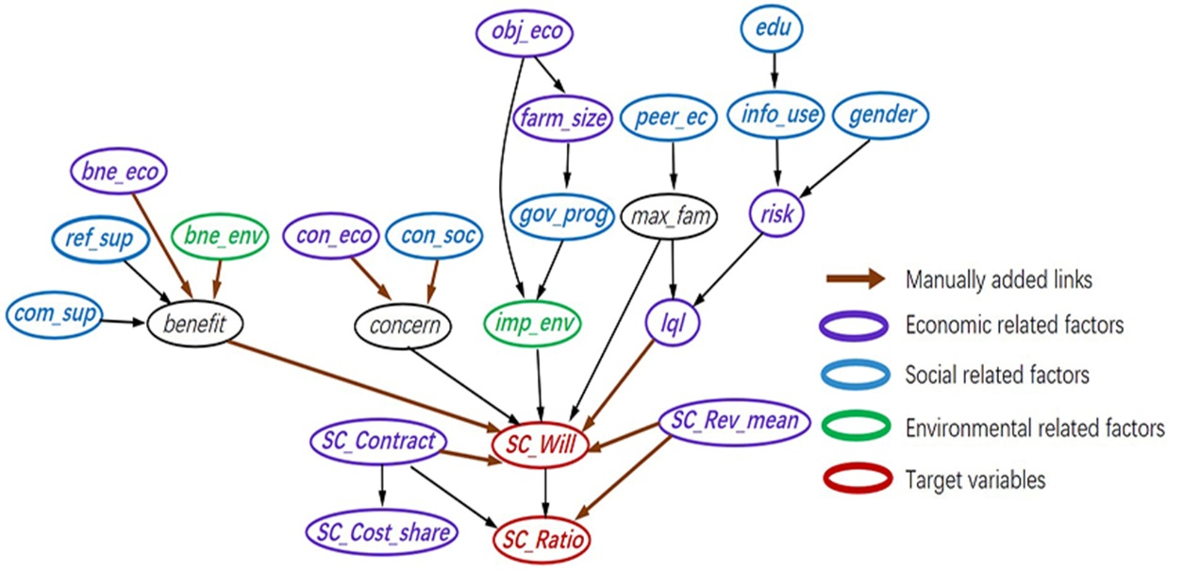
Figure 3. The Bayesian network structure learned from the survey data (referring to Table 1 for the full names of variables).
<Figure 3>
Several links in Figure 3 are manually enforced into the model based on common knowledge (marked by brown arrows.) Variables bne_eco (perceived economic benefit), bne_env (perceived environmental benefit), benefit (overall perceived benefit), con_eco (perceived economic concern), con_soc (perceived social concern), and concern (overall perceived concern) are all generated from farmers’ levels of agreement to a set of claims about the potential benefits and concerns related to perennial energy crops (Table S2 in the SI). The links between the above-mentioned benefit and concern related variables are thus manually enforced (Figure 3). The links from marginal land availability (lql), benefit, contract availability (SC_Contract), and expected average profit (SC_Rev_mean) to SC_Will, as well as the link from SC_Rev_Mean to SC_Ratio, are added based on literature reported relationships [14,15,18]. Part of the manually added links (bne_eco, bne_env, con_eco, and con_soc) in Figure 3 enable the quantitative comparison of the impacts of economic, environmental, and social factors in section 3.2, and other manually added links (benefit, lql, SC_Contract, and SC_Rev_mean) prove to be strong predictors of farmers’ perennial energy crop adoption (as detailed in section 3.2). The trained BN model has classification accuracies of 0.764 for SC_Will and 0.768 for SC_Ratio. The relatively high model accuracies further validate the BN structure and the manually added links in Figure 3.
Figure 3 shows a clear hierarchical structure. The influences of the various background information (e.g., education level and farm size) on farmers’ perennial energy crop adoption are mediated by their familiarities with perennial grass (max_fam), perceived importance of environment (imp_env), and marginal land availability (lql). Such a result is expected as the impact of background information on farmer adoption of agriculture innovations is usually found to be mediated by variables such as their knowledge or attitude toward the innovations [19]. The benefit and concern are two other intermediate variables that control the impacts of farmers’ specific attitudes toward perennial energy crops. In comparison, the impacts of market conditions (e.g., SC_Contract and SC_Rev_mean) are more direct without a mediating variable, suggesting the dominant role of the economic factors in controlling farmers’ decisions.
While most of the factors in Table 1 have been investigated in other studies, the causal-relationship structure in Figure 3 contributes to the literature by disentangling the complicated rationales of why certain factors potentially affect farmers’ decisions to adopt perennial energy crops. For example, neighbors’ land-uses (peer_ec, peer perennial grass adoption rate) have been identified as statistically significant predictors of farmer adoption decisions [53], but without explicit justification. Figure 3 suggests that peer_ec might have an impact through its influence on max_fam, farmers’ familiarity with perennial energy crops (the more neighbors growing perennial energy crops, the more likely the farmer is familiar with these crops).
Some new relationships can also be identified in Figure 3. For example, farmers sources of information (info_use, number of information sources) is a new variable investigated in this study. We find that it is influenced by farmer education level, and it also affects farmer willingness to adopt through the impact of their risk attitudes. Such results are as expected, given the common understanding that education affects people’s access to information sources, which further influences their risk attitudes [54–56]. Interestingly, we find that availability of marginal land (lql) is directly affected by max_fam. The result suggests that, once a farmer understands more about perennial grass (e.g., its relatively good performance on marginal land), they will be more likely to realize that they may have marginal land available for growing those grasses.
One disadvantage of the BN model over the traditional mixed logit regression model lies in the difficulty in interpreting the impact of specific variables. While such a task could be easily done by traditional regression models based on the variable’s regression coefficient, the impact of a variable on another in the BN model might be affected by the value(s) of a third (or even more) variable(s) (e.g., the impact of info_use on risk depends on the value of gender). In recognition of the above limitation, our choice of the BN model relies on its ability to disentangle the complex causal-relationship structure of farmer’s perennial energy crop adoption. Specifically, the BN model can potentially identify policy-relevant factors that traditional regression models might not be able to. For example, it is difficult to identify factors that improve farmer perception of marginal land availability, an important variable for energy crop adoption [57]. The causal-relationship structure in Figure 3 suggests that policymakers could potentially target peer_ec (e.g., through pilot projects and sharing) and info_use (e.g., through education program) for marginal land availability.
Meanwhile, the causal-relationship structure and the corresponding conditional distribution parameters identified by the BN model (Figure 3) could be used to generate hypotheses for understanding farmer decision-making processes and rationales. For example, a possible hypothesis can be: A farmer with more interactions with other farmers (e.g., neighbors) who grow perennial energy crops (peer_ec) would be more familiar with these crops (max_fam) and hence more willing to grow them (SC_Will). Another hypothesis is: Compared to male farmers, female farmers (gender) might be more risk-averse (risk) and thus perceive less marginal land availability (lql), which can finally lead to lower willingness to grow perennial bioenergy crops (SC_Will). However, it should be noted that the causal-relationship identified in Figure 3 only represents the most plausible structure among many possible ones given the information from survey data along with prior knowledge. More data available may end with a more reliable structure, and hence more reliable hypotheses.
  - Individual impacts of influencing factors
The marginal impact of a factor to changes in SC_Will and SC_Ratio is shown in Figure 4. Directions of impacts are identified based on the BN inferencing results in Figure S3 of the SI, which shows the perennial energy crop adoption probabilities under different factor states. The influencing factors are categorized as economic, social, and environmental factors, as defined in Figure 3. The other three variables (benefit, concern, and max_fam) that do not fall in the above categories are named as ‘aggregated’ variables (Figure 4). As mentioned in section 2.1, benefit represents farmers’ overall agreement with a series of claims about the advantages of perennial energy crops, including both economic and environmental aspects (Table S2 in the SI); concern represents their overall agreement with a series of claims about the limitations/disadvantages of these crops (Table S2 in the SI); finally, max_fam represents their maximum level of knowledge about any kind of perennial energy crop. A bootstrapping method [58] is applied to generate 1,000 realizations of the BN model based on resampling with replacement. The bootstrapping variances are used to calculate the error bars shown in Figure 4 and Figure S3 in the SI.
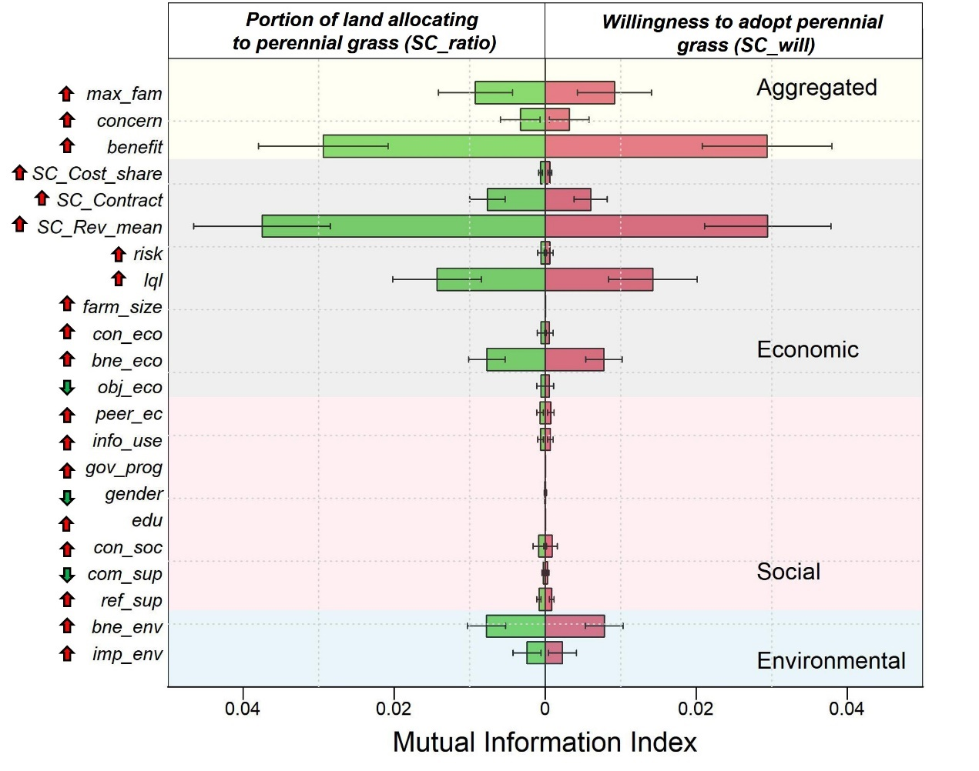
Figure 4. Individual impacts of economic, social, and environmental factors on farmers willingness to adopt perennial grass (SC_Will) and the portion of land they are willing to convert (SC_Ratio). Refer to Table 1 for the full names of variables; upward arrows indicate positive influence, and downward arrows indicate negative influence.
<Figure 4>
Results in Figure 4 suggest similar patterns for the impacts of influencing factors on SC_Will and SC_Ratio. The expected profit (SC_Rev_mean) appears to be the most critical factor for farmer adoption of perennial energy crops. When other factors held constant, the increase of SC_Rev_mean leads to a drastic increase in the perennial energy crop adoption probability (Figure S3 in the SI). Besides SC_Rev_mean, benefit (which combines economic and environmental information), lql, max_fam, bne_eco, bne_env, and SC_Contract also have considerable positive impacts on perennial energy crop adoption. In general, farmers’ decisions are mostly affected by economic factors (e.g., SC_Rev_mean, lql, and SC_Contract), but non-economic factors (e.g., bne_env, imp_env, and con_soc) also have considerable impacts.
Other studies also identified the dominant role of economic factors on farmer energy crop adoption, e.g., economic profit [59], availability of contract [60], availability of marginal land (lql) [61], and the existence of local market [62]. As summarized by a recent review [7], farmers place economic benefits as their primary concern in planting energy crops. While some surveys and interviews suggest strong impacts of social and environmental considerations on shaping farmers attitudes and adoptions of perennial energy crops [11,61], our result in Figure 4 shows that their impacts are not comparable with impacts of economic factors. Figure 4 also shows that farmers decisions are more affected by their positive perceptions of perennial energy crop (benefit) than by their negative perceptions (concern). Similar suggestions about the positive framing of bioenergy crops are also provided by Eaton et al. [11] and Helliwell [61]. It is therefore recommended that promotion and education plans targeting perennial energy crops should focus on the benefits, including both economic and environmental aspects of such crops [e.g., improvement of farm income and soil erosion (Figure S3 in the SI)].
  - Farmer types identified through survey responses
Following Skevas et al. [16], we cluster surveyed farmers into different groups based on their levels of agreement to 13 claims about energy crops (Table 2). We first use PCA to build four composite variables (principal components) representing ~60% of all the variances in the 13 claims. The first composite variable is named as ‘variable on environment’ (VEV), given the high loadings of environment-related claims (e.g., energy crop can improve water quality). The second composite variable, here referred to as ‘variable on uncertainty’ (VUC), has high loadings for claims relating to the uncertain nature of energy crops (e.g., concern about the lack of local market). The third composite variable has high loadings on profitability-related claims of energy crop, hence named as ‘variable on profit’ (VPF). Finally, the fourth composite variable is named as ‘variable on social support’ (VSS), as its constructing variables with high loading are relating to the support for perennial grass or biofuel from different social groups, including “Support for building new refinery”, “Community support”, and “Concern about changing traditional crop rotation”. Before the following analyses, the four composite variables are rotated to ensure that a larger value in these variables means a more positive attitude toward energy crops.
Table 2. Composite variables generated through PCA and their associated loadings
Claims about energy crops | Composite variables
Claims about energy crops | VEVª | VUC^{b} | VPF^{c} | VSS^{d}
Support for building new refinery | 0.186 | 0.135 | 0.278 | -0.455
Increase profit | 0.453 | -0.066 | 0.545 | -0.017
Increase reliability in poor weather | 0.578 | -0.343 | 0.423 | -0.033
Improve water quality | 0.807 | -0.338 | -0.223 | 0.149
Improve soil quality | 0.799 | -0.301 | -0.274 | 0.160
Improve national energy security | 0.783 | -0.067 | -0.164 | 0.286
Willing to convert flood/drought prone land | 0.575 | -0.138 | 0.000 | -0.486
Community support | 0.464 | -0.008 | 0.083 | -0.429
Concern about competition with other land-uses | 0.043 | 0.039 | 0.547 | 0.441
Concern about about signing contract | 0.441 | 0.667 | -0.242 | 0.241
Concern about lack of local market | 0.345 | 0.853 | 0.052 | -0.014
Concern about lack of knowledge about energy crops | 0.272 | 0.796 | 0.197 | -0.153
Concern about changing from traditional crop rotation | 0.080 | 0.105 | 0.362 | 0.469
Concern about not enough road network to support energy crop production and selling | 0.145 | 0.248 | -0.497 | 0.011
Notation: Values in black indicate the variables with absolute loading larger than 0.5;
ªVEV = variable on environment;
^{b}VUC = variable on uncertainty;
^{c}VPF = variable on profit;
^{d}VSS = variable on social support.
The four composite variables are used as inputs to the clustering algorithm k-means. K-means uses the within-group difference to identify the final number of groups. As shown in Figure S4, the within-group difference decreases quickly with more clusters but remains relatively stable after the fourth cluster. We then cluster farmers into four types (Table 3). Figure 5 shows each type of farmers’ average values of the four composite variables in Table 2, as well as two variables representing farmer willingness to grow perennial grass under two extreme scenarios (SC_will, and SC_will_max). The first willingness variable SC_will is identified under the scenario with no provision of contract and the lowest level of perennial energy crop profit, and is selected in Figure 5 to represent the farmers status-quo willingness. The second willingness variable SC_will_max is identified under the scenario with the provision of a long-term contract and the highest level of perennial energy crop profitability, and is selected to represent the sensitivity of different types of farmers to economic incentives. The average SC_will and SC_will_max values are estimated by the BN under a baseline financial scenario and a best-case scenario, respectively.
Table 3. Frequencies and characteristics of the four types of farmers
Farmer Type | Character | Count | Av. farm size (acre) | Av. grass adoption size from the survey (acre)
Type I | Farmers advocating environment | 94 (41.8%) | 884 | 23.9
Type II | Energy crop supporters | 49 (21.8%) | 1223 | 32.7
Type III | Farmers favoring profitability | 49 (21.8%) | 1372 | 16.1
Type IV | Energy crop skeptics | 33 (14.7%) | 958 | 9.7
Type I farmers are named as ‘Farmers advocating environment’ because of their distinctively high agreement with the environmental benefits (VEV) and low agreement with the profitability (VPF). Type II farmers are named as ‘energy crop supporters’, who show relatively high positive attitudes toward all four aspects of perennial energy crops as represented by the four composite variables in Table 2. Type III farmers are named ‘Farmers favoring profitability’ because of their distinctively high agreement with the profitability (VPF) and low agreement with the environmental benefits (VEV); Type IV farmers are named as ‘energy crop skeptics’ because of their low positive attitudes toward all the four aspects. Among the four types of farmers, Type I has the highest frequency in the survey samples (41.8%, Table 3), suggesting that most farmers agree about the environmental benefits of perennial energy crops but have a concern that these crops might not produce enough profits. Especially, given the fact that the market for cellulosic biomass is shrinking as existing cellulosic biorefineries have been shut down [63], a skeptical perception with perennial energy crops’ profitability might continue for some extended periods. Meanwhile, Type I ‘Farmers concerned about environmental benefits’ have the smallest average farm size (Table 3) among the four groups, suggesting that they are more likely owners of small farms.
Figure 5 shows the dominant role of economic concern on farmer perennial energy crop adoption. Type II farmers have the highest SC_Will level under the baseline scenario, followed by Type III farmers. Type I and Type IV farmers, who do not have as much positive attitudes toward the profitability of energy crops, have the lowest levels of SC_Will under the baseline scenario. The ranking of SC_Will_max varies over different farmer groups under the best-case scenario and is different from that under the baseline scenario. Type II farmers continue to have the highest level of SC_Will_max, followed by Type I and Type IV; Type III farmers turn out to have the lowest level of SC_Will_max, which suggests distinct sensitivities of different types of farmers to economic incentives. Importantly, we find all types of farmers have relatively negative attitudes toward the uncertainty associated with perennial energy crops and the social support for their adoption of such crops (as is shown by the low values of VUC and VSS in Figure 5). This implies that perennial energy crops are still considered risky land-use options, and farmers do not feel sufficient support from the government or community for them to deal with those risks.
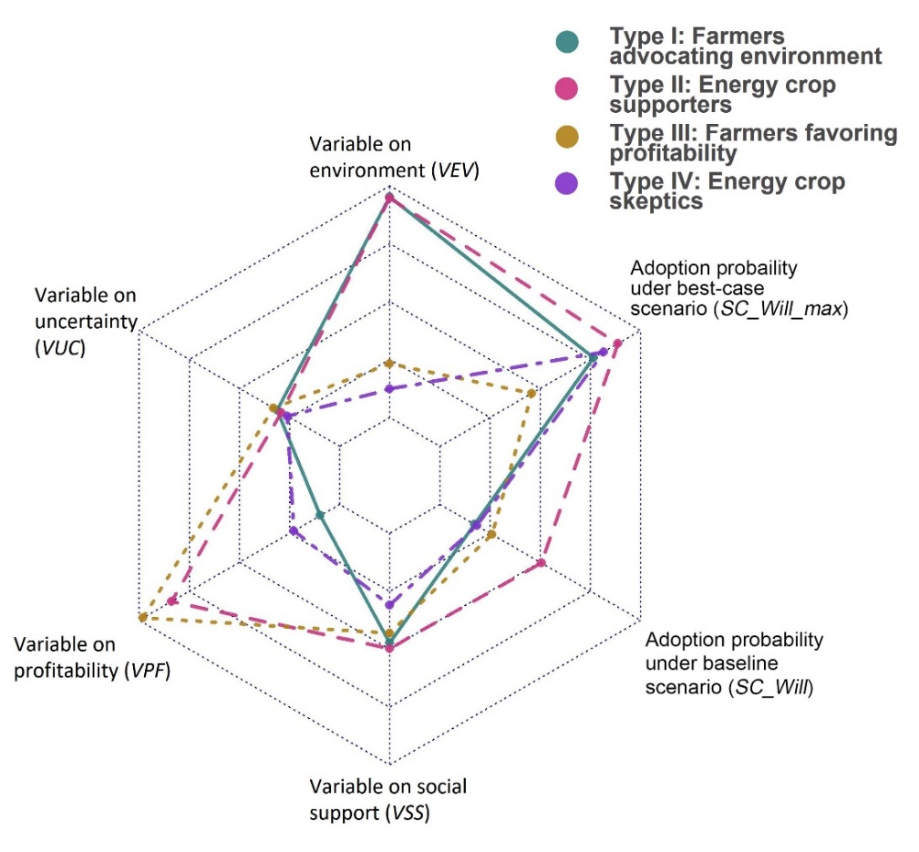
Figure 5. Radar plot of the four types of farmers identified through principle component analysis; value ranges for VEV, VUC, VPF, and VSS are 1-3, and the value ranges for SC_Will and SC_Will_max are 0-0.5.
<Figure 5>
The farmer typology confirms some previous findings. Skevas et al. [16] surveyed southern Michigan landowners for their attitude toward bioenergy and bioenergy crops and identified four types of farmers: i) ‘disamenity-sensitive’, ii) ‘profit-oriented’, iii) ‘bioenergy supporters’, and iv) ‘bioenergy skeptics’. Type II ‘energy crop supporters’ and Type IV ‘energy crop skeptics’ identified from our study agree with the ‘bioenergy supporters’ and ‘bioenergy skeptics’ types identified by Skevas et al. [16], respectively, representing the groups who are strongly positive or negative on renewable energy. The ‘profit-oriented’ farmers identified by Skevas et al. [16] are relatively positive about potential financial-related (e.g., insurance and length of contact) and agricultural-related (e.g., noise form agricultural activities and potential smell of refinery) concerns of renting out land for bioenergy crop production but are relatively neutral about the importance of renewable energy. Such ‘profit-oriented’ farmers show some similarity with our Type III ‘Farmers with profitability concerns’, who have a high agreement with the economic benefits of energy crop but a low agreement of environmental benefits of energy crop. Our analysis does not find a group of farmers that is similar to the ‘disamenity-sensitive’ type identified by Skevas et al. [16], who has concerns about the potential financial-related and agricultural-related factors of renting out land for bioenergy crop production, but is relatively neutral about the importance of renewable energy. The ‘Farmers concerned about environmental benefits’ type and its high frequency in our study also echo the result of Rossi and Hinrichs [64] that energy crops are pro-environmental land management options with higher risks and potentially lower profits. Similar types of farmers are also identified by Sutherland et al. [65] who surveyed Scottish farmers and Boon et al. [66] who surveyed Danish forest owners.
We further build four separate logit regression models to predict memberships for each of the four types of farmers. Independent variables in the logit regression models are identified as the socio-economic variables that could be estimated objectively (e.g., age and edu), in contrast to behavioral variables such as imp_env, the importance of environment. In this way, we can improve the reproducibility and reduce the difficulty of farmer type identification. We further test the statistical significance of the variable pairs that are connected in the BN model (e.g., gender and risk, Figure 3). If the pair of variables are significantly correlated (at the 0.05 significance level), the variable downstream of the causal-relationship diagram is removed from the logit regression model to avoid collinearity.
Table 4 shows the marginal effects of each background information factor on the probability of a farmer being classified as one of the four types I to IV, as well as their associated significance levels. The result suggests the ‘energy crop supporters’ are more likely to have larger farms, which might be explained by the impact of farm_size based on farmers experiences with government land conservation programs (gov_prog) and the perceived importance of environmental issues (imp_env) (see Figure 3).
The ‘energy crop supporters’ are also more likely male farmers, so do ‘Farmers favoring profitability’ (while the impact of gender for this type of farmer is not statistically significant). ‘Farmers advocating environment’, however, are likely to include more female farmers. Overall, the survey results show that male farmers are more likely to agree with the profitability of perennial energy crops while female farmers are more likely to agree with the environmental benefits. Gender has a mixed impact on farmers environmental behaviors. While males usually have more access to environmental education and knowledge [67], females have been identified to be more socially responsible and sensitive to environmental issues [68,69]. Our results suggest the latter mechanism might play a bigger role in farmers attitudes toward perennial energy crops and their environmental benefits.
Table 4. Logit regression models for predicting farmer type memberships
 | Farmers advocating environment | Energy crop supporters | Farmers favoring profitability | Energy crop skeptics
intercept | -0.176 | 0.200 | -2.193 | -1.834
info_use | -0.267 | -0.153 | 0.653*** | -0.162
crop_ins | -0.107 | -0.509 | 0.126 | 0.726
farm_size | -0.387** | 0.374* | -0.166 | 0.417
rent_ratio | 0.006 | 0.051 | 0.335 | -0.471*
peer_ec | -0.282* | 0.227 | 0.153 | 0.006
gender | 1.276** | -1.729* | -1.137 | 0.061
age | 0.163 | 0.057 | -0.284 | 0.182
edu | 0.147 | -0.112 | 0.360 | -0.577
farm_inc | -0.204 | 0.228 | -0.049 | 0.099
Notation: Values in black are statistically significant, * represent statistical significance at 0.1 level, ** at 0.05 level, and *** at 0.01 level; refer to Table 1 for the full names of variables.
In addition, farmers with smaller farms (farm_size) or fewer neighbors/friends adopting energy crops (peer_ec), are more likely to be ‘Farmers advocating environment’ who recognize the environmental benefits of perennial energy crops but have concerns about their profitability. The impact of farm sizes on farmer classification is consistent with our result in Table 3, which shows that ‘Farmers advocating environment’ are having the smallest average farm size among the four farmer groups. Some previous studies also find that farmers with conservation experiences and smaller farms are more likely to have positive environmental attitudes [70,71]. As per the impact of peer_ec, a farmer with more peers adopting perennial energy crops may be more familiar with these crops (max_fam, see the relationship between peer_ec and max_fam in Figure 3), and hence more likely to believe in the potential economic benefits. As a result, the farmer less likely belongs to ‘Farmers advocating environment’ (Table 4).
Farmers are more likely to be classified as ‘energy crop skeptics’ if they operate less rented land (rent_ratio). This contradicts the common assumption that farm ownership encourages positive attitudes toward agricultural innovations that could accrue benefits to land [72]. A possible explanation, as identified by Varble et al. [73], could be related to the different information sources used by farm owners and renters. As compared to farm owners, renters are more likely to seek information from government-supported conservation service centers [73]. Similarly, in our study, though not at a statistically significant level, ‘energy crop skeptics’ are using fewer sources of information for their land-use decisions (Table 4). However, we refrain from further analyzing the causes of such a contradiction, given our study’s limited scope.
Finally, farmers are more likely to be classified as ‘Farmers favoring profitability’ if they have more diversified information sources for land management (info_use). Our result thus suggests that the energy crop related information communicated via the various media might be mostly focused on the economic benefits rather than the environmental benefits of such crops.
  - Farmers’ heterogeneous responses to influencing factors
We then quantify the sensitivities of different types of farmers decisions to the various influencing factors through the mutual information index (section 2.2), as shown in Figure 6. Note that Figure 6 only shows the factors associated with statistically significant between-group differences in MI, resulting from the one-way ANOVA test [74] (with a significance level smaller than 0.1 in the F-test). A statistically significant factor for the MI index of SC_Will is not necessarily significant for the MI index of SC_Ratio (and vice versa). The result suggests that, among the statistically significant factors, farmer decisions are most sensitive to the expected profit (SC_Rev_mean), marginal land availability (lql), and perceived environmental benefits of perennial energy crops (bne_env).
Interestingly, we find that Type II and Type III farmers, who have relatively more positive attitudes toward perennial energy crop profitability, are less sensitive (as measured by the MI of SC_Will) to the changes of SC_Rev_mean. A possible explanation is that profitability is not a limiting factor for the two types of farmers (as they are already content with the profitability); instead, their willingness to adopt perennial energy crops is limited by their low perceived environmental benefits of these crops. This is supported by the relatively high sensitivities of these farmers (as measured by SC_Will) to the changes in bne_env.
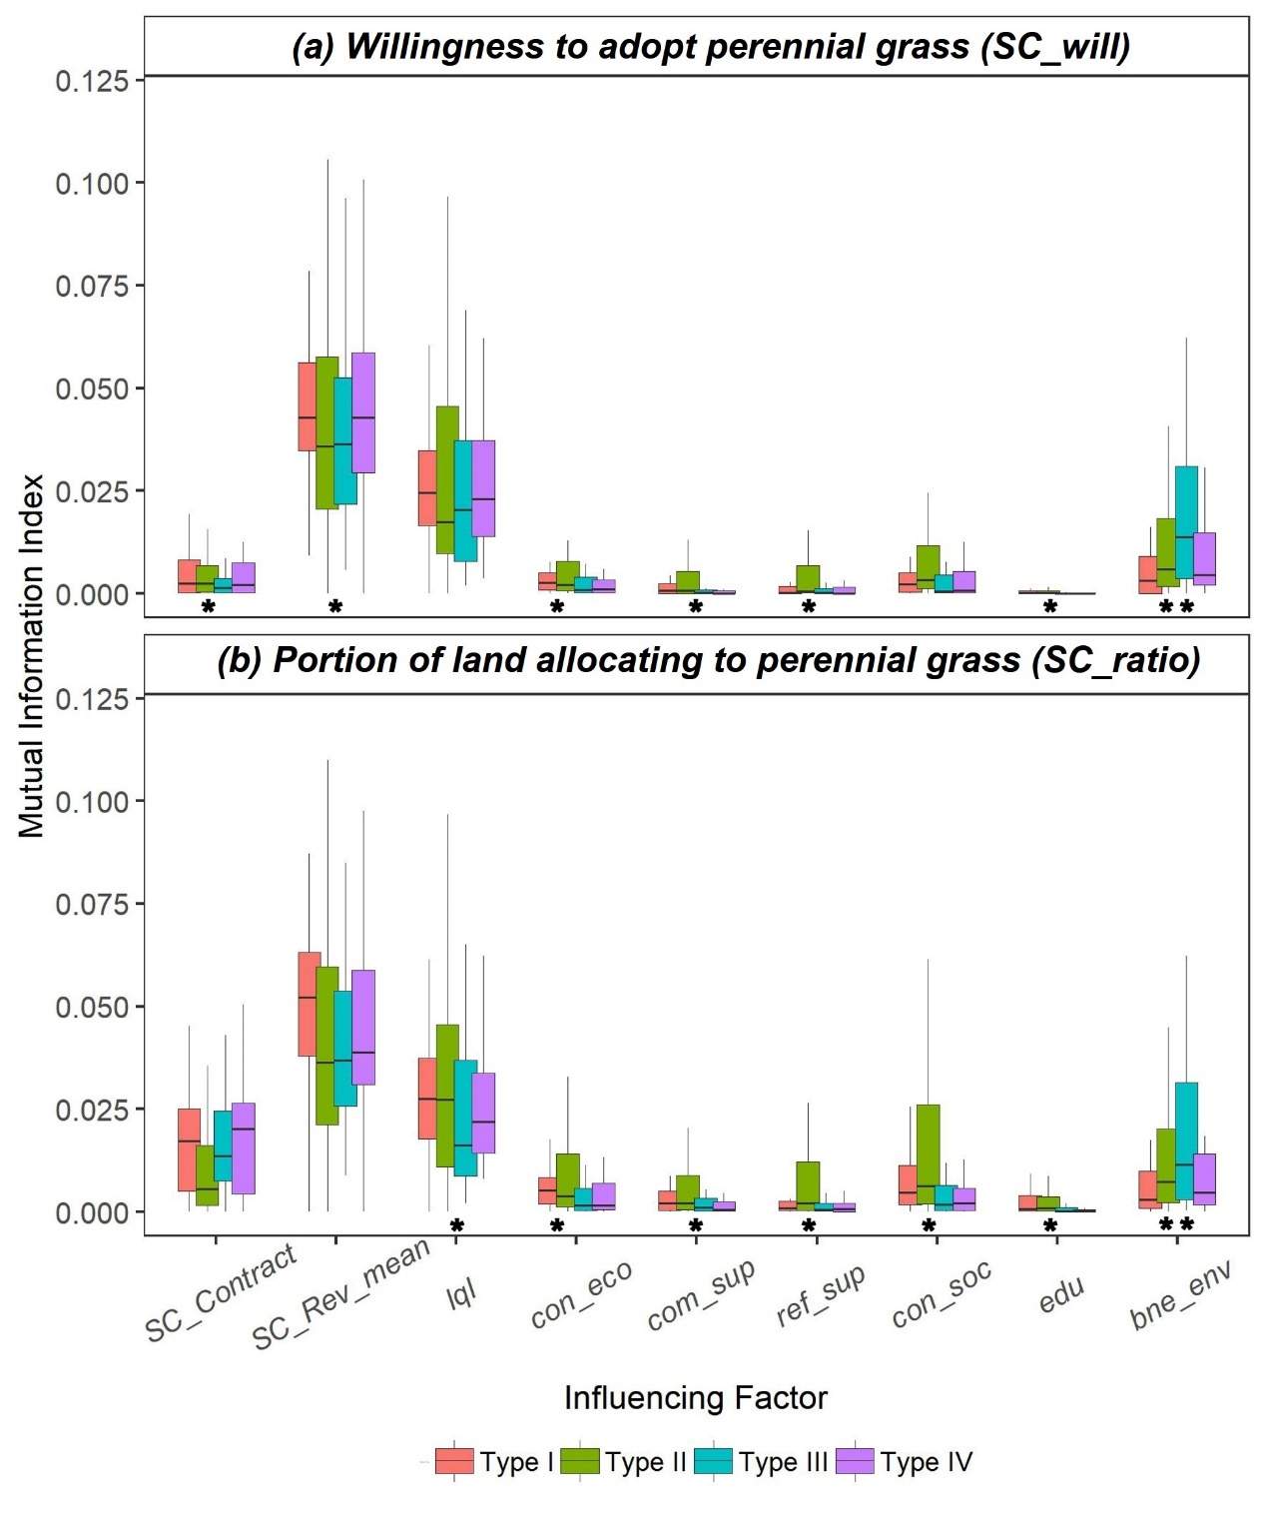
Figure 6. Average sensitivity of four types of farmers in (a) perennial grass adoption probability and (b) land conversion ratio to various influencing factors. One asteroid below the boxplot indicates the statistical significance at 0.1 level; two asteroids indicate the statistical significance at 0.05 level. Refer to Table 1 for the full names of the influencing factors.
<Figure 6>
As expected, for the farmers with more positive attitudes toward perennial energy crops’ environmental benefits (Type I and Type II), their land portions allocated for perennial energy crops (SC_Ratio) are more sensitive to marginal land availability (lql) than farmers of the other two types. Magnitudes of sensitivity for the other six statistically significant factors are smaller than SC_Rev_mean, lql, and bne_env; except for con_soc (expected social concern of perennial energy crop), which has the same level of sensitivity to bne_env for Type II farmers. This result indicates a potential to improve Type II farmer willingness by improving the social support for growing perennial energy crops, e.g., through non-government organizations and local agricultural outreach programs.
  - Policy Implications
The combined use of the BN model and the clustering technique enables more nuanced policy implications for promoting perennial grass among growers. Compared to traditional regression models such as mixed logit regression or probit model, the BN model is used to identify not only the important influencing factors such as lql (low quality land) but also the factors that directly or indirectly affect the influencing factors (e.g., max_fam and edu). Meanwhile, the clustering technique conducts farmer classification that enables more targeted policy designs for specific groups of farmers, given their distinct responses to different factors, as shown in Figure 6. Combination of the two approaches enables the identification of factors and target groups that a policymaker could effectively target.
More specifically, results in Figure 4 and Figure 6, suggest that the most effective policies for perennial energy crop adoption would be: i) to improve perennial energy crop profitability, ii) to target farmers with marginal lands, and iii) to develop more targeted education and outreach programs that reflect farmers’ heterogeneous behavior rules in perennial energy crop adoption.
Table 5. Average probabilities of perennial energy crop adoption by farmers (SC_Will) and average levels of adoption ratio (SC_Ratio) conditional on values of policy-relevant factors.
Variable | Level | SC_Will | SC_Ratio |  | Variable | Level | SC_Will | SC_Ratio
SC_Rev_mean | 1 | 0.100  (0.024) | 1.174  (0.048) |  | max_fam | 1 | 0.168  (0.031) | 1.337  (0.063)
SC_Rev_mean | 2 | 0.275  (0.032) | 1.596  (0.080) |  | max_fam | 2 | 0.230  (0.046) | 1.461  (0.094)
SC_Rev_mean | 3 | 0.342  (0.028) | 1.680  (0.066) |  | max_fam | 3 | 0.296  (0.022) | 1.600  (0.050)
lql | 1 | 0.164  (0.025 | 1.334  (0.052) |  | peer_ec | 1 | 0.250  (0.018) | 1.505  (0.041)
lql | 2 | 0.316  (0.025) | 1.634  (0.057) |  | peer_ec | 2 | 0.287  (0.020) | 1.581  (0.046)
lql | 3 | 0.278  (0.037) | 1.571  (0.081) |  | peer_ec | 3 | 0.283  (0.019) | 1.572  (0.045)
SC_Contract | 1 | 0.090  (0.024) | 1.175  (0.056) |  | info_use | 1 | 0.241  (0.018) | 1.486  (0.040)
SC_Contract | 2 | 0.272  (0.019) | 1.550  (0.043) |  | info_use | 2 | 0.271  (0.019) | 1.548  (0.043)
SC_Contract |  |  |  |  | info_use | 3 | 0.276  (0.019) | 1.557  (0.044)
Notation: Values in brackets denote the associated standard deviation of SC_Will and SC_Ratio. Refer to section 2.1 for full names of the influencing factors and their associated levels.
The cultivation of local markets with attractive biomass prices and possibly long-term contract availabilities would be helpful policy options to improve perennial energy crop profitability, especially given that Midwestern farmers are largely concerned about the uncertainties associated with these crops (Figure 5). Based on the BN model, farmer average willingness to adopt perennial energy crops would grow from 0.1 to 0.342 if the profitability level (the average profit of growing perennial grass) increases from the lowest to highest, and from 0.09 to 0.272 if a long-term contract is provided (Table 5). An attractive local market for biomass could be achieved through direct subsidies or tax credits for farmers growing perennial grasses, or through subsidies or tax credits for bioenergy and bioproduct industries that use cellulosic biomass as feedstock. For example, the cultivation of perennial grasses usually associates with high upfront costs in land preparation, seeding, etc., and the provision of establishment cost share subsidy could be used to help farmer overcome this financial difficulty and improve profitability of perennial grass [14]. Mandates such as renewable fuel standards (RFS) could also indirectly increase the profitability of perennial energy crops.
Growing perennial energy crops on marginal lands has been identified as an important potential solution to the ‘food v.s. fuel’ dilemma [2]. As is shown in Table 5, the availability of marginal land (lql level 2 or 3) would lead to at least an average increase of 0.114 in farmer willingness to grow perennial grass. Policies targeting farmers with marginal lands could include: i) direct subsidy for farmers with marginal lands [75], and ii) indirect policies for increasing marginal land availabilities (farmers’ perception of marginal land availability could be influenced by various factors, see a discussion in Yang et al. [57]). The former could be achieved by allowing bioenergy crops as viable options for existing government conservation programs [e.g., conservation reserve program (CRP) and best management practice (BMP) who pay subsidies to farmers with environmentally sensitive land for their adoption of conservative practices such as land retirement or cover crops], whose target lands partially overlap with marginal land [76]. As per the indirect policy, we find farmers’ familiarity with perennial energy crops could positively influence marginal land availability (see the impacts of max_fam in Figure 3 and Table 5). Therefore, education and outreach programs about perennial energy crops would be helpful policies. Experience sharing of farmers already planting perennial energy crops could be an especially effective measure given the direct impact of peer adoption ratio on familiarity (see the impacts of peer_ec in Figure 3 and Table 5). Policymakers can also consider diversifying the channels of perennial energy crop related information, which has been identified to influence farmers’ willingness to grow perennial grass through marginal land availability (see the impacts of info_use in Figure 3 and Table 5).
Refinement of the above policies based on farmer typology could further enhance farmers’ adoptions. More specifically, based on Figure 6, policies targeting ‘energy crop supporters’ (Type II) and ‘Farmers favoring profitability’ (Type III) could emphasize the improvement of farmer perceptions of perennial energy crop’s environmental benefits (e.g., through education and outreach programs), especially for Type II farmers with larger portions of marginal lands. Likewise, policies for ‘Farmers advocating environment’ (Type I) and ‘energy crop skeptics’ (Type IV) could emphasize perennial energy crop’s profitability (e.g., through subsidies), especially for Type I farmers with larger portions of marginal lands. In addition, our results suggest that factors related to the benefits of perennial energy crops have greater impacts than factors related to the limitations of those crops (Figure 4). Therefore, as suggested by Eaton et al. [11] and Helliwell [61], the communication with farmers should emphasize the positive framing (i.e., building a context with an overall focus on the potential gains) of perennial energy crops to encourage positive attitudes toward such crops.
3.6 Limitations
It should be noted that, given the currently limited perennial energy crop adoption, our survey takes an alternative approach to investigate farmer responses to various future financial scenarios (e.g., availability of contract and expected profit). Hence, our results and conclusions might be subject to the hypothetical bias [77] that respondents tend to overstate their willingness to adopt perennial energy crops. The lack of empirical data for farmers actually growing these crops also limits our ability to identify the magnitude of hypothetical bias [78]. Nevertheless, we do not anticipate the hypothetical bias to vary significantly across different farmers [79], and our conclusions about the relative importance of various influencing factors and the heterogeneities among the four types of farmer sensitivities to those factors should be valid.
Another potential source of bias in the survey is participation bias, i.e., certain groups of farmers are more willing or unwilling to respond to the survey [80]. In this study, we found that among the four types of farmers, Type I ‘Farmers advocating environment’ account for almost half of the participants. One may conjecture that ‘Farmers advocating environment’ are just more willing to respond to the survey. This participation bias could potentially lead to an underestimation of the total perennial energy crop adoption rate in the Midwestern US: Type I farmers are typically less willing to grow those crops under the baseline scenario as compared to Type II and Type III farmers (Figure 5). However, in theory, the BN structure, the four types of farmers, as well as the major characteristics of the four farmer types do not depend on the actual number of each type of farmer. Therefore, our major findings are less likely to be significantly changed due to the participation bias. The supporting or rejection of the participation bias requires additional comparisons of the statistics of both respondents and non-respondents [81], which will be conducted in a future study.
We also anticipate uncertainties in our results, given the relatively small sample size in our survey (225 effective survey responses). The uncertainties have been partly quantified through a bootstrapping approach. The result shown in the error bars in Figure 4 suggests our conclusions about the relative importance of various influencing factors are valid regardless of the uncertainty. Also because of the relatively small sample size and the uncertainty in survey responses, the BN model learned based on the MS-EM algorithm has to be manually modified based on expert knowledge, although such manually added links are validated by the BN model’s relatively high classification accuracies. Future research could be benefitted from additional sample sizes to reduce uncertainty. We also suggest future researchers combine BN and econometrics analysis [19,82] to further validate the BN links identified in this research.
In addition, the loosely coupled BN causal-relationship structure and farmer type classification could potentially be integrated in a tight form by treating the farmer type membership as a latent class variable in the BN model (see Masmoudi et al. [83] for an example). The tightly integrated BN model could provide an analysis mechanism on how different factors influence farmer type memberships; while how farmer typology potentially affects their perennial energy crop adoption decisions, by the mediating other intermediate variables, could also be revealed.
- Conclusions
This study develops a BN model to analyze the drivers of adoption of perennial energy crops based on survey data collected from Midwestern farmers. The impacts of the various factors that directly or indirectly affect farmer decision making are quantified through a set of mutual information (MI) indices in section 2.2. Furthermore, based on the survey data, we cluster Midwestern farmers into distinct types according to their attitudes toward the economic, social, and environmental aspects of perennial energy crops. Based on the causal-relationship structure identified from the BN model and the farmer classification, heterogeneous responses of the different types of farmers to various incentives are investigated.
The trained BN model shows good agreement with survey data. The causal-relationship structure identified from the BN model contributes to improved understandings of how a factor influences perennial energy crop adoption. For example, neighbors adoption of energy crops improve farmers familiarities with these crops, hence their likelihood of adoption. Among the investigated factors in this study, farmers decisions are mostly affected by economic-related factors such as profitability, but environmental and social related factors also have non-negligible impacts.
We identify four types of farmers based on the survey data. ‘Farmers advocating environment is the most common type (accounts for 41.8% of the surveyed farmers), and is characterized as farmers who mostly agree that energy crops provide environmental benefits rather than economic benefits. The result generally reflects the current status of perennial energy crops, i.e., they possess higher potential in environmental benefits over traditional food crops but lack the necessary profitability to attract massive adoption. We also identify statistically significant between-group differences among the four types of farmers in their sensitivities to different incentives. While certain types of farmers (‘energy crop supporters’ and ‘Farmers advocating environment’) are more sensitive to changes in profitability, others (‘energy crop supporters’ and ‘Farmers favoring profitability’) are more sensitive to changes in environmental factors.
The findings of this study have implications for the design of policies to induce adoption of perennial energy crops. Specifically, similar to other studies [14,18] we find that the availability of contract and local markets would be most beneficial. In addition, education and outreach programs that increase farmer understanding and influence their attitudes toward perennial energy crops can be helpful. The communication with farmers should emphasize the positive framing of perennial energy crops to encourage positive attitudes toward such crops. Farmer willingness to adopt could be further improved if more customed policies are available based on the farmer typology identified in this study.

Supporting Information
Supporting information include two tables (Tables S1-S2) and four figures (Figures S1-S4).
Acknowledgement
This work was funded by the DOE Center for Advanced Bioenergy and Bioproducts Innovation (U.S. Department of Energy, Office of Science, Office of Biological and Environmental Research under Award Number DE-SC0018420). Any opinions, findings, and conclusions or recommendations expressed in this publication are those of the author(s) and do not necessarily reflect the views of the U.S. Department of Energy. Brenna Ellison led the survey designing and implementation; Ximin Piao processed part of the survey data. We thank the two anonymous reviewers for their comments, which have been crucial in improving this paper.

References
[1] Z. Qin, J.B. Dunn, H. Kwon, S. Mueller, M.M. Wander, Soil carbon sequestration and land use change associated with biofuel production: empirical evidence, Glob. Chang. Biol. Bioenergy. 8 (2016) 66–80. https://doi.org/https://doi.org/10.1111/gcbb.12237.
[2] G.P. Robertson, S.K. Hamilton, B.L. Barham, B.E. Dale, R.C. Izaurralde, R.D. Jackson, D.A. Landis, S.M. Swinton, K.D. Thelen, J.M. Tiedje, Cellulosic biofuel contributions to a sustainable energy future: Choices and outcomes, Science (80-. ). 356 (2017) eaal2324. https://doi.org/10.1126/science.aal2324.
[3] L.R. Lynd, The grand challenge of cellulosic biofuels, Nat. Biotechnol. 35 (2017) 912. https://doi.org/https://doi.org/10.1038/nbt.3976.
[4] B.P. Werling, T.L. Dickson, R. Isaacs, H. Gaines, C. Gratton, K.L. Gross, H. Liere, C.M. Malmstrom, T.D. Meehan, L. Ruan, B.A. Robertson, G.P. Robertson, T.M. Schmidt, A.C. Schrotenboer, T.K. Teal, J.K. Wilson, D.A. Landis, Perennial grasslands enhance biodiversity and multiple ecosystem services in bioenergy landscapes, Proc. Natl. Acad. Sci. U. S. A. 111 (2014) 1652–1657. https://doi.org/10.1073/pnas.1309492111.
[5] R.D. Schnepf, B.D. Yacobucci, Renewable fuel standard (RFS): overview and issues, Congressional Research Service Washington, DC, 2010.
[6] U. EPA, Final Renewable Fuel Standards for 2020, and the Biomass-Based Diesel Volume for 2021, (2020). https://www.epa.gov/renewable-fuel-standard-program/final-renewable-fuel-standards-2020-and-biomass-based-diesel-volume (accessed September 24, 2020).
[7] C. Leibensperger, P. Yang, Q. Zhao, S. Wei, X. Cai, The Synergy Between Stakeholders for Cellulosic Biofuel Development—Perspectives, Opportunities, and Barriers, Renew. Sustain. Energy Rev. 137 (2020) 110613. https://doi.org/10.1016/j.rser.2020.110613.
[8] M. Anand, R. Miao, M. Khanna, Adopting bioenergy crops: Does farmers’ attitude toward loss matter?, Agric. Econ. 50 (2019) 435–450. https://doi.org/10.1111/agec.12501.
[9] R. Miao, M. Khanna, Effectiveness of the biomass crop assistance program: Roles of behavioral factors, credit constraint, and program design, Appl. Econ. Perspect. Policy. 39 (2017) 584–608. https://doi.org/https://doi.org/10.1093/aepp/ppx031.
[10] G. Bocqueho, F. Jacquet, The adoption of switchgrass and miscanthus by farmers: Impact of liquidity constraints and risk preferences, Energy Policy. 38 (2010) 2598–2607. https://doi.org/https://doi.org/10.1016/j.enpol.2010.01.005.
[11] W.M. Eaton, M. Burnham, K. Running, C.C. Hinrichs, T. Selfa, Symbolic meanings, landowner support, and dedicated bioenergy crops in the rural northeastern United States, Energy Res. Soc. Sci. 52 (2019) 247–257. https://doi.org/https://doi.org/10.1016/j.erss.2019.02.005.
[12] P. Burli, P. Lal, B. Wolde, S. Jose, S. Bardhan, Factors affecting willingness to cultivate switchgrass: Evidence from a farmer survey in Missouri, Energy Econ. 80 (2019) 20–29. https://doi.org/https://doi.org/10.1016/j.eneco.2018.12.009.
[13] J.S. Bergtold, A. Shanoyan, J.E. Fewell, J.R. Williams, Annual bioenergy crops for biofuels production: Farmers’ contractual preferences for producing sweet sorghum, Energy. (2017). https://doi.org/10.1016/j.energy.2016.11.032.
[14] M. Khanna, J. Louviere, X. Yang, Motivations to grow energy crops: the role of crop and contract attributes, Agric. Econ. 48 (2017) 263–277. https://doi.org/10.1111/agec.12332.
[15] T. Skevas, N.J. Hayden, S.M. Swinton, F. Lupi, Landowner willingness to supply marginal land for bioenergy production, Land Use Policy. 50 (2016) 507–517. https://doi.org/10.1016/j.landusepol.2015.09.027.
[16] T. Skevas, S.M. Swinton, N.J. Hayden, What type of landowner would supply marginal land for energy crops?, Biomass and Bioenergy. 67 (2014) 252–259. https://doi.org/10.1016/j.biombioe.2014.05.011.
[17] K. Jensen, C.D. Clark, P. Ellis, B. English, J. Menard, M. Walsh, D. de la Torre Ugarte, Farmer willingness to grow switchgrass for energy production, Biomass and Bioenergy. 31 (2007) 773–781. https://doi.org/10.1016/j.biombioe.2007.04.002.
[18] J.E. Fewell, J.S. Bergtold, J.R. Williams, Farmers’ willingness to contract switchgrass as a cellulosic bioenergy crop in Kansas, Energy Econ. 55 (2016) 292–302. https://doi.org/10.1016/j.eneco.2016.01.015.
[19] D. Lee, J.G. Arbuckle, Z. Zhu, L. Nowatzke, Conditional Causal Mediation Analysis of Factors Associated With Cover Crop Adoption in Iowa, USA, Water Resour. Res. 54 (2018) 9566–9584. https://doi.org/10.1029/2017WR022385.
[20] M. Moglia, K.S. Alexander, M. Thephavanh, P. Thammavong, V. Sodahak, B. Khounsy, S. Vorlasan, S. Larson, J. Connell, P. Case, A Bayesian network model to explore practice change by smallholder rice farmers in Lao PDR, Agric. Syst. 164 (2018) 84–94. https://doi.org/10.1016/j.agsy.2018.04.004.
[21] B.B. Walters, Explaining rural land use change and reforestation: A causal-historical approach, Land Use Policy. 67 (2017) 608–624. https://doi.org/https://doi.org/10.1016/j.landusepol.2017.07.008.
[22] R.A. Efroymson, K.L. Kline, A. Angelsen, P.H. Verburg, V.H. Dale, J.W.A. Langeveld, A. McBride, A causal analysis framework for land-use change and the potential role of bioenergy policy, Land Use Policy. 59 (2016) 516–527. https://doi.org/https://doi.org/10.1016/j.landusepol.2016.09.009.
[23] J.-M. Becker, C.M. Ringle, M. Sarstedt, F. Völckner, How collinearity affects mixture regression results, Mark. Lett. 26 (2015) 643–659.
[24] R. Johnston, K. Jones, D. Manley, Confounding and collinearity in regression analysis: a cautionary tale and an alternative procedure, illustrated by studies of British voting behaviour, Qual. Quant. 52 (2018) 1957–1976.
[25] E.D. Berkhout, R.A. Schipper, H. Van Keulen, O. Coulibaly, Heterogeneity in farmers’ production decisions and its impact on soil nutrient use: Results and implications from northern Nigeria, Agric. Syst. 104 (2011) 63–74. https://doi.org/https://doi.org/10.1016/j.agsy.2010.09.006.
[26] E. Karali, B. Brunner, R. Doherty, A.M. Hersperger, M.D.A. Rounsevell, The effect of farmer attitudes and objectives on the heterogeneity of farm attributes and management in Switzerland, Hum. Ecol. 41 (2013) 915–926. https://doi.org/https://doi.org/10.1007/s10745-013-9612-x.
[27] L.D.F. Saint-Cyr, H. Storm, T. Heckelei, L. Piet, Heterogeneous impacts of neighbouring farm size on the decision to exit: evidence from Brittany, Eur. Rev. Agric. Econ. 46 (2019) 237–266. https://doi.org/https://doi.org/10.1093/erae/jby029.
[28] D. Valbuena, P.H. Verburg, A.K. Bregt, A method to define a typology for agent-based analysis in regional land-use research, Agric. Ecosyst. Environ. 128 (2008) 27–36. https://doi.org/https://doi.org/10.1016/j.agee.2008.04.015.
[29] S. Venghaus, L. Acosta, To produce or not to produce: an analysis of bioenergy and crop production decisions based on farmer typologies in Brandenburg, Germany, Reg. Environ. Chang. 18 (2018) 521–532. https://doi.org/https://doi.org/10.1007/s10113-017-1226-1.
[30] M.H. Langholtz, B.J. Stokes, L.M. Eaton, 2016 Billion-ton report: Advancing domestic resources for a thriving bioeconomy, Volume 1: Economic availability of feedstock, Oak Ridge Natl. Lab. Oak Ridge, Tennessee, Manag. by UT-Battelle, LLC US Dep. Energy. 2016 (2016) 1–411.
[31] R. Miao, M. Khanna, Costs of meeting a cellulosic biofuel mandate with perennial energy crops: Implications for policy, Energy Econ. 64 (2017) 321–334. https://doi.org/https://doi.org/10.1016/j.eneco.2017.03.018.
[32] W. Jiang, K.Y. Zipp, M.H. Langholtz, M.G. Jacobson, Modeling spatial dependence and economic hotspots in landowners’ willingness to supply bioenergy crops in the northeastern United States, Glob. Chang. Biol. Bioenergy. 11 (2019) 1086–1097. https://doi.org/https://doi.org/10.1111/gcbb.12617.
[33] F. Daily, Expected Corn versus Soybean Returns in 2019, (2019). https://farmdocdaily.illinois.edu/2019/02/expected-corn-versus-soybean-returns-in-2019.html (accessed September 26, 2020).
[34] R.F. Gunst, R.L. Mason, Fractional factorial design, Wiley Interdiscip. Rev. Comput. Stat. 1 (2009) 234–244. https://doi.org/https://doi.org/10.1002/wics.27.
[35] Farm Market ID, (2020). https://www.farmmarketid.com/ (accessed October 3, 2020).
[36] M. Singh, Learning Bayesian networks from incomplete data, in: AAAI/IAAI, Citeseer, 1997: pp. 534–539.
[37] T. Koski, J. Noble, Bayesian networks: an introduction, John Wiley & Sons, 2011.
[38] A.P. Dempster, N.M. Laird, D.B. Rubin, Maximum likelihood from incomplete data via the EM algorithm, J. R. Stat. Soc. Ser. B. 39 (1977) 1–22.
[39] Z. Sun, D. Müller, A framework for modeling payments for ecosystem services with agent-based models, Bayesian belief networks and opinion dynamics models, Environ. Model. Softw. 45 (2013) 15–28. https://doi.org/10.1016/j.envsoft.2012.06.007.
[40] P. Poppenborg, T. Koellner, A Bayesian network approach to model farmers’ crop choice using socio-psychological measurements of expected benefits of ecosystem services, Environ. Model. Softw. 57 (2014) 227–234. https://doi.org/10.1016/j.envsoft.2014.03.006.
[41] M. Keshavarz, E. Karami, Farmers’ pro-environmental behavior under drought: Application of protection motivation theory, J. Arid Environ. 127 (2016) 128–136. https://doi.org/10.1016/j.jaridenv.2015.11.010.
[42] N. Friedman, Learning Belief Networks in the Presence of Missing Values and Hidden Variables, in: Fourteenth Inter. Conf. Mach. Learn., 1997: pp. 125–133.
[43] G. Schwarz, Estimating the Dimension of a Model, Ann. Stat. 6 (1978) 461–464. https://doi.org/10.1214/aos/1176344136.
[44] W. Shao, K. Feng, N. Lin, Predicting support for flood mitigation based on flood insurance purchase behavior, Environ. Res. Lett. 14 (2019) 54014. https://doi.org/https://doi.org/10.1088/1748-9326/ab195a.
[45] R. Squillante, D.J. Santos Fo, N. Maruyama, F. Junqueira, L.A. Moscato, F.Y. Nakamoto, P.E. Miyagi, J. Okamoto, Modeling accident scenarios from databases with missing data: A probabilistic approach for safety-related systems design, Saf. Sci. 104 (2018) 119–134. https://doi.org/10.1016/j.ssci.2018.01.001.
[46] T.T. Wong, Performance evaluation of classification algorithms by k-fold and leave-one-out cross validation, Pattern Recognit. 48 (2015) 2839–2846. https://doi.org/10.1016/j.patcog.2015.03.009.
[47] D.N. Barton, T. Saloranta, S.J. Moe, H.O. Eggestad, S. Kuikka, Bayesian belief networks as a meta-modelling tool in integrated river basin management - Pros and cons in evaluating nutrient abatement decisions under uncertainty in a Norwegian river basin, Ecol. Econ. 66 (2008) 91–104. https://doi.org/10.1016/j.ecolecon.2008.02.012.
[48] M. Scutari, Learning Bayesian networks with the bnlearn R package, ArXiv Prepr. ArXiv0908.3817. (2009).
[49] I.T. Jolliffe, Principal component analysis, Springer New York, NY, 2002. https://doi.org/https://doi.org/10.1007/b98835.
[50] J.A. Hartigan, M.A. Wong, Algorithm AS 136: A k-means clustering algorithm, J. R. Stat. Soc. Ser. c (Applied Stat. 28 (1979) 100–108. https://doi.org/https://doi.org/10.2307/2346830.
[51] D.J. Ketchen, C.L. Shook, The application of cluster analysis in strategic management research: an analysis and critique, Strateg. Manag. J. 17 (1996) 441–458. https://doi.org/https://doi.org/10.1002/(SICI)1097-0266(199606)17:6<441::AID-SMJ819>3.0.CO;2-G.
[52] D. Martin, Early warning of bank failure: A logit regression approach, J. Bank. Financ. 1 (1977) 249–276. https://doi.org/https://doi.org/10.1016/0378-4266(77)90022-X.
[53] M.T. Konrad, G. Levin, M. Termansen, Landowners’ motivation for adopting perennial energy crops: drivers, barriers and neighbourhood effects, Eur. Rev. Agric. Econ. 45 (2018) 809–829. https://doi.org/https://doi.org/10.1093/erae/jby015.
[54] M. Yaseen, S. Xu, W. Yu, S. Hassan, Farmers’ access to agricultural information sources: evidences from rural Pakistan, J. Agric. Chem. Environ. 5 (2016) 12–19. https://doi.org/10.4236/jacen.2016.51B003.
[55] R. Ullah, G.P. Shivakoti, G. Ali, Factors effecting farmers’ risk attitude and risk perceptions: the case of Khyber Pakhtunkhwa, Pakistan, Int. J. Disaster Risk Reduct. 13 (2015) 151–157. https://doi.org/https://doi.org/10.1016/j.ijdrr.2015.05.005.
[56] S. Fahad, J. Wang, A.A. Khan, A. Ullah, U. Ali, M.S. Hossain, S.U. Khan, N.T.L. Huong, X. Yang, G. Hu, Evaluation of farmers’ attitude and perception toward production risk: Lessons from Khyber Pakhtunkhwa Province, Pakistan, Hum. Ecol. Risk Assess. An Int. J. 24 (2018) 1710–1722. https://doi.org/https://doi.org/10.1080/10807039.2018.1460799.
[57] P. Yang, X. Cai, M. Khanna, Farmers’ heterogeneous perceptions of marginal land for biofuel crops in US Midwestern states considering biophysical and socioeconomic factors, GCB Bioenergy. 13 (2021) 849–861.
[58] D.A. Freedman, Bootstrapping regression models, Ann. Stat. 9 (1981) 1218–1228.
[59] C.A. Augustenborg, J. Finnan, L. Mcbennett, V. Connolly, U. Priegnitz, C. Müller, Farmers’ perspectives for the development of a bioenergy industry in Ireland, Glob. Chang. Biol. Bioenergy. 4 (2012) 597–610. https://doi.org/10.1111/j.1757-1707.2011.01151.x.
[60] J.S. Bergtold, J. Fewell, J. Williams, Farmers’ Willingness to Produce Alternative Cellulosic Biofuel Feedstocks Under Contract in Kansas Using Stated Choice Experiments, Bioenergy Res. 7 (2014) 876–884. https://doi.org/10.1007/s12155-014-9425-9.
[61] R. Helliwell, Where did the marginal land go? Farmers perspectives on marginal land and its implications for adoption of dedicated energy crops, Energy Policy. 117 (2018) 166–172. https://doi.org/10.1016/j.enpol.2018.03.011.
[62] C.M. Mattia, S.T. Lovell, A. Davis, Identifying barriers and motivators for adoption of multifunctional perennial cropping systems by landowners in the Upper Sangamon River Watershed, Illinois, Agrofor. Syst. 92 (2018) 1155–1169. https://doi.org/10.1007/s10457-016-0053-6.
[63] S. Farming, DuPont closes Iowa cellulosic ethanol facility, puts plant up for sale, (2017). https://www.agriculture.com/news/business/dupont-is-selling-iowa-cellulosic-ethanol-facility (accessed November 4, 2020).
[64] A.M. Rossi, C.C. Hinrichs, Hope and skepticism: Farmer and local community views on the socio-economic benefits of agricultural bioenergy, Biomass and Bioenergy. 35 (2011) 1418–1428. https://doi.org/https://doi.org/10.1016/j.biombioe.2010.08.036.
[65] L.-A. Sutherland, A. Barnes, G. McCrum, K. Blackstock, L. Toma, Towards a cross-sectoral analysis of land use decision-making in Scotland, Landsc. Urban Plan. 100 (2011) 1–10.
[66] T.E. Boon, H. Meilby, B.J. Thorsen, An empirically based typology of private forest owners in Denmark: improving communication between authorities and owners, Scand. J. For. Res. 19 (2004) 45–55.
[67] D.B. Tindall, S. Davies, Cé. MauboulÈs, Activism and conservation behavior in an environmental movement: The contradictory effects of gender, Soc. Nat. Resour. 16 (2003) 909–932. https://doi.org/10.1080/716100620.
[68] G.I. Orderud, R.D. Vogt, Environmental values and attitudes among farmers in China – a case study in the watershed of Yuqiao reservoir of Tianjin Municipality, China, Int. J. Environ. Stud. 73 (2016) 917–938. https://doi.org/https://doi.org/10.1080/00207233.2016.1220699.
[69] E. Karami, A. Mansoorabadi, Sustainable agricultural attitudes and behaviors: A gender analysis of Iranian farmers, Environ. Dev. Sustain. 10 (2008) 883–898. https://doi.org/10.1007/s10668-007-9090-7.
[70] R.S. Wilson, G. Howard, E.A. Burnett, Improving nutrient management practices in agriculture: The role of risk-based beliefs in understanding farmers’ attitudes toward taking additional action, Water Resour. Res. 50 (2014) 6735–6746. https://doi.org/10.1002/2013WR015200.
[71] V. Hammes, M. Eggers, J. Isselstein, M. Kayser, The attitude of grassland farmers towards nature conservation and agri-environment measures - A survey-based analysis, Land Use Policy. 59 (2016) 528–535. https://doi.org/10.1016/j.landusepol.2016.09.023.
[72] J. Fernandez-Cornejo, A. Mishra, R. Nehring, C. Hendricks, M. Southern, A. Gregory, Off-farm income, technology adoption, and farm economic performance, 2010.
[73] S. Varble, S. Secchi, C.G. Druschke, An examination of growing trends in land tenure and conservation practice adoption: Results from a farmer survey in Iowa, Environ. Manage. 57 (2016) 318–330. https://doi.org/10.1007/s00267-015-0619-5.
[74] R.M. Heiberger, E. Neuwirth, One-way anova, in: R through Excel, Springer, 2009: pp. 165–191.
[75] B.P.J. Andrée, V. Diogo, E. Koomen, Efficiency of second-generation biofuel crop subsidy schemes: Spatial heterogeneity and policy design, Renew. Sustain. Energy Rev. 67 (2017) 848–862.
[76] M. Khanna, L. Chen, B. Basso, X. Cai, J.L. Field, K. Guan, C. Jiang, T.J. Lark, T.L. Richard, S.A. Spawn‐Lee, Redefining marginal land for bioenergy crop production, GCB Bioenergy. (2021).
[77] J.J. Murphy, P.G. Allen, T.H. Stevens, D. Weatherhead, A meta-analysis of hypothetical bias in stated preference valuation, Environ. Resour. Econ. 30 (2005) 313–325. https://doi.org/https://doi.org/10.1007/s10640-004-3332-z.
[78] D.A. Hensher, Hypothetical bias, choice experiments and willingness to pay, Transp. Res. Part B Methodol. 44 (2010) 735–752. https://doi.org/https://doi.org/10.1016/j.trb.2009.12.012.
[79] S. Fifer, J. Rose, S. Greaves, Hypothetical bias in Stated Choice Experiments: Is it a problem? And if so, how do we deal with it?, Transp. Res. Part A Policy Pract. 61 (2014) 164–177. https://doi.org/https://doi.org/10.1016/j.tra.2013.12.010.
[80] L. Bickman, D.J. Rog, The SAGE handbook of applied social research methods, Sage publications, 2008. doi: https://dx.doi.org/10.4135/9781483348858.
[81] B.M. Hill, A. Shaw, The Wikipedia gender gap revisited: Characterizing survey response bias with propensity score estimation, PLoS One. 8 (2013) e65782. https://doi.org/https://doi.org/10.1371/journal.pone.0065782.
[82] D.L. Dowe, MML, hybrid Bayesian network graphical models, statistical consistency, invariance and uniqueness, in: Philos. Stat., Elsevier, 2011: pp. 901–982. https://doi.org/https://doi.org/10.1016/B978-0-444-51862-0.50030-7.
[83] K. Masmoudi, L. Abid, A. Masmoudi, Credit risk modeling using Bayesian network with a latent variable, Expert Syst. Appl. 127 (2019) 157–166.

Figure Captions

Figure 1. Flow chart for identifying Midwestern farmers’ heterogeneous rule of perennial energy crop adoption
Figure 2. An example of the scenario-based question
Figure 3. The Bayesian network structure learned from the survey data (referring to Table 1 for the full names of variables).
Figure 4. Individual impacts of economic, social, and environmental factors on farmers willingness to adopt perennial grass (SC_Will) and the portion of land they are willing to convert (SC_Ratio). Refer to Table 1 for the full names of variables; upward arrows indicate positive influence, and downward arrows indicate negative influence.
Figure 5. Radar plot of the four types of farmers identified through principle component analysis; value ranges for VEV, VUC, VPF, and VSS are 1-3, and the value ranges for SC_Will and SC_Will_max are 0-0.5.
Figure 6. Average sensitivity of four types of farmers in (a) perennial grass adoption probability and (b) land conversion ratio to various influencing factors. One asteroid below the boxplot indicates the statistical significance at 0.1 level; two asteroids indicate the statistical significance at 0.05 level. Refer to Table 1 for the full names of the influencing factors.

