Deformation of pores in response to uniaxial and hydrostatic stress cycling in Marcellus Shale: Implications for gas recovery

Tomasz Blachª, Andrzej P. Radlinskiª, Phung Vuª, Yeping Jiª, Liliana de Campo^{b}, Elliot P. Gilbert^{b}, Klaus Regenauer-Lieb^{a,c}, and Maria Mastalerz^{d}

ªSchool of Minerals and Energy Resource Engineering, Kensington, University of New South Wales, Sydney, NSW 2052, Australia
^{b}Australian Centre for Neutron Scattering, Australian Nuclear Science and Technology Organisation, New Illawarra Road, Lucas Heights, NSW 2232, Australia
^{c}WA School of Mines, Minerals, Energy and Chemical Engineering, Curtin University, Bentley 6102, WA, Australia
^{d}Indiana Geological and Water Survey, Indiana University, Bloomington, IN 47405-2208, USA

Graphical abstract:
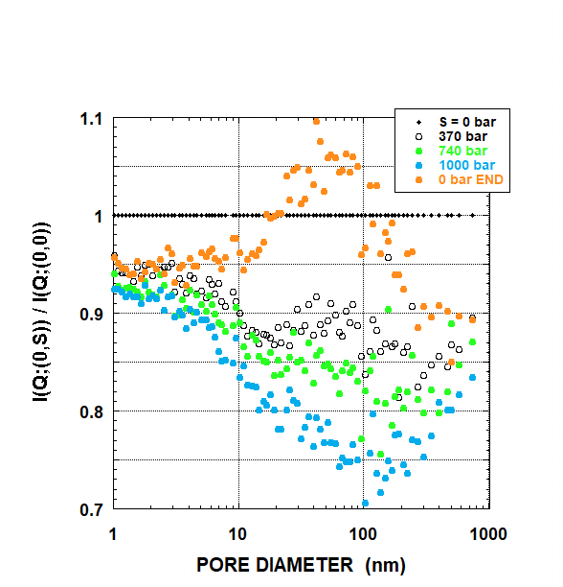
Abstract
One of the main challenges during gas production from shale reservoirs is low recovery rate. One contributing factor to this outcome is an insufficient understanding of pore systems, especially pore behaviour following changes in reservoir conditions or resulting from gas production practices. Because the pressure in the producing well can be controlled, understanding the effects of pressure variation on the pore size distribution and methane trapping is necessary to help design optimal conditions to improve the gas recovery rate. This work is the first systematic study of sub-millimeter pore deformation in shale caused by uniaxial and hydrostatic stress up to 100 MPa. Overmature samples from the Middle Devonian Marcellus Shale were analyzed using neutron scattering (SANS and USANS) techniques to interpret the response of nanopores to stress cycling of magnitude and duration compatible with the hydraulic fracturing treatments. Experiments reported here are performed at a series of uniaxial pressures up to 100 MPa and at hydrostatic pressures of deuterated methane 0 and 50 MPa. Since at the original depth of the shale samples’ burial of 2184 m the hydrostatic pressure is approximately 27 MPa and the lithostatic pressure is about 55 MPa, the experimental conditions reasonably well simulate the reservoir pressure regime.
Our SANS and USANS results show that different pore sizes are affected by uniaxial stress in different ways. Specifically, in the pore size range from 1 nm to 800 nm, a decrease of pore density with pressure is observed, with the most depleted being mesopores of about 100 nm in diameter. The observed decrease is likely related to deformation of kerogen, followed by a loss of pore nano-volume, as well as methane trapped in the micropores. For pores larger than 5 μm, USANS data suggest that the negative trend is reversed at above 74 MPa, and the number density of large macropores may increase with increased stress even above the original value. The increased number of macropores at high pressure may create new interconnected conduits for gas migration, resulting in a better recovery rate. Another important finding of this study is an irreversible rearrangement of pore size distribution taking place after pressure cycling. This irreversible reorganization of pore size distribution should be taken into account during management of well production to maximize recovery rate.

Keywords: shale, porosity, neutron scattering, pore deformation, pressure

1 Introduction
Although advances in horizontal drilling and hydraulic fracturing technologies have revolutionized the natural gas industry over the last decades (e.g., Clarkson et al., 2016; Elsaig et al., 2016), low gas recovery rates remain one of the major challenges for unconventional systems (Lee et al., 2011: Cao et al., 2017). One reason for low producibility is the insufficient understanding of pore systems, their size distribution, and static and dynamic geometries. Numerous studies of shale porosity demonstrated that the majority of pores in shale are smaller than 100 nm and a large proportion is smaller than 20 nm, although the exact number varies among shale systems (e.g., Kuila and Prasad, 2011; Clarkson et al., 2013; Mastalerz et al., 2013). Consequently, these small pores contribute the majority of internal surface area and volume to the overall pore system.
In addition to the varying distribution of nanopore sizes in shale, the proportions of volumes and surface areas for different pore size classes are subject to modifications which, to a large extent, are related to changes in the kerogen structure. These modifications may be caused by thermal maturity increase (transformation of kerogen and generation of bitumen) (e.g., Wei et al., 2014; Mastalerz et al., 2018) or stress exerted by intrapore fluids and surrounding rock mass (Neil et al., 2020). Understanding how pressure changes can affect the geometry and accessibility of the nanopore network and, consequently, gas transport in shale is of special importance because it could help to design stimulation treatments and well operations to maximize gas recovery.
Pressure management is one of a few tools available to the well operator to control production efficiency; it can be readily adjusted during well operation. Some studies have already suggested modifications to the pore size distribution caused by pressure (Neil et al., 2020); Zhang and Liu, 2021). Using the results from Marcellus Shale samples, Neil et al. (2020) interpreted changes in methane trapping in nanopores, observed following a stepwise change in pressure (from 1500 psi [10.3 MPa] to 3000 psi [20.7 MPa] to 6000 psi [41.4 MPa]), as a likely result of kerogen deformation. Similar nanopore deformation takes place during a high-pressure drawdown, and, if irreversible, can significantly impact methane recovery from shale during depressurization. Indeed, a better understanding of the nano-scale methane trapping mechanism and the influence of pressure regime on gas accessibility to adsorption sites is crucial.
Better accessibility of gas trapped in nanopores through pressure management can revolutionize the efficiency of methane recovery. This work contributes to better understanding of nanopore deformation and percolation mechanisms as a function of well pressure. Such knowledge will provide guidelines for selecting optimal pressure conditions during stimulation and well operation to free the gas trapped in nanopores. This, in turn, would prevent irreversible methane trapping and, on the other hand, take advantage of improved recovery rates at elevated pressures. We note that currently the modeling of well stimulation and production ends at the scale of the order of meters. Therefore, independent input from studies on the nanometer to millimeter scale could provide a new insight needed to improve the effeciency of recovery.
To this end, we have investigated nanopore deformation as a function of pressure using samples of the Middle Devonian Marcellus Shale, a gas-producing formation that constitutes the largest natural gas field in the United States (Lee et al., 2011). Neutron scattering (SANS and USANS) techniques are used to gain insight into the micro- and nanostructural characteristics of the accessible and inaccessible pore space. In this study, we measure and interpret the response of nanopores to the uniaxial and hydrostatic stress of magnitude compatible with reservoir pressures (20–35 MPa). Experimental work is performed at 23 ºC (lower than the average reservoir temperature of ~60 ºC; Williams et al., 2011) on oriented core slices using a neutron-transparent environmental cell approximating in-situ hydrostatic and lithostatic pressure conditions.
Pore classification in this paper follows that of the International Union of Pure and Applied Chemistry, with micropores <2 nm in diameter, mesopores 2-50 nm in diameter, and macropores >50 nm in diameter (Rouquerol et al., 1994). In addition, we use term nanopores to define pores with diameters in the range from ~1 nm to ~100 nm, with the sub-class of the narrowest pores (2r < 10 nm) referred to as SDN (Single Digit Nanopores; Faucher et al., 2019).
2 Experimental methods
2.1 Samples
Measurements were performed on samples that were cut from a Devonian Marcellus Shale oriented core. The samples were collected from a borehole at the depth of 7,084 feet (2184 m) in Pennsylvania, having helium porosity of 6.88% and containing TOC = 3.4 wt% of overmature organic matter (vitrinite reflectance ~2.5%). Mineralogically the samples are dominated by carbonates (37 wt%), quartz (30.6 wt%) and clays (15.5 wt %). Samples were cut in the direction parallel to bedding (L-type). Detailed tests were performed to confirm uniformity of the core material on the scale of centimeters; their results and the petrographic, chemical and microstructural characteristics are described in a separate publication (Radlinski et al., 2021). Results reported here were obtained using sub-samples L6 (t=0.71 mm) for SANS, and L3 (t=0.865 mm) and L4 (t=0.78 mm) for USANS, where t is the sample thickness.
2.2 Environmental pressure cell
Samples were measured using SANS and USANS, first at ambient conditions, and then at pressure. For measurements involving pressure, samples were mounted inside an environmental cell equipped with neutron-transparent titanium windows (Fig. 1). The cell has been certified for (hydrostatic) gas pressures (p) up to 100 MPa (1 kbar) and uniaxial pressure (S) up to 100 MPa. . Experiments reported here were performed at 23°C. Hydrostatic pressure was exerted by gas (deuterated methane, in this study), prepared at a preset pressure (p) and delivered via a side port. The outflow port was sealed. The sample was separated from each window by a thin grooved and perforated titanium plate to ascertain free gas access to its surfaces. Uniaxial stress (S) exerted on sample was delivered by pressing the sample between two titanium windows using a hydraulic ram. There was no free volume in the high-pressure chamber. In this paper, the experimental conditions are defined using a bracket (p,S), where stresses p and S are expressed in bar (1 bar = 0.1 MPa).
Figure 1. Left: schematic diagram of the small-angle-scattering environmental cell. Right: photograph of the cell mounted inside a SANS instrument. The incident neutron beam travels along the collimation system comprising neutron guides (on the right), enters the cell and scatters off the sample (center), and exits towards the 2D detector positioned inside a 20m-long vacuum vessel.
2.3. SANS and USANS measurements
2.3.1. Instruments.
Small angle neutron measurements were performed at the Australian Centre for Neutron Scattering, Australian Nuclear Science and Technology Organisation, Lucas Heights, New South Wales, Australia, using the instrument configurations and following procedures described in detail in Radlinski et al. (2021). In brief, SANS data were acquired using the 40 m pinhole instrument Quokka (Wood et al., 2018) and USANS measurements were performed using the double-crystal instrument Kookaburra (Rehm et al., 2013) configured for a neutron wavelength of 2.37 Å. SANS and USANS combined provided microstructural information for the continuous pore diameter range from ~1 nm to ~25 μm with a good overlap of data. Description of technical aspects of SANS and USANS can be found elsewhere (e.g., Radlinski et al., 2004; Zhang and Cheng, 2021).
2.3.2 Experimental configurations for SANS and USANS.
SANS and USANS measurements were performed for samples cut parallel to bedding (type L) with both the neutron beam and uniaxial stress oriented perpendicular to bedding. This experimental configuration (called configuration X) is described in detail in Radlinski et al. (2021). Configuration X enables measurements of L-type samples subjected to uniaxial stress (S) that simulates in-situ lithostatic pressures up to S = 100 MPa (1000 bar). SANS and USANS stress experiments were performed on separate L-type sub-samples, which were first measured at ambient conditions and found to have identical scattering patterns within experimental error. Experimental series consisted of a 1 hour waiting period at dynamic vacuum followed by ten (p, S) pressure steps (in bar): (0, 0), (500, 0); (0, 370), (500, 370); (0, 740), (500, 740); (0, 1000), (500, 1000) and (0, 0), (500, 0). Each SANS step lasted about 40 minutes (total 4 hours) and each USANS step about 6 hours (total 36 hours). For hydrostatic pressure steps, time was allowed for gas pressure inside the cell to equilibrate (typically about 30 minutes). The amplitude of uniaxial stress was controlled by pressure exerted on hydraulic ram, which confined the sample volume. No pressure variation was observed during SANS or USANS experimental runs, which indicates that the stress-induced deformation was practically instantaneous and there was no sample creeep on the time scale of hours.
These experimental conditions simulate the key aspects of pressure cycling performed during well stimulation by hydraulic fracturing (e.g., Ghahfarokhi et al., 2018). As illustrated for the Marcellus Shale well MIP-3H (Pankaj et al., 2018), the externally applied pressure step of the order of 330 bar (33 MPa) is applied over the time of about 2 minutes for the duration of about 85 minutes. Therefore, it is reasonable to assume that the induced increase of the uniaxial stress is of the same order of magnitude. Hence, pressure stimulation (both hydrostatic and axial) on the order of tens of MPa and the duration of about 2 hours is typical for field operations in the Marcellus Shale formation.

3. Response of SANS and USANS intensity to external stress
The scattering intensity I(Q) follows a power law, which indicates a broad distribution of pore sizes. For interpretation we use the polydisperse spherical pore (PDSP model), which provides a convenient approximation of the geometry of the pore space (Hinde, 2004). The scattering intensity for a system of polydisperse spherical pores is given by (Espinat, 1990; Liu and Zhang, 2020):
$I\left(Q\right)= {\left(∆ρ\right)}^{2}\int_{0}^{∞}{N\left(r\right) [{v\left(r\right)]}^{2 }}F_{0}\left(Q,r\right)dr$ (1)
where N(r) = N₀ f(r) is the number of spheres within the radius interval (r, r+dr) per unit volume, f(r) is the probability density for pore size distribution, N₀ is the concentration of pores, v(r) (= 4πr³/3) is the pore volume, and F₀(Q,r) is the form factor for a sphere of radius r normalised to unity at Q=0. The PDSP model is implemented in PRINSAS software (Hinde, 2004), which fits a distribution of N(r) in Eq. 1 to the measured absolute values of I(Q) and calculates microstructural parameters, called apparent microstructural parameters for moderately anisotropic samples (Radlinski et al., 2004; Gu and Mildner, 2018).
For rocks scattering according to the power law, there is an approximate relationship which is an analogue of Bragg’s law:
D ≈ 5/Q (2)
where D is the diameter of pores that dominate scattering intensity (Radlinski et al., 2000; Melnichenko et al., 2012). This leads to an approximate linear relationship between I(Q) and the concentration of pores of the diameter D=5/Q. The relative change of the apparent pore concentration N(D) in a sample subjected to hydrostatic stress (p) and/or uniaxial stress (S) is:
N(D;(p,S)) / N(D;(0,0)) ≈ I(Q;(p,S)) / I(Q;(0,0) (3)
which provides a way to quantify the evolution of the apparent pore size distribution with external pressure (p,S). To the best of our knowledge, the effect of uniaxial mechanical deformation on the distribution of nanopores in shale has not been investigated. Up to now the only work on Marcellus Shale using SANS monitored the effect of hydrostatic stress (exerted by CD₄; Eberle et al., 2016; Jubb et al., 2020; Neil et al, 2020; Neil et al., 2021). Related studies on coal investigated matrix deformation by the hydrostatic pressure of helium (Sakurovs et al., 2009) and the effect of uniaxial compression (Zhang and Liu, 2021). However, it is well known that plate collision processes and other geodynamic processes impose a non-hydrostatic stress state on all worldwide shale gas reservoirs, even when they are far away from plate boundaries (Zoback, 1992). Our configuration X experimental setup (described in section 2.3.2 and in Radlinski et al., 2021) therefore offers an important addition to investigate stress-induced internal mass exchange processes in shale gas reservoirs for non-hydrostatically loaded conditions, including the well stimulation industrial procedures.

4. Results and Discussion
As discussed in section 2, SANS intensity, I(Q), is approximately proportional to N(5/Q), i.e. the apparent concentration number of pores of diameter D ≈ 5/Q. Consequently, the scattering intensity measured at a (p,S) condition, normalised to I(Q) measured at the ambient conditions, (p,S) = (0,0), is proportional to the relative apparent concentration of pores of diameter D≈5/Q, equal to N(D;(p,S))/N(D;(0,0)).

A.
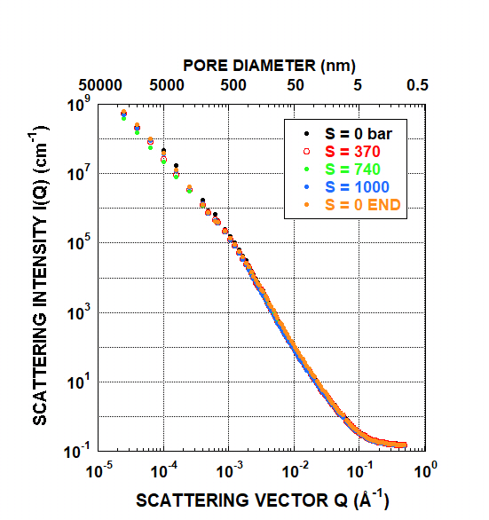

B. C.
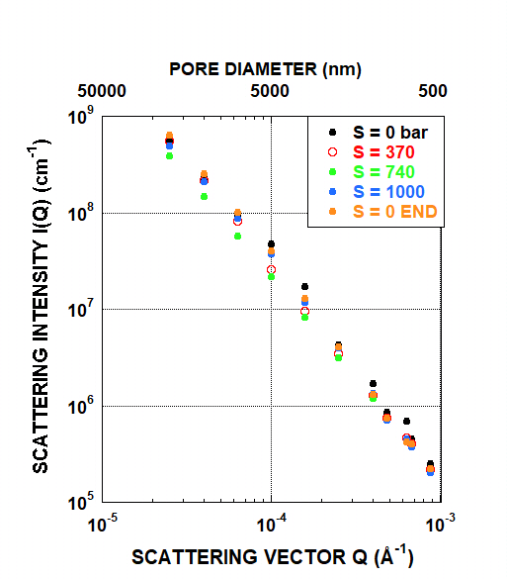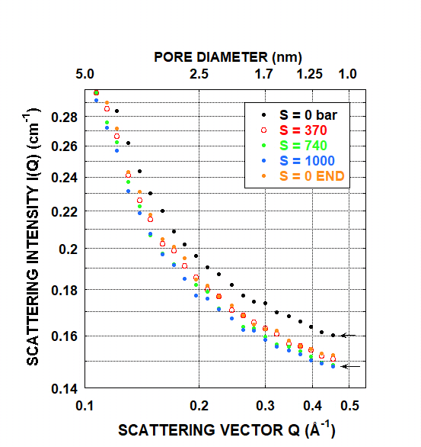
Figure 2. Plot of I(Q) for (p,S) = (0,S), where 0 < S < 1000 bar (100 MPa). (A) full Q-range, (B) small-Q detail (large pores, D > 500 nm), (C) large-Q detail (small pores, D < 5 nm). SANS measurements were performed on sub-sample L6, and USANS measurements on sub-sample L4. The statistical error for SANS intensity is much smaller than the symbol size; for USANS, the error is comparable to symbol size. (For interpretation of the references to colour in this figure legend, the reader is referred to the web version of this article.)
Figure 3A shows the relative SANS intensity, [I(Q; (0,0)] / [I(Q; (0,S)], versus D=5/Q, calculated for the hydrostatic pressure p=0 and five values of the uniaxial pressure (S = 0, 370, 740, 1000 bar and return to S=0). These results are interpreted according to Eq. 3 as the relative apparent number density of pores at given uniaxial stress, N(D;(p,S))/N(D;(0,0)). Note that the results in the SDN pore size region (Fig. 3B) may be underestimated because they are strongly influenced by the large-Q background scattering (discussed in detail in Radlinski et al., 2021). Data shown in Figure 3 have been computed assuming that the contributions arising from incoherent scattering, scattering on local heterogeneities (arising from solid inhomogeneous, e.g. chemically composite, nano-size regions) and diffuse coherent scattering to the large-Q background are very small with respect to changes arising from uniaxial stress deformational changes to the nanopores.
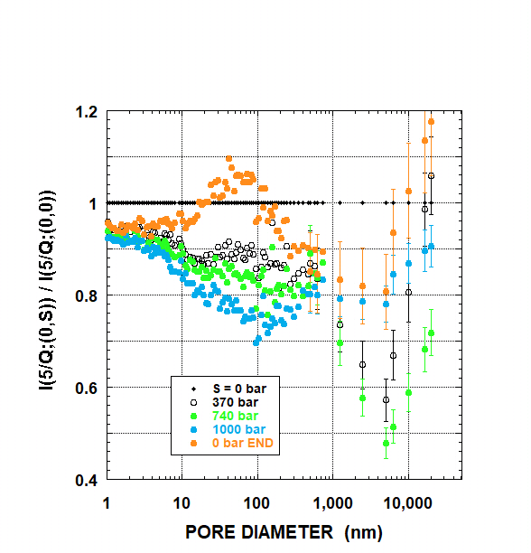 | 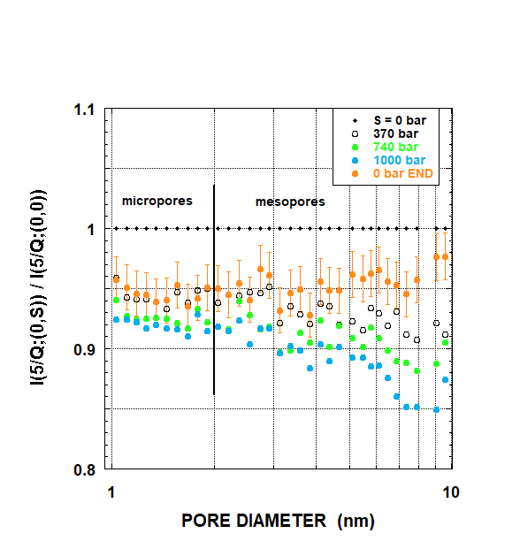
- B.

Figure 3. Variation of the relative SANS and USANS intensity (approximately equal to the relative pore number density (concentration) with uniaxial stress S. (A) SANS-based (sub-sample L6) and USANS-based (sub-sample L4) results versus apparent pore diameter and (B) detail for pore diameters D = 5/Q in the range from 1 nm to 10 nm. For clarity, statistical errors for SANS-based results are shown for only one pressure (B). (For interpretation of the references to colour in this figure legend, the reader is referred to the web version of this article.)

To minimize the scatter of calculated USANS intensity ratios in Figure 3A, data points for D = 750, 1100, and 5000 nm were interpolated from power-law fits to USANS experimental intensities in the Q-range 10⁻⁴ Å⁻¹ ≤ Q ≤ 10⁻³ Å⁻¹ and 10⁻⁵ Å⁻¹ ≤ Q ≤ 10⁻⁴ Å⁻¹. A zoom into the SDN (micropore and small mesopore) size region, 1 nm < D < 10 nm, is shown in Figure 3B.
Our results demonstrate that different pore sizes are affected by uniaxial stress in various ways. Specifically, in the pore size range from 1 nm to ~800 nm, the most depleted are mesopores of D ≈ 100 nm and macropores of D ≈ 5 μm(Fig. 3A). USANS results for pores sizes in the range 5-25 μm suggest that the negative trend is reversed and the number density of large macropores may increase with increased stress, even above the original (p,S) = (0,0) value (Fig. 3A). In addition, a permanent rearrangement of the pore size distribution takes place after pressure cycling (Figs. 2A and 3A, data annotated "END"). We note that this occurs after a return to ambient conditions, following eight consecutive uniaxial and hydrostatic pressure steps lasting ~4 hours for pores smaller than ~800 nm (SANS) and ~36 hours for larger macropores (USANS). These pressure values provide a relatively low maximal loading of 100 MPa ((p,S) = (50 MPa, 100 MPa)) in the macroscopically elastic regime, because the Young’s modulus for unconfined shale in the direction normal to bedding is on the order of 5 to 10 GPa (for the Marcellus shale it ranges from 7 to 50 GPa; Zheng et al., 2020) and unconfined compressive strength exceeds 70 GPa (Rybacki et al., 2015).
The pressure response of pores of different sizes is summarised in Figure 4. As mentioned before, in the pore size range from 1 nm to ~800 nm, the most affected are mesopores of D ≈ 100 nm. For these mesopores (at stress S = 100 MPa) the largest measured value of Ν(0,1000) / N((0,0)) is -0.74±0.01, therefore the average stress derivative of the number of pores of this size is ΔN/N(0,0) = -2.6·10⁻⁴ bar⁻¹. For smaller pores, ΔN/N(0,0) decreases to -1.6·10⁻⁴ bar⁻¹ for D = 10 nm nanopores, and to -0.7·10⁻⁴ bar⁻¹ for D = 1 nm SDN. For these three pore sizes (D = 100 nm, 10 nm, and 1 nm), ΔN/N(0,0) decreases linearly with uniaxial stress. The response of macropores differs: ΔN/N(0,0) is nonlinear with stress; for pores larger than D ≈ 5 μm, after the initial decrease it markedly increases back to the ambient values and greater. The initial response to stress of the D = 5 μm macropores is ΔN/N(0,0) = -1.16·10⁻³ bar⁻¹.
After the stress was released following measurements at S = 100 MPa, a permanent redistribution of the pore number density was observed. The final relative distribution of the apparent pore numbers is shown with symbols marked "0 bar END" in Figures 3A and 3B; it is also shown on the S = 0 line in Figure 4. The pore number density permanently decreased everywhere except for two pore size ranges: 20 nm < D < 50 nm and D > 5 μm (Figs. 3A and 4).
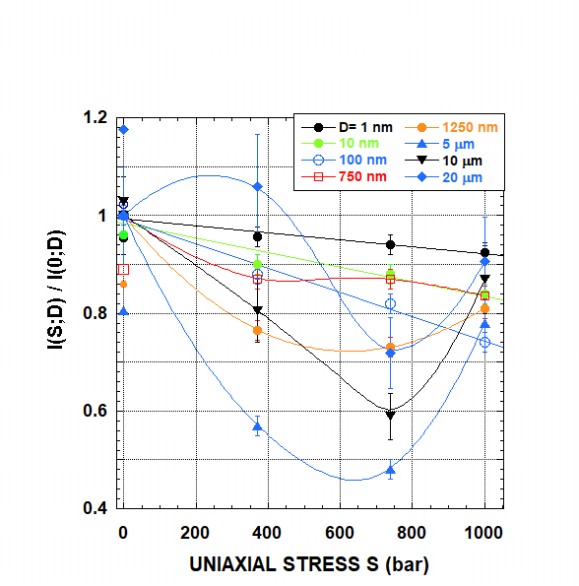
Figure 4. Variation of the relative SANS/USANS intensity (approximately equal to the relative number density of pores) with uniaxial stress S, calculated for eight apparent pore diameters from 1 nm to 20 μm. Plot is based on SANS and USANS results shown in Figures 2 and 3. (For interpretation of the references to colour in this figure legend, the reader is referred to the web version of this article.)

The data presented above provide important new information about the rearrangement of pores in response to uniaxial stress within the pressure range of up to 100 MPa. This pressure range is particularly relevant because it is of the same range as pressures characteristic of the producing intervals of the Marcellus Shale, even though our measurements were performed at 23 ºC rather than the average Marcellus Shale reservoir temperature of 60 ºC (Williams et al., 2010). At the shale sample depth of 2184 m, hydrostatic pressure in the normal-pressured Marcellus Shale is approximately 25 MPa ± 20% (Zagorski et al., 2012; USEIA, 2017) and the estimated lithostatic pressure is ~55 MPa. For instance, in the horizontal well MIP-3H drilled in Morgantown, West Virginia, located at the depocentre of the Marcellus Formation (Kavousi et al, 2018; measured depth about 7700' (~2375 m)), the initial measured bottom hole pressure is about 5000 psi (~34 MPa), the minimum horizontal stress is 6500 psi (~45 MPa; with stress anisotropy varying by 1.5% to 6%), and the overburden stress is approximately 8800 psi (~61 MPa) (Pankaj et al., 2018; Zheng et al., 2020). Moreover, fluid pressure during hydraulic fracturing typically reaches about 62 MPa at similar depths. Consequently, we expect deformation and rearrangement of pores documented under our experimental conditions to also take place at reservoir conditions in response to stress changes, owing either to change in burial or well management practices during the stimulation stages and gas production. It is well established that the macro-scale efficiency of fracture propagation in hydraulically fractured wells critically depends on the lithology-dependent horizontal stress regime in the surrounding rock formations, and in particular on the value and direction of the minimum horizontal stress and the Poisson ratio (e.g. Zheng et al., 2020). In addition to mechanical damage caused by well stimulation and management practices, the extent of pore space deformation is affected by local fluctuations in the stress regime; such fluctuations have been reported for the Marcellus Shale formation (Zheng et al., 2020). Importantly, our results indicate that stress cycling of amplitude similar to that used during fracturing stages causes a permanent nano- and micro-scale rearrangement of the pore size distribution.
Our data show that redistribution of the apparent pore sizes caused by uniaxial stress depends on the pore size, and is the largest for pore diameters ~100 nm in the micro- and mesopore range, but also significant for nanopores smaller than 100 nm (Figs. 3 and 4). This observation is of special importance because it has been well established that SDN (and micropores in particular) are the main sites for methane stored in unconventional reservoirs; there is a direct positive relationship between the volumes of micropores and methane adsorption capacity (e.g., Bustin and Clarkson, 1998; Wang et al., 2016), as well as between the volumes of micropores and in-situ gas content (e.g., Strąpoć et al., 2010). Therefore, by modifying the stress regime (e.g. well pressure), one can influence the capacity for methane release from micropores. Another significant aspect of microporosity is that the properties and behavior of fluids in tight confinement differ from those in pores with D ≥ 20 nm (e.g., Hazra et al., 2019; Jin and Firoozabadi, 2016), which impacts the kinetics of methane release and retention in micropores during production.
As discussed by Radlinski et al. (2021), for the Marcellus Shale samples studied here the total porosity is ~6 % and the accessible porosity for methane in the mesopore and smaller macropore region (25 nm ≤ D ≤ 500 nm) is about 0.4%. Consequently, the stress-induced rearrangement of the pore size distribution of the magnitude observed in this work must be dominated by pores that may contain dry gas but are not connected to the outside environment. Some of the observed phenomena, like the increase of the number of 20 to 100 nm mesopores and D > 5 μm macropores, may facilitate transfer of some of the gas confined in micropores to new storage sites and to form new conduits for migration of gas out of the rock. In turn, the observed decrease of the number density of the D ≤ 2 nm micropores with mechanical stress also has important implications: it could be related to (1) deformation (most likely shrinkage) of kerogen, followed by a consequent loss of micropore volume under stress and possibly mechanically-forced transfer of gas from micropores to mesopores; or (2) mechanically-forced trapping of residual methane in the micropores. Interpreting changes in SANS intensity measured for an overmature Marcellus sample subjected to hydrostatic pressure of deuterated methane, Neil et al. (2021) suggested an intra-kerogen mechanism of pressure-forced methane trapping, which is reversible at pressure 3000 psi (p ≈ 20 MPa), but becomes irreversible at p = 6000 psi (~ 42 MPa). Transfer from the reversible to irreversible trapping was attributed to a transition from the high mechanical flexibility of relatively "soft" kerogen at p = 3000 psi ("elastic" regime) to a permanent kerogen deformation at p = 6000 psi ("plastic" regime). A similar mechanism of hydrostatic-pressure-induced trapping of methane (at p = 50 MPa) in micropores has been observed for Marcellus samples cut from the same core interval as the samples measured in this work (Radlinski et al., 2021). However, the rearrangement of the pore space reported here, caused by uniaxial stress of comparable magnitude, appears to be much more extensive.
An important observation in this study is that rearrangement of pores caused by uniaxial stress becomes irreversible for stress values of no more than 100 MPa, and its characteristics depend on the details of pressure cycling. This is demonstrated using analysis of USANS results obtained for another sub-sample (L3) of the core Marcellus_7084. USANS measurements for this sample were first performed at ambient conditions, followed by ~13 hours at 100 MPa (1 kbar) of hydrostatic pressure of methane ((p, S) = (1000, 0)), followed by a series of ten measurements at (0, S) and (480, S) for S = 100, 350, 700, 1000, and 0 bar (for about 5 h 30 min for each measurement). Therefore, this sample was pre-stressed at p = 100 MPa (1 kbar) of methane for ~13 hours prior to the series of USANS measurements similar to those performed on sub-sample L4 (results for L4 are shown in Figures 3 and 4).
Pressure cycling of sub-sample L4 caused a permanent increase of the concentration of macropores larger than 10 μm (Figs. 3 and 4). Additional pressure-cycling USANS measurements performed on sub-sample L3 ( Fig. 5A), were used to calculate the variation of relative pore number values with uniaxial pressure. For uniaxial stress values larger than 35 MPa (350 bar) the concentration of pores larger than 500 nm dramatically increased; the rate of increase is pore-size-dependent and, importantly, the concentration of macropores doubles on average at S = 100 MPa (Fig. 5B).
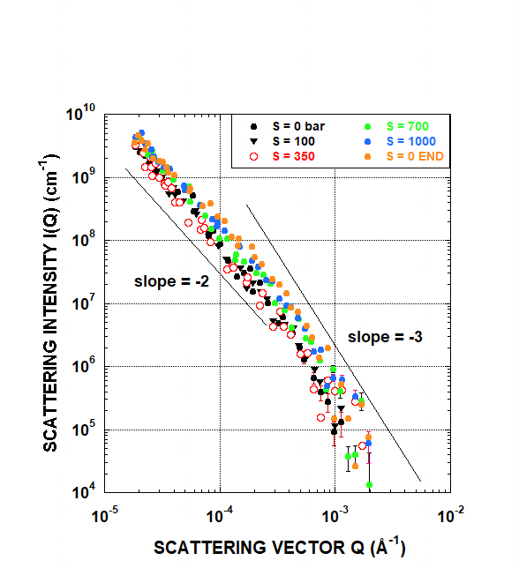 | 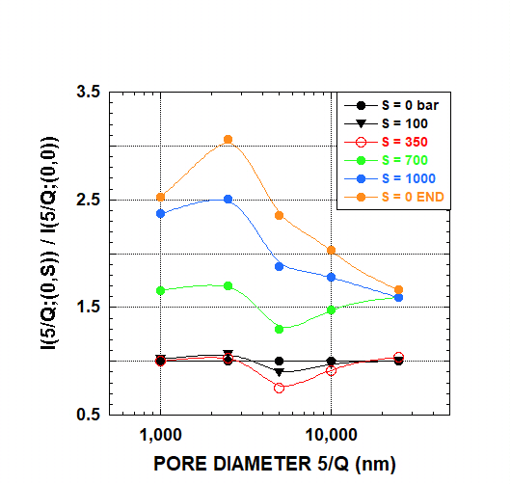
- B.
Figure 5. USANS results for sub-sample L3: (A) USANS intensity versus Q and (B) variation of the relative USANS intensity with uniaxial stress at five pore diameters, D = 5/Q for p = 0 and 0 ≤ S ≤ 100 MPa (1000 bar). (For interpretation of the references to colour in this figure legend, the reader is referred to the web version of this article.)

This change is totally irreversible, as indicated by the magnitude of the scattering intensity measured at the end of the cycle. Pressure-induced generation of pores larger than 1000 nm promotes gas recovery, and the higher the pressure, the higher methane recovery would be expected.

5. Conclusions
This work is the first systematic SANS and USANS study of pore deformation in shale caused by hydrostatic and uniaxial stress cycling. Overmature Marcellus Shale samples, representing a gas-producing depth interval, were exposed to several cycles of hydrostatic stress of 50 MPa and uniaxial stress up to 100 MPa. SANS and USANS techniques were applied to record changes in scattering intensities, which subsequently were used to interpret rearrangement of pore size distribution. The pressure range selected for the experiments is especially relevant because it spans reservoir pressures of the producing intervals of the Marcellus Shale. Consequently, the deformation and rearrangement of pores observed in this work are also expected to take place at reservoir conditions in response to stress variations, caused either by well stimulation, well management during gas production or in response to a change in the burial or tectonic regime.
We demonstrate that redistribution of the pore numbers caused by uniaxial stress strongly depends on the pore size. For the pore size range of 1 to 100 nm, the concentration of pores decreases with pressure, and the largest change occurs for pore diameters ~100 nm. The observed decrease is most likely related to deformation of kerogen, followed by a loss of nanopore volume and possibly mechanically-forced transfer of gas from smaller to larger pores and/or mechanically-forced trapping of residual methane in deformed micropores. Because evidence of methane trapping in the micropores is provided by the results of our SANS measurements performed at the pressure of 50 MPa of methane (Radlinski et al., 2021), we conclude that both mechanisms contribute to the pressure-induced pore rearrangement in the Marcellus_7084 samples studied.
Concentration of pores having diameters larger than 1000 nm initially decreases with the increase of pressure, and then increases at pressures above 74 MPa. This phenomenon is most accentuated for the largest pores. The increased number of macropores at high pressure may provide a way to transfer some of the gas confined in micropores to new storage sites and create new interconnected conduits for migration of gas out of the rock.
An important observation from this study is that the rearrangement of pores caused by uniaxial stress becomes irreversible for stress values of no more than 100 MPa, and the threshold pressure and nanostructural characteristics depend on details of pressure cycling. All this occurs well below the limit of macroscopic mechanical elasticity of shale. It is likely that every pressure cycle above the threshold value of less than 100 MPa can affect the final distribution of the micro-, meso-, and macropore sizes. This irreversible phenomenon should be taken into account during the stimulation and management of producing wells.
Our results indicate that stress cycling of amplitude similar to that used during hydraulic fracturing stages causes a nano- and micro-scale rearrangement of the pore size distribution, which results in an overall shift of the porosity towards the large pore sizes: a decreased concentration of the micro- and mesopores and increased concentration of the micrometer-size pores. This process occurs stepwise during pressure cycling, in parallel with the macro-scale fracture propagation. It is possible that such deformation of the pore space facilitates release and transport of gas molecules adsorbed in the nanopores to larger pores. However, the alternative option of permanent trapping of molecular methane in kerogen cannot be ruled out and should be further investigated.
Because, in addition, the extent of pore space deformation is affected by local fluctuations in the stress regime, the consequent uncertainty of the spatial distribution of accessible porosity and the kinetics of gas desorption constitutes a significant complication for the estimation of recoverable reserves and providing reliable input data for various modeling scenarios for well production; these variations are below the spatial resolution of such models. The amplitude of the possible stress-induced variation of pore accessibility is not known, nor is the case for the exact relationship between the pore nano- and microstructure in a realistic stress regime. Results presented here show, however, that these effects can be profound.

Acknowledgments
This material is based upon work supported by the U.S. Department of Energy, Office of Science, Office of Basic Energy Sciences, Chemical Sciences, Geosciences, and Biosciences Division under Award Number DE-SC0006978. Furthermore, this work was supported by the Australian Research Council (ARC LE200100209, DP170104550, DP170104557, LP170100233) and the strategic SPF01 fund of UNSW, Sydney. We also acknowledge support by the Australian Nuclear Science and Technology Organisation in providing the SANS and USANS neutron research facilities used in this work under proposal numbers P8360 and P8925. Finally, we would like to thank the Reviewer and the Editor for valuable comments and suggestions.

References
Blach, T., Radlinski, A.P, Edwards, D.S., Boreham,C., Rehm, C., de Campo, L., Gilbert, E.P., 2018. Fingerprint of hydrocarbon generation in the southern Georgina Basin, Australia, revealed by small angle neutron scattering. International Journal of Coal Geology 186, 135-144. https://doi.org/10.1016/j.coal.2017.10.013
Bustin, R.M., Clarkson, C.R., 1998. Geological controls on coalbed methane reservoir capacity and gas content. International Journal of Coal Geology 38, 3-26. https://doi.org/10.1016/S0166-5162(98)00030-5
Cao, P., Liu, J., Leong, Y-W., 2017. A multiscale-multiphase simulation model of the evaluation of shale gas recovery coupled the effect of water flowback. Fuel 199, 191-205. https://doi.org/10.1016/j.fuel.2017.02.078
Clarkson, C.R., Haghshenas, B., Ghanizadeh, A., Quanbari, F., Williams-Kovacs, J.D., Riazi, N., Debuhr, C., Deglint, H.J., 2016. Nanopores to megafracures: Current challenges and methods for shale gas reservoir and hydraulic fracture charcaterization. J. Nat. Gas Sci. Eng. 31, 612-657. https://doi.org/10.1016/j.jngse.2016.01.041
Clarkson, C. R., Solano, N., Bustin, R.M., Bustin, A. M. M., Chalmers, G.R.L., He, L., Melnichenko, Y.B., Radliński, A.P., Blach, T.P., 2013. Pore structure characterization of North American shale gas reservoirs using USANS/SANS, gas adsorption, and mercury intrusion. Fuel 103, 606-616, doi: 10.2118/j.fuel.2012.06.119.
Eberle, A.P.R., King H.E., Ravikovitch, P.I., Walters C.C, Rother, G., Wesolowski, D.J., 2016. Direct measure of the dense methane phase in gas shale organic porosity by neutron scattering. Energy & Fuels 30, 9022-9027.
Elsaig, M., Aminian. K., Ameri, S., Zamirian, M., 2016. Accurate evaluation of Marcellus Shale petrophysical properties. SPE-184042-MS. https://doi.org/10.2118/184042-MS
Espinat, D., 1990. Application des techniques de diffusion de la lumière, des rayons X et des neutrons à l'étude des systèmes colloïdaux, Revue de l'Institut Français du Pétrole 45 (6), 131 pp, Éditions Technip.
Faucher, S., Aluru, N., Bazant, M.Z., Blankschtein, D., Brozena, A.H., Cumings, J., Pedro de Sousa, J., Elimelech, M., Epsztein, R., Fourkas, J.T., Rajan, A.G., Kulik, H.J., Levy, A., Majumdar, A., Martin, C., McEldrew, M., Misra, R.P., Noy, A., Pham, T.A., Reed, M., Schwegler, E., Siwy, Z., Wang, Y-H., Strano, M., 2019. Critical knowledge gaps in mass transport through single digit nanopores: a review and perspective. Journal of Physical Chemistry C 123, 21309-21326.
Ghahfarokhi, P.J., Carr, T., Song, L., Shukla, P., Pankaj, P., 2018. Seismic attributes application for the distributed acoustic sensing data for the Marcellus Shale: New insights to cross-stage flow communication, SPE-1898888-MS, SPE Hydraulic Fracturing Technology Conference, The Woodlands, Texas, USA, 23 January 2018, 20 pp.
Gu, X., Mildner, D.F.R., 2018. Determination of porosity in anisotropic fractal systems by neutron scattering, Journal of Applied Crystallography 51, 175-184. https://doi.org/10.1107/S1600576718000080
Hazra, B., Wood, D.A., Mani, D., Singh, P.K., Singh, A.K., 2019. Organic and inorganic porosity, and controls of hydrocarbon storage in shales. Evaluation of Shale Source Rocks and Reservoirs, 107-138.
Hinde, A.L., 2004. PRINSAS - a Windows-based computer program for the processing and interpretation of small-angle scattering data tailored to the analysis of sedimentary rocks. Journal of Applied Crystallography 37, 1020-1024. https://doi.org/10.1107/S0021889804021260
Jin, Z., Firoozabadi, A., 2016. Thermodynamic modelling of phase behaviour in shale media. SPE J. 21, 190-207. https://doi.org/10.2118/176015-PA
Jubb, A.M., Ruppert, L.F., Youngs, T.G.A., Headen, T.F., 2020. Exploring methane behavior in Marcellus Shale micropores via contrast matching neutron scattering. Energy & Fuels 34, 10926-10932.
Kavousi et al, 2018, 2018. Seismic attributes application for the distributed acoustic sensing data for the Marcellus Shale: New insights to cross-stage flow communication. SPE-189888-MS, SPE Fracturing Technology Conference & Exhibition, The Woodlands, Texas, USA, 23-25 January 2018, 20pp.
Kuila, U., Prasad, M., 2011. Surface area and pore-size distribution in clays and shales: SPE Paper No 146869, presented at the SPE Annual Technical Conference and Exhibition, Denver, USA, 30 Oct – 2 Nov, 2011. http://www.spe.org/atce/2011/pages/schedule/tech_program/documents/spe146869%201.pdf
Lee, D.S., Herman, J.D., Elsworth, D., Kim, H.T., Lee, H.S., 2011. A critical evaluation of unconventional gas recovery from the Marcellus Shale, Northeastern United States. KSCE Journal of Civil Engineering 15, 679-687. DOI 10.1007/s12205-011-0008-4
Liu, S., Zhang, R., 2020. Anisotropic pore structure if shale and gas injection-induced nanopore alternation: A small angle neutron scattering study. International Journal of Coal Geology 219, 103384; https://doi.org/10.1016/j.coal.2020.103384
Mastalerz, M., Schimmelmann, A., Drobniak, A., Chen, Y., 2013. Porosity of Devonian/Mississippian New Albany Shale across a maturation gradient – Insights from organic petrology, gas adsorption, and mercury intrusion. AAPG Bulletin 97, 10, 1621-1643. http://dx.doi.org/10.1306/04011312194
Mastalerz, M., Wei, L., Drobniak, A., Schimmelmann, A., Schieber, J., 2018. Responses of specific surface area and micro- and mesopore characteristics of shale and coal to heating at elevated hydrostatic and lithostatic pressures. International Journal of Coal Geology 197, 20-30. https://doi.org/10.1016/j.coal.2018.06.026
Melnichenko, Y.B., He, L., Sakurovs, R., Kholodenko, A.L., Blach, T., Mastalerz, M., Radlinski, A.P., Cheng, G., Mildner, D.F.R., 2012. Accessibility of pores in coal to methane and carbon dioxide, Fuel 91, 200-208. https://doi.org/10.1016/j.fuel.2011.06.026
Neil, C. W., Hjelm, R.P., Howley, M.E., Watkins, E.B., Cockreham, C., Wu, D., Mao, Y., Fischer, T.B., Stokes, M.R., Xu, W., 2020. Small-angle neutron scattering (SANS) characterization of clay-and carbonate-rich shale at elevated pressures. Energy & Fuels. 34, 8178–8185. https://doi.org/10.1021/acs.energyfuels.0c01009
Neil, C.W., Mehana, M., Hjelm, R.P., Hawley, M.E., Watkins, E.B., Mao, Y., Viswanathan, H., Kang, Q., Xu,H., 2020b. Reduced methane recovery at high pressure due to methane trapping in shale nanopores. Communications Earth & Environment, 1-49; https://doi.org/10.1038/s43247-020-00047-w.
Pankaj, P. Shukla, P., Kavousi, P., Carr, T., 2018. Hydraulic fracture and reservoir characterization for determining optimal well spacing in the Marcellus Shale. SPE-191802, Liquids-rich Basins Conference - North America, Midland, Texas, USA, 5 - 6 Decermber 2018, 17 pp.
Radlinski, A.P., Boreham, C.J., Lindner, P., Randl, O.G., Hinde, A.L. and Hope, J.M., 2000. Small angle neutron scattering signature of oil generation in artificially and naturally matured hydrocarbon source rocks. Organic Geochemistry 31, 1–14. https://doi.org/10.1016/S0146-6380(99)00128-X
Radlinski, A.P., Ioannidis, M.A., Hinde, A.L., Hainbuchner, M., Baron, M., Rauch, H., Kline, S.R., 2004. Angstrom-to-millimeter characterization of sedimentary rock microstructure. Journal of Colloid and Interface Science 274 (2), 607-612. https://doi.org/10.1016/j.jcis.2004.02.035
Radlinski, A.P., Blach, T., Phung, V., Ji, Y., de Campo, L., Gilbert, E.P., Regenauer-Lieb, K., Mastalerz, M., 2021. Pore accessibility and trapping of methane in Marcellus Shale. International Journal of Coal Geology, in press.
Rehm, C., Brûle, A., Freund, A.K. and Kennedy, S.J., 2013. Kookaburra: the ultra-small-angle neutron scattering instrument at OPAL. Journal of Applied Crystallography 46, 1699–1704. https://doi.org/10.1107/S0021889813025788
Rouquerol, J., D. Avnir, C.W. Fairbridge, D.H. Everett, J.M. Haynes, N. Pernicone, J.D.F. Ramsay, K.S.W. Sing, and K.K. Unger, 1994, Recommendations for the characterization of porous solids (Technical Report): Pure and Applied Chemistry, v. 66, p. 1739−1758, doi: 10.1351/pac199466081739.
Rybacki, E., Reinicke, A., Meier, T., Makasi, M. and Dresen, G., 2015. What controls the mechaniucal properties of shale rocks? - Part I: Strength and Young modulus. Journal of Petroleum Science and Engineering 135, 702-722. https://doi.org/10.1016/j.petrol.2015.10.028
Sakurovs, R., Radlinski, A.P., Melnichenko, Y.B., Blach, T., Cheng, G., Lemmel, H., Rauch, H., 2009. Stability of bituminous coal microstructure upon exposure to high pressures of helium. Energy & Fuels 23 (10), 5022-5026. https://doi.org/10.1021/ef900439d
Strąpoć, D., Mastalerz, M., Schimmelmann, A., Drobniak, A., Hasenmueller, N.R., 2010. Geochemical constraints on the origin and volume of gas of the New Albany Shale (Devonian – Mississippian) in the eastern part of the Illinois Basin. AAPG Bulletin 94, 1713-1740. https://doi.org/10.1306/06301009197
U.S. Energy Information Administration, 2017. Marcellus Shale play: Geology Review, U.S. Department of Energy, Washington, Dc 20585
Zagorski, W. A., G. R. Wrightstone, and D. C. Bowman, 2012, The Appalachian Basin Marcellus gas play: Its historyof development, geologic controls on production, and future potential as a world-class reservoir, in J.A. Breyer, ed., Shale reservoirs -Giant resources for the 21st century: AAPG Memoir 97, p. 172-200.
Wang, Y., Zhu, Y., Liu, S., Zhang, R., 2016. Pore characterization and its impact on methane adsorption capacity for organic-rich marine shales. Fuel 181, 227-237. https://doi.org/10.1016/j.fuel.2016.04.082
Wei, L., Mastalerz, M., Schimmelmann, A., Chen, L., 2014. Influence of Soxhlet-extractable bitumen and oil on porosity in thermally maturing organic-rich shales. International Journal of Coal Geology 132, 38-50, http://dx.doi.org/10.1016/j.coal.2014.08.003

Williams, H., Khatri, D., Keese, R., Roy-Delage, L., Roye, J., Leach, D., Rottler, P., Procherie, O., Rodriguez, J., 2011. Flexible, Expanding Cement System (FECS) Successfully Provides Zonal Isolation Across Marcellus Shale Gas Trends. Paper SPE 149440, Canadian Unconventional Resources Conference, Calgary, Alberta, Canada, November 15-17
Wood, K., Mata, J.P., Garvey, C.J., Wu, C.-M., Hamilton, W.A., Abbeywick, P., Bartlett, D., Bartsch, F., Baxter, P., Booth, N., Brown, W., Christoforidis, J., Clowes, D., d’Adam, T., Darmann, F., Deura, M., Harrison, S., Hauser, N., Horton, G., Federici, D., Franceschini, F., Hanson,P., Imamovic, E., Imperia, P., Jones, M., Kennedy, S., Kim, S., Lam, T., Lee, W.T., Lesha, M., Mannicke, D., Noakes, T., Olsen, S.R., Osborn, J.C., Penny, D., Perry, M., Pullen, S.A., Robinson, R.A., Schulz, J.C., Xiong N., Gilbert, E.P., 2018. QUOKKA, the pinhole small-angle neutron scattering instrument at the OPAL research reactor, Australia: design, performance, operation and scientific highlights. Journal of Applied Crystallography 51, 294-314. https://doi.org/10.1107/S1600576718002534
Zhang, J., Cheng, G., 2021. Technical aspects of the pore structure in shale measured by small angle and ultrasmall-angle neutron scattering: A mini review. Energy&Fuels 35, 1957-1965. https://doi.org/10.1021/acs.energyfuels.0c04248
Zhang, R., Liu, S., 2021. Nanoscale coal deformation and alteration of porosity and pore orientation under uniaxial compression: An in-situ SANS study. Rock Mechanics and Rock Engineering. https://doi.org/10.1007/s00603-020-02321-x
Zheng, H., Zhang, J., Qi, Y., 2020. Geology and geomechanics of hydraulic fracturing in the Marcellus shgale gas play and their potential applications to the Fuling shale gas development. Energy Geoscience 1, 36-46. https://doi.org/10.1016/j.engeos.2020.05.002
Zheng, H., Zhang, J., Qi, Y., 2020. Geology and geomechanics of hydraulic fracturing in the Marcellus shgale gas play and their potential applications to the Fuling shale gas development. Energy Geoscience 1, 36-46. https://doi.org/10.1016/j.engeos.2020.05.002
Zoback, M. L., 1992. First- and second-order patterns of stress in the Lithosphere: The World Stress Map Project. Journal of Geophysical Research 97(b8), 11703-11728. https://doi.org/10.1029/92JB00132

