Binding of Formic Acid on Anatase TiO₂(101)
Yang Wang,†, Bo Wen,‡ Arjun Dahal,†,⊥ Greg A. Kimmel,†
Roger Rousseau,† Annabella Selloni,‡,* Nikolay G. Petrik,†,* and Zdenek Dohnálek†,§,*
† Physical and Computational Sciences Directorate and Institute for Integrated Catalysis, Pacific Northwest National Laboratory, P.O. Box 999, Richland, Washington 99352, United States
‡ Department of Chemistry, Princeton University, Princeton, New Jersey 08544, United States
§ Voiland School of Chemical Engineering and Bioengineering, Washington State University, Pullman, Washington 99163, United States
* Corresponding authors: AS email: aselloni@Princeton.edu, NGP email: Nikolai.Petrik@pnnl.gov, ZD email: Zdenek.Dohnalek@pnnl.gov
⊥ Current Address: Department of Physics, University of South Alabama, Mobile, AL 36688, USA

ABSTRACT
The adsorption of formic acid (FA) and the formation of formate species on metal oxide surfaces are of great interest in catalysis. Formic acid is used to probe the adsorption properties of surface sites and formates are common intermediates in many catalytic reactions. Here we focus on the interaction of FA with a prototypical anatase TiO₂(101) surface by using a combination of scanning tunneling microscopy (STM), infrared reflection absorption spectroscopy (IRAS), electron stimulated desorption (ESD), and density functional theory (DFT) to assess the coverage dependent evolution of different FA-derived surface species at low temperatures (80–240 K). We find that isolated FA adsorbs at 80 K in both monodentate (MD) and bidentate (BD) configurations on top of undercoordinated Ti sites (Ti_{5c}). The MD form is likely deprotonated and readily converts upon annealing to deprotonated bridging BD on two neighboring Ti_{5c} sites. DFT calculations show that molecularly-bound MD FA is metastable and readily converts to a deprotonated state in the proximity of subsurface oxygen vacancy. The stability of the MD species increases as the availability of the paired Ti_{5c} sites for BD formation diminishes at high coverages. Upon surface saturation, a mixed configuration of alternating MD and BD species with coverage of 2/3 FA/Ti_{5c} represents the most favorable configuration. This is in contrast with the adsorption of FA on rutile TiO₂(110) and many other oxides, where bidentate formate species dominate.

INTRODUCTION
Fundamental understanding of the adsorption of small organic molecules on well-defined oxide surfaces provides critical insight into their catalytic conversion on complex high surface area catalysts. As a prototypical reaction, the catalytic decomposition of formic acid (FA) has been used as a probe to investigate the acid-base and redox properties of the catalysts since more than one century ago.¹⁻³ This reaction can either follow a dehydration (HCOOH → CO + H₂O) or a dehydrogenation (HCOOH → CO₂+ H₂) pathway. The energy barriers for these two reaction pathways in the gas phase are high and close to each other.⁴⁻⁵ Heterogeneous catalysts can greatly lower the energy barriers and change the selectivity depending on the character of the surface sites.⁶⁻¹¹ Typically, the dehydration occurs on acidic oxides, while the dehydrogenation occurs on basic oxides.
Although FA is the simplest carboxylic acid, a molecular-level understanding of the adsorption configurations and the factors controlling the selectivity have not been fully ascertained. Titanium dioxide (TiO₂) single crystal is often chosen as the prototypical catalyst because of its widespread use and well-characterized surface structure.¹²⁻¹⁴ Many experimental and theoretical studies have been carried out on rutile TiO₂(110),^{6, 15-21} which is the thermodynamically most stable surface of the rutile phase. It is agreed that formic acid generally adsorbs dissociatively at temperatures above 110 K to form a bidentate (BD) bridging formate with an O-C-O plane parallel to the [001] direction and a bridging OH group (OH_{b}).^{17, 22-24} When a BD bridging formate is close to an oxygen vacancy (V_{O}), it can migrate on the five-fold coordinated Ti (Ti_{5c}) row at elevated temperatures and occupy the oxygen defect with an oxygen atom from the formate species. Consequently, the O-C-O plane rotates to become parallel to the $\left[\text{1}\overline{\text{1}}\text{0}\right]\text{ d}$irection.^{15, 17} A monodentate (MD) configuration, where the formate occupies the V_{O} site with the O-C-O plane parallel to the [001] direction, has also been reported in several combined STM and DFT studies.^{15, 25}
Anatase TiO₂ is generally considered to be more chemically active than the rutile phase.²⁶⁻²⁷ The <101> facets are dominantly exposed in powders because of their lowest surface free energy.²⁸⁻³⁰ Well-defined anatase TiO₂(101) has a sawtooth-like morphology exposing alternating rows of Ti_{5c} atoms and two-fold-coordinated oxygen atoms (O_{2c}) along the [010] direction. Theoretical studies have not come to a consensus on the stable adsorption configurations of formic acid on anatase TiO₂(101),^{19, 31-33} and also disagree with the experimental results.³⁴ Three different models have been proposed as the low energy structures, depending on the exchange-correlation functional used in the calculations, with differences in the adsorption energies smaller than 0.2 eV. Two of these configurations³¹⁻³³ have the carbonyl oxygen of the formic acid coordinated to a surface Ti_{5c} site while the hydroxyl forms a weak hydrogen bond with either the nearest O_{2c} or the second nearest O_{2c}. The third configuration is a dissociated BD,¹⁹ where the two oxygen atoms from formate are coordinated to two adjacent Ti_{5c} atoms along the [010] direction while the proton bonds to the nearby O_{2c} atom, forming a bridging hydroxyl (HO_{2c}).
To the best of our knowledge, experimentally, only one study explored the adsorption of formic acid on anatase TiO₂(101), via Infrared Absorptions Spectroscopy (IRAS).³⁴ It was reported that FA dissociates above room temperature to yield two different types of formate species.³⁴ One is an MD formate with one O atom coordinated to a Ti_{5c} site. In addition, a BD formate, different from the bridging configuration, was identified to reside at a surface V_{O} site with the two oxygen atoms of the formate bound to the Ti_{4c} and Ti_{5c} adjacent to the V_{O}. The study also concluded that FA deprotonation produced formate at temperatures as low as 120 K.
In this study, we address the adsorption behavior of formic acid on anatase TiO₂(101) between 80 and 240 K using STM, IRAS, and ESD measurements. The experiments are combined with DFT calculations to achieve a detailed molecular-level understanding of the FA adsorption. The symmetry of the bright FA-related features along the Ti_{5c} rows ([010] direction) in the STM images is used to identify MD (on top of Ti_{5c}) and BD species (in between Ti_{5c}). In complementary experiments, ν(C=O) and ν_{asym}(OCO) stretching modes in the polarized IRAS are used to identify MD and BD surface species in deprotonated and molecularly-bound forms. Both MD and BD species are found to coexist at these temperatures. At very low coverages, MD species, that are likely deprotonated, are observed at 80 K. DFT calculations show that on the stoichiometric surface molecularly-bound MD FA is more stable than deprotonated MD formate. In contrast, in the proximity of subsurface Vo’s, molecularly-bound MD FA is metastable and readily converts into a deprotonated MD state. The MD species further convert to BD species upon annealing to 150 K, and DFT shows that it is thermodynamically preferred. At saturation coverage, the molecular MD species are stabilized by the lack of neighboring Ti_{5c} sites required for BD formation. In such a case, annealing to 240 K is required to deprotonate the MDs and convert a fraction of them to BDs. Locally ordered (3×1) periodic arrangements with alternating MD and BD species with coverage of 0.67 FA/Ti_{5c} are observed with STM. DFT shows that a few high-coverage configurations are close in energy and, therefore, likely to coexist. Overall, our studies demonstrate that the deprotonated BD species are not as dominant on anatase TiO₂(101) as on rutile TiO₂(110). This is likely a consequence of the large spacing between the Ti_{5c} sites, making the MD configurations closer in energy to the BD ones.

METHODS
Experimental Details. The experiments were conducted in two different ultrahigh vacuum (UHV) systems. The detailed descriptions of both systems were presented in previous reports.³⁵⁻³⁷ The first UHV system (base pressure < 2 × 10⁻¹¹ Torr) is equipped with three chambers for an Omicron low-temperature STM, sample preparation and molecular beam doser, respectively. A naturally grown 5×5×1 mm³ single-crystalline anatase TiO₂(101) sample (SurfaceNet, miscut angle < 0.3°) was cleaned with cycles of Ne⁺ sputtering and annealing to 920 K in vacuum. For the STM studies, the scanning stage was cooled down to 80 K using liquid nitrogen. Annealing to 150 K was realized by warming up the whole STM stage and controlled by a silicon diode sensor. STM tips were made from electrochemically etched tungsten wire and cleaned in situ by vacuum annealing. Empty-state STM images were collected in constant-current mode at a positive sample bias of 0.80 to 1.30 V and tunneling current of 5 - 100 pA.
The second UHV system (typical base pressure = 1×10⁻¹⁰ Torr) is equipped with a closed-cycle helium cryostat (Advanced Research Systems 204B), a quadrupole mass spectrometer (Extrel), a molecular beamline for dosing adsorbates, a Fourier transform infrared spectrometer (FTIR, Bruker Vertex 80) for IRAS, and low-energy electron gun (Kimball Physics, model ELG-2), and a quadrupole mass spectrometer (Extrel, model EXM720) for ESD and temperature programmed desorption (TPD) measurements. A naturally grown 7×5×2 mm³ anatase TiO₂(101) single crystal, also by the SurfaceNet, was cleaned with cycles of Ne⁺ sputtering followed by annealing in O₂ beam at 720 K and after that annealing in UHV at 950 K. This annealing procedure is similar to the one suggested by Setvin et al.³⁸ It is likely that it results in a smaller concentration of subsurface V_{O}s than the procedure used in the STM UHV system. In IRAS annealing experiments, the sample temperature was ramped to the desired temperature at 2K/s, then the heating was stopped, and the sample was cooled down to ~ 30 K where the spectrum was measured.
For the IRAS experiments, the s-and p-polarized infrared beams were incident on the sample along an azimuth rotated 20° with respect to the $\left[\text{10}\overline{\text{1}}\right]$ direction and at grazing incidence (~85° with respect to the surface normal) and detected in the specular direction (Section S1, Supporting Information). For s-polarized light on a dielectric substrate, all the absorbances peaks are negative (i.e. they appear to be “emission” peaks).³⁹⁻⁴¹ For s-polarized light, the measurement is sensitive to vibrations that are parallel to the surface and perpendicular to the IR beam direction. For p-polarized light, the electric field vector has components perpendicular and parallel to the surface and the absorbance peaks can be positive or negative depending on the substrate, the geometry for the IR setup and the orientation of the dipole moment responsible for the absorbance. For TiO₂(101) with the IR used here, p-polarized modes that are perpendicular to the surface show up as negative absorbance (“emission”) peaks, while modes that are parallel to the surface show up as positive peaks.^{40, 42} Each individual IRAS experiment includes 2000 interferometer scans from the clean surface and 2000 interferometer scans from the surface with formic acid layer. The presented IRAS spectra are the average of up to 100 individual experiments. All the IRAS measurements were collected at ~ 30 K. The resolution was set to 4 cm⁻¹.
For the ESD experiments, the electron beam was incident at 40º with respect to the sample normal. The incident energy of the electrons, E_{i}, was 100 eV, and the instantaneous current densities were ~1.8 × 10¹⁵ cm⁻² s⁻¹ as measured with a Faraday cup. The electron beam was smaller than the molecular beam spot size on the sample (~1.5 mm and 7.0 mm, respectively). To produce a uniform electron fluence across the films, the electron beam was rastered over an area slightly larger than the formic acid spot (Fig. S1c, Supplemental Information), delivering 1.5 × 10¹³ cm⁻² electrons per scan at 0.4 s per scan.
Energetic electrons are expected to induce a variety of non-thermal reactions in the adsorbate layer. One reaction – the electron-stimulated desorption of the parent FA molecule – was of interest here. We used it to assess whether any formic acid molecularly adsorbed on the surface at low temperatures or whether it all dissociated. In our experience, we have not observed electron-stimulated reactions in which species that are adsorbed at separate sites on the surface (e.g., after dissociative adsorption) undergo stimulated diffusion, reaction and then desorption. The impulsive nature of most stimulated reactions typically precludes such a complicated reaction path. Therefore, ESD of the parent molecule is typically a good indicator of molecular adsorption, and this is supported by the results presented below.
In both experimental systems, the formic acid was cleaned by repeated freeze-pump-thaw cycles and a molecular beam was used to dose the formic acid. We used 97% HCOOH by Alfa Aesar, 98% DCOOD and 98% HCOOD from Cambridge Isotope Laboratories. The coverage in monolayers (ML) is defined relative to the density of Ti_{5c} sites (1 ML = 5.17 × 10¹⁴ molecules/cm²). From our STM data, the absolute coverage of formic acid at saturation of Ti_{5c} sites is 2/3 ML which corresponds to ∼ 3.5 × 10¹⁴ FA/cm². In the TPD/IRAS system, we used Kr TPD to measure the saturation coverage of the formic acid molecules on the Ti_{5c} sites. Details are shown in Section S2 of the Supporting Information.
Computational details. Calculations were conducted using density functional theory (DFT)⁴³⁻⁴⁴ as implemented in the CP2K package.⁴⁵ We adopted the strongly constrained and appropriately normed (SCAN)⁴⁶ meta-GGA functional, which has been shown to well describe the water-TiO₂ interface in a recent study⁴⁷. The Goedecker-Teter-Hutter⁴⁸ norm-conserving pseudopotentials and a hybrid gaussian-planewaves basis set were used to describe electron-ion interactions and valence electron wavefunctions, with a cutoff energy of 1200 Ry for the planewave part. Structural optimizations were carried out until the residual forces on all atoms were less than ~ 0.02 eV/Å, and only the Γ point was used for k-sampling. The performance of this computational setup was assessed through calculations on the gas phase FA molecule and FA dimer (see Supporting Information, Section S3). For comparison, selected calculations with the PBE⁴⁹ functional were also carried out. Results obtained with CP2K were compared to calculations performed using the plane wave pseudopotential scheme within the Quantum Espresso package⁵⁰. For such calculations, the electron-ion interactions were described by PBE norm-conserving pseudopotentials⁵¹ with electrons from O 2s, 2p; Ti 3s, 3p, 3d, 4s; C 2s, 2p and H 1s shells explicitly included. The electronic wavefunctions were expanded in plane waves with a cutoff energy of 80 Ry. The convergence thresholds for total energy and forces were 0.003 eV and 0.05 eV/Å, respectively.
The anatase (101) surface was modeled using a slab of four TiO₂ layers, and (1×4) and (1×6) surface unit cells were considered. To describe the reduced surface, a V_{O} was introduced in the subsurface layer, as suggested by previous studies⁵²⁻⁵⁵. We choose V_{O}s as the source of reduction because they are a well-recognized subsurface defect formed as a result of the reduction of anatase TiO₂(101) in the sputter-anneal preparation procedure and because of the existing evidence for their importance in the adsorption of carboxylic acids on TiO₂ surfaces.^{15, 17, 34} Consecutive slabs were separated by a vacuum of ~ 12 Å along the z direction. To estimate the binding energy of formic acid (FA) on anatase, the adsorption energy (E_{a}) was calculated using the expression:
$$E_{a}=(E_{slab+nFA}-E_{slab}-n*E_{FA})/n$$
where $E_{slab+nFA}$, $E_{slab}$ and $E_{FA}$ are the total energies of substrate with n formic acid molecules, substrate anatase and single formic acid, respectively. To estimate the activation barrier from the molecular MD to the dissociated BD configuration of adsorbed HCOOH, climbing image nudged elastic band (CI-NEB)⁵⁶ calculations were carried out. To find the minimum energy path, eight images were used with the two end images fixed.

RESULTS AND DISCUSSION
Binding Configurations of Isolated Formic Acid upon Adsorption at Low Temperatures. High-resolution STM images of TiO₂(101) following the adsorption of a small amount of formic acid (0.03 ML) at 80 K are shown in Figure 1. The images exhibit the underlying TiO₂(101) structure with alternating bright and dark rows along the [010] direction. Both Ti_{5c} and O_{2c} contribute to the bright rows observed on the anatase TiO₂(101) surface. This is different from rutile TiO₂(110), where bright and dark rows in empty state STM images originate from Ti_{5c} and O_{2c} atoms, respectively.⁵⁷⁻⁵⁸ The larger-scale image in Figure 1a reveals the overall spatial distribution of adsorbed species (bright spots), and closer inspection shows that the majority of the bright features appear in pairs (several marked by yellow ellipses) and only a smaller number are isolated (white circles). Statistical analysis demonstrates that 70 ± 10 % of features are paired. We attribute this behavior to the fact that in the gas phase, ~77% of the FA molecules are dimerized.⁵⁹ Occasionally, a single feature related to the FA dimers can be found on the surface. During repeated STM imaging, such features split into a pair of features (see Section S4, Supporting Information) such as those shown in Figure 1.
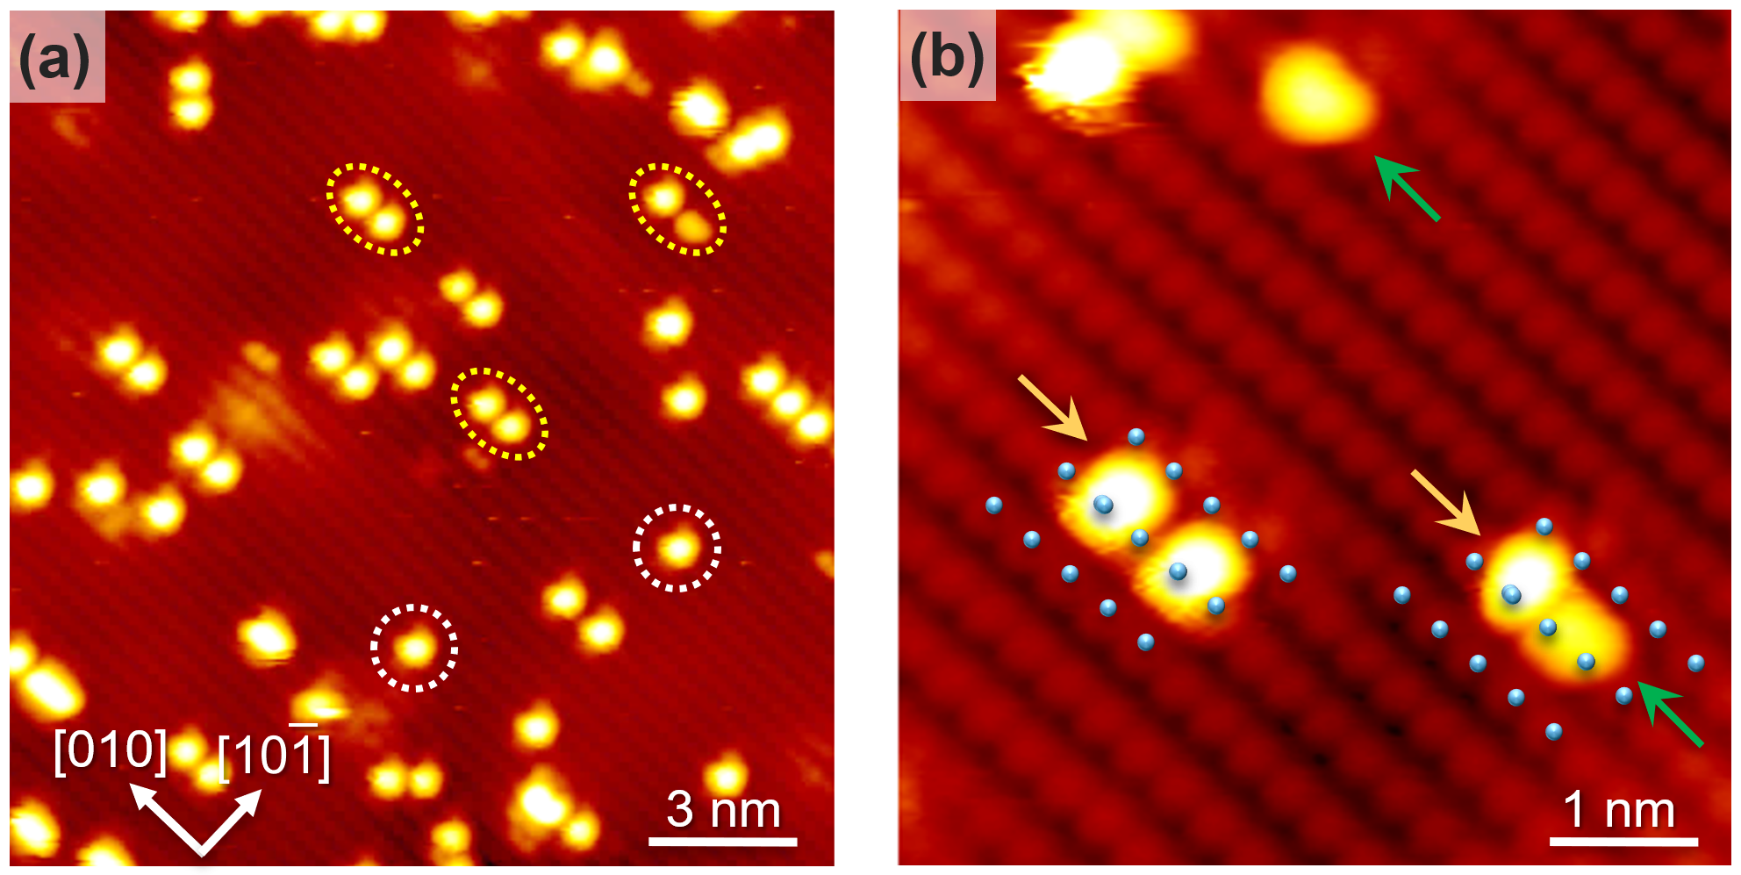
Figure 1. Empty state STM image of TiO₂(101) surface after dosing a small amount (0.03 ML) of formic acid at 80 K. The white circles and yellow ellipses in (a) mark several typical isolated and paired features. The positions of Ti_{5c} atoms in (b) are marked with blue circles. The arrows in (b) point to the formic acid-related bright spots of different along-the-row symmetry; yellow on top of Ti_{5c}, green in-between Ti_{5c}.

Figure 1b shows the high-resolution image of the observed surface species. Two types of features can be distinguished based on the brightness, shape, and symmetry relative to the underlying Ti_{5c} lattice. The spots marked by yellow arrows are positioned on top of the Ti_{5c} atoms along the [010] direction (i.e., along the rows), and appear fuzzy and elongated along the $\left[\text{10}\overline{\text{1}}\right]$ direction (across the rows). Based on the symmetry, these species are assigned to MD binding with the carbonyl O atom bound to Ti_{5c} and the OH group extended towards the second nearest O_{2c} atom. The fuzzy character and centered appearance along the $\left[\text{10}\overline{\text{1}}\right]$ direction, further suggest dynamic switching of the OH orientation between the two equivalent second nearest O_{2c} atoms. Our images do not allow us to conclude whether the fuzzy features correspond to molecularly (schematic view in Figure 2a) or dissociatively (Figure 2b) bound MD FA, but our IRAS studies and DFT calculations on the reduced surface suggest a preference for deprotonated configuration as further discussed below.
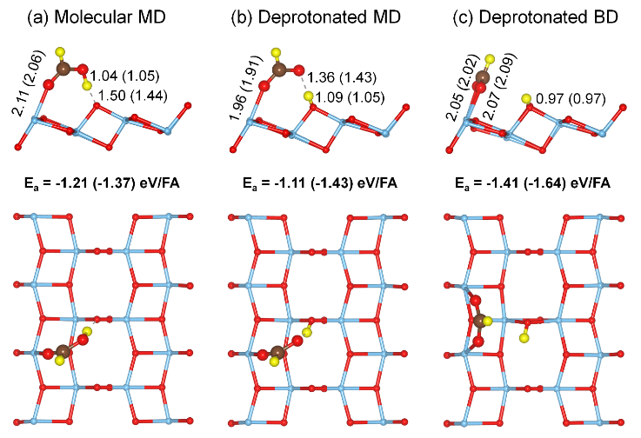
Figure 2. Structures of: (a) molecular MD, (b) deprotonated MD and (c) deprotonated BD configurations of adsorbed FA on anatase (101) surface at 1/8 ML coverage computed using SCAN functional. Adsorption energies (in eV) and selected bond lengths (in $Å)$are reported, with values in parentheses referring to the reduced surface with a subsurface V_{O} close to the adsorbed FA. Blue, red, brown and yellow spheres represent Ti, O, C and H atoms, respectively. For better visualization, FA and substrate are shown as ball and stick model, respectively.

The second type of species observed after the FA adsorption at 80 K is represented by kidney-shaped features (green arrows, Figure 1b) located between two adjacent Ti_{5c} sites along the row. These features are less bright than the fuzzy features, and we assign them to deprotonated FA bound as BD. The schematic view of the BD species based on DFT calculations is shown in Figure 2c.
At low coverage, the large scale image in Figure 1a is dominated by the isolated and paired fuzzy features. Most paired MD species are spaced apart by a bare Ti_{5c} site rather than sitting on the neighboring Ti_{5c} sites, but it is possible that a small fraction of features shown in Section S4 of the Supporting Information correspond to the nearest neighbor FA pairs.

Table 1. Computed adsorption energies (eV) per FA molecule on the stoichiometric (1×4) and (1×6) and reduced (1× 4)-V_{O} surfaces at various coverages, where “low” means one molecule per unit cell. The labels MD-m, MD-d, and BD-d denote molecular monodentate (MD-m), MD dissociated (MD-d), and bidentate dissociated (BD-d) adsorption configurations; the configuration denoted as “Mixed” consists of alternating MD-m and BD-d adsorbed molecule along the [010] direction.

HCOOH  Surface | MD-m  low | MD-d  low | BD-d  low | BD-d  0.5 ML | Mixed  0.67 ML | MD-m  1 ML
(1×4) | -1.21 | -1.11 | -1.41 | -1.39 | -- | -1.26
(1×4) +V_{O} | -1.37 | -1.43 | -1.64 | -1.49 | -- | -1.28
1×6 | -1.19 | -1.09 | -1.33 | -1.39 | -1.32 | -1.26

The adsorption structures for species resulting from the adsorption of FA on TiO₂(101) computed using SCAN functional are shown in Figure 2; analogous results for paired species are presented in Section S5, Supporting Information. For isolated molecularly-bound MD (Figure 2a) and dissociatively-bound BD (Figure 2c), the DFT calculations have also been carried out using the PBE functional. The SCAN functional was chosen for its accurate description of hydrogen-bonded systems,⁴⁷ and the PBE functional for its widespread use as a reference.⁶⁰ The structural parameters given by the two functionals are very similar and in agreement with those reported previously.³³ In contrast, SCAN and PBE yield quite different results for the relative stability of MD and BD species. The PBE adsorption energies for the molecular MD and deprotonated BD geometries on the stoichiometric surface are -0.85 and -0.80 eV, respectively, i.e., the MD geometry is slightly more stable than the BD one. In contrast, SCAN (Figure 2 and Table 1) predicts the BD geometry to be more favorable by ~0.2 eV (~0.3 eV) on the stoichiometric (reduced) surface, in agreement with our experimental observations discussed below. Therefore, we choose the SCAN functional for the calculations reported in the rest of this article.
While Figure 2 shows an isolated FA in a (1×4) TiO₂(101) surface cell, we have also studied how the coverage influences the stability of molecular and deprotonated species by considering (1×6) supercells on the stoichiometric surface. The dissociated BD configuration is 0.2 eV (0.3 eV) more stable than the molecular (dissociated) MD one in the 1×4 surface cell but becomes only 0.14 eV (0.24 eV) more stable in the (1× 6) surface cell, i.e., at lower coverage (Table 1). This trend suggests that the relative stability of the MD configurations might increase at very low coverage, in agreement with our experimental observations.
Experimentally, it is not straightforward to evaluate the role of subsurface defects in the FA adsorption, whereas their effect can easily be assessed computationally. It was reported previously that V_{O}’s give rise to special FA adsorption configurations on anatase.³⁴ In contrast, hybrid density functional theory calculations predicted MD dissociative adsorption on both the defect-free and reduced surfaces as the lowest energy configuration.³¹ To explore the effect of surface reduction on FA adsorption, we examined HCOOH on reduced anatase with a V_{O} in the subsurface.⁵⁴⁻⁵⁵ As shown in Table 1, deprotonated MD becomes slightly (0.06 eV) more stable than molecular MD on the reduced surface. However, it is still less stable than dissociated BD, which overall remains the most favorable configuration also in the presence of subsurface V_{O}’s. We also note that the absolute values of computed adsorption energies are larger in the proximity of a subsurface V_{O} than on the stoichiometric surface. However, these values decrease with increasing distance from the V_{O,} and thus decrease more significantly with increasing coverage on the reduced surface than on the stoichiometric one. Therefore, for high coverage FA structures (see below), we present primarily computational results for stoichiometric TiO₂(101).
To make closer connection with the experiments, the adsorption of FA pairs was also investigated (Section S5, Supporting Information) on the stoichiometric surface. Compared with the isolated species, the absolute value of the adsorption energy per FA of the molecular MD (dissociated BD) pair increases (decreases) by 0.02 eV. Moreover, the molecular MD pair at nearest neighbor Ti_{5c} sites is 0.01 eV more stable than the pair at second nearest neighbor sites shown in Figure S5. This indicates that proximity effects tend to increase the relative stability of the molecular MD species.
The observation of both MD and BD species in the STM experiments (Figure 1) suggests that the barrier for their interconversion is relatively small, but not negligible, allowing for the presence of both species at 80 K. Motivated by these findings, we performed NEB calculations on both stoichiometric and reduced surface to determine the reaction pathway from FA adsorbed in molecular MD configuration to a deprotonated BD species. The transition involves an O-H bond cleavage and a rotation of the formate species around the other O-Ti_{5c} bond. The computed activation energy of the overall reaction is similar on the stoichiometric and reduced surfaces: 0.29/0.24 eV for the direct (molecular MD → BD) and 0.49/0.46 eV/FA for the reverse (BD → molecular MD) reaction (Figure 3). However, due to the stabilization of the deprotonated MD configuration, the O-H cleavage is essentially barrierless on the reduced surface, whereas the barrier for the deprotonated MD → BD transition is higher than on the stoichiometric surface. These values explain the observed kinetic stability of the metastable MD species at 80 K, as well as its transformation to the thermodynamically more stable BD configuration at higher temperatures. This is consistent with a recent publication, where proton shuttling between the molecularly-bound FA and the surface in a shallow two-well free energy potential was reported.⁶¹
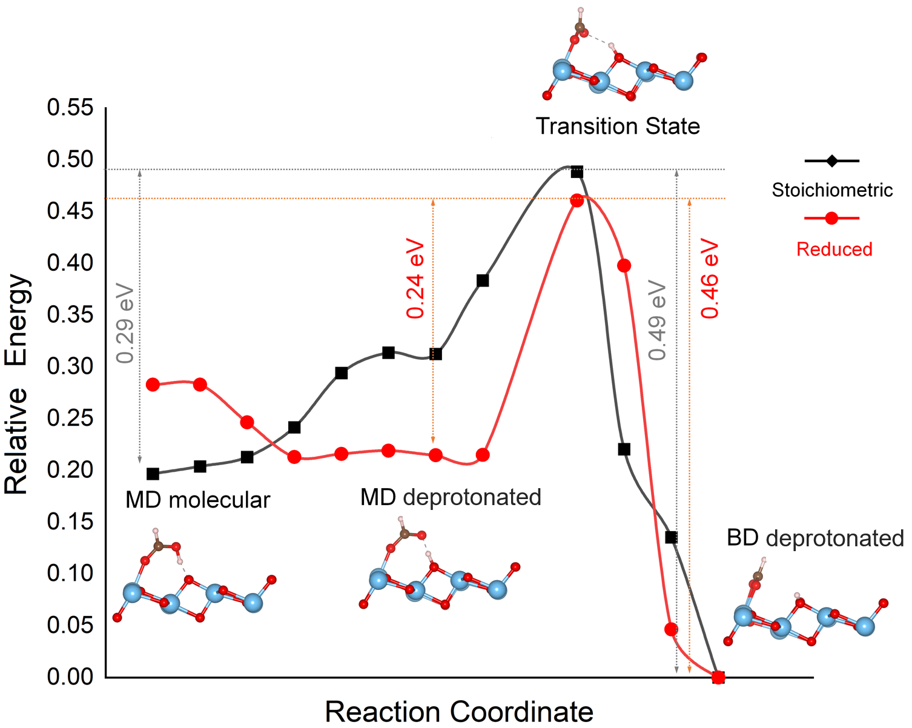
Figure 3. Minimum energy pathway for the transition from FA adsorbed in the molecular MD configuration to the deprotonated BD configuration on stoichiometric (black) and reduced (red) TiO₂(101). The schematics show the side views of the initial (molecular MD), intermediate (deprotonated MD), transition, and final (deprotonated BD) state structures. Triangles in the energy profile, correspond to NEB images in the calculation, the line represents the spline interpolation between the NEB images. Note the stabilization of the MD dissociated structure on the reduced surface.

Coverage Dependent Distribution of Monodentate and Bidentate Species at Low Temperatures. The nature of the surface species and their relative stability on TiO₂(101) were further investigated by IRAS. Figure 4 shows (a) p-polarized (b) s-polarized IRAS spectra for 0.13, 0.33, and 0.67 ML of FA following adsorption at 90 K (blue traces), and subsequent flash to 127 K (red) or 245 K (green). All spectra were acquired at 30 K. After adsorption at 90 K, peaks corresponding to both MD and BD-bound species are seen, which is consistent with the STM and DFT results presented above. For the MD species, a mostly negative feature around 1688 cm⁻¹ (Fig. 4a and b, shaded yellow) is associated with ν(C=O) based on comparison with the HREELS spectra of FA on rutile TiO₂(110).¹⁷
For the BD species, several HCOO formate peaks are seen in p-polarized spectra (Figure 4a): ν_{sym}(OCO) at 1361 cm⁻¹, δ(HCO) at 1386 cm⁻¹ (both negative) and the broad positive peak of ν_{asym}(OCO) at ∼1560 cm⁻¹ (shaded blue). These peaks are similar to previously reported formate peaks on rutile TiO₂(110) at 300 K. ⁶²⁻⁶⁴ The IRAS spectra of formic acid on anatase TiO₂(101) obtained previously at 300 K by Xu et al.³⁴ were also interpreted in terms of dissociative adsorption but their spectra look different from ours. The formate peaks were observed at different frequencies: 1647 cm⁻¹ for ν(C=O) in deprotonated MD form and 1598 cm⁻¹ for ν_{asym}(OCO) in deprotonated BD form, they are broader and less resolved.
The observed C=O and OCO IRAS peaks are also quite close to the reported IR spectra of formic acid on P25 TiO₂ (80% anatase and 20% rutile) pressed powder (1675 cm⁻¹ and 1550 + 1378 cm⁻¹ correspondingly) where the coexistence of molecular and deprotonated FA was suggested.⁶⁵
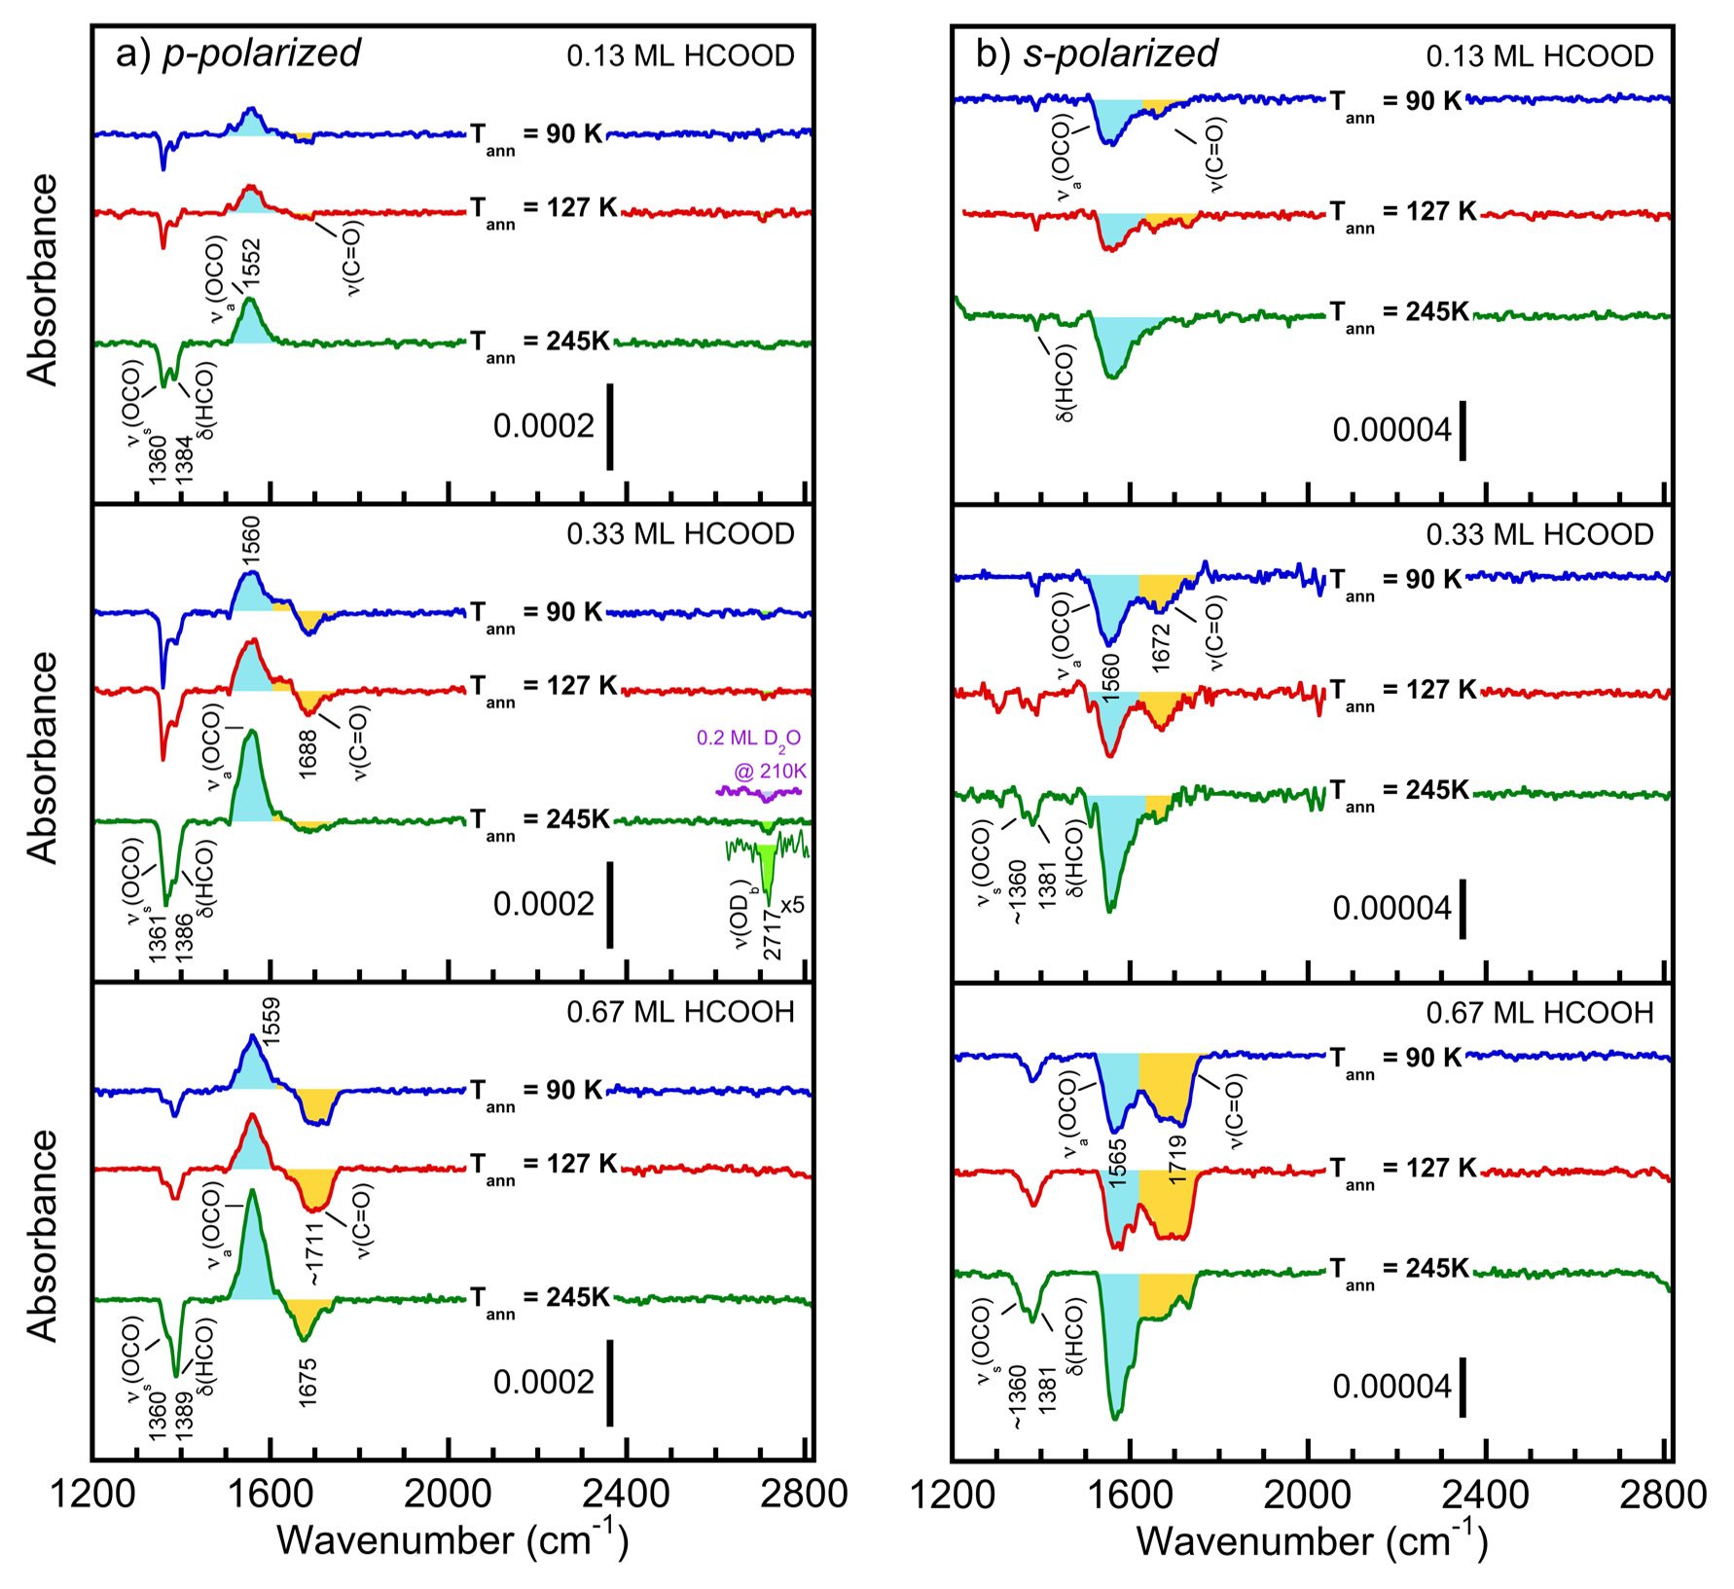
Figure 4. IRAS spectra in p-polarized (a) and s-polarized (b) modes for 0.13, 0.33, and 0.67 ML of FA adsorbed on TiO₂(101) at 90 K (blue), and after 2 K/s flash to 127 K (red) or 245 K (green). The spectra for 0.13 and 0.33 ML correspond to the adsorption of HCOOD, while 0.67 ML corresponds to the adsorption of HCOOH. All the IRAS spectra are obtained at 30 K. The yellow and light blue shading highlights the C=O and OCO stretching modes, respectively.

Additional evidence for some level of FA deprotonation is provided by a small but measurable peak at ∼2717 cm⁻¹ that can be seen at a higher coverage of 0.33 ML (shaded green). This peak is associated with ν(OD) produced from the FA dissociation where the deuteron combined with the surface oxygen (most likely O_{2c}) to form a hydroxyl. A quite similar ν(OD) peak is seen after the adsorption of 0.2 ML D₂O on TiO₂(110) and annealing at 210 K (purple trace). As was proposed for formic acid on rutile TiO₂(110),^{17-18, 62, 64} the hydroxyl is produced as a result of deprotonation of formic acid and association of the proton (deuteron) with the bridging oxygen via the following reaction:
HCOOD + O_{2c}²⁻ → HCOO⁻ + O_{2c}D⁻ (1)
As described in Section 2, the sign of an absorbance feature for p-polarized light provides information on the orientation of the oscillator with respect to the surface normal. In particular, the negative absorbances for ν(C=O), ν_{sym}(OCO), ν(HCO), and ν(OD) are associated with the molecular dipoles having components perpendicular to the surface. For ν_{sym}(OCO) of formate, the OCO symmetry axis (along the C-H bond) shall have a component normal to the surface, which is consistent with the BD orientation of the formate with both oxygens bound to the Ti_{5c} sites as suggested by the theoretical calculations (Figure 2c). On the other hand, the positive absorbance for ν_{asym}(OCO) is consistent with the molecular dipole orientation parallel to the O-O axis and parallel to the surface, which is also consistent with the BD formate adsorption configuration.
At 90 K, the negative ν_{sym}(OCO) and ν(C=O) peaks at ∼1560 cm⁻¹ and ∼1672 cm⁻¹ for the BD and MD species, respectively, dominate the s-polarized spectra (Figure 4b). A small peak at ∼1390 cm⁻¹ is likely δ(HCO). For ν_{asym}(OCO) at 1560 cm⁻¹ the BD formate on two Ti_{5c} sites would satisfy the polarity of the IRAS peaks. A quite similar ν_{asym}(OCO) peak at 1566 cm⁻¹ ⁶⁴ or 1534 cm⁻¹ ^{20, 63} with a similar polarization response was observed previously in the spectra of formic acid adsorbed on rutile TiO₂(110). In that case, the peaks were associated with bridging BD formate adsorbed on the Ti_{5c} rows.
The ν(C=O) feature shows negative peaks in p- and s-polarized modes, which indicates that the C=O bond of the adsorbed FA is tilted from the surface normal and has components (projections) parallel and perpendicular to the surface. A small positive ν(C=O) component in the p-polarized spectrum (Figure 4a) is also consistent with the tilted orientation of the C=O bond.
As the coverage is increased, all principal IRAS peaks in both polarizations grow as the coverage is increased from 0.13 to 0.67 ML, but the relative intensity ratios for different peaks is not changing significantly. Additional IRAS spectra for 0.33 ML of HCOOH and DCOOD isotopologues are shown in Section S6, Supporting Information. Structurally, they are similar to the HCOOD spectra, with the expected shifts of corresponding vibrations of deuterated and hydrogenated groups according to the mass ratio.
The spatial distribution of MD and BD species as a function of coverage was assessed by high-resolution STM imaging at 80 K. The typical STM images after dosing 0.08, 0.26, and 0.65 ML at 80 K are shown in Figure 5. At the lowest coverage of 0.08 ML (Figure 5a), many paired species due to the adsorption of gas-phase FA dimers can still be recognized (see Figure 1), but the clusters of neighboring features start to overshadow this pattern. Overall, the image is dominated by features that are centered on top of Ti_{5c} sites, indicating that the MD binding configuration dominates.
At intermediate coverages (0.26 ML, Figure 5b), a clear preference for the formation of the clusters of FA-related features can be seen. While in most areas, MD and BD configurations are mixed, short chains of purely MD and/or BD species are also observed. Several of such chains are marked with ellipses in Figure 5b. The yellow ellipse marks the chain with features that are closely packed on top of Ti_{5c} sites and are therefore interpreted as the chains of MD species. Due to electronic effects (also previously seen for water and methanol),⁶⁶⁻⁶⁷ they appear brighter than isolated MD species. The corresponding along-the-row line scan is shown in Figure 5d.
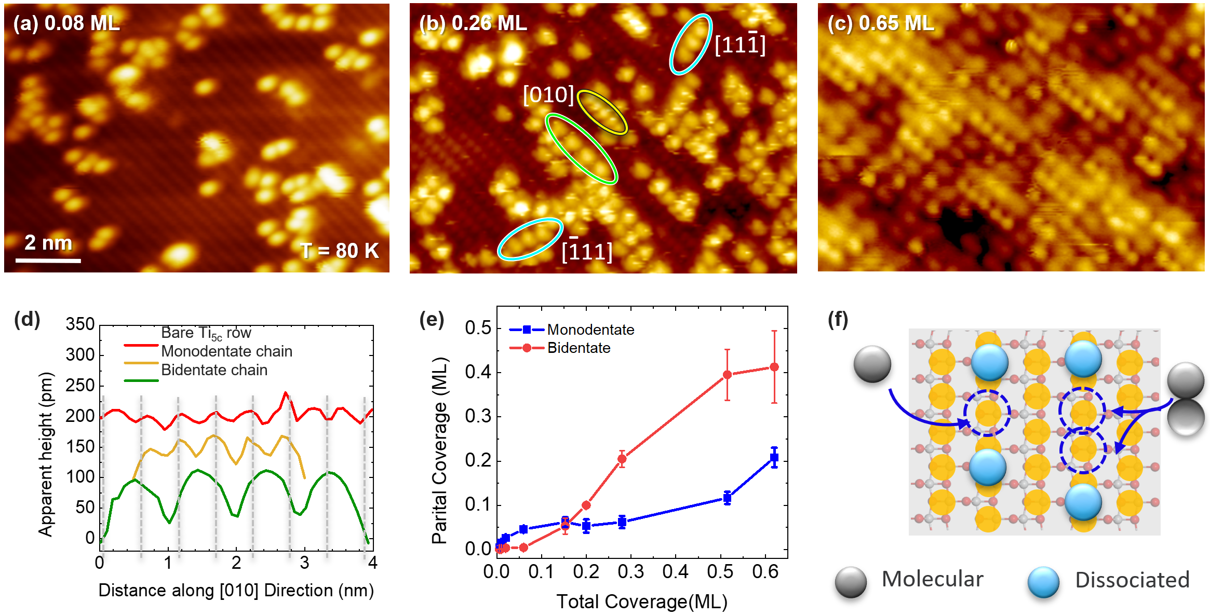
Figure 5. (a-c) Empty-state STM images after dosing (a) 0.08 ML, (b) 0.26 ML, and (c) 0.65 ML of FA at 80 K. Yellow and green ellipses mark FA chains along the rows with symmetries that correspond to MD and BD binding, respectively. Cyan ellipses mark BD FA chains across the rows. (d) Line profiles along bare Ti_{5c} row (red), and along the chains of FA-related features with distinct periodicity along the Ti_{5c} row (yellow and green). The profiles are vertically offset for clarity, and the dashed black lines mark the positions of Ti_{5c} sites. (e) The coverage dependence of the FA features centered on-top (blue, MD) and in-between (red, BD) the Ti_{5c} sites determined from images such as those shown in (a-c). (f) Schematic view of the site constraints expected to play a role at high coverages.

The chain highlighted by the green ellipse has a less bright appearance, and two times the periodicity of Ti_{5c} atoms along the rows (Figure 5b). The along-the-row line scan (green, Figure 5d) shows that the maxima are positioned between the Ti_{5c} sites, in accord with the symmetry expected for the BD species. The features highlighted by cyan ellipses, have the same brightness and maxima in-between the Ti_{5c} sites but are extending along the Ti_{5c} sites across the rows, and are also interpreted as being due to the BD species. Similar clustering was seen for water and methanol on TiO₂(101).⁶⁶⁻⁶⁷ There, we speculated that the molecules become initially trapped in a mobile precursor state (e.g., on top of O_{2c} sites), diffuse along the low barrier pathway before being captured on empty Ti_{5c} sites neighboring already immobilized molecules on the same Ti_{5c} row. Similar types of motifs with the periodicity of one and two lattice spaces along the Ti_{5c} rows can be seen upon saturation (0.65 ML, Figure 5c).
We have quantified the number of MD and BD species vs. coverage by evaluating a number of images (Figure 5e). We find that MD species dominate at very low coverages (< 0.1 ML), where mostly isolated and paired FA species are present (Figure 1 and Figure 5a). In the intermediate coverages (0.1-0.4 ML), their number increases only slightly from 0.05 to 0.1 ML, whereas the number of BD species steadily increases from 0 to 0.3 ML. This evolution is somewhat puzzling, as it is hard to understand why the MD species do not continue to grow. This initial increase of the MD species could be related to subsurface defects. It has been shown previously that V_{O}’s are more stable in the subsurface than at the surface.⁵²⁻⁵³ Since the adsorbing FA monomers and dimers are transiently mobile upon adsorption, surface Ti_{5c} sites with subsurface V_{O} defects may be initially preferentially occupied.⁶⁸⁻⁷⁰ As shown by the DFT results in Table 1, the proximity of subsurface V_{O}’s indeed stabilizes the binding of all FA species, especially of the deprotonated MD configuration. Although the dissociated BD structure is still the most stable species, also close to a subsurface V_{O}, the MD species are kinetically hindered (see Figure 3) and do not necessarily reach their thermodynamically preferred configurations at temperatures around 80 K. It seems, therefore, reasonable to assume that the isolated MD monomers and dimers are metastable species close to subsurface defects. The metastable nature of such species is confirmed by our STM studies following the annealing that are discussed in the next section. Interestingly, the occupation of sites away from subsurface V_{O}’s and clustering of the species at intermediate coverages promotes the formation of BD species.
At the highest coverages (0.5-0.65 ML, Figure 5c) that approach saturation of the surface layer, the coverage of BD species plateaus above ~0.4 ML (Figure 5e), whereas a significant increase in MD coverage (~0.2 ML) is observed. This is likely a consequence of a limited Ti_{5c} site availability, as illustrated in a schematic view in Figure 5f. There, only a single MD species can adsorb on an isolated Ti_{5c} site (left), and two MD species from a dimer FA can fill two neighboring Ti_{5c} sites (right). Additionally, streaks along the scanning direction (left to right, Figure 5c) indicate the presence of more weakly-bound, mobile species (likely in the second layer) that cannot be imaged at 80 K.
While the STM results at high-coverage do not allow us to assess whether the MD species are molecularly or dissociatively bound, additional information can be gleaned from the high-coverage IRAS spectra. For the saturated layer at 90 K (0.67 ML, Figure 4, bottom panels, blue traces), the complex shape of the ν(C=O) band, which extends to higher wavenumbers at higher coverages (1720 cm⁻¹ versus 1675 cm⁻¹), is probably an indication of the coexistence of two adsorption configurations. For coverages greater than a monolayer where molecular adsorption is expected, a narrow, intense peak develops at 1734 cm⁻¹ (Section S7, Figures S7a, Supporting Information). This suggests that the blue-shifted component seen at 0.67 ML is also associated with the molecularly-bound MD species. Between 0.33 and 0.67 ML HCOOH, the ν_{asym}(OCO) peak increases just slightly, but the ν(C=O) peak almost doubles mostly at the expense of the blue-shifted molecular component (Figures S7b, Supporting Information).
While the IRAS evidence for the presence of molecularly-bound MD species at coverages close to saturation is rather tenuous, the electron-stimulated desorption of molecular FA (Figure 6) provides further support for this assignment. In cases where adsorbates react instead of thermally desorbing, ESD can be a useful method for detecting these species at low temperatures. For example, ESD was successfully utilized in the past to study thermal dissociation and reactions of water on rutile TiO₂(110).⁷¹⁻⁷² Here, ESD of molecular FA (46 amu) was measured at 100 K after FA was dosed at 90 K and flash-annealed at 127 K (top inset, Figure 6). Because the ESD signal is related to the amount of molecular FA on the surface, it can be used to show that some of the FA adsorbs without dissociating. In particular, Figure 6 shows the integrated HCOOH ESD signal as a function of coverage (blue squares). The key observation is that for coverages greater than 0.4 ML, the HCOOH ESD signal increases approximately linearly. The results indicate that for coverages less than 0.4 ML, little or no molecular FA is present, which corroborates the arguments for the deprotonated character of MD species at low coverages discussed above. The lack of signal at low coverages also demonstrates that, as expected, the energetic electrons do not lead to appreciable back reactions of the dissociated species to produce molecular FA. However, the energetic electrons probably induce a variety of reactions in the adsorbates, including dissociation, in addition to the desorption of molecular FA. These non-thermal reactions are not the focus of the current work and they do not affect the interpretation of the results shown in Figure 6.
Figure 6 further shows
the integrated HCOOH molecular desorption signal at 46 amu (red circles) obtained during TPD. This signal allows us to assess at which coverage the first layer is completed, and a multilayer starts to develop. As illustrated in the bottom inset of Figure 6, the multilayer desorption appears above 130 K, and the integrated HCOOH TPD signal increases linearly with the FA coverage after the saturation of the surface (0.67 ML). (Further details about the reactions of FA and products observed at elevated temperatures in TPD will be discussed in our forthcoming publication.) These results suggest that below ~ 0.4 ML, both MD and BD species are deprotonated following the flash-annealing to 127 K. Additional FA above ~ 0.4 ML, is likely molecular MD. However, for coverages below saturation, the molecular FA does not desorb upon heating. These results correlate nicely with the increase of the population of MD species above 0.4 ML in the STM (Figure 5e) and with the appearance of ν(C=O) peak at ~1720 cm⁻¹ (Figure 4 and Figure S7) of the molecular HCOOH above ~ 0.4 ML. Conversely, the second ν(C=O) peak at ~1675 cm⁻¹ does not increase above 0.4 ML and it is therefore likely associated with the deprotonated MD species.
Figure 6. Integrated HCOOH (46 amu) TPD and ESD signals versus coverage. HCOOH is dosed at 90 K. Before the ESD, the sample was flash annealed at 127 K, then the ESD signal was measured at 100 K using 100 eV electrons. Bottom inset: HCOOH (46 amu) TPD spectra versus coverage. Top inset: HCOOH (46 amu) ESD signal versus time with electron beam ON and OFF.

Thermally-Induced Changes in the Distribution of Monodentate and Bidentate Species. We now focus on the thermally-induced changes in the coverage-dependent overlayers. Our DFT simulations (Figure 3) show that the energy barrier for the conversion of isolated MD species to BD species is ~0.3 eV. As such, a small temperature increase from the base temperature of 80 K should be sufficient to overcome it. However, this result refers to isolated FA species, and the situation is likely more complex at higher coverages, where site constraints come into play, and additional rearrangements of neighboring species may be required.
To assess how the stability of different species depends on coverage, we turn back to IRAS results in Figure 4. While brief annealing to 127 K does not affect the IRAS spectra significantly at any coverage, a considerable decrease in ν(C=O) of the MD species is apparent after flashing to 245 K. No ν(C=O) peak is seen for 0.13 ML HCOOD, a very small contribution remains for 0.33 ML HCOOD, but a significant fraction of HCOOH remains as MD at 0.67 ML. At the same time, the OCO peaks increase proportionally in accord with the MD → BD conversion. The high signal to noise spectrum obtained for 0.33 ML of HCOOD also allows us to confirm the dissociation by following the increase in the ν(O_{2c}-D) at 2717 cm⁻¹. Other isotopologues exhibit analogous behavior as shown in Section S6, Supporting Information.
We have also determined that there are only minor differences when FA is dosed at elevated temperatures (rather than flashed). The data for 0.33 ML HCOOH dosed at 90, 170, 250, and 330 K are shown in Section S8, Supporting Information. The ν(OCO) peak increases and the ν(C=O) peak decreases with increasing dose temperature in a qualitative agreement with the spectra presented in Figure 4 after the flash.
To investigate the changes in the spatial distribution and population of MD and BD species at the elevated temperature, we performed STM experiments at 150 K (Figure 7). In contrast to the results at 80 K, only BD species are observed at low coverage (Figure 7a). This indicates that isolated FA can readily deprotonate and convert to their most stable configuration, in agreement with the DFT calculations (Figure 3). While IRAS spectra cannot be obtained at such low coverages, the results obtained for the lowest coverage of 0.13 ML also show a decrease of the ν(C=O) MD peak upon annealing (Figure 4, top). Interestingly, the pairing of FA species observed at 80 K (Figure 1 and Figure 5a) due to adsorption from the gas phase FA dimers, is barely observable. This is likely a consequence of the higher mobility of FA monomers on the surface, leading to larger separation of the final BD species.

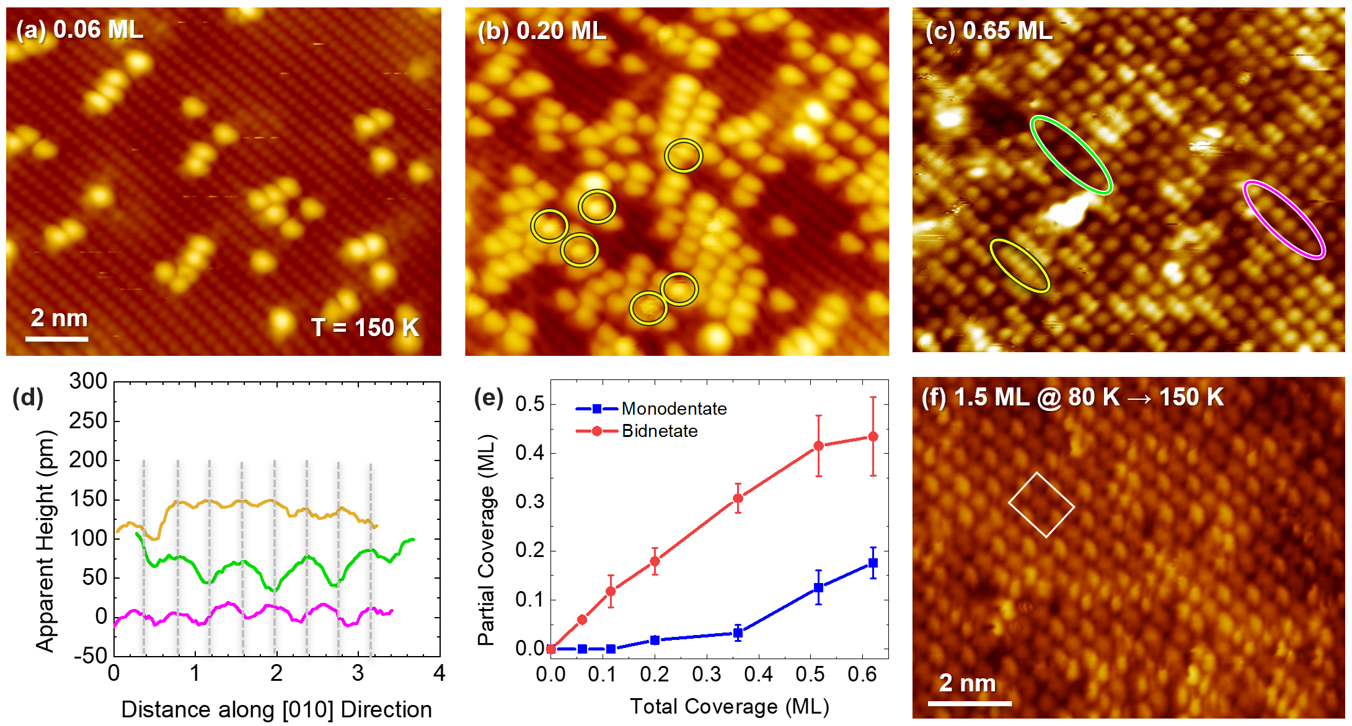
Figure 7. (a-c) Empty-state STM images after dosing (a) 0.06 ML, (b) 0.20 ML, and (c) 0.65 ML of FA at 150 K. Yellow circles in (b) indicate several MD species that are spatially constrained between two BD species. Yellow, magenta, and green ellipses in (c) mark FA chains along the Ti_{5c} rows with a periodicity of one, one and a half, and two Ti_{5c}, respectively. (d) Line profiles along the FA chains marked with yellow, magenta, and green ellipses. The profiles are offset vertically for clarity, and the dashed grey lines mark the positions of Ti_{5c} sites. (e) The coverage dependence of the FA features centered on-top (blue, MD) and in-between (red, BD) Ti_{5c} sites determined from images such as those shown in (a-c). (f) STM image of the FA overlayer prepared by adsorbing 1.5 ML at 80 K and annealing it to 150 K to desorb the FA from the second layer.

At the intermediate coverage of 0.2 ML (Figure 7b), the BD species continue to dominate, but few MD species are also observed (yellow circles). All MD species are found in constrained configurations with a single Ti_{5c} site available between two BDs.
The surface structure becomes rather complex at close-to-saturation coverage of 0.65 ML (Figure 7c). As in the low-temperature saturation images (Figure 5c), the chains of MD (yellow ellipse) and BD (green) species with the periodicity of one and two lattice constants are observed along the Ti_{5c} rows. Their corresponding line profiles are shown in Figure 7d. Interestingly, a new type of chain (magenta) with a periodicity of a one and a half lattice constant is also observed. These chains are interpreted to be a result of alternating MD and BD species. No streaks are observed upon saturation (Figure 7c), indicating that the more weakly-bound species inferred at 80 K (Figure 5c) have been incorporated into the first layer or desorbed.
The statistical analysis of the coverage of MD and BD species as a function of total coverage is shown in Figure 7e. Except for the absence of the MD species at low coverages, the functional forms and final saturation coverages of MD and BD species are similar to those observed at 80 K (Figure 5d). These findings are consistent with the lack of changes observed in this temperature range at higher coverages in our IRAS experiments (see Figure 4).
In addition to the adsorption experiments at 150 K, we have prepared saturation coverage of FA by adsorbing 1.5 ML of FA at 80 K, followed by slow annealing to 150 K. The resulting image obtained at 80 K (Figure 7f), which shows a relatively well-ordered overlayer with alternating brighter and darker protrusions along the Ti_{5c} rows suggesting the presence of two distinct species in the chains, is consistent with the MD-BD chains discussed above. The chains are aligned in an out-of-phase fashion from one row to another, forming an overlayer with a (3×1) periodicity. The complete sequence with the initial image after the adsorption at 80 K and the line scans across the ordered (3×1) regions is shown in Section S8 of the Supporting Information. The corresponding IRAS spectra for 0.67 and 1.5 ML HCOOH dosed at 90 K and annealed 600 s at 160 K are shown in Figure S8b of the Supporting Information. The spectra in both annealed samples look simpler than the sample dosed at 90K and rather similar, both having a contribution of the MD and BD forms.
We further studied the stability of selected adsorption configurations at high FA coverages by DFT (Figure 8). For dissociated BD species at the saturation coverage of 0.5 ML (Figure 8a), the calculated adsorption energy per FA molecule is -1.39 eV (-1.49 eV) on the stoichiometric (reduced) surface, which is essentially the same as that of an isolated BD species (Table 1). This structure corresponds to the BD chains observed in the STM images in Figure 5b and Figure 7b.

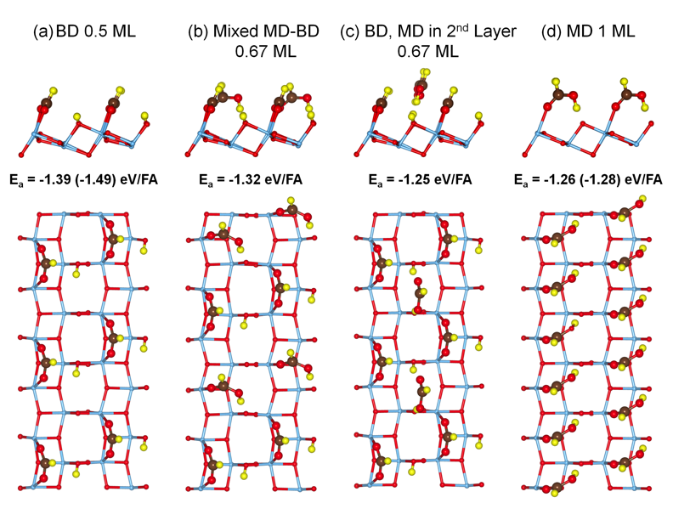
Figure 8. Computed adsorption structures and energies of selected high-coverage configurations of FA on anatase TiO₂(101): (a) deprotonated BD configuration, 0.5 ML; b) mixed molecular MD - deprotonated BD, 0.67 ML; c) the first layer of deprotonated BD species with the second layer of molecular MD species hydrogen-bonded to surface O_{2c} atoms, 0.67 ML; (d) molecular MD layer, 1.0 ML. Adsorption energy values in parentheses refer to the reduced surface with a subsurface V_{O}.

The computed structure for the mixed MD-BD overlayer in the STM image of Figure 7f is shown in Figure 8b. The overlayer is composed of alternating dissociatively-bound BD and molecularly-bound MD species on Ti_{5c} sites with an overall coverage 0.67 ML. The decrease in the binding energy resulting from the increased coverage on the stoichiometric surface is small, from -1.39 to -1.32 eV/FA. This suggests that increasing coverage by forming such a mixed layer is preferred over adding FA molecules into the second layer. The adsorption energy of analogous structure (not shown) where both MD and BD species are deprotonated on the stoichiometric surface is -1.28 eV/FA. This is only slightly less favorable as compared to -1.32 eV/FA for the MD is molecular.
An alternative 0.67 ML structure that builds on the saturation BD layer (Figure 8a) is shown in Figure 8c. Here, two additional FAs are hydrogen-bonded to surface O_{2c} sites. While the adsorption energy of -1.25 eV/FA is slightly less favorable, this structure allows for further coverage increase up to 0.75 ML. These results suggest that different configurations may be present on the surface. Although not observed experimentally, even higher coverage is in principle possible when all FA molecules are bound as MD species (Figure 8d). The computed adsorption energy for this configuration is -1.26 eV/FA, indicating that it is quite favorable.

SUMMARY
We have carried out detailed structural studies of formic acid (FA) adsorption and deprotonation on anatase TiO₂(101) at low temperatures (< 300 K). The combination of high-resolution imaging via STM with spectroscopic characterization via IRAS and ESD and computational studies via DFT yield a complex molecular view of the adsorption configurations as a function of coverage and temperature.
At very low coverages, FA pairs are observed on the surface due to adsorption from the gas-phase dimers. We find that FA binds in the form of a monodentate (MD) species on top of the undercoordinated Ti_{5c} sites. DFT calculations suggest that these species are deprotonated and are stabilized by subsurface oxygen vacancies. The deprotonated nature of the isolated MD species is further supported by IRAS and ESD studies. These species are metastable and convert readily to deprotonated bidentate (BD) formate upon annealing to 150 K. The BD species occupy two neighboring Ti_{5c} sites along the rows. In accord with these findings, our DFT calculations show that the isolated BD structure is thermodynamically preferred, and the barrier for the MD → BD conversion is rather small (~0.3 eV).
At intermediate coverages, clustering of the surface species is observed even at 80 K, indicating the transient mobility of adsorbing FA in the precursor state before chemisorption. In this regime, BD species become more populated, and the annealing to elevated temperatures results in further conversion of MD to BD formate.
As the coverage is further increased, the molecular MD species are found to be stabilized when spatially constrained to a single available Ti_{5c} site between two BD species. The stabilization of the MD species continues and results in the saturation overlayer with alternating molecular MD and deprotonated BD species and coverage of 0.67 ML. The DFT calculations demonstrate that this overlayer is energetically favored and the broad IRAS features indicate that other high-coverage configurations may be possible. This overlayer is stable even upon annealing to 245 K.
Overall, our studies show that the deprotonated BD species are not as dominant on anatase TiO₂(101) as on rutile TiO₂(110) and other oxides, making this surface rather unique. This is likely a consequence of the large spacing between the Ti_{5c} sites, making the MD adsorption configuration closer in energy to the BD configuration.

ASSOCIATED CONTENT
Supporting Information. Section S1, Sample Orientation for TPD and IRAS Measurements; Section S2, TPD Measurements of the Saturation Coverage of Formic Acid on Ti_{5c} Sites; Section S3, Calculations of Gas-Phase Monomer and Dimer Structures; Section S4, Imaging Induced Conversion of the Nearest-Neighbor FA Pair to Second-Nearest-Neighbor FA Pair; Section S5, Structures and Adsorption Energies Calculated for FA Different Pairs; Section S6, Comparison of IRAS Spectra of HCOOH and DCOOD Isotopologues; Section S7, Dose Temperature-Dependent IRAS Spectra; Section S8, Annealing Induced Development of Ordered Saturation Layer.
AUTHOR INFORMATION
Corresponding Authors
* AS email: aselloni@Princeton.edu, NGP email: Nikolai.Petrik@pnnl.gov, ZD email: Zdenek.Dohnalek@pnnl.gov.
ACKNOWLEDGMENT
YW, AD, GAK, RR, AS, and ZD were supported by the US Department of Energy (DOE), Office of Science, Office of Basic Energy Sciences (BES), Division of Chemical Sciences, Geosciences and Biosciences (CSGB) under FWP 47319. BW and AS acknowledge the support of DOE BES, CSGB Division under Award DESC0007347. The experimental studies were performed in EMSL, a national scientific user facility sponsored by the Department of Energy’s Office of Biological and Environmental Research and located at Pacific Northwest National Laboratory (PNNL). PNNL is a multiprogram national laboratory operated for DOE by Battelle. We also acknowledge computational resources from the TIGRESS high-performance computer center at Princeton University.

REFERENCES
1. Che, M., Nobel Prize in chemistry 1912 to Sabatier: Organic chemistry or catalysis? Catal. Today 2013, 218, 162-171.
2. Schierz, E. R., The catalytic decomposition of formic acid in acetic anhydride. J. Am. Chem. Soc. 1923, 45, 455-468.
3. Clark, C. H. D.; Topley, B., The catalytic decomposition of formic acid vapour. J. Phys. Chem. 1928, 32, 121-126.
4. Ruelle, P.; Kesselring, U. W.; Namtran, H., Abinitio Quantum-Chemical Study of the Unimolecular Pyrolysis Mechanisms of Formic-Acid. J. Am. Chem. Soc. 1986, 108, 371-375.
5. Saito, K.; Shiose, T.; Takahashi, O.; Hidaka, Y.; Aiba, F.; Tabayashi, F., Unimolecular decomposition of formic acid in the gas phase - On the ratio of the competing reaction channels. J. Phys. Chem. A 2005, 109, 5352-5357.
6. Uemura, Y.; Taniike, T.; Tada, M.; Morikawa, Y.; Iwasawa, Y., Switchover of reaction mechanism for the catalytic decomposition of HCOOH on a TiO₂(110) surface. J. Phys. Chem. C 2007, 111, 16379-16386.
7. Larsson, R.; Jamroz, M. H.; Borowiak, M. A., On the catalytic decomposition of formic acid. I. The activation energies for oxide catalysis. J. Mol. Catal. A-Chem. 1998, 129, 41-51.
8. Liu, Y.; Li, Z. H., Adsorption and decomposition mechanism of formic acid on the Ga₂O₃ surface by first principle studies. Surf. Sci. 2017, 656, 86-95.
9. Jeong, B.; Jeon, H.; Toyoshima, R.; Crumlin, E. J.; Kondoh, H.; Mun, B. S.; Lee, J., Dehydration Pathway for the Dissociation of Gas-Phase Formic Acid on Pt(111) Surface Observed via Ambient-Pressure XPS. J. Phys. Chem. C 2018, 122, 2064-2069.
10. Bowker, M.; Stone, P.; Bennett, R.; Perkins, N., Formic acid adsorption and decomposition on TiO₂(110) and on Pd/TiO₂(110) model catalysts. Surf. Sci. 2002, 511, 435-448.
11. Koos, A.; Solymosi, F., Production of CO-Free H₂ by Formic Acid Decomposition over Mo₂C/Carbon Catalysts. Catal. Lett. 2010, 138, 23-27.
12. Diebold, U., The Surface Science of Titanium Dioxide. Surf. Sci. Rep. 2003, 48, 53-229.
13. Pang, C. L.; Lindsay, R.; Thornton, G., Chemical reactions on rutile TiO₂(110). Chem. Soc. Rev. 2008, 37, 2328-2353.
14. Setvin, M.; Wagner, M.; Schmid, M.; Parkinson, G. S.; Diebold, U., Surface point defects on bulk oxides: Atomically-resolved scanning probe microscopy. Chem. Soc. Rev. 2017, 46, 1772-1784.
15. Aizawa, M.; Morikawa, Y.; Namai, Y.; Morikawa, H.; Iwasawa, Y., Oxygen vacancy promoting catalytic dehydration of formic acid on TiO₂(110) by in situ scanning tunneling microscopic observation. J. Phys. Chem. B 2005, 109, 18831-18838.
16. Grinter, D. C.; Woolcot, T.; Pang, C. L.; Thornton, G., Ordered Carboxylates on TiO₂(110) Formed at Aqueous Interfaces. J. Phys. Chem. Lett. 2014, 5, 4265-4269.
17. Henderson, M. A., Complexity in the decomposition of formic acid on the TiO₂(110) surface. J. Phys. Chem. B 1997, 101, 221-229.
18. Hu, S. L.; Bopp, P. A.; Osterlund, L.; Broqvist, P.; Herrnansson, K., Formic Acid on TiO_{2-x}(110): Dissociation, Motion, and Vacancy Healing. J. Phys. Chem. C 2014, 118, 14876-14887.
19. Luschtinetz, R.; Gemming, S.; Seifert, G., Anchoring functional molecules on TiO₂ surfaces: A comparison between the carboxylic and the phosphonic acid group. Eur. Phys. J Plus 2011, 126, 98.
20. Mattsson, A.; Hu, S. L.; Hermansson, K.; Osterlund, L., Adsorption of formic acid on rutile TiO₂(110) revisited: An infrared reflection-absorption spectroscopy and density functional theory study. J. Chem. Phys. 2014, 140, 034705.
21. Onishi, H.; Aruga, T.; Egawa, C.; Iwasawa, Y., Adsorption of CH₃OH, HCOOH and SO₂ on TiO₂(110) and stepped TiO₂(441) Surfaces. Surf. Sci. 1988, 193, 33-46.
22. Busca, G., Infrared studies of the reactive adsorption of organic molecules over metal oxides and of the mechanisms of their heterogeneously-catalyzed oxidation. Catal. Today 1996, 27, 457-496.
23. Pang, C. L.; Lindsay, R.; Thornton, G., Structure of Clean and Adsorbate-Covered Single-Crystal Rutile TiO₂ Surfaces. Chem. Rev. 2013, 113, 3887-3948.
24. Sayago, D. I.; Polcik, M.; Lindsay, R.; Toomes, R. L.; Hoeft, J. T.; Kittel, M.; Woodruff, D. P., Structure determination of formic acid reaction products on TiO₂(110). J. Phys. Chem. B 2004, 108, 14316-14323.
25. Morikawa, Y.; Takahashi, I.; Aizawa, M.; Namai, Y.; Sasaki, T.; Iwasawa, Y., First-principles theoretical study and scanning tunneling microscopic observation of dehydration process of formic acid on a TiO₂(110) surface. J. Phys. Chem. B 2004, 108, 14446-14451.
26. Linsebigler, A. L.; Lu, G. Q.; Yates, J. T., Photocatalysis on TiO₂ Surfaces - Principles, Mechanisms, and Selected Results. Chem. Rev. 1995, 95, 735-758.
27. Xu, M. C.; Gao, Y. K.; Moreno, E. M.; Kunst, M.; Muhler, M.; Wang, Y. M.; Idriss, H.; Woll, C., Photocatalytic Activity of Bulk TiO₂ Anatase and Rutile Single Crystals Using Infrared Absorption Spectroscopy. Phys. Rev. Lett. 2011, 106, 138302.
28. Jun, Y. W.; Casula, M. F.; Sim, J. H.; Kim, S. Y.; Cheon, J.; Alivisatos, A. P., Surfactant-assisted elimination of a high energy facet as a means of controlling the shapes of TiO₂ nanocrystals. J. Am. Chem. Soc. 2003, 125, 15981-15985.
29. Lazzeri, M.; Vittadini, A.; Selloni, A., Structure and energetics of stoichiometric TiO₂ anatase surfaces. Phys. Rev. B 2001, 63, 155409.
30. Yang, H. G.; Sun, C. H.; Qiao, S. Z.; Zou, J.; Liu, G.; Smith, S. C.; Cheng, H. M.; Lu, G. Q., Anatase TiO₂ single crystals with a large percentage of reactive facets. Nature 2008, 453, 638-41.
31. Kou, L.; Frauenheim, T.; Rosa, A. L.; Lima, E. N., Hybrid Density Functional Calculations of Formic Acid on Anatase TiO₂(101) Surfaces. J. Phys. Chem. C 2017, 121, 17417-17420.
32. Nilsing, M.; Lunell, S.; Persson, P.; Ojamae, L., Phosphonic acid adsorption at the TiO₂ anatase (101) surface investigated by periodic hybrid HF-DFT computations. Surf. Sci. 2005, 582, 49-60.
33. Vittadini, A.; Selloni, A.; Rotzinger, F. P.; Gratzel, M., Formic acid adsorption on dry and hydrated TiO₂ anatase (101) surfaces by DFT calculations. J. Phys. Chem. B 2000, 104, 1300-1306.
34. Xu, M. C.; Noei, H.; Buchholz, M.; Muhler, M.; Woll, C.; Wang, Y. M., Dissociation of formic acid on anatase TiO₂(101) probed by vibrational spectroscopy. Catal. Today 2012, 182, 12-15.
35. Wang, Z. T.; Wang, Y. G.; Mu, R.; Yoon, Y. H.; Dahal, A.; Schenter, G. K.; Glezakou, V. A.; Rousseau, R.; Lyubinetsky, I.; Dohnalek, Z., Probing equilibrium of molecular and deprotonated water on TiO₂(110). Proc. Natl. Acad. Sci. U. S. A. 2017, 114, 1801-1805.
36. Petrik, N. G.; Kimmel, G. A., Nonthermal Water Splitting on Rutile TiO₂: Electron-Stimulated Production of H₂ and O₂ in Amorphous Solid Water Films on TiO₂(110). J. Phys. Chem. C 2009, 113, 4451-4460.
37. Petrik, N. G.; Huestis, P. L.; LaVerne, J. A.; Aleksandrov, A. B.; Orlando, T. M.; Kimmel, G. A., Molecular Water Adsorption and Reactions on a-Al₂O₃(0001) and a-Alumina Particles. J. Phys. Chem. C 2018, 122, 9540-9551.
38. Setvin, M.; Daniel, B.; Mansfeldova, V.; Kavan, L.; Scheiber, P.; Fidler, M.; Schmid, M.; Diebold, U., Surface preparation of TiO₂ anatase (101): Pitfalls and how to avoid them. Surf. Sci. 2014, 626, 61-67.
39. Schaich, W. L.; Chen, W., Nonlocal Corrections to Fresnel Optics - How to Extend D-Parameter Theory Beyond Jellium Models. Phys. Rev. B 1989, 39, 10714-10724.
40. Chabal, Y. J., Surface Infrared Spectroscopy. Surf. Sci. Rep. 1988, 8, 211-357.
41. Hansen, W. N., Reflection spectroscopy of adsorbed layers. Symp. Faraday Soc. 1970, 4, 27-35.
42. Kimmel, G. A.; Baer, M.; Petrik, N. G.; VandeVondele, J.; Rousseau, R.; Mundy, C. J., Polarization- and Azimuth-Resolved Infrared Spectroscopy of Water on TiO₂(110): Anisotropy and the Hydrogen-Bonding Network. J. Phys. Chem. Lett. 2012, 3, 778-784.
43. Hohenberg, P.; Kohn, W., Inhomogeneous Electron Gas. Phys. Rev. 1964, 136, B864-B871.
44. Kohn, W.; Sham, L. J., Self-Consistent Equations Including Exchange and Correlation Effects. Phys. Rev. 1965, 140, A1133-A1138.
45. VandeVondele, J.; Krack, M.; Mohamed, F.; Parrinello, M.; Chassaing, T.; Hutter, J., Quickstep: Fast and accurate density functional calculations using a mixed Gaussian and plane waves approach. Comput. Phys. Commun. 2005, 167, 103-128.
46. Sun, J.; Ruzsinszky, A.; Perdew, J. P., Strongly Constrained and Appropriately Normed Semilocal Density Functional. Phys. Rev. Lett. 2015, 115, 036402.
47. Calegari Andrade, M. F.; Ko, H. Y.; Car, R.; Selloni, A., Structure, Polarization, and Sum Frequency Generation Spectrum of Interfacial Water on Anatase TiO₂. J Phys Chem Lett 2018, 9, 6716-6721.
48. Goedecker, S.; Teter, M.; Hutter, J., Separable Dual-Space Gaussian Pseudopotentials. Phys. Rev. B 1996, 54, 1703-1710.
49. Perdew, J. P.; Burke, K.; Ernzerhof, M., Generalized Gradient Approximation Made Simple. Phys. Rev. Lett. 1996, 77, 3865-3868.
50. Giannozzi, P.; Baroni, S.; Bonini, N.; Calandra, M.; Car, R.; Cavazzoni, C.; Ceresoli, D.; Chiarotti, G. L.; Cococcioni, M.; Dabo, I., et al., QUANTUM ESPRESSO: a modular and open-source software project for quantum simulations of materials. J Phys Condens Matter 2009, 21, 395502.
51. Hamann, D. R., Optimized norm-conserving Vanderbilt pseudopotentials. Phys. Rev. B 2013, 88, 085117.
52. He, Y. B.; Dulub, O.; Cheng, H. Z.; Selloni, A.; Diebold, U., Evidence for the Predominance of Subsurface Defects on Reduced Anatase TiO₂(101). Phys. Rev. Lett. 2009, 102, 106105.
53. Scheiber, P.; Fidler, M.; Dulub, O.; Schmid, M.; Diebold, U.; Hou, W. Y.; Aschauer, U.; Selloni, A., (Sub)Surface Mobility of Oxygen Vacancies at the TiO₂ Anatase (101) Surface. Phys. Rev. Lett. 2012, 109, 136103.
54. Cheng, H.; Selloni, A., Surface and subsurface oxygen vacancies in anatase TiO₂ and differences with rutile. Phys. Rev. B 2009, 79, 092101.
55. Setvín, M.; Aschauer, U.; Scheiber, P.; Li, Y.-F.; Hou, W.; Schmid, M.; Selloni, A.; Diebold, U., Reaction of O₂ with Subsurface Oxygen Vacancies on TiO₂ Anatase (101). Science 2013, 341, 988-991.
56. Henkelman, G.; Uberuaga, B. P.; Jónsson, H., A climbing image nudged elastic band method for finding saddle points and minimum energy paths. J. Chem. Phys. 2000, 113, 9901-9904.
57. Hebenstreit, W.; Ruzycki, N.; Herman, G. S.; Gao, Y.; Diebold, U., Scanning tunneling microscopy investigation of the TiO₂ anatase (101) surface. Phys. Rev. B 2000, 62, R16334-R16336.
58. Stetsovych, O.; Todorovic, M.; Shimizu, T. K.; Moreno, C.; Ryan, J. W.; Leon, C. P.; Sagisaka, K.; Palomares, E.; Matolin, V.; Fujita, D., et al., Atomic species identification at the (101) anatase surface by simultaneous scanning tunnelling and atomic force microscopy. Nat. Commun. 2015, 6, 7265.
59. Chao, J.; Zwolinski, B. J., Ideal-Gas Thermodynamic Properties of Methanoic and Ethanoic Acids. J. Phys. Chem. Ref. Data 1978, 7, 363-377.
60. Sun, J.; Remsing, R. C.; Zhang, Y.; Sun, Z.; Ruzsinszky, A.; Peng, H.; Yang, Z.; Paul, A.; Waghmare, U.; Wu, X., et al., Accurate first-principles structures and energies of diversely bonded systems from an efficient density functional. Nat. Chem. 2016, 8, 831-836.
61. Tabacchi, G.; Fabbiani, M.; Mino, L.; Martra, G.; Fois, E., The Case of Formic Acid on Anatase TiO₂ (101): Where is the Acid Proton? Angew. Chem., Int. Ed. 2019, 58, 12431-12434.
62. Mattsson, A.; Osterlund, L., Co-adsorption of oxygen and formic acid on rutile TiO₂ (110) studied by infrared reflection-absorption spectroscopy. Surf. Sci. 2017, 663, 47-55.
63. Mattsson, A.; Hu, S. L.; Hermansson, K.; Osterlund, L., Infrared Spectroscopy Study of Adsorption and Photodecomposition of Formic Acid on Reduced and Defective Rutile TiO₂ (110) Surfaces. J. Vac. Sci. Technol. A 2014, 32, 061402.
64. Hayden, B. E.; King, A.; Newton, M. A., Fourier transform reflection-absorption IR spectroscopy study of formate adsorption on TiO₂(110). J. Phys. Chem. B 1999, 103, 203-208.
65. Miller, K. L.; Lee, C. W.; Falconer, J. L.; Medlin, J. W., Effect of water on formic acid photocatalytic decomposition on TiO₂ and Pt/TiO₂. J. Catal. 2010, 275, 294-299.
66. Dahal, A.; Dohnálek, Z., Formation of Metastable Water Chains on Anatase TiO₂(101). J. Phys. Chem. C 2017, 121, 20413-20418.
67. Dahal, A.; Petrik, N. G.; Wu, Y.; Kimmel, G. A.; Gao, F.; Wang, Y.; Dohnálek, Z., Adsorption and Reaction of Methanol on Anatase TiO₂(101) Single Crystals and Faceted Nanoparticles. J. Phys. Chem. C 2019, 123, 24133-24145.
68. Aschauer, U.; He, Y. B.; Cheng, H. Z.; Li, S. C.; Diebold, U.; Selloni, A., Influence of Subsurface Defects on the Surface Reactivity of TiO₂: Water on Anatase (101). J. Phys. Chem. C 2010, 114, 1278-1284.
69. Huygh, S.; Bogaerts, A.; Neyts, E. C., How Oxygen Vacancies Activate CO₂ Dissociation on TiO₂ Anatase (001). J. Phys. Chem. C 2016, 120, 21659-21669.
70. Lang, X. F.; Liang, Y. H.; Sun, L. L.; Zhou, S. X.; Lau, W. M., Interplay between Methanol and Anatase TiO₂(101) Surface: The Effect of Subsurface Oxygen Vacancy. J. Phys. Chem. C 2017, 121, 6072-6080.
71. Zhang, Z.; Du, Y.; Petrik, N. G.; Kimmel, G. A.; Lyubinetsky, I.; Dohnalek, Z., Water as a Catalyst: Imaging Reactions of O₂ with Partially and Fully Hydroxylated TiO₂(110) Surfaces. J. Phys. Chem. C 2009, 113, 1908-1916.
72. Petrik, N. G.; Kimmel, G. A., Hydrogen bonding, H-D exchange, and molecular mobility in thin water films on TiO₂(110). Phys. Rev. Lett. 2007, 99, 196103.

TOC Graphics
