Impacts of Hydrogen Bonding Interactions with Np(V/VI)O₂Cl₄ Complexes: Vibrational Spectroscopy, Redox Behavior, and Computational Analysis.

Mikaela M. Pyrch, Jennifer L. Bjorklund, James M. Williams, Daniel L. Parr IV, Sara E. Mason, Johna Leddy, and Tori Z. Forbes*
Department of Chemistry, University of Iowa, Iowa City, IA 52242, United States
*corresponding author: tori-forbes@uiowa.edu; 319-384-1320

Abstract
The neptunyl (Np(V)O₂⁺/Np(VI)O₂²⁺) cation is the dominate form of ²³⁷Np in acidic aqueous solutions and the stability of the Np(V) and Np(VI) species is driven by the specific chemical constituents present in the system. Hydrogen bonding with the oxo group may impact the stability of these species, but there is a limited understanding of how these intermolecular interactions influence the behavior of both solution and solid-state species. In the current study, we systematically evaluate the interactions between neptunyl tetrachloride species and hydrogen donors in coordination complexes and in the related aqueous solutions. Both Np(V) compounds (N₂C₄H₁₂)₂[Np(V)O₂Cl₄]Cl (Np(V)pipz) and (NOC₄H₁₀)₃[Np(V)O₂Cl₄] (Np(V)morph) exhibit directional hydrogen bonding to the neptunyl oxo group while Np(VI) compounds (NC₅H₆)₂[Np(VI)O₂Cl₄] (Np(VI)pyr) and (NOC₄H₁₀)[Np(VI)O₂Cl₄]Cl (Np(VI)morph) assembles via halogen interactions. Raman spectra of the solid-state phases indicates activation of vibrational bands when there is asymmetry of the neptunyl bond, while these spectral features are not observed within the related solution phase spectra. Density Functional Theory calculations of the Np(V)pipz system suggest that activation of the ν₃ asymmetric stretch and other combination modes lead to the additional complexity within the solid-state spectra. Electrochemical analysis for complexes in the solution phases are consistent with the results from the crystallization experiments as the voltammetric potentials for Np(V)/Np(VI) complexes in the presence of protonated heterocycles differ from potentials for pure Np(V) and may correlate with hydrogen bonding interactions..

Introduction
Neptunium (Np) is a problematic radionuclide within nuclear waste separations due to the difficulty of predicting its chemistry.¹ Np separations processes rely heavily on controlling redox behavior and capitalizing on subtle differences in chemical speciation.²⁻³ Within waste streams, multiple oxidation states can exist for the actinide elements and neptunium can occur as Np(IV), Np(V), and Np(VI) depending on the chemical environment.^{2, 4} In both the pentavalent and hexavalent state, Np forms strong bonds to two oxygen atoms to create a nearly linear neptunyl cation [Np(V)O₂⁺ or Np(VI)O₂²⁺].⁵⁻⁷ Both Np(IV) and Np(VI)O₂²⁺ are extracted in the typical PUREX separation process, but Np(V)O₂²⁺ in this system is considered inextractable.⁸⁻⁹ The redox behavior of neptunium is complex given the propensity to exist in multiple oxidation states, complex speciation behavior, and the variability of ligand binding in aqueous media.¹⁰ Precise control over the redox state of the neptunium in these systems is necessary to achieve optimal separations, but unpredictable behavior can occur because of the lack of information and knowledge about fundamental ²³⁷Np chemistry.
Controlling the redox behavior of Np species in aqueous systems requires a complete understanding of the electrochemical reactivity in the presence of complex matrices, yet discrepancies and challenges remain within even the most simple systems.^{4, 10-13} For instance, Plock determined that the redox behavior for the NpO₂²⁺/NpO₂⁺ couple was reversible in the presence of HClO₄ when using glassy carbon, which Kihara similarly observed using a column electrode system, but reports by Ikeda-Ohno et al. indicated that the process was quasi-reversible in HNO₃ and HClO₄ solutions at a range of concentrations.¹⁴ These discrepancies are compounded by difficulties in collecting high quality data because obtaining single oxidation states in solution for Np is not trivial and spectral signals are often problematic to interpret due to variability in the molar absorptivity of Np species.^{4, 15} In addition, strong intermolecular interactions with the soluble neptunyl species may also impact the redox potential of the Np in solution. Yet low concentrations of Np are detectable in solution with secondary species. For example Casadio et al. used a pyrolytic graphite electrode to demonstrate that cyclic voltammetry can result in both qualitative and quantitative values for 6mM NpO₂²⁺ solutions in 1M HNO₃ in the presence of Pu ions.
To precisely describe these intermolecular interactions and how they impact chemical behavior, we propose classifying them into four unique groups: Actinyl-Actinyl Interactions (AAI), Actinyl-Cation Interactions (ACI), Actinyl-Halogen Interactions (AXI), and Actinyl-Hydrogen Interactions (AHI) (Figure 1). In each case, the lone pair on the actinyl oxo atom (O_{yl}) of the neptunyl engages in a bonding interaction with a neighboring species. The most well-studied interactions are of the AAI type, which was previously designated a cation-cation interaction (CCI).¹⁶⁻²⁰ AAIs are prevalent in both solution and in crystalline materials, but very little is understood about how AAIs influences and perturbs the electronic structure of the neptunium cation.¹⁸ Our previous work focused on the interaction of alkali cations with the oxo groups within the [Np(VI)O₂Cl₄]²⁺ complex or an ACI.²¹ We observed a direct interaction between the oxo group on the Np(VI)O₂²⁺ moiety and the Li⁺ cation that led to variations in the vibrational spectra stemming from the ACI.²¹ Advances in understanding AXIs have more recently been highlighted by Surbella et al.²²⁻²³ As yet, less focus and thus less is understood regarding the final class (AHIs). These interactions, particularly when combined with electrostatics to form charge-assisted hydrogen bonding, may influence the neptunyl bonds and impact the electrochemical potential of Np in solution.

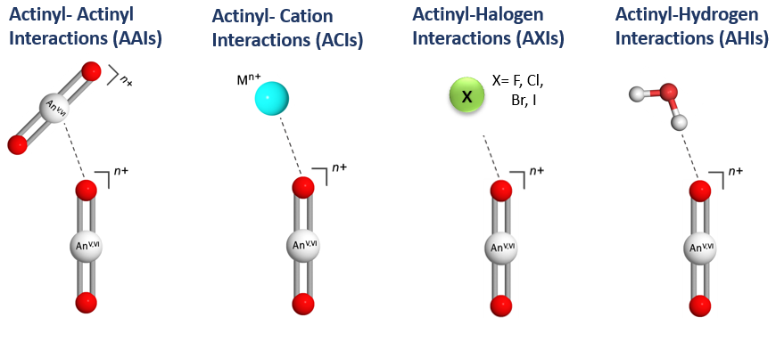
Figure 1. Four primary interactions of the neptunyl cation, from left to right; Actinyl-Actinyl Interactions (AAI), Actinyl-Cation Interactions (ACI), Actinyl-Halogen Interactions (AXI), and Actinyl-Hydrogen Interactions (AHI).

Herein, we report the full characterization of a series of the neptunyl tetrachloride species, [NpO₂Cl₄]^{2-/3-} in the presence of protonated N-heterocycles (Scheme 1). Based upon our previous work, we hypothesized that charge assisted hydrogen bonds would engage more strongly with the neptunyl oxo, further impacting the vibrational spectra and possibly influencing the redox behavior in solution.²⁴⁻²⁵ crystalline materials were synthesized and characterized via single crystal X-ray diffraction and solid-state Raman spectroscopy and then compared to related aqueous solution. Computational vibrational analysis based on density functional theory (DFT) calculations were used to deconvolute the spectral bands and provide information on the relative energetics of possible neptunyl species present in solution. Cyclic voltammetry studies performed in the presence of the heterocyclic cations that yield small potential shifts may correlate with AHI energies in the redox behavior of Np in solution
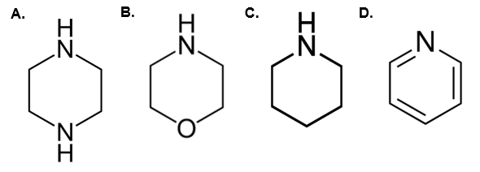
Scheme 1: The four heterocycles utilized in this study are (a) (N₂C₄H₁₂) Piperazine (pipz), (b) (NOC₄H₁₀) Morpholine (morph), (c) (NC₅H₁₁) Piperidine (pip), and (d) (NC₅H₆) Pyridine (pyr).

Experimental Methods
Caution! Neptunium-237 is a highly radioactive alpha emitter. Research with this isotope is restricted to specialized laboratories and must be handled under appropriate regulatory controls. Approximately 400 mg of ²³⁷Np was reprocessed from previous synthetic experiments. After eight hours of ozonolysis, the mixed valent Np(V)/Np(VI) solution was reduced to pure Np(V) using NaNO₂, precipitated with saturated NaOH, re-dissolved in 1 M HClO₄, and further purified by a cation exchange column containing Dowex-50-X8 resin. This purified Np(V) solution was again precipitated with small amounts of NaOH and the gray-green solid was rinsed with ultrapure H₂O three times. The solid Np phase was then dissolved in 1.0 M HCl to serve as the Np(V) stock solution for the crystallization, spectral, and electrochemical experiments. A Packard Tri-Carb Liquid Scintillation Counter was used to determine the concentration of the stock and the Np(V) oxidation state in the solution was confirmed with Raman spectroscopy (Figure S1).
Synthesis of solid-state compounds.
Np(V)pipz (N₂C₄H₁₂)₂[Np(V)O₂Cl₄]Cl: Np(V)pipz was synthesized by adding 200 μL of a 20 mM Np(V)O₂⁺ stock solution to a 10 mL glass vial containing 200 μL of a 0.2 M piperazine solution and 400 μL of methanol. After 2 weeks of slow evaporation, the resulting dark teal crystals formed at the bottom of the vial in significant quantities. Given characterization limitations of the highly radioactive material, quantitative yields could not be determined for any of the solid phases.
Np(V)morph (NOC₄H₁₀)₃[Np(V)O₂Cl₄]: High quality single crystals of Np(V)morph were formed in a similar manner, where 200 μL of a 20 mM Np(V)O₂⁺ stock solution was combined with 200 μL of a 0.1 M morpholine solution and of 400 μL of methanol in a 10 mL glass vial. After 2 weeks of slow evaporation, light green plates formed in moderate yields at the bottom of the vial.
Np(VI)pyr (NC₅H₆)₂[Np(VI)O₂Cl₄]: A 100 μL aliquot of a 100 mM Np(V)O₂⁺ stock solution was mixed with 300 μL of a 0.1 M pyridine solution in a 5 mL glass vial. After 4 weeks of slow evaporation, crystals of Np(VI)pyr formed as yellow plates in high yields.
Np(VI)morph (NOC₄H₁₀)₂[Np(VI)O₂Cl₄]Cl: Np(VI)morph was crystallized from a 300 μL aliquot of a 66 mM Np(V)O₂⁺ stock solution and 200 μL of a 0.1 M morpholine solution. After 2 weeks of slow evaporation to near dryness, yellow-green plates formed in the vial in moderate yields.
Structural Characterization
High quality single crystals of the neptunyl tetrachloride coordination compounds were isolated and mounted on a MiTeGen MicroMount using NVH immersion oil (Cargille Labs) for single-crystal X-ray diffraction. Structural analysis was performed on a Bruker D8 Quest single crystal X-ray diffractometer equipped with a microfocus beam (Mo Kα; λ = 0.71073 Å). Data were collected with the Bruker APEX3 software package²⁶ and peak intensities were corrected for (Lorentz, polarization, background effects, and absorption). The initial structure was solved by intrinsic phasing methods and refined on the basis of F² for all unique data using the SHELXTL version 5 series of programs.²⁷ Np atoms were located by direct methods and the C, O, N, and Cl atoms were found and modeled from the difference Fourier maps. Hydrogen atoms associated with amino group of the morpholinium cations (Np(V)morph and Np(VI)morph) were observed in the Difference Fourier map, but were modeled using the AFIX 23 command at a distance of 0.89 Å. Unit cells associated by Np(V)pipz and Np(VI)pyr were previously reported by Payne et al. and Surbella et al., but were included in this study for consistency and completeness.^{22, 28} Thermal ellipsoids for Np(V)morph and Np(VI)morph are located in the ESI Figure S1 and S2. The crystallographic information files for Np(V)morph and Np(VI)morph can be found on the Cambridge Structural Database by requesting numbers 1972624 and 1972625. Select crystallographic parameters are included in Table 1. Additional information on bond distances and angles were collected and can be found in the supporting information section (Table S1 and S2).

Table 1. Crystallographic information for Np(V)morph and Np(VI)morph.
 | Np(V)morph | Np(VI)morph
Empirical formula | (NOC₄H₁₀)₃ [NpO₂Cl₄] | (NOC₄H₁₀)₂ [NpO₂Cl₄]Cl
Formula weight | 673.17 | 208.55
Space group | P2₁/n | P-1
a (Å) | 7.3582(4) | 9.1938(8)
b (Å) | 20.4362(11) | 9.3020(10)
c (Å) | 4.4158(8) | 10.8819(11)
α (°) | 90 | 92.223(4)
β (°) | 96.690(2) | 113.075(3)
γ (°) | 90 | 113.397(4)
V (Å3) | 2153.0(2) | 764.66(13)
Z | 4 | 1
ρ (g/cm³) | 2.077 | 1.812
μ (mm⁻¹) | 5.349 | 3.956
F(000) | 1288 | 407
θ range for data collection (°) | 2.845 to 26.115° | 2.574 to 25.379°.
Limiting indices | -9≤h≤9, | -11≤h≤11,
 | -25≤k≤25,  -17≤l≤17 | -11≤k≤11,  -13≤l≤13
Reflections collected / unique | 69085/4254 | 18181/ 2786
R_{int} | 0.0373 | 0.0444
Data / restraints / parameters | 4254 / 0 / 228 | 2786 / 0 / 155
GOF on F² | 1.167 | 1.051
Final R indices | R₁ = 0.0124 | R₁ = 0.0189
[I>2σ(I)] | wR₂ = 0.0295 | wR₂ = 0.0377
R indices (all data) | R₁ = 0.0139  wR₂ = 0.0298 | R₁ = 0.0197  wR₂ = 0.0380
Largest diff. peak and hole | 0.349 and -0.699 e.Å-3 | 0.351 and -0.373 e.Å-3

Raman Spectroscopy
Solid-state phase Raman spectra were acquired on a SnRI High-Resolution Sierra 2.0 Raman spectrometer equipped with 785 nm laser energy and 2048 pixels TE-cooled CCD. Laser power was set to the maximum output value of 15 mW, giving the highest achievable spectral resolution of one cm⁻¹. Single crystals of the neptunyl tetrachloride coordination compounds were isolated from the mother liquor and placed on a glass slide with a small amount of NVH immersion oil. Each sample was irradiated and average of the five scans were acquired for the final Raman spectrum. To accurately process the observed Raman signals, the background was subtracted, and multiple peaks were fit using the peak analysis protocol with Lorenzian functions using the OriginPro 9.1.0 (OriginLab, Northampton, MA) 64-bit software. ²⁹
Raman spectra of related neptunyl solutions were collected and analyzed using similar methodology. Spectra for all starting materials were collected and are located in the supporting information (Figure S2-S5). Each solution was placed into a five mL low-background borosilicate glass vial, which is specifically designed for Raman spectroscopy measurements. The neptunyl stock solution was routinely analyzed before every solution measurement and neptunyl speciation during the solid-state crystallization experiments was evaluated by collecting a spectrum of the mother liquor before and after crystallization. To further explore the influence of H-donor concentration on the spectral signals, titration experiments were performed for the piperazinium and morpholinium systems. Aliquots of piperazine and morpholine salts (details provided in Table S5) were added to 300 μL of 66 mM Np(V)O₂⁺ stock. A spectrum was collected after each addition of the H donor and analyzed using the methodology described for the related solid-state materials.

Electrochemical analysis
Cyclic voltammograms (CV) were collected at room temperature for 35 mM neptunyl stock solutions in 1 M HCl with a CHI660E electrochemical analyzer (CH Instruments). All electrochemical measurements were collected in a Pine instruments compact voltammetry cell (total volume = 1 mL) equipped with a 0.62 cm² gold honeycomb screen-printed electrode, gold counter electrode, and a low volume Ag|AgCl (saturated KCl) reference electrode. All four N-donor systems were electrochemically analyzed with experimental conditions shown in Table 2. For each sample, 600µL of 33.3 mM Np (0.02mmol) in 1M HCl was added to cell and the volume of heterocycle is added as noted in Table 2. Because Np(V) reacts with dissolved oxygen to form Np(VI), the open circuit potential (OCP) lies positive of the Np^{V|VI} formal potential. To collect voltammograms starting at zero current, the potential was held at 0.5 V vs Ag|AgCl for 60 seconds before each cyclic voltammogram was recorded. Scan rates of 10 mV/s, 25mV/s , 50mV/s , and 100mV/s were carried out for each Np solution and are found in Figure S15-S18. A potential hold of 60 s was determined to be sufficient because potentials held for 120 and 180 s produced similar voltammograms. The pH of the solutions were measures using a micro LE422 electrode from Mettler Toledo that is suitable for small sample sizes.
Table 2: Experimental conditions for the electrochemical analysis of the neptunyl chloride system.
Sample | Np(V) in 1M HCl | piperazine | morpholine | pyridine | piperidine
Volume/weight of Heterocycle | N/A | 0.007g | 10 µL | 20µL | 20 µL
Mol heterocycle | N/A | 0.080 mmol | 1.10 mmol | 0.25 mmol | 0.20 mmol
Total approx. volume | 600 µL | 600 µL | 610 µL | 620 µL | 620 µL
pH | 0.22 | 0.46 | 0.45 | 0.50 | 0.32

Computational Methodology
DFT calculations were performed on isolated (non-periodic) [NpO₂Cl₄]³⁻ units that engaged with zero to four countercations. The piperazinium cation was specifically chosen for the modeling to systematically probe AHI interactions with the Np(V)O₂⁺ moiety based upon the features observed in the structural and Raman spectroscopy analysis (vide infra). Initial atomic coordinates of [NpO₂Cl₄]³⁻ crystallized with piperazinium cations were taken directly from the crystallographic information file. In the subsequent geometry optimizations, all atoms were allowed to fully relax without symmetric constraints to within an energy tolerance of 0.03 meV, corresponding to a residual force on the atoms no greater than 5 meV/Å. All DFT calculations were performed using the Turbomole 7.2 package at the hybrid Becke 3-parameter Lee-Yang-Parr (B3-LYP) level.³⁰⁻³¹ The default polarized triple zeta (def-TZVP) basis set was used for all atoms, and the Stuttgart small-core (60 core electrons) relativistic effective core potential (RECP) was used to treat the Np atom.³²⁻³³ To simulate aqueous solvent conditions, the continuum solvent model COSMO was used with a dielectric constant (ε) of 78.54.³⁴
Results and Discussion
Structural characterization of [Np(V/VI)O₂Cl₄]^{2-/3-} Coordination Compounds
The neptunyl tetrachloride coordination complex is the primary building unit of the four phases described herein, where the structures vary based upon the oxidation state of the Np cation (Figure 2). The neptunyl (Np=O) bond lengths for Np(V)pip and Np(V)morph range between 1.830(1) and 1.853(2) Å, which are fully consistent with the Np(V) oxidation state based upon previously characterized compounds. The corresponding O=Np=O bond angle for both compounds are nearly linear (178.6 and 178.9°) and the equatorial Np-Cl bonds range between 2.7358(7) to 2.7772(6) Å. The two Np(VI) complexes, Np(VI) morph and Np(VI)pyr, crystallized from an initial Np(V) solution. While Np(V) is favored in aqueous solutions, disproportionation of NpO₂⁺ to NpO₂²⁺ occurs under acidic conditions and more concentrated neptunyl solution.^{11, 16, 20, 35} The disproportionation lends itself to the crystallization of Np(VI) morph and Np(VI)pyr from a Np(V) stock during the evaporation process. In both cases, the average Np=O and Np-Cl bond distances are 1.751 and 2.666 Å and the O=Np=O bond angle is 180°. The [Np(VI)O₂Cl₄]²⁻ has been previously crystallized using a range of charge balancing cations and the current results are consistent with the observed neptunyl bond lengths, which range between 1.740-1.760 Å.^{21-22, 36-38}
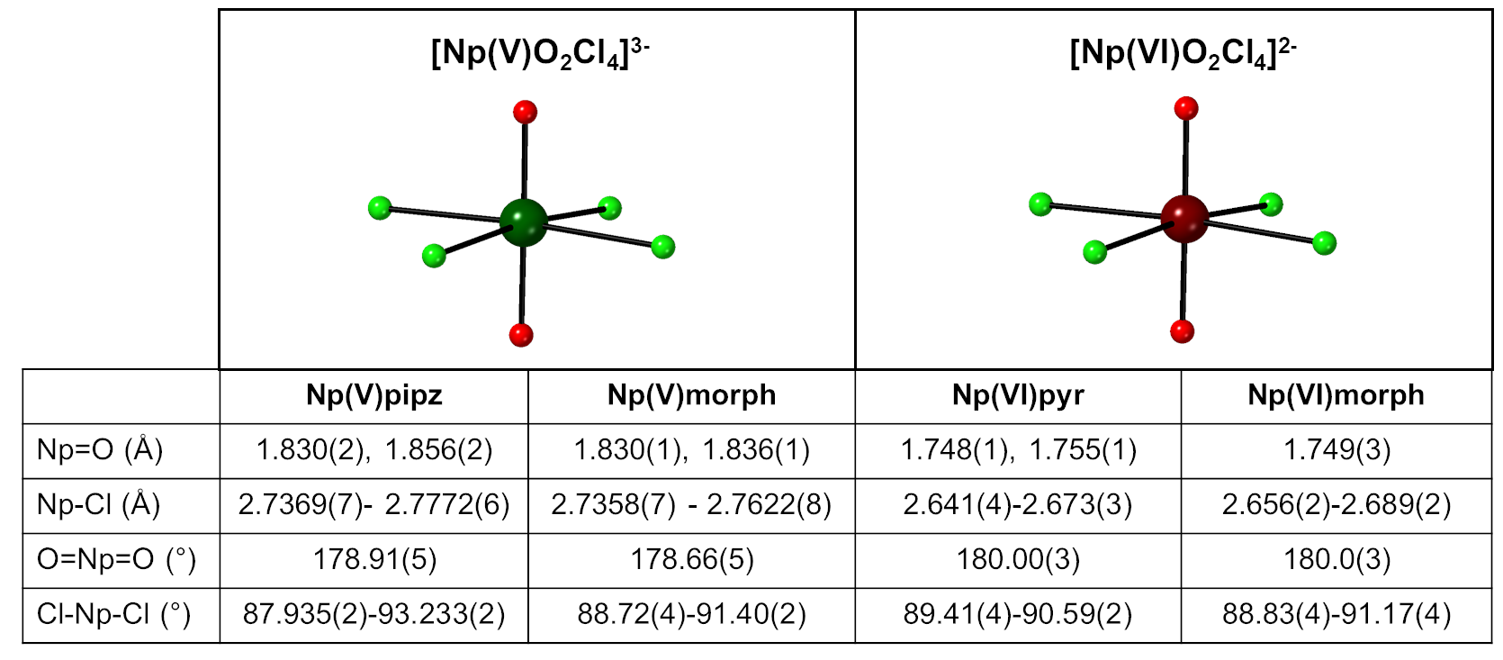
Figure 2. The neptunyl tetrachloride complexes observed in the four coordination compounds (Np(V)pip, Np(V)morph, Np(VI) morph, and Np(VI) pyr). The Np(V), Np(VI), Cl, and O atoms are represented by dark green, maroon, light green, and red spheres, respectively. The table contains bond distance and angles for the [Np(V)O₂Cl₄]³⁻ and [Np(VI)O₂Cl₄]²⁻ complexes. Np(V)pipz and Np(VI)pyr was also previously reported by Payne et al. and Surbella et al., respectively, but is included here for completeness.^{22, 28}
While all four compounds contain the neptunyl tetrachloride species, the identity of the charge balancing heterocycles differ (Figure 3). The Np(V) tetrachloride coordination complex can be crystallized in the presence of either piperazinium or morpholinium cations, whereas the hexavalent species are formed in the presence of pyridinium or morpholinium cations. We previously reported the Np(V)pipz material as the first coordination compound to contain the [Np(V)O₂Cl₄]³⁻ species and now find the same species in the presence of the morpholinum cation (Np(V)morph). This is important to note because the hexavalent [Np(VI)O₂Cl₄]²⁻ complex has been previously observed to crystallize under a range of experimental conditions and counterions (e.g. alkali, alkylammonium, heterocycles), whereas the [Np(V)O₂Cl₄]³⁻ species is rarely observed in solid state materials. Helliwell et al., previously noted that the Np(VI) tetrachloride species was unusually stable, but there was not additional experimental evidence available to evaluate the stability.³⁸
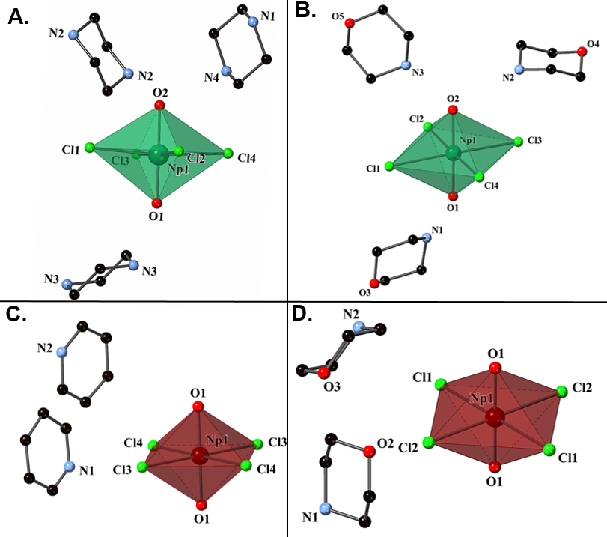Figure 3. [Np(V)O₂Cl₄]³⁻ coordination complexes crystallize in the presence of (A) piperazinium (Np(V)pipz) and (B) morpholinium cations (Np(V)morph). The [Np(VI)O₂Cl₄]²⁻ anion forms a solid phase in the presence of either (C) pyridinium (Np(VI)pyr) or (D) morpholinium (Np(VI)morph). Np(VI) polyhedral is maroon, Np(V) polyhedral is dark green while O, C, N, Cl, are red, black, blue, and lime green, spheres respectively.
During the crystallization process, we noticed that the choice of the heterocycle led to differences in the final oxidation state of the neptunyl tetrachloride coordination compound. Use of piperazine in the presence of the Np(V) stock solution resulted in the crystallization of Np(V)pip, and the synthesis is highly reproducible. Np(V)morph could be precipitated using freshly prepared Np(V) stock solutions along with faster evaporation times (two weeks versus one month for Np(VI)morph). Switching to the pyridinium cation resulted in the oxidation of the Np(V) stock to form Np(VI)pyr and Np(V) complexes were not able to be crystallized under these conditions. Surbella et al. note the same redox behavior in their synthesis when combining pyridine with an initial Np(V) solution.²² The piperidinium cation was also evaluated but no solid state material was produced during the course of these reactions.
Additional investigation of the structural features in the solid also suggested that H-bonding interactions, and more specifically AHIs may play a role in the stability of the [Np(V)O₂Cl₄]³⁻ coordination complex. In the case of Np(V)pip, the asymmetric unit is completed with two piperazinium cations and a single interstitial chloride. Three unique H∙∙∙O=Np interactions are observed, with hydrogen-acceptor distances of 1.881, 1.999, and 2.109 Å (Fig. 2a). Within the Np(V)morph compound, three protonated morpholinium cations are located around the [NpO₂Cl₄]³⁻ complex engaged in AHIs. Two unique H∙∙∙O=Np interactions can be seen, with hydrogen-acceptor distances of 1.899 and 1.849Å. These AHIs are not observed within the [Np(VI)O₂Cl₄]²⁻ coordination compound, where the extended structures of Np(VI) morph and Np(VI)pyr form through halogen interactions. These bonding interactions for Np(VI)morph occur through halogen-hydrogen interactions at the interstitial chloride with distances of N-H∙∙∙Cl distances of 3.139, 3.140, 3.391, 4.558, and 4.808 Å. Similar features are found within the Np(VI)pyr compound with acceptor-donor distances from the chloride to nitrogen at 3.351, 3.497, 3.549 Å. Presence of AHIs within the Np(V) species and lack of them within the Np(VI) system is not entirely surprising given the changes in the electronic structure between the NpO₂⁺ and NpO₂²⁺ moieties. The stronger bonding interaction within the NpO₂²⁺ cation will decrease the Lewis basicity of the oxo group and create a weaker H-acceptor group. Weakening of the neptunyl bond within NpO₂⁺ will lead to additional interactions with the oxo group and a higher likelihood of inducing AHIs.
While AHIs occur within the Np(V) compounds, the bonds are considered relatively weak. Hydrogen bonds are electrostatic interactions, the strength of which falls between Van der Waal interactions and covalent bonds.³⁹ Using a dichotic characterization of very strong bonds and normal or weak bonds based upon that of Hay, we begin to classify these bonds from bond lengths and bond angles.⁴⁰ Very strong bonds have a narrow range of bond lengths, being between 1.2 to 1.5 Å from H atom to the acceptor with an angle of approximately 180°. Normal or weak bonds have a broad range of bond lengths from 1.5 to 3.0 Å for the hydrogen to acceptor and bond angles of 160 ± 20°. Under these classifications the bonds for Np(V)pipz being normal to weak, and Np(V)morph also being normal to weak. While these interactions may be considered weak, they do seem to have an impact on the structural features, most notable with the asymmetric (Np(V)pipz) and elongated (Np(V)morph) neptunyl bond lengths that are observed within the solid-state compounds.
From these initial crystallization processes, we note that AHIs occur within Np(V) tetrachloride coordination compounds and are absent in the case of the analogous Np(VI) system. These interactions have apparent impact on certain structural features, but it is unclear how much, if any, that these interactions influence other chemical properties. In the next section, we will evaluate the vibrational bands associated with the solid-state compounds and related solution state species to provide additional insight in the bond perturbation caused by AHIs.
Raman spectroscopy
Solid State Raman Spectroscopy
The solid-state Raman spectra were collected for all four neptunyl tetrachloride coordination compounds and the spectral windows of interest (600-900 cm⁻¹) for the neptunyl features depicted in Figure 4. Full spectra of the solid state compounds and starting materials can be found in the supporting information section (Fig S3-S10). Bands between 1000-1100 cm⁻¹ are associated with the heterocycles as evidenced by previous literature results ⁴¹⁻⁴³ and additional features within the spectral window of interest include the band at 815 cm⁻¹ for piperazinium, and 826, 836, and 912 cm⁻¹ for morpholinium. There are five bands at 670, 681, 725, 758, and 823 cm⁻¹ that are unaccounted for in the Np(V)pipz spectrum and two at 717 and 734 cm⁻¹ within the Np(V)morph compound. Typically, the ν₁ symmetric stretch is the only Raman active band for the actinyl cation, but the ν₃ asymmetric stretch can be present if the symmetry of the actinyl cation decreases from D_{∞h} to C_{∞v}.⁴⁴ The crystallographic data suggests that in the case of Np(V)pipz, this asymmetry does occur as the bond distances differ by 0.023 A. However, this is not the case for the Np(V)morph structure, where the bond distances differ by 0.006 A. Additional interactions within the crystalline lattice may activate combination modes due to concerted motion of the neptunyl cation and neighboring ligands. In the case of the Np(VI)morph and Np(VI)pyr solids, the neptunyl symmetric stretching vibration (ν₁) can be identified as the band at 821 and 795 cm⁻¹, respectively. With the Np(VI)pyr compound, this band position is similar to previous reported values for the [NpO₂Cl₄]²⁻ complexes (795 to 805 cm⁻¹),^{21, 38, 45} but there is a substantial blue-shift of the (ν₁) (16 cm⁻¹) for Np(VI)morph. There are two additional weak bands at 609 and 636 cm⁻¹ in Np(VI)pyr, but those modes can be attributed to the piperazinium cation.^{41-42, 46-47}

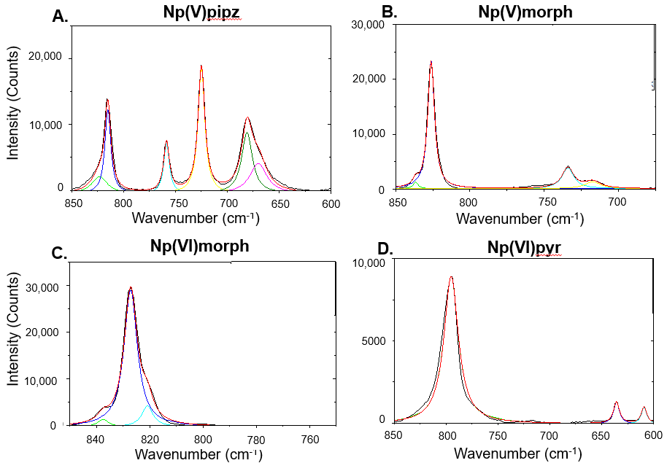
Figure 4. Solid state Raman spectra of crystalline solids (a) Np(V)pipz, (b) Np(V)morph, (c) Np(VI) morph, (d) Np(VI)pyr.

Solution Phase Raman Spectroscopy
Aqueous phase speciation and the presence of AHIs were evaluated directly through additional solution state studies. Initially, the neptunyl stock solution in 1 M HCl was analyzed using methods described in the experimental methods section. The major band in the spectrum of the neptunyl stock associated with the [Np(V)O₂]⁺ symmetric stretching (ν₁) band and is located at 767 cm⁻¹ . Addition of the heterocycles (piperazine, morpholine, piperadine, and pyridine) do not impact the ν₁ peak position. Bands associated with the ligands also occur within this spectral window of interest and the major peaks within the solutions are summarized in Table S4.
Based upon the crystallization studies, the piperazinium and morpholinium cations are more likely to engage in the AHIs and were used for the titration studies to further investigate if these interactions can be induced with increasing ligand concentration (Fig. 5a) The solution spectra of Np(V) pyridine and Np(V) pipiridine were collected and found in Figure S10-S11. With the initial addition of solid piperazine to the Np stock solution to create a 1:2 pip:Np ratio, the major band at 816 cm⁻¹ (N-H stretching mode of piperazine molecule) increases, but the NpO₂⁺ symmetric stretch remains at 765 cm⁻¹. Additional peak fitting of the spectral features indicates that the full-width half-max (FWHM) for the peaks within these spectra are 12.2 and 30.0 cm⁻¹ for the N-H and O=Np=O stretches, respectively. Subsequent additions of the piperazine solid to the neptunyl solution results in no changes to the peak centroids associated with the two major stretching bands. As the piperazine concentration increases, the FWHM decreases by 4 and 11.2 cm⁻¹ for the N-H and neptunyl stretching modes, respectively. For the morpholinium system, the Raman spectral window of interest for the Np:Morph ratio of 1:2 displayed four peak centroids (Fig. 5b). Three of the peaks at 876, 839 and 824 cm⁻¹ correspond to morpholine bands, while a signal at 766 cm⁻¹ is assigned to the NpO₂⁺ ν₁ symmetric stretching. The FWHM for the peak centroids are as follows: 7.55, 7.5, 7.3 and 20.4, for the 876, 839, 824, and 766 cm⁻¹ bands, respectively. With the subsequent additions of morpholine (Np:morph ratios of 1:6 and 1:8), the peak centroid of the neptunyl band remains unchanged while FWHM decreases from 20 to 14 cm⁻¹ as the ratio of morpholine to Np increases.

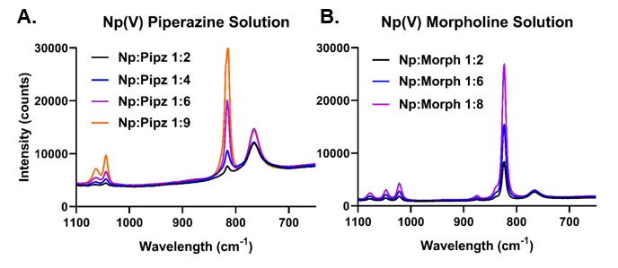
Figure 5. Raman spectra for the solution titration experiments (A) of Np(V) with piperazine and (B) Np(V) with morpholine. Individual fits for the titration experiments are found in Figure S12 and S13 with a table summarizing the peak centers, FWHM , and areas in Table S5.
Previous solution phase Raman titrations that evaluated actinyl-cation interactions (ACIs) between Np(VI)O₂²⁺ and Li⁺ noted the appearance of a new spectral feature with increasing concentration of LiCl solid that is not induced with AHIs.^{21, 48} In our previous study, lower Li⁺ ratios (2.4 M Li) the NpO₂²⁺ symmetric stretching band was unaffected, yet subsequent additions of Li⁺ resulted in the appearance of a new, second band that was red-shifted by approximately 40 cm⁻¹. Appearance of the second band was indicative of an ACI between the Li⁺ cation and neptunyl oxo, which elongated and weakened the neptunyl bond. This interaction was further investigated and confirmed by additional DFT calculations. In the case of the neptunyl and piperazine or morpholine, the absence of peak shifts indicates that there is no perturbation to the bond, further supported by no apparent spectral shift or ingrowth of a secondary band in any of the Raman spectra. It was noted in both the morpholinium and piperazinium titration study that the FHWM of the neptunyl band decreases with increasing concentration of the heterocycle. This decrease could be the result of a more structured environment for the neptunyl cation as the result of hydrogen bonding interactions with the neptunyl within a second coordination sphere.⁴⁹ To further explore the expected vibrational bands associated with AHI interactions and the energetics of this interaction, we turn to DFT calculations for the [Np(V)O₂Cl₄]³⁻ species.

Density Functional Theory Calculations
Solid state characterization of the systems (both single crystal X-ray diffraction and Raman spectroscopy) indicated that the piperazinium cation was the most likely heterocycle to engage in AHIs to the Np(V)O₂²⁺; thus, the neptunyl piperazinium system was selected for additional analysis by DFT calculations. Isolated [NpO₂Cl₄]³⁻ and systems of [NpO₂Cl₄]³⁻ interacting with one, two, three, and four piperazinium cations were modeled for this work. Our naming scheme for the structures is as follows: two unique structures for [NpO₂Cl₄]³⁻ interacting with one cation were obtained, referred to as Np pipz 1A (Figure 6A) and Np pipz 1B (Figure 6B). The remaining structures with two, three, and four cations are referred to as Np pipz 2 (Figure 7A), Np pipz 3 (Figure 7B), and Np pipz 4 (Figure 7C), respectively. The details of the structures, vibrational analysis, and energetics are discussed below.

AHIs between [NpO₂Cl₄]³⁻ and one piperazinium cation
To isolate and study AHIs between countercations and [NpO₂Cl₄]³⁻, we first model the unit interacting with a single piperazinium molecule. Characterization of the Np(V)pipz crystal structure revealed two different neptunyl bond lengths: 1.830(2) Å (referred to as O1) and 1.853(2) Å (referred to as O2). Two distinct and [NpO₂Cl₄]³⁻piperazinium geometries were initialized, wherein the cation interacts with either of the axial oxygen atoms (O1 or O2). Upon geometry optimization, the two structures (Np pipz 1A and Np pipz 1B) exhibit nearly identical neptunyl subunits, but exhibit different hydrogen bond length to the piperzainum, which is also distinctly oriented, as shown in Figure 6. The DFT total energies for these two geometries are within 0.02 eV. In both Np pipz 1A and Np pipz 1B, the Np=O bond lengths are 1.85 and 1.81 Å, with corresponding Np=O∙∙∙H distances of 1.54 and 1.65 Å. Changes in the neptunyl distances from the isolated neptunyl tetrachloride species suggest that the Np=O bond involved in the AHI elongates, while the non-interacting axial oxygen bonds shorten.

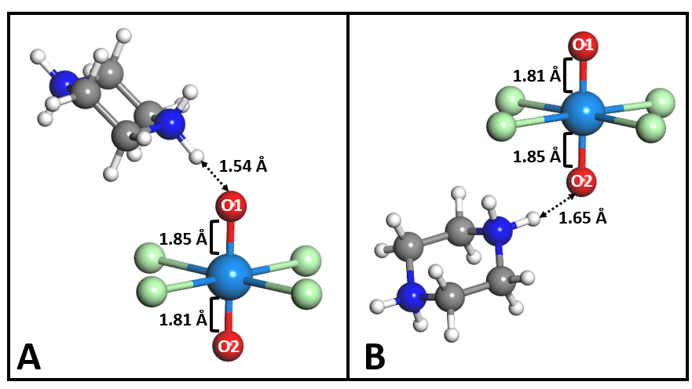
Figure 6. Ball and stick representations of the DFT geometry-optimized single piperazinium cation structures, where A corresponds to Np pipz 1A; and B was corresponding to Np pipz 1B. The Np, Cl, O, N, C, and H atoms are colored teal, light green, red, blue, gray, and white, respectively. The hydrogen bonds between the axial oxygen atoms are shown with dashed line arrows and the distances are labeled.

Neptunyl interactions with multiple piperazinium cations
The final optimized geometries for Np pipz 2, Np pipz 3, and Np pipz 4 are depicted in Figure 7. As shown in Figure 7A, the Np pipz 2 structure has equivalent Np=O bonds (1.84 Å) and two distinct hydrogen bond distances of1.60 Å to O1 (D-H∙∙∙A = 2.66 Å) and 1.64 Å to O2 (D-H∙∙∙A = 2.69 Å). With the addition of a third piperazinium cation (Np pipz 3, Figure 7B), only two of the three piperazinium cations engage O2 in hydrogen bonds, with lengths of 1.71 and 1.78 Å (D-H∙∙∙A = 2.76 and 2.78 Å). In this case, the third cation moved from the initial position to engage in H∙∙∙Cl interactions with the equatorial chloride ligands, forming two longer hydrogen bonds (2.09 and 2.26 Å (D-H∙∙∙A = 3.13 and 3.20 Å)). Also in the Np pipz 3 structure, the interaction of the piperazinium cations with O2 leads to elongation of the Np=O2 bond by 0.05 Å compared to the isolated [NpO₂Cl₄]³⁻ unit and shortening of the non-interacting Np=O1 bond by 0.03 Å. Figure 7C depicts the optimized structure for Np pipz 4, where the axial O1 interacts with one piperazinium cation through a single short hydrogen bond at 1.67 Å (D-H∙∙∙A = 2.72 Å) and the axial O2 interacts with three piperazinium cations through longer hydrogen bonds at 1.79, 1.99, and 2.49 Å (D-H∙∙∙A = 2.81, 2.91, 3.37 Å). The neptunyl bond lengths are unequal with the longer Np=O2 (1.87 Å) engaging in three hydrogen bonds and the shorter Np=O1 (1.82 Å) engaging in one hydrogen bond. It is noteworthy that the Np pipz 4 structure shown in Figure 7C most closely (of the isolated structures modeled at the DFT level) resembles the Np(V)pipz crystal structure, particularly in terms of comparative donor-acceptor distances. In Np pipz 4, the computed distance between the piperazinium NH₂ donor and acceptor O1 are 2.72 Å and 2.81, 2.91, and the distance to O2 is 3.37 Å. In the Np(V)pipz crystal structure, the distance between the three piperazinium NH₂ donor groups and O2 acceptor are 2.83, 2.95, and 3.11 Å, and the distance between the donor NH₂ group and O1 is 2.75 Å.

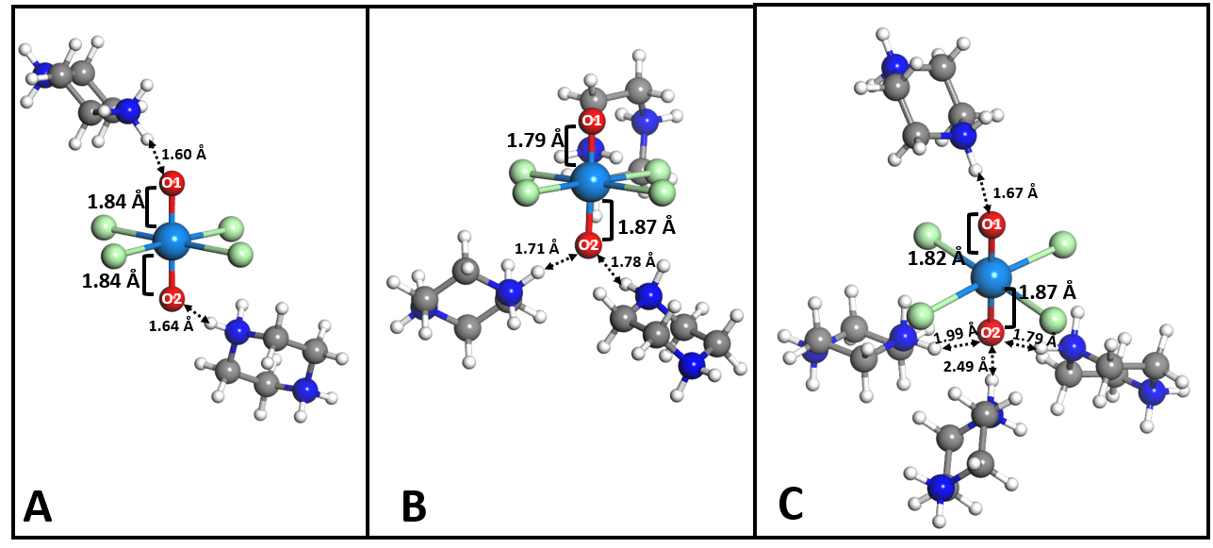
Figure 7. Ball and stick representations of the two, three, and four piperazinium cation structures. A is Np pipz 2; B is Np pipz 3; and C is Np pipz 4. The hydrogen bonds between the axial oxygen atoms are shown with dashed line arrows and the distances are labeled. Color scheme is identical to Figure 6.
Overall, the computational results suggest that when both axial O atoms are engaged in the same degree of hydrogen bonding, the neptunyl bond elongates in a symmetric fashion. Engaging one axial oxygen atom causes elongation of the interacting Np=O bond and shortening of the non-interacting atom bond, as shown by Np pipz 3 and Np pipz 1A and Np pipz 2B. The number of hydrogen bonds also impacts the resulting neptunyl structure, with the greatest elongation of the Np=O2 bond occurring as O2 atom interacts with multiple piperazinium cations.
Calculated vibrational modes for the neptunyl piperazinium interactions
Table 3 reports the computed vibrational frequencies for the optimized structures of [Np(V)O₂Cl₄]³⁻, Np pipz 1A, Np pipz 1B, Np pipz 2, Np pipz 3, and Np pipz 4. Specific trends and differences are noted in comparing the values of the ν₁ symmetric stretch for molecular [NpO₂Cl₄]³⁻ and the Np pipz 1A and Np pipz 1B. In the absence of hydrogen-bonding interactions, the ν₁ neptunyl symmetric stretch is calculated at 773 cm⁻¹ and the asymmetric stretch at 807 cm⁻¹. As noted, introducing one piperazinium cation causes elongation of the interacting Np=O bond, and results in a redshift of 55 cm⁻¹. Visualization of the normal modes for both structures shows that the ν₁ mode involves concerted motions between the engaged axial O atom and the amine groups, where Np=O stretching is coupled with NH₂ motions in the piperazinium. A visualization of the concerted motions using arrows to indicate direction of the motion can be found in Figure S14. The Np pipz 1A has a shorter hydrogen bond of 1.54 Å (donor N – acceptor O1 distance of 2.62 Å) compared to Np pipz 1B hydrogen bond of 1.65 Å (donor N – acceptor O2 distance of 2.68 Å), which influences the extent of the redshift. For example, Np pipz 1A exhibits the shorter hydrogen bond and experiences a larger shift in the ν₁ compared to the isolated [NpO₂Cl₄]³⁻. The asymmetric stretch is less impacted by hydrogen-bonding interactions than the symmetric stretch, changing by at most 7 cm⁻¹. Similar to the trend observed for ν₁, shorter hydrogen bonds result in a redshift of ν₃. The normal modes observed for the neptunyl asymmetric stretch includes piperazinium breathing motions.
Table 3. DFT-calculated neptunyl active vibrational frequencies for an isolated [Np(V)O₂Cl₄]³⁻ model structures.
Structure | ν₁ (cm⁻¹) | ν₃ (cm⁻¹)
[NpO₂Cl₄]³⁻ | 773 | 807
Np pipz 1A | 711 | 800
Np pipz 1B | 718 | 802
Np pipz 2 | 723 | 738
Np pipz 3 | 681 | 832
Np pipz 4 | 681 | 771

Computational vibrational analysis shows that increasing the number of piperazinium cations results in additional changes in the spectral positions for the neptunyl symmetric and asymmetric stretches. Comparing the vibrational modes of Np pipz 2 to Np pipz 1A and Np pipz 1B, the ν₁ mode at 723 cm⁻¹ is blue-shifted compared to the single piperazinium modes at 711 and 718 cm⁻¹. The ν₁ normal modes for Np pipz 2 display coupling between the neptunyl stretch and the amine group of both of the piperazinium cations. The ν₃ for Np pipz 2 occurs at 738 cm⁻¹, which is a much lower frequency than any other structures in this study, where the piperazinium displays an NH₂ twisting motion due to hydrogen bonding. All other structures exhibit coupling between the asymmetric stretch and piperazinium breathing motions as opposed to NH₂ twisting.
With the addition of three or four piperazinium cations (Np pipz 3 and Np pipz 4), the symmetric stretch occurs at the same frequency (681 cm⁻¹), where one piperazinium NH₂ group twists to interact with O2 through hydrogen bonding. For Np pipz 3, the ν₃ is difficult to discern; only O2 is engaged AHIs and the motion of Np=O bonds differ by 0.08 Å. Alternatively, the ν₃ is more easily identified in Np pipz 4 structure at 771 cm⁻¹, where the Np=O bonds motion differ by 0.05 Å and both axial O atoms are engaged in AHIs.
The computational vibrational analysis of molecular units modeled in aqueous conditions go on to provide some interpretation of the solid-state Raman spectra. Specifically, these results point to how counteraction interactions can influence the vibrational frequencies of the neptunyl stretch, and normal mode analysis indicates concerted motions of the Np=O and counteraction functional groups. As indicated vide supra, there are five bands at 670, 681, 725, 758, and 823 cm⁻¹ that are unaccounted for in the Np(V)pipz spectrum and two at 717 and 734 cm⁻¹ within the Np(V)morph compound. The calculated Np pipz 4 mode displays concerted motions associated with the piperazinium-neptunyl complexes at 681 cm⁻¹, which is similar to bands observed at 670 and 681 cm⁻¹ in the structure. As the Raman features in the experiment are associated with the surface of the crystal, it is possible that we may be evaluating several different piperazinium interactions in this region. Though vibrational calculations were not performed on Np(V)morph, we can extrapolate the DFT Np pipz 4 results to assign the morpholinium band at 734 cm⁻¹ to similar concerted motions. Similar features at 717 and 734 cm⁻¹ in the morpholinium system may also be due to the presence of multiple interactions within the crystal surface.

Electrochemical analysis
To further explore the stability of the neptunyl tetrachloride species engaged in AHIs with the heterocyclic cations, we evaluated the redox properties of NpO₂⁺ in the presence of these ligands. Cyclic voltammetric data have been collected for [Np(z)L_{x}]^{y} where Np(z) represents [NpO₂Cl₄]³⁻ for several different heterocyclic ligands (L = piperazine, morpholine, piperidine, pyridine) as noted in Table 4 and Figure 8-9. A model for ligand binding and indirect assessment of hydrogen bonding interactions is outlined. Consider the electron transfer reaction between Np(z) and Np(z-w).
$Np (z) + we ⇌Np(z - w) {E_{Np}}^{0 }$ (Eq. 1)
This yields the Nernst equation in the absence of ligands.
$E = {E_{Np}}^{0} - \frac{2.303 RT}{wF}log\frac{[Np(z - w)]}{[Np(z)]}$ (Eq. 2)
Consider binding constants for Np(z) and Np(z - w) where each binds the same number of ligands x. The charge of the ligand is embedded in y.
$Np(z) + xL ⇌ [Np(z)L_{x}]^{y} K_{z} =\frac{[[Np(z)L_{x}]^{y}]}{[Np(z)][L]^{x}}$ (Eq. 3)
$Np(z-w) + xL ⇌ [Np(z-w)L_{x}]^{y-w} K_{z-w} =\frac{[[Np(z-w)L_{x}]^{y-w}]}{[Np(z-w)][L]^{x}}$ (Eq. 4)
Express [Np(z)] and [Np(z-w)] in terms of binding constants K_{z} and K_{z-w} and substitute into the Nernst equation.
$E = {E_{Np}}^{0_{}} - \frac{2.303 RT}{wF}log\frac{K_{z}}{K_{z-w}} - \frac{2.303 RT}{wF}log\frac{[{\left[Np(z-w)L_{x}\right]}^{y-w}]}{[[Np(z){L_{x}]}^{y}]}$ (Eq. 5)
The formal potential for this reaction is
$E^{0'}={E^{0}}_{Np} - \frac{2.303RT}{wF}log\frac{K_{z}}{K_{z-w}}$ (Eq. 6)
The formal potential E^{0’} characterizes the relative binding strength of the ligand to Np(z) and Np(z-w). To the extent that hydrogen binding sets ligation, E^{0’} will illustrate differences in hydrogen bonding for the ligands. For electrochemically reversible and quasi-reversible cyclic voltammograms, the half-wave potential E_{1/2} is a good estimate of E^{0’}, provided the diffusion coefficients are the same for the oxidized and reduced forms of the couples. All reported E^{0’} values are estimated from E_{1/2}, the average of the peak potentials E_{pf} and E_{pr} measured at the forward and reverse cyclic voltammetric peak currents i_{pf} and i_{pr} (eq. 7). The estimate is appropriate in the presence of uncompensated solution resistance provided the cyclic voltammogram is symmetric.
$E_{1/2 }≅{ E}_{ave}= \frac{E_{pf} + E_{pr} }{2}$ (Eq. 7)
Typically, redox probe concentrations in electrochemical experiments are ~1 mM with electrolyte concentration 100 fold greater. The high electrolyte concentration provides ions that move to compensate the faradaic charge transferred at electrodes. Voltammetry of Np salts reported by Ikeda-Ohno et al. use redox probe concentrations that are large (e.g., 40 mM) relative to the electrolyte (e.g., 1 M). ⁵⁰ When the redox probe concentration is large relative to the electrolyte, voltammetry exhibits solution resistance manifest as increased peak splitting, ΔE_{p} = |E_{pf} - E_{pr}|, Peak splitting can be used to estimate electron transfer rates, but solution resistance leads to underestimates of rate. Figure 8 illustrates voltammetry at several neptunyl concentrations and fixed 1 M HCl electrolyte. We note that peak splitting increases with as Np concentration increases relative to the electrolyte. Peak splitting is a diagnostic indicator for the electron transfer kinetics of the redox probe, but solution resistance can be misinterpreted as electron transfer resistance. We report cyclic voltammetry of neptunyl tetrachloride with NpO₂⁺ concentrations of 33.3 mM to be consistent with inorganic chemistry literature.⁵⁰⁻⁵¹ All cyclic voltammograms are corrected for uncompensated solution resistance prior to data analysis as shown by Leddy and Parr (in preparation).⁵² The algorithm was vetted by comparison of corrected 33.3 mM stock neptunyl with uncorrected 8.35 mM stock neptunyl. E^{0’} estimated by the algorithm for 33.3 mM stock neptunyl is -0.076 V compared to uncorrected 8.35 mM stock neptunyl with E^{0’} = -0.077 V. The difference of 1 mV is on the order of uncertainty for e voltammetric measurements (i.e., +1 mV).

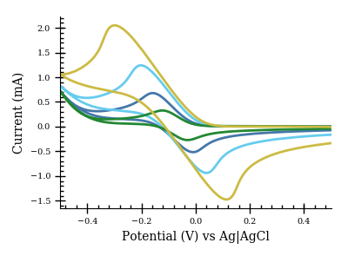
Figure 8. Cyclic voltammograms of neptunyl at different concentrations (66.6 mM (gold), 33.3 mM (light blue), 16.7 mM (navy), and 8.35 mM (green)) at 50 mV/s. Electrolyte is fixed at 1 M HCl. Electrode is a gold (Pine Instruments) high surface area (~0.62 cm²) honeycomb screen-printed electrode. The solution was not degassed. The concentration ratio of electrolyte to probe is not sufficiently high and the voltammograms are distorted by uncompensated resistance where the effect increases with probe concentration and so current. Concomitantly, ΔE_{p} increases with concentration ratio of probe to electrolyte. However, the average of the peak potentials, E_{1/2} remains a good estimate of E⁰’ for the symmetric voltammograms.

Cyclic voltammograms of the neptunyl tetrachloride complex in the presence of the five heterocyclic cations are shown in Figure 9. The formal potentials, estimated from E_{1/2}, are shown in Table 4. The resistance corrected data yields E_{1/2} and the ligated E_{1/2} values are reported relative to the E_{Np}, the half wave potential for the neptunyl salt. The corresponding energy of the shift is reported as ΔG = F(E_{1/2}-E_{Np}). The observed potential shifts are a few millivolts with correspondingly small changes in energy. Shifts of 2 to 3 mV are comparable to the uncertainty in single replicate measurements.
The largest shifts are negative for pyridine (pyr) and morpholine (morph), with energies of 1 kJ/mol or less with piperazine (pipz) and piperidine (pipd) shifts likely about 0 kJ/mol. Thus, shifts are pyr > morph > pipz , pipd ≅ 0. From the equation for the formal potential, a negative potential shift occurs where the ratio of formation constants, K_{z}/K_{z-w} , > 1, where K_{z}/K_{z-w} = 10^{-(E}_{1/2}^{-E}_{Np}^{)w/0.059} at 25 ℃. K_{z}/K_{z-w} is ~1.6 for pyridine and ~1.3 for morpholine. For piperazine and piperidine K_{z}/K_{z-w} is ~1. A K_{z}/K_{z-w} >1 suggests higher affinity of the ligand for Np(z) vs. Np(z-w). The energetics of the system are small, but may be suggestive that a propensity of forming AHIs in the neptunyl solutions may impact the redox properties of the system. Given the small amount of Np available these experiments, statistical analysis could not be performed on these data. Future work in this area is planned to further delineate the effects of intermolecular interactions on the neptunyl redox and provide additional statistical analysis of the electrochemical data.
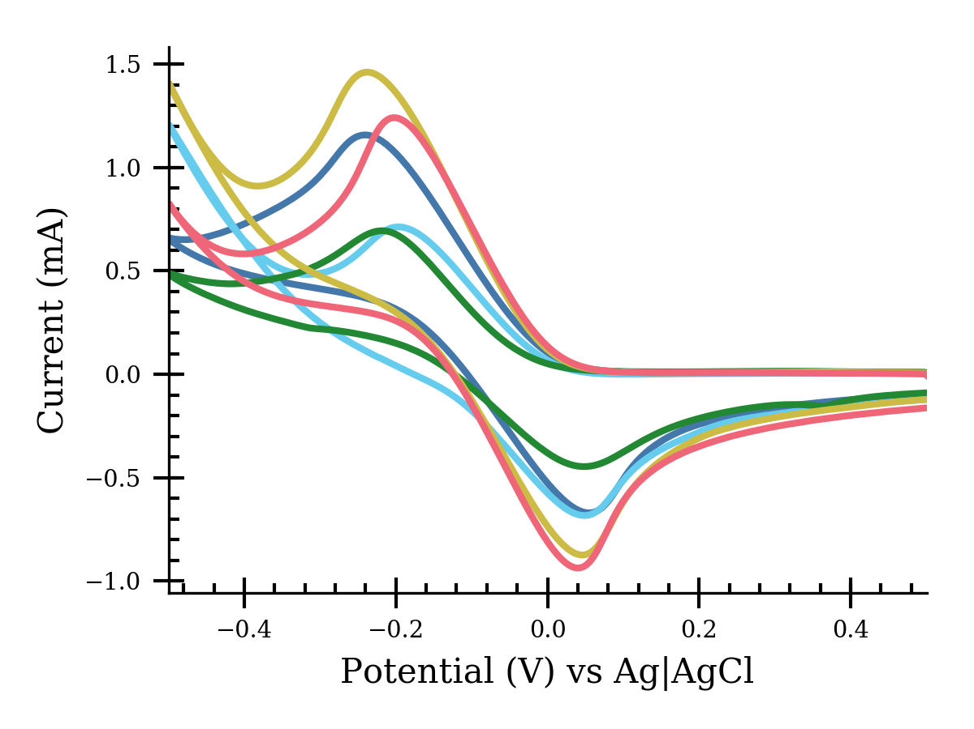
Figure 9. Cyclic voltammograms of 33.3 mM neptunyl (salt) ligand systems at 50 mVs⁻¹. Electrolyte is 1 M HCl. Electrode is a gold Pine Instruments high surface area (~0.62 cm²) honeycomb screen-printed electrode. The solution was not degassed. Prior to each scan, the electrode potential was held 0.5 V vs Ag|AgCl for 60 s to generate the oxidized species about the electrode and then scanned toward negative potentials. The ligands are morpholine (morph, navy blue), pyridine (pyr, yellow), piperidine (pipd, light blue), and piperazine (pipz, green) with stock neptunyl in red. Voltammograms are resistance corrected as shown. Shifts in E_{1/2} and so E^{0’}are shown in Table 4.

Table 4. Formal potentials estimated from E_{1/2} for several Neptunyl ligand systems.
Np Conc.  (mM) | Ligand | E_{1/2}  (V vs Ag|AgCl) | E_{1/2} - E_{Np}  (V vs Ag|AgCl) | 𝚫G  (J/mol) | K_{z}/K_{z-w}
33.3 mM | - | -0.076 | - | -
33.3 mM | Piperazine  (pipz) | -0.078 | -0.003 | -200 | 1
33.3 mM | Morpholine  (morph) | -0.083 | -0.007 | -700 | 1.3
33.3 mM | Pyridine  (pyr) | -0.088 | -0.012 | -1200 | 1.6
33.3 mM | Piperidine  (pipd) | -0.074 | 0.002 | 200 | 1

The large shifts in formal potential shown by Estes et al. were not observed in the current study.⁵³ It is worthwhile to note that Estes et al. show voltammetry with electrolyte at 5.0 M and 5 mM neptunyl, which provides more than adequate 1000 fold excess of electrolyte. Estes et al. report large shifts (e.g., 220 mV) in the Np formal potential for electrolyte NMe₄Cl relative to electrolyte LiCl. Activity effects at such high electrolyte concentrations may impact the observed shift for NMe₄Cl relative to LiCl.

Conclusion
Our investigations on neptunyl tetrachloride in the presence of heterocyclic cations indicated that AHIs can occur in the solid state through charge-assisted hydrogen bonding. This was particularly pronounced in the case of piperazinium and in the morpholinium structure, but did not occur in the presence of pyridininium and pipiridinium cations. Stabilization of Np(V) in the solid state was noted to occur in tandem with charge assisted hydrogen interactions to the neptunyl oxo groups (Np(V)pipz and Np(V)morph), while oxidation to Np(VI) materialized with no AHIs (as shown for Np(VI)morph and Np(VI)pyr compounds). Perturbation of the neptunyl bond was observed in the structural characterization of Np(V)pipz and Np(V)morph with largely asymmetric bonds in the case of Np(V)pipz. Additional Raman spectroscopy of the solid-state material provide evidence of bond perturbation, although this is not observed in the solution phase. DFT calculations of the neptunyl tetrachloride complex in the presence of piperazinium cations captured similar bond perturbations and was used to aid the interpretation of the Raman modes present in the experimental spectra. Cyclic voltammograms of the neptunyl tetrachloride species in the presence of the heterocyclic cations showed only subtle energy differences in solution, although the experimental trends correlate with the redox behavior observed in the corresponding solid-state materials. Additional studies to further explore the influence of AHIs on the electrochemical and spectral behaviors are planned to provide better insight to the importance of the hydrogen bonding interactions within neptunyl systems.
Acknowledgements
We would like to acknowledge the Department of Energy Early Career Award (DE-SC0013980) for supporting this work. This work was supported, in part, by the computational resources supported by the University of Iowa. This work also used the Extreme Science and Engineering Discovery Environment (XSEDE), supported by the National Science Foundation Grant number ACI-1548562 though allocation TG-GEO160006.⁵⁴

References
1. Guillaume, B.; Moulin, J. P.; Maurice, C., Chemcial Properties of Neptunium Applied to Neptunium Management in Extraction Cycles of Purex Process. Proc. of Extraction 1984, 88, 31.
2. Jianchen, W.; Jing, C., Separation of plutonium and neptunium from uranium by N,N-dimethyl-3-oxa-glutaramic acid (DMOGA) as a complexant in the PUREX process. Hydrometallurgy 2015, 157, 44-49.
3. Horwitz, E. P.; Chiarizia, R.; Dietz, M. L.; Diamond, H., Separation and Preconcentration of Actinides from Acidic Media by Extraction Chromatography. Anal. Chim. Acta 1993, 281, 361.
4. Chatterjee, S.; Bryan, S. A.; Casella, A. J.; Peterson, J. M.; Levitskaia, T. G., Mechanisms of neptunium redox reactions in nitric acid solutions. Inorganic Chemistry Frontiers 2017, 4 (4), 581-594.
5. Clark, A. E.; Samuels, A.; Wisuri, K.; Landstrom, S.; Saul, T., Sensitivity of Solvation Environment to Oxidation State and Position in the Early Actinide Period. Inorg Chem 2015, 54 (13), 6216-25.
6. Denning, R. G., Electronic structure and bonding in actinyl ions and their analogs. J Phys Chem A 2007, 111 (20), 4125-43.
7. Matsika, S.; Zhang, Z.; Brozell, S. R.; Blaudeau, J. P.; Wang, Q.; Pitzer, R. M., Electronic Structure and Spectra of Actinyl Ions. The Journal of Physical Chemistry A 2001, 105 (15), 3825-3828.
8. Birkett, J. E.; Carrott, M. J.; Fox, O. D.; Jones, C. J.; Maher, C. J.; Roube, C. V.; Taylor, R. J.; Woodhead, D. A., Recent Developments in the Purex Process for Nuclear Fuel Reprocessing: Complexant Based Stripping for Uranium/Plutonium Separation. CHIMIA International Journal for Chemistry 2005, 59 (12), 898-904.
9. Chen, H.; Taylor, R. J.; Jobson, M.; Woodhead, D. A.; Boxall, C.; Masters, A. J.; Edwards, S., Simulation of Neptunium Extraction in an Advanced PUREX Process—Model Improvement. Solvent Extraction and Ion Exchange 2017, 35 (1), 1-18.
10. Antonio, M. R.; Soderholm, L.; Williams, C. W.; Blaudeau, J. P.; Bursten, B. E., Neptunium redox speciation. Radiochim. Acta 2001, 89, 17.
11. Kihara, S.; Yoshida, Z.; Aoyagi, H.; Maeda, K.; Shirai, O.; Kitatsuji, Y.; Yoshida, Y., A Critical Evaluation of the Redox Properties of Uranium, Neptunium and Plutonium Ions in Acidic Aqueous Solutions. In Pure and Applied Chemistry, 1999; Vol. 71, p 1771.
12. O’Loughlin, E. J.; Boyanov, M. I.; Antonopoulos, D. A.; Kemner, K. M., Redox Processes Affecting the Speciation of Technetium, Uranium, Neptunium, and Plutonium in Aquatic and Terrestrial Environments. In Aquatic Redox Chemistry, American Chemical Society: 2011; Vol. 1071, pp 477-517.
13. Kitatsuji, Y.; Kimura, T.; Kihara, S., Reduction behavior of neptunium(V) at a gold or platinum electrode during controlled potential electrolysis and procedures for electrochemical preparations of neptunium(IV) and (III). Journal of Electroanalytical Chemistry 2010, 641 (1), 83-89.
14. Plock, C. E., Voltammetric determination of neptunium at the glassy carbon electrode. Journal of Electroanalytical Chemistry and Interfacial Electrochemistry 1968, 18 (3), 289-293.
15. Bagnall, K. W., The analytical chemistry of neptunium: V. A. Mikhailov
translated by R. Kondor and edited by D. Slutzkin
published by Halsted Press, John Wiley and Sons, New York, 1973
pp. vii + 235, 47 figs., 63 tables
price £9.35. 1974; Vol. 34, pp 180-180.
16. Burn, A. G.; Martin, L. R.; Nash, K. L., Pentavalent Neptunyl ([O≡Np≡O]+) Cation–Cation Interactions in Aqueous/Polar Organic Mixed-Solvent Media. Journal of Solution Chemistry 2017, 46 (6), 1299-1314.
17. Falaise, C.; Delille, J.; Volkringer, C.; Vezin, H.; Rabu, P.; Loiseau, T., Series of Hydrated Heterometallic Uranyl-Cobalt(II) Coordination Polymers with Aromatic Polycarboxylate Ligands: Formation of U═O—Co Bonding upon Dehydration Process. Inorganic Chemistry 2016, 55 (20), 10453-10466.
18. Krot, N. N.; Grigoriev, M. S., Cation—cation interaction in crystalline actinide compounds. Russian Chemical Reviews 2004, 73 (1), 89-100.
19. Madic, C.; Guillaume, B.; Morisseau, J. C.; Moulin, J. P., “Cation-cation” complexes of pentavalent actinides—I: Spectrophotometric study of complexes between neptunium (V) and UO22+ and NpO22+ ions in aqueous perchloric and nitric solutions. Journal of Inorganic and Nuclear Chemistry 1979, 41 (7), 1027-1031.
20. Sarsfield Mark, J.; Taylor Robin, J.; Maher Chris, J., Neptunium(V) disproportionation and cation–cation interactions in TBP/kerosene solvent. In Radiochimica Acta, 2007; Vol. 95, p 677.
21. Bjorklund, J. L.; Pyrch, M. M.; Basile, M. C.; Mason, S. E.; Forbes, T. Z., Actinyl-cation interactions: experimental and theoretical assessment of [Np(vi)O2Cl4]2− and [U(vi)O2Cl4]2− systems. Dalton Transactions 2019, 48 (24), 8861-8871.
22. Surbella, R. G.; Ducati, L. C.; Pellegrini, K. L.; McNamara, B. K.; Autschbach, J.; Schwantes, J. M.; Cahill, C. L., Transuranic Hybrid Materials: Crystallographic and Computational Metrics of Supramolecular Assembly. Journal of the American Chemical Society 2017, 139 (31), 10843-10855.
23. Serezhkin, V. N.; Grigoriev, M. S.; Savchenkov, A. V.; Budantseva, N. A.; Fedoseev, A. M.; Serezhkina, L. B., Peculiarities of the Supramolecular Assembly of Tetraethylammonium and 3-Bromopropionate Ions in Uranyl, Neptunyl, and Plutonyl Coordination Compounds. Inorganic Chemistry 2019, 58 (21), 14577-14585.
24. de Groot, J.; Gojdas, K.; Unruh, D. K.; Forbes, T. Z., Use of Charge-Assisted Hydrogen Bonding in the Supramolecular Assembly of Hybrid Uranyl Materials. Crystal Growth & Design 2014, 14 (3), 1357-1365.
25. de Groot, J.; Cassell, B.; Basile, M.; Fetrow, T.; Forbes, T. Z., Charge-Assisted Hydrogen-Bonding and Crystallization Effects within UVI Glycine Compounds. European Journal of Inorganic Chemistry 2017, 2017 (13), 1938-1946.
26. Sheldrick, G. M. APEX3, Bruker AXS: Madison, WI, 2015.
27. Sheldrick, G. M., Acta Crystallographica Section A: Foundations of Crystallography 2008, 64, 112-122.
28. Payne, M. K.; Pyrch, M. M.; Jubinsky, M.; Basile, M. C.; Forbes, T. Z., Impacts of oxo interactions within actinyl metal organic materials: highlight on thermal expansion behaviour. Chemical Communications 2018, 54 (77), 10828-10831.
29. Origin(Pro), 2019b; OriginLab Corporation.
30. GmbH, U. o. K. a. F. K., TUROBOMOLE V7.2. University of Karlsruhe, Karlsuhe, Germany.
31. Becke, A. D.; A., P. J.; M., H.-G.; J., F. D.; K., R.; A., C. L., Density‐functional thermochemistry. III. The role of exact exchange. The Journal of Chemical Physics 1993, 98 (7), 5648-5652.
32. Cao, X.; Dolg, M.; Stoll, H., Valence basis sets for relativistic energy-consistent small-core actinide pseudopotentials. The Journal of Chemical Physics 2003, 118 (2), 487-496.
33. Dolg, M.; Stoll, H.; Preuss, H.; Pitzer, R. M., Relativistic and Correlation-Effects for Element 105 (Hahnium, Ha) - a Comparative-Study of M and Mo (M = Nb, Ta, Ha) Using Energy-Adjusted Abinitio Pseudopotentials. J. Phys. Chem. 1993, 97, 5852.
34. Klamt, A.; Schüürmann, G., COSMO: a new approach to dielectric screening in solvents with explicit expressions for the screening energy and its gradient. Journal of the Chemical Society, Perkin Transactions 2 1993, (5), 799-805.
35. Freiderich, J. W.; Burn, A. G.; Martin, L. R.; Nash, K. L.; Clark, A. E., A Combined Density Functional Theory and Spectrophotometry Study of the Bonding Interactions of [NpO2.M](4+) Cation-Cation Complexes. Inorg Chem 2017, 56 (9), 4788-4795.
36. Pyrch, M. M.; Williams, J. M.; Forbes, T. Z., Exploring crown-ether functionalization on the stabilization of hexavalent neptunium. Chemical Communications 2019, 55 (63), 9319-9322.
37. Estes, S. L.; Qiao, B.; Jin, G. B., Ion association with tetra-n-alkylammonium cations stabilizes higher-oxidation-state neptunium dioxocations. Nature Communications 2019, 10 (1), 59.
38. Cornet, S. M.; Redmond, M. P.; Collison, D.; Sharrad, C. A.; Helliwell, M.; Warren, J., The unusual stability of [NpO2Cl4]2−: Synthesis and characterisation of [NpO2(DPPMO2)2Cl]2[NpO2Cl4] and [Ph3PNH2]2[NpO2Cl4]. Comptes Rendus Chimie 2010, 13 (6), 832-838.
39. Rozas, I., On the nature of hydrogen bonds: an overview on computational studies and a word about patterns. Physical Chemistry Chemical Physics 2007, 9 (22), 2782-2790.
40. Vargas, R.; Garza, J.; Dixon, D. A.; Hay, B. P., How Strong Is the Cα−H···OC Hydrogen Bond? Journal of the American Chemical Society 2000, 122 (19), 4750-4755.
41. SenGupta, S.; Maiti, N.; Chadha, R.; Kapoor, S., Probing of different conformations of piperazine using Raman spectroscopy. Chemical Physics 2014, 436-437, 55-62.
42. Cariati, F.; Marcotrigiano, G.; Menabue, L.; Morazzoni, F.; Pellacani, G. C.; Zanderighi, G. M., Solid state vibrational spectroscopy of some piperidinium and morpholinium salts of tin(IV), antimony(III) and bismuth(III) halide complexes. Spectrochimica Acta Part A: Molecular Spectroscopy 1978, 34 (7), 801-805.
43. Rogers, D. J.; Luck, S. D.; Irish, D. E.; Guzonas, D. A.; Atkinson, G. F., Surface enhanced raman spectroscopy of pyridine, pyridinium ions and chloride ions adsorbed on the silver electrode. Journal of Electroanalytical Chemistry and Interfacial Electrochemistry 1984, 167 (1), 237-249.
44. Lu, G.; Haes, A. J.; Forbes, T. Z., Detection and identification of solids, surfaces, and solutions of uranium using vibrational spectroscopy. Coordination Chemistry Reviews 2018, 374, 314-344.
45. Schnaars, D. D.; Wilson, R. E., Synthesis, Structure, and Vibrational Properties of [Ph4P]2NpO2Cl4 and [Ph4P]2PuO2Cl4 Complexes. Inorganic Chemistry 2018, 57 (6), 3008-3016.
46. Hendra, P. J.; Powell, D. B.
47. Gunasekaran, S.; Anita, B., Spectral investigation and normal coordinate analysis of piperazine. Indian Journal of Pure and Applied Physics 2008, 46, 833-838.
48. Danis, J. A.; Lin, M. R.; Scott, B. L.; Eichhorn, B. W.; Runde, W. H., Coordination Trends in Alkali Metal Crown Ether Uranyl Halide Complexes: The Series [A(Crown)]2[UO2X4] Where A = Li, Na, K and X = Cl, Br. Inorganic Chemistry 2001, 40 (14), 3389-3394.
49. Zoidis, E.; Yarwood, J.; Danten, Y.; Besnard, M., Spectroscopic studies of vibrational relaxation and chemical exchange broadening in hydrogen bonded systems. IV. Analysis of the isotropic Raman bands of pyridine/water system. Molecular Physics 1995, 85 (2), 385-393.
50. Ikeda-Ohno, A.; Hennig, C.; Rossberg, A.; Funke, H.; Scheinost, A. C.; Bernhard, G.; Yaita, T., Electrochemical and Complexation Behavior of Neptunium in Aqueous Perchlorate and Nitrate Solutions. Inorganic Chemistry 2008, 47 (18), 8294-8305.
51. Takao, K.; Takao, S.; Scheinost, A. C.; Bernhard, G.; Hennig, C., Complex Formation and Molecular Structure of Neptunyl(VI) and -(V) Acetates. Inorganic Chemistry 2009, 48 (18), 8803-8810.
52. Parr, D. L. L., Johna, Limitations in Estimation of E1/2 from Cyclic Voltammetric Data for Various Electochemical Mechanisms. Journal of Electrochemical Society 2020.
53. Estes, S. L.; Qiao, B.; Jin, G. B., Ion association with tetra-n-alkylammonium cations stabilizes higher-oxidation-state neptunium dioxocations. Nat Commun 2019, 10 (1), 59.
54. Towns, J.; Cockerill, T.; Dahan, M.; Foster, I.; Gaither, K.; Grimshaw, A.; Hazlewood, V.; Lathrop, S.; Lifka, D.; Peterson, G. D.; Roskies, R.; Scott, J. R.; Wilkins-Diehr, N., XSEDE: Accelerating Scientific Discovery. Computing in Science & Engineering 2014, 16 (5), 62-74.

