Low-temperature and high-rate-charging lithium metal batteries enabled by an electrochemically active monolayer-regulated interface

Yue Gao¹, Tomas Rojas^{2,3}, Ke Wang⁴, Shuai Liu¹, Daiwei Wang¹, Tianhang Chen¹, Haiying Wang⁴, Anh T. Ngo², and Donghai Wang¹*
¹Department of Mechanical Engineering, The Pennsylvania State University, University Park, PA, USA. ²Materials Science Division, Argonne National Laboratory, Lemont, IL, USA. ³Nanoscale and Quantum Phenomena Institute and the Department of Physics and Astronomy, Ohio University, Athens, OH, USA. ⁴Materials Research Institute, The Pennsylvania State University, University Park, PA, USA. *e-mail: dwang@psu.edu.
Stable operation of rechargeable lithium (Li)-based batteries at low temperatures is important for cold-climate applications but is plagued with dendritic Li plating and unstable solid-electrolyte interphase (SEI). Here we report high-performance Li-metal batteries under low-temperature and high-rate-charging conditions. This is realized by utilizing a self-assembled monolayer of electrochemically active molecules on current collectors that regulates the nanostructure and composition of SEI and deposition morphology of Li metal anodes. A multilayer SEI containing a LiF-rich inner phase and amorphous outer layer effectively seals the Li surface in contrast to the conventional impassive SEI at low temperatures. Consequently, galvanic Li corrosion and self-discharge were suppressed; stable Li deposition was realized from -60º to 45ºC; and a Li|LiCoO₂ cell with a capacity of 2.0 mAh cm⁻² displayed a 200-cycle life at -15ºC with a recharge time of 45 minutes.

Rechargeable lithium (Li)-based batteries have become one of the most important energy-storage devices^{1,2}. The batteries function reliably at ambient temperature but display dramatically reduced energy, power, and cycle life at low temperatures (below -10ºC)^{3–7}, which limit the battery utilization in cold climates^{8,9}. The intrinsic reason is the insufficient dynamics at low temperatures, resulting in the structural change of the solid-electrolyte interphase (SEI)^{15–18} and dendritic Li plating at the anode^{10–14}. As we found in the present study, at -15ºC, the Li anode SEI derived from a conventional electrolyte is highly crystalline and inhomogeneous. The formation of passive SEI components such as lithium fluoride nanosalts and amorphous species is significantly restrained. This fact leads to poor surface passivation, Li corrosion, and dendrite growth on the Li surface (see the main text and illustration in Fig. 1a). Although the use of protective layers^{19–26}, alternative electrolytes^{27–32}, and Li hosts^{33–36} stabilizes Li metal anodes at room temperature and some special electrolytes enable Li deposition at ultralow temperatures^{37–39}, the formed SEI remains insufficiently passive and stable due to the lack of the precise control of the SEI nanostructure at low temperatures. An approach to precisely regulate the interface especially to construct a passive SEI at the nanoscale level is thus highly needed to enable stable Li metal anodes at low temperatures.
Toward this end, we report here an interface manipulation approach to stabilize Li metal anodes at low temperatures, in which the SEI nanostructure and Li nucleation are regulated by a self-assembled monolayer of 1,3-benzenedisulfonyl fluoride on the surface of copper (Cu) current collectors. This electrochemically active monolayer (EAM) alters the interfacial chemical environment by in situ forming LiF nuclei on the Li metal surface. The pathway and dynamics of electrolyte decomposition at the interface are consequently changed, leading to the formation of a structurally and compositionally different SEI with enhanced passivation. Meanwhile, the EAM forms a lithiophilic anion, benzenesulfonate, on Cu, which induces guided Li nucleation and growth in the presence of a low interfacial Li-ion concentration. At -15ºC, a multilayer SEI is formed, containing a LiF-rich inner phase and an amorphous outer layer (Fig. 1b). It is completely different from conventional low-temperature SEI that displays a highly crystalline and Li₂CO₃-dominant structure. These features were confirmed by cryogenic transmission electron microscopy (cryo-TEM) with ﻿scanning transmission electron microscopy (STEM) and electron energy-loss spectroscopy (EELS), high-resolution and depth-profiling X-ray photoelectron spectroscopy (XPS), and molecular dynamics simulation. With the EAM-regulated SEI, stable Li deposition was realized in a wide temperature range from -60º to 45ºC. The galvanic Li corrosion of Li metal anodes and self-discharge of full cells were effectively suppressed. A Li|LiCoO₂ cell displayed a 200-cycle life under low-temperature (-15ºC), high-capacity (2.0 mAh cm⁻²), and high-rate-charging (45 min of recharge time) conditions. The Li|LiCoO₂ cells also presented stable reversible capacities when the temperature was repeatedly switched between -15º and 25ºC.
Li nucleation and growth on the EAM Cu
We bonded a self-assembled monolayer of 1,3-benzenedisulfonyl fluoride on Cu substrates via a thiol-Cu reaction^{40,41}. The synthesis was depicted in Supplementary Figs 1-4. A high surface coverage of ~91% on Cu was realized (Supplementary Fig. 5), and the Cu surface remains electronically conductive⁴². The in situ generation of benzenesulfonate and LiF was confirmed by XPS, 19^{F} nuclear magnetic resonance (NMR), and cyclic voltammetry. Li deposition was performed on EAM Cu with a fluorine-free electrolyte. After dissolving the formed SEI, we analyzed the surface of the EAM Cu using XPS. For pristine EAM Cu, the -C₆H₃-(SO₂F)₂ peaks were at 169.6 and 170.8 eV in the S 2p spectrum (Fig. 2a). After Li deposition, the S 2p peaks shifted to 168.5 and 169.7 eV, indicating the formation of -C₆H₃-(SO₂Li)₂ (Fig. 2b and Supplementary Fig. 6a,b). In the solution of the dissolved SEI, we detected the signals of LiF derived from -C₆H₃-(SO₂F)₂ (Supplementary Fig. 6c). This

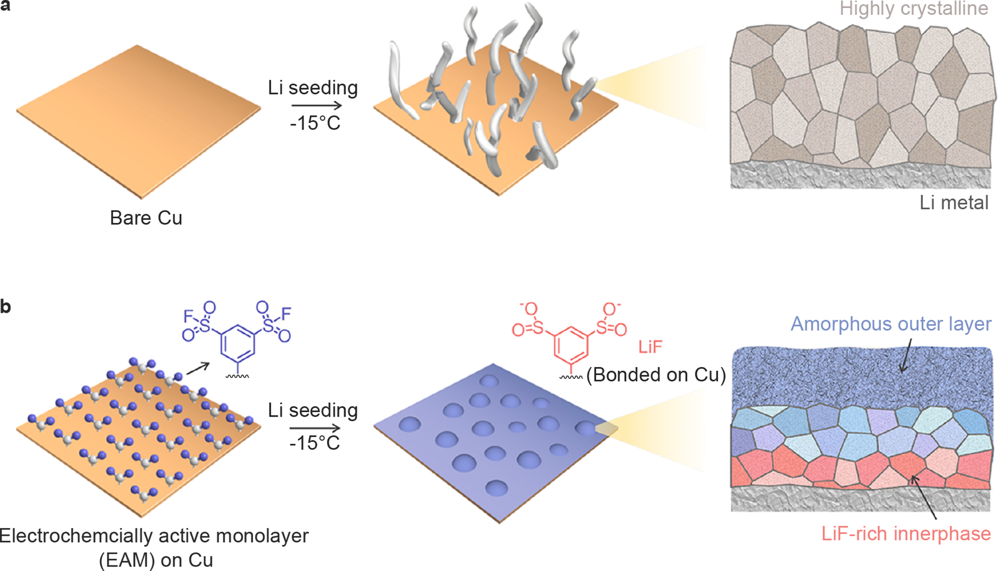
Fig. 1. Illustration of a stable low-temperature SEI regulated by an electrochemically active monolayer (EAM) on Cu. a, Low-temperature Li deposition on a Cu substrate, associated with needle-shaped Li growth and unstable SEI. At -15ºC, Li dendrites aggressively grow; and the SEI layer is highly crystalline and inhomogeneous. b, Evenly seeded Li with a stable SEI layer on the EAM Cu, which has a self-assembled monolayer of electrochemically active 1,3-benzenedisulfonyl fluoride (purple compound) on the surface. After Li deposition, EAM-derived LiF salts act as nuclei to induce the formation of a LiF-rich inner phase of SEI, and EAM-derived benzenesulfonate groups (red compound) are bonded on the Cu surface. The SEI displays a multilayered structure with an inner phase containing a large amount of LiF nanocrystals (reddish layer attached to the Li surface) and an outer layer mainly composed of amorphous species (blueish layer on the top surface).

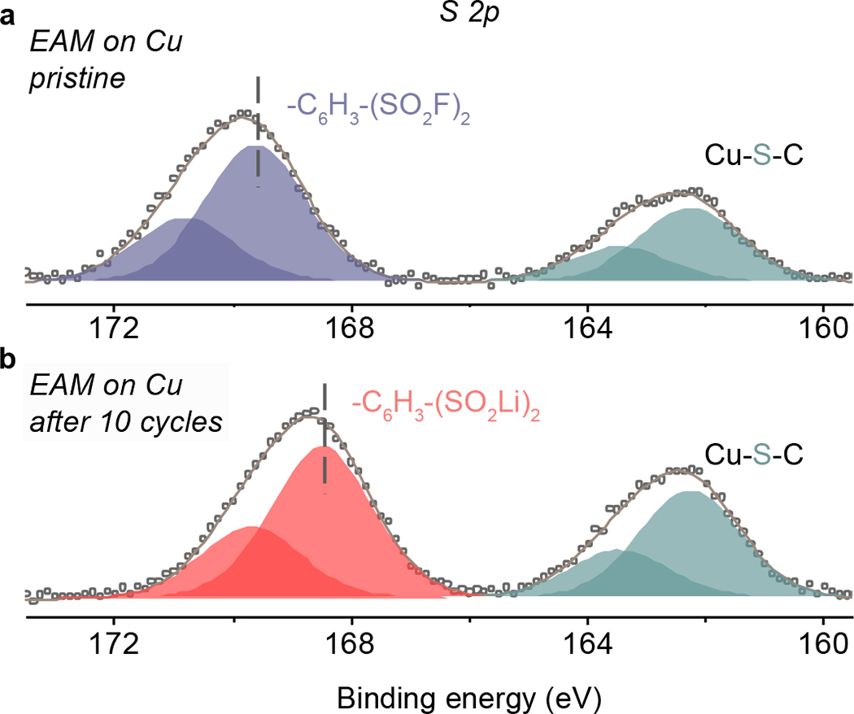
Fig. 2. In situ decomposition of the EAM during SEI formation. High-resolution XPS spectra of the pristine EAM Cu (a) and the EAM Cu after 10 cycles (b). A peak shifting related to EAM decomposition was observed after the Li deposition.

process was also evidenced by peak shifting in cyclic voltammetry (Supplementary Fig. 7).
We first probed the Li deposition morphology on the EAM Cu using scanning electron microscopy (SEM). At a current density of 6.0 mA cm⁻² and -15ºC, the Li seeds formed on a bare Cu foil have a needle-shaped morphology (Fig. 3a), which are smaller than those formed at 25ºC (Supplementary Fig. 8). This finding implies that the growth of Li dendrite is exaggerated at low temperatures. Contrastingly, guided by EAM, Li seeds are uniform and show an
island-shaped morphology (Fig. 3b). After Li stripping, no clear SEI residues and dead Li were seen on EAM Cu, implying excellent SEI stability and highly reversible Li plating and stripping (Supplementary Fig. 9). In contrast, we observed a large amount of waste SEI and dead Li on the bare Cu surface, probably because of excessive SEI reformation and Li dendrite growth. Uniform Li seeding was also realized at different currents and temperatures, including 6.0 mA cm⁻² and 25ºC (Supplementary Fig. 8), 1.0 mA cm⁻² and -15ºC (Supplementary Fig. 10), and 2.0 mA cm⁻² and 25ºC (Supplementary Fig. 11).
We also investigated the Li deposition regulated by a self-assembled monolayer of lithium benzenesulfonate (C₆H₅-SO₃Li), which is lithiophilic but electrochemically inactive. This layer cannot induce a uniform Li deposition (Fig. 3c), indicating that the EAM-formed LiF is important to guide Li nucleation and uniform Li growth on Cu. The use of other inactive monolayers also led to Li dendrite growth (Supplementary Fig. 12). We next bonded the EAM on a three-dimensional Cu host that possesses pores with a diameter of 45µm (Fig. 3d). Li deposition was conducted at -15ºC with a current density of 6.0 mA cm⁻² and a capacity of 6.0 mAh cm⁻². After 30 cycles, we saw uniformly deposited Li on the EAM Cu host (Fig. 3i,g and Supplementary Fig. 13), while Li dendrites

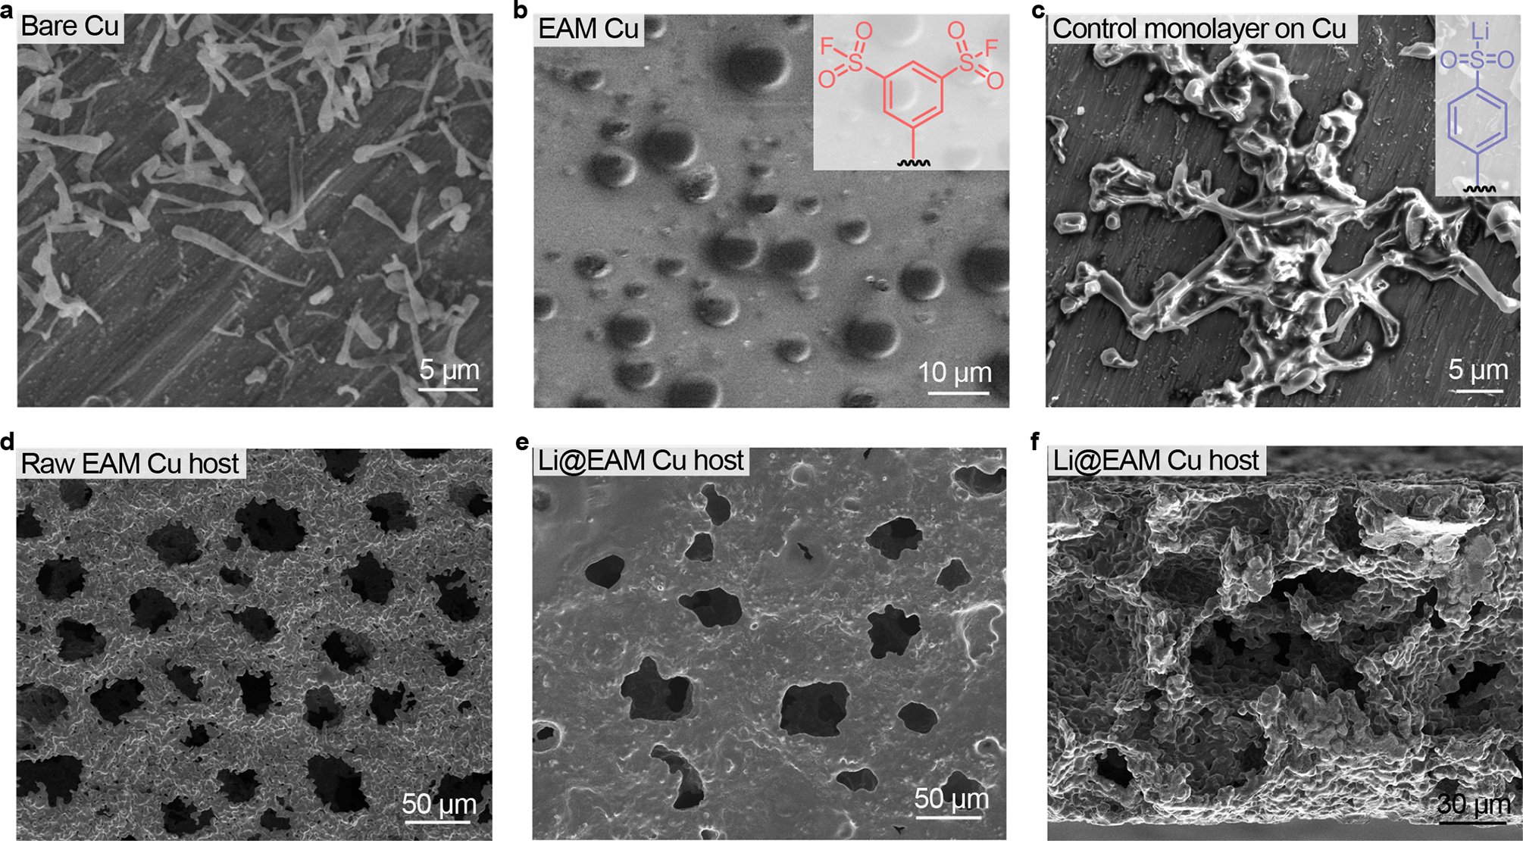
Fig. 3. Li nucleation and growth regulated by the EAM Cu. a-c, SEM images of Li nuclei deposited on the bare Cu (a), EAM Cu (b), and control Cu modified by an electrochemically inactive monolayer (c). d-e, SEM images of three-dimensional EAM Cu hosts before (d) and after (e and f) Li deposition after 30 cycles. The deposition amount is 6.0 mAh cm⁻². All the samples were cycled at a current density of 6.0 mA cm⁻² and at -15ºC.

were found on bare Cu (Supplementary Fig. 14). After Li stripping, we saw very limited Li residues on the EAM Cu host (Supplementary Fig. 15), while dendritic Li residues were seen on the bare Cu host (Supplementary Fig. 16). Uniform Li deposition was also realized for the Li@EAM Cu electrode after 200 cycles (Supplementary Fig. 17a,b) and for the electrode with an elevated Li deposition amount of 12 mAh cm⁻² (Supplementary Fig. 17b,c).
Nanostructure of the low-temperature SEI
To reveal the uniform Li deposition behavior, we next studied the
nanostructure of low-temperature SEI using cryo-TEM. At -15ºC, the SEI formed on the bare Cu and on the EAM Cu are completely different regarding the nanostructure and dominant components. The SEI layer formed on the bare Cu is highly crystalline (Fig. 4a and Supplementary Fig. 18a), in which Li₂CO₃ (a lattice spacing of 0.28 nm) crystals were largely seen and Li₂O (a lattice spacing of 0.27 nm) and LiF (lattice spacings of 0.20 nm) crystals⁴³ were found as well. The major salt component, Li₂CO₃, is generally considered as an unfavorable SEI component due to insufficient passivation¹⁵. This highly crystalline SEI structure at -15ºC is completely different from that formed on bare Cu at 25ºC with more amorphous species (Supplementary Fig. 19). Surprisingly, when the EAM Cu was used, we saw a multilayer SEI, which has a LiF-rich inner phase, a highly amorphous outer layer, and an amorphous matrix embedded with Li₂CO₃ and LiF nanocrystals in between (Fig. 4b and Supplementary Fig. 18b). The lattice spacings of the crystals were identified in the corresponding fast Fourier transform images (Supplementary Figs 20 and 21). The TEM images without labels are shown in Supplementary Figs 22 and 23. Besides, by observing the region where the deposited Li is thicker, we captured clear lattice and lattice fringe features of LiF nanosalts in the inner phase of the SEI (Supplementary Fig. 24).
Meanwhile, we conduct EELS to further validate the presence of the LiF-rich inner phase in the EAM-regulated SEI. Fig. 4c shows a scanning transmission electron microscopy (STEM) image of the EAM-regulated SEI on Li. The inner phase of the SEI is brighter than other regions, probably due to different compositions. We boxed four regions in the image that represent Li layer (brown), inner phase of SEI (red), middle layer of SEI (green), and outer layer of SEI (purple), respectively, and examined their composition pixel by pixel (Fig. 4d). The Li K-edge spectrum taken from the brown region has a broad peak at ~63 eV, corresponding to metallic Li. In the SEI layer, the peak shape of the inner phase region primarily corresponds to LiF⁴⁴, suggesting the presence of the LiF-rich inner phase. The peak shapes of the top two regions represent a mixture of Li₂O, Li₂CO₃, and LiF⁴⁴. In contrast, we did the same study on the SEI sample formed on bare Cu and found Li₂CO₃-dominant spectral features without a LiF-rich inner phase (Supplementary Fig. 25).
To investigate the SEI after Li stripping, we studied an EAM-regulated SEI on Cu sample after the 1st Li deposition and stripping. In the STEM and corresponding ﻿energy-dispersive X-ray spectroscopy (EDS) images, the EAM-regulated SEI was found on Cu (Fig. 4e), and the presence of S and F was confirmed in the EDS spectrum (Supplementary Fig. 26). A carbon coating layer generated during the sample preparation was also seen on the top of SEI. In the high-resolution TEM image, we found LiF crystals with clearly observed lattice structures in the inner phase of the SEI (Fig. 4f and Supplementary Fig. 27), demonstrating the presence of the LiF-rich inner phase of SEI after the Li stripping.

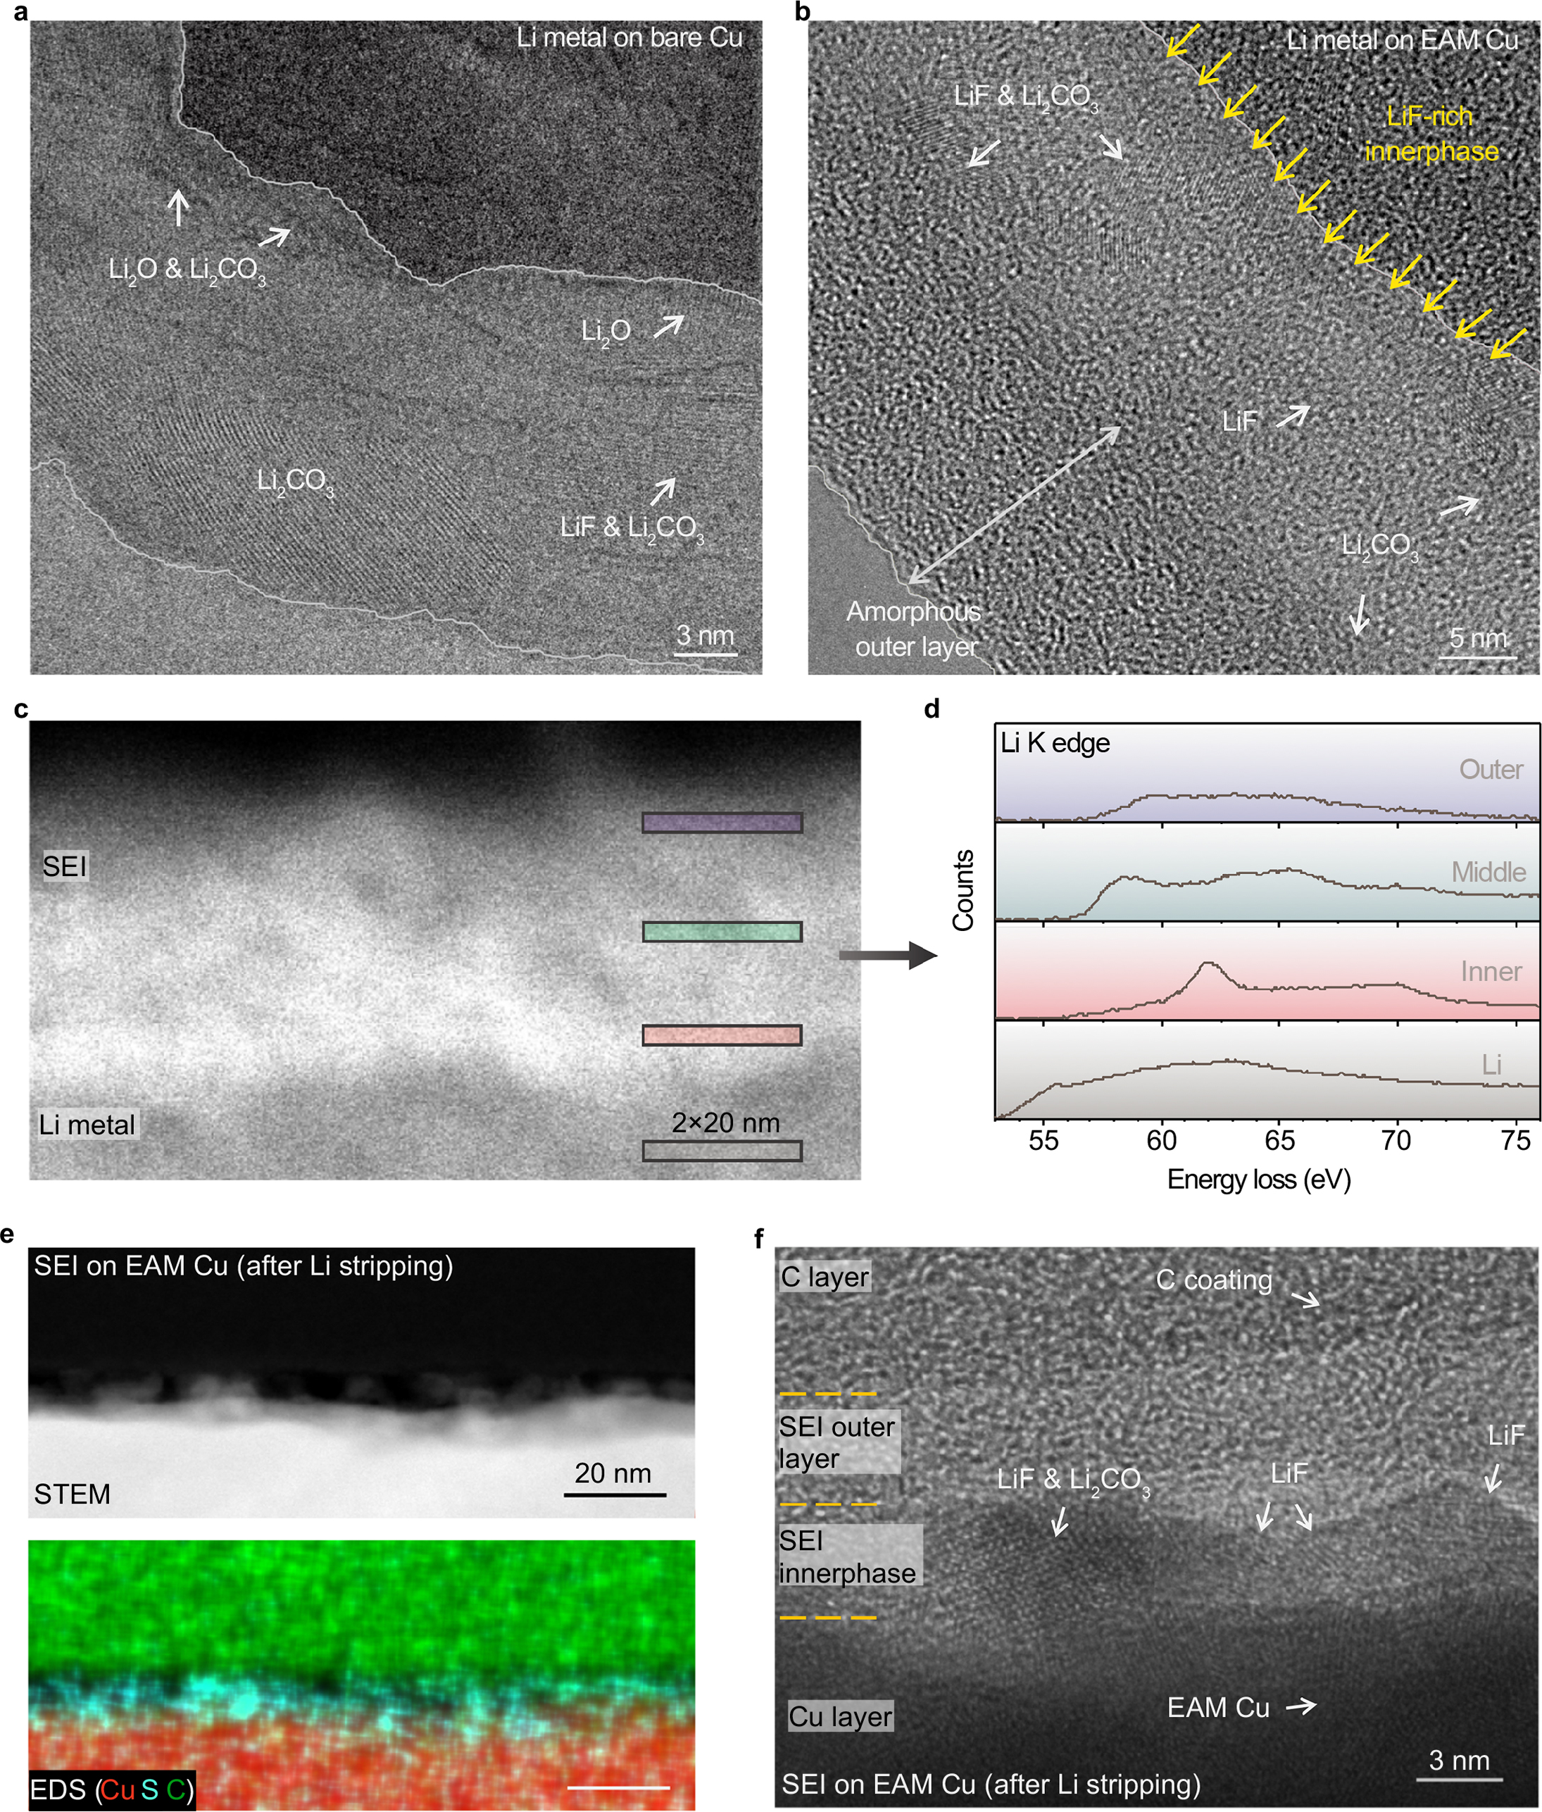
Fig. 4. SEI nanostructure regulated by the EAM. a,b, Cryo-TEM images of the SEI layers formed on a Li@bare Cu (a) and a Li@EAM Cu (b) after 10 cycles. Distinguished from the conventional SEI at -15ºC that is highly crystalline, the EAM-regulated SEI has a LiF-rich inner phase and an amorphous outer layer. c,d, STEM image (c) of the interface of Li@EAM Cu and the corresponding Li K-edge spectra (d) of the boxed regions in c. e,f, The STEM and corresponding EDS images (e) and high-resolution TEM image (f) of the EAM-regulated SEI on Cu, in which the deposited Li was stripped out after the initial deposition. A LiF-rich inner phase was observed in the EAM-regulated SEI layer.

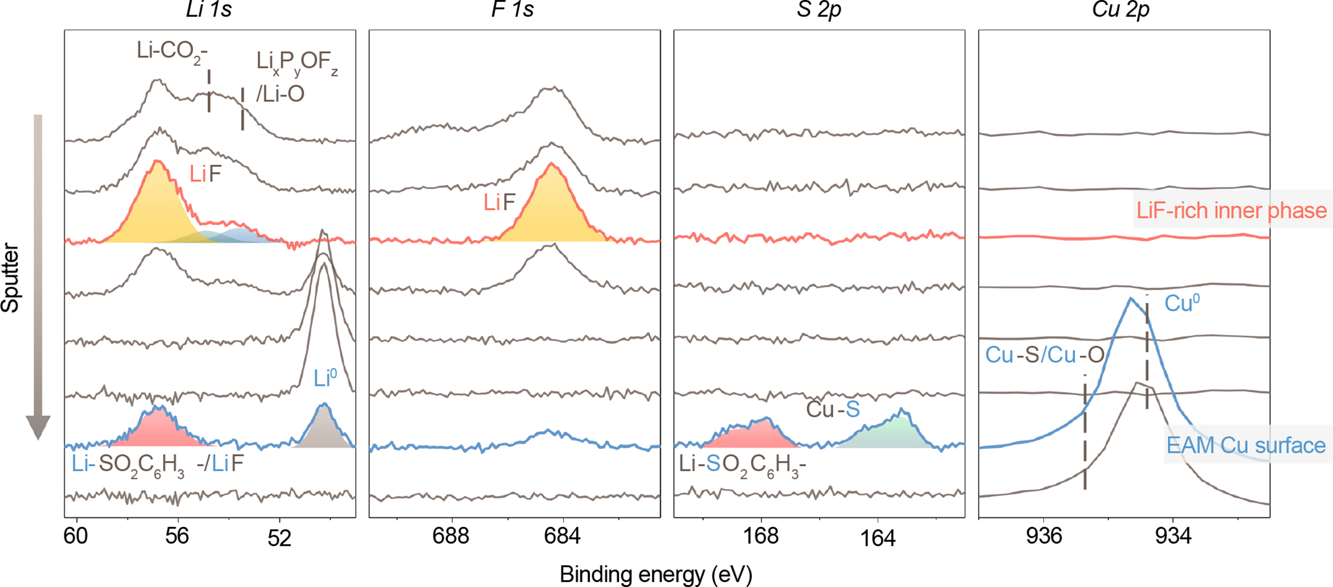
Fig. 5. EAM decomposition at the interface by nanoscale XPS depth profiling. XPS depth profiling spectra of Li@EAM Cu after 10 cycles. A LiF-rich inner phase of SEI was identified. Curves from top to bottom represent the spectra acquired after sputtering for 0, 1, 2, 3, 6, 100, 101, and 105 min. The sputter rate is ~10 nm min⁻¹ based on SiO₂.
Nanoscale depth-profiling XPS also supports our findings. We sputtered a Li@EAM Cu sample from the top surface of SEI to the Cu substrate underneath. As depicted in Fig. 5, the top three curves represent the SEI layer, evidenced by the presence of Li salts (peaks at 54-58 eV in the Li 1s spectra). In the third curve from the top, we found a high concentration of LiF, indicating the presence of the LiF-rich inner phase. Upon sputtering, the fourth to sixth curves start to show Li metal signals (the peak at ~51 eV in the Li 1s spectra), which is the deposited Li layer. In the seventh curve, the Cu surface was reached, evidenced by the presence of Cu peaks at ~933 eV in the Cu 2p spectrum. We also saw the signals of lithium benzenesulfonate (Li-SO₂-C₆H₃-) (peaks at ~57 eV in the Li 1s spectrum and ~169 eV in the S 2p spectrum) and Cu-S (the peak at ~164 eV in the S 2p spectrum) in this layer, confirming that lithium benzenesulfonate is bonded on Cu during Li deposition.
To further reveal the unique multilayered structure of EAM-regulated SEI, we also comparatively probed the SEI regulated by the electrochemically inactive monolayer of C₆H₅-SO₃Li. We saw no LiF-rich inner phase in the SEI (Supplementary Fig. 28). Based on these findings, we conclude that EAM-derived LiF salts induce the formation of the LiF-rich inner phase in the multilayer SEI. Together, these findings verify that the use of the EAM alters the structure of the low-temperature SEI from a highly crystalline film to a multilayer with a LiF-rich inner phase.
Composition of the low-temperature SEI
﻿To identify the SEI composition, we performed XPS on the cycled Li after 30 cycles. The SEI formed on a bare Cu at 25ºC contains a high concentration of Li-CO₂- (peaks at 288.8 eV in the C 1s spectrum and 54.4 eV in the Li 1s spectrum), LiF (peaks at 684.6 eV in the C 1s spectrum and 56.2 eV in the Li 1s spectrum), ROCO₂R (the peak at 291.3 eV in the C 1s spectrum) derived from FEC, and Li_{x}P_{y}OF_{z} (peaks at 136.9 eV in the P 2p spectrum and 53.1 eV in the Li 1s spectrum) (Fig. 6a). The composition of this room-temperature SEI is consistent with the previous SEI characterization⁴⁵. When the temperature falls to -15ºC, the SEI composition on bare Cu changes markedly. As shown in Fig. 6b, the atomic percentage of ROCO₂R in the C-containing species was decreased to 4.1%, which is lower than that of 18.2% at 25ºC. The LiF percentage was decreased from 36% (at 25ºC) to 14.5% (at -15ºC) (Supplementary Fig. 29). Li-CO₂- and Li_{x}P_{y}OF_{z} become the dominant salts in the low-temperature SEI. Encouragingly, the use of the EAM alters the SEI composition at -15ºC. In the EAM-regulated SEI at -15ºC (Fig. 6c), the percentages of Li_{x}P_{y}OF_{z} and Li-CO₂- were markedly lowered; LiF percentage was increased from 14.5% to 46.8%; and ROCO₂R percentage was enhanced to 10.7% (Fig. 6c and Supplementary Fig. 29). At 25ºC, the EAM-regulated SEI also contains a high concentration of LiF (49.6%) (Supplementary Figs. 29 and 30), higher than that of 36% in the SEI on bare Cu at 25ºC. Moreover, the composition of EAM-regulated SEI at -15ºC after 200 cycles (Supplementary Fig. 31) is
similar to that at -15ºC after 30 cycles (Fig. 6c).
Low-temperature performance of Li-metal batteries
After identifying the structure and composition of SEI, we next investigated the low-temperature performance of Li-metal batteries. The EAM-regulated SEI effectively suppresses side reactions on the Li anode surface. This was evidenced by the restrained galvanic Li corrosion on Cu⁴⁶ and the self-discharge of Li-metal batteries. Fig. 7a depicts the galvanic Li corrosion in a Li|EAM Cu host cell. The galvanic current was dropped to a stable value below 0.1 µA cm⁻² within 2 h, indicating a limited Li corrosion. In contrast, the current in the control cell was slowly reduced and stabilized at ~0.4 µA cm⁻² after 8 h (Fig. 7b). Meanwhile, a charged EAM Cu|LiCoO₂ cell (4.2 V) had an open-circuit voltage of 4.13 V after a 325 h rest, and the cell had a capacity retention of 80.3% in the subsequent

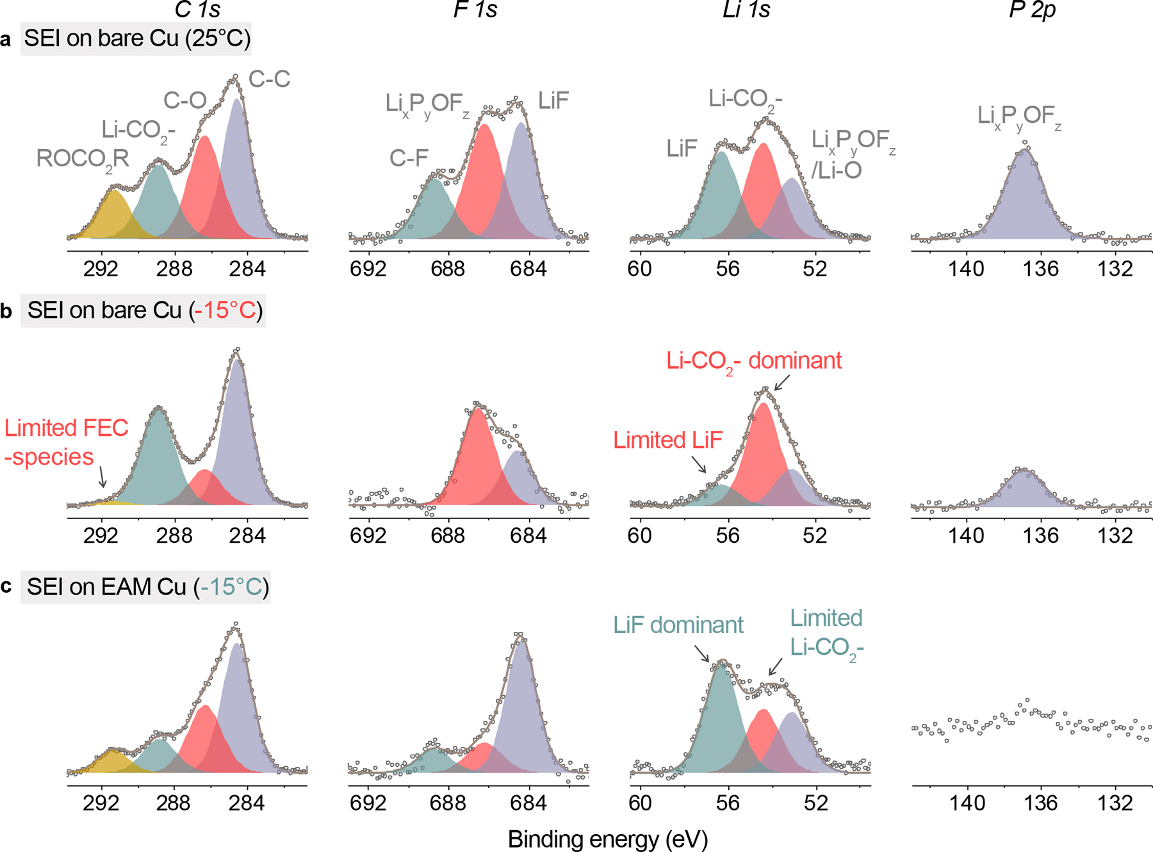
Fig. 6. Composition of Li metal anode SEI formed at 25º and -15ºC. a, XPS spectra of the Li SEI formed on the bare Cu at 25ºC. FEC generates ROCO₂R and LiF to passivate the Li surface. b, XPS spectra of the Li SEI formed on the bare Cu at -15ºC. FEC decomposition was restrained at -15ºC, and Li-CO₂- becomes the dominant SEI components. c, XPS spectra of the Li SEI formed on the EAM Cu at -15ºC. The EAM Cu contributes LiF in the SEI layer, and the formation of Li_{x}P_{y}OF_{z} was suppressed.
discharge (Fig. 7c). An open-circuit voltage of 4.07 V was recorded for a parallel cell after a 2777 h rest (Supplementary Fig. 32). In contrast, the open-circuit voltage of the control cell rapidly dropped to 4.13 V merely after a 2.2 h rest (Fig. 7d). The use of self-assembled monolayers of C₆H₅-SO₃Li and CH₃-(CH₂)₁₂CH₂- also reduced the cell self-discharging (Supplementary Fig. 33) but is significantly less effective than the use of EAM.
We next studied the efficiency of Li deposition on the EAM Cu host under high-current (6.0 mA cm⁻²), high-capacity (6.0 mAh cm⁻²), and low-temperature (-15ºC) conditions. An average efficiency of 98.6% in 250 cycles was realized in comparison with a rapid short circuit of the control cell after 60 cycles (Fig. 7e). The use of the EAM Cu induced a low Li nucleation overpotential of 14 mV and a deposition potential of -66 mV (Fig.7e). In contrast, the control cell had a high nucleation overpotential of 53 mV (Fig. 7e), and the deposition potential was increased to -125 mV along with the accumulation of Li dendrites and slowly fell back due to the merge of dendrites (Supplementary Fig. 34). Stable Li deposition was also achieved at a capacity of 10 mAh cm⁻² and a current density of 10 mA cm⁻² (Supplementary Fig. 35) and a low areal capacity of 2.0 mAh cm⁻² and a current density of 2.0 mA cm⁻² (Supplementary Fig. 36). During Li deposition, the interfacial resistance of the Li|EAM Cu cell remained low (Fig. 7g and Supplementary Fig. 37), while that of the cell was extensively increased. Moreover, Li deposition was stably conducted in a wide temperature range from -60º to 45ºC. Low Li nucleation overpotentials were observed owing to the use of the EAM Cu host (Supplementary Fig. 38).
To further demonstrate the SEI stability, we cycled Li-metal batteries at -15ºC with a recharge time 45 min. LiCoO₂ cathodes with a capacity of 2.0 mAh cm⁻² were precharged and paired to the Li@EAM Cu anodes those accommodate 10 mAh cm⁻² of Li. The Li|LiCoO₂ cell had a capacity retention of 87.7% in 200 cycles (Fig. 7h). The specific recharge capacity is ~123 mAh g⁻¹, and no clear polarization was observed (Supplementary Fig. 39a). Contrastingly, the control cell rapidly faded in 40 cycles and showed increased polarization with cycling. The Li|LiCoO₂ cell with a high capacity of 3.1 mAh cm⁻² had a 170-cycle life at -15ºC (Supplementary Fig. 40). Moreover, the Li|LiCoO₂ cells can be stably operated in a wide temperature range. The cells showed stable reversible capacities when the temperature was gradually varied from -30º to 45ºC (Supplementary Fig. 41) and repeatedly switched between -15º and 25ºC (Fig. 7i and Supplementary Fig. 39b), respectively. We also operated Li|LiCoO₂ cells at 25ºC for 1 cycle before cycling them at -15ºC. This activation process is used for commercial batteries and allows more LiF generation in the initial SEI. Unfortunately, the cycle life of the control cell was merely extended from 37 to 63 cycles (Supplementary Fig. 42), due to the repeated SEI breaking and reforming (Supplementary Fig. 43). In contrast, the cell incorporating EAM showed a similar cycle life with the cell having no room-temperature activation (Supplementary Fig. 42). These results verify the good stability of the Li metal anode SEI in a wide
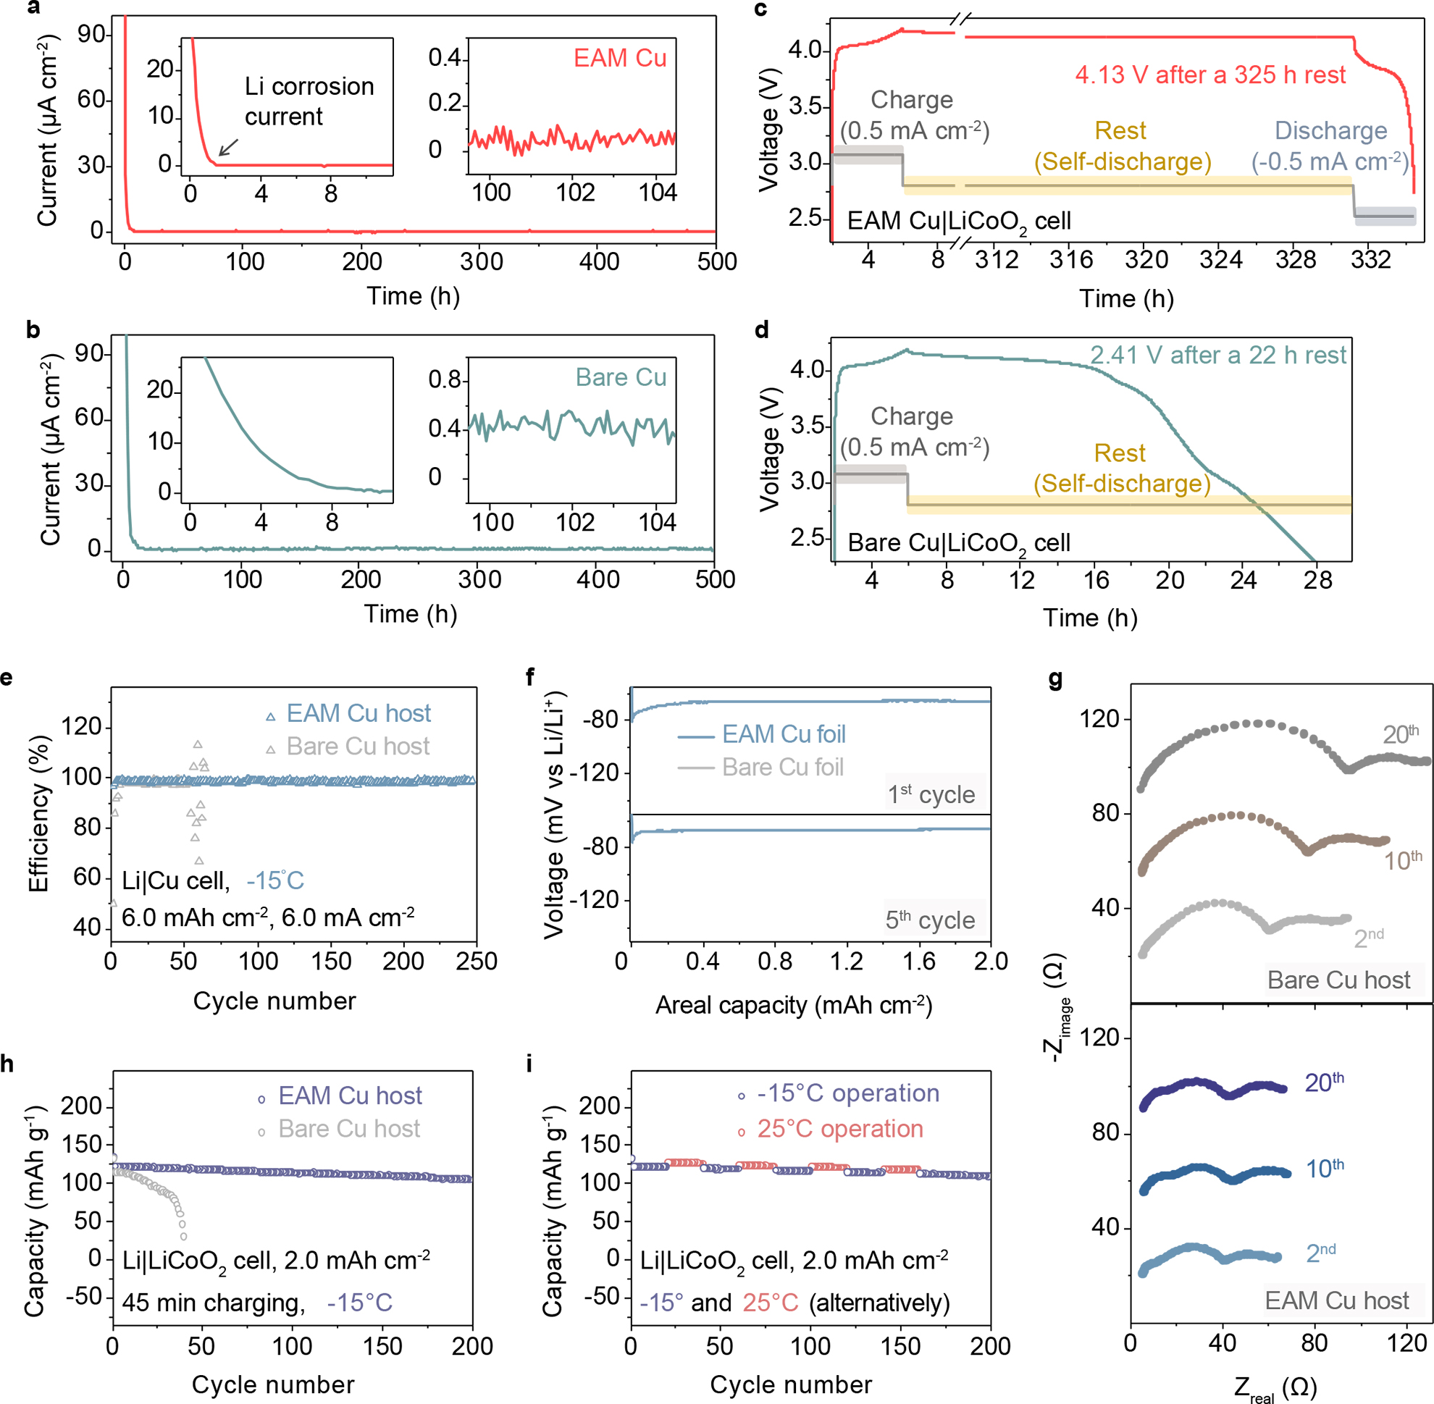
Fig. 7. Battery performance under low-temperature conditions. a,b, The galvanic currents corresponding to Li corrosion on the EAM Cu (a) and bare Cu (b). ﻿Zoom-in curves are shown as the insets. A significantly reduced current was observed in the Li|EAM Cu cell. c,d, Voltage versus time curves display the self-discharging of Li anode-free Cu|LiCoO₂ cells incorporating the EAM Cu host (c) and bare Cu host (d). An external current of 0.5 mA cm⁻² was applied to charge the cell. The fully charged EAM Cu|LiCoO₂ cell presented a limited and low self-discharge in comparison with the rapid failure of the control cell. After rest, the cell incorporating the EAM Cu host (c) was further discharged with a current of -0.5 mA cm⁻². e,f, The efficiency (e) and voltage profile (f) of Li deposition at -15ºC with a current density of 6.0 mA cm⁻². The EAM Cu enables high-efficiency Li deposition in contrast to a low efficiency and severe polarization on the bare Cu. g, Impedance evolution of Li|Cu cells at -15ºC. h, Cycling stability of Li|LiCoO₂ cells at -15ºC with a charge capacity of 2.0 mAh cm⁻² and a charge current density of 2.67 mA cm⁻². i, Cycling stability of a Li|LiCoO₂ cell incorporating the EAM Cu host. The temperature was repeatedly switched between -15º and 25 ºC.

temperature range. Besides, the use of the EAM also improved the cycling stability of Li|LiCoO₂ cells incorporating an ethylene carbonate (EC)-based electrolyte by providing additional LiF in the SEI (Supplementary Figs 44 and 45).
Modeling of low-temperature SEI chemistry
To unravel the origin of the low-temperature SEI chemistry, we performed ab initio molecular dynamics (AIMD) simulations of the SEI formation process at -15º and 25ºC. We designed two Li-electrolyte interface models. For the Li@bare Cu, Li atoms are directly contacted with electrolyte molecules (Fig. 8a). For the Li@EAM Cu, we added LiF molecules to partially cover the Li surface (Fig. 8b). We first monitored the energetics of these two systems over time to determine the decomposition rate of the electrolyte and its influences on the SEI composition (Fig. 8c and Supplementary Figs 46 and 47). A smaller reaction energy change of ~17 eV was observed for the Li@EAM Cu in contrast to that of ~60 eV for the Li@bare Cu, implying effective restraint of
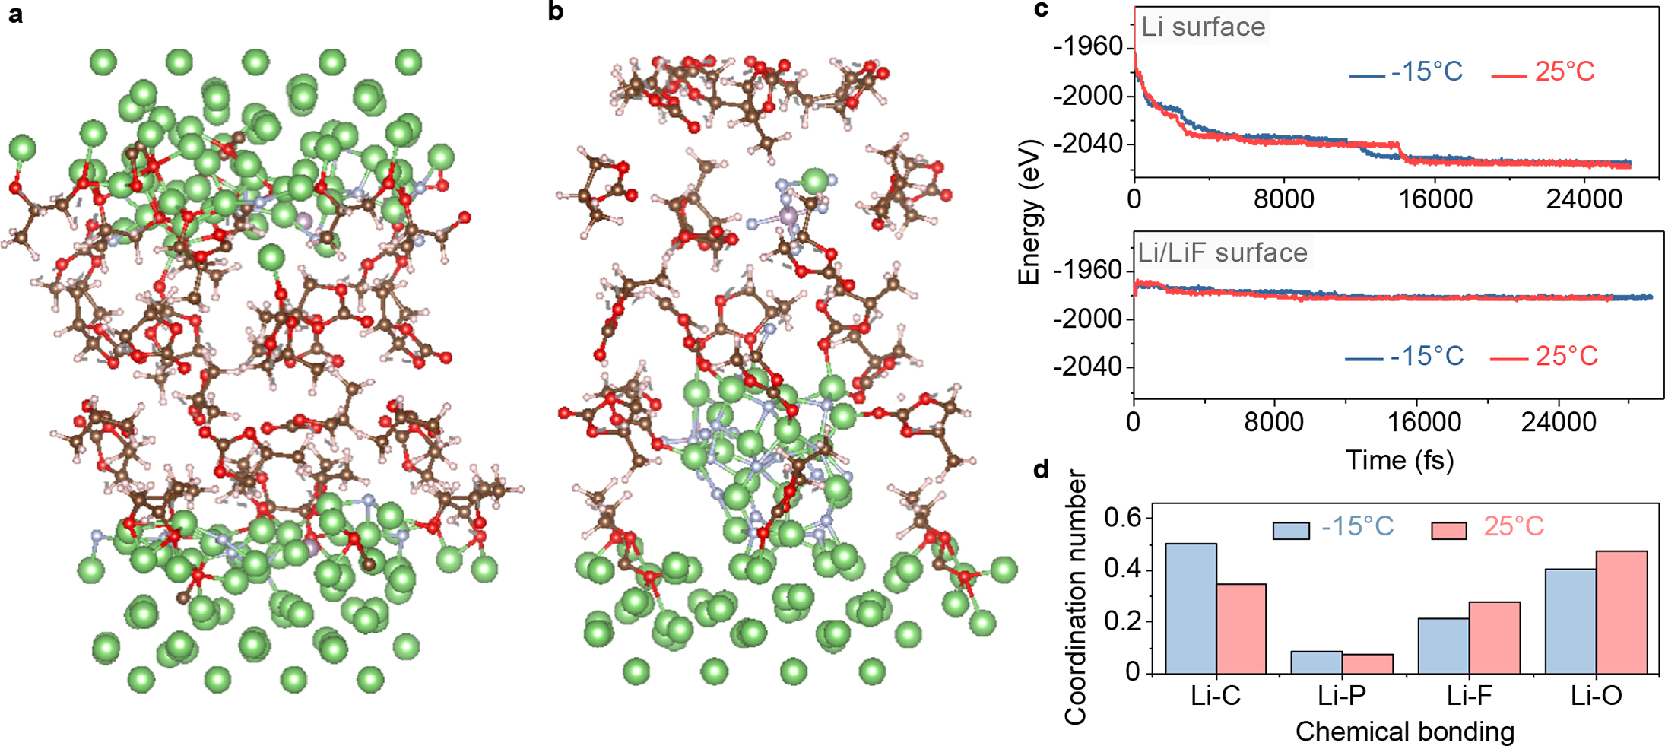
Fig. 8. Low-temperature SEI chemistry studied by modeling and quantitative NMR. a,b, Simulation models of the Li-electrolyte interfaces on the bare Cu (without LiF) (a) and on the EAM Cu (with LiF that partially covers the Li surface). The spheres of color green, brown, red, pink, purple and silver represent the Li, C, O, H, P and F atoms respectively. (b). c, Energy versus time curves present the rates of SEI formation to reach an equivalent equilibrium point at -15º and 25ºC, respectively. d, Favorable SEI components at -15º and 25ºC based on the pair distribution function.

electrolyte decomposition in the SEI formation. For the Li@bare Cu, the equilibrium energy level was reached faster (~18 ps) at -15ºC, while the Li@EAM Cu system showed similar energetic evolutions at -15º and 25ºC. This result suggests that the limited influence of the temperature on the SEI stability due to the LiF-rich inner phase in the Li@EAM Cu system.
To further probe the temperature influence on the SEI structure, we studied the favorable bonding of Li with C, O, F, and P by calculating the coordination number of Li atoms in the surface as a function of distance via integrated radial distribution functions of AIMD trajectories. At -15ºC, the coordination numbers of Li-C and Li-P are increased and that of Li-F is decreased compared to those at 25ºC (Fig. 8d and Supplementary Figs 48 and 49), indicating that Li atoms are bonded with more C and P atoms and less F atoms. This is responsible for the increased content of Li-CO₂- and Li_{x}P_{y}OF_{z} and reduced content of LiF in the low-temperature SEI.
We also monitored the consumption rate of each electrolyte component using quantitative NMR and AIMD simulation. The use of the EAM Cu reduces the electrolyte, implying a stabilized interface of Li metal anodes (Supplementary Figs 50 and 51 and Supplementary Tables 1-9).
Conclusions
In this work, we have demonstrated an interfacial strategy that enables superior performance of Li-metal batteries at -15ºC. An electrochemically active monolayer was employed to alter the SEI structure and Li nucleation at low temperatures and in a carbonate electrolyte. The formed SEI has a LiF-rich inner phase, which is distinguished from the crystalline structure of the conventional low-temperature SEI. Consequently, dendrite-free Li deposition was realized; Li anodes were stably cycled in a wide temperature range from -60º to 45ºC; Li-metal batteries cells showed long cycle lives at -15ºC with a recharge time of 45 min. Our findings open up a promising avenue to the development of low-temperature rechargeable batteries.

Methods
Synthesis of the EAM Cu. The EAM Cu host (Tmax Battery Equipment), foil, and grid were prepared by forming a self-assembled monolayer of 5-((2-mercaptoethyl)carbamoyl) benzene-1,3-disulfonyl difluoride on the Cu surface. To prepare the 5-((2-mercaptoethyl) carbamoyl)benzene-1,3-disulfonyl difluoride molecule, a dichloromethane solution (50 ml) of 3,5-bis(fluorosulfonyl)benzoic acid (343 mg, 1.2 mmol), sulfuryl chloride (243 mg, 1.8 mmol), and triethylamine (12 mg, 0.12 mmol) was refluxed for 30 min, following the dropwise addition of cysteamine (77 mg, 1.0 mmol). The solution was further refluxed for 1 h, and the solvents were then removed by rotary evaporation. The mixture was immediately dissolved in 100 ml anhydrous ethanol. The Cu substrates with clean surface were immersed in the ethanol solution of thiols for 6 h under nitrogen. After that, the achieved Cu substrates were rinsed with anhydrous ethanol 3 times and dried under vacuum for use. To clean the Cu surface, Cu substrates were washed with acetone under sonication for 30 min, then rapidly rinsed in a nitric acid solution (6.5%) for 10 s and immersed in a chloric acid (3.7%) for 10 min, washed with deionized water 6 times, and finally dried under nitrogen.

Preparation of electrodes and electrolytes. The Li@host electrodes were prepared by electrochemically depositing 10 mAh cm⁻² of Li on the as-prepared EAM Cu host at a current density of 2.0 mA cm⁻² and at -15ºC. To fabricate the LiCoO₂ cathode electrodes, LiCoO₂ powders, polyvinylidene fluoride, and conductive carbon (80:14:6) were mixed in anhydrous dimethylformamide. The slurry was cast on an aluminum foil and dried at 100°C under vacuum for 24 h. A 1 M LiPF₆ in PC/FEC (8:1, v/v) electrolyte was used for Li deposition morphology and SEI characterizations, NMR experiments, and galvanic Li corrosion tests. A 1 M LiPF₆ in PC/FEC/ethyl 2,2,2-trifluoroethyl carbonate (ETFEC)¹² (8:1:1, v/v/v) with 10 wt.% tris(pentafluorophenyl)borane (TPFPB), 5 wt.% lithium tetrafluoroborate (LiBF₄), and 0.5 wt.% lithium nitrate (LiNO₃) electrolyte was used to cycle the Li|LiCoO₂ cells and the Li|Cu cells for Li deposition efficiency and impedance measurements. The electrolyte amount was ~15 µl mAh⁻¹. Battery-grade electrolytes were purchased from BASF and further dried using 4Å molecular sieves before use. Celgard 3501 membranes were used as separators.
Electrochemical test. The batteries (CR2016 coin cells) were tested under galvanostatic charge-discharge conditions. To measure the Li deposition efficiency in the Li|Cu host cells, we deposited 6.0 mAh cm⁻² of Li onto the host at a current density of 6.0 mA cm⁻² and stripped Li at a current density of 1.0 mA cm⁻². The efficiency was measured by the amount of the stripped Li. The Li|LiCoO₂ cells were prepared by pairing pre-delithiated LiCoO₂ cathodes with Li@host anodes. As-prepared LiCoO₂ electrodes were charged to 4.2 V at a current density of 0.5 mA cm⁻² and at -15ºC, and 10 mAh cm⁻² of Li was deposited onto the Cu host at a current density of 1.0 mA cm⁻² and at -15ºC. The gas generation at the cathode can be excluded in this way. The galvanic Li corrosion current was measured in the Li|Cu foil cell. We held the Cu electrode (1.13 cm⁻²) at 0 V and monitored the generated current. Electrochemical impedance spectroscopy tests for Li|Cu cells were conducted between 0.1 and 100000 Hz on a Nuvant EZStat Pro instrument. All the cells were held at the designed operation temperature (-15º and 25ºC) immediately once assembled. For the self-discharge of Cu|LiCoO₂ cell experiment, we assembled the Cu|LiCoO₂ cells by pairing the Cu electrodes (EAM Cu or bare Cu) with pristine LiCoO₂ cathodes. After a 2 h rest, we first charged the as-assembled cells to 4.2 V by applying a constant current of 0.5 mA cm⁻². The cells were then kept resting afterwards, during which we started to observe the self-discharge phenomenon by recording the open-circuit voltage. After the rest, the cell incorporating the EAM Cu was further discharged with a constant current of -0.5 mA cm⁻².

Cryo-TEM experiment. To prepare SEI samples, we deposited Li seeds on the EAM Cu grid and the bare Cu grid, respectively, at -15ºC. The grids placed on stainless steel spacers were used as working electrodes in Li|Cu grid cells. A constant current of 6.0 mA cm⁻² (based on the area of the stainless steel) was applied for 160 s. The grids were collected afterward in an argon-filled glovebox, gently rinsed with PC solvent 2 times, and dried under vacuum. The grid samples were then loaded on a cryo-TEM holder and inserted into the microscope. TEM images were captured on a dual spherical aberration-corrected FEI Titan² G2 60-300 STEM at an accelerating voltage of 200 kV.

Characterization. The XPS and ¹⁹F NMR samples for characterizing the in situ decomposition of EAM were prepared by conducting Li deposition on the EAM Cu electrode for 10 cycles. A 0.5 M lithium bis(oxalato)borate in EC/ethyl methyl carbonate (EMC) electrolyte was used, in which F-based species are only derived from -C₆H₃-(SO₂F)₂. After cycling, the electrode sample was immersed in the deuterate dimethylsulfoxide (DMSO-d₆) and under ultrasonication for 2 h. The Cu electrode was then washed with EMC and dried for XPS analysis, while the DMSO-d₆ solution was used for ¹⁹F NMR test. The TEM samples of the EAM-regulated SEI on Cu were prepared on an FEI Helios Nanolab 660 Dual Beam focused ion beam using the ‘in situ lift-out’ technique²⁴. A carbon layer was coated on the sample surface to protect the SEI layer. XPS samples were analyzed on a PHI VersaProbe II Scanning XPS Microprobe. A vacuum transfer vessel was used to transfer the samples from the glovebox into the instrument. SEM images were captured on a Nova NanoSEM 630 instrument. The XPS and SEM samples were washed with PC solvent 2 times and dried under vacuum. NMR experiments were conducted on a Bruker AV-3-HD-500 instrument. The amounts of LiPF₆, deuterated PC, and FEC were monitored independently by using ¹⁹F, ²H, and ¹H NMR. The electrolyte solvents were collected from the cells using chloroform (6 times, 4.2 ml in total). The solutions were transferred into NMR tubes in the glovebox. The electrolyte samples before cycling were also prepared using this procedure to reduce errors. Instrument parameters for all NMR tests were exactly the same in order to quantify the electrolyte amount with the absolute integrals of NMR peaks. The average integral of three parallel samples was used to calculate the electrolyte retention.

Modeling of SEI chemistry. The AIMD calculations were performed in the density functional theory (DFT) framework using the generalized gradient approximation. The projector-augmented wave (PAW) formalism was used as implemented in the Vienna Ab initio Simulation Package (VASP)^{47,48}. We simulated an interface between the electrolyte and Li (100) surface using a computational supercell (14 × 14 × 30 Å) that are composed of 440 atoms with periodic boundary conditions along all directions. To represent the Li on the bare Cu (Fig. 8a), we built an interface between the PC:FEC electrolyte (composed of 283 atoms) and 10 layers of Li (100) (composed of 160 atoms). To represent the Li on the EAM Cu (Fig. 8b), we presented the PC:FEC electrolyte (composed of 380 atoms), 5 layers of Li (100), and a LiF nanoparticle composed of 38 atoms sitting at the interface between the electrolyte and Li surface. Cu substrates are not considered as a part of the simulations given that are out of the scale accessible with modern computational resources. Besides, we also used AIMD simulations to study the decomposition rate of each electrolyte component. We employed the PAW pseudopotentials supplied by VASP, and the exchange correlation is described by the Perdew-Burke-Ernzerhof functional⁴⁹. The plane-wave energy cutoff was set at 600 eV and the Brillouin zone was sampled at the gamma point. The initial electrolyte configurations were prepared by setting the PC, FEC and LiPF₆ molecules at random positions and orientations; the concentrations of each compound is determined by experimental volume ratios. Each system was equilibrated at -15º and 25ºC in the canonical ensemble (NVT) for at least 20 ps with a time step of 1 fs. The condition of constant- temperature was imposed by using a Nose-Hoover thermostat⁵⁰.

Data Availability

All relevant data are included in the paper and its Supplementary Information. The data that support the plots in the paper are available from the corresponding author upon reasonable request.

Reference
1. Tarascon, J. M. & Armand, M. Issues and challenges facing rechargeable lithium batteries. Nature 414, 359–67 (2001).
2. Choi, J. W. & Aurbach, D. Promise and reality of post-lithium-ion batteries with high energy densities. Nat. Rev. Mater. 1, 16013 (2016).
3. Nagasubramanian, G. Electrical characteristics of 18650 Li-ion cells at low temperatures. J. Appl. Electrochem. 31, 99–104 (2001).
4. Zhang, S. S., Xu, K. & Jow, T. R. The low temperature performance of Li-ion batteries. J. Power Sources 115, 137–140 (2003).
5. Lin, H. -p. et al. Low-Temperature Behavior of Li-Ion Cells. Electrochem. Solid-State Lett. 4, A71 (2002).
6. Petzl, M., Kasper, M. & Danzer, M. A. Lithium plating in a commercial lithium-ion battery - A low-temperature aging study. J. Power Sources 275, 799–807 (2015).
7. Fleischhammer, M., Waldmann, T., Bisle, G., Hogg, B. I. & Wohlfahrt-Mehrens, M. Interaction of cyclic ageing at high-rate and low temperatures and safety in lithium-ion batteries. J. Power Sources 274, 432–439 (2015).
8. Ratnakumar, B. V. et al. Lithium ion batteries for Mars exploration missions. Electrochim. Acta 45, 1513–1517 (2000).
9. Rodrigues, M.-T. F. et al. A materials perspective on Li-ion batteries at extreme temperatures. Nat. Energy 2, 1–14 (2017).
10. Wang, C., Appleby, A. J. & Little, F. E. Low-Temperature Characterization of Lithium-Ion Carbon Anodes via Microperturbation Measurement. J. Electrochem. Soc. 149, A754 (2002).
11. Zhang, S. S., Xu, K. & Jow, T. R. A new approach toward improved low temperature performance of Li-ion battery. Electrochem. commun. 4, 928–932 (2002).
12. Smart, M. C. et al. Improved performance of lithium-ion cells with the use of fluorinated carbonate-based electrolytes. J. Power Sources 119–121, 359–367 (2003).
13. Smart, M. C. Irreversible Capacities of Graphite in Low-Temperature Electrolytes for Lithium-Ion Batteries. J. Electrochem. Soc. 146, 3963 (1999).
14. Lin, D., Liu, Y. & Cui, Y. Reviving the lithium metal anode for high-energy batteries. Nat. Nanotechnol. 12, 194–206 (2017).
15. Aurbach, D. Review of selected electrode-solution interactions which determine the performance of Li and Li ion batteries. J. Power Sources 89, 206–218 (2000).
16. Peled, E. & Menkin, S. Review—SEI: Past, Present and Future. J. Electrochem. Soc. 164, A1703–A1719 (2017).
17. Scrosati, B. & Garche, J. Lithium batteries: Status, prospects and future. J. Power Sources 195, 2419–2430 (2010).
18. Xu, W. et al. Lithium metal anodes for rechargeable batteries. Energy Environ. Sci. 7, 513–537 (2014).
19. Tung, S.-O., Ho, S., Yang, M., Zhang, R. & Kotov, N. A. A dendrite-suppressing composite ion conductor from aramid nanofibres. Nat. Commun. 6, 6152 (2015).
20. Choudhury, S., Mangal, R., Agrawal, A. & Archer, L. A. A highly reversible room-temperature lithium metal battery based on crosslinked hairy nanoparticles. Nat. Commun. 6, 10101 (2015).
21. Liu, K. et al. Lithium Metal Anodes with an Adaptive “Solid-Liquid” Interfacial Protective Layer. J. Am. Chem. Soc. 139, 4815–4820 (2017).
22. Kim, M. S. et al. Langmuir–Blodgett artificial solid-electrolyte interphases for practical lithium metal batteries. Nat. Energy 3, 889–898 (2018).
23. Gao, Y. et al. Interfacial Chemistry Regulation via a Skin-Grafting Strategy Enables High-Performance Lithium-Metal Batteries. J. Am. Chem. Soc. 139, 15288–15291 (2017).
24. Gao, Y. et al. Polymer–inorganic solid–electrolyte interphase for stable lithium metal batteries under lean electrolyte conditions. Nat. Mater. 18, 384–389 (2019).
25. Liang, X. et al. A facile surface chemistry route to a stabilized lithium metal anode. Nat. Energy 6, 17119 (2017).
26. Dudney, N. J. Addition of a thin-film inorganic solid electrolyte (Lipon) as a protective film in lithium batteries with a liquid electrolyte. J. Power Sources 89, 176–179 (2000).
27. Qian, J. et al. High rate and stable cycling of lithium metal anode. Nat. Commun. 6, 6362 (2015).
28. Basile, A., Bhatt, A. I. & O’Mullane, A. P. Stabilizing lithium metal using ionic liquids for long-lived batteries. Nat. Commun. 7, 1–11 (2016).
29. Zeng, Z. et al. Non-flammable electrolytes with high salt-to-solvent ratios for Li-ion and Li-metal batteries. Nat. Energy 3, 674–681 (2018).
30. Fan, X. et al. Non-flammable electrolyte enables Li-metal batteries with aggressive cathode chemistries. Nat. Nanotechnol. 13, 715–722 (2018).
31. Wei, S. et al. Stabilizing electrochemical interfaces in viscoelastic liquid electrolytes. Sci. Adv. 4, 1–9 (2018).
32. Ding, F. et al. Dendrite-free lithium deposition via self-healing electrostatic shield mechanism. J. Am. Chem. Soc. 135, 4450–4456 (2013).
33. Lin, D. et al. Layered reduced graphene oxide with nanoscale interlayer gaps as a stable host for lithium metal anodes. Nat. Nanotechnol. 11, 626–632 (2016).
34. Yang, C.-P., Yin, Y.-X., Zhang, S.-F., Li, N.-W. & Guo, Y.-G. Accommodating lithium into 3D current collectors with a submicron skeleton towards long-life lithium metal anodes. Nat. Commun. 6, 8058 (2015).
35. Li, G. et al. Stable metal battery anodes enabled by polyethylenimine sponge hosts by way of electrokinetic effects. Nat. Energy 3, 1076–1083 (2018).
36. Zhang, R. et al. Lithiophilic Sites in Doped Graphene Guide Uniform Lithium Nucleation for Dendrite-Free Lithium Metal Anodes. Angew. Chemie Int. Ed. 56, 7764–7768 (2017).
37. Rustomji, C. S. et al. Liquefied gas electrolytes for electrochemical energy storage devices. Science 356, eaal4263 (2017).
38. Yang, Y. et al. High-Efficiency Lithium-Metal Anode Enabled by Liquefied Gas Electrolytes. Joule 1–15 (2019). doi:10.1016/j.joule.2019.06.008
39. Plichta, E. J. & Behl, W. K. A low-temperature electrolyte for lithium and lithium-ion batteries. J. Power Sources 88, 192–196 (2000).
40. Uvdal, K., Bodö, P. & Liedberg, B. l-cysteine adsorbed on gold and copper: An X-ray photoelectron spectroscopy study. J. Colloid Interface Sci. 149, 162–173 (1992).
41. Caprioli, F., Decker, F., Marrani, A. G., Beccari, M. & Castro, V. Di. Copper protection by self-assembled monolayers of aromatic thiols in alkaline solutions. Phys. Chem. Chem. Phys. 12, 9230–9238 (2010).
42. Mandler, D. & Turyan, I. Applications of self-assembled monolayers in electroanalytical chemistry. Electroanalysis 8, 207–213 (1996).
43. Li, Y. et al. Atomic structure of sensitive battery materials and interfaces revealed by cryo–electron microscopy. Science 358, 506–510 (2017).
44. Wang, F. et al. Chemical Distribution and Bonding of Lithium in Intercalated Graphite: Identification with Optimized Electron Energy Loss Spectroscopy. ACS Nano 5, 1190–1197 (2011).
45. Ding, F. et al. Effects of Carbonate Solvents and Lithium Salts on Morphology and Coulombic Efficiency of Lithium Electrode. J. Electrochem. Soc. 160, A1894–A1901 (2013).
46. Lin, D. et al. Fast galvanic lithium corrosion involving a Kirkendall-type mechanism. Nat. Chem. 11, 382–389 (2019).
47. Kresse, G. & Furthmüller, J. Efficient iterative schemes for ab initio total-energy calculations using a plane-wave basis set. Phys. Rev. B - Condens. Matter Mater. Phys. 54, 11169–11186 (1996).
48. Kresse, G. & Joubert, D. From ultrasoft pseudopotentials to the projector augmented-wave method. Phys. Rev. B 59, 1758–1775 (1999).
49. Perdew, J. P., Burke, K. & Ernzerhof, M. Generalized Gradient Approximation Made Simple. Phys. Rev. Lett. 77, 3865–3868 (1996).
50. William G. Hoover. Canonical dynamics: Equilibrium phase-space distributions William. Phys. Rev. A 31, 1695–1697 (1985).
Acknowledgments

﻿This work was supported by the Assistant Secretary for Energy Efficiency and Renewable Energy, Office of Vehicle Technologies of the US Department of Energy, through the Advanced Battery Materials Research (BMR) Program (Battery500 Consortium) award no. DE-EE0008198. T.R. and A. N. acknowledge the computing resources provided on Bebop, a high-performance computing cluster operated by the Laboratory Computing Resource Center at Argonne National Laboratory. We thank Dr. Shiyao Zheng for the discussion on the low-temperature battery performance.

Author Contributions

Y.G. and Do.W. conceived the idea and designed the experiments. Y.G., T.C., and S.L. performed the material and electrode preparations. T.R. and A.N. designed and conducted the electrochemical simulation of the low-temperature SEI. K.W. and H.W. performed the TEM experiments. Y.G. and Da.W. conducted the electrochemical tests. All authors discussed and analyzed the data. Y.G. and Do.W. prepared the manuscript with inputs from all other co-authors.

Competing Financial Interests
The authors declare that they have no competing interests.

