Application of STEM/EELS to Plasmon-Related Effects in Optical Spectroscopy
Final report for DOE Award number DE-SC0013679 (2014-2016)
Aug 15, 2017

Principal Investigator: Jon P. Camden, Department of Chemistry and Biochemistry, University of Notre Dame, Notre Dame, IN 46556

I. Introduction and Project Objectives
The localized surface plasmon resonance (LSPR) results from the collective oscillation of the conduction band electrons in small (d << λ) metallic nanoparticles. LSPRs holds enormous promise in a wide range of applications such as ultra-fast communication, plasmon-enhanced catalysis, sensing, and high-efficiency solar energy harvesting. Despite the fact that almost all applications of plasmonic particles rely on the large near electric- field enhancements obtained upon LSPR excitation, it remains quite challenging to directly image these near-field enhancements with appropriate spatial and energy resolution. Theoretical predictions indicate that field enhancements can be confined to spaces as small as 1-2 nm, even when quantum effects are included, which is well below the diffraction limit for visible light microscopes. While all-optical methods have made impressive progress towards sub-diffraction limited resolution, atomic imaging still remains out of reach. To this end, the emergence of electron-energy loss-spectroscopy (EELS) in a scanning transmission electron microscope (STEM) made it possible to map plasmonic properties on a scale 100 times smaller than optical wavelengths (~1nm), with the typical energy resolution approaching 0.1eV when an electron-beam monochromator is used.
EELS is an analytical technique that measures the loss of kinetic energy of electrons upon interacting with a material. When a material is exposed to an energetic beam of electrons, such as those generated in a STEM, a small amount of the interacting electrons are inelastically scattered while the rest are elastically scattered. The resulting electron-energy loss (EEL) spectrum consists of three regions: the elastic scattering or zero-loss peak (ZLP) region, the low-loss region (≤50 eV), and the core-loss region (≥50 eV). The low-loss region of the EEL spectrum is associated with phonon, interband transitions, and surface plasmon excitations, while the core-loss region corresponds to inelastic processes, such as the ionization of inner-shell electrons in the material under examination. While the observation of plasmons in EEL spectra are known since the 1950s, it was not until 2007 that useful information has been extracted from the very low EEL region (<3 eV, >400 nm), where the visible LSPR modes are located. Such progress have been achieved thanks to the advanced aberration-corrected EEL spectrometers and monochromators, and the use of the coldfield-emission electron gun (CFEG), More recently, the next generation aberration corrected microscopes are achieving significantly improved energy resolutions (~10 meV). This suggests that EELS can now reach spectral features in the far-infrared regime with significantly reduced linewidth broadening, which opens the potential of future EELS in quantitative analysis of plasmon and highlights the need for experiments to fully explore the relationships between STEM/EELS and optical processes.
In this project we employed EELS/STEM to understand the near-field enhancements that drive current applications of plasmonic nanostructures. In particular, we explore the connection between optical and electron excitation of plasmon modes in metallic nanostructures: (1) Probing the structural parameters and dielectric properties of multimetallic nanoparticles; (2) Characterization of the near-electric-field enhancements obtained upon excitation of the localized surface plasmon resonance and understand the connection between electron- and photon-driven plasmons; (3) Understanding the behavior of molecules in plasmon-enhanced fields which is essential to emerging applications such as plasmon-assisted catalysis and solar energy harvesting.
II. Accomplishments
This project resulted in a series of in-depth STEM/EELS study of plasmon properties of metallic nanostructures and addressed a wide range of questions. These questions include substrate-induced plasmon mode splitting, size and composition effects on the plasmonic modes of nanoparticle alloys, plasmon hybridization, and plasmon-enhanced energy transfer to resonant semiconducting substrates or catalytic metals. Most recently, we have theoretically and experimentally demonstrated magnetic plasmon resonance localized in silver oligomers and consequent Fano interference between the magnet resonances. Upon invitation, we also published a review in Annual Review of Physical Chemistry summarizing the most state-of-the-art experimental and theoretical advances in the plasmon STEM/EELS field to date.
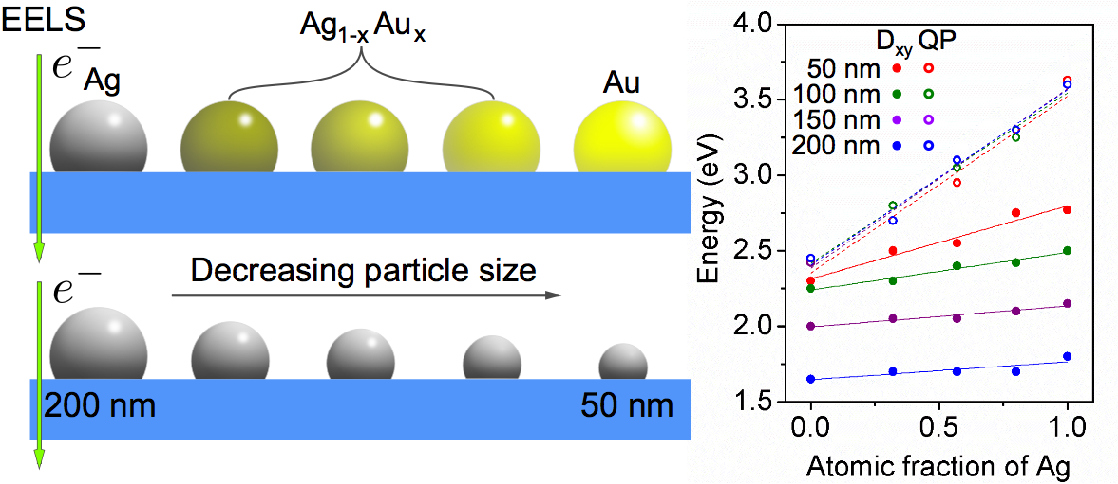Figure 1. Schematic and plot illustrating the team’s recent study of the Au-Ag alloy system, which correlated the composition and size of self-assembled nanoparticles to the spectral peak of the dipole (D_{x-y}) and quasiplanar (Q_{p}) LSPR mode.
- Explored size and composition effects on the plasmonic modes of nanoparticle alloys
In this work, EELS study elucidated the size and composition effects on the full plasmonic spectrum of truncated AuxAg1−x nanospheres on an insulator substrate. We were able to capture a linear red-shift in both bright and dark modes as a function of the atomic fraction of Au and a progressive red-shift of all modes as the size of nanoparticle increases (Figure 1). The results are successfully interpreted using Mie theory and e-DDA simulations. The obtained knowledge of the full plasmonic spectrum of the AuxAg1−x alloy system can provide a valuable data base for our future hot electron transfer studies based on alloy system, through engineering these nanoparticles on semiconductor substrates and investigating the interaction between them.
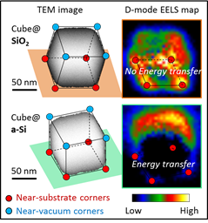
Figure 2. Mapping energy transfer in Ag nanocube@substrate systems. The EELS map of the dipole (D) mode in the cube@SiO₂ system shows strong substrate-localization (upper), indicating that no energy transfer occurs at the interface. In contrast, the near-zero EELS signal at the cube@a-Si interface (lower) is the signature of energy transfer.
B. Demonstrated plasmon-enhanced energy transfer to resonant semiconducting substrates
While previous applications of STEM/EELS have been focused on imaging surface plasmons in nanoparticles supported by an insulating substrate, we have carefully tailored the local dielectric environment by replacing the insulator with resonant semiconducting substrates instead. This study demonstrated that it is possible to not only direct the flow of plasmonic energy to bandgap excitations in the substrate but also to isolate competing energy transfer pathways. To accomplish this, we performed 3D STEM/EELS experiments, full-wave electrodynamics simulations, and developed analytical theory on both plasmon-insulator and plasmon-semiconductor systems, to reveal both the spectral and spatial signatures of energy transfer. In particular, we allowed the substrate-localized dipole mode of the nanocube to interact with three different substrates: one insulating, silicon dioxide (SiO2), and two semiconducting, crystalline boron phosphide (BP) and amorphous silicon (a-Si), enabling us to switch energy transfer on and off and control the flow of energy. As illustrated in Figure 2, plasmon modes mapping in the Ag cube@SiO2 system and Ag cube@Si system clearly revealed the energy transfer at the cube@Si interface. This work was accomplished by solving several experimental and theoretical challenges such as fabrication of electron transparent semiconductor substrates using focused ion beam (FIB) milling, 3D EELS imaging to identify plasmon modes interacting with substrate, and effective electron beam simulation of nanoparticle-semiconductor systems.
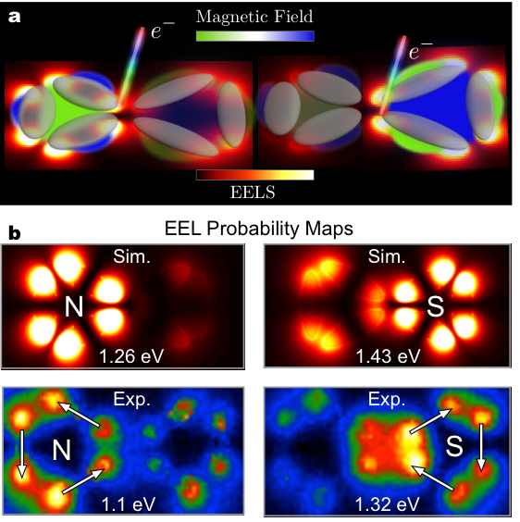Figure 3. a) Schematic illustrating a recently designed silver oligomer network. b) Simulated and experimental EELS maps confirming the existence of a symmetry-broken hybridized magnetic plasmon.

C. Imaged magnetic Hybridization in Symmetric and Symmetry-Broken Plasmon Oligomer Dimers and All-Magnetic Fano Interference
More recently, we designed and characterized a silver oligomer structure possessing spatially and spectrally controllable optical-frequency magnetic plasmons. Significantly, we show that the hybridization of optical-frequency magnetic plasmons in the oligomer system supports an all-magnetic Fano resonance based solely on the interplay of bright and dark magnetic modes. The nanometer spatial-resolving power of electron energy-loss spectroscopy enable us to conclusively demonstrate the hybridization of magnetic plasmons in the oligomer structures (Figure 3). This work lays the groundwork for future metamaterial applications such as optical cloaking, superlensing, and nanolithography at multiple target wavelengths in the visible.

III. List of Publications
Li, G.; Cherqui, C.; Wu, Y.; Bigelow, N. W.; Simmons, P. D.; Rack, P. D.; Masiello, D. J.; Camden, J. P., Examining Substrate-Induced Plasmon Mode Splitting and Localization in Truncated Silver Nanospheres with Electron Energy Loss Spectroscopy. The Journal of Physical Chemistry Letters 2015, 6, 2569-2576.
Li, G.; Cherqui, C.; Bigelow, N. W.; Duscher, G.; Straney, P. J.; Millstone, J. E.; Masiello, D. J.; Camden, J. P., Spatially Mapping Energy Transfer from Single Plasmonic Particles to Semiconductor Substrates via STEM/EELS. Nano Letters 2015, 15, 3465-3471.
Wu, Y.; Li, G.; Cherqui, C.; Bigelow, N. W.; Thakkar, N.; Masiello, D. J.; Camden, J. P.; Rack, P. D., Electron Energy Loss Spectroscopy Study of the Full Plasmonic Spectrum of Self-Assembled Au−Ag Alloy Nanoparticles: Unraveling Size, Composition, and Substrate Effects. ACS Photonics 2016, 3, 130-138
Quillin, S. C.; Cherqui, C.; Montoni, N. P.; Li, G.; Camden, J. P.; Masiello, D. J., Imaging Plasmon Hybridization in Metal Nanoparticle Aggregates with Electron Energy-Loss Spectroscopy. The Journal of Physical Chemistry C 2016, 120, 20852–20859
Griffin, S.; Montoni, N. P.; Li, G.; Straney, P. J.; Millstone, J. E.; Masiello, D. J.; Camden, J. P., Imaging Energy Transfer in Pt-Decorated Au Nanoprisms via Electron Energy-Loss Spectroscopy. The Journal of Physical Chemistry Letters 2016, 7, 3825-3832.
Cherqui, C.; Wu, Y.; Li, G.; Quillin, S. C.; Busche, J. A.; Thakkar, N.; West, C. A.; Montoni, N. P.; Rack, P. D.; Camden, J. P.; Masiello, D. J., STEM/EELS Imaging of Magnetic Hybridization in Symmetric and Symmetry-broken Plasmon Oligomer Dimers and All-magnetic Fano Interference. Nano Lett 2016, 16, 6668–6676
Cherqui, C.; Thakkar, N.; Li, G.; Camden, J. P.; Masiello, D. J., Characterizing Localized Surface Plasmons Using Electron Energy-loss Spectroscopy. Annual Review of Physical Chemistry 2016, 67, 331-357

