Final Report
Multiscale Investigation of Thermal Fluctuations on Solar-Energy Conversion
Margaret S. Cheung
Department of Physics, University of Houston

Photoinduced charge transfer (CT) plays a central role in biologically significant systems and in applications that harvest solar energy. We investigate the relationship of CT kinetics and conformation in a molecular triad. The triad, consisting of carotenoid, porphyrin, and fullerene is structurally flexible and able to acquire significantly varied conformations under ambient conditions. With an integrated approach of quantum calculations and molecular dynamics simulations, we compute the rate of CT at two distinctive conformations. The linearly extended conformation, in which the donor (carotenoid) and the acceptor (fullerene) are separated by nearly 50 Å, enables charge separation through a sequential CT process. A representative bent conformation that is entropically dominant, however, attenuates the CT, although the donor and the acceptor are spatially closer. Our computed rate of CT at the linear conformation is in good agreement with measured values. Our work provides unique fundamental understanding of the photoinduced CT process in the molecular triad. Please see below for the summary:
.
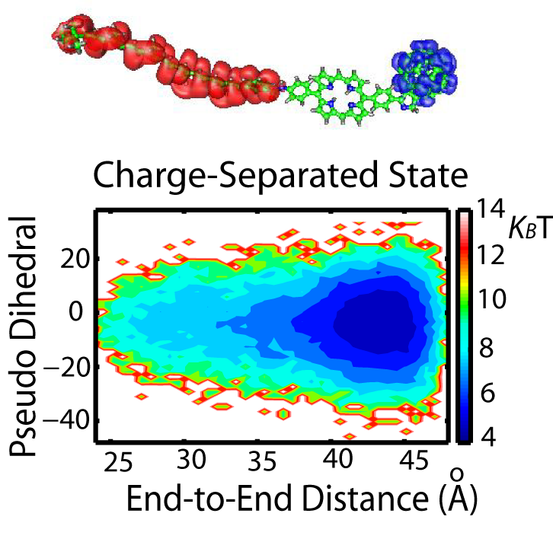
QM/MD simulation of the ground and photo-induced charge-separated states of molecular triad: The replica exchange molecular dynamics was used for the enhanced sampling of the ensemble in order to explore the phase space of the ground state and the photo-induced charge-separated excited state of triad in explicit tetrahydrofuran (THF) solvent. We analyzed the free energy landscape, the structural fluctuations, the solvent arrangements, the static dielectric constant, and the interactions between the triad and the solvent molecules. The analysis of the free energy landscape of the triad indicates that the charge-separated excited state of the triad is thermodynamically stable in a linearly extended geometry, while the ground-state triad explores several extended and bent conformations that are populated in the local free energy minima separated by low free energy barriers at an order of thermal fluctuation (k_{B}T). This work was performed in collaboration with quantum chemists who performed the calculation of electronic states of vast structures strategically sampled from the molecular dynamics simulations [1, 2].
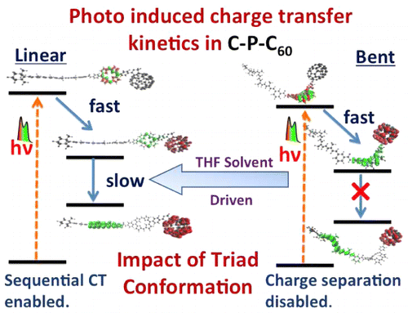
Kinetic mechanics of charge-transfer in two dominant structures of molecular triad: We studied the photo-induced kinetics of the triad solvated in THF. We show that the conformational freedom of the large molecular system determines the efficiency of charge separation. We compare the kinetics in two key conformations of the triad. The linear conformation, which is energetically most stable, is found to enable the charge separation through a sequential mechanism of electron transfer steps involving the bridging subunit. On the other hand, the bent conformation, that is entropically the dominant conformation, is found to effectively eliminate the charge transfer. This work was performed in collaboration with quantum chemists who performed the calculation of charge-transfer rates on several conformations from the molecular simulations[3].

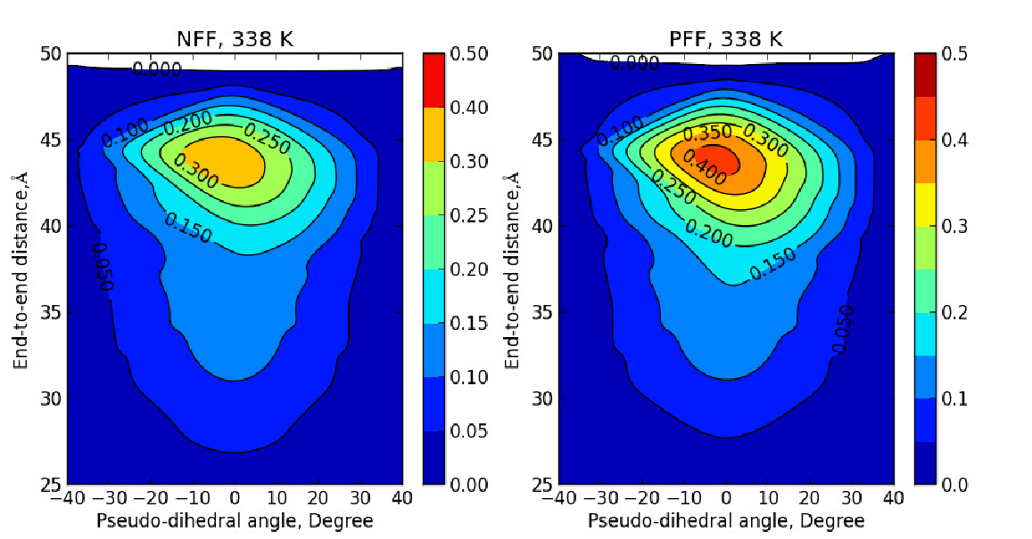
Polarizable force fields restrict the conformational space of molecular triad in THF: Our group employed molecular dynamics simulations with non-polarizable force fields showed the structural stability of the triad for the ground and excited states. Although the simulations with non-polarizable force fields describe the thermodynamics and structural properties of the triad well, they lack the effect of induced polarization that is critical to the charge transfer properties of organic photovoltaic (OPV) materials. We parameterized the polarizable force fields for the individual component of the molecular triad as well as the THF solvent by matching their ensemble properties from simulations against the experimental measurements. We employed the Replica Exchange Molecular Dynamics simulations (REMD) to enhance the sampling of this very large system. We plotted the 2-D distribution plot with the end-to-end distance and the pseudo-dihedral angle of a molecular triad. The distribution of the triad from the simulations using the polarizable force fields is noticeably sharper than the non-polarizable ones. After the structural analysis, we found that the induced polarization stabilizes the rotational isomerization of the polyene chain that gives a sharp peak. The impact of polarizable force may affect the structural distribution; thus dipole moments of triad in apolar solvent [4].

Grant Numbers and Grant Titles
DE-SC0004832 Multiscale Investigation of Thermal Fluctuations on Artificial Photosynthetic
Postdoc: Oleg Starovoytov
1. G. Su, A. Czader, D. Homouz, G. Bernardes, S. Mateen, M.S.Cheung, "Multiscale simulation on a light-harvesting molecular triad", J. Phys. Chem. B. 116, 8460–8473 (2012).
2. D. Balamurugan, A. J. A. Aquino, F. De Dios, L. Flores Jr., H. Lischka, M. S. Cheung, "Multiscale simulation of the ground and photo-induced charge-separated states of molecular triad in polar organic solvent: exploring the conformations, fluctuations and the free energy landscapes", Journal of Physical Chemistry, B, 117, 12065-12075 (2013).
3. A. K. Manna, D. Balamurugan, M. S. Cheung, B. D. Dunietz, “Unraveling the mechanism of photo-induced charge-transfer in carotenoid-porphyrin-C60 molecular triad”, Journal of Physical Chemistry Letters, 6, 1231-1237 (2015).
4. O. Starovoytov, P. Zhang, P. Cieplak, M.S. Cheung, “Computational investigations of a light-harvesting molecular triad in explicit tetrahydrofuran solvent using molecular dynamics simulations” submitted (2017)

