NexusHaus: 2015 U.S. Solar Decathlon
Final Technical Report

The University of Texas at Austin
Technical University of Munich

"This material is based upon work supported by the Department of Energy under Award DE-EE0006558 ."This report was prepared as an account of work sponsored by an agency of the United States Government. Neither the United States Government nor any agency thereof, nor any of their employees, makes any warranty, express or implied, or assumes any legal liability or responsibility for the accuracy, completeness, or usefulness of any information, apparatus, product, or process disclosed, or represents that its use would not infringe privately owned rights. Reference herein to any specific commercial product, process, or service by trade name, trademark, manufacturer, or otherwise does not necessarily constitute or imply its endorsement, recommendation, or favoring by the United States Government or any agency thereof. The views and opinions of authors expressed herein do not necessarily state or reflect those of the United States Government or any agency thereof."

The University of Texas at Austin and The Technical University of Munich 2015 Solar Decathlon house is called Nexushaus because it combines UT Austin and TUM students in an affordable modular residential green building in the context of Austin, Texas, based on shape forming principles found in nature that demonstrates transformative technologies in Zero Net Energy, Zero Net Water and Carbon Neutrality. To meet the needs of the competition, a portable modular design has been developed with an assembly that enables ease of installation and both quantitative and qualitative performance in the design. The prefabricated house sits lightly on the land and forms the superstructure for photovoltaic technologies, rainwater collection, aquaculture and permaculture gardening and indoor/outdoor living. The ultimate goal of Nexushaus is to serve as a potential prototype for a next-generation modular home that could be reproduced in masse in an assembly plant in Austin.

In the final standings of Solar Decathlon 2015, the Nexushaus finished fourth with several top five finishes including: Market Appeal, Home Life, and Communications; placed third for Engineering; second for Affordability and tied for first in Commuting and Energy Balance.

NEXUSHAUS: BUILDING DESCRIPTION
The Nexushaus design form affects the energy performance of the house. The building configuration consists of two modular rectangular structures with layers and components attached that interact with the environment to provide an energy-efficient and affordable home. The thin width of each module allows for ease of highway transportation and effective cross ventilation and daylighting throughout the interior. The building orientation of the modules is designed to take best advantage of the southern exposure during the winter, and to reduce the over-bearing intensity of the sun in the afternoon hours during the hot summer months (Fig. 1&2).

Layered onto, and around the modules are a series of rain screens, canopies and arrays that either passively filter the sun's rays before they strike the building's skin, or actively harvest their solar energy to power the systems and appliances within the home, or to harvest rainwater and support an edible permaculture landscape. These layers also extend the threshold of the house into the landscape, providing a screen for the flow of indoor/outdoor living. Three large nine foot wide folding glass “Nanawalls” systems open up to connect the modules to the outdoor deck enhancing a spacious sensibility to the modest 784 square foot conditioned house.

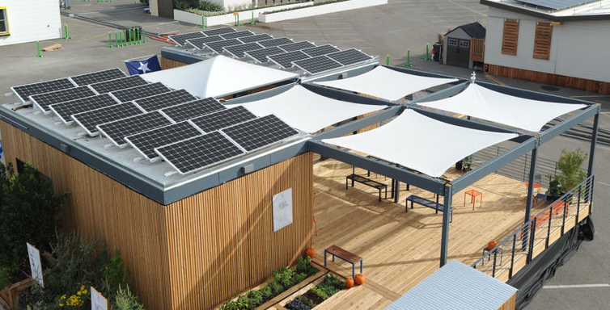
Figure 1: Photo of Nexushaus in Irvine, CA

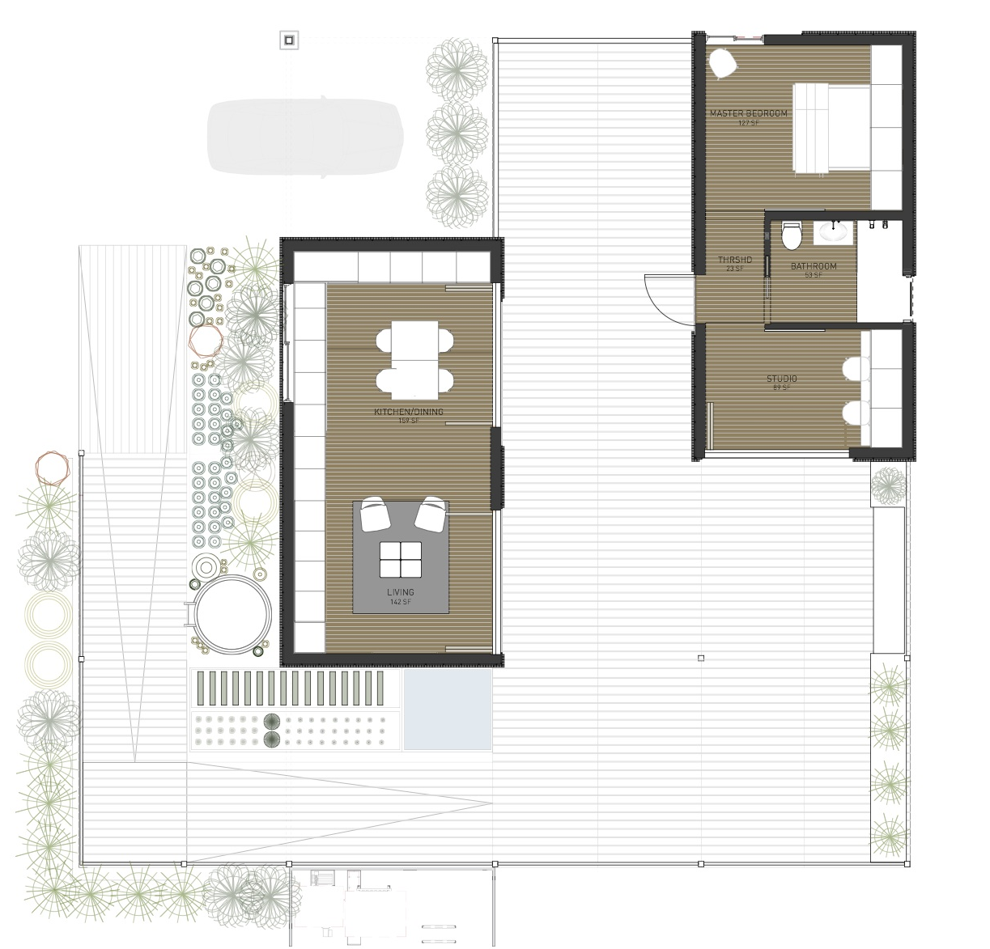

Figure 2: Nexushaus floor Plan

INNOVATIVE DESIGN CONCEPTS
Austin is currently one of the fastest growing cities in the country. At the same time, an enduring drought and projected long-term water availability shortfall have tightened water resources across the state. Additionally, as a consequence of both of population growth and warming regional climate, the electricity grid is under increasing strain—much of which is due to residential air conditioning. Therefore, the 2015 UT and TUM Solar Decathlon House, Nexushaus, addresses both sustainability and affordable urban housing as its key goals. The house accomplishes these goals by incorporating innovative design concepts and integrated systems, has come to be “zero net energy”, “zero net water” and “carbon neutral” through smart design and integrated systems such as its smart water design concept.

NEXUSHAUS SMART WATER DESIGN
The world’s population growth—spurred by technological innovation and fossil fuel energy—has accelerated over the past several hundred years, leading to a corresponding growth in consumption of water. This growth can strain resources and has exposed the underlying connections and tensions between energy and water systems. The built environment is a major contributor to these energy and water stresses. The built environment (residential and commercial buildings) are responsible for approximately 40% of the energy consumption and 46% of the water use (12% directly, and 34% indirectly through thermoelectric power generation (Maupin et al., 2010) in the United States. Moreover, the Texas population is anticipated to grow by 80% in the next 50 years. Such increase in population coupled with predicted warming temperature will result in a constant increase in residential water demands and air conditioning loads (TWDB, 2012). During the summer in Texas, the cumulative electric demand from residential air conditioners alone can exceed 40% of the peak load on the electric grid (ERCOT, 2014). Because most of these power plants use water for cooling, water scarcity can force them to reduce their power output or turn off entirely (Stillwell et al., 2011; Cook et al., 2015). If power plants do not have the water available to produce power, price could significantly increase, and/or the supply could become less reliable (Stillwell et al., 2011; Cook et al., 2015. Thus, focusing on the ‘Energy-Water Nexus’ of the built environment provides an opportunity to significantly address energy and water issues.

There is a mutual relation between water and energy, as thermoelectric power plants providing electricity to buildings definitely need water, and electricity is also required to treat and move water for residential use (Sanders, 2012). This interdependence of energy and water can lead to many potential supply and availability issues; in addition, it could be the solution to most effectively addressing these issues (Webber, 2016). As a consequence, the Nexushaus takes advantage of a holistic approach in order to offer such a solution. The house incorporates an Integrated Thermal Energy and Rainwater Storage (ITHERST) system to shift air conditioning load off-peak to the early morning hours. The proposed combined system concept could potentially increase the economic viability of both systems beyond that of two separate systems. Thermal storage technology has traditionally only been employed on the large commercial and industrial scale, but Nexushaus demonstrates the concept on a residential scale.

Furthermore, there is a supplementary water system for the house, including potable rainwater collection system, greywater collection and irrigation system, and AC condensate collection, which will be further discussed.

Finally, the Nexushaus employs an aquaponic garden in which fish and vegetables are grown together in a constructed aquatic ecosystem. The effluent from the fish fertilizes the water which is pumped to vegetable grow beds where bacteria convert the effluent into usable nutrients for the plants. The plants in turn absorb nutrients from the water, thereby purifying the water, which flows back to the fish. However, this paper addresses the two former solutions of water design in Nexushaus and the latter one is out of scope of this paper.

Hydronic air conditioning and heating system with rainwater thermal storage
Active thermal energy storage (TES) is a method of reducing peak electricity load for AC systems by coupling the system with a thermal mass- regularly a tank of water or ice, but could also be a phase change material (PCM). This mass is pre-cooled off-peak so that it can be used on-peak to reduce (or replace) the compressor portion of the AC system by supplementing (or fully meeting) the cooling load by warming the pre-cooled water or melting the ice or PCM (Dincer & Rosen, 2010; Hyman, 2011; ASHRAE, 2009; Bourne & Novoselac, 2015).

To alleviate afternoon electricity grid congestion, and avoid higher-priced power, the house will incorporate a stratified water thermal storage system to shift air conditioning load off-peak to the early morning hours. In fact, it is an integrated thermal energy and rainwater storage (ITHERST) system that is combined with the residential air source chiller/heat pump with hydronic distribution. Hydronic refers to the system using a water (or water/glycol mix) thermal working fluid to deliver heating/cooling from the heat pump to the house. This configuration can lessen the air conditioning-related peak load significantly more than prior configurations because the heat pump can be turned off entirely during the on-peak hours, leaving only circulation pumps operating (Upshaw et al., 2016).

The thermal storage system is incorporated indirectly into the house’s hydronic air conditioning system via a heat exchanger, isolating the two liquids. The indirect coupling allows for the thermal storage water to be used in the event of an emergency without compromising the air conditioning and heating system (for example, fire sprinkler supply water, or in the event of a serious drought or natural disaster).

It must be noted that ITHERST provides both heating and cooling; however, the focus of study is on cooling due to the fact that peak-shifting is not a concern through winter in Texas. Figure 3 contains a schematic representation of the main components in the proposed ITHERST concept using a residential hydronic cooling and heating system with indirect rainwater thermal storage.

Figure 3: This ITHERST concept uses an air-source reversible heat pump (chiller) with hydronic distribution to fan coil units to provide cooling. An indirect rainwater thermal storage system allows the heat pump to turn off during afternoon hours, reducing on-peak power demand.

Figure 4: Schematic diagram of the rainwater harvesting system for Nexushaus

Supplementary water collection systems
Active water source replacements, such as rainwater harvesting considerably result in decrease or deletion of residential demand for municipal water (TWDB, 2005; 2006). A research in the United States indicates that rain water collection and greywater reuse could potentially save energy on the utility side via reducing energy spent pumping and treating water and wastewater (Malinowski,2015). Accordingly, in Nexushaus, a supplementary water system has been designed which comprises potable rainwater collection system, greywater collection and irrigation system, and AC condensate collection. This system is separated into three portions: 1) rainwater collection, 2) potable water consumption, and 3) greywater and air conditioner condensate captured for irrigation. These three segments of the auxiliary water system are represented through a series of volume balances that track the water collected, held, and consumed by the household on a daily basis.

The house captures rainwater to supply all of its potable water needs, relying on a small city water re-fill line only for backup during long dry spells. The potable rainwater harvesting system minimizes added stress to the region’s water supplies, and minimizes the additional load on the existing neighbourhood water and wastewater infrastructure. Additionally, the on-site treatment system avoids the water losses along the municipal distribution system (approximately 10%). The thermal storage tank acts as a secondary storage volume for rainwater, giving the system additional capacity while also providing beneficial load shifting.

Figure 4 shows the rainwater harvesting and wastewater reuse portion of the ITHERST system for Nexushaus. As indicated, the system is designed to capture and treat the rainwater for potable consumption. If the water obtains adequate treatment to prevent the thermal storage heat exchanger from fouling, a non- potable arrangement will be also conceivable. Moreover,

it is possible for a non-potable version of this system to utilize greywater for thermal storage provided sufficient pre-filtration and treatment.

Rainwater is collected off the roof and pre-screened for large debris, and the first-flush diverter diverts the initial rainfall away from the rest of the rainwater collection system. An additional inlet may be used to screen organic matter (such as leaves, bugs, etc.) from the incoming water to minimize contaminants accumulating in the primary collection tank. The primary rainwater collection tank catches rainwater, and stores it for eventual consumption in the potable water system, or transfers it to the rainwater thermal storage tank, provided it is not full and/or occupied by thermal storage operation.

RESULTS AND DISCUSSION: SYSTEM PERFORMANCE
Upshaw et al. discusses two simplified models developed to perform an initial assessment of the system performance for both the thermal storage and potable rainwater collection systems in the Nexushaus (Upshaw et al., 2016).

The purpose of this analysis was twofold: 1) provide a first approximation of the TES system performance of the described ITHERST system, 2) estimate the water savings for the rainwater collection system, and assess the impact of utilizing a portion of it for thermal storage. A step-wise hourly thermodynamic model of the thermal storage system is deliberated to assess on-peak performance, and a daily volume-balance model of supplementary water collection and consumption is provided to assess water savings potential.
The results are totally convincing: “Comparing the modelled cooling load to that of a typical Austin house shows that the solar decathlon house used in this analysis represents a smaller and more thermally efficient design scenario. Analysis performed suggests that the proposed

ITHERST system could reduce the on-peak cooling load (compared to the same system without TES) by over 75%, when operating in Austin, Texas. Based on this limited analysis, there appears to be minimum tank volume needed to provide maximum peak load reduction (approximately 1500 L or 400 gallons). However, there does not appear to be any further benefits gained from having a tank significantly larger than the minimum” (Upshaw et al., 2016).

This approach benefits other grid-connected stakeholders, from customer to utility, and could therefore be a source of savings and/or revenue generation. The thermal storage system will save the home occupant on their utility bills in areas where there is real-time or time-of-use pricing. Conceivably, these systems could be rebated by the electric utility, giving the homeowner a reduced-price (or maybe even free) rainwater collection system in the process (Figure 5).

The rainwater collection and consumption analysis indicated that the system can reduce municipal water consumption significantly, but that it would not be able to reach full water independence if it were routinely facing low rainfall rates as those during 2011 in Texas. Upshaw et al. research reveals that “Maximum reduction in municipal water consumption was 89%, and which was achieved by total storage volumes of 8,000 gallons (30283 L) and larger. In this analysis, there was no addi-
Figure 5: Thermal storage reduces the overall load from the Nexushaus to minimize consumption during high electricity price hours, and maximize the utility of the house’s solar electricity production.

-tional benefit to having systems larger than 8,000 gallons, however these systems did continue to accrue water even if it did not occur during the times needed to displace municipal use. The thermal storage operation had a minor impact on overall rainwater collection performance, increasing municipal consumption from 47% (no TES) to 51% (with TES) at the lowest system volumes level; at volumes of 5,000 gallons (18927 L) and higher, thermal storage operation had zero impact on the municipal water savings” (Figure 6).

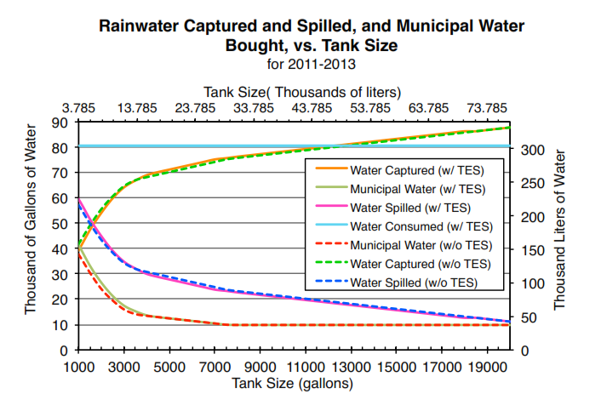
Figure 6: Rainwater captured increases and both rainwater spilled and municipal make-up water consumed decrease non-linearly with increasing storage tank size. This figure shows the impact of using a portion of the volume for thermal storage has little impact to no impact on the ability of the rainwater catchment system to reduce municipal water consumption.

Towards Carbon Neutral
The selection of building materials for the construction of the NexusHaus was dependent on a variety of variables. The material’s strength, weight, life span, surface quality, cost and many other factors were considered from engineering, design, through economic perspectives. Adding a Life Cycle Analysis (LCA) to this design process early enhanced our ability to make decisions based on environmental effects, with the goal of moving the NexusHaus towards carbon neutrality. A NexusHaus life cycle analysis allowed us to evaluate different building material options considering their overall environmental effects throughout the NexusHaus‘ forty-year lifetime, from resource extraction, construction through operation until disassembly. In each phase, an inventory of input and output of materials, energy, water etc. was calculated. The environmental impacts of these input and output values were estimated using available databases and background information.

This LCA evaluation basis was directed towards a set of environmental impacts including, Acidification Potential (AP), Eutrophication Potential (EP), Global Warming Potential (GWP), Ozone Depletion Potential (ODP), Photochemical Ozone Creation Potential (POCP), as well as indicators of Primary Energy Demand (PED), Non-renewable Energy Demand (NED), and Renewable Energy Demand (RED). We limited the results from eight indicators to only two: global warming potential and energy use. These two indicators are quite popular with the mass media and commonly understood by consumers even outside of scientific communities.
The LCA comparison perfectly aligned with the objective of creating an intuitive graphic for our visitors. The graphic (figure 7) displays three baselines: miles driven equating to the carbon dioxide being prevented from entering our atmosphere (global warming potential); gallons of gasoline being saved (Non-Renewable Energy); and a percentage of renewable energy used.
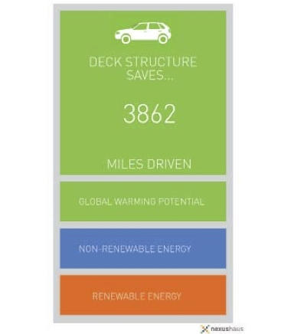
Figure 7; Sample graphic of NexusHaus LCA.
Standard products and systems were used as a baseline to evaluate how much energy we save or how much less greenhouse gases we emit compared to standard solutions. For the GWP we converted the NexusHaus‘ impact and its savings to the impact in miles driven in an average US passenger vehicle. For the non-renewable and renewable Primary Energy we used the heating value of gasoline and the number of days to power the NexusHaus (by PV) respectively.
Result | Amount | Unit | Comparison
Global Warming Potential (GWP) | 423 | g CO2 eq. | per mile driven (average U.S. passenger vehicle) [5]
Non renewable Primary Energy  (PE nr) | 137 | MJ | per gallon of gasoline  (heating value) [6]
Renewable Primary Energy (PE r) | 17.5 | kWp | Per day to power the  NexusHaus

Figure 8: Conversion factors for visualizing the LCA results.

The LCA design process of the NexuHaus involved informed tradeoffs of many considerations including cost benefit ratios, efficiency, diversity and the ‘sprit’ of the design. Alternative models analyzed detailed alterations to the design and made it a challenge to calculate a traditional LCA. When confronted with this problem, the need for mass-information computing software to integrate LCA into the design process arose. In this particular design process several design possibilities were first created in 3D modeling software then judged against other iterations based on drawings, renderings and structural feasibility. The concept was to integrate LCA at this conceptual phase by using the 3D modeling software’s quantity take off calculators that easily extracted the volume of many different components. Ideally, our tool would use these 3D generated quantities to run LCA studies of the different iterations and quickly tell us the implications of our latest iteration.
The tool we used for used four our LCA evaluation is a plug-in software application called Tally [7]. Tally was developed in 2008 by KT Innovations partnered with Autodesk Sustainability Solutions and PE International in response to a growing industry awareness of life cycle considerations. Tally methodology is consistent with the latest LCA standards ISO 14040-14044 [8].
Tally was able to extract quantities from 3D models in Autodesk Revit [9] and calculate environmental impacts of these values using its database. During our studies of LCA and research into different information sets we found an inclusive database in ökobau.dat [10]. This database provided the detailed information we needed and gave us the option of hundreds of different material types. To be able to incorporate these massive amounts of data in the same way as Tally a program definition had to be made that would mimic Tally but allow us to easily add and vary our material choice palette. To do this, our team switched to Rhino3D [11] and Grasshopper [12] (an information processor for Rhino3D) in Grasshopper our team created a definition that would analyze 3D solids and evaluate them based on excel information compiled in a separate file, which was information extracted from ökobau.dat. Our definition allowed us to select any 3D solid and apply custom material properties. Then, we could fine-tune the life span, coatings or combination of materials we would like to test. Our definition returned environmental impact sets and graphs that we used to evaluate our different iterations. At the conceptual phase we were able to see the environmental implications of even minor architectural considerations like beam type. This gave us the flexibility our team needed to easily incorporate LCA into the design process.
In order to enable a comparison between materials, a functional unit had to be defined. The functional unit is the indicator of the product’s performance under defined circumstances [13]. The scope in our case was in identifying the best material for a residential home from an environmental perspective. Figure 6, shows the three different materials we analyzed for the NexusHaus.

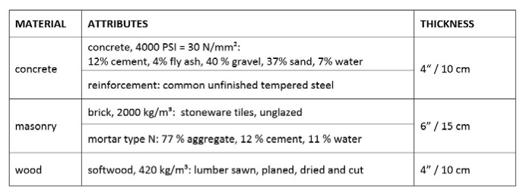
Figure 9: Material details of the function unit 1 m2 of wall

Typical construction materials for residential homes are masonry, concrete and wood. Their performance is indicated by the amount of material needed to guarantee safety in a wall construction. While running meters and height remain the same for all materials, the thickness has to be adjusted according to the material performance in a solid wall construction. Consequently, the functional unit for our material LCA evaluations was, “1 m2 of wall with the minimal thickness needed to provide safety in load bearing walls” [14].

To start our analysis, we first built three simplified Autodesk Revit model versions of the original design to designate the materials and construction systems we wanted to compare and analyze with Tally. We then analyzed the main material for the construction of the building: wood, brick or concrete. We ran the comparison based on an assumption of 40 years building service life, which is reached by all compared materials under normal circumstances without replacements [15]. Consequently, we did not consider any maintenance or replacement efforts. Figure 10 shows the results obtained for the different materials for performance indicators and impact.

Figure 10: LCA analysis for concrete, masonry and wood building materials

Wood weighs much less than brick or concrete and this grants major benefits for the transportation in case of prefabrication. It also outperforms both brick and concrete in the impact category of Global Warming Potential and the input category of Non-renewable Primary Energy Demand. By scaling up the results for NexusHaus LCA, we found that the amount CO2 saved compared to brick is the same amount as is caused by driving 11,900 miles. Also, the Non Renewable Primary Energy saved equals 889 gallons of gasoline. The calculated savings result from a total wall area of 840 ft2.

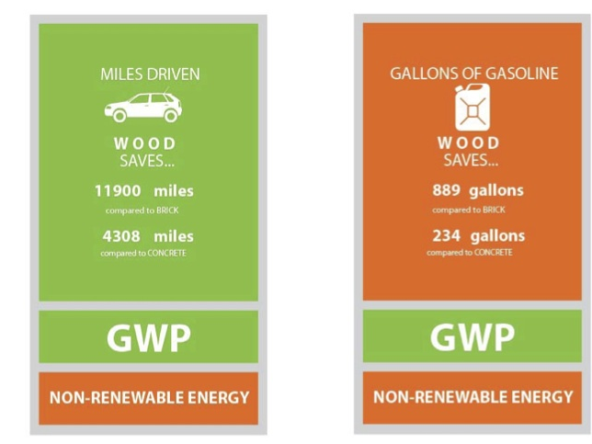
Figure 11; Tour Graphic Equivalents for Material Type

After using Tally to help us determine the primary building material we used a LCA evaluation to compare three different wood construction assemblies: standard timber frame, advanced timber frame and cross-laminated timber (CLT).
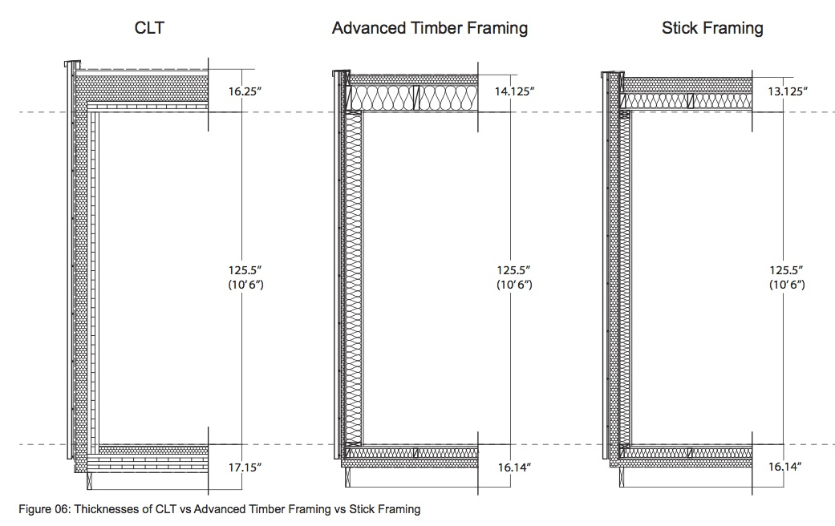
Figure 12: Thickness of CCLT vs. Advanced Timber Framing vs. Stick Framing.

In our LCA wood framing comparison we assigned to each framing system, the amount of material, life expectancy, manufacturer and thickness to be analyzed. When Tally gave us the results we were able to filter which were our best LCA option and we could pick and choose our materials and construction systems with more precision. For example one of our main goals for this building was to use the lowest U-value feasible for the roof, floor and wall systems. Tally reported that cork is a very good insulator with a low carbon footprint. With the help of Tally we also realized that our best option for the construction was advanced timber frame. In the end we came out with an optimized version, which, consisted of wood as the construction material, advanced timber framing with cork as rigid insulation and Icynene fill insulation.

During the LCA we used Tally to evaluate tradeoffs between our extensive amount of wood used as a finish material in our rain screen, decking and wood interior finishes to offset our use of steel as a support for the shading canopy and for deck railing, figure 13.

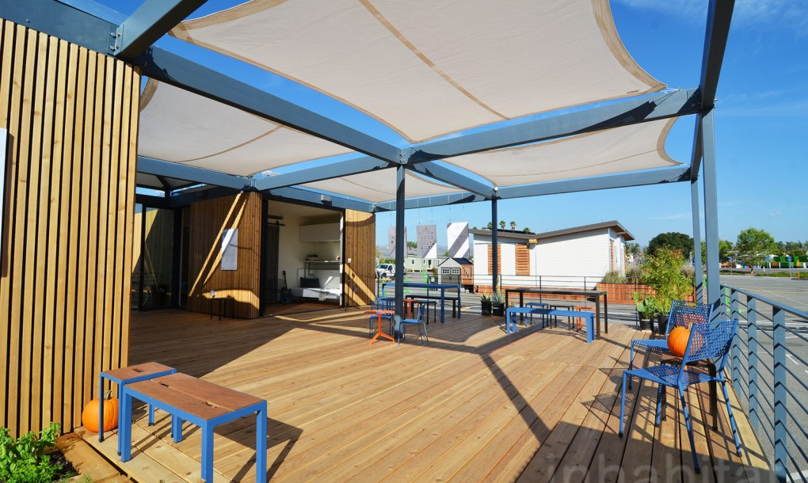
Figure 13: NexusHaus features extensive use of wood

The wooden structure was made of 6”x6” columns (12’ tall/tributary area of 49 sq ft) with 4”x8” beams (14’ span) and the steel structure W6 columns (12’ tall/tributary area of 49 sq ft) with 6” deep steel flange beams (14span). The steel structure had 1,400 kg CO of Global Warming Potential [33] as compared to 4.30 kg [33] of the wooden structure and consumed almost three times as much energy. The steel structure increased the Global Warming Potential of the NexusHaus the equivalent of 2,335 miles driven and was more than offset by extensive amount of wood used in the façade, deck and structure of the NexusHaus which saved an equivalent of 11,900 miles driven compared to another finish material like brick.

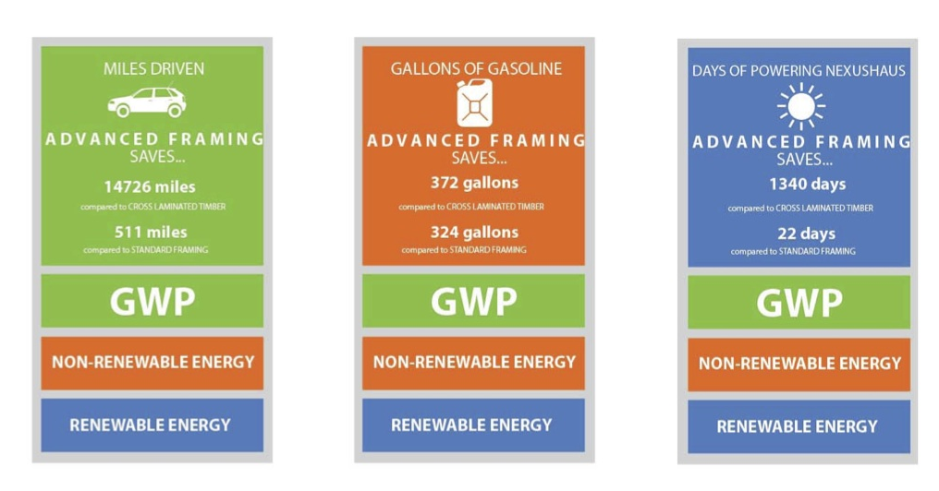
Figure 14 LCA evaluation of steel vs. wood deck canopy

Using the amount of CO2 sequestered in the wood used in the construction of NexusHaus, the materials specified balanced the C02 generated in the manufacturing of our other building materials used in the house such that NexusHaus is moving towards carbon neutrality, Tosi [16].

CONCLUSION

The Nexushaus demonstrates an affordable completely solar-powered and water efficient home, and the innovations of the house serve as catalysts for change, leading the residential housing industry toward more sustainable practices while addressing the need for well-designed, appropriately diverse, economically viable, and environmentally responsible housing. The jury has commended the Nesuxhaus team for its highly innovative water treatment system, integrated rainwater collection and thermal storage system, high efficiency chiller and student designed smart home control system. Among all factors, this paper addresses the responsible integrated energy-water design in Nexushaus, which takes advantage of an Integrated Thermal Energy and Rainwater Storage (ITHERST) system, and a supplementary water system for the house (including potable rainwater collection system, greywater collection and irrigation system, and AC condensate collection).

The developed models to perform an initial assessment of the system suggest that these integrated systems have the technical potential to significantly reduce the Electric Peak load demand and water consumption from residential houses. While the magnitude of the results from the case study analysis in this paper are not directly applicable to different sized houses or locations, the relative load reduction and water savings (approximately 75% peak load reduction, approximately 90% municipal water savings) could be reasonably achieved on larger, more traditional, homes given proper system sizing and water efficiency measures.

While the ability to achieve zero net energy through properly sized PV systems and to achieve net positive water through rainwater harvesting are well documented, the documentation of carbon neutrality represents several challenges. The building materials up stream and down stream database assumptions are based on statistical averages and the amount of the building materials is based on general sizing. A more nuisance carbon neutral analysis should be based on actual up stream and downstream environmental impacts and a more exact calculation of material volumes. Although the magnitude of the results from the case study analysis in this paper are not directly applicable to different sized houses or locations, the relative load reduction, water savings and reduction in the embodied energy of building materials could be reasonably achieved on larger, more traditional, homes given proper system sizing, water efficiency measures and the specification of low embodied energy materials

The ultimate goal of Nexushaus is to serve as a potential prototype for a next-generation modular home that could be reproduced en masse in an assembly plant in Austin. Nexushaus has been be shipped to McDonald Observatory in West Texas to house scientists and other University staff members, where further monitoring and experimental evaluation will be carried on in order to further investigate the building performance

Footnotes

- Nexushaus, www.Nexushaus.com, The University of Texas at Austin, J The U.S. Dept. of Energy Solar Decathlon 2015 Competition, www.solardecathlon.gov, The .S. Department of Energy, January, 2016.
- Texas Water Development Board. The Texas Manual on Rainwater Harvesting. Technical Report, Texas Water Development Board, 2005.
- Texas Water Development Board. Rainwater Harvesting Potential and Guidelines for Texas Report to the 80th Legislature. Technical Report November, State of Texas Rainwater Harvesting Evaluation Committee, 2006.
- Upshaw, C.R., Rhodes, J.D., Webber, M.E., Modeling Electric Load and Water Consumption Impacts from an Integrated Thermal Energy and Rainwater Storage System for Residential Buildings in Texas, 10.1016/j.apenergy, 2016.
- United States Environmental Protection Agency. 2014. Green- house Gas Emissions from a Typical Passenger Vehicle. Last Accessed December 1, 2014. http://www.epa.gov/otaq/climate/ documents/420f14040.pdf.
- Office of Air Quality Planning and Standards, Office of Air and Radiation U.S. Environmental Protection Agency, January 1995: Compilation of Air Pollutant Emission Factors, Appendix A: Miscellaneous Data and Conversion Factors.. http://www.epa.gov/ttn/chief/ ap42/appendix/appa.pdf
- TALLY. Computer software. Http://choosetally.com/. Vers. 2014.12.10.01. KT Innovations, PE International, and Autodesk, n.d. Web.
- Environmental management – Life cycle assessment – Principles and framework (ISO 14040:2006).
- REVIT. Computer software. Http://www.autodesk.com/pro- ducts/revit-family/overview. Vers. 2015. Autodesk, n.d. Web.
- ÖKOBAUDAT, Informationsportal Nachhaltiges Bauen: Baustoff- Und Gebäudedaten“, http://www.nachhaltigesbauen. de/baustoff-und-gebaeudedaten/ oekobaudat.html, 2014.
- RHINO 3D. Computer Soft- ware. Https://www.rhino3d.com/. Vers.5Mcneel, 2015.
- GRASSHOPPER. Computer software. Http://www.grasshop- per3d.com/. Vers. 0.9.0076. Scott Davidson, 2015.
- Lund, E., M. Nowak, and J. Crandell. Building Con- crete Masonry Homes: Design and Construction Issues. Malboro: National Association of Home Buil- ders Research Center, 1998. pages 5-6.
- Weidema, B., H. Wenzel, and C. Petersen. „The Product, Functional Unit and Reference Flows in LCA.“ Environmental News 70/2004 (2004): page 13.
- Cross Laminated Timber: A Primer.“ FP Innovations. Janu- ary 1, 2010. Accessed December 12, 2014. https://fpinnovations.ca/ media/publications/Documents/clt- primer.pdf.
- Tosi A., Hanisch, C., Maia, I., Park, J., Maric, M., Recher, M., & Urena, M., “Building Systems: Life Cycle Analysis of the NexusHaus, Materials, Photovoltaic’s, Construction & Transport, Integrated Life Cycle Analysis of NexusHaus, Technische Universitat Munchen, Institute for Energy Efficient and Sustainable Planning and Building, Munich Germany, March 2015.

REFERENCES

ASHRAE. 2009 ASHRAE Handbook Fundamentals. ASHRAE, 2009.
Cook, M. A., King, C. W., Davidson, F. T., & Webber, M. E. Assessing the impacts of droughts and heat waves at thermoelectric power plants in the United States using integrated regression, thermodynamic, and climate models. Energy Reports, 1, 193–203, October 2015 doi:10.1016/j.egyr.2015.10.002
Dincer, M. A. Rosen. Thermal Energy Storage: Systems and Applications, John Wiley &, Ltd., 2010.
ERCOT. (2014). Report on the Capacity, Demand, and Reserves in the ERCOT Region – February 2014, Electric Reliability Council of Texas.
Hyman, l.,B Sustainable Thermal Storage Systems: Planning, Design, and Operations. McGraw-Hill, 2011.
Malinowski, P. A., Stillwell, A. S., Wu, J. S., & Schwarz, P. M. Energy-Water Nexus: Potential Energy Savings and Implications for Sustainable Integrated Water Management in Urban Areas from Rainwater Harvesting and Gray-Water Reuse. Journal of Water Resources Planning and Management, A4015003, 2015, doi:10.1061/(ASCE)WR.1943-5452.0000528
Maupin, M. A., Kenny, J. F., Hutson, S. S., Lovelace, J. K. , Barber, N. L. , and Linsey, K. S.(2014). Estimated Use of Water in the United States in 2010, U.S. Geological Survey, November, 2014.
Michael E. Webber (2016). Thirst for Power: Energy, Water and Human Survival. Yale University Press.
Sanders, K. T., & Webber, M. E.(2012). Evaluating the energy consumed for water use in the United States. Environmental Research Letters, 7(3), 034034, September, doi:10.1088/17489326/7/3/034034.
Stillwell, A. S., King, C. W., Webber, M. E., Duncan, I. J., & Hardberger, A. The EnergyWater Nexus In Texas. Ecology And Society, 16(1), 2011, Retrieved from http://www.ecologyandsociety.org/vol16/iss1/art2/
Texas Water Development Board. 2012 Texas State Water Plan. Technical report, Texas Water Development Board, 2012.
Texas Water Development Board. The Texas Manual on Rainwater Harvesting. Technical Report, Texas Water Development Board, 2005.
Texas Water Development Board. Rainwater Harvesting Potential and Guidelines for Texas Report to the 80th Legislature. Technical Report November, State of Texas Rainwater Harvesting Evaluation Committee, 2006.
Upshaw, C.R., Rhodes, J.D., Webber, M.E. (2016). Modeling Electric Load and Water Consumption Impacts from an Integrated Thermal Energy and Rainwater Storage System for Residential Buildings in Texas [In Press] doi reference code 10.1016/j.apenergy.2016.02.130 once it's published
Nexushaus, www.Nexushaus.com, The University of Texas at Austin, Last Accessed: January, 2016.
The U.S. Dept. of Energy Solar Decathlon 2015 Competition, www.solardecathlon.gov, The .S. Department of Energy, Last Accessed: January, 2016.
The 2002 University of Texas Solar Decathlon Team, Report on the 2002 Texas Solar D House, National Renewable Energy Lab, Washington D.C., 2003.

