Research Performance Final Report
Due: 11/30/2014
The University of Georgia Research Foundation, Inc.
Development of Bio-Oil Commodity Fuel as a Refinery Feedstock from High Impact Algae Biomass

Authors
PI: Jim Kastner,

Co-PI’s
Sudhagar Mani and KC Das - Associate and Full Professor
Roger Hilten – Post-Doctoral Research Engineer
Umakanta Jena – Desert Research Institute

Organizations
Biochemical Engineering, College of Engineering, The University of Georgia, Athens GA
The Desert Research Institute, Reno NV

Timeline
- Project start date: 1-1-2013
- Project end date: 8-31-2014
- Percent complete: 100%
Barriers
- Al-B. Algal Fuel Production
- High Nitrogen Oil
Budget
- Total project funding ($698,000)
- Funding for FY 2013-2014 ($698,000)
Partners & Roles
- Intertek – Microcrude Assay (not included in the final decision on the project)
- Desert Research Institute – Short residence time HTL
- Refinery – To Be Determined

Acknowledgment: “This material is based upon work supported by the Department of Energy under Award Number DE-EE0006201].”

Disclaimer: “This report was prepared as an account of work sponsored by an agency of the United States Government. Neither the United States Government nor any agency thereof, nor any of their employees, makes any warranty, express or implied, or assumes any legal liability or responsibility for the accuracy, completeness, or usefulness of any information, apparatus, product, or process disclosed, or represents that its use would not infringe privately owned rights. Reference herein to any specific commercial product, process, or service by trade name, trademark, manufacturer, or otherwise does not necessarily constitute or imply its endorsement, recommendation, or favoring by the United States Government or any agency thereof. The views and opinions of authors expressed herein do not necessarily state or reflect those of the United States Government or any agency thereof.”
Contents
1. Executive Summary 8
2. Introduction 10
3. Project Objectives 17
4. Project Scope 18
5. Tasks Performed 18
5.1. Task 1.0: Develop a two-stage HTL process for low-nitrogen bio-oil production 18
5.2. Task 2.0: Develop a process of upgrading the bio-oil obtained in objective 1 19
5.3. Task 3: Evaluate the treated bio-oil as a refinery feedstock 19
5.4. Task 4: Process cost modeling and life cycle analysis study 20
5.5. Task 5: Initiate talks with a refinery company 20
5.6. Task 6: Project Management and Reporting 21
6. Experimental Methods 21
6.1. Algae Cultivation and Strains: 21
6.2. Algae Analysis: 22
6.3. Hydrothermal Liquefaction (HTL): 23
6.4. Two-Stage HTL (Protein/Nitrogen Reduction): 23
6.5. Short Residence Time HTL: 24
6.6. Protein Analysis: 25
6.7. Catalysts: 26
6.8. Catalytic Hydrodeoxgenation (HDO): 27
6.9. Catalyst Characterization: 27
6.9.1. Surface Area: 27
6.9.2. Chemisorption: 27
6.9.3. H₂-Temperature Programmed Reduction (TPR): 28
6.9.4. Algal Oil Separation: 29
6.10. Algal Oil Characterization: 29
7. Results 31
7.1. Algae Composition: 31
7.2. Catalyst Characteristics: 32
7.2.1. Surface Area 32
7.2.2. H₂-TPR 32
7.3. Low Temperature HTL – Nitrogen Reduction: 36
7.4. Short Residence Time HTL-DRI Result 42
7.5. Catalytic HDO of Algal Oil: 44
7.5.1. Catalyst Loading 45
7.5.2. Agitation Effect 53
7.5.3. Repeated Catalytic HDO Effect 53
7.5.4. Simulated Distillation of Repeated HDO Samples 68
7.5.5. Repeated HDO Oil Yields 79
7.6. Catalyst Reuse: 81
7.7. Spent Catalyst Characterization: 84
7.8. Properties of Final Oil: 84
7.9. Process Modeling and Techno-Economic Analysis 88
7.10. Petroleum Refinery Insertion: 95
8. References: 97

List of Figures and Tables
Figure 1. Two-stage HTL (or TCL) process integrated with HDO/HDN for bio-oil production (HDO: Hydrodeoxygenation; HDN: Hydrodenitrogenation). 12
Figure 2. Schematic of the proposed research for integration of algae biorefinery into petroleum refinery process for production of commodity fuels. 14
Figure 3: Algae cultivation in carboys (A) and six raceways under green house facility (B). 21
Figure 4: Catalytic test bed for algae liquefaction and algal oil upgrading studies (A-low temperature, pressure system [300°C, 3000 psig, max]; B-high pressure, temperature [500°C, 5000 psig, max] system). 23
Figure 5: Flowsheet for experimental steps and analytical procedures for a 2 stage HTL/HDO algae to liquid fuel process. Note – TCL is equivalent to HTL in our procedures. 24
Figure 6. The two-chamber reactor system used for first-stage HTL experiments; (A) Schematic of the system, (B) Photo of the actual laboratory system. 25
Figure 7. Schematic of steps during operation of DRI’s two-chamber reactor (TCR) system, (a) water in reactor is heated to desired temperature; (b) ball valve is opened to drop biomass into hot reaction chamber; (c) biomass (inside screen) is reacted for desired time, then entire reactor is quenched in ice bath. 26
Figure 8: Temperature programmed reduction of the catalysts using H₂. The red lines indicate the temperature at which H₂ reduction occurs (just before the large reduction in TCD signal due to H₂ consumption). 35
Figure 9: Effect of low temperature HTL on solids yield and reduction of nitrogen in the algae solids for Spirulina and UGA strains. The percent N removal was calculated based on the original N content of the algae solids and remaining N content in the solids after HTL. 37
Figure 10: Effect of low temperature HTL on solids yield and reduction of nitrogen in the algae solids for Nannochlorpsis. The percent N removal was calculated based on the original N content of the algae solids and remaining N content in the solids after HTL. 38
Figure 11: Effect of HTL temperature on protein levels released to the aqueous phase after subcritical hydrolysis. The bottom graph is the mean (± standard deviation) of protein levels at all measured retention times. 39
Figure 12: GC/MS analysis of aqueous phase generated from low temperature HTL of Spirulina. Chromatograms were similar for the other strains under the same HTL conditions. Compounds left to right are acetic acid, methyl-pyrazine, 4,5-dimethyl-pyrimidine, 2-ethyl-3-methyl-pyrazine, dl-alanyl-l-leucine, and pyrrolo[1,2-a]pyrazine-1,4-dione, hexahydro-3-(2-methylpropyl)-. 40
Figure 13: HPLC analysis of aqueous phase generated from low temperature HTL of Spirulina. Chromatograms were similar for the other strains under the same HTL conditions 41
Figure 14: Effect of temperature and residence on protein levels released to the recovered aqueous phase of HTL experiments with UGA raceway strains. 42
Figure 15: Effect of short τ, low temperature HTL on % N in algae solids. Potential outlier shown in red circle. 43
Figure 16: Reduction in nitrogen relative to initial content in UGA algae. Error bars were calculated based on the largest possible deviation in % reduction using measurement standard deviation and mean % N in starting UGA algae (7.76 ± 0.30 g/g). 43
Figure 17: Effect of holding time on algal yield for single stage HTL (left) and the effect of pretreatment temperature and holding time on oil yield for the UGA raceway strain (right, 2 stage HTL, pretreatment temperatures shown). 44
Figure 18: Oil yields (dry ash free basis or DAF) for single stage HTL (w/o pretreatment) and a range of HTL/HDO combinations in a micro-reactor system. See Table 3 for a description of the legend. RRM is reduced red mud, Ru/C is Ru on carbon. 47
Figure 19: Nitrogen levels (dry basis) for single stage HTL (w/o pretreatment) and a range of HTL/HDO combinations in a micro-reactor system. See Table 3 for a description of the legend. RRM is reduced red mud, Ru/C is Ru on carbon. 48
Figure 20: Hydrogen consumption levels (per gram of catalyst basis) for a range of HTL/HDO combinations in a micro-reactor system. See Table 3 for a description of the legend. RRM is reduced red mud, Ru/C is Ru on carbon. The arrow indicates that a measurement was not taken. 49
Figure 21: Hydrogen consumption levels (per gram of oil basis) for a range of HTL/HDO combinations in a micro-reactor system. See Table 3 for a description of the legend. RRM is reduced red mud, Ru/C is Ru on carbon. The arrow indicates that a measurement was not taken. 50
Figure 22: Effect of catalyst loading on hydrodeoxygenation of algal oil generated via HTL of Nannochloropsis. Pretreatment HTL was conducted at 225°C, 15 min. HTL was conducted at 350°C for 60 min. HDO was conducted at 350°C with 100% H₂ at 750 psig (initial P) for 4 h. Catalyst loading was 0.7 g and 2.1 g per 7 g of algae paste in 40 ml of DI water. RRM is reduced red mud – primarily hematite and magnetite (via XRD analysis). Note - PT is pretreatment at 225°C for 15 min, HTL was conducted at 350°C for 60, and HDO is hydrodeoxygenation. 51
Figure 23: GC/MS profile of A) HTL of Nannochloropsis sp. (350°C, 60 minutes, 20% solids w/w) and B) PT/HTL/HDO using Ru/C catalyst (2.1 g of catalyst/7g of algae paste). 52
Figure 24: Effect of agitation rate on H₂ consumption during HDO of algal oil using Ru/Carbon. First, an algae suspension was treated via a two stage HTL (225°C,300psig→350°C, 500psig) with aqueous nitrogen removed between the stages. Next a catalytic HDO step was conducted on the algal oil at 350°C for 4 h (100% H₂ in headspace at time zero, 750 psig). All experiments were conducted with 2.1 g-cat (Ru/C)/40 algal oil. 54
Figure 25: Effect of agitation rate on the nitrogen content algal oil undergoing HDO using Ru/Carbon. First, an algae suspension was treated via a two stage HTL (225°C,300psig→350°C, 500psig) with aqueous nitrogen removed between the stages. Next a catalytic HDO step was conducted on the algal oil at 350°C for 4 h (100% H₂ in headspace at time zero, 750 psig). All experiments were conducted with 2.1 g-cat (Ru/C)/40 algal oil. 55
Figure 26: Effect of repeated batch catalytic HDO of algal oil generated from hydrothermal liquefaction. Conditions are the same as noted in the caption of Figure 20, except for the last two experiments performed at a first stage HTL temperature of 175°C. RRM is H₂ reduced red mud (at 300°C); Ru/C is ruthenium on activated carbon catalyst; 2.1 is the amount of catalyst in grams per 40 ml of algae suspension; 2-HDO is for two HDO steps using the same batch of algal oil and catalyst. 56
Figure 27: GC/MS analysis of resultant oil (UGA Raceway) after catalytic HDO using Ru/Carbon catalyst – top: single stage HDO, bottom-2 stage HDO. 57
Figure 28: Compositional analysis of algal oil, from UGA strains, after catalytic HDO (Ru/C vs. CoMo-S), based on GC/MS analysis and % peak area. AH – aromatic hydrocarbons, LCH – long chain hydrocarbons, LCH>C20 – long chain hydrocarbons greater than C20, NA-nitrogenated aromatics, LCA-long chain amides, PAH – polycyclic aromatics. See Table 4, group 2 for reaction conditions. 62
Figure 29: Compositional analysis of algal oil, from Nannochloropsis, after catalytic HDO (Ru/C, CoMo-H2, CoMo-S, RRM), based on GC/MS analysis and % peak area. AH – aromatic hydrocarbons, LCH – long chain hydrocarbons, LCH>C20 – long chain hydrocarbons greater than C20, NA-nitrogenated aromatics, LCA-long chain amides, PAH – polycyclic aromatics. See Table 4, group 3 for reaction conditions. 63
Figure 30: Compositional analysis of algal oil, from different strains, after catalytic HDO (Ru/C), based on GC/MS analysis and % peak area. AH – aromatic hydrocarbons, LCH – long chain hydrocarbons, LCH>C20 – long chain hydrocarbons greater than C20, NA-nitrogenated aromatics, LCA-long chain amides, PAH – polycyclic aromatics. See Table 4, group 1 for reaction conditions. 64
Figure 31: Compositional analysis of algal oil (from Nannochloropsis), under different HTL conditions, after catalytic HDO (Ru/C), based on GC/MS analysis and % peak area. AH – aromatic hydrocarbons, LCH – long chain hydrocarbons, LCH>C20 – long chain hydrocarbons greater than C20, NA-nitrogenated aromatics, LCA-long chain amides, PAH – polycyclic aromatics. See Table 4, group 4 for reaction conditions. 65
Figure 32: Compositional analysis of algal oil (from UGA strains), under different HTL conditions, after catalytic HDO (Ru/C), based on GC/MS analysis and % peak area. AH – aromatic hydrocarbons, LCH – long chain hydrocarbons, LCH>C20 – long chain hydrocarbons greater than C20, NA-nitrogenated aromatics, LCA-long chain amides, PAH – polycyclic aromatics. See Table 4, group 4 for reaction conditions. 66
Figure 33: Hydrogen consumption during (mmols/g of initial oil) catalytic HDO (sum of 2 stages) of algae oil (generated from three strains – Nannochloropsis, UGA, and Spirulina). 67
Figure 34: Simulated distillation analysis of a 3 stage HTL/HDO algal oil generated from Nannochloropsis using Ru/C catalyst for HDO (2.1 g cat, 2 HDO runs). MN is medium naphtha, HN is heavy naphtha, DFO is distillate fuel oil. 69
Figure 35: Simulated distillation analysis of a 3 stage HTL/HDO algal oil generated from Nannochloropsis using CoMo-S catalyst for HDO (2.1 g cat, 2 HDO runs). MN is medium naphtha, HN is heavy naphtha, DFO is distillate fuel oil. 70
Figure 36: Simulated distillation analysis of a 3 stage HTL/HDO algal oil generated from UGA strains using Ru/C catalyst for HDO (2.1 g cat, 2 HDO runs). MN is medium naphtha, HN is heavy naphtha, DFO is distillate fuel oil. 71
Figure 37: Simulated distillation analysis of a 3 stage HTL/HDO algal oil generated from UGA strains using CoMo-S catalyst for HDO (2.1 g cat, 2 HDO runs). MN is medium naphtha, HN is heavy naphtha, DFO is distillate fuel oil. 72
Figure 38: Simulated distillation analysis of a 3 stage HTL/HDO algal oil generated from Nannochloropsis using different catalysts for HDO (2.1 g cat, 2 HDO runs). MN is medium naphtha, HN is heavy naphtha, DFO is distillate fuel oil. 73
Figure 39: Simulated distillation analysis of a 3 stage HTL/HDO algal oil generated from UGA Strain using different catalysts for HDO (2.1 g cat, 2 HDO runs). MN is medium naphtha, HN is heavy naphtha, DFO is distillate fuel oil 74
Figure 40: Simulated distillation analysis of 3 stage HTL/HDO algal oil generated from different algae strains using Ru/C. MN is medium naphtha, HN is heavy naphtha, DFO is distillate fuel oil. 75
Figure 41: GC/MS analysis of Gas Oil reference (Gas Oil No. 1, ASTM D2887). 77
Figure 42: Comparison of simulated distillation analysis between a Gas Oil reference (shown in Fig. 38) and 3 stage HTL/HDO algal oil generated from different algae strains using Ru/C. MN is medium naphtha, HN is heavy naphtha, DFO is distillate fuel oil (according to Table 8). 78
Figure 43: TGA analysis of Nannochloropsis algal oil generated from repeated catalytic HDO using three different catalysts. 79
Figure 44: Final primary oil yields (based on amount of dry, initial algae mass) from coupled HTL/two stage catalytic HDO experiments. 80
Figure 45: GC/MS chromatograms for catalytic HDO of UGA algal oil reusing Ru/C: Top is oil using fresh catalyst, bottom is oil generated using recovered/reused catalyst. 82
Figure 46: Compositional analysis of algal oil, from UGA strains, after catalytic HDO (Ru/C) using recycled catalyst, based on GC/MS analysis and % peak area. AH – aromatic hydrocarbons, LCH – long chain hydrocarbons, LCH>C20 – long chain hydrocarbons greater than C20, NA-nitrogenated aromatics, LCA-long chain amides, PAH – polycyclic aromatics. 83
Figure 47: Ru on carbon catalyst properties (tar, surface area and pore volume via BET) after repeated batch HDO and one reuse for HDO of UGA Raceway oil generated from a two-step HTL. UGA\225\350\350\Ru-C\RU is the reused catalyst result. 83
Figure 48: Effect of repeated use on pore volume distribution for Ru-carbon in the catalytic HDO (batch) of UGA raceway algal oil generated via a two-step HTL process. 84
Figure 49: Tar accumulation, % change in surface area and pore for recoved catalysts used the repeated batch HDO experiments (UGA/225/350/Ru-C/RU indicates a reuse run). 85
Figure 50: Simplified flow diagram of the overall process 88
Figure 51: Breakdown of the capital cost of the algal bio crude plant 93
Figure 52: Breakdown of the operating cost of the algal bio crude plant 94
Figure 53: Sensitivity analysis of the minimum selling price of the algal bio crude 95

Table 1: Composition of algae biomass used in the HTL and HDO studies. 33
Table 2: Physical properties of catalyst used in HDO experiments. 34
Table 3: Experimental Conditions for catalytic hydrodeoxygenation studies on algal oil generated by hydrothermal liquefaction. These conditions were performed for all algae strains. 46
Table 4: Experimental conditions for repeated batch catalytic hydrodeoxygenation studies on algal oil. These conditions were performed for all algae strains. 58
Table 5: Initial CHNS results for repeated batch catalytic hydrodeoxygenation studies on algal oil. These conditions were performed for all algae strains. All experiments performed at 500 rpm and 2.1 g-cat per 40 ml of algal oil. Results were obtained with one sample holder. 59
Table 6: Typical GC/MS analysis output of repeated batch HDO samples – UGA, Ru/C (225°C, 350°C, 2 HDO steps). 60
Table 7: Typical GC/MS analysis output of repeated batch HDO samples – UGA, CoMo-S/C (225°C, 350°C, 2 HDO steps). 61
Table 8: Petroleum boiling point cuts used in simulated distillation analysis of catalytic HDO samples (Distillation cut classifications from Manual of Hydrocarbon Analysis, 6th ed., 1998, Ed: A.W. Drews, ASTM International, Conshohocken, PA). 68
Table 9: Catalyst properties after repeated batch HDO of algal HTL generated oil. Stage 2, 3, and 4 conditions are in Table 4. 86
Table 10: Properties of oil generated by repeated batch catalytic hydrodeoxygenation. Stage 2, 3, and 4 conditions are in Table 4 87
Table 11: Costs for determining the direct fixed capital (Peters et al., 2003). 90
Table 12: Mass balance of algae liquefaction plant 91
Table 13: Summary of algae liquefaction plant costs. 92
Table 14: Comparison of the cost of scenarios with different plant capacity 94

Executive Summary
A two-stage hydrothermal liquefaction (HTL) process was developed to 1) reduce nitrogen levels in algal oil, 2) generate a nitrogen rich stream with limited inhibitors for recycle and algae cultivation, and 3) improve downstream catalytic hydrodenitrogenation and hydrodeoxygenation of the algal oil to refinery intermediates. In the first stage, low temperature HTL was conducted at 125, 175, and 225°C at holding times ranging from 1 to 30 min (time at reaction temperature). A consortium of three algal strains, namely Chlorella sorokiniana, Chlorella minutissima, and Scenedesmus bijuga were used to grow and harvest biomass in a raceway system – this consortium is called the UGA Raceway strain throughout the report. Subsequent analysis of the final harvested product indicated that only two strains predominated in the final harvest - Chlorella sorokiniana and Scenedesmus bijuga. Two additional strains representing a high protein (Spirulina platensis) and high lipid algae (Nannochloropsis) strains were also used in this study. These strains were purchased from suppliers. S. platensis biomass was provided by Earthrise Nutritionals LLC (Calipatria, CA) in dry powder form with defined properties, and was stored in airtight packages at 4°C prior to use. A Nannochloropsis paste from Reed Mariculture was purchased and used in the two-stage HTL/HDO experiments. The solids and liquids from this low temperature HTL pretreatment step were separated and analyzed, leading to the following conclusions.

- An HTL temperature of 225°C and a holding time of 15 min resulted in the largest reduction in solids nitrogen content for all strains – 60% reduction in nitrogen. As the HTL temperature increased, the solids yield decreased, ultimately leading to reduction in oil yield.

- A temperature of 175°C appears to be an optimum pretreatment temperature, when based on protein levels in the aqueous phase, contrary to %N reduction analysis. Higher temperatures lead to protein hydrolysis.

- Analysis of the stage one aqueous phase clearly indicates high protein levels for all strains. These results indicate this stream can be recycled and used as a nitrogen source for algae cultivation.

A majority of our work was performed in stirred, batch reactors (Parr) with long heat-up times (∼20 min). The temperatures and holding times reported above and throughout report (except for section 7.4) are for residence times (τ) at the reaction set point and don’t include this heat-up time. To determine if much shorter residence times would accomplish similar % nitrogen removal values, we contracted with DRI to perform short τ HTL experiments (i.e., no heat-up time) and determine nitrogen removal efficiencies. The same batch of raceway cultivated algae grown at UGA and used in the HTL/HDO experiments was also shipped to DRI and used in their experiments. The major results and conclusions follow.
- Percent nitrogen removal approached 50% (reduction based on N content in starting algae) at 250°C for a 5 min holding time (and a 30% reduction at 3 min).

- Flash or short holding time HTL can be used to reduce nitrogen in algal HTL generated oil and create a nutrient stream for recycle and algae cultivation
Next, the low temperature pretreatment step was coupled with a higher temperature HTL step (350°C, 1h), followed by catalytic HDO. The higher temperature HTL step is required for lipid hydrolysis. In these experiments, controls (algae HTL without pretreatment followed by HDO), 2 stage HTL-HDO runs (HTL pretreatment followed directly by HDO), and 3 stage HTL-HDO runs (pretreatment→HTL→2 HDO) were performed. A total of four catalysts were evaluated – reduced red mud (iron oxides are active metal oxides), Ru on activated carbon, H₂ reduced CoMo, and sulfided CoMo. The resultant product generated from HDO, after extraction, was analyzed using CHNSO analysis, GC/MS, GC/TCD (off-gas), H₂ consumption, and simulated distillation. In addition, catalyst was recovered and analyzed for surface area and pore size distribution. The major results from a 3 stage HTL/HDO coupled process is as follows.
- Ru on carbon (5% loading) generated the lowest level of nitrogen and heteroatoms and was the most effective HDO catalyst. The CoMoS catalyst generated higher nitrogen and heteroatom levels, and resulted in a higher TAN value and lower heating value, probably due to the low sulfur levels in the oil.

- The highest quality oil was generated from the UGA raceway strain using Ru/C and HTL pretreatment (225°C, 15 min) with a repeated batch HDO step – 3.24% N, 9.3% O, TAN of 12, 1.25% water, and an HHV of 40 MJ/kg (2 HDO runs at 350°C for 4 h).

- The highest quality oil (based on N and heteroatom levels) had a higher boiling point range then a Gas Oil reference: ∼20% kerosene, ∼30% distillate fuel oil, and ∼50% gas oil (based on peak area in a GC/MS analysis).

- Final yields (g oil/g-dry starting algae) for the highest quality oil generated via the coupled HTL/HDO using Ru/C ranged from 15-22%.

- The coupled HTL/HDO process reduced the nitrogen content of the oil by 22-25% (relative to a run without the HTL pretreatment step). A 57% reduction in nitrogen content of the oil was realized when repeated HDO coupled with HTL pretreatment was performed using Ru/C at 4.3 wt. % loading (g-cat/g-total including algae solids, water, and catalyst). This reduction in nitrogen is relative to the 7.5% N in a single stage HTL/HDO oil.

- Catalyst recovery analysis after use indicated that surface area and pore volume were reduced significantly – e.g., an 85% reduction in surface area and 75% reduction in pore volume resulted after one repeated HDO step with Ru/C. Recovery and reuse of the catalyst (Ru/C) caused further reduction in these values to a 92% and 86% reduction in surface area and pore respectively. Similar results were observed will all other catalysts tested.

Overall, these results indicate that low temperature HTL (200-250°C) at short residence times (5-15 min) can be used to lyse algae cells and remove/separate protein and nitrogen before subsequent higher temperature HTL (for lipid and other polymer hydrolysis) and HDO. The significant reduction in nitrogen when coupled with low protein/high lipid algae cultivation methods at scale could significantly improve downstream catalytic HDO results. However, significant barriers and knowledge gaps exist that must be overcome and understood. The ability of the separated protein/nitrogen rich aqueous stream to support algae cultivation needs to be verified (and the kinetics of growth measured). The kinetics of algae hydrothermal liquefaction on a mechanistic basis needs to be measured and understood. A better understanding of Maillard reactions during algae HTL is needed. And the impact of Maillard reaction products and incompletely hydrolyzed cell wall components on catalyst deactivation during HDO needs to be understood. Finally, an inexpensive HDO process and associated catalyst capable of converting the algal oil to hydrocarbons needs to be developed.

Introduction

The Energy Independence and Security Act of 2007 (EISA) requires the United States to produce 36 billion gallons of renewable fuels from the biomass sources by 2022. In support, the U.S. Department of Energy (DOE) has set a goal to promote energy diversity and independence in its strategic plan. Consequently, the DOE Energy Efficiency and Renewable Energy (EERE) Biomass Program emphasizes four key priorities: 1) reduction of dependence on foreign oil, 2) promotion of diverse, sustainable, domestic energy resources, 3) reduction of carbon emissions and 4) establishment of a domestic biomass industry (EERE, 2010). Meeting the renewable fuel goals of EISA 2007, will require the production of liquid biofuels from a large and diverse volume of sustainable feedstocks.

Producing liquid fuels from the renewable sources such as biomass is critical to energy security and sustainability and alternative sources of liquid fuels will protect the economic growth of the U.S. by eliminating the uncertainties caused by fluctuating petroleum prices. Algae as a source of liquid fuel production are attractive since they are renewable, grow rapidly even in adverse conditions, and reduce net greenhouse gas emissions by utilizing CO₂. Although algal biomass production has been commercialized in the recent years, downstream processing and conversion of algal biomass to fuels is a significant bottleneck in commercialization according to the recent evaluations (e.g. NABT Roadmap). There has been limited focus on the conversion of algal biomass into liquid fuels, except for biodiesel production via transesterification process. Liquid fuels from algal biomass via transesterification is limited to high lipid algal species and requires algae monocultures which leads to higher production costs. Also, the algal biomass needs to be dried before undergoing lipid extraction and subsequent transesterification. Drying is a highly energy intensive process and negatively affects the economy of the whole process.
Thus, a conversion process that directly converts the wet algae biomass into liquid hydrocarbons is required. Such a product could then be catalytically upgraded to a product similar to gas oil or refinery intermediate. One such conversion technology is the ‘thermochemical or hydrothermal liquefaction’ or ‘TCL or HTL’ (synonymous terminology is hydrothermal liquefaction), where algae biomass is pressure cooked in hot compressed water (at 5-20 atmospheric pressure and 280-380ºC) to generate bio-oil, gases, water solubles and a solid residue. The bio-oil is subsequently separated from the rest of the products and can potentially be upgraded to a product similar to crude oil or gas oil. Although results on HTL bio-oil production from algae biomass are encouraging, there is limited information on catalytic upgrading of the HTL generated bio-oil. Moreover, there is large knowledge gap on the fate of nitrogen in the algal bio-oil and its effect on catalytic upgrading. It is clear that additional research is needed on algal bio-oil production via HTL and upgrading to increase sustainability of the algal liquid fuel production pathway.
Problem
HTL and pyrolysis are two thermochemical conversion processes that directly convert biomass into liquid hydrocarbons. Previous comparative evaluation of HTL and pyrolysis processes for bio-oil production from microalgae biomass indicate that HTL is energetically more efficient for liquid fuel production than the pyrolysis process resulting in 29% higher bio-oil yield and ~32% more energy recovery (Jena and Das, 2011). Also, past studies indicate that HTL bio-oil is more energy dense and shows higher thermal and oxidative stability than the bio-oil produced from pyrolysis (Jena and Das, 2011). To reduce overall energy and cost input, it is necessary to process algae without complete drying (unlike the pyrolysis process), which can be accomplished by hydrothermal liquefaction (HTL) process. HTL is performed using hot compressed water and appropriate catalysts, since it is a highly reactive medium as it approaches its critical point (374°C, 22.1 MPa) due to changes in properties such as solubility, density, dielectric constant and reactivity. HTL depolymerizes lipids, proteins and carbohydrates in algae, transforming them into a bio-oil (also referred to as ‘biocrude’ in the literature), water solubles, gas, and solids (char). Multiple reactions occur in three steps, namely, hydrolysis, depolymerization and repolymerization/self-condensation reactions (Yin et al., 2010). Protein molecules are hydrolyzed into amino acids followed by deamination (release of NH₃) and decarboxylation reactions to form complex hydrocarbons (Sato et al., 2004). The bio-oil is a dark viscous liquid with an energy value 70-95% of that of petroleum fuel oil (Brown et al., 2010; Dote et al., 1994; He et al., 2000; Minowa et al., 1998). Thus, HTL converts organic constituents of algae into a liquid bio-oil that in theory can be refined to gasoline/diesel-like fuels. However, due to the large amount of proteins present in the starting algae biomass, the bio-oil has a large abundance of nitrogen heterocyclic compounds leading to higher amount of nitrogen in the bio-oil which poses potential problems in the subsequent upgrading processes. The various nitrogen compounds generated in the HTL product bio-oil are nitrogen heterocyclics (pyridine, pyrrole, pyrrolidine, and indole) and non-heterocyclics such as open-chain amines and amides (hexadecanenitrile, and hexadecanamides) (Jena et al., 2011b; Ross et al., 2010). Also, the presence of polypetides and proteins lead to the high molecular weight compounds in the bio-oil in the range of 2,000-10,000 g/mol (Alba et al., 2012). The rest of the components, result in low (100 to 300 g/mol) and medium (400 to 500 g/mol) molecular weight compounds. Additionally, nitrogen in the bio-oil will pose potential problem in further upgrading and use of this product, since it leads to poisoning of the catalyst and deactivation of catalysts.
Approach
Performing a two-stage HTL process (Figure 1) would be a novel approach to minimize N and the nitrogenated compounds in the HTL bio-oil. In theory it is possible to extract the protein fractions from the biomass by a first stage low temperature HTL process, and separate the nitrogen rich aqueous fraction and then hydro-liquefy the remaining fractions into a bio-oil product via a second stage HTL step. The nitrogen rich fraction in the aqueous phase can be recycled to algae cultivation system as indicated in earlier studies showing that algae can be cultivated using recycled aqueous phase as the sole nutrient medium (Jena et al. 2011a). Additional advantages of integrating nitrogen recovery with algae HTL include, the fact that drying is not needed, carbon conversion is high, high reaction rates and low residence times (seconds to minutes) increase bio-oil productivity, and the resultant aqueous phase is sterile (contaminating microorganisms and viruses are eliminated). LCA and process simulations of algae production indicate that scale-up of algae to liquid fuel processes is not sustainable without nitrogen, phosphorous, and water recycling as part of an integrated design (Hulatt et al., 2012; Pate et. al., 2011). Recently, liquefaction (HTL) of algae has been shown to generate a bio-oil phase potentially ready for catalytic upgrading to liquid fuels and an aqueous fraction rich in nitrogen (Alba et al., 2012). The majority of the nitrogen was found in the aqueous phase at 200°C, yet as temperature increased to 300-375°C the majority was found in the oil (Alba et al., 2012). Subsequent increases in temperature (>375°C) resulted in deamination of molecules in the oil phase and a majority of the nitrogen formed in the gas phase. However, the nitrogen content of the oil was significantly higher at 375°C (6%) when compared to 250°C (but with lower oil yields).
In the last two decades significant research on HTL of algae and other biomass has been conducted around the world and are specially by Minowa’s group at the Science University of Tokyo (Japan), Savage’s group at the University of Michigan (USA), Ross’s group at the University of Leeds (UK), Zhang’s group at University of Illinois, USA), and by Das at University of Georgia, (USA). Single-stage or direct hydrothermal liquefaction (HTL) for bio-oil production from algae has been explored for a varieties of algal species in the above research groups. Generally HTL has been performed at 280-380ºC and 0-120 min to obtain bio-oil, aqueous phase co-products, solid char and gas in most studies. While production of bio-oil through optimization of operating parameters has been the primary interest in most of the studies, only a few (Jena et al. 2011b) have explored the aqueous phase as a nutrient rich (N, P) medium for recycling into the algae growth medium.
Figure 1. Two-stage HTL (or TCL) process integrated with HDO/HDN for bio-oil production (HDO: Hydrodeoxygenation; HDN: Hydrodenitrogenation).
Recently, Miao et al. (Miao et al., 2012) demonstrated a two-step sequential HTL process for deriving polysaccharides and bio-oil from Chlorella sorokiniana. Their study indicated that two-stage HTL produced ~5% bio-oil and ~50% less char than the direct HTL process, while extracting 32% polysachharides in the first stage HTL adding value to the process as a whole. Miao et al.’s results indicated significantly lower N and O in the bio-oil obtained in the two-stage HTL than that of the direct HTL process. Although in their study they used an algal biomass having low protein (~17%), and high carbohydrate (~46% polysachharides), it suggests that a sequential two-stage process could be explored more to convert other algal species into bio-oil and co-products.
Although there is no direct information available on two-stage HTL work for nitrogen removal and bio-oil production, literature analysis on HTL shows that it is possible to extract nitrogen from the algae biomass into the aqueous phase at a low liquefaction reaction temperature. Alba et al., 2012 demonstrated that HTL conducted from 175-250ºC and minimum holding time of 5 min resulted in higher solids yield (50-66%), and a 21-33% yield of a water soluble aqueous phase with the balance being the gas and oil products yields. The nitrogen partitioning to the aqueous phase was facilitated at a low temperature (175-250ºC) and minimum hold time (5-15 min). The yields of solids decreased and the aqueous phase increased with an increase in temperature, but more importantly with an increase in the hold time there was a N decrease in the aqueous phase (48.9 wt% at 5 min to 19.3 wt% at 60 min). This was due to further transformation of nitrogen compounds in the aqueous phase into the gas and bio-oil, thus increasing the N percentage in the bio-oil at a higher hold time. In a previous study on HTL of Spirulina (Jena et al. 2011b), solids production at 200ºC and a 60 min hold time was ~22% and the aqueous phase yield was ~54%, suggesting that a first stage HTL that is targeted to reduce the nitrogen in the reactants from the aqueous phase should be performed at a lower temperature (175-250ºC) and minimum hold time 0-15 min). A lower temperature first stage that produces higher solids yields, yet facilitates the removal of the protein fraction would be ideal for the two stage process. The apparent selective extraction of nitrogen in the aqueous phase at temperatures lower than 250ºC indicates the possibility of separating this phase and recycling it as a nitrogen source. Preliminary efforts to reduce nitrogen in this manner indicated about 23% to 42% protein could be removed from the low temperature HTL of algae biomass (Spirulina) at 120ºC and 150ºC temperature respectively at a 45 min hold time.
Utilizing the two-stage HTL process previously outlined, our goal is to generate a refinery grade bio-oil feedstock from algal biomass that has low N and can be directly processed or co-processed with crude oil intermediates (such as gas oil) at the appropriate insertion point (hydrotreating unit or catalytic cracking unit) in the petroleum refinery process as shown in Figure 2. Generation and evaluation of algal bio-oil from the HTL/ upgrading process formed the core of our research effort. An integration of the algal bio-refinery with the petroleum refinery process is possible through production of fuels and chemicals while recycling the N and P rich aqueous phase co-products and CO₂ in the gaseous co-products into the algae growth system. The aqueous phase co-product has sufficient N, and P and their recycling will potentially make the whole process cost effective. Previous research has demonstrated N and P recycling via algae cultivation using aqueous phase co-products produced in a HTL process (Jena et al., 2011a). This concept is further supported by the recent works of Brilman’s at the University of Twente, Netherlands confirming HTL as a core technology in an algae-biorefinery (Alba et al., 2011). Additionally recycling of CO₂ in the process gas into the algae cultivation system will reduce the environmental risks due to greenhouse gas emissions in the HTL/ upgrading process. A mass balance of products has shown that CO₂ evolved in the HTL process alone is only 11% of the CO₂ requirement for algae growth (Jena et al., 2011a) and the additional requirement of CO₂ can be met from the bio-oil upgrading process and the refining process as shown in Figure 2 thus enhancing the environmental sustainability of the integrated process. A mixed consortia algae biomass grown in a UGA developed innovative hybrid raceway [algal floway systems (AFS)] and selected strains were chosen as model biomass sources.

Petrochemical refinery
CO₂

Hydrotreating
Reforming
Cracking
Hydrotreating
Hydrotreating
Gas
Residue
Crude oil
Petrochemical feedstock
B, T, X
Stream 2 Kerosene
Stream 3 Gas oil
Insertion point 1
Insertion point 2
Insertion point 3
Gasoline
Jet fuel
Diesel fuel
Kerosene

Further processing
Further processing
Stream 1 Naptha
Fuel oil A
Fuel oil B
Fuel oil C

Vacuum gas oil
Algal Raceway pond/ Floway system
TCL process (T, P)
Harvesting and cell concentration (20% solids)
Product separation/ Fractionation
TCL oil
Residue
Gas
Aqueous product

Upgrading Process
Upgraded oil
O₂
CO₂ recycling
N, P recycling
Additional CO₂
Algal refinery
Additional nutrients
Final Products
Distillation

Algae
CO₂
Figure 2. Schematic of the proposed research for integration of algae biorefinery into petroleum refinery process for production of commodity fuels.
Catalytic Hydrodeoxygenation (HDO/HDN) of Algal Oil
The bio-oil produced from HTL of algae is a complex mixture of oxygenated (phenols, ketones, fatty acids) and nitrogenated (indole, pyrollidines) compounds making it unsuitable for use in the refinery units as a feedstock in its pure form (Ross et al., 2010; Jena et al., 2011b). The upgrading of bio-oil is required to eliminate the oxygenated groups to improve its thermal stability, chemical stability, heating value, and volatility. Oxygenated compounds such as carboxylic acids, aldehydes, ketones and esters are present in the algae derived bio-oil (Brown et al., 2010; Biller and Ross, 2010; Jena et al., 2011a) leading to the net oxygen content of 9-15% and they significantly affect its storage and transportation stability. Also, irrespective of the baseline process (whether, HTL or pyrolysis), the nitrogen content in the algal bio-oil is very high (3-7%). For example, in a previous study the microalga Spirulina produced a bio-oil with a high level of nitrogen from slow pyrolysis (350-500ºC) and HTL process (Jena and Das, 2011) ranging from 7-10%. Literature analysis suggests that the ‘N’ content in HTL bio-oil is more sensitive to the biochemical composition of the algal species (Biller and Ross, 2011) and species having high protein results in higher ‘N’, such as ~7% N for Spirulina (Jena et al. 2011b), and 6.5% N for Chlorella (Biller and Ross, 2011) than the species having lower protein and higher lipids such as Porphyridium (Biller and Ross, 2011), and Desmodesmus sp. (Alba et al., 2012). Severe HTL process conditions process conditions such as temperature (>374ºC), and catalysts can reduce the N- level in HTL bio-oil to some extent; however, an ideal HTL bio-oil candidate should have ‘N’ content as low as possible (less than 1.0%) to match the refinery intermediates such as heavy gas oil and vacuum gas oil and suggests the need for further upgrading of HTL bio-oil from algae. Thus, catalytic upgrading should hydrogenate and hydrocrack HTL bio-oil and should eliminate oxygen and nitrogen thereby improving stability.
Hydrodeoxygenation is a catalytic upgrading method performed at high temperature and high pressure hydrogen in the presence of a suitable catalyst and is targeted to remove oxygen and nitrogen heteroatoms from bio-oil derived from HTL and other liquefaction processes such as pyrolysis, thereby increasing the energy density and selectivity of desirable hydrocarbons in the upgraded bio-oil. Hydrodeoxygenation (HDO), hydro-desulfurization (HDS), hydro-denitrogenation (HDN), hydrodemetalization (HDM), and hydrogenation HDN) occur simultaneously in a single stage in the high pressure hydrogen atmosphere in presence of a catalyst (Furimsky, 2000). In the presence of a suitable catalyst, the oxygenated compounds in the bio-oil are broken down to straight chain compounds and other non-oxygenated aromatics/ aliphatic compounds to release CO₂, H₂O, CO and CH₃OH. The overall reaction stoichiometry of the hydro-deoxygenation/ hydrogenation reaction may be generalized by the equation as follows:
-(CH_{x}O_{y})- + aH₂ $→$ -(CH_{x})- + (H₂O, CO₂ , CH₄ ,CO)
The values for x (H/C) and y (O/C) depend on feedstock, operating conditions, any further treatment methods, water content and so on. Initial work on hydro-processing of bio-oil was reported by Elliott (2007). Elliot’s hydro-processing work at Pacific National Laboratory included various catalysts using CoMo, NiMo, NiW, Co, Pd, and CuCrO to hydrogenate phenol, p-cresol, ethyl-phenol, dimethyl-phenol, trimethyl-phenol, napthol, and guaiacol (methoxyphenol) at 300ºC or 400ºC. Low temperature catalytic hydro-processing using Ni-Mo catalyst could reduce the O content of the original bio-oil by ~28% and the heating value by ~37%. The H/C ratio is increased in the resultant product and the O/C ratio is decreased. For the petroleum derived fuels, H/C is 1-2. Hence, our goals in performing the catalytic HDO will be to achieve a suitable H/C ratio, to reduce the O/C and N/C ratio, and increase the selectivity of gasoline range compounds (such as non-oxygenated compounds) in the hydrogenated products. Reviews of catalytic hydro-deoxygenation have reported selectivity towards single ring compounds (cyclohexane, cyclopentane, cyclohexene and benzene) using NiMo and CoMo over alumina as 72 and 71%, respectively (Furimsky, 2000). Many of the recent studies used noble metal carbon supported catalysts in the hydro-treatment of bio-oil (Wildschut et al. 2009; Wildschut et al. 2010;) and bio-oil and model compounds (Mohedano et al. 2007; Gutierrez et al. 2009; Zhao et al. 2009; Zhao et al. 2011).
Limited information is available on HDO upgrading of algal HTL bio-oil, except the one, Savage’s group (University of Michigan, USA) that has reported recent studies on the upgrading of HTL bio-oil in supercritical water. Supercritical water (SCW) (>374ºC, 3205 psi) becomes a highly reactive medium due to change in acidity, density, solubility, and activity that increase the selectivity of distillate range products from algal bio-oil. Savage’s group performed the SCW upgrading of microalgae derived HTL bio-oil at 400ºC over a range of reaction hold times (1-8 h) using Pd/C and Pt/C catalysts (Duan and Savage 2011a; Duan and Savage 2011b). They reported a complete desulfurization of the bio-oil, and over 50% reduction in N and O and overall improvement in the quality of upgraded bio-oil over the HTL bio-oil. Pd/C at 20-40 wt% loadings and 4-6 h hold time showed significant results producing an oil with 2.1% N, 3.08 % O compared to 4.5% N and 11% O in the untreated HTL bio-oil. Also, there was a significant increase in the higher heating value (HHV), H/C ratio and selectivity of gasoline range compounds. The upgraded bio-oil chemically consisted of mixture of alkanes, and aromatic compounds. The untreated bio-oil had several long chain saturated and unsaturated hydrocarbons such as naphthalene, pyrrolidine derivatives, piperidine derivatives, amides and other N-containing compounds.
Given that supercritical reactors will need robust design and special operational skills and safety features involved in bench scale studies in the laboratory, considerable research is needed to explore the hydroprocessing of bio-oil at subcritical conditions (at <375ºC temperature). In many fast pyrolysis oil studies compounds have been hydro-treated in two stages: mild hydrodeoxygenation stage at lower temperature (200ºC), pressure (100 bar) followed by a deep hydrodeoxygenation stage that used severe reactions conditions of temperature (350ºC) and pressure (200 bar) using Ru, Pd, and Pt catalysts (Wildschut et al. 2009). Ru/C was found to be a superior hydro-treating catalyst with an upgraded oil yield of 60% and a de-oxygenation level of 90%. An oxygen content of as low as 6 wt% (dry basis, db) could be achieved in the hydro-treated oil using Ru/C catalyst in the deep hydro-treating reaction. The mechanism of de-oxygenation shows that in presence of a suitable metal catalyst (Pd/C for example) the bio-derived compounds are converted into cyclohexanol (Zhao et al. 2011).

Recent studies on fast pyrolysis oil upgrading has shown that the oxygen content of fast pyrolysis bio-oil obtained from wood can be reduced by 2 to 3-fold (Jena et al., 2012) in catalytic hydrodeoxygenation using Ru/C and Pd/C catalysts. In this work single-stage, two-stage and three-stage HDO runs were performed using 4-6 h hold time in a high pressure hydrogen atmosphere. A two-stage HDO run with mild treatment in the first-stage (250ºC, 4 h) followed by deep treatment second-stage (350ºC, 6 h) significantly reduced the oxygen O/C ratio and resulted in aromatics compounds (formation of cyclohexanes) in the reacted bio-oil. Fast pyrolysis bio-oil taken in the study was generated from wood and had significantly lower N in the untreated bio-oil; hence reduction of N in this study was not an objective.

Early experiments on catalytic HDO of algal bio-oil generated from a single stage HTL indicate significant reduction in N is possible with the subsequent formation of gasoil range molecules. In this work, after HTL the products were separated and the light fraction HTL bio-oil was used for an HDO run. Ru on carbon catalyst was used at 10 wt% loadings and HDO reaction was started at 725 psi H₂ pressure and performed for 4 h. Results indicated that HDO could significantly improve the H/C ratio, and reduce O/C and N/C ratio. About 35% -N and 52% - O could be reduced in the HDO treated bio-oil resulting in a higher energy dense product (41.6 MJ/kg) compared to 42 MJ/kg for the heavy oil. Analysis of the chemical composition shows straight-chain alkanes (C₁₅-C₁₇), aromatics and aromatic compounds in the upgraded bio-oil. Given these results, it was theorized that a two-stage HTL, which removes or significantly reduces N in the bio-oil, can then be coupled with catalytic HDO to address key barriers to algae to liquid fuel biorefinery.

This work addressed several key barriers in the HTL process, bio-oil upgrading, and the algal biofuel production. It addresses the direct conversion of wet algae biomass without drying and integrates into existing petroleum refineries. Technical barriers in HTL include improving yield, minimizing entrained solids, and minimizing hydrocarbons in the aqueous phase and maximizing nitrogen in the aqueous fraction, and improved separation of products. Algal HTL-oil is a complex mixture with wide range of boiling points amongst its components. This makes distillation difficult because of solid residue formation after polymerization of some reactive compounds during slow heating. While the molecular weights of many HTL bio-oil constituents are similar to those in gasoline, diesel and jet fuels, many of these molecules are unsuitable for co-processing into gasoline, diesel like fuels, thus requiring catalytic upgrading by hydrogenation.

Catalytic upgrading of HTL-oil faces several technical barriers. Oils thermally derived from biomass (HTL-oil and fast pyrolysis oil) have solid levels and levels of thermally unstable, or chemically reactive oxygenated hydrocarbons and nitrogen heteroatoms that are too high for current refinery catalysts. The high oxygen content of biomass-derived oils causes enough water release during catalytic hydrotreating to destroy conventional refinery catalysts. Thus, it will be necessary to develop and characterize new catalysts compositions, both supports and metals that are stable and active in these conditions including activity at lower temperatures that may be required due to oil stability. Catalyst substrates need to possess high surface area and pore-volume stability in the presence of high temperature water or steam. Catalytically active metals must display high activity at low temperatures required for oil stability, high selectivity to liquid fuel products, and stability in the presence of N, S, and other contaminants or poisons in the HTL bio-oil. The content of both O and N must be reduced to the level that would be accepted in a petroleum refinery, less than about 0.5%, although some refineries are evaluating dedicated streams for biofuels that might reduce O and N constraints.

A primary barrier in using the algal HTL bio-oil in existing refinery infrastructure is baseline evaluation. To date, there is little information available on a defined baseline such as percentages of identified hydrocarbon groups in the bio-oil compared to the crude oil intermediates- heavy oil, vacuum gas oil, gas oil, residue oil and naptha. Without knowing the distillate range of the above compounds in the HTL bio-oil, it is difficult to make decisions on the suitable co-processing methods of the bio-oil in the existing refinery infrastructure. Also lack of information on actual data or simulated data on co-processing of algal HTL bio-oil and crude oil intermediate remains a major challenge. Suggesting the appropriate insertion point for processing algal bio-oil is the major objective of the present effort. Co-products will be derived from process residuals that carry nutrients captured by the biomass. The liquid residuals, being dilute, are limited to local markets and are reduced in value. Barriers to increasing the total value of co-products and increasing the geographical market size are 1) energy inputs for separation, concentration, or other processing and 2) reducing associated operational and capital costs. Evaluation of process cost and environmental emissions will provide input for future R&D works in and commercialization of algal bio-oil.

Project Objectives

This project develops algal bio-oil as a refinery feedstock from high impact algae biomass thus increasing the sustainable energy production. We will evaluate a two-stage thermochemical liquefaction (HTL) process for producing low nitrogen algal bio-oil, upgrading of HTL bio-oil by hydro-deoxygenation methods and its catalytic co-processing and characterization for a refinery feedstock. Anticipated outcomes include a refinery feedstock in the form of a bio-oil generated from a high impact algae feedstock. Additionally, recycling N and P from the first stage HTL processing, will add value to the algal-biorefinery process and will be cost economic for the integrated algae-biorefinery and petroleum refinery process.

Project Scope

We will implement integrated technologies for (1) efficient conversion of wet algae biomass via two-stage HTL process, (2) efficient upgrading process for developing low-nitrogen algal bio-oil, and (3) co-processing of algal bio-oil and vacuum gas oil. We will characterize the end product bio-oil from the refinery stand point and invite a private refinery company to evaluate our product and generate information for pre-commercialization testing. Our process cost modeling and life cycle analysis will provide techno-economic feasibility of the feedstock development and the net environmental impact of the process. Results will be disseminated to industry and the scientific community, and the close partnership with industry will allow rapid technology transfer. We will train three students (two at doctoral level) and two technical staff over the course of this project.

Specific project goals: In order to develop a sustainable bio-oil feedstock from the high impact algae biomass, we will pursue the following:

- Evaluate a two-stage HTL process for low-nitrogen bio-oil production.
- Develop a process to upgrade the bio-oil obtained in objective 1.
- Evaluate the treated bio-oil as a refinery feedstock.
- Modeling the process via Super Pro Designer and a LCA study.
- Engage a refinery company for evaluation of products.

Tasks Performed

Task 1.0: Develop a two-stage HTL process for low-nitrogen bio-oil production

We will develop a two-stage HTL process (combination of low temperature first stage and higher temperature second stage) that will produce a bio-oil with significantly lower nitrogen than our previously evaluated single-stage HTL. The work will entail optimization of the second stage HTL parameters (temperature and catalysts) reducing energy inputs, and producing a high N-content aqueous co-phase for process recycling that allows easy upgrading of the bio-oil. This Task will be organized into the following
Milestone 1: Establishment of the proof of concept of nitrogen reduction in HTL bio-oil by removal of aqueous phase in first stage. This part of the work will be considered Phase 1 [Quarter 1].

SubTask 1.1: Algal biomass production for the HTL study
Goal/Purpose: To generate enough algal biomass (5 kg dry wt.) for the HTL study and bio-oil generation
Approach: Raceway ponds will be employed for algae cultivation from a mixed species growth using wastewater for evaluation of HTL. An aliquot of the sample will be dried and feedstock characterization will be performed for CHNSO composition, proximate analysis and biochemical composition of protein, lipid and carbohydrates.

SubTask 1.2: Two-stage HTL Studies
Goal/Purpose: To reduce the N-content in the HTL bio-oil
Approach: A two-stage HTL experiments will be performed with and without separation of the aqueous co-phase from the first-stage HTL and the product bio-oil will be evaluated by physical and chemical characterization methods. The first stage HTL will be performed at 200ºC temperature and 5 min hold time and the second stage will be performed at 350ºC and 60 min hold time using Ru/C and Na₂CO₃ catalysts. Evaluation of mass and energy balance will be performed to see the overall effect of nitrogen removal. A total 30 experiments (HTL first and second stages) will be performed in this task.
SubTask 1.3: Evaluation of the aqueous phase for its characteristics
Goal/Purpose: Determining composition of ACP and its variability under different scenarios
Approach: ACP will be collected from both stages of HTL and analyzed for different algal-nutrient related analyses including N, P, micronutrients, pH, and toxic compounds (phenols).

Task 2.0: Develop a process of upgrading the bio-oil obtained in objective 1

We will develop catalytic upgrading method for further lowering the N, and O contents of the algal bio-oil from Task 1 and increase the selectivity of straight chain and cycloalkane compounds in the upgraded bio-oil. This task will pursue two different steps such as catalytic hydrodeoxygenation in step 1.
Milestones: Screening of catalysts, Evaluation of catalysts, Screening of adsorbents, Evaluation of adsorbents, Establishment of methods for upgrading algal bio-oil
Phase: This part of the work will be considered Phase 2 [Quarter 1 - Quarter 3].

SubTask 2.1: Hydrodeoxygenation (HDO) of bio-oil
Goal/Purpose: This task will be performed to screen and characterize the catalysts, and evaluate the effect of catalysts on bio-oil hydrogenation
Approach: Five different catalysts will be screened by reviewing the literature on catalytic hydrogenation (HYD) and hydrodenitrogenation (HDN) methods for bio-oil and petroleum products. HDO experiments will be performed under high pressure H₂ at two temperatures and 4 h hold time. Upgraded bio-oil will be characterized by standard laboratory methods such as ASTM methods.

SubTask 2.3: Generation of large quantity of upgraded bio-oil
Goal/Purpose: Obtaining enough treated oil for characterization and evaluation as refinery feedstock .
Approach: Generating 1 L of upgraded bio-oil with low-N content from two best conditions. The integration of HTL with HDO will be evaluated for maximizing the treated bio-oil quality. HTL and HDO runs will be repeated at two best conditions to generate 1 L of final product.

Task 3: Evaluate the treated bio-oil as a refinery feedstock

In this task we will do detail characterization of the upgraded algal bio-oil, compare the properties and hydrocarbon composition with an intermediate petroleum refinery feedstock (vacuum gas oil) and do a preliminary evaluation of the catalytic co-processing/ processing for generation of refinery end products (diesel, gasoline, aromatics etc.)
Milestone 3.2: Identification of a method and operating condition that maximizes nutrient recycling.

SubTask 3.1: Procurement of commercial vacuum gas oil
Phase-2: This part of the work will begin at the end of Quarter-1 and continue to Phase-3 [Quarter 2-4].
Goal/Purpose: To compare the characteristics of the algal bio-oil (from Tasks 1 and 2) with the vacuum gas oil.
SubTask 3.2: Analysis of upgraded HTL bio-oil by microcrude assay
Goal/Purpose: To compare the physical and chemical properties and hydrocarbon composition of upgraded algal bio-oil (from Sub Task 2.3) with a commercial refinery feedstock intermediate
Approach: Commercially available vacuum gas oil will be purchased.

SubTask 3.3: Evaluation of co-processing of upgraded HTL bio-oil and vacuum gas oil
Phase: This part of the work will be considered Phase 2 [Quarter 2-4].
Goal/Purpose: Explore the feasibility of co-processing of algal bio-oil
Approach: HTL bio-oil (untreated and upgraded) and vacuum gas oil will be catalytically co-processed.

Task 4: Process cost modeling and life cycle analysis study

In this task, our overall goal is to evaluate the cost economics of the integrated the HTL process and upgrading processes and evaluate the life cycle of the bio-oil production from algae biomass as refinery feedstock.
Milestones: Evaluation of cost economics of the algal bio-oil until the insertion point and compare with crude oil based vacuum gas oil, engage a refinery company, and evaluate the sustainability of algal bio-oil as refinery feedstock
Phase: This part of the work will be considered Phase I-III [Quarter 1-4].

SubTask 4.1: Develop a process based engineering economic model to generate microalgae based crude bio-oil as a refinery feedstock
Goal/Purpose: Determining cost economics of alga bio-oil production and upgrading
Approach: A systematic process based engineering cost analysis will be conducted using SuperPro Designer

SubTask 4.3: Evaluation of greenhouse gas (GHG) impacts reduction and advanced biofuels requirements
Goal/Purpose: Evaluate the process GHG emissions in HTL and upgrading steps to see the fit of algal feedstock as advanced biofuel as per the Energy Independent and Security Act 2007 (EISA)
Approach: LCA model will be developed for the HTL based technology for generating refinery feedstock from algae biomass.

Task 5: Initiate talks with a refinery company

This task will be performed to compare the algae based refinery feedstock with crude oil based vacuum gas oil and to see the compatibility of the algal feedstock in the existing refinery infrastructure
Goal/Purpose: To use algae based feedstock at certain insertion point (hydrotreating unit, and cracking unit) in the refinery process
Approach: Refinery companies with open minded views on biomass based fuel will be contacted. We will discuss our results from characterization of upgraded bio-oil from HTL and test results from the co-processing/ cracking experiments from Task 3 and seek their expert opinion on its potential for processing in the existing refinery for production of gasoline, diesel, fuel oil and aromatic chemicals.

Task 6: Project Management and Reporting

Reports will be provided in accordance with the Federal Assistance Reporting Checklist. Copies of
refereed journal articles resulting from this research will be delivered electronically. A one-year PMP is
attached and will be updated annually. Golden Field Office project management personnel are invited to
visit research facilities in Athens, Georgia at any time.

Experimental Methods

Algae Cultivation and Strains:

A consortium of three algal strains, namely Chlorella sorokiniana, Chlorella minutissima, and Scenedesmus bijuga were used to grow and harvest biomass used in this study. A monoculture inocula of the constituent strains were first grown in 20L carboys (Figure 3A) under controlled conditions in a growth chamber at 25±1°C for 12h with alternating light-dark cycles. Light intensity was 100 µmoles m⁻² s⁻¹ with continuous air bubbling. The final consortium was prepared by mixing equal proportions (v/v) of each individual strain and then used as inoculum @ 10% v/v for outdoor cultivation in raceway ponds under green house facility at algae bioenergy lab of UGA (Figure 3B).
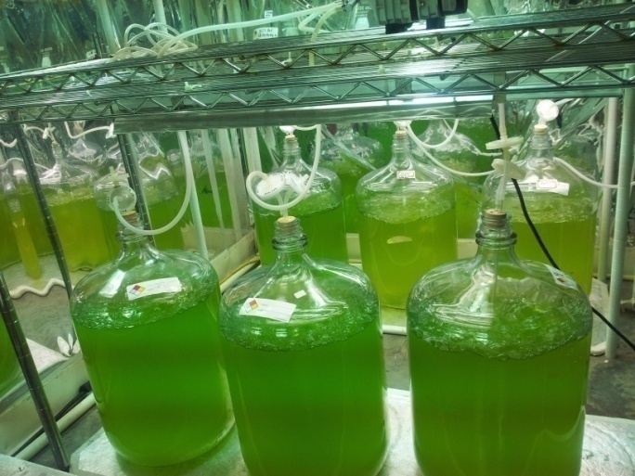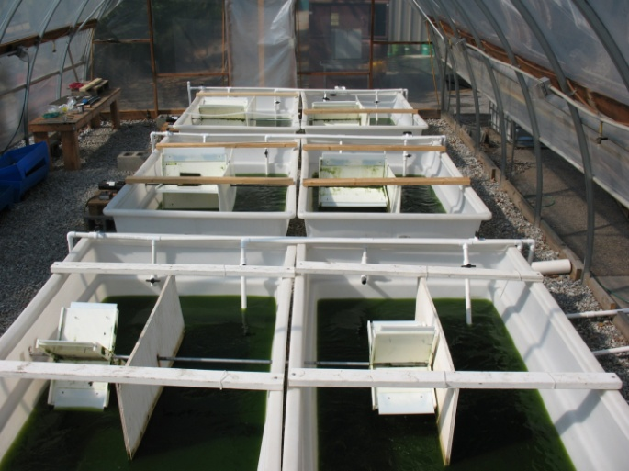
B
A
Figure 3: Algae cultivation in carboys (A) and six raceways under green house facility (B).
The raceway ponds are constructed of HDPE plastic and are 1.32 m wide, 2.18 m long, and 0.61 m deep with a working volume of approximately 500L at 0.17m water depth. Standard algae growth medium BG11 was used in fresh water for cultivation. Supplemental CO₂ was derived from a commercial 10% CO₂ storage cylinder and used as carbon source and for pH control. The UGA designed carbonation column (Putt et al. 2011) was used for CO₂ mass transfer. Once cell density in raceways reached ~500 mg/L, biomass was harvested using a continuous centrifuge and dried at 55°C until constant weight was observed after multiple weighing. The dried biomass was packed in zip-lock bags and stored at 4°C until further use. A total of 1800 g (dry weight) of algae biomass was been generated for use in this research project. The algae biomass was processed, characterized, and used in subsequent HTL and catalytic HDO studies using small volume batch reactors. Subsequently, the dried microalgae was ground to a fine powder using a heavy-duty laboratory knife mill (Retsch SM 2000, Germany) with a screen size of 0.5 mm. The knife mill’s cutting blade rotor (1690 rpm, 60 Hz) was powered by a 1.5 kW electric motor. The ground samples were subsequently used for hydrothermal liquefaction studies. Compositional analysis of the algae was also performed. The algae were analyzed for carbohydrate, lipids, proteins (from CHNS analysis the %N was multiplied by 4.58 to obtain the % protein) and minerals using local UGA labs. Past analysis of Spirulina indicated a composition of 49.23% protein, 31.20% carbohydrates, and 11.20% lipids.

Two additional strains representing a high protein (Spirulina platensis) and high lipid algae strains were also used in this study. These strains were purchased from suppliers. S. platensis biomass was provided by Earthrise Nutritionals LLC (Calipatria, CA) in dry powder form with defined properties, and was stored in airtight packages at 4°C prior to use. A Nannochloropsis paste from Reed Mariculture (www.reedmariculture.com) with a reported lipid content of 18-28% of dry weight was purchased and used in the two-stage HTL/HDO experiments. The Nannochloropsis paste was freeze dried and stored at 4°C until use. The higher lipid content should increase oil yields and potentially allow better separation of proteins/nitrogen during the pretreatment HTL step. Nannochloropsis is considered a viable algae strain for liquid drop-in fuel production (Faeth et al., 2013; Brown et al., 2010; Elliot et al., 2014).

Algae Analysis:

Untreated biomass, solid residues, HTL bio-oil, and HDO samples were analyzed for elemental C, H, N, S, O (ultimate analysis) using a Flash 2000 organic elemental analyzer (Thermo Scientific) following methods outlined in ASTM D 5291. The analyzer was calibrated using BBOT or 2,5-Bis (5-tert-butyl-2-benzo-oxazol-2-yl) thiophene (C–72.59%, H–6.06%, N–6.54%, O-7.42%, and S–7.43%) as the standard material. Atomic ratio and empirical formula of raw feedstock and the biocrudes were derived from the elemental results. Higher heating values (HHV) of solid and biocrude samples were measured using an isoperibol bomb calorimeter Model 1351 (Parr Instruments Co., Moline, Illinois) following ASTM D 5865 and D 4809 standard methods.

Carbohydrate content of the algal biomass was measured using the DuBois method (DuBois et al., 1956), protein content was estimated by multiplying the elemental N content by a factor of 4.58 (Lourenco et al., 1998), and lipid content was measured by gravimetric method using an ANKOMXT10 automated extraction system (ANKOM Technology, Macedon, NY) where hexane was used as extraction solvent.

The metal composition of algae strains and biocrude were analyzed using an inductively coupled plasma (argon) spectrometer equipped with a mass spectral (ICP–MS) detector system (Isaac and Johnson, 1985). Water content of the biocrude samples was measured using a Mettler-Toledo titrator (Model-DL31, Columbus, OH) following the ASTM D 1744 and ASTM E 203. The titrant used was manufactured by AquaStar (Composite 5 K) designed for materials containing aldehydes and ketones and the solvent was AquaStar-Solvent KC containing dichloromethane for enhanced solubility with oils and fats. Specific gravity values (g mL⁻¹) were determined gravimetrically using 2 mL Gay-Lussac pycnometers. Dynamic viscosities of biocrude samples were measured at using a Brookfield DV-I + Viscometer with a UL/YZ spindle adapter using, in some cases, a modified version of ASTM D 2983. The modification was the use of a higher temperature (60 °C) than the standard, because of the very high viscosity of biocrude at lower temperatures.

Hydrothermal Liquefaction (HTL):

A series of high temperature, pressure micro-reactors were used to perform both HTL and HDO experiments. The catalytic test bed consists of 3-100 ml, 5000 psig, 500°C Parr batch reactors and 6, 75 ml, 3000 psig, 300°C independently controlled reactors (Fig. 4). The lower temperature, pressure reactors were used to perform the low temperature HTL experiments (125, 175, 225 °C) investigating N partitioning between the aqueous phase and solids. These reactors used a magnetic stir bar to provide agitation, whereas the high temperature, pressure reactors used a motor driven agitation system.
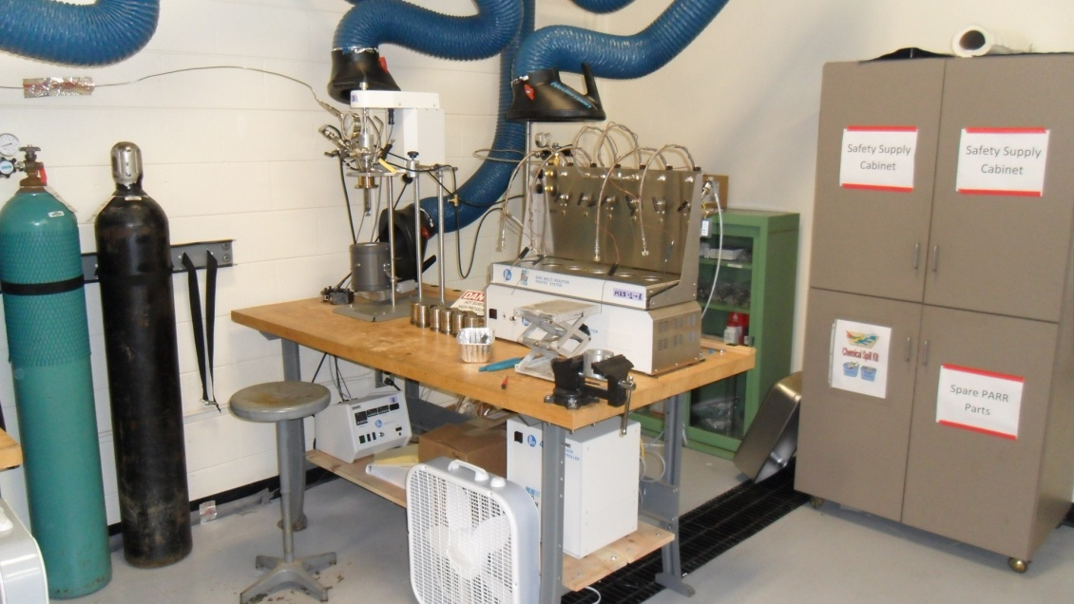

A

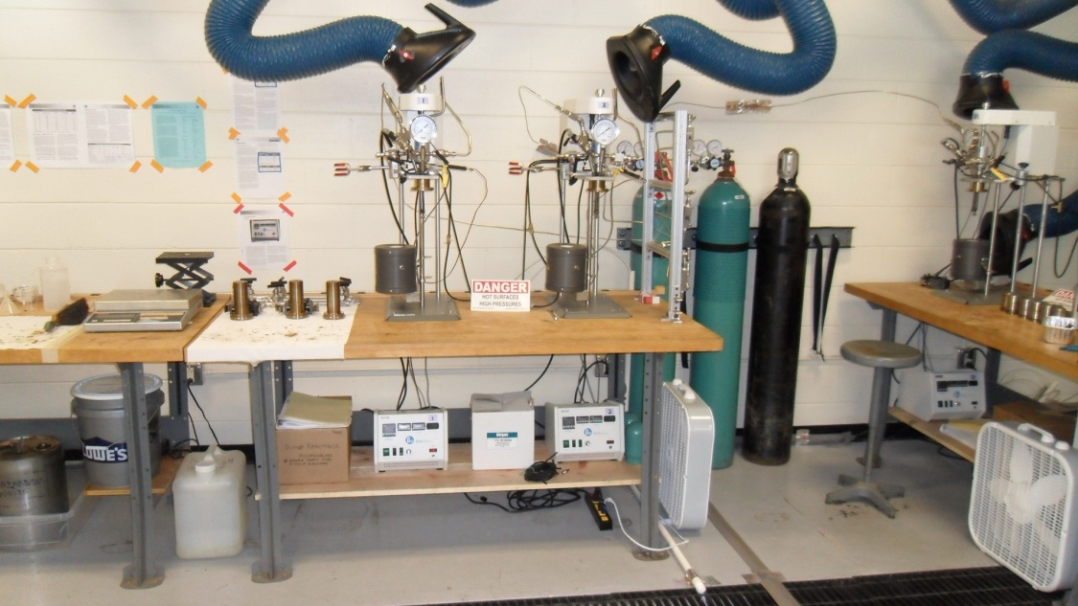

B

Figure 4: Catalytic test bed for algae liquefaction and algal oil upgrading studies (A-low temperature, pressure system [300°C, 3000 psig, max]; B-high pressure, temperature [500°C, 5000 psig, max] system).

Two-Stage HTL (Protein/Nitrogen Reduction):

In this step, the 6 microreactor, low T and P system, was used to perform HTL analysis of our three algae biomass sources. First, single stage HTL runs were performed at 350°C and 30-120 min hold times as controls runs. Subsequently, 2 stage HTL studies using the microreactors were performed. In the 2 stage runs we collected both the aqueous phase and solids/oil phase to calculate solids yield and the nitrogen partition coefficient (protein levels were also measured in the aqueous phase) between the two phases. This allowed us to rapidly optimize the first stage lower temperature HTL step to reduce nitrogen levels in the subsequently derived algal oil. These results were used design the catalytic hydrodeoxygenation (HDO) experiments. An outline of the experimental steps is shown in Figure 5.

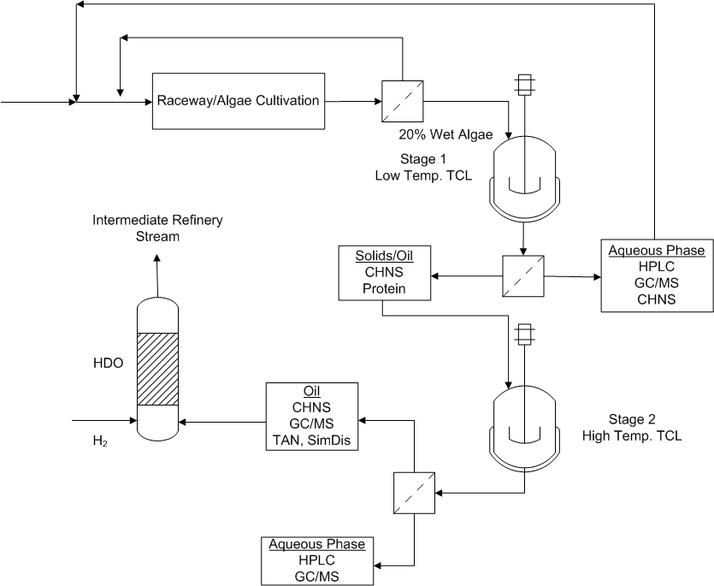

Figure 5: Flowsheet for experimental steps and analytical procedures for a 2 stage HTL/HDO algae to liquid fuel process. Note – TCL is equivalent to HTL in our procedures.

Short Residence Time HTL:

In this series of experiments, a first-stage, low temperature HTL of a mixed consortia algae biomass feedstock (provided by the UGA Algae-Biorefinery Laboratory) was conducted at 175, 200, 225, and 250 ºC temperature at 1, 2.5, and 5 min residence times using Desert Research Institute’s (DRI) two-chamber reactor (TCR) system (Fig. 6 and 7). This reactor system is designed to minimize heat-up times and were conducted to determine if protein separation and nitrogen reduction could be conducted at very short residence times. In a typical run ~5 g algae biomass and 40 mL deionized water were used. At the end of experiment, the reactor was ice-cooled and the gaseous products were vented to the atmosphere. The remaining products (treated solids and aqueous phase products) were separated using vacuum filtration; the treated solids were oven dried overnight at 105ºC and aqueous phase samples were stored in a refrigerator until further analyses. A matrix of 24 experimental runs was performed in this task. Analyses were performed at different analytical laboratories at DRI.

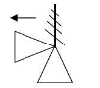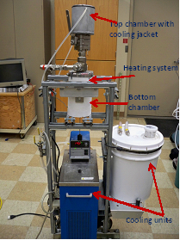
PPP
P
T2
PPP
T1
PPP
2
8
1
9
3
10
5
7
6
4
1. Bottom chamber; 2. Top chamber; 3. Biomass catridge 4. Ball valve; 5. Pressure relief valve; 6. Water-cooling coil; 7. Pressure gauge 8. Radiant heater; 9. Temperature indicator; 10. PID temperature controller.

Figure 6. The two-chamber reactor system used for first-stage HTL experiments; (A) Schematic of the system, (B) Photo of the actual laboratory system.

Protein Analysis:

The concentration of protein in the HTL aqueous phase samples was estimated using the Bradford Protein Assay. Bovine Serum Albumin was used as a standard and standards were prepared from 0.1 – 0.5 g/L using BSA and Coomassie Blue Bradford reagent. The samples were incubated at room temperature for 10 min and absorbance measured at 595nm using a Beckman DU 650 Spectrophotometer. Samples were prepared by mixing 1.1 grams with 10 ml of DI water, well mixed by vortexing, centrifuged at 6000 rpms for 15 minutes, and the aqueous portion used for protein analysis. In some cases, samples were diluted prior to addition of the Bradford reagent, incubated at room temperature, and absorbance measured.
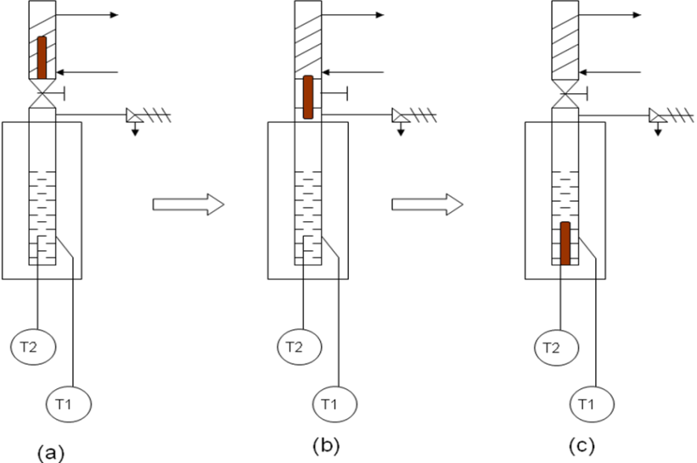

Figure 7. Schematic of steps during operation of DRI’s two-chamber reactor (TCR) system, (a) water in reactor is heated to desired temperature; (b) ball valve is opened to drop biomass into hot reaction chamber; (c) biomass (inside screen) is reacted for desired time, then entire reactor is quenched in ice bath.

Catalysts:

Ru on Carbon:

Ru on carbon catalyst (5 wt% ruthenium, w/w and 20 µm particle size) was purchased from the Sigma Aldrich. The surface area for Ru/C was 721 m² g⁻¹ with an average pore size of 11.4 Å (using the BET method and instrumentation at UGA). This catalyst was used as received.

Red Mud (Mixed Metal Oxide):
A sample of red mud was obtained from Rio Tinto (Alcan, Canada), dried (105°C), crushed, sieved into two size fractions, and reduced using H₂ (50-65 g of red mud reduced in-situ under flowing H₂ [100%] at 90 mL/min by heating at 10°C/min to 300°C and holding for 20 h. The reduced fraction (1.5-2 mm) was used in the batch HDO experiments. The surface area of this material was measured in-house via the BET method (30.7 m²/g).

Cobalt Molybdenum:

A cobalt oxide (3.4-4.5%) molybdenum oxide (11.5-14.5%) on alumina (Al₂O₃) catalyst was purchased from Alfa Aesar. The CoMo/Al₂O₃ catalyst was of a trilobe extruded form (2.5 mm). The surface area of this material was measured in-house via the BET method (253 m²/g for received catalyst and 259 m²/g for the H₂ reduced CoMo). The CoMo/Al₂O₃ catalyst was reduced in the presence of flowing H₂ (100%) at 400°C in a tubular packed bed reactor. Typically, 50 g of CoMo/Al₂O₃ was added to a 1 in (ID) continuous reactor tube. The tube was heated using an external furnace to an internal temperature of 400°C (measured using a thermocouple placed within the catalyst bed). Typically, 100 mL/min of 100% hydrogen gas was passed over the catalyst bed for 2 hours. The hydrogen gas was allowed to flow over the bed while the vessel was cooled (by removing the furnace jacket and placing a fan next to the tube). Upon reaching room temperature, the tube was opened and the recovered catalyst was reweighed (49.1 g were typically retained). The catalyst was stored in an airtight contained (jar) in catalyst storage cabinet.

In addition, a pre-sulfided CoMo catalyst (5-25% Mo-S and 2-7% Co-S) was obtained from a division of Albemarle (Eurecat) and used in our catalytic HDO step. The pre-sulfided CoMo was of the trilobe form.

Catalytic Hydrodeoxgenation (HDO):

Algal oil generated in the HTL step was collected and transferred to the high temperature, pressure Parr reactor system. Typically a working volume of 40 ml was used for each catalytic HDO/HDN experiment. Catalyst loading ranged from 0.7 and 2.1 g per 40 ml of algal oil. After reactor loading, the headspace was pressurized with 100% H₂ (750 psig) and heated to reaction temperature. The time to reach the prescribed reaction temperatures of 125, 175, 225, and 350°C were 9, 14, 21, and 29 min respectively. Reaction or holding times were defined based on the time at the reaction temperature and does not include the heat-up time. During the HDO experiments the holding time was held constant at 4 h per batch treatment. The effect of agitation on H₂ consumption was tested at 300, 500, and 700 rpm with the Ru/C catalyst. In some experiments, repeated HDO steps were performed in which the headspace of the reactor was recharged with H₂ after cooling and a second HDO step conducted. In some experiments, catalyst was recovered by filtration after a single HDO step, and recycled for use to determine catalyst longevity. After an HDO experiment the reactor was cooled, the headspace sampled for GC/MS/TCD analysis (CO, CO₂, H₂, CH₄), the liquid collected, and the oil separated for analysis.

Catalyst Characterization:

Surface Area:

Surface areas of the catalysts (0.1 g sample size) were measured by N₂ adsorption over a relative pressure range (P/P₀) of 0.05–0.35 using a 7-point BET analysis equation (Quantachrome AUTOSORB-1C; Boynton Beach, FL). Pore size distribution, average pore radius, and total pore volume were estimated from N₂ desorption curves using BJH analysis. All samples were degassed ranging from 250 to 300°C for 3–4 h before analysis.

Chemisorption:

Hydrogen chemisorption was used to estimate Ru dispersion on the Ru/carbon catalysts. All samples were degassed ranging from 250 to 300°C for 3–4 h before analysis. Samples (0.5-1.0 g) were loaded in a quartz U-tube and packed between two quartz-wool layers, degassed at 120°C for 30 min in helium, the helium then purged and evacuated, and finally the temperature was set at 40°C. In some cases the catalyst was reduced with H₂ in the U-tube before chemisorption analysis. In this case, flowing H₂ (100%) was used to reduce the catalyst at 400C for 120 min. After reduction, any H₂ was purged by evacuation with Helium for 120 min. Subsequently a series 10 strong adsorption points and 10 weak adsorption points were measured (volume of H₂ adsorbed was measured) at different H₂ partial pressures using Quantachrome, AUTOSORB-1C instrument.

The active surface area (ASA, m²/g) was estimated by estimating the number of chemisorbed gas molecules (N_{M}), using the number of surface atoms covered by each chemisorbed gas molecule from the adsorption stoichiometry (S; e.g., 2 for H₂ chemisorption on Ru metal sites), and using the cross-sectional area occupied by each active surface atom (A_{M}). ASA was estimated using the equation below,

$$ASA=\frac{N_{M}×S × A_{M}}{166}$$

N_{M} (µmol H₂/g) was estimated from the volume of monolayer uptake (V_{M}, cm³ at STP/g) and is noted in the equation below,
$$N_{M}=V_{M}×44.61$$

The percent metal dispersion (D), defined as the fraction metal atoms on the particle surface available for chemisorption was calculated as noted below, where M is the molecular weight of the metal and L the metal percent loading.
$$D=\frac{N_{M}×S × M}{100 ×L}$$

Finally the average crystallite size (d) was estimated from the equation below, where Z is the metal density and f the particle shape correction factor (typically assumed to be spherical and f=6).

$$d=\frac{100×L × f}{ASA×Z}$$

H₂-Temperature Programmed Reduction (TPR):

Fresh catalyst and reacted catalyst were analyzed by H₂-TPR and NH₃-CO₂-TPD. Ammonia temperature programmed desorption (TPD) was used to estimate acid site strength of the catalysts. All samples were degassed ranging from 250 to 300°C for 3–4 h before NH₃ or CO₂ TPD analysis. Samples (0.2 g) were loaded in a quartz U-tube and packed between two quartz-wool layers, degassed at 185°C for 30 min in helium, saturated with ammonia (pure electronic grade) at 40°C for 15 min, flushed with helium at 40°C for 15 min, then desorbed with helium from 40 to 800°C at 10°C/min (all flows at 80 mL/min). For CO₂-TPD, samples were saturated with 100% CO₂ at 30°C for 10 min, then desorbed with helium from 30 to 800°C at 10°C/min (all flows at 80 mL/min). Desorbed NH₃ and CO₂ were detected using a TCD (16×attenuation) and measurements were made using a Quantachrome AUTOSORB-1C instrument.

Hydrogen temperature program reduction (TPR) was used to estimate the metal valance state in the mud catalyst and reacted catalysts. Degassed samples (0.2 g) were loaded in a quartz U-tube and packed between two quartz-wool layers, degassed at 185°C for 30 min in N₂, the temperature reduced to 60°C and switched to H₂ (4% in N₂) flow while heating to 800°C at 20°C/min. The reduction in H₂ concentration across the catalyst was monitored using a TCD.

Algal Oil Separation:

After HTL or HDO, the product (liquids and solids) was emptied from the reaction vessel and mixed thoroughly with an equal portion of dichloromethane or DCM (typically 40mL). This mixture was then filtered under vacuum through a Buchner funnel and Whatmann #1 70 mm filter paper and the cake rinsed with 15 mL of DCM. The filtrate was then transferred to a separatory funnel (150mL) and allowed to phase separate for 15 minutes. The bottom phase was then decanted and 1 gram of anhydrone (magnesium perchlorate) was added to the decanted phase. This phase was filtered again under the same conditions with 10 mL DCM used to rinse the anhydrone, and the filtrate transferred to a rotary evaporator (Rotovap) flask. The flask was then rotated under vacuum in a 36°C water bath for 15 minutes.

Algal Oil Characterization:

GC/MS Analysis (Liquid):

Chemical composition of the fast pyrolysis oil and the upgraded samples was determined by GC-MS analysis using a Hewlett-Packard (Model HP-6890) gas chromatograph in conjunction with a Hewlett-Packard mass spectrometer (Model HP-5973) with a mass selective detector. The GC contained an HP-5 MS column of the following dimensions: 30 m length, 0.25 mm internal diameter, and 0.25 µm film thickness. The method used was as follows: inlet temperature 260˚C, detector temperature 280˚C (mass spectrometer interface temperature, with the ion source at 230°C), flow at 0.8 mL min⁻¹ He, oven at 40˚C for 4 min followed by a ramp at 5˚C min⁻¹ to 275˚C (held for 5-8 min). The mass spectrometer scan range was from 30-400 mass units. A sample size of 1 µL and split ratio of 50:1 was used and samples were prepared for GC-MS analysis by diluting the algal oil to 2.5 % (v/v) with acetone. The compounds were identified using Agilent Technologies software (MSD ChemStation D.03.00.611), which uses a probability-based matching (PBM) algorithm to match unknown spectra to those found in a mass spectral library using National Institute of Standards and Technology’s 2008 version (NIST 2008). The quality of a match determined by ChemStation is defined as the probability that the unknown is correctly identified as the reference. Match quality ranges between 1 and 100 and values above 90 were considered as very good matches in our analysis.

In some cases the algal oil and catalytically upgraded oil were quantitatively analyzed using an external standard method and GC/MS analysis. Hexanol was used as the standard and added to the oil at 2.03 g/L and analyzed using the previously described methods. Neat compounds of 1-hydroxy-2-propanone, furfural, 2-methoxy phenol, 2-methoxy-4-methyl phenol, tetrahydrofuran, 1-butanol, and eugenol (99.9%, Sigma) were mixed with hexanol (2.03 g/L), acetone, and methanol to generate standard mixtures and analyzed on the GC/MS using identical methods.

GC/TCD Analysis (Gas):

Gas samples were analyzed for hydrogen, nitrogen, oxygen, carbon monoxide, methane and carbon dioxide using a HP 5890 Plus Gas Chromatograph (TCD) with a Carboxen (60/80) 1000 stainless steel packed column (15’ x 1/8”). Standard curves were generated using pure gas concentrations of individual gas and mixing with nitrogen in Tedlar bags for dilution at 4-5 different percentages of each gas to be quantified. The GC/TCD method was the following - inlet temperature of 100°C, a detector temperature of 140°C, the oven at 35°C which was held for 5 min, then ramped at 20°C/min to 180°C and held for 4 min. A sample size of 50 μl was used for injection.
HPLC Analysis:

The water soluble components in the aqueous phase were analyzed by a high performance liquid chromatography (LC-20 AT, Shimadzu Corp., USA) equipped with a RID-10A refractive index detector and a 7.8×300 mm Coregel 64-H transgenomic analytical column for sugars (e.g., levoglucosan) and carboxylic acids (e.g., formate and acetate). About 2 mL of the oil was diluted with DI water at 1:1 ratio and centrifuged at 5000 rpm for 30 min, and then decanted. The supernatant was filtered through a 0.45-µm filter into 2-mL auto-sampling vials. A sample size of 5 µL was injected into the column using the LC-20 AT Shimadzu auto-injector. The samples were analyzed at 6.89 MPa (1000 psi) and 60˚C with an eluent (4 mN H₂SO₄) flow rate of 0.6 mL min⁻¹ for a 55 min run time. Glucose and xylose (if present), formic acid, acetic acid, levoglucosan, cellobiosan (if present), furfural, hydroxyl methyl furfural (HMF), and other compounds (if present) in the liquid samples were identified by comparing retention times with standards and they were quantified using a 5 point standard curve.

Total Acid Number (TAN):

The total acid number was determined using the Standard Test Method for Acid and Base Number by Color Indicator Titration (ASTM D974-12). A titrant solution was prepared by combining 1.0 L of isopropanol, 6.0 g of potassium hydroxide, and 2.0 g of barium hydroxide. Titrant standardization was performed by titrating a mixture consisting of 0.2000 g of dried potassium phthalate, 40 mL of distilled water, and 0.3 mL of phenolphthalein indicator solution. The titration solvent solution was then prepared by combining 500 g of toluene, 495 g of isopropanol, and 5.0 g of distilled water. Subsequently, the total acid number of each oil sample was determined by adding 0.2 g of oil sample and 0.5 mL of p-naphtholbenzein indictor to 100 mL of titration solvent and titrating with the potassium hydroxide titrant solution. The total acid number was calculated based on the volume of titrant required to achieve a green color change persisting for 15 seconds. Titrations were performed in duplicate and the average of two values are reported.

CHNS:

Untreated biomass, solid residues, HTL bio-oil, and HDO samples were analyzed for elemental C, H, N, S, O (ultimate analysis) using a Flash 2000 organic elemental analyzer (Thermo Scientific) following methods outlined in ASTM D 5291. The analyzer was calibrated using BBOT or 2,5-Bis (5-tert-butyl-2-benzo-oxazol-2-yl) thiophene (C–72.59%, H–6.06%, N–6.54%, O-7.42%, and S–7.43%) as the standard material.

Water Content:

Water content of the biocrude samples was measured using a Mettler-Toledo titrator (Model-DL31, Columbus, OH) following the ASTM D 1744 and ASTM E 203. The titrant used was manufactured by AquaStar (Composite 5 K) designed for materials containing aldehydes and ketones and the solvent was AquaStar-Solvent KC containing dichloromethane for enhanced solubility with oils and fats.

Simulated Distillation – GC/MS method and TGA:

Boiling point distributions of the HTL algal oil and catalytically upgraded oil were estimated using two methods. First the GC/MS results were used to estimate a boiling point distribution. In this method the chromatograms (TIC) generated by the GC/MS were integrated using the same integration parameters for each chromatogram. The peak areas of the highest match factor compounds (i.e., the top hit using the NIST algorithm) were determined by integration and total peak area determined by summation of all peak (excluding any residual solvent). Then % peak area and cumulative peak area as a function of retention time were determined. Normal boiling points for the identified compound were found from the NIST Web Book (all boiling are at P_{atm}). Subsequently, cumulative peak area versus boiling point plots were performed, and the boiling point distribution for petroleum cuts overlaid on the plots.

In addition to the GC/MS technique, simulated distillation of the algal oils were estimated using thermogravimetric analysis (Mettler Toledo – Model TGA/SDTA851). In this method, 3-5 mg of oil was heated from 25 C to 625 °C at 10C/min in the presence of flowing N₂ (50 ml/min). During heating the change in mass was measured and the fraction of mass lost and the first derivative of the mass change with time was calculated. Subsequently, the mass, % mass lost, and first derivative (as an absolute value) were plotted as a function of temperature.

Liquid, Solids, and Gas Yields:

The yield of each product fraction was determined as the ratio of their mass to the initial mass of the biomass used. Algal oil (or biocrude) yields were reported on a dry basis and reported as the weight of total biocrude fraction. The gaseous product (denoted as ‘‘Gas’’) yield was quantified by measuring the weight difference of the reactor and contents before and after the experiment. The water soluble products of liquefaction were the products in the aqueous phase (deionized water) and were quantified from the mass balance as follows:

Yield of water solubles; % = 100 –Yield % (of Biocrude + Gas + Solid residue)

Results

Algae Composition:

As expected the Nannochloropsis strain purchased from Reed Mariculture did have a higher lipid content, yet it was not significantly higher than the Spirulina and the UGA raceway strains (Table 1). Interestingly, the UGA raceway strain did have a lower protein content then Nannochloropsis and as expected the Spirulina strain had the highest protein content. Please note, that it was our original intent to grow three algae strains in the UGA raceway - Chlorella sorokiniana, Chlorella minutissima, and Scenedesmus bijuga. Subsequent analysis of the final harvested product indicated that only two strains predominated in the final harvest - Chlorella sorokiniana and Scenedesmus bijuga.

Catalyst Characteristics:

Surface Area
The catalyst used in the HDO experiments were characterized by measuring surface area, pore size distribution, and H₂ chemisorption. A brief rational for the use of these catalysts follows. Red mud was selected since it has a high level of potentially active metal oxides (primarily iron oxides) and when activated with H₂ could potentially act to deoxygenate fatty acids in the algal oil (i.e., a potential reverse Mar van Krevelen deoxygenation mechanism of FFA’s). Moreover, red mud is an inexpensive waste material and has been used as a coal liquefaction HDO catalyst. Ruthenium on activated carbon was used since it is a demonstrated HDO catalyst for fast pyrolysis oil generated from biomass (lignocellulosics). CoMo on Al₂O₃ and a sulfided CoMo catalyst were used since the sulfided CoMo is used as refinery HDO/HDS catalyst. Since sulfur levels are low in algal oil we reasoned that a H₂ reduced CoMo on Al₂O₃ would successfully hydrodeoxygenate the algal oil without the need for sulfiding the catalyst. Clearly, the Ru/C catalyst had the highest surface area – more than double the CoMo (Table 2). The reduced red mud had a very low surface area relative to the two other catalysts.

H₂-TPR
Temperature programmed reduction (H₂-TPR) of the three catalysts used in the HDO reveal qualitative information on the metal surface properties of the materials. H₂-TPR of the red mud does indicate that the selected temperature for reduction (300°C) was probably not high enough to drive complete reduction of the iron oxides to zero valent iron (Fe₂O₃→Fe). As indicated by Figure 6, reduction temperatures in the 400 to 500°C range are needed for complete reduction. H₂-TPR of the Ru/C catalyst did indicate significant reduction of the as received catalyst (Fig. 8). This suggests that a portion of the surface bound Ru was in an oxide state and not completely reduced. Pre-reduction of the Ru/C catalyst may improve catalyst activity. H₂-TPR of the CoMo/Al₂O₃ did indicate that the selected reduction temperature of 400°C was reasonable, since significant reduction (i.e., H₂ consumption) occurs at this temperature (Fig. 8).

Table 1: Composition of algae biomass used in the HTL and HDO studies.
Composition
(% w/w, dry basis)
Parameter | Spirulina | UGA  (Raceway) | Nannochloropsis  (Reed Mariculture)
C | 50.1 | 46.6 | 51
N | 11.3 | 7.6 | 10
S | 0.7 | 0.0 | 0.83
Protein | 48 | 33 | 45.8
Lipids | 0.5-11 | 6 | 9ª-18^{b}
Carbohydrates | 16 | 17 | 14
Moisture | 6.6 | 4.8 | 1.3
Ash | 8.5 | 10.1 | 7.4
ª, Analysis performed at UGA
^{b}, Reported by Reed Mariculture

Table 2: Physical properties of catalyst used in HDO experiments.

Catalyst  Properties | Ru/C | RRM | CoMo | CoMo-H₂ Reduced | CoMo-S Sulfided
Surface Area (m²/g) | 721 | 31 | 253 | 259 | 194
Pore Volume (cm³/g)ª | 0.52 | 0.038 | 0.292 | 0.30 | 0.53
Average Pore Size (radius Å) | 14.4 | 24.85 | 46.2 | 46 | 111
Co, % (dry basis) | - | - | - | 3-4.5 | 2-7 Co-S
Mo, % | - | - | - | 11-14.5 | 5-25 Mo-S
Ru,% | 5 | - | - | - | -
Fe,% | - | 23.9 | - | - | -
ª, evaluated at P/Po = 0.72-0.86

Figure 8: Temperature programmed reduction of the catalysts using H₂. The red lines indicate the temperature at which H₂ reduction occurs (just before the large reduction in TCD signal due to H₂ consumption).

Low Temperature HTL – Nitrogen Reduction:

Results indicated that a significant fraction of nitrogen partitioned to the aqueous phase when undergoing hydrothermal liquefaction at low temperature (i.e., a temperature lower than typically used in HTL). Separation and recovery of the aqueous phase after the low temperature step (125, 175, and 225°C), generated a stream high in protein with low levels of algae growth inhibitors, and reduced the nitrogen level in the subsequently derived oil. The reduction in the nitrogen content of the algae increased with temperature, yet for two of the strains was independent of holding time (Figures 9 and 10). Clearly an HTL temperature of 225°C and a holding time of 15 min or greater resulted in the largest reduction in solids nitrogen content for all strains. However, as the HTL temperature increased, the solids yield decreased (Figs. 9 and 10), ultimately leading to reduction in oil yield.

Evidence of nitrogen reduction in the low T, HTL step was corroborated by the measured release and partitioning of protein to the aqueous phase. Again, as for nitrogen partitioning, the protein levels released and partitioning to the aqueous phase depended on temperature and in this case the strain type (Fig. 11). Protein versus time data indicated little change with respect to time, suggesting that we could average the data and present a mean protein level with respect to HTL temperature (Fig. 9). The optimum temperature for protein removal was lower than for nitrogen removal, 175°C versus 225°C, and protein removal was higher for the two algae strains with initially higher protein levels (Fig. 11). The reduction in protein level at the higher temperature (225°C) was probably due to protein hydrolysis.
In order to determine the feasibility of recycling the aqueous phase for algae cultivation, GC/MS and HPLC analysis was performed on this fraction. GC/MS and HPLC analysis indicated low levels of acetic acid and no presence of potentially inhibitory compounds, such as phenol, for any strain or low temperature HTL condition. Trace levels (qualitative assessment) of pyrazines and pyrimidine are present but peak areas are very small relative to those that form in the algal oil upon HTL (compare Figs. 12 and 20). Quantifying some of the peaks via HPLC (and matching with standard curves) indicates acetic acid levels at 0.5 to 1.5 g/L. Overall analysis indicated the following,

- A temperature of 175°C appears to be an optimum pretreatment temperature, when based on protein levels in the aqueous phase (Fig. 11), contrary to %N reduction analysis (225°C, 15 min indicated in last report). Data analysis also indicates that low temperature HTL pretreatment may be possible at shorter residence times (<15 min, Figs. 9, 10, 11).

- Protein analysis of the stage one aqueous phase clearly indicates high protein levels for all strains (Fig. 11). These results indicate this stream can be recycled and used as a nitrogen source of algae cultivation.

- Regardless of the protein data reported and noted in Fig. 11, we decided to select 225°C and a 15 min hold time for HTL pretreatment and subsequent HDO studies, since these were the same conditions used for the Spirulina and UGA strain work and nitrogen reduction was the highest under these conditions.

Figure 9: Effect of low temperature HTL on solids yield and reduction of nitrogen in the algae solids for Spirulina and UGA strains. The percent N removal was calculated based on the original N content of the algae solids and remaining N content in the solids after HTL.

Figure 10: Effect of low temperature HTL on solids yield and reduction of nitrogen in the algae solids for Nannochlorpsis. The percent N removal was calculated based on the original N content of the algae solids and remaining N content in the solids after HTL.

Figure 11: Effect of HTL temperature on protein levels released to the aqueous phase after subcritical hydrolysis. The bottom graph is the mean (± standard deviation) of protein levels at all measured retention times.

Figure 12: GC/MS analysis of aqueous phase generated from low temperature HTL of Spirulina. Chromatograms were similar for the other strains under the same HTL conditions. Compounds left to right are acetic acid, methyl-pyrazine, 4,5-dimethyl-pyrimidine, 2-ethyl-3-methyl-pyrazine, dl-alanyl-l-leucine, and pyrrolo[1,2-a]pyrazine-1,4-dione, hexahydro-3-(2-methylpropyl)-.

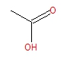

Figure 13: HPLC analysis of aqueous phase generated from low temperature HTL of Spirulina. Chromatograms were similar for the other strains under the same HTL conditions

Short Residence Time HTL-DRI Result

In this series of experiments, a first-stage, low temperature HTL of the UGA mixed consortia algae biomass feedstock was conducted at 175, 200, 225, and 250 ºC and 1, 2.5, and 5 min residence times (τ) using the Desert Research Institute’s (DRI) two-chamber reactor (TCR) system. In a typical run, approximately 5 g of algae biomass and 40 mL deionized water were used. At the end of experiment, the reactor was ice-cooled and the gaseous products were vented to the atmosphere. The remaining products (treated solids and aqueous phase products) were separated using vacuum filtration; the treated solids were oven dried overnight at 105ºC and aqueous phase samples were stored in a refrigerator until further analyses at UGA. As shown in Figure 14 the protein levels measured in the recovered aqueous phase from these short τ runs were significantly lower than the longer residence time runs (due to heat up time in traditional batch reactors at UGA – compare with Fig. 11).

Figure 14: Effect of temperature and residence on protein levels released to the recovered aqueous phase of HTL experiments with UGA raceway strains.
However, the short residence time HTL experiments (w/o heat-up time) do indicate it is possible to reduce nitrogen levels in the algae in a rapid fashion using lower temperature HTL. Using CHNS analysis of the recovered algae solids after the low temperature HTL, the % N was reduced from an average of 7.76 ± 0.30 g/g to 4 ± 0.75 g/g (Fig. 15). Clear evidence of nitrogen reduction was most noticeable at 200 and 250°C and residence times from 2.5 to 5 minutes (Fig. 16). These results indicate the feasibility of using continuous, short residence time HTL to pretreat algae by reducing nitrogen content before higher temperature HTL and catalytic HDO. Recently, it has been reported that subcritical HTL at a 10 s residence time removes 60% of the nitrogen in Scenedesmus at 240°C (Garcia-Moscoso et al., 2013). Our data, coupled with recent reports in the literature, suggest continuous, short τ HTL is a feasible method to nitrogen reduction in algal oil. Clearly, future work should focus on measuring the kinetics of this step and coupling it with continuous HTL and HDO to drop-in fuels.

Figure 15: Effect of short τ, low temperature HTL on % N in algae solids. Potential outlier shown in red circle.

Figure 16: Reduction in nitrogen relative to initial content in UGA algae. Error bars were calculated based on the largest possible deviation in % reduction using measurement standard deviation and mean % N in starting UGA algae (7.76 ± 0.30 g/g).

Catalytic HDO of Algal Oil:

Based on the previous results it was determined that HTL performed at 225°C for 15 min as a pretreatment step, would provide the highest nitrogen removal without significant reduction in oil yields. Prolonged contact beyond 15 min was not needed. These conditions were used for all algae strains and catalysts used in the subsequent HDO steps. In these experiments, controls (algae HTL without pretreatment followed by HDO), 2 stage HTL-HDO runs (HTL pretreatment followed directly by HDO), and 3 stage HTL-HDO runs (pretreatment→HTL→HDO) were performed. A total of four catalysts were evaluated – reduced red mud (iron oxides are active metal oxides), Ru on activated carbon, H₂ reduced CoMo, and sulfided CoMo. The resultant product generated from HDO, after extraction, was analyzed using CHNSO analysis, GC/MS, GC/TCD (off-gas), H₂ consumption, and simulated distillation. In addition, catalyst was recovered and analyzed for H₂ chemisorption, surface area, pore size distribution, H₂-TPR, TPD, and coke. The conditions imposed for these experiments are noted in Table 3.

After the low temperature HTL step to reduce nitrogen (225°C) all HTL runs were performed at 350°C for 60 min. Typical oil yields are shown in Figure 17 and as noted below were not a strong function of holding time.

Figure 17: Effect of holding time on algal yield for single stage HTL (left) and the effect of pretreatment temperature and holding time on oil yield for the UGA raceway strain (right, 2 stage HTL, pretreatment temperatures shown).

One can also see in Figure 17, that increasing the pretreatment HTL temperature from 125°C to 175°C and higher, increased the algal oil yield after the final HTL step (Fig. 17), yet there was a reduction in oil yield relative to HTL runs without pretreatment; i.e., a decrease in yield from 25-35% to 15-20% (Fig. 17). This same trend was noted for the other algae strains (Fig. 18). This appears to be the price to pay for nitrogen removal in algae strains with high starting protein content.

More detailed analysis of the coupled HTL/HDO experiments indicated further reduction in oil yields (but an increase in quality detailed later). For example, the lowest nitrogen content in the final oil was generated via PT/HTL/HDO with Ru/C catalyst using the algae strains (4.5-5% N, reduced from 7-7.5%), yet oil yields ranged from 7-10% w/w (Figs. 18-19). In these experiments there was little observable difference in the nitrogen content of the oil when using reduced red mud as an HDO catalyst, compared to Ru/C (see Fig. 19).

Two measurements of hydrogen consumption (mmol H₂ used/g-cat/h and mmol H₂ used/g-oil/h) were measured by quantifying the amount of H₂ consumed (GC/TCD) and dividing by the amount of catalyst or starting oil and time at reaction temperature. We theorized that reduced nitrogen levels in oil would reduce the amount of H₂ required for oxygen and nitrogen removal. In these experiments there was no clear trend in H₂ consumption during the HDO step (Fig. 20). Results working with Spirulina do suggest that lower temperature HTL as a pretreatment lowered H₂ consumption due to the lower %N in the oil – e.g. 5-7 mmol H₂/g/h versus 25 mmol/g/h for the HTL/HDO control (see Fig. 20). The higher H₂ consumption levels in runs without HTL were probably due to the additional need for hydrogenolysis, since HTL hydrolyzes lipids (runs 7, 8, 9, 10 in Fig. 20). However, this noted trend was not observed with the other two strains (UGA and Nannochloropsis) and if H₂ consumption was reported on a gram of oil basis (Fig. 21), thus we can’t conclusively point to reduction in a H₂ consumption when low temperature HTL was applied. At this point several general conclusions could be made,
- Algae oil yields ranged from 15-22% (pretreatment→HTL), slightly lower than the 25% oil yield for single stage HTL without pretreatment
- The nitrogen content of the oil was reduced by ∼22-25% by pretreatment and HDO, relative to the control of HTL only, for Spirulina and the UGA raceway strains
- The lowest nitrogen content of the final oil was ∼4.65%
- The lowest oxygen content of the oil was ∼7.5%
- The nitrogen and oxygen content of the algal oil is too high for co-processing with a petroleum refinery intermediate

Catalyst Loading
Subsequently, additional improvements in catalytic hydrodenitrogenation and HDO of the algae were implemented to reduce the nitrogen content and improve the properties of the resultant oil, and included testing higher catalyst loadings, increased agitation to enhance H₂ mass transfer, testing CoMo as a HDO/HDN catalyst, and prolonged HDO runs (repeated batch runs with added H₂). Thus, we next performed a set of experiments with increased catalyst loading; the catalyst mass was increased from 0.7 g to 2.1 g of catalyst per 7 g dry algae in 40 ml (all other condition were the same – e.g., 300 rpm, pressure, and holding times). The effect of increased catalyst loading were conducted using Nannochloropsis and UGA strains, with Ru/Carbon, CoMo/Al₂O₃ (oxide form and H₂ reduced) and red mud (iron oxides).
Increasing catalyst loading reduced the nitrogen content of the oil by ∼46%, when using Ru/Carbon (Fig. 22) resulting in a nitrogen content of final oil at ∼3.5% (Fig. 22). GC/MS analysis of the HDO treated algae oil clearly indicated reduction of nitrogen heteroatoms (qualitative assessment) and the formation of long chain alkanes, relative to HTL only. The reduction was most noticeable when catalyst loading was increased and Ru/C was used as the catalyst (Fig. 23). Subsequently, further testing of red mud as a catalyst was limited, since its activity for HDO/HDN was much lower than Ru/C.

Table 3: Experimental Conditions for catalytic hydrodeoxygenation studies on algal oil generated by hydrothermal liquefaction. These conditions were performed for all algae strains.

 | HTL/HDO Stage and Reaction Conditions
 | Stage 1 |  | Stage 2 |  | Stage 3ª-HDO^{c} |  |  | Stage 4ª-HDO^{c}
Experiment | T, °C | τ, min | T, °C | τ, min | T, °C | P, psig | τ, min | T, °C | P, psig | τ, min
HTL Control | 350 | 60 | ------- | ------- | ------- | ------- | ------- | ------- | ------- | -------
PT/HTL | 225 | 15 | 350 | 60 | ------- | ------- | ------- | ------- | ------- | -------
HTL/HDO | 350 | 60 | ------- | ------- | 350 | 750 (H₂) | 240 | ------- | ------- | -------
PT/HTL/HDO | 225 | 15 | 350 | 60 | 350 | 750 (H₂) | 240 | 350 | 750 (H₂) | 240
PT/HDO | 225 | 15 | ------- | ------- | 350 | 750 (H₂) | 240 | ------- | ------- | -------
HDO Control | 350 | 60 | ------- | ------- | 350 | 750 (H₂) | 240 | ------- | ------- | -------

τ, reaction holding time at the temperature set-point (does not include heat-up time)

^{a,b,} 100 % H₂ used to set initial headspace pressure (750 psig) at room temperature

^{c}, agitation was 300 rpm for these runs

PT is pretreatment, HTL is hydrothermal liquefaction, HDO is hydrodeoxygenation

Figure 18: Oil yields (dry ash free basis or DAF) for single stage HTL (w/o pretreatment) and a range of HTL/HDO combinations in a micro-reactor system. See Table 3 for a description of the legend. RRM is reduced red mud, Ru/C is Ru on carbon.

Figure 19: Nitrogen levels (dry basis) for single stage HTL (w/o pretreatment) and a range of HTL/HDO combinations in a micro-reactor system. See Table 3 for a description of the legend. RRM is reduced red mud, Ru/C is Ru on carbon.

Figure 20: Hydrogen consumption levels (per gram of catalyst basis) for a range of HTL/HDO combinations in a micro-reactor system. See Table 3 for a description of the legend. RRM is reduced red mud, Ru/C is Ru on carbon. The arrow indicates that a measurement was not taken.

Figure 21: Hydrogen consumption levels (per gram of oil basis) for a range of HTL/HDO combinations in a micro-reactor system. See Table 3 for a description of the legend. RRM is reduced red mud, Ru/C is Ru on carbon. The arrow indicates that a measurement was not taken.

Figure 22: Effect of catalyst loading on hydrodeoxygenation of algal oil generated via HTL of Nannochloropsis. Pretreatment HTL was conducted at 225°C, 15 min. HTL was conducted at 350°C for 60 min. HDO was conducted at 350°C with 100% H₂ at 750 psig (initial P) for 4 h. Catalyst loading was 0.7 g and 2.1 g per 7 g of algae paste in 40 ml of DI water. RRM is reduced red mud – primarily hematite and magnetite (via XRD analysis). Note - PT is pretreatment at 225°C for 15 min, HTL was conducted at 350°C for 60, and HDO is hydrodeoxygenation.

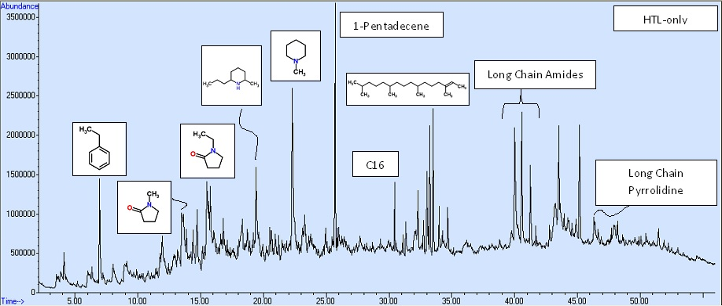
A- HTL of Nannochloropsis sp. (350°C, 60 min., 20% solids w/w)

B- UGA, 225C, 15 min→ 350C,60min,300rpm,2438psig → Ru/C, 4h, H₂ Catalyst Mass Increased from 0.7 to 2.1 g/7 g algae in 40 ml - Ru/C
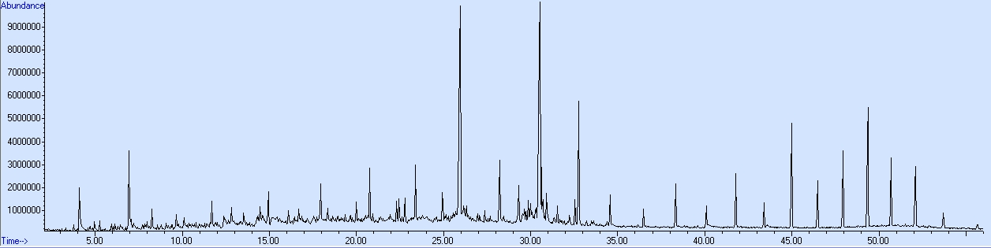

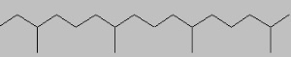



Denitrogenation – Trace Levels of Pyrazines, Pyrrolidinones, Piperidines
No Amides All Long Chain
Alkanes

Figure 23: GC/MS profile of A) HTL of Nannochloropsis sp. (350°C, 60 minutes, 20% solids w/w) and B) PT/HTL/HDO using Ru/C catalyst (2.1 g of catalyst/7g of algae paste).

Agitation Effect
Next a series of experiments were performed in which the agitation rate was increased in the HDO step at the highest catalyst loading (2.1 g cat per 40 ml of algal oil). To limit the number of experiments only two algal oils (the Nannochloropsis and UGA Raceway generated strains) and one catalyst were tested (Ru/C catalyst). It was assumed that any effect on nitrogen content and deoxygenation would be similar with the other catalysts. As can be seen in Figure 24, H₂ consumption increased up to an agitation rate of 500 rpm and leveled; there was no additional increase in H₂ consumption at an agitation rate of 700 rpm. Although H₂ consumption increased as the agitation rate increased the nitrogen content of the oil did not decline to a lower value than that generated at the lower agitation rate (300 rpm) and increased catalyst loading (2.1 g-cat/40 ml of algal oil). As shown in Fig. 25, the nitrogen content of the oil ranged from 2.5 to 3.5% and was constant with agitation rate. This study was conducted with two types of algal oil – one from Nannochloropsis and the other from our UGA grown raceway. All subsequent HDO work was then performed at 500 rpm.

Repeated Catalytic HDO Effect
In an attempt to further reduce the nitrogen content of the algal oil, a series of HTL/HDO experiments were performed in which the HDO step was repeated (Table 4). First, an algae suspension was treated via a two stage HTL (225°C,300psig→350°C,500psig) with aqueous nitrogen removed between the stages. Next the catalytic HDO step was conducted two times on the algal oil at 350°C for 4 h (100% H₂ in headspace at time zero, 750 psig). Note, the same batch of catalyst was used for both HDO steps. These HDO experiments were conducted with Ru/carbon, H₂ reduced iron oxides, H₂ reduced CoMo, and sulfide CoMo using Nannochloropsis and the UGA raceway strain. CHNS analysis indicated a significant reduction in the nitrogen content (Fig. 26) of the oil and the clear formation of long chain hydrocarbons (confirmed via GC/MS analysis – Fig. 27). GC/MS analysis of Ru/C conducted repeated batch HDO runs also indicate a relatively nitrogen free oil (Fig. 27). However, we must note that the CHNS analysis of the repeated HDO samples resulted in a very large variation in CHNS results and thus should be viewed with caution. Apparently the repeated catalytic HDO treatment of the algal oil generated an oil with higher volatility then single stage treatment. The resultant oil is volatile and leads to significant mass loss during CHNS analysis which causes error in calculations of the CHNS content. As noted later, this problem with CHNS analysis was solved by using 2 samples holders, more easily combustible material for the holders, and single sample analysis.

Heteroatom Composition- GC/MS
Due to initial problems with the CHNS analysis of the repeated HDO samples, an alternative method to estimate heteroatom composition in the algae was performed. In this method, results from the GC/MS analysis of each samples were used to estimate the composition of key compounds based on % peak area. As outlined in the experimental methods section, each sample was analyzed under the same conditions (e.g., injection volume, GC conditions, MS conditions), compounds identified based on a NIST 2008 database and search algorithm, the peak areas determined via integration of the total ion chromatogram or TIC (all based on the same integration parameters), and % peak area calculated based on the total peak area. Typical output of this analysis is shown in Tables 6 and 7. Subsequently, these data were analyzed to determine the % composition (based on peak area) for different classes of compounds which included aromatics (e.g. toluene, ethyl benzene), long chain hydrocarbons including branched hydrocarbons (C10-C20 and >C20), nitrogenated aromatics (pyridines), long chain amides and nitriles (octadecanamide), polycyclic aromatics, phenolics (phenol), and oxygenates (ketones). These results were then used to compare/contrast catalyst type effects, strain differences, and pretreatment effects.

Figure 24: Effect of agitation rate on H₂ consumption during HDO of algal oil using Ru/Carbon. First, an algae suspension was treated via a two stage HTL (225°C, 300 psig →350°C, 500psig) with aqueous nitrogen removed between the stages. Next a catalytic HDO step was conducted on the algal oil at 350°C for 4 h (100% H₂ in headspace at time zero, 750 psig). All experiments were conducted with 2.1 g-cat (Ru/C)/40 algal oil.

Figure 25: Effect of agitation rate on the nitrogen content algal oil undergoing HDO using Ru/Carbon. First, an algae suspension was treated via a two stage HTL (225°C,300psig→350°C, 500psig) with aqueous nitrogen removed between the stages. Next a catalytic HDO step was conducted on the algal oil at 350°C for 4 h (100% H₂ in headspace at time zero, 750 psig). All experiments were conducted with 2.1 g-cat (Ru/C)/40 algal oil.

Figure 26: Effect of repeated batch catalytic HDO of algal oil generated from hydrothermal liquefaction. Conditions are the same as noted in the caption of Figure 20, except for the last two experiments performed at a first stage HTL temperature of 175°C. RRM is H₂ reduced red mud (at 300°C); Ru/C is ruthenium on activated carbon catalyst; 2.1 is the amount of catalyst in grams per 40 ml of algae suspension; 2-HDO is for two HDO steps using the same batch of algal oil and catalyst.

Figure 27: GC/MS analysis of resultant oil (UGA Raceway) after catalytic HDO using Ru/Carbon catalyst – top: single stage HDO, bottom-2 stage HDO.
Table 4: Experimental conditions for repeated batch catalytic hydrodeoxygenation studies on algal oil. These conditions were performed for all algae strains.
 |  | HTL/HDO Stage and Reaction Conditions
 |  | Stage 1 |  | Stage 2 |  | Stage 3ª-HDO^{c} |  |  | Stage 4ª-HDO^{c}
Algae Strain | Catalyst | T,°C | τ, min | T, °C | τ, min | T, °C | P, psig | τ, min | T, °C | P, psig | τ,min
UGA | Ru/C | 225 | 15 | 350 | 60 | 350 | 750 (H₂) | 240 | 350 | 750 (H₂) | 240
Nanno | Ru/C | 225 | 15 | 350 | 60 | 350 | 750 (H₂) | 240 | 350 | 750 (H₂) | 240
Spirulina | Ru/C | 225 | 15 | 350 | 60 | 350 | 750 (H₂) | 240 | 350 | 750 (H₂) | 240
(Group 1)
UGA | Ru/C | 225 | 15 | 350 | 60 | 350 | 750 (H₂) | 240 | 350 | 750 (H₂) | 240
(Group 2) | CoMo-S | 225 | 15 | 350 | 60 | 350 | 750 (H₂) | 240 | 350 | 750 (H₂) | 240
Nanno | Ru/C | 225 | 15 | 350 | 60 | 350 | 750 (H₂) | 240 | 350 | 750 (H₂) | 240
(Group 3) | CoMo-H2 | 225 | 15 | 350 | 60 | 350 | 750 (H₂) | 240 | 350 | 750 (H₂) | 240
 | CoMo-S | 225 | 15 | 350 | 60 | 350 | 750 (H₂) | 240 | 350 | 750 (H₂) | 240
 | RRM-300C | 225 | 15 | 350 | 60 | 350 | 750 (H₂) | 240 | 350 | 750 (H₂) | 240
(Group 4)
UGA | Ru/C | 175 | 15 | 350 | 60 | 350 | 750 (H₂) | 240 | 350 | 750 (H₂) | 240
 |  | 225 | 15 | 350 | 60 | 350 | 750 (H₂) | 240 | 350 | 750 (H₂) | 240
Nanno | Ru/C | 175 | 15 | 350 | 60 | 350 | 750 (H₂) | 240 | 350 | 750 (H₂) | 240
 |  | 225 | 15 | 350 | 60 | 350 | 750 (H₂) | 240 | 350 | 750 (H₂) | 240
Spirulina | Ru/C | 175 | 15 | 350 | 60 | 350 | 750 (H₂) | 240 | 350 | 750 (H₂) | 240
 |  | 225 | 15 | 350 | 60 | 350 | 750 (H₂) | 240 | 350 | 750 (H₂) | 240
τ, reaction holding time at the temperature set-point (does not include heat-up time)
^{a,b,} 100 % H₂ used to set initial headspace pressure (750 psig) at room temperature
^{c}, agitation was 500 rpm for these runs and catalyst loading was 2.1 g per 40 ml of algal oil generated from HTL steps, Nanno – Nannochloropsis
Table 5: Initial CHNS results for repeated batch catalytic hydrodeoxygenation studies on algal oil. These conditions were performed for all algae strains. All experiments performed at 500 rpm and 2.1 g-cat per 40 ml of algal oil. Results were obtained with one sample holder.
 |  |  |  | HTL/HDO Stage and Reaction Conditions
 |  | Stage 1 |  | Nitrogen %,A |  | Carbon % |  | Hydrogen % |  |  | Sulfur %
Algae Strain | Catalyst | T,°C | τ, min | Mean | Stnd. Dev. | Mean | Stnd. Dev. | Mean | Stnd. Dev. |  | Mean | Stnd Dev.
UGA | Ru/C | 225 | 15 | 3.74 | 0.163 | 63.0 | 54.5 | 0.0 | 0.0 |  | 0.0 | 0.0
Nanno | Ru/C | 225 | 15 | 3.57 | 0.071 | 89.1 | 0.107 | 11.95 | 0.475 |  | 0.0 | 0.0
Spirulina | Ru/C | 225 | 15 | A,B | A,B | A,B | A,B | A,B | A,B |  | A,B | A,B
UGA | Ru/C | 225 | 15 | 3.74 | 0.163 | 63.0 | 54.5 | 11.95 | 0.475 |  | 0.0 | 0.0
 | CoMo-S | 225 | 15 | A,B | A,B | A,B | A,B | A,B | A,B |  | A,B | A,B
Nanno | Ru/C | 225 | 15 | 3.57 | 0.071 | 89.1 | 0.107 | 11.95 | 0.475 |  | 0.0 | 0.0
 | CoMo-H2 | 225 | 15 | A,B | A,B | A,B | A,B | A,B | A,B |  | A,B | A,B
 | CoMo-S | 225 | 15 | A,B | A,B | A,B | A,B | A,B | A,B |  | A,B | A,B
 | RRM-300C | 225 | 15 | A,B | A,B | A,B | A,B | A,B | A,B |  | A,B | A,B
UGA | Ru/C | 175 | 15 | 1.53 | 0.20 | 0.0 | 0.0 | 0.0 | 0.0 |  | 0.0 | 0.0
 |  | 225 | 15 | 3.74 | 0.163 | 63.0 | 54.5 | 0.0 | 0.0 |  | 0.0 | 0.0
Nanno | Ru/C | 175 | 15 | 0.98 | 0.10 | 0.0 | 0.0 | 0.0 | 0.0 |  | 0.0 | 0.0
 |  | 225 | 15 | 3.57 | 0.071 | 89.1 | 0.107 | 11.95 | 0.475 |  | 0.0 | 0.0
Spirulina | Ru/C | 175 | 15 | 1.81 | 0.23 | 0.0 | 0.0 | 0.0 | 0.0 |  | 0.0 | 0.0
 |  | 225 | 15 | A,B | A,B | A,B | A,B | A,B | A,B |  | A,B | A,B
A – Could not analyze due to volatility issues during CHNS analysis
B- Due to the large variation in CHNS values O content could not be estimated by subtraction

Table 6: Typical GC/MS analysis output of repeated batch HDO samples – UGA, Ru/C (225°C, 350°C, 2 HDO steps).
Compound | Retention Time, min | Name | Match Quality | % Peak Area
1 | 4.10 | Toluene | 91 | 1.53
2 | 6.29 | Cyclopentanone, 2-methyl- | 95 | 0.53
3 | 6.94 | Ethylbenzene | 91 | 2.32
4 | 14.47 | Indan, 1-methyl- | 90 | 0.39
5 | 14.94 | Undecane | 93 | 0.76
6 | 17.95 | Dodecane | 95 | 0.96
7 | 20.01 | Tridecane, 7-methyl- | 53 | 0.63
8 | 20.76 | Tridecane | 95 | 1.40
9 | 22.31 | Naphthalene, 1,2,3,4-tetrahydro-1,1,6-trimethyl- | 96 | 0.71
10 | 22.78 | Dodecane, 2,6,10-trimethyl- | 90 | 0.57
11 | 23.39 | Tetradecane | 97 | 1.63
12 | 24.94 | Dodecane, 2,6,11-trimethyl- | 55 | 0.93
13 | 25.55 | Cyclopentadecane | 95 | 1.13
14 | 25.63 | Cyclopentadecane | 91 | 0.50
15 | 25.68 | 1-Tetradecene | 93 | 0.69
16 | 25.93 | Pentadecane | 97 | 11.63
17 | 26.01 | Cyclopentadecane | 45 | 0.31
18 | 28.22 | Hexadecane | 98 | 2.66
19 | 29.32 | Pentadecane, 2,6,10-trimethyl- | 96 | 1.53
20 | 29.87 | 4-Chlorobenzenesulfonamide, N-methyl- | 91 | 0.54
21 | 29.99 | Bicyclo[3.1.1]heptan-3-one, 2,6,6-trimethyl-, (1.alpha.,2.beta.,5.alpha.)- | 43 | 0.50
22 | 30.10 | 8-Heptadecene | 98 | 0.75
23 | 30.53 | Heptadecane | 98 | 16.96
24 | 30.61 | Pentadecane, 2,6,10,14-tetramethyl- | 98 | 2.67
25 | 30.91 | Bicyclo[4.2.0]oct-5-ene-2,3-dicarboxylic anhydride, 1-ethyl- | 27 | 1.21
26 | 31.54 | 2-Butene-1,4-diol, 2,3-dibromo-, (E)- | 94 | 0.49
27 | 32.56 | Octadecane | 99 | 1.68
28 | 32.77 | Hexadecane, 2,6,10,14-tetramethyl- | 99 | 6.78
29 | 34.56 | Nonadecane | 97 | 1.40
30 | 36.48 | Eicosane | 99 | 0.99
31 | 38.33 | Heneicosane | 99 | 1.69
32 | 40.08 | Docosane | 98 | 2.21
33 | 41.79 | Octadecane | 97 | 2.50
34 | 43.40 | Tetracosane | 99 | 1.10
35 | 44.99 | Eicosane | 97 | 5.87
36 | 46.48 | Hexacosane | 98 | 2.49
37 | 47.94 | Heptacosane | 99 | 4.21
38 | 49.36 | Hexadecane, 1-iodo- | 95 | 6.83
39 | 50.69 | Nonacosane | 99 | 3.40
40 | 52.09 | Triacontane | 99 | 3.64
41 | 53.71 | Octadecane | 95 | 1.28

Table 7: Typical GC/MS analysis output of repeated batch HDO samples – UGA, CoMo-S/C (225°C, 350°C, 2 HDO steps).
Compound | Retention Time, min | Name | Match Quality | % Peak Area
1 | 2.37 | 2-Butanone | 59 | 0.73
2 | 3.41 | 2-Pentanone | 86 | 0.53
3 | 5.24 | Toluene | 95 | 1.52
4 | 5.93 | Cyclopentanone | 83 | 1.41
5 | 7.57 | Cyclopentanone, 2-methyl- | 95 | 1.83
6 | 7.78 | (R)-(+)-3-Methylcyclopentanone | 94 | 1.15
7 | 8.27 | Ethylbenzene | 91 | 4.22
8 | 10.72 | Pyridine, 2,5-dimethyl- | 95 | 0.25
9 | 10.98 | Cyclopentanone, 2-ethyl- | 94 | 1.00
10 | 12.70 | Phenol | 94 | 7.14
11 | 13.08 | Pyrazine, 2-ethyl-5-methyl- | 74 | 1.11
12 | 13.99 | Pyridine, 5-ethyl-2-methyl- | 97 | 1.09
13 | 14.45 | 2-Cyclopenten-1-one, 2,3-dimethyl- | 90 | 1.29
14 | 15.09 | Phenol, 2-methyl- | 97 | 1.80
15 | 15.51 | Benzenamine, 3-methyl- | 95 | 1.32
16 | 15.76 | Phenol, 4-methyl- | 96 | 8.86
17 | 15.94 | Indan, 1-methyl- | 92 | 1.03
18 | 16.12 | Benzenamine, N-ethyl-3-methyl- | 45 | 1.93
19 | 17.98 | Phenol, 2,4-dimethyl- | 92 | 2.43
20 | 18.60 | Phenol, 4-ethyl- | 93 | 5.73
21 | 20.60 | Phenol, 4-ethyl-3-methyl- | 60 | 1.08
22 | 22.14 | 5H-1-Pyrindine | 76 | 3.28
23 | 24.67 | 1H-Indole, 3-methyl- | 93 | 3.57
24 | 27.08 | Benzonitrile, 2,4,6-trimethyl- | 83 | 3.20
25 | 27.19 | 1-Pentadecene | 95 | 1.48
26 | 27.29 | 1H-Indole, 2,3-dimethyl- | 95 | 1.82
27 | 27.40 | Pentadecane | 97 | 3.93
28 | 27.51 | 1-Tridecene | 95 | 0.82
29 | 29.75 | Hexadecane | 98 | 1.28
30 | 32.00 | Heptadecane | 98 | 4.81
31 | 32.11 | 3-Heptadecene, (Z)- | 96 | 1.48
32 | 34.12 | Octadecane | 98 | 1.43
33 | 34.33 | Hexadecane, 2,6,10,14-tetramethyl- | 98 | 1.85
34 | 35.08 | 2-Pentadecanone, 6,10,14-trimethyl- | 95 | 2.08
35 | 41.49 | Octadecanamide | 97 | 1.95
36 | 43.42 | Heneicosane | 98 | 1.21
37 | 45.05 | Heptadecane | 96 | 3.38
38 | 46.63 | Pentacosane | 98 | 2.47
39 | 48.14 | Hexacosane | 99 | 2.73
40 | 49.60 | Heptacosane | 98 | 2.43
41 | 51.02 | Octacosane | 99 | 2.71
42 | 52.52 | Heneicosane | 96 | 2.82
43 | 54.27 | Octacosane | 99 | 1.81

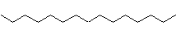
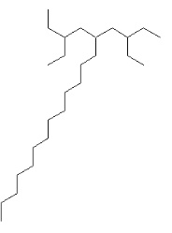

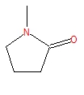
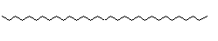
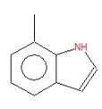
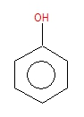
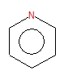
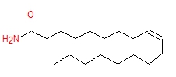
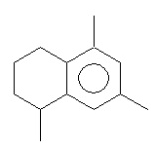
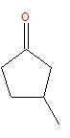
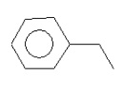

Figure 28: Compositional analysis of algal oil, from UGA strains, after catalytic HDO (Ru/C vs. CoMo-S), based on GC/MS analysis and % peak area. AH – aromatic hydrocarbons, LCH – long chain hydrocarbons, LCH>C20 – long chain hydrocarbons greater than C20, NA-nitrogenated aromatics, LCA-long chain amides, PAH – polycyclic aromatics. See Table 4, group 2 for reaction conditions.

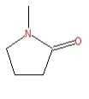
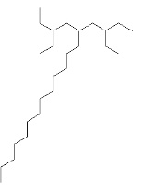
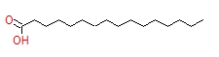
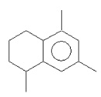
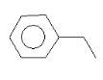

Figure 29: Compositional analysis of algal oil, from Nannochloropsis, after catalytic HDO (Ru/C, CoMo-H2, CoMo-S, RRM), based on GC/MS analysis and % peak area. AH – aromatic hydrocarbons, LCH – long chain hydrocarbons, LCH>C20 – long chain hydrocarbons greater than C20, NA-nitrogenated aromatics, LCA-long chain amides, PAH – polycyclic aromatics. See Table 4, group 3 for reaction conditions.

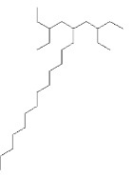

Figure 30: Compositional analysis of algal oil, from different strains, after catalytic HDO (Ru/C), based on GC/MS analysis and % peak area. AH – aromatic hydrocarbons, LCH – long chain hydrocarbons, LCH>C20 – long chain hydrocarbons greater than C20, NA-nitrogenated aromatics, LCA-long chain amides, PAH – polycyclic aromatics. See Table 4, group 1 for reaction conditions.

Figure 31: Compositional analysis of algal oil (from Nannochloropsis), under different HTL conditions, after catalytic HDO (Ru/C), based on GC/MS analysis and % peak area. AH – aromatic hydrocarbons, LCH – long chain hydrocarbons, LCH>C20 – long chain hydrocarbons greater than C20, NA-nitrogenated aromatics, LCA-long chain amides, PAH – polycyclic aromatics. See Table 4, group 4 for reaction conditions.

Figure 32: Compositional analysis of algal oil (from UGA strains), under different HTL conditions, after catalytic HDO (Ru/C), based on GC/MS analysis and % peak area. AH – aromatic hydrocarbons, LCH – long chain hydrocarbons, LCH>C20 – long chain hydrocarbons greater than C20, NA-nitrogenated aromatics, LCA-long chain amides, PAH – polycyclic aromatics. See Table 4, group 4 for reaction conditions.

Figure 33: Hydrogen consumption during (mmols/g of initial oil) catalytic HDO (sum of 2 stages) of algae oil (generated from three strains – Nannochloropsis, UGA, and Spirulina).

Analysis of the repeated batch HDO results clearly indicated that Ru/C was the most effective catalyst. The Ru/C catalyst generated significantly higher levels of long chain hydrocarbons compared to other catalysts (Figs. 28 and 29); e.g., for the UGA strain Ru/C generated an oil with 90% long chain hydrocarbons compared to ~37% for CoMo-S. Moreover, contrary to CoMo-S, the Ru/C treated oil had minimal heteroatom percentages. For example, no heteroatoms were present when using the UGA strain, and phenolics and long chain amides were 2.5% each for Nannochloropsis oil (Fig. 29). However, CoMo-S treated oil resulted in 25% phenolics (e.g., phenol, 4-methyl phenol), 8% ketones, 19% nitrogenated aromatics (1-methyl-Indan), and 2% long chain amides (e.g., octadecanamide). Similar trends were observed for the Nannochloropsis strain. When comparing algae strains and Ru/C as the catalyst, the most noticeable trend was the significantly higher percentages of heteroatoms and incomplete deoxygenation of the FFA’s when using Spirulina (Fig. 30). We attribute this to the significantly higher protein level (and lower lipid level) in Spirulina and potentially higher H₂ demand for heteroatom denitrogenation. It is possible that the nitrogenated aromatics are preferentially deoxygenated (or compete for active site) relative to the FFA’s leading to incomplete HDO of the FFA’s. Finally, since previous work indicated that a lower pretreatment HTL temperature (175°C) generated higher protein level we wanted to determine if this lower temperature would still result in significant HDO/HDN of the algal oil. As observed in Figures 31 and 32, the lower HTL temperature resulted in higher heteroatom percentages and incomplete deoxygenation of FFA’s for both UGA and Nannochloropsis strains.

Simulated Distillation of Repeated HDO Samples

As described in the experimental methods section, simulated distillation was performed by GC/MS and TGA analysis of the HDO treated algal oil. A typical output from the analysis is shown in Figures 34-38, and the boiling point range for petroleum products applied to the analysis is shown in Table 8. The TGA analysis was performed to capture boiling point distributions for fractions that the GC/MS could not analyze; i.e., boiling points greater than 400-500 °C.
Table 8: Petroleum boiling point cuts used in simulated distillation analysis of catalytic HDO samples (Distillation cut classifications from Manual of Hydrocarbon Analysis, 6th ed., 1998, Ed: A.W. Drews, ASTM International, Conshohocken, PA).
Fraction |  | Lower BP, °C | Higher BP, °C
Light Naphtha | LN | 25 | 79
Medium Naphtha | MN | 79 | 121
Heavy Naphtha | HN | 121 | 191
Kerosine | Kerosine | 191 | 277
Distillate Fuel Oil | DFO | 277 | 343
Gas oil | GO | 343 | 566
Residuum | Residuum | 566 | 1000

Figure 34: Simulated distillation analysis of a 3 stage HTL/HDO algal oil generated from Nannochloropsis using Ru/C catalyst for HDO (2.1 g cat, 2 HDO runs). MN is medium naphtha, HN is heavy naphtha, DFO is distillate fuel oil.

Figure 35: Simulated distillation analysis of a 3 stage HTL/HDO algal oil generated from Nannochloropsis using CoMo-S catalyst for HDO (2.1 g cat, 2 HDO runs). MN is medium naphtha, HN is heavy naphtha, DFO is distillate fuel oil.
Figure 36: Simulated distillation analysis of a 3 stage HTL/HDO algal oil generated from UGA strains using Ru/C catalyst for HDO (2.1 g cat, 2 HDO runs). MN is medium naphtha, HN is heavy naphtha, DFO is distillate fuel oil.

Figure 37: Simulated distillation analysis of a 3 stage HTL/HDO algal oil generated from UGA strains using CoMo-S catalyst for HDO (2.1 g cat, 2 HDO runs). MN is medium naphtha, HN is heavy naphtha, DFO is distillate fuel oil.

Figure 38: Simulated distillation analysis of a 3 stage HTL/HDO algal oil generated from Nannochloropsis using different catalysts for HDO (2.1 g cat, 2 HDO runs). MN is medium naphtha, HN is heavy naphtha, DFO is distillate fuel oil.

Figure 39: Simulated distillation analysis of a 3 stage HTL/HDO algal oil generated from UGA Strain using different catalysts for HDO (2.1 g cat, 2 HDO runs). MN is medium naphtha, HN is heavy naphtha, DFO is distillate fuel oil

Figure 40: Simulated distillation analysis of 3 stage HTL/HDO algal oil generated from different algae strains using Ru/C. MN is medium naphtha, HN is heavy naphtha, DFO is distillate fuel oil.

Simulated distillation via GC/MS and TGA analysis indicated that the repeated HDO runs with Ru/C generated a mixture with a majority of compounds (∼70-80 %) with boiling points between 200 and 320 °C when using UGA and Nannochloropsis HTL generated oil (Fig. 34-40). Using the petroleum cuts presented in Table 8 this suggests an oil similar to mixture of kerosene, distillate fuel oil, and gas oil. These results were corroborated by using a Gas Oil reference (Table 8) and applying the same GC/MS methods for simulated distillation analysis of this standard and then overlaying against our algae HDO results. Such an analysis is presented in Figure 41. The algal oil generated via HDO using Ru/C from either the UGA strains or Nannochloropsis had boiling point distributions similar to Gas Oil, but with a larger fraction of higher boiling point components ∼ 95% between 190 and 500 °C versus 25% for the Gas Oil reference (Fig. 42).
Using CoMoS catalyst generated an oil with a lower boiling point fraction than Ru/C for the same algae strains; ∼10-20% between 80-180°C (Fig. 35, 37, and 39). This was primarily due to the formation of ketones, phenolics, and pyridines when using CoMo-S catalyst. Significantly lower boiling point fractions (∼20-30% between 80-180°C) were also observed for the other catalysts including CoMoH₂ and RRM (Fig. 38). TGA analysis of the HDO treated algae also suggested a higher boiling point fraction when using CoMo catalyst (H₂ reduced and sulfide, Fig. 43). This may have been due to the presence of hexadecanamide and octadecanamide in these oils, which have higher boiling points then their denitrogenated forms (e.g., 317°C for octadecane vs. 408 °C for octadecanamide). Finally, the effect of starting with high protein concentration in the algae strain on the boiling point range was most noticeable when using Spirulina. When comparing the same catalyst (Ru/C) and HTL/HDO conditions one can see that a much lower boiling fraction (80-180°C) is generated in the oil; ∼ 15% for Spirulina versus ∼ 6-7% for Nannochloropsis, compared to 0% for the UGA strains (Fig. 40). One can’t rule out the possibility that cell wall structure differences between the three strains and not just initial protein content, may have also played a role in protein separation in the HTL step thus effecting the catalytic HDO step.
Finally, a Gas Oil reference (ASTM D2887, Supelco) was analyzed using our GC/MS method to verify the simulated distillation method. This Gas Oil reference has a boiling point (BP) range from 121 to 454 °C. Our GC/MS method confirmed this BP range and is shown in Fig. 41. Except for the presence of BTEX at the low BP range (compounds with retention time < 10 min, Fig. 41), a majority of the compounds were long chain straight chain alkanes – octane (C8) to heptacosane (C27). The simulated distillation curves for the Gas Oil reference were then plotted with the catalytic HDO results (Fig. 42). As shown in Fig. 42, the upgraded algal oil had higher a boiling point range then the Gas Oil reference. This is due to the absence or low levels of benzene, xylene, and C8-C12 alkanes. This difference is also noticeable when comparing chromatograms of the Gas Oil reference with the HDO treated algae (compare Figs. 41 and 45).

Figure 41: GC/MS analysis of Gas Oil reference (Gas Oil No. 1, ASTM D2887).

Figure 42: Comparison of simulated distillation analysis between a Gas Oil reference (shown in Fig. 38) and 3 stage HTL/HDO algal oil generated from different algae strains using Ru/C. MN is medium naphtha, HN is heavy naphtha, DFO is distillate fuel oil (according to Table 8).

Figure 43: TGA analysis of Nannochloropsis algal oil generated from repeated catalytic HDO using three different catalysts.

Repeated HDO Oil Yields

Oil yields ranged from 15-22% for conditions that resulted in the highest quality oil (lowest level of nitrogenated and oxygenated compounds). For example, an oil yield of 15-20% was measured using Ru/C for UGA and Nannochloropsis strains (Fig. 44) and these oils had heteroatoms percentages (based on GC/MS) ranging from 0 to 5% (Figs. 28 and 29). Oil yields using CoMo-S were in the same range as Ru/C (Fig. 44), yet the oil quality based on heteroatom percentage was poor; e.g., heteroatom percentages ranged from 29-53% for UGA and Nannochloropsis strains when using CoMo-S (Figs. 28-29). Oil yields were higher when using the other catalysts (CoMo-H₂ and RRM), yet this was due to incomplete hydrodeoxygenation and hydrodenitrogenation. Oil yields were higher when using a lower temperature pretreatment HTL temperature (Fig. 44), yet the quality of the oil was poor (higher heteroatom levels) due to incomplete protein hydrolysis and limited nitrogen reduction in the algal oil before HDO (see Figs. 31-32).

Figure 44: Final primary oil yields (based on amount of dry, initial algae mass) from coupled HTL/two stage catalytic HDO experiments.

Catalyst Reuse:

In one experiment, the Ru/C catalyst was recycled and reused in a subsequent catalytic HDO step. Thus, the following procedure was followed using the UGA algae strains. First, a 4 stage HTL/HDO sequence was initiated as described in Table 4 (Group 1). The whole product at the end of this run was filtered and then re-used (catalyst, solids, residual tar) as catalyst for another 4 stage HTL/HDO sequence. Qualitatively, the two different oil products look very similar in composition based on GC/MS analysis (Fig. 45). However, review of the chromatograms does indicate peaks of nitrogenated compounds (e.g., indoles) that were not apparent in the first treatment. More detailed analysis of the chromatograms indicates higher levels of heteroatoms in the oil upgraded using the recycled catalyst, suggesting catalyst poisoning of active sites or coking, resulting in blockage of active sites (Fig. 48). Oils yields were similar for fresh and reused catalyst – 20.9 g oil/g dry algae for the fresh Ru/C and 23.0 g/g for the reused Ru/C catalyst.
Recovery of the reused Ru-C catalyst and analysis of its physical properties indicate significant coke/tar accumulation and subsequent reduction in surface area and pore volume. As noted in Figure 47, the amount of tar accumulated was similar between a single use and multiple use Ru-C catalyst (3.92% for a single run and 3.7% for a second use). However, after the Ru-C catalyst was washed with solvent and degassed, one will notice that surface area and pore volume were reduced significantly – i.e., an 85% reduction in surface area and 75% reduction in pore volume resulted. One reuse step of the catalyst caused further reduction in these values to a 92% and 86% reduction in surface area and pore respectively (Fig. 47). The drastic reduction in pore volume is clearly observed in Fig. 48.

Figure 45: GC/MS chromatograms for catalytic HDO of UGA algal oil reusing Ru/C: Top is oil using fresh catalyst, bottom is oil generated using recovered/reused catalyst.

Figure 46: Compositional analysis of algal oil, from UGA strains, after catalytic HDO (Ru/C) using recycled catalyst, based on GC/MS analysis and % peak area. AH – aromatic hydrocarbons, LCH – long chain hydrocarbons, LCH>C20 – long chain hydrocarbons greater than C20, NA-nitrogenated aromatics, LCA-long chain amides, PAH – polycyclic aromatics.

Figure 47: Ru on carbon catalyst properties (tar, surface area and pore volume via BET) after repeated batch HDO and one reuse for HDO of UGA Raceway oil generated from a two-step HTL. UGA\225\350\350\Ru-C\RU is the reused catalyst result.

Figure 48: Effect of repeated use on pore volume distribution for Ru-carbon in the catalytic HDO (batch) of UGA raceway algal oil generated via a two-step HTL process.

Spent Catalyst Characterization:

Catalysts used in the HDO step were recovered and characterized. As noted in the previous section, a significant reduction in surface area and pore volume was measured for all used catalysts. The catalysts with the lowest reduction in surface area and pore volume were the least effective HDO/HDN catalysts – i.e., CoMoH2, CoMoS, and RRM (Fig. 49 and Table 10).

Properties of Final Oil:

Oil generated via repeated batch HDO was collected and analyzed for nitrogen, oxygen, and water content and TAN measurements were performed. In our original CHNS analysis of these oils we had significant problems with volatility and variation in the results (see Table 5). We solved this problem by using two sample holders and adding an ingredient to enhance combustion of the sample. This resulted in consistent CHNS values for the oil generated via repeated HDO. The lowest nitrogen content (3.24%) and TAN value (12) oil with the highest heating value was observed for the UGA raceway strain and repeated HDO with Ru/C catalyst (Table 10). Reuse of the Ru/C catalyst significantly increased the TAN value, % heteroatoms (based on GC/MS analysis), and % nitrogen (Table 10). The degradation in physical properties of the catalyst (Table 9) coupled with the decline in oil quality when reusing the catalyst indicates that catalyst deactivation must be understood and addressed before scale-up.

Figure 49: Tar accumulation, % change in surface area and pore for recoved catalysts used the repeated batch HDO experiments (UGA/225/350/Ru-C/RU indicates a reuse run).

Table 9: Catalyst properties after repeated batch HDO of algal HTL generated oil. Stage 2, 3, and 4 conditions are in Table 4.
 |  | Catalyst Properties After HTL/HDO Stage and Reaction Conditions
 |  | Stage 1-HTL |  | Surface Area |  |  | Average Pore Size |  |  | Average Pore Volume
Algae Strain | Catalyst | T,°C | τ, min |  | (m²/g) |  |  | (Diameter, Å) |  |  | (cm³/g)
 | CoMo |  |  |  | 253 |  |  | 46 |  |  | 0.29
 | Ru/C |  |  |  | 721 |  |  | 14.4 |  |  | 0.52
 | CoMo-H2 |  |  |  | 258 |  |  | 46 |  |  | 0.30
 | CoMo-S |  |  |  | 194 |  |  | 111 |  |  | 0.53
 | RRM-300C |  |  |  | 31 |  |  | 25 |  |  | 0.04
UGA | Ru/C | 225 | 15 |  | 110 |  |  | 47.2 |  |  | 0.13
Nanno | Ru/C | 225 | 15 |  | 181 |  |  | 41.2 |  |  | 0.19
Spirulina | Ru/C | 225 | 15 |  | 347 |  |  | 33.65 |  |  | 0.29
(Group 1)
UGA | Ru/C | 225 | 15 |  | 110 |  |  | 47.2 |  |  | 0.13
(Group 2) | CoMo-S | 225 | 15 |  | 73 |  |  | 56.3 |  |  | 0.10
Nanno | Ru/C | 225 | 15 |  | 181 |  |  | 41.2 |  |  | 0.19
(Group 3) | CoMo-H2 | 225 | 15 |  | 224 |  |  | 46.8 |  |  | 0.26
 | CoMo-S | 225 | 15 |  | 125 |  |  | 47.1 |  |  | 0.15
 | RRM-300C | 225 | 15 |  | 27 |  |  | 6.0 |  |  | 0.0041
Spirulina | CoMo-S | 225 | 15 |  | 102 |  |  | 56.3 |  |  | 0.10
(Group 4)
UGA | Ru/C | 175 | 15 |  | 122 |  |  | 44.0 |  |  | 0.13
 |  | 225 | 15 |  | 110 |  |  | 47.2 |  |  | 0.13
Nanno | Ru/C | 175 | 15 |  | 200 |  |  | 40.2 |  |  | 0.20
 |  | 225 | 15 |  | 181 |  |  | 41.2 |  |  | 0.19
Spirulina | Ru/C | 175 | 15 |  | 405 |  |  | 111.6 |  |  | 0.32
 |  | 225 | 15 |  | 347 |  |  | 33.65 |  |  | 0.29
(Group 5) | Ru/C Reuse | 225 | 15 |  | 56 |  |  | 53 |  |  | 0.075
RRM is reduced red mud (reduced with H₂ at 300°C)
Table 10: Properties of oil generated by repeated batch catalytic hydrodeoxygenation. Stage 2, 3, and 4 conditions are in Table 4
 |  | Oil Properties After HTL/HDO Stage and Reaction Conditions
 |  | Stage 1-HTL |  | Acidity/Water |  |  | Heteroatoms |  |  | Physical Properties
Algae Strain | Catalyst | T,°C | τ, min | TAN | %Water | pH | %HAª | %N^{b} | %O^{c} |  | HHV (MJ/kg)
UGA | Ru/C | 225 | 15 | 11.6 ± 1.4 | 1.25 ± 0.6 |  | 0.0 | 3.24 ± 0.2 | 9.31±0.66 |  | 39.81
Nanno | Ru/C | 225 | 15 | 47.05 ± 4.7 | 3.6 ± 1.5 |  | 5.3 | 3.76 ± 0.5 | 9.57±1.66 |  | 39.66
Spirulina | Ru/C | 225 | 15 | NP | 0.33 ± 0.32 |  | 40 | NP | NP |  | NP
(Group 1)
UGA | Ru/C | 225 | 15 | 11.6 ± 1.4 | 1.25 ± 0.6 |  | 0.0 | 3.24 ± 0.2 | 9.31±0.66 |  | 39.81
(Group 2) | CoMo-S | 225 | 15 | 63.1 ± 3.9 | 0.8 ± 0.08 |  | 53 | 4.1 ± 0.05 | 12.47±0.86 |  | 36.10
Nanno | Ru/C | 225 | 15 | 47.05 ± 4.7 | 3.6 ± 1.5 |  | 0.0 | 3.76 ± 0.5 | 9.57±1.66 |  | 39.66
(Group 3) | CoMo-H2 | 225 | 15 | 70.8 ± 1.8 | 1.24 ± 0.23 |  | 70 | 4.91 ± 0.04 | 7.42±0.46 |  | 39.04
 | CoMo-S | 225 | 15 | 65.8 ± 8.7 | 1.0 ± 0.2 |  | 53 | 3.82 ± 0.04 | 5.96±0.28 |  | 41.37
 | RRM-300C | 225 | 15 | 67.8 ± 1.2 | 1.4 ± 0.25 |  | 61 | 4.9 ± 0.11 | 9.85±0.61 |  | 37.64
Spirulina | CoMo-S | 225 | 15 | 74 ± 5.5 | 0.81 ± 0.04 |  | 50 | 4.81±0.39 | 14.23±0.20 |  | 34.96
(Group 4)
UGA | Ru/C | 175 | 15 | 20.8 | NP |  | 14.2 | 3.15 ± 0.15 | 19.54±2.37 |  | 33.10
 |  | 225 | 15 | 11.6 ± 1.4 | 1.25 ± 0.6 |  | 0.0 | 3.24 ± 0.20 | 9.31±0.66 |  | 39.81
Nanno | Ru/C | 175 | 15 | 6.3 ± 0.35 | 0.25 ± 0.034 |  | 30.5 | 3.92 ± 0.03 | 15.12±0.52 |  | 35.50
 |  | 225 | 15 | 47.05 ± 4.7 | 3.6 ± 1.5 |  | 5.3 | 3.76 ± 0.50 | 9.57±1.66 |  | 39.66
Spirulina | Ru/C | 175 | 15 | 18.8 ± 0.6 | 0.17± 0.04 |  | NP | NP | NP |  | NP
 |  | 225 | 15 | NP | 0.33 ± 0.32 |  | 40 | NP | NP |  | NP
(Group 5) | Ru/C Reuse | 225 | 15 | 171 ± 0.9 | NP |  | 23 | 3.85 ± 0.04 | 7.66±0.15 |  | 40.24
^{a,} % Heteroatoms based on % peak area in GC/MS analysis – includes phenolics, ketones, nitrogenated aromatics, amides, fatty acids
NP – not performed, not enough oil for analysis; ^{b}, CHNS using two tin holders and single sample analysis, which solved volatility issue and resulted in consistent results; c,
HHV using Dulong's Formula

Process Modeling and Techno-Economic Analysis

A process based simulation model was developed using a process modeling simulation platform, SuperPro Designer. The algae to biocrude oil production plant was designed in a continuous mode that includes nutrients storage and feeding, algae cultivation and harvesting, slurry storage, water and nutrients recycling, two stages hydrothermal liquefaction, hydrodeoxygenation, liquid-liquid extraction and product storage. The whole plant was divided into four major sections: cultivation, harvesting, HTL and separation, followed by HDO (Figure 50). The design capacity of the algae liquefaction plant of the base case is to produce 0.5 million gallons of bio crude per year. It was assumed that the plant operated 24 h/d and 330 d/yr with a plant life of 30 years
The algae species and composition significantly influence the overall process design and cost estimation. Carbohydrate, lipid and protein are three key fractions in algae. In a previous work, it was claimed that Spirulina contains 65% protein, 20% carbohydrates and 5% lipid (dry and ash free basis % wt.) while Chlorella consists of 55% protein, 9% carbohydrates and 25% lipid (Biller and Ross, 2011). In this design model, the composition of algae was assumed as 28% carbohydrates, 25% lipid and 47% protein, which was modified from other studies (Frank et al., 2013 and Lardon et al., 2009).
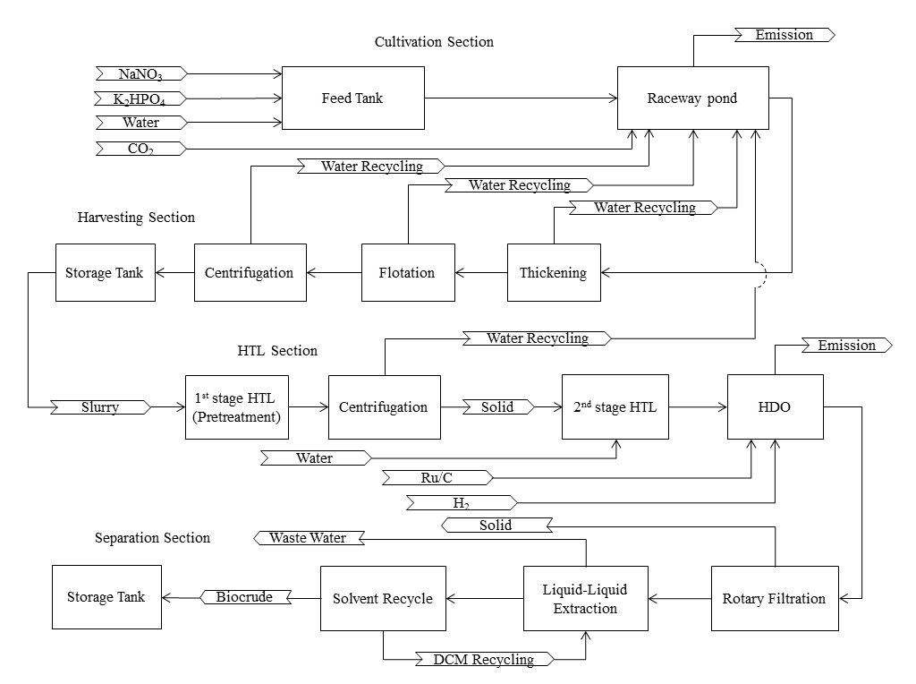
Figure 50: Simplified flow diagram of the overall process

Process Design
In the algae cultivation step, sodium nitrate, dipotassium phosphate as nutrients are mixed with water from the feeding tank, then sent to the open raceway pond as algae cultivation medium. CO₂ was pumped directly to the pond to provide carbon source. A single unit pond was as large as 40,000 m² with depth of 30 cm and its design followed the previous work (Lundquist et al., 2010). The algae productivity was assumed as 25 g/m²/d and the algae growth was modeled with kinetics from another study (Goldman and Carpenter, 1974).
Algae slurry from the open raceway pond was then sent to the harvesting section to dewater through thickening, dissolved air flotation and centrifugation from 0.5 to 150 g/L of the slurry concentration. The water collected from slurry dewatering was 100% recycled to reuse in the raceway pond. Harvested algae slurry went to the HTL section to produce bio-crude oil. A two stage HTL process combined with an HDO system were modeled to reduce nitrogen content in the crude oil. At the first stage, nitrogen dissolved in aqueous phase was removed by centrifugation after protein was hydrolyzed in a plug flow reactor for 15 min at the low temperature of 225 ℃ at which carbohydrate and lipid were assumed to be only slightly hydrolyzed. The solid phase was sent to the second stage PFR for further hydrolysis at 350℃ for 60 min to generate crude oil, which then was reacted with hydrogen in a continuous stirred-tank reactor at the same temperature for 240 min to reduce nitrogen and oxygen content. Ruthenium on carbon was used as the catalyst for the HDO process with 5 wt%. loading and a 2-year lifetime. Reactions were simulated based on the kinetics and the mass balance from the project experimental works. After HDO, the remaining solid was filtered using a rotary vacuum filter and upgraded crude oil was extracted using dichloromethane that might be recycled after distillation. Final crude oil was storage in tanks for further transportation.

Economic Model for Algae Bio Crude-oil
The techno-economic analysis (TEA) of simulated algae liquefaction plant was conducted using the concept of ‘n^{th}-plant’ economics meaning the designed plant was not a pioneer plant and several plants using the same technology have already been built and used so that the risk financing, longer start-ups, equipment overdesign, and other costs associated with first-of-a-kind were not taken into consideration. The total capital cost refers to the fixed costs that are associated with a process, which includes direct fixed capital (DFC) and working capital (WC). DFC is the cost of fixed assets such as equipment, which is calculated as the sum of the total plant cost (TPC), contractor’s fee and contingency. In the model, the DFC was estimated from the purchase cost of all major process equipment and cost factors with respect to purchase cost of all other cost elements (Table 11).

The purchased costs (PC) used here refers to the vendor’s selling price that is the free-on-board cost excluding the taxes, insurance, delivery and installation. The PC of the main equipment was calculated based on the follow equation.
$$PC=C_{0}{(\frac{Q}{Q_{0}})}^{a}$$
Where $C_{0}$ is the base cost, $Q_{0}$ is base capacity, $Q$ is simulated capacity and $a$ is scaling factor.

The working capital refers to the costs that can cover the operation of the plant for a certain amount of time including labor, raw material, utilities and waste disposal. In the model, it was assumed that the working capital cost was 18% of the direct fixed capital, which referenced from solid-liquid industry processes (Peters et al., 2003).
The annual operating cost (AOC) refers to the costs that are related to the annual demand of resources including feedstock, labor, heat transfer agent, power and additional operational costs. The feedstock resources considered are water, CO₂, sodium nitrate, dipotassium phosphate, hydrogen, dichloromethane and Ru/C, however, CO₂ and N nutrient costs varied from the different source. If the algae cultivation process combined with flue gas and wastewater treatment, CO₂ and nitrogen fertilizer can be much cheaper than the regular industrial prices. This was discussed and studied in the sensitivity analysis. The employees’ number and type of the plant were determined depended on previous work (Dutta et al., 201, Humbird et al., 2011, Knorr et al., 2013 and Lundquist et al., 2010). In the large capacity production plant, control technology for a fully automatic operation is installed and only needs several people to take care of the control system. The total number of employees in the plant was designed as 31 with 20 operators, 4 supervisors, 4 quality control analysts, 1 engineer, 1 secretary and 1 plant manager. The major energy cost in this system is the electricity and thermal energy. The overall electricity energy cost was assumed about $0.06/kWh that was based on a previous TEA work (Humbird et al., 2011). The electrical energy mainly consumed by heating and stirring the feedstock.

Table 11: Costs for determining the direct fixed capital (Peters et al., 2003).
Descriptions |  |  | Amount
Direct Cost (DC)
 | Equipment Purchase Cost (PC) |  | 100% of PC
 | Installationª |  | -
 | Process Piping |  | 31% of PC
 | Instrumentation |  | 26% of PC
 | Insulation |  | 3% of PC
 | Electrical Facilities |  | 10% of PC
 | Buildings |  | 29% of PC
 | Yard Improvement |  | 12% of PC
 | Auxiliary Facilities |  | 55% of PC
Indirect Cost (IC)
 | Engineering |  | 15% of DC
 | Construction |  | 20% of DC
Total Plant Cost (TPC) |  |  | TPC=DC+IC
Constructor’s Fee |  |  | 5% of TPC
Contingency |  |  | 10% of TPC
a. Installation costs for equipment were specified for each facility based on the install factor

Solid wastes and wastewater were produced in the separation section from rotary vacuum filter and crude oil extractor respectively. The disposal cost of the unreacted algae biomass was estimated as $0.02886/kg (Humbird et al., 2011) and the wastewater treatment cost was assumed as $0.01/gal. The maintenance cost accounts for additional costs related to the use of a facility such as equipment maintenance. In the model, the maintenance cost of specific equipment was obtained by multiply the purchase cost with the maintenance cost factor which was 0.15 for thickener, flotation tank, bowl centrifuge and rotary vacuum filter, and 0.1 for other equipment. The miscellaneous operating cost was estimated as 5% of the annual operating cost.

Results & Discussion
The designed algae liquefaction plant runs 24 h/d and 330 d/yr. From the simulation model, 38 unit raceways were used to produce 578,661 gallons crude oil per year. Table 12 gives the overall mass balance. Around 61% of the carbon in the initial input of CO₂ remained in the crude oil. The rest, about 39% of the initial carbon, was lost during the production through emission, wastewater and solid disposal. The amount of 19.80 kg harvested algae (dry and ash free) was required to generate 1 gallon of final crude oil. With the assumption of oil density of 873.90 g/L, the overall conversion rate from harvested algae to final crude oil was about 17% on a weight basis that compared with the experimental data. The water consumption was remarkable for algae liquefaction technology compared to other feedstock usage due to the very low concentration of algae slurry in the cultivation medium.

Table 12: Mass balance of algae liquefaction plant
Items | Annual Amount (kg) | Unit Amount (kg/gal of crude oil)
CO2 | 32,804,640 | 56.69
NaNO₃ | 915,762 | 1.58
K₂HPO₄ | 486,653 | 0.84
Water | 940,796,864 gal | 1625.82 gal
Hydrogen | 712,886 | 1.23
DCM | 370,460 | 0.64
Ru/C | 886 | 0.00
Cultivated algae | 12,687,998 | 21.93
Harvested algae | 11,459,369 | 19.80
Final crude oil | 578,661 gal | -

Water consumption of algae production is typically very high compared to other biomass cultivation in terms of gallons of water used per kg of biomass produced. Because of the huge amount of water required, algae production is usually combined with wastewater treatment or using seawater.
Based on the simulation model, about 88% of the water in the open raceway pond could be recycled from the harvesting and HTL processes and the add-on water from input was about 12%, which was estimated as 929 million gallons per year. The add-on water to the pond mainly compensated for the loss of evaporation. The annual net water consumption of the algae liquefaction plant was 944 million gallons excluding the water used for heat transfer agents. If the recycling unit was not utilized in the plant, then water usage would increase as 10 times larger of the amount with recycling on site. From an economic perspective, water reuse in the algae industry was considered as a requirement to avoid remarkable feedstock cost.
Electricity was used for pumping, stirring and high temperature heating (350°C). Heat transfer agents included steam, steam with high pressure, cooling water and chilled water were other sources of heat energy supplied to the plant. The total of 37,988,573 kWh of electricity and 1,917,998 metric tonnes (MT) of heat transfer agents were used per year in the algal bio crude plant which gave the total energy cost of $3,148,557 annually. To reduce the high consumption of electricity, it is better to improve the efficiency of the mixing in the open raceway pond or to improve the heat transfer rate in the HTL and HDO processes. For the heat transfer agents, chilled water and cooling water were consumed at a large amount of 759,977 and 1,124,003 MT per year, respectively, compared with the relatively low usages of the steam (21,414 MT) and steam with high pressure (12,604 MT), however, water was much cheaper than the steam. The total cost of water agents was $360,191 while the steam’s was $509,051. Together, the total cost of heat transfer was $869,242 and the total cost of the electricity was $2,279,315.

Cost Analysis
Table 13 summarizes the cost of 0.5 million gallon algae bio crude oil production plant. The total capital investment was estimated as $113,231,000 and the annual operating cost was $13,110,000. The bio crude was annually produced of 578,661 gallons with the annual unit production cost of $22.66 and the minimum-selling price (MSP) of $49.80/gal. The minimum selling price was estimated as the selling price that made the net present value (NPV) equal to zero using the discounted cash flow method with a 7% NPV interest, however, the annual unit production cost was calculated just by the annual operating cost divided by the bio crude yield.

Table 13: Summary of algae liquefaction plant costs.
Description | Annual Cost (2013 $)
Capital Cost
Equipment Purchase Cost | $17,655,000
Installation | $14,874,000
Process Piping | $5,473,000
Instrumentation | $4,590,000
Insulation | $530,000
Electrical | $1,766,000
Buildings | $5,120,000
Yard Improvement | $2,119,000
Auxiliary Facilities | $9,710,000
Total Plant Direct Cost | $61,836,000
Engineering | $9,276,000
Construction | $12,367,000
Contractor's Fee | $4,174,000
Contingency | $8,348,000
Total Plant Indirect Cost | $34,165,000
Direct Fixed Capital Cost | $96,001,000
Working Capital | $17,230,000
Investment Charged to This Project | $113,231,000
Annual Operating Cost
Raw Material | $5,226,000
NaNO₃ | $412,093
K₂HPO₄ | $728,479
Carbon Dioxide | $1,312,186
Water | $1,411,102
Hydrogen | $1,069,329
Dichloromethane | $185,230
Ru/C | $107,000
Waste Treatment/Disposal | $305,000
Waste Solids | $124,844
Waste Water | $180,066
Utilities | $3,065,000
Stand Power | $2,194,588
Steam | $256,968
Steam (High P) | $252,083
Cooling Water | $56,200
Chilled Water | $303,991
Labor-Dependent | $1,862,000
Facility-Dependent | $1,975,000
Miscellaneous | $676,000
Total Annual Operating Cost | $13,110,000
Product Cost
Bio Crude Yield Rates | 578,661 | gal crude oil/yr
Unit Production Cost | 22.66 | $/gal crude oil
Minimum Selling Price | 49.80 | $/gal crude oil

A recently published PNNL report estimated the MSP of the algae diesel as $4.77 per gallon (Jones et al., 2014), Our MSP of crude oil was $49.80 per gallon which is more than 10 times higher than their estimation due to low algae productivity and low conversion yield of algae oil with limited or no reuse of residual algae and wastewater streams. The PNNL report used the algae oil yield rate of 59 % wt. of the dry and ash free algae in the HTL process and 77 % wt. oil production rate in the hydro-treating process. Together, the rate from dry and ash free algae to the final upgraded oil was about 45 % wt.; however, our simulation used the experimentally achievable conversion rate from algae to final crude oil of around 17 % wt. Besides, they claimed that the algae feedstock was $430/ U.S. ton on a dry and ash free basis which was equal to $474/MT but the minimum selling price of the algae production model in this research was estimated as $1,400/MT which was about 3 times of the PNNL report price. Furthermore, they accounted the credits of co-products such as naphtha and electricity so the utilities cost reduced and the profits increased, and their plant capacity was 54 million gallon of diesel per year which was 100 times of our plant capacity.

Figure 51 illustrates the capital cost breaking down with each section. The algae cultivation and HTL & HDO sections contributes to 38.80% and 39.06%, respectively of the total capital investment. Separation section had the lowest capital cost of 6.06% and harvesting processes was about 16.08%.
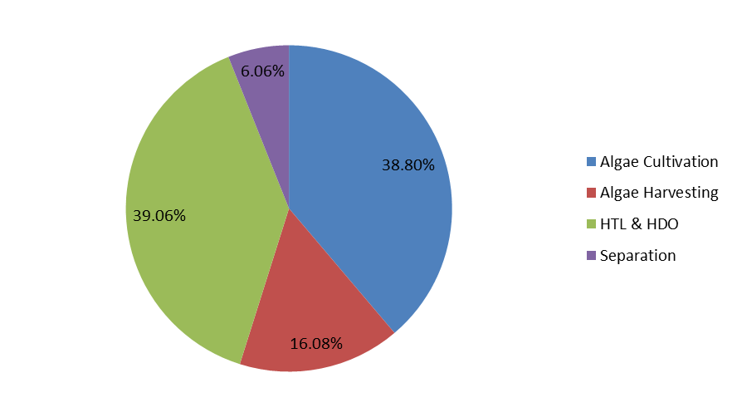
Figure 51: Breakdown of the capital cost of the algal bio crude plant
The breakdown analysis of the operation cost was conducted and shown in Figure 52. The cost of the raw materials was the highest, about 39.54% of the total operating cost. Nutrients, water and hydrogen possessed the majority cost of the feedstock. The second high operating cost was the utilities, which was about 23.19% of the total. Labor and facilities costs were more or less the same with each other, which were 14.09% and 14.94% respectively. The miscellaneous and waste treatment costs only minimally contributed to the total operating cost. Reducing the cost of the feedstock would considerably decrease the total operating cost of the algae liquefaction technology. Instead of using fresh water, it might make a lot of advantage of growing the algae in wastewater and pumping flue gas instead of pure carbon dioxide. Also, using the emission gases from the HTL process to generate hydrogen on site could save the cost comparing to purchasing the hydrogen.
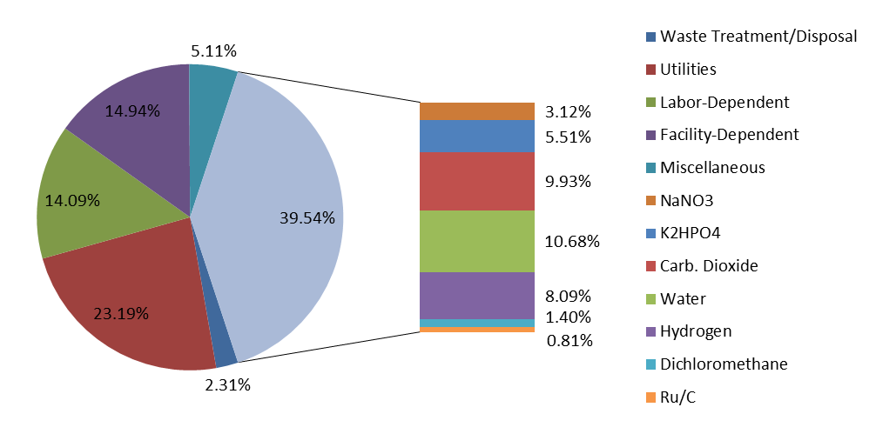
Figure 52: Breakdown of the operating cost of the algal bio crude plant

Scenario Analysis
The whole plant was designed with the production capacity of 0.5 million gallons of bio crude per year as a base case, however, this capacity was very small compared to the target of 2022 with the biofuel production of 36 million annually. In order to evaluate the difference between the plant capacity and the cost of the bio crude production, two scenarios with 1 and 10 million gallons per year were analyzed and compared with the base case (Table 14). It was found that the production cost and the minimum-selling price were reduced with the increasing in plant capacity. The reduction was gradually decreased since the minimum selling price was decreased about 2 dollars from 0.5 million to 1 million capacity and 5 dollars from 1 million to 10 million. It was good to enlarge the plant capacity; however, it meant more investment in the beginning period.

Table 14: Comparison of the cost of scenarios with different plant capacity
Capacity  (MM gallon) | Capital Cost  ($) | Operating Cost  ($/yr) | Production Cost ($/gal) | Minimum Selling  Price ($/gal)
0.5ª | 113,231,000 | 13,110,000 | 22.66 | 49.80
1 | 188,182,000 | 21,793,000 | 21.57 | 47.81
10 | 1,681,725,000 | 194,292,000 | 19.23 | 42.95
a. The plant capacity with 0.5 MM gallon crude oil production per year is the baseline case.

Sensitivity Analysis
The sensitivity analysis was conducted to find out the reflection of the minimum bio crude selling price to the change of the key parameters such as algae growth rate and HTL yield percentage. The results of the sensitivity analysis are illustrated in the Figure 53. The base case was set as control group with the MSP of $49.80/gal. Six key parameters were investigated: HTL yield rate, HDO yield rate, algae growth rate, CO2 cost, fertilizer cost and HDO catalyst lifetime. To double the HTL yield rate of the base case, MSP of the bio crude reduced about $24.07/gal from the baseline, but MSP increased by $43.15/gal when reducing the HTL yield rate to a half of the original value. Same trend was found when changing the HDO yield rate. Reducing the algae growth rate influenced the MSP more efficiently than increasing the rate. Feedstock cost and HDO catalyst lifetime did not influence the MSP much. If CO₂ is free, the price only goes down for $2.14/gal. Above all, the MSP of the crude were most sensitive to the HTL and HDO yield rate. To reduce the MSP, it was better to increase the HTL and HDO yield rate as well as the algae growth rate, and to decease the feedstock cost.
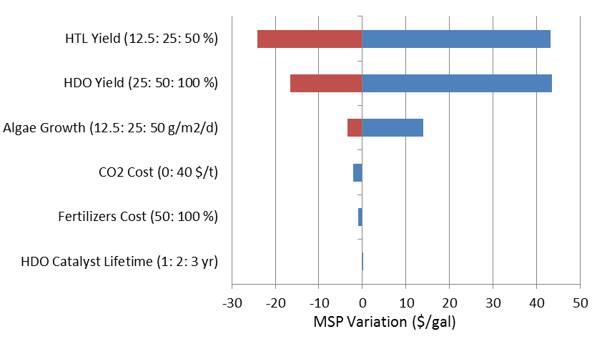
Figure 53: Sensitivity analysis of the minimum selling price of the algal bio crude

Petroleum Refinery Insertion:

We contacted three refineries during this reporting period. The three refineries included Hunt Refining (Tuscaloosa AL), Ergon Refining (Vicksburg, MS), and Phillips 66 (Bartlesville, OK). A letter and presentation were sent to key contacts at these refineries. A sample letter and presentation sent to company representatives are included at the end of this section. We received no indication of interest or contact from these companies.

Sample Letter to Refineries:
July 11, 2014
Dr. Craig Barker
Chief Engineer, Sustainability Technologies
Research and Development, Phillips 66
Bartlesville, OK

Dear Dr. Barker,

Our research group at UGA is currently investigating a two stage, hydrothermal algae liquefaction process to produce low nitrogen algae oil. We are also investigating the subsequent catalytic HDO/HDN of that oil to further reduce heteroatoms and generate a stream that can be inserted into a refinery (potentially in a gasoil or VGO stream). This project has been funded by the Department of Energy.
DOE indicates that applicants are not required to have a petroleum refinery partner at the time of application, but must engage with the intent to secure a refinery partner by the end of the project. Engaging a petroleum refinery partner by the end of the project period is a key project deliverable and it is anticipated that a partnership of this nature would be critical to secure the funding necessary to enable advancement of the technology.
We would like to ask Phillips 66 if they would be willing to discuss the possibility of engaging in a collaborative partnership involving co-processing algal oil. We would like to discuss the possibility of providing input to the research direction, such as 1) identifying appropriate insertion points in a refinery, 2) identifying key chemical/physical requirements for the algal oil, 3) providing inputs towards catalyst selection for upgrading experiments, 4) helping identify key reaction pathways for HDO and HDN of algal oil molecules, and 4) providing a small amount of refinery intermediate (e.g., gasoil or VGO) for co-processing experiments.
I have attached a PowerPoint presentation indicating our project goals, ongoing methods, and recent results. We hope this presentation will provide a starting point for discussions with Phillips 66 (since these data have not been published we ask that you please keep this confidential). I would certainly be willing to travel to Bartlesville, OK (if I can find the funding) to present our work in greater detail and discuss opportunities to collaborate with Phillips 66 (e.g., collaborate and write large DOE demonstration proposals). I see potential for a Southeastern/Southwestern led algae biorefinery Academic/Industrial consortium and the possibility of developing renewable fuel and carbon credits for Phillips 66 if successful.
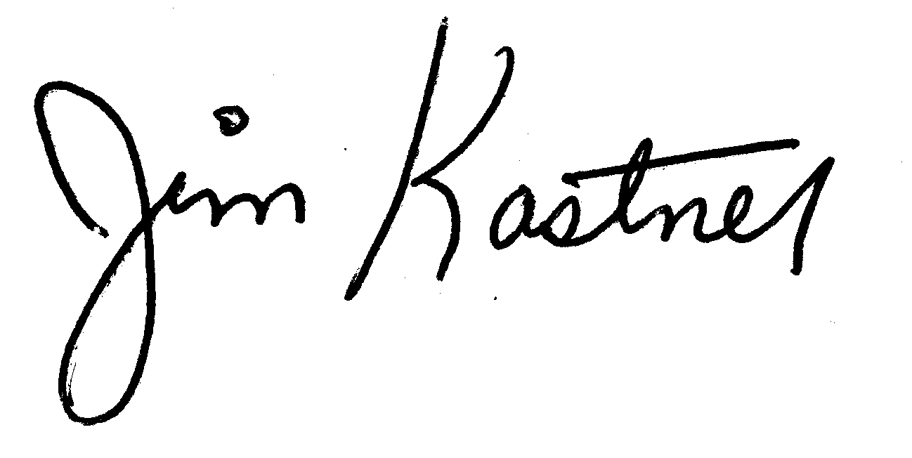
Sincerely,

___________________________
James R. Kastner, Ph.D.
Associate Professor, BioChemical Engineering, UGA

References:

Alba, L.G., Torri, C., Samorì, C., van der Spek, J., Fabbri, D., Kersten, S. R. A., Brilman, D.W.F. Hydrothermal Treatment (HTT) of Microalgae: Evaluation of the Process As Conversion Method in an Algae Biorefinery Concept. Energy Fuels 2012, 26, 642–657.

Brown, T.M., Duan, P.G., Savage, P.E. 2010. Hydrothermal Liquefaction and Gasification of Nannochloropsis sp. Energy & Fuels, 24, 3639-3646.

Consoli F et al. (Eds), Guidelines for life cycle assessment: a code of practice (1st ed.) Society of Environmental Toxicology and Chemistry (SETAC), Brussels, 1993.

Corma, A., Huber, G.W., Sauvanaud, L., O’Conor, P. 2007. Processing biomass-derived oxygenates in the oil refinery: catatlytic cracking (FCC) reaction pathways and role of catalyst. Journal of Catalysis, 247(2007): 307-327.

Biller, P., A. B. Ross, S. C. Skill, A. Lea-Langton, B. Balasundaram, C. Hall, R. Riley and C. A. Llewellyn. (2012). Nutrient recycling of aqueous phase for microalgae cultivation from the hydrothermal liquefaction process. Algal Research (In press).

Davis, R., A. Aden and P. T. Pienkos. (2011). Techno-economic analysis of autotropic microalgae for fuel production. Applied Energy 88: 3524-3531.

Duan, P., Savage, P.E. Upgrading of crude algal bio-oil in supercritical water. Bioresource Technology 102 (2011) 1899–1906.

Duan P, Savage PE. Hydrothermal Liquefaction of a Microalga with Heterogeneous Catalysts. Industrial & Engineering Chemistry Research. 2010;50:52-61.

Distillation cut classifications from Manual of Hydrocarbon Analysis, 6th ed., 1998, Ed: A.W. Drews, ASTM International, Conshohocken, PA

Fava, J. A., Denison, R., Jones, B., Curran, M. A., Vigon, B., Selke, S., & Barnum, J. (1991). A technical framework for life cycle assessments. SETAC.

Frank, E. D., J. Han, I. Palou-Rivera, A. Elgowainy and M. Q. Wang. 2011. Life cycle analysis of algal lipid fuels with the GREET Model. Technical Report # ANL/ESD/11-5, Energy Systems Division, Argonne National Laboratory, Washington, DC.

Furimsky, E. 2000. Catalytic hydrodeoxygenation. Applied Catalysis-A. 199(2): 147-190.

Garcia-Moscoso Jose Luis., Wassim Obeidb, Sandeep Kumar, Patrick G. Hatcher. Flash hydrolysis of microalgae (Scenedesmus sp.) for protein extraction and production of biofuels intermediates. J. of Supercritical Fluids 82 (2013) 183–190.

Gutierrez, A. Kaila, RK, Honkela, ML, Slioor, R. Krause AOI. 2009. “Hydrodeoxygenation of guaiacol on noble metal catalysts”. Catalysis Today 147(3–4): 239–246.

Huber, G.W., Corma, A., 2007. Synergies between bio- and oil refineries for the production of fuels from biomass. Angew. Chem. Int. Ed. 46(2007): 7184-7201.

Hulatt, C.J., Lakaniemi, A-M., Puhakka, J.A., Thomas, D.T. Energy Demands of Nitrogen Supply in Mass Cultivation of Two Commercially Important Microalgal Species, Chlorella vulgaris and Dunaliella tertiolecta Bioenerg. Res. 2012. DOI 10.1007/s12155-011-9175-x.

Jena, U., Vaidyanathan, N., Chinnasamy, S., Das, K.C. Evaluation of microalgae cultivation using recovered aqueous co-product from thermochemical liquefaction of algal biomass. Bioresource Technology 102 (2011) 3380–3387.

Jena, U., Das, K.C. Comparative Evaluation of Thermochemical Liquefaction and Pyrolysis for Bio-Oil Production from Microalgae. Energy Fuels 2011, 25, 5472–5482.

Jena, U., Das, K.C., Kastner, J.R. Effect of operating conditions of thermochemical liquefaction on biocrude production from Spirulina platensis. Bioresource Technology 102 (2011) 6221–6229.

Jena, U., Mani, S., Kastner, J.R., Hilton, R., Miller, J., Das, K.C. Upgrading of Fast Pyrolysis Bio-oil into Drop-in-biofuels. FINAL TECHNICAL REPORT. Prepared for The Oak Ridge National Laboratory. Subcontract # 4000107218.

Miao, C., Chakraborty,M., Chen, S. 2012. Impact of reaction conditions on the simultaneous production of polysaccharides and bio-oil from heterotrophically grown Chlorella sorokiniana by a unique sequential hydrothermal liquefaction process. Bioresource Technology, 110(2012): 617–627.

Pate, R., Geoff Klise, Ben Wub. Resource demand implications for US algae biofuels production scale- up. Applied Energy 88 (2011) 3377–3388.

Ross AB, Biller P, Kubacki ML, Li H, Lea-Langton A, Jones JM. Hydrothermal processing of microalgae using alkali and organic acids. Fuel. 2010;89:2234-43.

Sato, N., Quitain, A.T., Kang, K., Daimon, H., Fujie, K. 2004. Reaction Kinetics of Amino Acid Decomposition in High-Temperature and High-Pressure Water. Industrial & Engineering Chemistry Research, 43(13), 3217-3222.

Vardona, D.R., Sharmab, B.K., Scottb, J., Yu, G., Wang, Z., Schideman, L., Zhang, Y. Strathmann, T.J. 2011. Chemical properties of biocrude oil from the hydrothermal liquefaction of Spirulina algae, swine manure, and digested anaerobic sludge. Bioresource Technology, 102(17): 8295–8303.

Wildschut, J., Mahfud, FH, Venderbosch, RH, Heeres, HJ. 2009. Hydrotreatment of Fast Pyrolysis oil using Heterogeneous Noble Metal Catalysts. Industrial Engineering Chemistry Research. 2009, 48 (23):10324–10334.

Wildschut, J., Cabrea, IM., Heeres, HJ. 2010. Catalyst studies on the hydrotreatment of fast pyrolysis oil. Applied Catalysis B: Environmental 99(1–2): 298–306.

Yin, S.D., Dolan, R., Harris, M., Tan, Z.C. 2010. Subcritical hydrothermal liquefaction of cattle manure to bio-oil: Effects of conversion parameters on bio-oil yield and characterization of bio-oil.
Bioresource Technology, 101(10), 3657-3664.

Zhao, C., He, J., Lemonidou1, AA, Li, X., Lerche, JA. 2011. Aqueous-phase hydrodeoxygenation of bio- derived phenols to cycloalkanes. Journal of Catalysis 280(1): 8–16.

Zhao, C., Kou, Y., Lemonidou, AA, Li X., Lercher, JA. 2009. “Highly Selective Catalytic Conversion of Phenolic Bio-Oil to Alkanes”. Angewandte Chemie 48(22): 3987–3990.

References related to Process Modeling Section
Biller, P., Ross, A.B., 2011. Potential yields and properties of oil from the hydrothermal liquefaction of microalgae with different biochemical content. Bioresour. Technol. 102(1), 215-225.
Davis, R., Aden, A., Pienkos, P.T., 2011. Techno-economic analysis of autotrophic microalgae for fuel production. Appl. Energy. 88(10), 3524-3531.
Dutta, A., Talmadge, M., Hensley, J., Worley, M., Dudgeon, D., Barton, D., et al., 2011. Process design and economics for conversion of lignocellulosic biomass to ethanol: thermochemical pathway by indirect gasification and mixed alcohol synthesis. DOI: 10.2172/1015885.
Frank, E.D., Elgowainy, A., Han, J., Wang, Z., 2013. Life cycle comparison of hydrothermal liquefaction and lipid extraction pathways to renewable diesel from algae. Mitig. Adaptation Strategies Glob. Change 18(1), 137-158. 7.
Goldman, J.C., Carpenter, E.J., 1974. A kinetic approach to the effect of temperature on algal growth. Limnol. Oceanogr. 19(5), 756-766.
Humbird, D., Davis, R., Tao, L., Kinchin, C., Hsu, D., Aden, A., et al., 2011. Process design and economics for biochemical conversion of lignocellulosic biomass to ethanol: dilute-acid pretreatment and enzymatic hydrolysis of corn stover. DOI: 10.2172/1013269.
Jones, S., Zhu, Y., Anderson, D., Hallen, R., Elliott, D., Schmidt, A., et al., 2014. Process design and economics for the conversion of algal biomass to hydrocarbons: whole algae hydrothermal liquefaction and upgrading. DOI: 10.2172/1126336.
Knorr, D., Lukas, J., Schoen, P., 2013. Production of advanced biofuels via liquefaction - hydrothermal liquefaction reactor design: April 5, 2013. DOI: 10.2172/1111191.
Lardon, L., Hélias, A., Sialve, B., Steyer, J.P., Bernard, O., 2009. Life-cycle assessment of biodiesel production from microalgae. Environ. Sci. Technol. 43(17), 6475-6481.
Lundquist, T.J., Woertz, I.C., Quinn, N.W.T., Benemann, J.R., 2010. A realistic technology and engineering assessment of algae biofuel production. Energy Biosci. Inst. 1, 1-178.
Ma, J., 2011. Techno-economic analysis and engineering design consideration of algal biofuel in southern Nevada. http://digitalscholarship.unlv.edu/me_fac_articles/8/
Peters, M.S., Timmerhaus, K.D., West, R.E., 2003. Plant Design and Economics for Chemical Engineers, fifth ed. McGraw-Hill, New York.
Rickman, M., Pellegrino, J., Hock, J., Shaw, S., Freeman, B., 2013. Life-cycle and techno-economic analysis of utility-connected algae systems. Algal. Res. 2(1), 59-65.

