Gold in the Layered Structures of R₃Au₇Sn₃: from Relativity to Versatility

Alessia Provino,^{a,b,c} Simon Steinberg,^{a,d} Volodymyr Smetana,^{a,d} Uday Paramanik,^{e}
Anja-Verena Mudring,^{a,d} Pietro Manfrinetti,^{a,b,c} Sudesh K. Dhar^{e}

ª The Ames Laboratory, U.S. Department of Energy, Iowa State University, Ames, IA 50011, USA
^{b} Department of Chemistry, University of Genova, Via Dodecaneso 31, 16146 Genova, Italy
^{c} Institute SPIN-CNR, Corso Perrone 24, 16152 Genova, Italy
^{d} Department of Materials Science and Engineering, Iowa State University, Ames, IA 50011, USA
^{e} Department of Condensed Matter Physics & Materials Science, T.I.F.R. Homi Bhabha Road, Mumbai 400 005, India

Keywords: Complex Intermetallics, Gold Clusters, Kondo Interaction, Strongly Correlated Materials, Electronic Structure Calculations.

Corresponding Author
E-mail: mudring@iastate.edu

Abstract
A new isotypic series of ternary rare earth element-gold-tetrel intermetallic compounds has been synthesized and their structures and properties have been characterized. R₃Au₇Sn₃ (R = Y, La-Nd, Sm, Gd-Tm, Lu) crystallize with the hexagonal Gd₃Au₇Sn₃ prototype (Pearson symbol hP26; P6₃/m, a = 8.110-8.372 Å, c = 9.351-9.609 Å, V_{cell} = 532.7-583.3 Å³, Z = 2), an ordered variant of the Cu₁₀Sn₃-type. Their structure is built up by GdPt₂Sn-type layers, which feature edge-sharing Sn@Au₆ trigonal antiprisms connected by trigonal R₃ groups. Additional insertion of gold atoms leads to the formation of new homoatomic Au clusters, Au@Au₆; alternatively, the structure can be considered as a superstructural polyhedral packing of the ZrBeSi-type. The magnetization, heat capacity and electrical resistivity have been measured for R₃Au₇Sn₃ (R = Ce, Pr, Nd and Tb). All four compounds order antiferromagnetically with the highest T_{N} of 13 K for Tb₃Au₇Sn₃. In Ce₃Au₇Sn₃, which has a T_{N} of 2.9 K, the heat capacity and electrical resistivity data in zero and applied fields indicate the presence of Kondo interactions. The coefficient of the linear term in the electronic heat capacity, γ, derived from the heat capacity data below 0.5 K is 211 mJ/Ce mol K² suggesting strong electronic correlations due to the Kondo interaction. The electronic structure calculations based on the projector augmented wave method for particular representatives of the series suggest different tendencies of the localized R-4f AOs to hybridize with the valence states. LMTO-based bonding analysis on the non-magnetic La₃Au₇Sn₃ indicates that the integrated crystal orbital Hamilton populations (COHPs) are dominated by the heteroatomic Au–Sn contacts; however, contributions from La–Au and La–Sn separations are significant, both together exceeding 40 % in the overall bonding. Homoatomic Au–Au interactions are evident for the Au@Au₆ units but, despite of the high atomic concentration of Au in the compound, they do not dominate the entire bonding picture.

Introduction
The gold-rich parts of the R-Au-M phase diagrams (R = rare-earth, M = group IIIA/IVA element) are both poorly explored and understood.¹ In contrast, the R-Au-M systems with less than 50 at.% gold are well recognized for a series of isostructural compounds, i.e. the stoichiometric RAuM²⁻⁴ and R₂Au₂M,^{5,6} and certain M-rich phases,⁷⁻¹⁴ which show remarkable chemical and physical properties.¹⁵ For instance, Eu₂AuGe₃ undergoes a metamagnetic transition at 5 K,⁹ while non-collinear antiferromagnetic or even spin-glass states have been observed for alloys of the RAuIn series (R = Ce-Nd, Tb-Er).¹⁶
Our interest in gold-rich alloys in the R-Au-M systems was motivated by the more recent discoveries of a series of complex alloys for R = Eu and M = Al,¹⁷ Ga,¹⁸ In^{19,20} featuring, amongst others, a number of Tsai-type quasicrystals and their approximants for diverse rare-earth metals,^{21,22} as these structures comprise large gold-containing, polyanionic networks enclosing monoatomic cations. Such networks have also been encountered in previous structural investigations of the A/Ae-Au-M systems (A/Ae = alkaline/alkaline earth) and illustrate the strong tendency of gold to form and participate in homo- and heteroatomic networks in binary and complex metallic alloys.²³⁻³⁵ The electronegativity and the strong influence of the relativistic effects of gold^{36,37} are important aspects of the bonding and stabilization of these networks; however, the low valence electrons concentration (VEC) of these Au-rich intermetallic phases hamper the application of conventional valence electron counting rules and position them close to Hume-Rothery phases.³⁸⁻⁴⁰ In addition, we are also interested in investigating the Au-richer (and R-poorer) regions of the R-Au-M systems as magnetic ordering at even longer ranges provides essential knowledge about the origin of magnetic singularities, as illustrated by studies on magnetic particles diluted in alloys.⁴¹
Systematic explorations of the Au-richer regions for the R-Au-M systems yielded the isotypic series R₃Au₇Sn₃ (R = Y, La-Nd, Sm, Gd-Tm, Lu), which are the first representatives to exceed 50 at.% gold within a class of intermetallic compounds with the general formula R_{m+n}T_{2m+n}Sn_{m+n}, viz. Yb₂Au₃Sn₂,⁴² R₃Au₄Sn₃ (R = La, Ce, Pr, Nd), R₅Au₈Sn₅ (R = Sm, Gd) and La₄Au₇Sn₄.⁴³ In particular, these structures are composed of m slabs of the GdPt₂Sn type of strucure⁴⁴ and n slabs of SrPtSb type,⁴⁵ respectively, while a unique structural feature of the R₃Au₇Sn₃ series is the presence of a Au@Au₆ units. The incorporation of diverse rare-earth metals in the gold-containing host networks allows the evaluation of general structural tendencies related to geometric effects such as the lanthanide contraction as well as the manipulation of the physical (electronic and magnetic) properties through tuning the electronic behavior. The particular physical properties of the rare earth elements are typically governed by the strongly correlated electrons of the 4f states, which are expected to be well shielded against interaction with ligand orbitals;⁴⁶ however, the R-4f states show different tendencies to hybridize with the R valence states leading to dissimilar properties of the alloys.⁴⁷ For that reason, we investigated the syntheses, phase widths, structure, physical properties and electronic structures of representatives for the R₃Au₇Sn₃ series (R = Y, La-Nd, Sm, Gd-Tm, Lu).

Experimental Section
Synthesis. Pieces of rare earth metals [R = Y, La-Nd, Sm, Gd-Tm, Lu; from Smart-Elements GmbH (99.9 wt.% for most of them, 99.95 wt.% for Y, 99.99 wt.% for Sm, Gd, Lu, 99.997 wt.% for Tm. All purities in wt.%/TREM), gold granules [MaTeck GmbH (99.99 wt.%)] and tin ingots (Alfa Aesar, 99.999 wt.%) were used as starting materials. The metals were stored, and handled, in an Ar-filled glove box with strict exclusions of air and moisture (O₂ < 0.1 ppm, H₂O < 0.1 ppm). The alloys (1.5-2.5 g total) were prepared by arc-melting the elements, weighed in stoichiometric proportion, under a pure Zr-gettered Ar atmosphere. To achieve optimal homogenization, all samples were remolten four times after turning the buttons upside-down; weight losses were below 0.5 wt.%. The Sm-containing samples were prepared in Ta tubes (outgassed by induction-heating under vacuum), sealed by arc welding under pure Ar, by high-frequency induction melting. The alloys were then placed in outgassed Ta tubes, sealed in evacuated silica ampoules and annealed at 950°C for the light R, 900°C for Gd, and 850-800°C for the heavy R for 5-10 days. Finally, the samples were slowly-cooled to room temperature.
Elemental analysis. The samples were examined by light optical and scanning electron microscopy [LOM (Reichert, Austria) and SEM (Oxford Instruments, model 7353)]. Phase compositions were determined with electron microprobe by energy dispersive spectroscopy [EDS, Oxford-INCA software v. 4.07 (working distance: 15 mm, counting time: 60 s)]. For each specimen EDS analysis was performed on at least three points (or areas) with backscattered electrons.
Differential Thermal Analysis (DTA). Alloy specimens of about 0.8-1.0 g, generally cut from the as-cast button, were used for DTA analysis. They were sealed in a Mo crucible (outgassed under vacuum by induction heating) by arc welding, and subjected to heating (20°C/min) and cooling (5-10°C/min) runs (accuracy of ± 5°C/min) in a Netzsch 404 thermoanalyzer.
X-ray Diffraction Studies. Suitable single crystals of R₃Au₇Sn₃ (R = Nd and Y/Ho) were extracted from the bulk as-cast materials, fixed on glass fibers and transferred to a Bruker APEX CCD diffractometer (Bruker Inc., Madison, USA; Mo-Kα radiation; λ = 0.71073 Å). Sets of single-crystal X-ray intensity data were collected at room temperature in φ- and ω-scan modes with exposures of at least 15 s/frame. The raw intensity data were integrated with the aid of the SAINT program within the SMART⁴⁸ software suite, while the program SADABS⁴⁹ was employed for empirical absorption corrections.
Analyzing the extinction conditions by the XPREP algorithms within the SHELXTL⁵⁰ software package on the X-ray intensity data sets allows to assign the space group P6₃/m (No. 176) for the hexagonal R₃Au₇Sn₃. All structures were solved utilizing direct methods (SHELXS-97) and refined on F² in full-matrix least-squares (SHELXL-97),⁵¹ while further cycles of refinements also included anisotropic atomic displacement parameters. The difference Fourier maps exhibited a series of high residual electron density peaks. Close analyses of the reciprocal spaces for the collected X-ray intensity data sets of the selected single crystals indicated twinning by merohedry and, therefore, a twinning matrix of (0 1 0; 1 0 0; 0 0 −1) was applied to correct the intensity data sets. This method, which resulted in a reliable outcome for Y₃Au₇Sn₃ and Gd₃Au₇Sn₃,⁵² did not allow the removal of all twinning artifacts in La and Nd. But this refinement yielded, especially for the heavy rare-earth compounds due to perfect racemic mixtures of the tested crystals, really low (< 3 %) R₁ values. To confirm the correct structure solution powder X-ray techniques were used.
Precise determinations of the lattice parameters for all alloys were accomplished based on powder X-ray diffraction patterns, which were recorded on a Guinier-Stoe camera (Stoe & Cie, Darmstadt, Germany, Cu-Kα1 radiation; λ = 1.54059 Å) using pure Si as an internal standard [a = 5.4308(1) Å]. The patterns were indexed utilizing the program LAZY PULVERIX⁵³ and the lattice parameters were determined by least-squares methods. Sets of powder X-ray diffraction patterns for Rietveld refinements were collected on a Philips X’Pert (Philips, Eindhoven, The Netherlands; point detector, Cu-Kα1 radiation) and STOE STADI P (Stoe & Cie, Darmstadt, Germany; area detector; Cu-Kα1 radiation) diffractometers at room temperature. The program FULLPROF⁵⁴ was employed for analyses of the data and the Rietveld refinements.
Physical Property Measurements. The DC magnetization was measured as a function of both temperature (1.8-300 K) and applied magnetic fields (0.05 to 7 Tesla) using Quantum Design MPMS and VSM magnetometers (QD, San Diego, USA). Heat capacity data were collected from 1.8 to 30 K in the PPMS (QD), which uses the relaxation method. For the Ce- and Pr-containing compounds, the data were taken down to 0.1 K using the dilution refrigeration insert of the PPMS. Resistivity measurements were carried out between 1.8 and 300 K by the four-probe DC method in the PPMS. For Ce₃Au₇Sn₃ the resistivity was also measured up to 14 Tesla at selected temperatures in the PPMS.
Computational Details. Density functional theory (DFT)-based band structure calculations on R₃Au₇Sn₃ (R = La, Pr) were performed utilizing the projector-augmented wave (PAW) method of Blöchl⁵⁵ as implanted in the Vienna ab initio Simulation Package (VASP) by Kresse and Joubert.⁵⁶⁻⁶⁰ Exchange and correlation were described in the generalized-gradient approximation (GGA) using the Perdew, Burke and Enzerhof (PBE) exchange correlation potential.⁶¹ To account for the strong correlations within the Pr-4f states,⁶² an effective on-site Coulomb interaction term (U_{eff}= 5.5 eV) was added to the Kohn-Sham Hamiltonian of all Pr₃Au₇Sn₃ computations. Three Pr₃Au₇Sn₃ starting models with different magnetic ordering of the Pr lattices were examined to provide conclusive hints to the magnetic structure of this compound (see Electronic Structures). Additionally, models of both Cu₁₀Sn₃-type and Au₁₀In₃-type of structures for La₃Au₇Sn₃ were examined to evaluate structural preferences between two possible modifications of the hexagonal R₃Au₇Sn₃ structures. The energy cutoffs of the plane wave basis sets for all calculations were set to 500 eV, while the first Brillouin zones were sampled by starting meshes of 4 × 4 × 4 up to 8 × 8 × 8 k-points for reciprocal space integrations. Full structural optimizations were accomplished for all computations until the energy differences between two iterative steps fell below 0.01 meV.
A full (chemical) bonding analysis on the electronic structure of the lanthanum-containing compound was carried out based on the crystal orbital Hamilton population (COHP) curves and their integrated values (ICOHP). To identify bonding and antibonding states, the off-site projected density-of-states (DOS) are weighted with their corresponding Hamilton matrix elements within the Stuttgart tight-binding, linear muffin-tin orbital (TB-LMTO) code with its atomic sphere approximation (ASA).^{63,64} The Wigner-Seitz (WS) spheres of the respective atoms were generated automatically and empty spheres (ES) were added to achieve an optimal approximation of full potentials. 224 irreducible k-points were employed to sample the first Brillouin zone for reciprocal space integrations using the tetrahedron method.⁶⁵ The basis set employed the following orbitals (orbitals treated in the downfolded⁶⁶ technique are in parentheses): Au-6s/-6p/-5d/(-5f), La-6s/(-6p)/-5d/-4f, Sn-5s/-5p/(-5d)/(-4f) with the corresponding WS radii [Å]: Au, 3.00-3.14; La, 3.67; Sn, 3.20-3.31. Plots of the DOS and -COHP curves are shown below, while –ICOHP values may be extracted from the Supporting Information.

Results and Discussion
Formation and Stability. Detailed phase analyses indicated that the targeted products were obtained as single phase or as high yield products (> 97 mol.%). R₃Au₇Sn₃ are ordered ternary representatives of the Cu₁₀Sn₃ structure type.⁶⁷ Our preliminary investigation on the two prototypical specimens Y₃Au₇Sn₃ and Gd₃Au₇Sn₃¹ has been extended to the whole series of rare earths as well as neighboring transition and post transition elements to understand the tendencies to adopt a certain structure type, to reveal the changing physical properties and to inspect the stability ranges. The existence of the R₃Au₇Sn₃ phase was confirmed for Y and all of the light (except Eu) and the heavy rare earth elements down to Lu (but not Yb). The lattice parameters (a and c) and the unit cell volumes (V_{cell}), as obtained from the Guinier patterns, are compiled in Table 1, while their trends versus the R³⁺ ionic radius, which reflect well the lanthanide contraction, are shown in Figure l. The crystal structures were refined by the Rietveld method for Nd₃Au₇Sn₃ (see Figure 2 and Table 2) and the Ce-, Sm- and Tb-containing compounds (FigureS1 and Tables S1, S2, S3).
As observed from DTA analysis, these compounds form by a peritectic reaction; however, the formation temperature decreases from the light R to the heavy ones, therefore showing a decrease in the relative stability of the R₃Au₇Sn₃ compounds (see Tables S5). The observation on the formation and their stability might indicate the importance of geometric factors. Moreover, starting from at least Dy, a new competing pseudo-ternary phase R(Au_{1−x}Sn_{x})₃ has been identified. It appears to have a composition of about R₂₅Au₅₅Sn₂₀ and is structurally related to the cubic BiF₃-type (cF16, Fm−3m, No. 225) [a = 6.8763(5) Å for Ho₂₅Au₅₅Sn₂₀]. The solubility range of the R(Au_{1−x}Sn_{x})₃ compound has not been investigated. DTA analysis reveals a similar behavior for other heavy R. A typical DTA curve (cooling run), for a sample with nominal composition Ho₃Au₇Sn₃, is shown in Figures 3. Three thermal effects are observed: the first at higher temperature (1085°C) is associated with the formation of the cubic Ho(Au_{1−x}Sn_{x})₃, which forms from the liquid before the Ho₃Au₇Sn₃ compound (840°C). The weak thermal effect at 270°C indicates the presence of a small amount of Sn-rich Au-Sn binaries in accordance with the SEM data (Figure 4) and powder X-ray diffraction patterns of as-cast and annealed samples. Moreover, the equiatomic compound RAuSn⁶⁸ forms first at higher temperatures for the heaviest R (R = Tm, Lu) and for Sc, which does not form the 3:7:3 phase. All attempts to replace Au or Sn by neighboring elements resulted in the formation of a different structure that might indicate the significance of electronic factors.
Crystal Chemistry. The polyhedra packing of R₃Au₇Sn₃ is represented in the Figure 5. The structure remains unchanged from Y until Tm. Also any mixture of two rare earths, viz. Y/Ho, leaves the structure type unchanged. All previously reported members of the R_{m+n}T_{2m+n}Sn_{m+n} family⁴³ are based on various combinations of GdPt₂Sn-⁴⁴ and SrPtSb-type⁴⁵ slabs. However, in the current case a different situation is observed as the SrPtSb slab in the crystal structure of R₃Au₇Sn₃ is completely missing. Its structure can be described by slabs of GdPt₂Sn type with Sn-centered trigonal antiprisms of Au that share common edges. These slabs alternate with layers featuring Au@Au₆ and trigonal R₃ units (Figure 5, bottom). The Au@Au6 trigonal prisms are capped by Sn atoms in the GdPt₂Sn type layers. As Au fills 1/6 of the voids in the plane between the R₃ groups a visible distortion of the triangular R network occurs.
The crystal structure of R₃Au₇Sn₃ can also be considered as a polyhedral superstructure of the ZrBeSi type.⁶⁹ Three or formally four polyhedra can be considered as independent building units of this structure. Depending on their locations within the slabs the aforementioned trigonal Sn@Au₆ antiprisms have two slightly different shapes, which can be identified by the site symmetries of the endohedral Sn atoms. The antiprisms penetrated by (001) (Sn: Wyckoff symbol 2b; axial) are regular and ideally centered, whereas those located inside the unit cell (central) are distorted featuring a major shift of the centering Sn atoms (Wyckoff symbol 4f; Figures 6a and b). The last type rather plays the role of a connecting link between the axial Sn@Au₆, Au@Au₆ and R₃ groups. In summary, the Sn@Au₆ units occupy the positions of Zr atoms, while the Au@Au₆ units which are axially capped by two Sn atoms and the R₃ units (Figures 6c and d) can be assigned to the Be and Si sites in ZrBeSi, respectively.
Au–Au interatomic distances within the Sn@Au₆ slabs are notably longer than those to the inter slab Au atoms, pointing to the presence of the formally isolated Au@Au₆ clusters. The latter are axially and equatorially capped by two Sn and three R atoms, correspondingly. Since these clusters show nearly identical structural features for all representatives for R, the Nd-containing compound was taken for an exemplary detailed structural analysis dicussion. The Au–Au contacts from the cluster center to the edges and edge lengths along the c axis are 2.9751(4) and 2.9405(6) Å, respectively, whereas edge lengths in the a-b plane, which are common with the Sn@Au₆ units, are 4.4798(7) Å. Another group of Au–Au edge distances within the latter is also found to be slightly above the normal bonding separations [3.1371(4) and 3.3973(4) Å]. Au–Sn contacts in the Sn@Au₆ trigonal antiprisms are split into two ranges due to the imperfect centering of the unit [2.882(4) and 2.892(4) Å].
The number of examples for Au₇ clusters is very limited in the solid state. So far, only an elongated centered trigonal prism, akin to the vertices-sharing bi-tetrahedra in the two compounds Au₁₀In₃⁷⁰ and Rb₄Au₇Sn₂, have been reported.⁷¹ However, a significantly different geometry of the Au₇ cluster is observed for the rare earth-containing compounds. Keeping the same form, the shape of the cluster has been inverted to three vertex-sharing isoscele Au₃ triangles. The form of both clusters in binary compounds is in fact opposite to the shapes of the unit cells, squashed in Cu₁₀Sn₃⁶⁷ and elongated in Au₁₀In₃.⁷⁰ The coordination environments of the Au@Au₆ clusters in R₃Au₇Sn₃ are similar to those in Rb₄Au₇Sn₂ compound, axially and equatorially capped by two and three atoms, respectively. Yet, the elongated Au₇ units in the Rb-containing structure are encased solely by Rb atoms, whereas those in R₃Au₇Sn₃ exhibit mixed atom (Sn/R) coordination spheres. The cluster in Au₁₀In₃ is capped exclusively equatorially by three In and three extra Au atoms with the latter playing the role of establishing links to six other cluster units. It should also be noted that Cu₁₀Sn₃ features a slightly denser atom packing than Au₁₀In_{3,} when calculating the unit-cell volume contractions as the difference of the cell volumes and the sum of the respective atomic volumes in pure elements: 7.4 % for the Sn- and 6.5 % for the In-containing phase, respectively.
R–Au distances slightly increase in the row from Lu to La and depend mainly on the atomic size of the corresponding rare earth element, which well reflects the lanthanide contraction in the isostructural series and, therefore, affects the sizes of the unit cells (Figure 1). Additionally, Nd–Au distances are in the range 3.01(1)-3.29(1) Å, while Tb–Au contacts are located between 2.90(1) and 3.27(1) Å. On the other hand, the lengths of the R–R contacts do not directly depend on the relative atomic radii of R due to their large separations by the polyanionic networks. For instance, the shortest Nd–Nd, Tb–Tb and Y–Y contacts are 4.433(3), 4.461(4) and 4.496(3) Å, respectively; they do not show any evident correlation with the ionic radii.
Thus, the R₃Au₇Sn₃ compounds can be derived from the Cu₁₀Sn₃ structure type rather than from the competing Au₁₀In₃-type. In particular, R₃Au₇Sn₃ form on the basis of the Cu₁₀Sn₃-type to the extent that the Sn atoms are fully substituted by R atoms, while Cu is replaced by Sn and Au atoms, respectively. Hence, R₃Au₇Sn₃ can be regarded as the first ternary ordered representatives of the Cu₁₀Sn₃-type. From the first look it might appear that relatively large R cations cannot be included in the parental structure without significant changes. Electronic aspects which will be discussed below provide conclusive clues accounting for the formations of certain structures; however, the adaption of the Cu₁₀Sn₃-type can also be substantiated based on geometrical factors. The Sn/Cu and In/Au covalent radii⁷² ratios are very close: 1.20 and 1.12, respectively. An average covalent radius of the rare earths forming R₃Au₇Sn₃ is ~ 1.6 Å leading to the R/(Au,Sn) ratio of 1.18, which is definitely closer to the corresponding value in the Cu₁₀Sn₃ structure.
Physical Properties. The temperature-dependent inverse magnetic susceptibility, χ⁻¹, of R₃Au₇Sn₃ (R = Ce, Pr, Nd and Tb) compounds is shown in Figure 7. For the Pr-, Nd- and Tb-containing alloys χ⁻¹ vs. T shows a Curie-Weiss behavior, which extends from 300 K down to about ~ 25 K, indicating that the crystal electric field splitting in these compounds is low. The fit of the Curie-Weiss law χ = C_{CW}/(T −θ_{p}) to the data is shown by the solid lines in Figure 7. The Curie-Weiss parameters, the effective moments μ_{eff} and the paramagnetic Curie temperature θ_{p}, are listed in Table 3. In contrast, the inverse susceptibility of Ce₃Au₇Sn₃ does not follow a Curie-Weiss behavior. A modified Curie-Weiss expression χ = C_{CW}/(T − θ_{p}) + χ₀ fits the data well (solid line) between 50 and 300 K, with μ_{eff} = 2.22 μ_{Β}/Ce, χ₀ = 3.92×10⁻² emu/mol and θ_{p} = − 7.1 K. The μ_{eff} of the Pr-, Nd- and Tb-containing compounds are comparable to their respective Hund’s rule derived values for the trivalent oxidation state of these rare earth ions (Pr³⁺: 3.58 µ_{B}; Nd³⁺: 3.68 µ_{B}; Tb³⁺: 9.72 µ_{B}),⁴⁶ but in Ce₃Au₇Sn₃ the magnitude of μ_{eff} is less than the value of 2.54 μ_{Β} for a trivalent Ce ion and χ₀ is comparable to χ at 300 K (4.54×10⁻² emu/mol). While the latter may question the validity of fitting the modified Curie-Weiss expression to the susceptibility of the Ce-compound, the low temperature susceptibility and the heat capacity data are consistent with the trivalent state of the Ce ions ordering antiferromagnetically at 2.9 K. The negative sign of θ_{P} for all the compounds is in conformity with their antiferromagnetic transition at low temperatures. Figure 8 shows the susceptibility of R₃Au₇Sn₃ below 50 K for R = Ce, Pr, Nd and Tb. Peaks in the susceptibility, characteristic of antiferromagnetic transition, are seen in all the four compounds; the Néel temperatures, T_{N} (the peak temperature), are listed in Table 3, which also includes the relevant data of the recently studied Gd₃Au₇Sn₃¹ for comparison. It may be noted that the magnetic transition temperatures, T_{N}, do not obey the de Gennes scaling, which predicts that T_{m} in the mean field approximation is proportional to (g_{J} − 1)² J (J + 1), where g_{J} is the Landé’s g-factor and J the total angular momentum of the R-ion.
The in-field magnetization at 1.8 K is plotted in Figure 9. The field variation of the magnetization is in agreement with antiferromagnetic ground state for these compounds. The data suggest a spin-flop transition in Pr and Tb compounds at ~ 15 kOe. The magnetization is not yet saturated at the highest applied field of 70 kOe, particularly in Tb₃Au₇Sn_{3,} and to a lesser extent in Nd₃Au₇Sn₃.
The heat capacity of the R₃Au₇Sn₃ (R = Ce, Pr, Nd, Tb) compounds is plotted in Figures 10 and 11; the data of the non-magnetic reference analogues, Y₃Au₇Sn₃ and La₃Au₇Sn₃, have been added. For Ce and Nd compounds, La₃Au₇Sn₃ was taken to be the non-magnetic reference compound as the heat capacity of La₃Au₇Sn₃ is lower than those of the two magnetic compounds at all temperatures. That makes it plausible to assume that the phonon heat capacities of the non-magnetic reference and magnetic compounds are identical after normalization to account for slight mass difference of the rare earth R and La ions. On the other hand, the heat capacity of La₃Au₇Sn₃ exceeds that for Pr and Tb compounds at high temperatures and, therefore, Y₃Au₇Sn₃ was chosen as the non-magnetic reference for these two compounds. Below 5 K, the heat capacity of La₃Au₇Sn₃ is described by the expression C/T = γ + βΤ² with γ = 5.16 mJ/mol K² and a Debye temperature, Θ_{D}, of 142.7 K derived from β. The corresponding values of γ and Θ_{D} in Y₃Au₇Sn₃ are 8.9 mJ/mol K and 144 K.
The heat capacity of Pr₃Au₇Sn₃ and Nd₃Au₇Sn₃ shows a peak close to 2.9 and 3.2 K, respectively, confirming the bulk nature of the magnetic transition in these two compounds (Figure 10). A prominent tail in the heat capacity above the magnetic transition temperature, seen in all the compounds, suggests substantial short range order in the paramagnetic region. The upturn in the heat capacity of the Pr compound below 1 K is due to the nuclear Schottky heat capacity arising from the magnetic and possibly quadrupolar hyperfine interaction. Most likely the nuclear Schottky heat capacity in the remaining magnetic R₃Au₇Sn₃ compounds occurs at much lower temperatures. The 4f contribution to the heat capacity C_{4f} was estimated by subtracting the heat capacity of the appropriate reference compound, after proper normalization following the procedure described earlier,⁷³ from the total heat capacity of the two compounds. The entropy S_{4f}, calculated by integrating C_{4f}/T against temperature T, is plotted in Figure 10. It is noted that S_{4f} at T_{N} is 3.4 J/R mol K in both compounds and that it attains the value of Rln2 (5.76 J/R mol K) at 5.4 and 11.2 K in Pr₃Au₇Sn₃ and Nd₃Au₇Sn₃, respectively, which is above their respective T_{N}. Therefore, it is likely that the crystal electric field split ground state is a doublet with effective spin S = 1/2 in both compounds.
For Ce₃Au₇Sn₃ and Tb₃Au₇Sn₃ the heat capacity data and the entropy S_{4f} are shown in Figure 11. The J = 5/2 state of Ce³⁺ in Ce₃Au₇Sn₃ is expected to be split into three doublets by the crystal electric field. S_{4f} reaches 3.75 J/Ce mol K at T_{N} and Rln2 at ~ 8.3 K, indicating prima-facie the existence of short range order above T_{N}; however, a second factor may also be at play for a lower value of S_{4f} at T_{N}. The low temperature heat capacity below 0.4 K is plotted in the inset of Figure 11 as C/T vs. T². The upturn seen at very low temperatures is tentatively attributed to nuclear Schottky heat capacity. A linear extrapolation of the data (shown by the solid line) gives an intercept of 211 mJ/Ce mol K² as T → 0. The linear coefficient of the electronic heat capacity, γ, in Ce₃Au₇Sn₃ is therefore large and indicates substantially strong electronic correlations arising from Kondo interaction. A strong hybridization between the Ce-4f orbital and the itinerant electrons is the basis for Kondo interaction in Ce and Yb compounds, which makes the exchange interaction between the Ce 4f-spins and the conduction electrons antiferromagnetic, giving rise to a host of anomalies associated with the Kondo phenomenon. In Ce₃Au₇Sn₃, where the Ce ions order magnetically, the Kondo interaction can partially screen the Ce 4f-derived magnetic moment leading to a reduced entropy at T_{N} as experimentally observed. A strong hybridization of the 4f states with the conduction band orbitals also offers an explanation for the reduced μ_{eff} and an appreciable χ₀ inferred from the susceptibility data above. Apparently, the hybridization is not strong enough to destabilize the Ce-moment completely as the temperature is decreased and the Ce magnetic moments manage to order magnetically at low temperature. The peak in the heat capacity of Tb₃Au₇Sn₃ at 12.5 K confirms the bulk nature of the magnetic ordering in this compound. The entropy reaches the value of Rln2 close to 15 K indicating a doublet ground state. At higher temperatures the entropy S_{4f} increases due to the Schottky contribution from the excited crystal electric field levels, similar to the behavior seen in Pr and Tb compounds as well.
The electrical resistivity of the R₃Au₇Sn₃ compounds (R = Pr, Nd and Tb) is plotted in Figure 12. The resistivity exhibits metallic behavior decreasing smoothly with decreasing temperature. An anomaly in the resistivity is observed at the magnetic transition in all compounds as the resistivity decreases faster in the magnetically ordered state due to the rapid freezing of spin-disorder scattering.
The electrical resistivity of Ce₃Au₇Sn₃ was studied in greater detail as the magnetization and heat capacity data described above point to a possible Kondo interaction in this compound. Figure 13 shows the resistivity in zero and an applied field of 14 T. In the latter case the data were taken up to 100 K only. The electrical resistivity decreases down to ~ 20 K, showing a broad minimum as the sample is further cooled, followed by an upturn below ~ 15 K. The resistivity peaks at 4.6 K and then decreases before the transition to the antiferromagnetic state sets in at 2.9 K. The upturn below 15 K may arise due to the Kondo interaction and the resistivity decrease at 4.6 K may be linked to the onset of Kondo coherent regime in a Kondo lattice. There is apparently no anomaly at T_{N}, (see the inset, Figure 13) which is presumably submerged in the faster rate of decrease due to Kondo coherence. The resistivity at 14 T is lower than its corresponding zero-field values below ~ 40 K down to the lowest temperature of 1.8 K, implying a negative magnetoresistivity, MR. The MR is defined as MR = [ρ(B)−ρ(0)]/ρ(0). It is shown as a function of magnetic field at selected temperatures in Figure 14. Typically, the MR in the antiferromagnetic state is positive as initially the field tends to disrupt the antiferromagnetic alignment leading to a greater spin-disorder resistivity. In the paramagnetic state, close to T_{N}, the MR is typically positive due to the quenching of random magnetic moment orientations by the field. Contrarily, in Ce₃Au₇Sn₃ the MR is negative at all temperatures up to ~ 40 K. This tends to strengthen the argument for the presence of Kondo interaction in the Ce compound as the MR of a Kondo compound is negative.
Electronic Structures. The electronic structures of R₃Au₇Sn₃ (R = La, Pr) were investigated to provide conclusive insights into the origin of the structure-property relationship and its variations along the isotypic R₃Au₇Sn₃ series (R = Y-Lu). Therefore, the electronic ground states of Cu₁₀Sn₃- and Au₁₀In₃-type based La₃Au₇Sn₃ models were first examined to identify the structural preferences to adopt a certain structure type. Then, the electronic structures of a non-magnetic (La₃Au₇Sn₃) and a magnetic (Pr₃Au₇Sn₃) representative of the R₃Au₇Sn₃ series were both investigated to account for the particular physical properties, while (general) bonding tendencies were evaluated based on the -COHP curves and their respective integrated values for the lanthanum-containing structure.
Geometry Optimization and Equation of State. Two equiatomic and structurally related structure types, that are (I) the Cu₁₀Sn₃-type and (II) the Au₁₀In₃-type, were considered as possible parental prototypes for the hexagonal R₃Au₇Sn₃. Full geometry optimization of the experimentally observed La₃Au₇Sn₃ (Cu₁₀Sn₃-type) resulted in minor differences between the calculated and experimental volumes as well as atomic coordinates. A hypothetical model of La₃Au₇Sn₃ was also created on the basis of the Au₁₀In₃ structure type. In analogy with Cu₁₀Sn₃ post transition element positions were replaced by R atoms, while Au positions close to the Au₇ groups were assigned to Sn (Figure S2). Since no ternary experimentally observed representative of the type II was known, cell shape (c/a) and volume optimization started from the values taken from the binary compound and the La representative of type I, respectively. The energy versus volume trends for both modifications were established in order to prove the stability ranges and detect possible transformations under pressure. Figure 15 shows the E(V) curves for La₃Au₇Sn₃ in both modifications plotted around the optimized volumes. Type I exhibits 1.7 eV/f.u. lower energy, which also corresponds to the ~ 4 % volume contraction if compared to II. No intersection point is observed at or below the equilibrium volumes indicating no possible pressure induced transition between the types. Both curves can be fitted with a third order Birch-Murnaghan equation of state (EOS).⁷⁴ Bulk modulus values (B₀) extracted from the fitting were 76.4 and 61.6 GPa for the models I and II, respectively, which might also points towards a more efficient atom packing in the Cu₁₀Sn₃ type, as discussed in the structure description section of this work.
Density-of-states (DOS). Band structure calculations were carried out for both non-magnetic La₃Au₇Sn₃ and magnetic Pr₃Au₇Sn₃. The latter structure exhibits an antiferromagnetic state below 2.7 K and three Pr₃Au₇Sn₃ models with different spin orientations of the Pr-4f electrons were inspected to provide certain hints accounting for the magnetic order between the Pr layers (Figure S3). In the antiferromagnetic model 1 (AFM1) alternating spin orientations are implemented for the praseodymium triangle layers T1 and T2, while the spins of the Pr-4f electrons have parallel intralayer, but antiparallel interlayer alignments in the antiferromagnetic model 2 (AFM2) (Figure S3). Additionally, a third Pr₃Au₇Sn₃ model with a ferromagnetic spin orientation of the Pr-4f electrons (FM) was examined to substantiate the absence of a ferromagnetic ground state for this compound. Furthermore, the results of the magnetic measurements for the praseodymium-containing compound also point to localized Pr-4f states, which require further considerations.^{62,75} Because of these states show strong correlations, an effective on-site Coulomb interaction term (U_{eff} = 5.5 eV) was introduced as a correctional parameter to the Kohn-Sham Hamiltonian of each Pr₃Au₇Sn₃ band structure calculation.
The total energies of the three Pr₃Au₇Sn₃ models indicate that the AFM2 model is highest in energy and differs from the FM model by 0.30 eV, while there is an energy difference of 1.67 eV between the FM and lowest-energy AFM1 state. Accordingly, an antiparallel intralayer spin orientation is suggested for the Pr triangle layers T1 and T2. All inspected models of the Pr triangle layers are based on collinear orderings, since a geometrically frustrated system (for which the mean field theory predicts θ_{P} to be significantly larger than T_{N})⁷⁶ can be precluded for Pr₃Au₇Sn₃ (T_{N}≈ θ_{P}). Contrary a geometrically frustrated system with θ_{P}> T_{N} is suggested for Nd₃Au₇Sn₃. Based on the Weiss molecular field theory⁷⁷ a χ(T = 0)/χ(T_{N}) value of 0.49 for a polycrystalline Nd₃Au₇Sn₃ sample suggests a non-collinear magnetic structure for that compound.
To develop certain trends for the electronic structures of the R₃Au₇Sn₃ series, we followed up with an analysis of the DOS curves for La₃Au₇Sn₃ and the lowest-energy Pr₃Au₇Sn₃ AFM1 model and compared the general consequences to those of the recently published R₃Au₇Sn₃ (R = Y, Gd).¹ The spin-polarized DOS curves of Pr₃Au₇Sn₃ reflect an antiferromagnetic ground state for that compound, as the spin-up and spin-down curves superimpose for the AFM1 model (Figure 16). The lanthanum-containing analogue does not show any magnetic anomalies at lower temperatures, as expected, and, therefore, all band structure calculations on this compound were carried out in a non-spin-polarized regime. An analysis of the DOS near E_{F} for R₃Au₇Sn₃ (R = La, Pr) reveals that these states stem primarily from the Au-d atomic orbitals (AOs) with minor contributions from the R-d and Sn-p states. Close inspections of the energy regions near the Fermi levels indicate that E_{F} in La₃Au₇Sn₃ falls close to a local maximum, whereas the Fermi level in Pr₃Au₇Sn₃ is placed in a pseudogap. Such characteristics of the DOS curves infer metallic conductivities for these compounds, which is further substantiated by the temperature-dependent electrical resistivity measurements (Figure 12). Below E_{F}, there are broad gaps in the DOS of La₃Au₇Sn₃ (between – 0.67 and 0.69 eV) and Pr₃Au₇Sn₃ (between – 1.34 and – 0.05 eV), which separate the Au-d from the Sn-s AOs. Note that the gap is slightly smaller in Pr₃Au₇Sn₃ than in the isostructural lanthanum-containing compound.
A major difference in the DOS curves of Pr₃Au₇Sn₃ from those of the isostructural lanthanum compound arises from the occupation of the 4f states below the Fermi level (Figure 16). In particular, the La-4f states reside mostly between E_{F} and 9.14 eV and, hence, are unoccupied, while the Pr-4f states are located in energy regions below (between 1.88 and 3.60 eV) as well as about (between 7.34 and 8.77 eV) the Fermi level in Pr₃Au₇Sn₃ (Figures S4-S6). Additionally, the modest dispersions of the bands accounting for the Pr-4f states lead to sharp peaks in DOS curves at 3.14 and 8.40 eV indicating rather localized states. A close inspection of these energy regions for the spin-polarized Pr PDOS reveals that the “spin-up” Pr-4f states originate primarily from the T1 layers with minor contributions from the T2 layers, while the latter contribute primarily to the “spin-down” Pr-f PDOS. Furthermore, these sharp peaks correspond to an exchange splitting of 5.26 eV for the Pr-4f states, which is in good agreement with previously reported experimental results for bulk Pr metal.⁷⁸
Such different characteristics in the electronic structure of Pr₃Au₇Sn₃ from that of the recently reported Gd₃Au₇Sn₃,¹ in which the occupied Gd-4f states reside in energy regions below the Gd-d states, point to unlike tendencies of the R-4f AOs (or electrons) to hybridize with the valence band states (or 6s and 5d conducting electrons). This tendency is also indicated by the deviations of the observed effective magnetic moments per R for R₃Au₇Sn₃ (R = Ce, Pr, Nd, Gd, Tb; Table 3) from the theoretical values of the respective R³⁺ ions for their ground terms. For instance, µ_{eff}/R of the Gd- and Tb-containing compounds are higher than the Hund’s rule derived values of the trivalent state for the respective ions of these heavy rare-earth elements, which tend to show excess effective magnetic moments due to conduction electron enhancement. Certainly, such tendencies are also well recognized from the magnetic and thermodynamical data of the bulk lanthanide metals.⁴⁷ It is worth noting that the exchange splitting of the Pr-4f states for Pr₃Au₇Sn₃ is smaller than those of the Gd-4f states for Gd₃Au₇Sn₃ (11.23 eV).¹ This outcome suggests the absence of direct f-f interactions and that the electric and magnetic properties are controlled by the DOS near the Fermi level; however, the tendency of the R-4f electrons to hybridize with the conducting electrons differs for each system. This trend is most conspicuous for Ce₃Au₇Sn₃, in which the linear coefficient of the electronic heat capacity and the negative magnetoresistivity suggest the presence of Kondo interactions.
In summary, the results of the magnetic measurements as well as the theoretical examinations indicate rather localized R-4f states, while overall bonding is determined by the contributions from the Au-d, R-d and Sn-p AOs. To inspect this outcome in more detail, we followed up with a bonding analysis for the non-magnetic La₃Au₇Sn₃.
Bonding Analysis. The physical and theoretical examinations of the R₃Au₇Sn₃ representatives suggest that the 4f electrons are responsible for their respective magnetic properties; however, they play a negligible role in overall bonding for R₃Au₇Sn₃ (R = La, Pr). This outcome is in accord with previous studies⁷⁹, indicating that the R-4f states are rather localized and can be treated as core-like states for TB-LMTO-based bonding analyses.^{80,81} For that reason La₃Au₇Sn₃ was chosen as an example to investigate the bonding situation in the Sn@Au₆ slabs and the Au@Au₆ units connecting them, as well as the involvement of R as formal cations into overall bonding.
First, the role of Au and Sn in the stabilization of the layered structure and the monoatomic formation Au@Au₆ is checked. -ICOHP values of the Au–Au bonds within the Au@Au₆ clusters (1.13 and 0.80 eV/bond) are larger than those for the intercluster contacts (0.56 and 0.33 eV/bond) indicating the affinity of Au to form homoatomic clusters.²³ Still, the highest overlap populations, as seen from Table S4, correspond to the heteroatomic Au–Sn bonds between Sn atoms encapsulated by the Au₆ cages and Au atoms centering the Au@Au₆ units. The Au–Sn bonds within the Sn@Au₆ clusters are ~ 15-30% less populated, which allows considering the structure on the basis of Au@Au layers and Au@Au₆ units, with additional Sn atoms and R₃ groups as connecting bridges. La–Sn and La–Au overlap populations are relatively high and qualitatively comparable to the other heteroatomic interactions. This points to significant involvement of the rare earths atoms in the overall bonding. This outcome is reminiscent of the behavior of heavy alkaline earth metals in contrast to typical electron donors from group I.^{29,30}
A close inspection of the energy regions near E_{F} (Figure 17) reveals that the La–Au and La–Sn interactions are bonding at and beyond E_{F}, whereas Au–Au bonds get optimized at ~ 0.2 eV above E_{F}. Any larger number of electrons would populate Au–Sn antibonding states. These bonding tendencies correspond well to the presence of a wide pseudogap (Figure 16) in the DOS curves of the La-containing structure. The largest contributions to the total orbital interactions arise from the Au–Sn contacts (40.5 %); however, 28.1 % from La–Au bonds remained unexpected if compared to alkali and alkaline earth metal systems.^{29,30} Additionally, La–Au and La–Sn bonding interactions contribute more than 40 % to the total ICOHP, indicating the involvements of the rare earths in overall bonding. Homoatomic Au–Au contacts still play an important role and contribute for 18.9 % to the total bonding capacities.

Conclusions
A new isotypic series of gold-rich R₃Au₇Sn₃ (R = Y, La-Nd, Sm, Gd-Tm, Lu) compounds has been synthesized. All compounds crystallize in the Gd₃Au₇Sn₃ prototype forming layers of edge-sharing Sn@Au₆ trigonal antiprisms, which alternate with a rare-earth metal triangular network. The latter accommodates additional isolated Au atoms forming trigonal-prismatic, propeller-like Au@Au₆ units together with Au sites from the Au₆Sn octahedra. Cell volume and interatomic distances follow the lanthanide contraction. The temperature-dependent magnetic susceptibility data of the Ce-, Pr-, Nd- and Tb-containing representatives of this series indicate antiferromagnetic transitions at lower temperatures (< 13 K); however, the magnetic ordering temperatures of these compounds vary due to the different tendencies of the R-4f electrons to hybridize with the conduction electrons. The most conspicuous outcome of this tendency is evident for Ce₃Au₇Sn₃, as the linear coefficient of the electronic heat capacity as well as the electrical resistivity data of this compound point to the presence of Kondo interactions. Band structure calculations for two selected representatives, La₃Au₇Sn₃ and Pr₃Au₇Sn₃, confirm metallic conductivity, which is in full accordance with the experimentally determined temperature-dependent electrical resistivity. An analysis based on the DOS data of the representatives for this series substantiates the presence of possible diverse magnetic ordering in these compounds. A chemical bonding analysis has been undertaken for the non-magnetic La₃Au₇Sn₃; it reveals that the bonding is dominated by heteroatomic Au–Sn and Au–La contacts within and between the Au₆Sn slabs, respectively, while homoatomic Au–Au bonding is evident within the Au@Au₆ cluster units.

Supporting Information
Tables with atomic coordinates for R₃Au₇Sn₃ (R = Ce, Sm, Tb); interatomic distances, multiplicities, thermal data, -ICOHP/bond for selected interactions in La₃Au₇Sn₃; powder X-ray diffraction patterns and simulated Rietveld refinement profiles of R₃Au₇Sn₃ (R = Ce, Sm, Tb); representations of spin orientations for the Pr₃Au₇Sn₃models with the antiferromagnetic ground states; site- and orbital-projected DOS curves of R₃Au₇Sn₃ (R = La, Pr).

Acknowledgments
The research was supported by the Office of the Basic Energy Sciences, Materials Sciences Division, U.S. DOE. Ames Laboratory is operated for DOE by Iowa State University under contract DE-AC02-07CH11358.

References
(1) ASM Alloy Phase Diagram Database, Villars, P.; Okamoto, H.; Cenzual, K. ASM International, Materials Park, OH, USA, 2006-2016.
(2) Rossi, D.; Marazza, R.; Ferro, R. J. Alloys Compd. 1992, 187, 267.
(3) Rossi, D.; Ferro, R. J. Alloys Compd. 2001, 317-318, 521.
(4) Pöttgen, R. Z. Naturforsch. B 2006, 61, 677.
(5) Pöttgen, R. Z. Naturforsch. B 1994, 49, 1309.
(6) Pöttgen, R. Z. Naturforsch. B 1994, 49, 1525.
(7) Hoffmann, R. D.; Pöttgen, R.; Rosenhahn, C.; Mosel, B. D.; Kunnen, B.; Kotzyba, G. J. Solid State Chem. 1999, 145, 283.
(8) Muts, I. R.; Schappacher, F. M.; Hermes, W.; Zaremba, V. I.; Pöttgen, R. J. Solid State Chem. 2007, 180, 2202.
(9) Sebastian, C. P.; Malliakas, C. D.; Chondroudi, M.; Schellenberg, I.; Rayaprol, S.; Hoffmann, R.-D.; Pöttgen, R.; Kanatzidis, M. G. Inorg. Chem. 2010, 49, 9574.
(10) Sebastian, C. P.; Salvador, J.; Martin, J. B.; Kanatzidis, M. G. Inorg. Chem. 2010, 49, 10468.
(11) Chondroudi, M.; Sebastian, C. P.; Malliakas, C. D.; Balasubramanian, M.; Li, Q. A.; Kanatzidis, M. G. Inorg. Chem. 2011, 50, 1184.
(12) Sebastian, C. P.; Sarkar, S.; Kanatzidis, M. G. Inorg. Chem. 2012, 51, 10793.
(13) Sarkar, S.; Gutmann, M. J.; Peter, S. C. Cryst. Growth Des. 2013, 13, 4285.
(14) Salvador, J. R.; Hoang, K.; Mahanti, S. D.; Kanatzidis, M. G. Inorg. Chem. 2007, 46, 6933.
(15) Kraft, R.; Pöttgen, R.; Kaczorowski, D. Chem. Mater. 2003, 15, 2998.
(16) Gondek, L.; Szytula, A.; Baran, S.; Hernandez-Velasco, J. J. Mag. Mag. Mat. 2004, 272, E443.
(17) Gerke, B.; Pöttgen, R. Z. Naturforsch. B 2014, 69, 121.
(18) Smetana, V.; Steinberg, S.; Card, N.; Mudring, A. V.; Miller, G. J. Inorg. Chem. 2015, 54, 1010.
(19) Steinberg, S.; Card, N.; Mudring, A.-V. Inorg. Chem. 2015, 54, 8187.
(20) Muts, I.; Rodewald, U. C.; Zaremba, V. I.; Pavlosyuk, O.; Pöttgen, R. Z. Naturforsch. B 2012, 67, 107.
(21) Morita, Y.; Tsai, A. P. Jap. J. Appl. Phys. 2008, 47, 7975.
(22) Gebresenbut, G. H.; Tamura, R.; Eklöf, D.; Gomez, C. P. J. Phys.: Condens. Matter 2013, 25, 135402.
(23) Li, B.; Kim, S.-J.; Miller, G. J.; Corbett, J. D. Inorg. Chem. 2009, 48, 6573.
(24) Smetana, V.; Corbett, J. D.; Miller, G. J. J. Solid State Chem. 2013, 207, 21.
(25) Smetana, V.; Miller, G. J.; Corbett, J. D. Inorg. Chem. 2013, 52, 12502.
(26) Lin, Q.; Corbett, J. D. Inorg. Chem. 2011, 50, 1808.
(27) Lin, Q.; Corbett, J. D. Inorg. Chem. 2007, 46, 8722.
(28) Lin, Q.; Smetana, V.; Miller, G. J.; Corbett, J. D. Inorg. Chem. 2012, 8882.
(29) Smetana, V.; Miller, G. J.; Corbett, J. D. Inorg. Chem. 2012, 51, 7711.
(30) Smetana, V.; Corbett, J. D.; Miller, G. J. Inorg. Chem. 2012, 51, 1695.
(31) Smetana, V.; Lin, Q.; Pratt, D.; Kreyssig, A.; Ramazanoglu, M.; Corbett, J. D.; Goldman, A.; Miller, G. J. Angew. Chem. Int. Ed. 2012, 51, 12699.
(32) Lin, Q.; Corbett, J. D. Inorg. Chem. 2008, 47, 7651.
(33) Li, B.; Corbett, J. D. J. Am. Chem. Soc. 2006, 128, 12392.
(34) Lin, Q.; Corbett, J. D. J. Am. Chem. Soc. 2007, 129, 6789.
(35) Lin, Q.; Corbett, J. D. Inorg. Chem. 2010, 49, 4570.
(36) Pyykkö, P. Chem. Rev. 1988, 88, 563.
(37) Pyykkö, P. Angew. Chem. Int. Ed. 2004, 43, 4412.
(38) Corbett, J. D. Inorg. Chem. 2010, 49, 13.
(39) Lin, Q.; Corbett, J. D. Inorg. Chem. 2011, 50, 11091.
(40) Lin, Q.; Mishra, T.; Corbett, J. D. J. Am. Chem. Soc. 2013, 135, 11023.
(41) Mydosh, J. A. J. Mag. Mag. Mat. 1978, 7, 237.
(42) Fornasini, M. L.; Manfrinetti, P.; Mazzone, D. Z. Kristallogr. NCS 2010, 225, 221.
(43) Fornasini, M. L.; Mazzone, D.; Provino, A.; Michetti, M.; Paudyal, D.; Gschneidner, K. A. Jr.; Manfrinetti, P. Intermetallics 2014, 53, 169.
(44) de Mooij, D.; Buschow, K. J. Less-Common Met. 1984, 102, 113.
(45) Wenski, G.; Mewis, A. Z. Anorg. Allg. Chem. 1986, 535, 110.
(46) Cotton, S. Lanthanide and Actinide Chemistry; John Wiley and Sons Ltd.: Chichester, England, 2007.
(47) Gschneidner, K. A. Jr. J. Alloys Compd. 1993, 192, 1.
(48) Bruker AXS, Inc.: Madison, WI, 1996.
(49) Blessing, R. Acta Crystallogr., Sect. A 1995, 51, 33.
(50) SHELXTL Bruker AXS Inc. Madison, WI, 2000.
(51) Sheldrick, G. M. Acta Crystallogr., Sect. A 2008, 64, 112.
(52) Provino, A.; Steinberg, S.; Smetana, V.; Kulkarni, R.; Dhar, S. K.; Manfrinetti, P.; Mudring, A.-V. J. Mat. Chem. C 2015, 3, 8311.
(53) Yvon, K.; Jeitschko, W.; Parthé, E. J. Appl. Crystallogr. 1977, 10, 73.
(54) Rodriguez-Carvajal, J. Phys. B. 1993, 192, 55.
(55) Blöchl, P. E. Phys. Rev. B 1994, 50, 17953.
(56) Kresse, G.; Marsman, M.; Furthmüller, J. Vienna Ab initio Simulation Package (VASP) VASP, the user Guide 2010.
(57) Kresse, G.; Furthmüller, J. J. Comput. Mat. Sci. 1996, 6, 15.
(58) Kresse, G.; Furthmüller, J. Phys. Rev. B 1996, 54, 11169.
(59) Kresse, G.; Hafner, J. Phys. Rev. B 1993, 47, 558.
(60) Kresse, G.; Joubert, D. Phys. Rev. B 1999, 59, 1758.
(61) Perdew, J. P.; Burke, K.; Ernzenhof, M. Phys. Rev. Lett. 1996, 77, 3865.
(62) Setyawan, W.; Curtarolo, S. Comput. Mat. Sci. 2010, 49, 299.
(63) Tank, R.; Jepsen, O.; Burkhardt, A.; Andersen, O. K.; Max-Planck-Institut für Festkörperforschung: Stuttgart, Germany, 1994.
(64) Andersen, O. K.; Jepsen, O. Phys. Rev. Lett. 1984, 53, 2571.
(65) Blöchl, P. E.; Jepsen, O.; Andersen, O. K. Phys. Rev. B 1994, 49, 16223.
(66) Lambrecht, W. R. L.; Andersen, O. K. Phys. Rev. B 1986, 34, 2439.
(67) Lenz, J.; Schubert, K. Monatsh. Chem. 1971, 102, 1689.
(68) Dwight, A. Rare Earth in Modern Science and Technology 1976, 1, 480.
(69) Nielsen, J. W.; Baenziger, N. C. Acta Crystallogr. 1954, 7, 132.
(70) Jandali, M. Z.; Rajasekharan, T.; Schubert, K. Z. Metallkunde 1982, 73, 463.
(71) Sinnen, H. D.; Schuster, H. U. Z. Naturforsch. B 1981, 36, 833.
(72) Cordero, B.; Gomez, V.; Platero-Prats, A.; Reves, M.; Echeverria, J.; Cremades, E.; Barragan, F.; Alvarez, S. Dalton Transaction 2008, 2008, 2832.
(73) Bouvier, M.; Lethuillier, P.; Schmitt, D. Phys. Rev. B 1991, 43, 13137.
(74) Birch, F. Phys. Rev. 1947, 71, 809.
(75) Harima, H. J. Mag. Mag. Mat. 2001, 226, 83.
(76) Ramirez, A. P. Annu. Rev. Mater. Sci. 1994, 24, 453.
(77) Morrish, A. H. The Physical Principles of Magnetism; IEEE Press: Piscataway, NJ, USA, 2001.
(78) Lang, J. K.; Baer, Y.; Cox, P. A. J. Phys. F: Met. Phys. 1981, 11, 121.
(79) Maron, L.; Eisenstein, O. J. Phys. Chem. A 2000, 104, 7140.
(80) Chai, P.; Corbett, J. D. Inorg. Chem. 2012, 51, 3548.
(81) Steinberg, S.; Bell, T.; Meyer, G. Inorg. Chem. 2015, 54, 1026.

Table 1. Lattice parameters and unit cell volume of the R₃Au₇Sn₃ compounds (R = Y, La-Nd, Sm, Gd-Tm, Lu).

Compound | a [Å] | c [Å] | V_{cell} [Å³]
La₃Au₇Sn₃ | 8.3722(6) | 9.6088(6) | 583.28
Ce₃Au₇Sn₃ | 8.3334(7) | 9.5337(11) | 573.37
Pr₃Au₇Sn₃ | 8.3009(14) | 9.5041(16) | 567.14
Nd₃Au₇Sn₃ | 8.2640(6) | 9.4589(11) | 559.44
Sm₃Au₇Sn₃ | 8.2187(5) | 9.4285(9) | 551.54
Gd₃Au₇Sn₃ | 8.1833(8) | 9.4145(16) | 545.99
Tb₃Au₇Sn₃ | 8.1691(4) | 9.4037(6) | 543.47
Dy₃Au₇Sn₃ | 8.1608(11) | 9.3907(15) | 541.62
Ho₃Au₇Sn₃* | 8.1411(6) | 9.3793(10) | 538.35
Er₃Au₇Sn₃* | 8.1435(4) | 9.3863(8) | 539.07
Tm₃Au₇Sn₃ | 8.1104(13) | 9.3507(28) | 532.67
Lu₃Au₇Sn₃ | 8.1071(7) | 9.3930(13) | 534.65
Y₃Au₇Sn₃ | 8.1573(8) | 9.4239(13) | 543.07
* as cast

Table 2. Atomic coordinates of Nd₃Au₇Sn₃ compound [Gd₃Au₇Sn₃-type (hP26, P6₃/m, No. 176)], as obtained from Rietveld refinement.

Atom | Wyckoff site | Crystallographic data |  |  | U_{iso} [Å²] | Occ.
Atom | Wyckoff site | x | y | z | U_{iso} [Å²] | Occ.
Nd | 6h | 0.29665(2) | 0.31985(2) | 1/4 | 0.409(1) | 1
Au1 | 2d | 2/3 | 1/3 | 1/4 | 0.744(2) | 1
Au2 | 12i | 0.35621(1) | 0.01961(1) | 0.09530(1) | 0.6959(8) | 1
Sn1 | 4f | 1/3 | 2/3 | 0.04085(2) | 0.431(2) | 1
Sn2 | 2b | 0 | 0 | 0 | 0.5424(1) | 1
a = 8.27518(5) Å, c = 9.48045(5) Å
R_{B} = 0.66 %, R_{F} = 0.64 %, R_{wp} = 6.50 %, χ² = 0.90

Table 3. Curie-Weiss parameters and Néel temperature for the R₃Au₇Sn₃ compounds.

Compound | T_{N} [K] | µ_{eff} [µ_{B}/R] | θ_{p} [K] | χ₀ [emu/mol]
Ce₃Au₇Sn₃ | 2.9 | 2.22 | −7.1 | 3.92 ×10⁻²
Pr₃Au₇Sn₃ | 2.7 | 3.75 | −0.9 | 0
Nd₃Au₇Sn₃ | 3.2 | 3.46 | −6.9 | 0
Gd₃Au₇Sn₃* | 13.0 | 8.13 | −8.6 | 0
Tb₃Au₇Sn₃ | 13.0 | 9.91 | −7.7 | 0
* Ref. 1

Figure 1. Lattice parameters a (red) and c (green) and unit cell volume V_{cell} (blue) vs. R³⁺ ionic radii for R₃Au₇Sn₃ compounds.
Figure 2. Observed X-ray powder pattern (red circles) and Rietveld refinement profile (black line) for Nd₃Au₇Sn₃. The lower profile (blue line) gives the difference between the observed and calculated data; the Bragg angle positions are indicated by vertical bars (green).

Figure 3. DTA trace of Ho₃Au₇Sn₃, as a typical representative for the thermal behavior of R₃AuSn₇ compounds, recorded on cooling from 1190°C at a rate of 10°C/min. Three exothermic thermal effects are detected at about 1085°C, 840°C and 270°C (onset, the last is very weak and not shown).

Figure 4. SEM image [backscattered electron (BSE) mode] showing the microstructure of the Ho₃Au₇Sn₃ DTA sample. The dark-gray primary phase (A) is Ho(Au_{1−x}Sn_{x})₃ and the light-gray phase in hexagonal grains (B) is Ho₃Au₇Sn₃; these two become visible only after maximizing the color contrast. The minority dark matrix (few volume %) (C) is constituted by AuSn and AuSn₂.

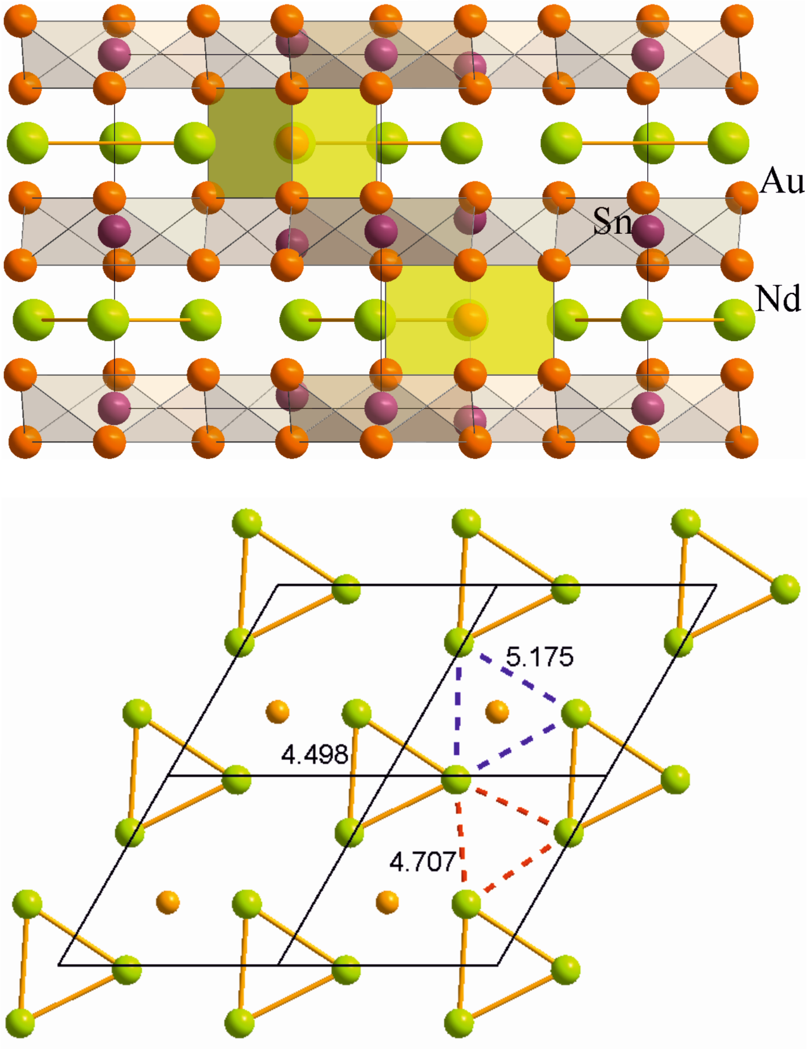

Figure 5. (top) The crystal structure of Nd₃Au₇Sn₃ projected along the c axis; the Sn@Au₆ and Au@Au₆ units are outlined in grey and orange, respectively. (bottom) Au atoms within the triangular network of Nd atoms in the crystal structure of Nd₃Au₇Sn₃ projected on the a-b plane. Three different Nd–Nd contacts are marked orange, blue and red to outline the distortion of R hexagonal network due to Au intercalation.

Figure 6. Basic building units in the crystal structure of Nd₃Au₇Sn₃.

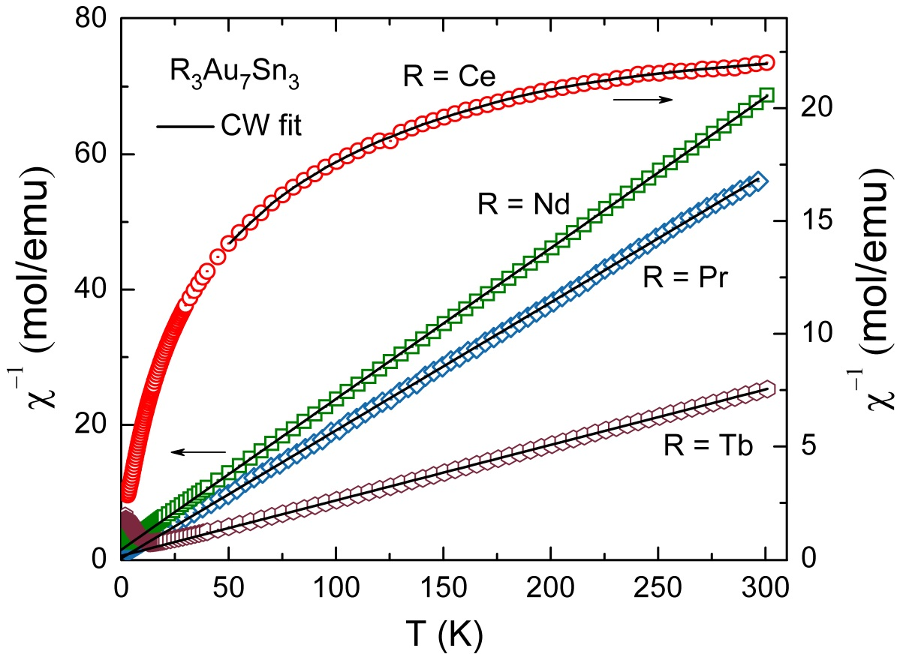
Figure 7. Temperature dependence of the inverse susceptibility for R₃Au₇Sn₃ (R = Ce, Pr, Nd and Tb) measured in applied magnetic field of 0.3 T. The solid lines show the fit of the Curie-Weiss law to data (see text).

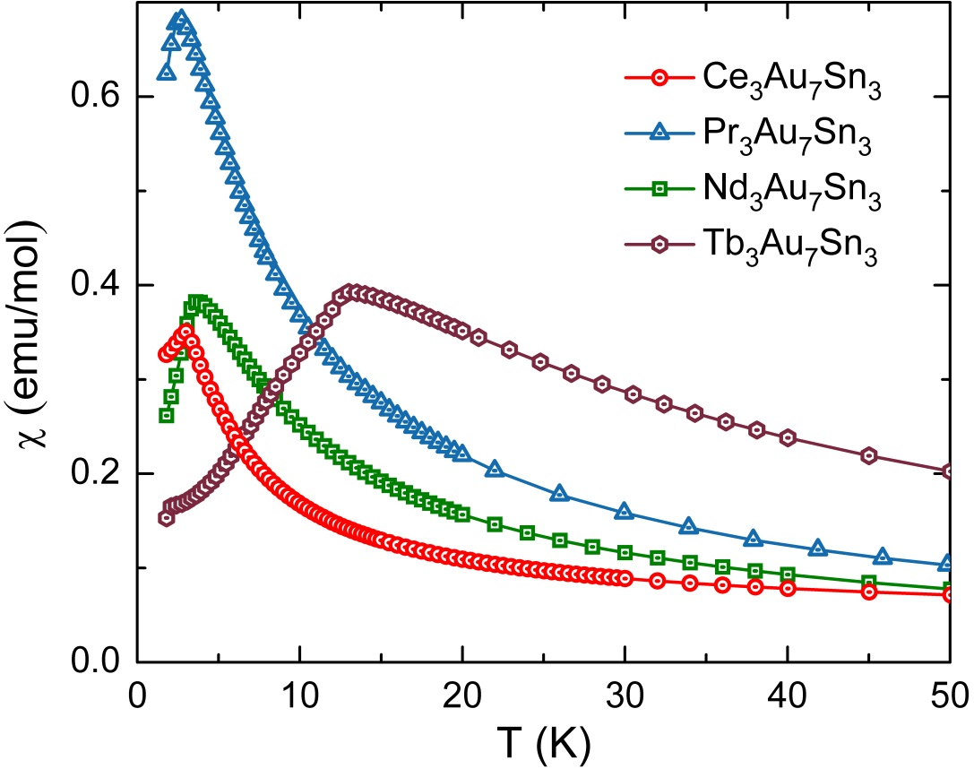
Figure 8. Temperature dependence of the magnetic susceptibility, measured in applied magnetic field of 0.3 T, for R₃Au₇Sn₃ (R = Ce, Pr, Nd and Tb) below 50 K.

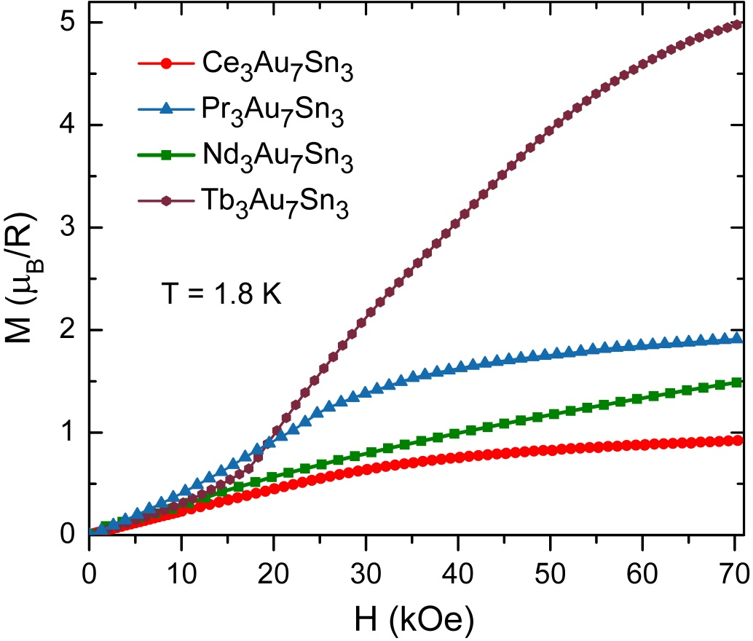
Figure 9. The isothermal magnetization of R₃Au₇Sn₃ (R = Ce, Pr, Nd and Tb) at 1.8 K and up to 7 T.

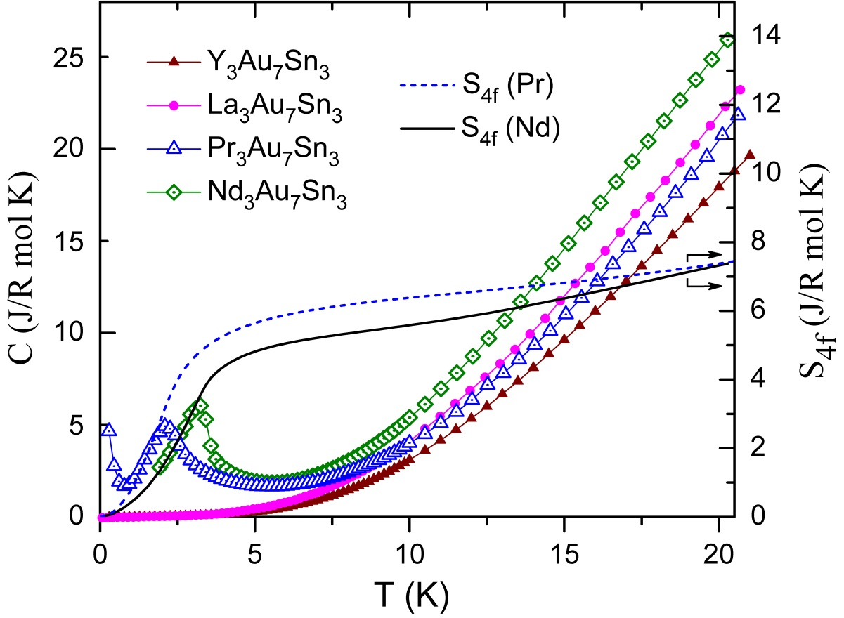
Figure 10. Heat capacity C and 4f-derived entropy S_{4f} (per R atom) of Pr₃Au₇Sn₃ and Nd₃Au₇Sn₃. The heat capacity of non-magnetic reference compounds La₃Au₇Sn₃ and Y₃Au₇Sn₃ is also plotted.
.
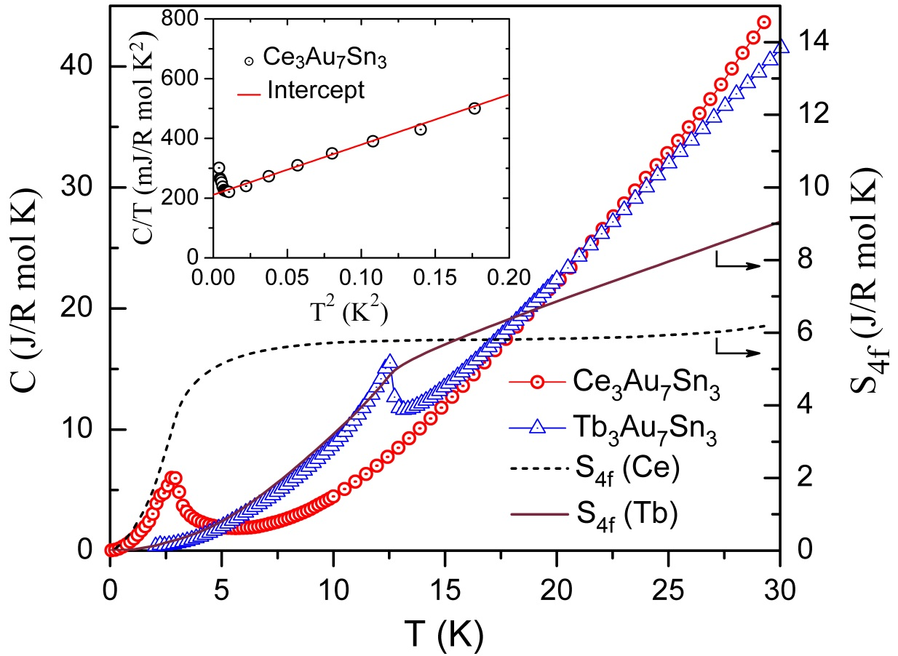
Figure 11. The heat capacity C and 4f-derived entropy S_{4f} (per R atom) of Ce₃Au₇Sn₃ and Tb₃Au₇Sn₃.

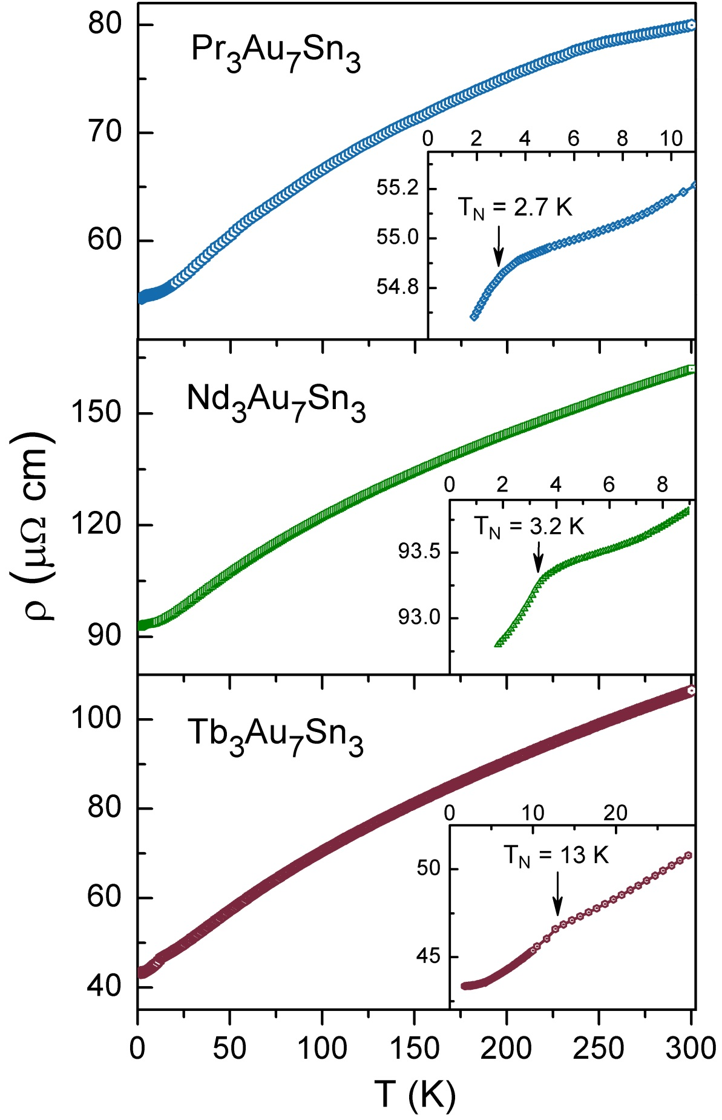
Figure 12. The electrical resistivity of R₃Au₇Sn₃ (R = Pr, Nd and Tb) measured between 1.8 and 300 K.

Figure 13. The electrical resistivity of Ce₃Au₇Sn₃ between 1.8 and 300 K, in zero and applied field of 14 T.
Figure 14. Magnetoresistivity of Ce₃Au₇Sn₃ at selected temperatures in applied fields up to 14 T.

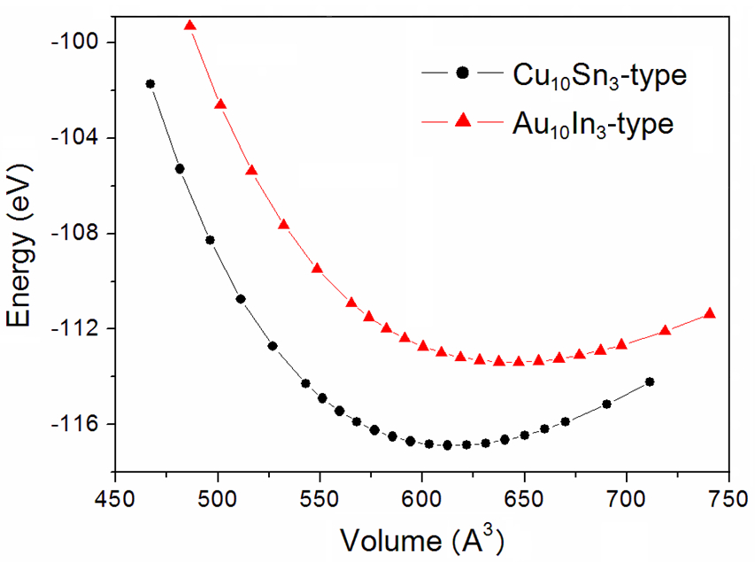

Figure 15. Energy versus volume curves for Cu₁₀Sn₃- and Au₁₀In₃-based La₃Au₇Sn₃ models.

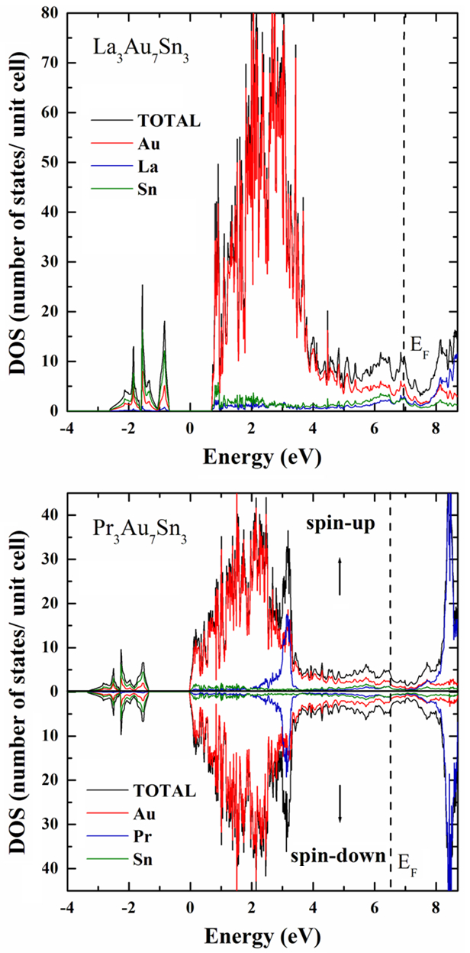
Figure 16. Total and site projected density-of-states (DOS) curves of the non-magnetic La₃Au₇Sn₃ (top) and the magnetic Pr₃Au₇Sn₃ (bottom) obtained from the VASP-based calculations; the Fermi level is represented by the dashed lines, while the spin-polarized DOS curve of Pr₃Au₇Sn₃ represents the antiferromagnetic model 1 (see text for detailed description).

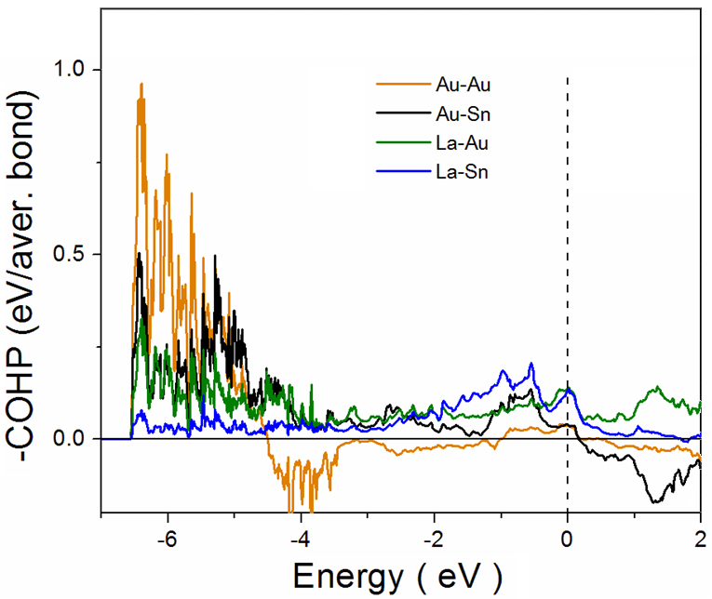

Figure 17. -COHP analysis for specific interactions in La₃Au₇Sn₃.

For table of contents only. Au₆Sn layers and triangular Ce network in the heavy fermion Ce₃Au₇Sn₃.
Supporting Information

Table S1. Atomic coordinates of Ce₃Au₇Sn₃ [Gd₃Au₇Sn₃-type (hP26, P6₃/m, No. 176)], as obtained from Rietveld refinement.

Atom | Wyckoff site | Crystallographic data |  |  | Occ.
Atom | Wyckoff site | x | y | z | Occ.
Ce | 6h | 0.29039(3) | 0.31666(4) | 1/4 | 1
Au1 | 2d | 2/3 | 1/3 | 1/4 | 1
Au2 | 12i | 0.35253(2) | 0.01765(2) | 0.09660(1) | 1
Sn1 | 4f | 1/3 | 2/3 | 0.03727(3) | 1
Sn2 | 2b | 0 | 0 | 0 | 1
a = 8.33173(4) Å, c = 9.53291(4) Å
R_{B} = 1.23 %, R_{F} = 2.03 %, R_{wp} = 8.49 %, χ² = 1.22, B_{over} = 0.33(1)

Table S2. Atomic coordinates of Sm₃Au₇Sn₃ [Gd₃Au₇Sn₃-type (hP26, P6₃/m, No. 176)], as obtained from Rietveld refinement.

Atom | Wyckoff site | Crystallographic data |  |  | Occ.
Atom | Wyckoff site | x | y | z | Occ.
Sm | 6h | 0.30072(2) | 0.32248(3) | 1/4 | 1
Au1 | 2d | 2/3 | 1/3 | 1/4 | 1
Au2 | 12i | 0.34944(1) | 0.01784(1) | 0.09555(1) | 1
Sn1 | 4f | 1/3 | 2/3 | 0.03853(2) | 1
Sn2 | 2b | 0 | 0 | 0 | 1
a = 8.21446(1) Å, c = 9.42933(2) Å
R_{B} = 0.91 %, R_{F} = 1.24 %, R_{wp} = 7.61 %, χ² = 1.18; B_{over} = 0.709(2)

Table S3. Atomic coordinates of Tb₃Au₇Sn₃ [Gd₃Au₇Sn₃-type (hP26, P6₃/m, No. 176)], as obtained from Rietveld refinement.

Atom | Wyckoff site | Crystallographic data |  |  | Occ.
Atom | Wyckoff site | x | y | z | Occ.
Tb | 6h | 0.30401(5) | 0.32702(6) | 1/4 | 1
Au1 | 2d | 2/3 | 1/3 | 1/4 | 1
Au2 | 12i | 0.34795(3) | 0.01878(2) | 0.09684(3) | 1
Sn1 | 4f | 1/3 | 2/3 | 0.04080(1) | 1
Sn2 | 2b | 0 | 0 | 0 | 1
a = 8.1720(1) Å, c = 9.4033(1) Å
R_{B} = 0.30 %, R_{F} = 0.38 %, R_{wp} = 4.64 %, χ² = 1.38, B_{over} = 1.32(3)

Table S4. Interatomic distances, multiplicities and –ICOHP/bond for selected interactions in La₃Au₇Sn₃.

Interaction | Distance [Å] | No. of bonds | −ICOHP/bond [eV/bond] | Interaction | Distance [Å] | No. of bonds | −ICOHP/bond [eV/bond]
Au-Au interactions |  |  |  | Au-La interactions
Au1-Au2 | 3.026 | 12 | 0.8037 | Au1-La3 | 3.023 | 6 | 0.7461
Au2-Au2 | 2.965 | 6 | 1.1335 | Au2-La3 | 3.093 | 12 | 0.7246
Au2-Au2 | 3.217 | 6 | 0.5558 | Au2-La3 | 3.151 | 12 | 0.6683
Au2-Au2 | 3.413 | 12 | 0.3276 | Au2-La3 | 3.274 | 12 | 0.5652
Au2-Au2 | 4.569 | 12 | −0.0153 | Au2-La3 | 3.333 | 12 | 0.5211
Au-Sn interactions |  |  |  | Sn-La interactions
Au1-Sn4 | 2.810 | 4 | 1.5663 | Sn4-La3 | 3.412 | 12 | 0.6149
Au2-Sn4 | 2.910 | 12 | 1.3599 | Sn4-La3 | 4.127 | 12 | 0.0948
Au2-Sn4 | 2.953 | 12 | 1.1316 | Sn5-La3 | 3.539 | 12 | 0.5582
Au2-Sn5 | 3.019 | 12 | 1.0991
Table S5. Differential thermal analysis data for the compounds R₃Au₇Sn₃ and compositionally related samples.

Sample  (nominal composition) | Thermal effects [°C]  (cooling at 10°C/min)
La₂₃Au₅₄Sn₂₃ | 1010 | 1000
La₃Au₄Sn₃ | 1073 | 960 | -
La₅Au₈Sn₅ | 1060 | 1010 | -
Nd₂₃Au₅₄Sn₂₃ | 1060 | 1055 | 1025
Sm₃Au₇Sn₃ | 1050 | 970 | 920
Y₃Au₇Sn₃ | 1085 | 925 | -
Ho₃Au₇Sn₃ | 1085 | 840 | -
Er₃Au₇Sn₃ | 1080 | 795 | -
Tm₃Au₇Sn₃ | 1065 | 785 | -
Lu₃Au₇Sn₃ | 1120 | 970 | 650

Figure S1. Observed X-ray powder patterns (red circles) and Rietveld refinement profiles (black line) for Ce₃Au₇Sn₃ (a), Sm₃Au₇Sn₃ (b) and Tb₃Au₇Sn₃ (c). The lower profile gives the difference between observed and calculated data (blue line); the Bragg angle positions are indicated by vertical bars (green).
Figure S2. La₃Au₇Sn₃ models on the basis of (a) Cu₁₀Sn₃ and (b) Au₁₀In₃ structure types. Au atoms are marked red, Sn and In – violet, and La – green.
Figure S3. Representations of spin orientations of the Pr-4f electrons for the antiferromagnetic Pr₃Au₇Sn₃ models: “Spin-up” Pr atoms are represented in red, whereas “spin-down” Pr atoms are marked in green. Intralayer as well as interlayer antiparallel ordering is evident for the AFM1 model (left), while all spins are aligned parallel within, but antiparallel between layers of the AFM2 model (right). The Au@Au₆ cages are encased by the layers of the Pr triangles T1 (z = ¾) and T2 (z = ¼) as well as Sn atoms, which have been omitted for the benefit of a clearer illustration.

Figure S4. Site and orbital projected density-of-states curves of the La₃Au₇Sn₃ obtained from VASP computations; the Fermi level is represented by dashed lines.

Figure S5. Spin-polarized, site as well as orbital projected density-of-states curves of Pr₃Au₇Sn₃ obtained from VASP computations; the Fermi level is represented by dashed lines.

Figure S6. Representation of the antiferromagnetic spin ordering model 1 (AFM1; top) for the layers of the praseodymium triangles: the spins are aligned in opposite directions within and between the T1 and T2 layers, respectively. “Spin-up” praseodymium atoms are highlighted in red, whereas “spin-down” Pr are represented by the green atoms. The trigonal-prismatic Au@Au₆ cages (yellow atoms) are enclosed by the Pr layers, while Sn atoms have been omitted for the benefit of a clearer illustration. Bottom: the major contributions of the “spin-up” states to the spin-polarized Pr PDOS clearly arises from the T1 layers, while the T2 layers predominantly contribute to the “spin-down” PDOS.

