High-Spectral-Resolution Lidar (HSRL)
Instrument Handbook
September 2025
R Bambha J Garcia
I Razenkov E Eloranta

DISCLAIMER
This report was prepared as an account of work sponsored by the U.S. Government. Neither the United States nor any agency thereof, nor any of their employees, makes any warranty, express or implied, or assumes any legal liability or responsibility for the accuracy, completeness, or usefulness of any information, apparatus, product, or process disclosed, or represents that its use would not infringe privately owned rights. Reference herein to any specific commercial product, process, or service by trade name, trademark, manufacturer, or otherwise, does not necessarily constitute or imply its endorsement, recommendation, or favoring by the U.S. Government or any agency thereof. The views and opinions of authors expressed herein do not necessarily state or reflect those of the U.S. Government or any agency thereof.
High-Spectral-Resolution Lidar (HSRL)
Instrument Handbook

R Bambha, University of Colorado-Boulder
J Garcia, University of Wisconsin-Madison (UW)
I Razenkov, UW
E Eloranta, UW

September 2025

How to cite this document:

Bambha, R, J Garcia, I Razenkov, and E Eloranta. High-Spectral-Resolution Lidar (HSRL) Instrument Handbook. U.S. Department of Energy, Atmospheric Radiation Measurement user facility, Richland, Washington. DOE/SC-ARM-TR-157.

Work supported by the U.S. Department of Energy,
Office of Science, Office of Biological and Environmental Research

Acronyms and Abbreviations
ACAPEX ARM Cloud Aerosol Precipitation Experiment
AMF ARM Mobile Facility
AMIE ARM Madden-Julian Oscillation Investigation Experiment-Gan Island
ARM Atmospheric Radiation Measurement
BAECC Biogenic Aerosols-Effects on Clouds and Climate
BNF Bankhead National Forest
DFB distributed-feedback
FOV field of view
GCSS GEWEX Cloud System Study
GEWEX Global Energy and Water Exchanges
GPCI GCSS/WGNE Pacific Cross-Section Intercomparison
HSRL high-spectral-resolution lidar
MAGIC Marine ARM GPCI Investigation of Clouds
MOSAiC Multidisciplinary drifting Observatory for the Study of Arctic Climate
MPL micropulse lidar
NSA North Slope of Alaska
RL Raman lidar
SAIL Surface Atmosphere Integrated Field Laboratory
SGP Southern Great Plains
STORMVEX Storm Peak Lab Cloud Property Validation Experiment
UTC Coordinated Universal Time
UW University of Wisconsin-Madison
WGNE Working Group on Numerical Experimentation

Contents
Acronyms and Abbreviations iii
1.0 Instrument Description 1
1.1 Technical Specifications 1
1.2 Instrument/Measurement Theory 2
2.0 Data 3
2.1 Data Description 3
2.2 Data Quality and Uncertainty 3
2.3 Examples of Data 4
3.0 Historical Background 5
3.1 2019 Upgrade of the NSA HSRL (HSRL1) 6
3.2 2021 Upgrade of the AMF2 HSRL (HSRL2) 6
3.3 2025 Completion of HSRL3 6
4.0 Maintenance Plan 6
5.0 User Notes and Known Issues 7
6.0 Citable References 7

Figures
- The modeled spectrum of the combined molecular and aerosol signal. 3
- (top) Plot of backscatter coefficient at 532 nm and (bottom) ratio of backscatter cross-sections, 1064nm/532 nm, taken on February 10, 2024 at the ARM SGP site. 4
- Range-height indicator plots of data taken at the ARM SGP site on February 10, 2024, during a period contained in the plots in Figure 2, 18:00-19:00 UTC. 5

Tables
- General specifications for the ARM HSRLs. 1
- ARM HSRL locations/campaigns. 5

Instrument Description
High-spectral-resolution lidar (HSRL) systems provide vertical profiles of optical depth, extinction coefficient, backscattering coefficient, and depolarization. All HSRL measurements are calibrated by reference to molecular scattering, which is measured at each point in the lidar profile. Like the Raman lidar (RL), but unlike simple backscatter lidars such as the micropulse lidar (MPL), this enables the HSRL to measure backscatter coefficients and optical depths without prior assumptions about the scattering properties of the atmosphere. The depolarization observations allow robust discrimination between ice and water clouds. Rigorous error estimates can be computed for all measurements. A very narrow angular field of view reduces multiple scattering contributions. The small field of view, coupled with a narrow optical bandwidth, nearly eliminates noise due to scattered sunlight.
The laser transmitter is a diode-pumped, Nd:YAG laser operating at its fundamental wavelength, 1064 nm, and frequency-doubled wavelength, 532 nm. Narrow-band, single-frequency operation is provided by injection seeding with a single-frequency, cw distributed-feedback (DFB) laser. The main laser cavity is maintained in resonance with the seed laser by adjusting the cavity length to minimize the time between the Q-switch trigger and the emission of the laser pulse. The emission wavelength is tuned via temperature control of the seed laser crystal and is locked to line #1109 of the iodine absorption spectra. Locking is accomplished by minimizing the transmission through a 10-cm-long iodine absorption cell. Use of a high-repetition-rate laser and expansion of the transmitted beam through a 400-mm telescope reduces the transmitted energy density to eye-safe levels. It is possible to look directly into the output beam without hazard.
The receiver and transmitter use the same afocal telescope, simplifying the maintenance of stable alignment of the transmitter and receiver although the angular FOV is only 100 μrad. The small FOV and the 4-kHz repetition rate also limit the near-field signal strength, making it possible to record continuous profiles that start at an altitude of ~100 m and extend to 30 km using photon counting detectors. The small FOV also suppresses multiple scattering contributions. The instrument is also equipped with a 700 μrad wide-field-of-view receiver that provides the measurements used to generate the instrument overlap function for the narrow-field-of-view channels.

Technical Specifications
The U.S. Department of Energy Atmospheric Radiation Measurement (ARM) User Facility’s HSRLs were developed by the team at the University of Wisconsin led by Ed Eloranta, and the UW team has been refining the instrument design since the early 1980s. The original versions of the ARM HSRLs transmitted a single wavelength at approximately 532 nm locked to line 1109 of iodine, and the receiver had a single field of view. Upgrades added wide-field-of-view detection, transmission and reception at 1064 nm, and scanning capability. The general specifications for the ARM HSRLs are given in Table 1.
Table 1. General specifications for the ARM HSRLs.
Power and wavelength transmitted (late 2020) | ~400 mw at 532 nm
Power and wavelength transmitted (late 2020) | ~170 mW at532nm; ~400 mW at 1064 nm
Laser pulse duration | 40 ns
Repetition rate | 4 kHz
Receiver field of view, narrow | 100 microradians
Region of geometrical overlap, narrow FOV | ~6km and above
Receiver field of view, wide | 700 microradians
Region of geometrical overlap, wide FOV | ~575m and above
Receiver aperture | 40 cm
Receiver spectral bandpass @ 532nm | ~ 8 GHz (pressure-tuned etalon)
Aerosol blocking filter bandwidth @ 532nm | 1.8 GHz (line 1109 of iodine spectrum)
Receiver spectral bandpass @ 1064nm | ~ 7 GHz (thermally tuned etalon)
Aerosol blocking filter bandwidth @ 1064nm | 1.5 GHz (FSR of Michelson Interferometer for HSRL2)
Detection mode | Photon counting
Range resolution | 7.5 m (50 nsec bin width)
Altitude range recorded | 0 to 30km
Typical time resolution | 2.5 s (programable)

Instrument/Measurement Theory
Two primary optical mechanisms are responsible for the production of a lidar signal: backscatter of the laser beam by particles (including molecules), and attenuation of the laser beam before it reaches the backscatter region and of the backscattered light before it is detected. Thus at least two measurements must be made in order to determine these two atmospheric unknowns (attenuation and backscatter coefficients). A simple backscatter lidar only provides one measurement, and thus it is necessary to assume a functional dependence of these two unknowns (for example the Klett method). The HSRL method avoids the need to make this assumption by the use of two measured profiles instead of just one. This method uses the Doppler frequency shifts produced when photons are scattered from molecules in random thermal motion. The Maxwellian distribution of molecular velocities has a width of ~300m/s that produces Doppler shifts of ~1 GHz. In contrast, aerosols, cloud particles, and other particulate matter move with velocities determined by the wind (~10m/s) and turbulence (~1m/s), producing Doppler shifts of ~30 MHz and ~3 MHz, respectively. As a result, the frequency distribution of light backscattered from the atmosphere consists of a narrow spike near the frequency of the laser transmitter caused by particulate scattering riding on a much broader distribution produced by molecular scattering (see Figure 1).
Figure 1. The modeled spectrum of the combined molecular and aerosol signal.

Data

Data Description
The fundamental measurements obtained by the HSRL are the photon counts per laser shot per 50 ns time bin (7.5 m range bin) in the molecular return, co-polarized combined aerosol and molecular return, and cross-polarization channels. As presented in the equations in section 1, the backscatter coefficient is derived from ratios of HSRL molecular and particulate channels, cancelling out range-sensitive instrumental artifacts and thereby eliminating the primary systematic effects associated with the lidar.

Data Quality and Uncertainty
Because the HSRL data system is photon counting not analog detection, the noise characteristics can be treated as having Poisson characteristics and can be directly quantified. Application of the standard propagation-of-error methods to the (Poisson) statistical uncertainties calculated for the primary lidar measurements (photon counts) can be used to derive their uncertainties. In order to reduce uncertainties to acceptable values, the photon counts can be summed in time (by adding values from multiple laser shots for the same range bin) and/or in space (by adding counts in adjacent range bins for the same laser shot) at the expense of temporal and/or spatial resolution. Temporal averaging can also result in systematic biases as the relationship between the photon counts and derived products is nonlinear; those sums are applied before calculating the derived backscatter coefficient and/or depolarization values.
Atmospheric extinction is derived from the slope of the molecular backscatter return alone. As a result, extinction is more sensitive to noise and requires significantly longer averaging intervals compared to the backscatter-coefficient measurement. Additionally, because the extinction is derived from a single channel, as opposed to a ratio of channels, the extinction is more sensitive to systematic uncertainties such as the lidar overlap function.

Examples of Data
Figure 2 and 3 show data collected at the ARM Southern Great Plains (SGP) site using HSRL1. These plots show some of the features that can be observed using dual wavelength operation and near-zenith scanning. Figure 2 displays conditions under which the differences in the backscatter coefficients at
532 nm and 1064 nm reveal differences in the size distributions of the particles at different times and altitudes. Figure 3 shows the effect of scan angle on the backscatter depolarization at 532 nm from aligned ice particles.
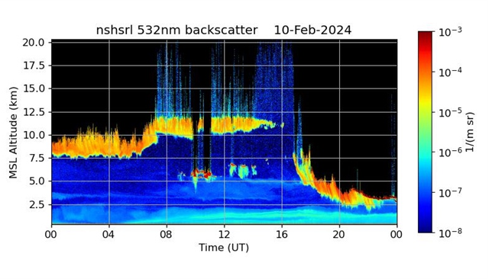
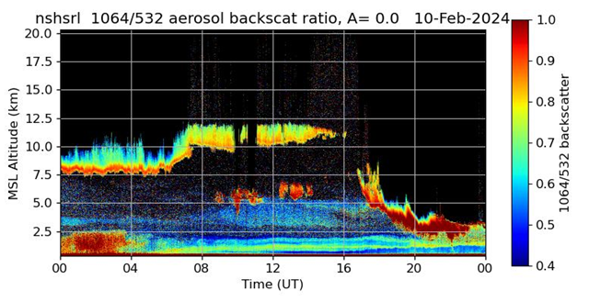
Figure 2. (top) Plot of backscatter coefficient at 532 nm and (bottom) ratio of backscatter
cross-sections, 1064nm/532 nm, taken on February 10, 2024 at the ARM SGP site. The color ratio shows evidence for size-dependent backscatter of the aerosol. These plots were constructed from data with the instrument scanning in elevation around zenith using data taken at angles outside the range, -3º to +3º , to avoid specular reflections from aligned ice particles.
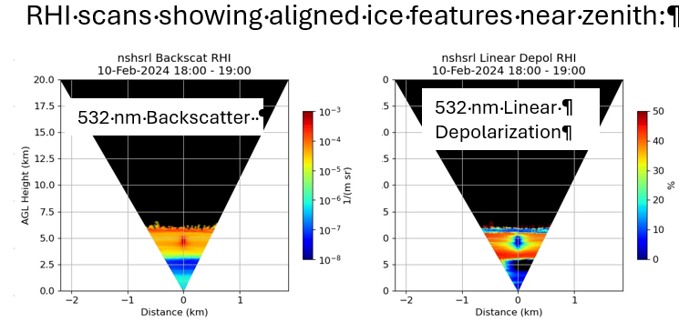
Figure 3. Range-height indicator plots of data taken at the ARM SGP site on February 10, 2024, during a period contained in the plots in Figure 2, 18:00-19:00 UTC. The plots show evidence for aligned ice particles. The left-hand plot shows an enhancement in backscatter near zenith at 532 nm, while the right-hand plot shows a suppression of depolarization near zenith at
532 nm.

Historical Background
The ARM User Facility initially deployed one HSRL with the second ARM Mobile Facility (AMF2) and one at the ARM North Slope of Alaska (NSA) site. The first two instruments transmitted circularly polarized light at a single wavelength, 532 nm, and employed quarter wave plates to separate co- and cross-polarized returns.
Table 2. ARM HSRL locations/campaigns.
HSRL 1
Beginning | End | Campaign | Location
11/15/2010 | 4/25/2011 | STORMVEX | Steamboat Springs, Colorado
8/20/2020 | 5/12/2021 | SGP | SGP (Optical Trailer)  36.60519, -97.48571
7/16/2021 | 6/16/2023 | SAIL | Gothic, Colorado
1/30/2024 | present | SGP | SGP (optical trailer)
HSRL 2
Beginning | End | Campaign | Location
11/15/2010 | 4/25/2011 | STORMVEX | Steamboat Springs, Colorado
10/1/2011 | 3/31/2012 | AMIE | Gan Island, Maldives
10/01/12 | 9/30/2013 | MAGIC | Voyage, Los Angeles to Hawaii
2/1/2014 | 9/13/2014 | BAECC | Hyytiälä, Finland
1/12/2015 | 2/12/2015 | ACAPEX | Voyage, Hawaii to San Diego
10/5/2019 | 10/1/2020 | MOSAiC | Arctic
3/10/2025 | present | BNF | BNF, Alabama

2019 Upgrade of the NSA HSRL (HSRL1)
Between July 2019 and August 2020, the NSA HSRL received significant upgrades at the University of Wisconsin. Several major changes to the transmitter and receiver were made: transmission at 1064 nm in addition to 532 nm, reception of 1064 nm backscatter for combined molecular and aerosol returns, reconfiguration of the polarization optics to transmit and detect linearly polarized light, and addition of
532-nm wide-field-of-view channels to reduce the height of complete overlap of the transmitter and receiver. Additionally, a short-range, elevation scanning capability was added that allows the instrument to be scanned over the zenith direction and measure angular dependence of backscatter and depolarization from aligned ice particles. These upgrades added variables to the HSRL data set corresponding to the new capability. A noteworthy modification to the set of variables prior to the upgrade was the discontinuation of circularly polarized measurements and the replacement of these quantitates with their linearly polarized analogs.

2021 Upgrade of the AMF2 HSRL (HSRL2)
After its deployment to the MOSAiC campaign that ended in October 2020, the HSRL associated with AMF2 was sent to University of Wisconsin for upgrades. The set of upgrades for this instrument included all the upgrades listed above for HSRL1 plus a molecular channel at 1064 nm. HSRL2 employs a
field-widened Michelson interferometer to separate molecular and aerosol contributions to backscatter at 1064 nm. The first deployment of HSRL2 with the new 1064-nm HSRL capabilities was to the Bankhead National Forest (BNF) site in Alabama in March 2025.

2025 Completion of HSRL3
Construction of a third HSRL by University of Wisconsin was completed in 2025. This entirely new instrument is functionally equivalent to HSRL2 with only minor hardware differences. During the construction of HSRL3, the instrument shelter at the ARM NSA site was modified to accept the larger size and scanning capability of HSRL3.

Maintenance Plan
The HSRL instruments require minimal maintenance beyond regular cleaning of their shelter window. Weekly inspection and possible cleaning of the window is recommended. The laser coolant level should be checked monthly but typically requires no maintenance.
The calibration of the HSRLs has three major components: calibration using radiosonde inputs, measurement of the receiver’s transmission spectrum, and a correction for the internally scattered light. Vertical profiles of temperature and pressure measured by a radiosonde are used to determine the expected backscatter as a function of range from clear air. These radiosonde-derived expected backscatter profiles serve as a calibration source for the molecular channels, and that calibration is updated at the frequency of the available radiosondes. Alternatively, an atmospheric model can be used to supply a priori knowledge of the atmospheric density profile, but co-located radiosonde measurements are generally preferred. The internal calibrations of the spectroscopic filters are performed automatically on a daily basis and are used to correct the data for changes in the receiver’s transmission spectrum. Characterization of the baselines for all of the receiver channels is performed on a monthly basis by blocking the telescope for a prescribed period while the instrument is running. The baselines for the channels are the components of measurements that are independent of atmospheric backscatter.

User Notes and Known Issues
The extinction measurements from the HSRLs are much more sensitive to systematic effects such as drifts in the geometric overlap than HSRL backscatter measurements. Measurements under clear-sky conditions are used to correct drifts in the geometric overlap and detector after-pulsing. Extended periods of cloudy or aerosol-laden conditions can reduce the frequency of updates to the corrections and their effectiveness.
Data taken with the HSRL on AMF2 prior to 2019 were influenced by alignment drift correlated with humidity. The impact was primarily in the stability of the boundary-layer extinction coefficient estimates from the narrow FOV channel.

Citable References
Ackerman, SA, RE Holz, R Frey, EW Eloranta, B Maddux, and M McGill. 2008. “Cloud Detection with MODIS: Part II Validation.” Journal of Atmospheric & Oceanic Technology 25(7): 1073–1086, https://doi.org/10.1175/2007JTECHA1053.1
Bourdages, L, TJ Duck, G Lesins, JR Drummond, and EW Eloranta. 2009. “Physical properties of High Arctic tropospheric particles during winter.” Atmospheric Chemistry and Physics 9(18): 6881–6897, https://doi.org/10.5194/acp-9-6881-2009
de Boer, G, GJ Tripoli, and EW Eloranta. 2008. “Preliminary comparison of CloudSAT-derived microphysical quantities with ground-based measurements for mixed-phase cloud research in the Arctic.” Journal of Geophysical Research – Atmospheres 113(D8): D00A06, https://doi.org/10.1029/2008JD010029
de Boer, G, EW Eloranta, and MD Shupe. 2009.“Arctic Mixed-Phase Stratiform Cloud Properties from Multiple Years of Surface-Based Measurements at Two High-Latitude Locations.” Journal of the Atmospheric Sciences 66(9): 2874–2887, https://doi.org/10.1175/2009JAS3029.1
Eloranta, EW. 2005. High Spectral Resolution Lidar in Lidar: Range-Resolved Optical Remote Sensing of the Atmosphere. Klaus Weitkamp editor, Springer Series in Optical Sciences, Springer-Verlag, New York.
Holz, R.E. 2002. Measurements of cirrus backscatter phase functions using a high-spectral-resolution lidar. Master’s Thesis, University of Wisconsin-Madison.
Klein, SA, R McCoy, H Morrison, A Ackerman, A Avramov, G de Boer, M Chen, J Cole, AD DelGenio, M Falk, M Foster, A Fridlind, J-C Golaz, T Hashino, J Harrington, C Hoose, M Khairoutdinov, V Larson, X Liu, Y Luo, G McFarquhar, S Menon, R Neggers, S Park, K von Salzen, JM Schmidt, I Sednev, B Shipway, M Shupe, D Spangenberg, Y Sud, D Turner, D Veron, G Walker, Z Wang, A Wolf, S Xie,
K-M Xu, F Yang, and G Zhang. 2009.” Intercomparison of model simulations of mixed-phase clouds observed during the ARM Mixed-Phase Arctic Cloud Experiment. Part I: Single layer cloud.” Quarterly Journal of the Royal Meteorological Society 135(641): 823–1094, https://doi.org/10.1002/qj.416
Lesins, G, L Bourdages, TJ Duck, EW Eloranta, J Drummond and VP Walden. 2009. “Large surface radiative forcing from tropospheric blowing snow residuals measured in the High Arctic at Eureka.” Atmospheric Chemistry and Physics 9(6): 1847–1862, https://doi.org/10.5194/acp-9-1847-2009
McMillian, WW, JX Warner, M McCourt Comer, E Maddy, A Chu, L Sparling, E Eloranta, R Hoff, G Sachse, C Barnet, I Razenkov, and W Wolf. 2008. “AIRS views transport from 12-22 July 2004 Alaskan/Canadian fires: Correlation of AIRS CO and MODIS AOD with forward trajectories and comparison of AIRS CO retrievals with DC-8 in situ measurements during INTEX-A/ICARTT.” Journal of Geophysical Research – Atmospheres 113(D20): D20301, https://doi.org/10.1029/2007JD009711
O'Neill, NT, O Pancrati1, K Baibakov1, E Eloranta, RL Batchelor, J Freemantle, LJB McArthur, K Strong, and R Lindenmaier. 2008. “Occurrence of weak, sub-micron, tropospheric aerosol events at high Arctic latitudes.” Geophysical Research Letters 35(14): L14814, https://doi.org/10.1029/2008GL033733
Shupe, MD, P Kollias, M Poellot, and E Eloranta. 2008. “On Deriving vertical Air Motions from Cloud Radar Doppler Spectra.” Journal of Atmospheric & Oceanic Technology 25(4): 547–557, https://doi.org/10.1175/2007JTECHA1007.1
Shupe, MD, JS Daniel, G de Boer, EW Eloranta, P Kollias, E Luke, CN Long, D Turner, and J Verlinde. 2008. “A Focus on Mixed-Phase Clouds: The Status of Ground-Based Observational Methods” Bulletin of the American Meteorological Society 89(10): 1549–1562, https://doi.org/10.1175/2008BAMS2378.1
Tenti, G, CD Boley, and RC Desai. 1974. “On the kinetic model description of Rayleigh–Brillouin scattering from molecular gases.” Canadian Journal of Physics 52(4), 285–290, https://doi.org/10.1139/p74-041
Turner, DD, and EW Eloranta. 2008. “Validating Mixed-Phase Cloud Optical Depth Retrieved from Infrared Observations with High Spectral Resolution Lidar.” IEEE Geoscience and Remote Sensing Letters 5(2): 285–288, https://doi.org/10.1109/LGRS.2008.915940

