Second and final report
Program Scope

The goal of our research was to gain deeper insight into the collective electron dynamics in nanosystems in strong, ultrashort laser fields. The laser field strengths will be strong enough to extract and accelerate electrons from the nanoparticles and to transiently modify the materials electronic properties. We aimed to observe, with sub-cycle resolution reaching the attosecond time domain, how collective electronic excitations in nanoparticles are formed, how the strong field influences the optical and electrical properties of the nanomaterial, and how the excitations in the presence of strong fields decay. The project ended with the move of the PI to the Ludwig-Maximilians-Universität (LMU) in Munich, Germany.

Accomplishments during the last reporting period (04/01/2013 – 08/31/2013)

Electron motion in condensed matter driven by intense light waves in the visible spectrum can proceed on attosecond timescales, where the propagation of electrons is restricted to nanometer dimensions. Laser pulses with well-defined electric field waveforms provide an ideal tool for manipulating this motion and offer unique spatio-temporal control on nanometer spatial and attosecond temporal scales. Consequently, the application of such laser fields to nanostructured materials has a high potential for the control of ultrafast, nonlinear processes on the nanoscale, with important implications for enhancing laser-driven electron acceleration, and the design of lightwave-driven electronic devices for information processing in optical communication.

The electric field of a laser pulse consisting of only a few optical cycles can be described as E(t) = E₀(t)cos(ωt+φ), where E₀(t) is the amplitude envelope function, ω the angular frequency of the carrier wave, and φ the carrier-envelope phase (CEP). The field evolution of such ultrafast laser fields critically depends on the value of the CEP. In the reporting period, we have employed such pulses to steer the collective electron motion in neutral C₆₀ and probe the electronic wave packet via strong-field ionization. The C₆₀ studies were performed by MSc student Hui Li in collaboration with the Max Planck Institute of Quantum Optics (MPQ) in Garching, Germany and a number of other groups from Europe participated in the experiments and their interpretation.

After extensive theory work, our studies on employing sub-wavelength nanofocusing to tailor the controlled photoemission from dielectric nanoparticles have been completed. We were able to demonstrate symmetry breaking and directional controllability of the carrier-envelope-phase dependent emission of recollision electrons due to the propagation-induced near-field deformation. We could show that the directionality of the photoemission remains largely unaffected by local field ellipticity and nonlinear many-particle charge interaction, even if the latter results in a significant boost of the final electron energies. The results indicate the possibility to expand attosecond nanoscience far into the realm of ultrafast high-field phenomena.

We have furthermore devised a new experimental setup for nanoparticle studies at the J.R. Macdonald Laboratory (JRML) using aerosol techniques for the injection of the particles into vacuum. The setup has been employed in velocity-map imaging studies on metal nanoparticles of different sizes. The nanoparticles were synthesized in-house by PhD student Jeff Powell, who also performed the measurements. After the end of this grant and move of the PI, this line of research has been locally continued by Prof. Artem Rudenko (in collaboration with the PI). First data resulting from these ongoing investigations are shown below. They form the basis for potential nanoplasmonic streaking investigations on metal nanoparticles in the future.

Finally, the design of lightwave-driven electronic devices for information processing in optical communication requires applying the same principles to surface systems. As a preparatory step in this direction, we have collaborated locally with Profs. Bret Flanders and Carlos Trallero-Herrero to investigate the damage threshold of gold nanowires in femtosecond laser fields. The optical setup was built by two undergraduate students, Adam Ramm and Adam Summers, one of which was employed under this grant.

- Attosecond control of electron emission from C₆₀
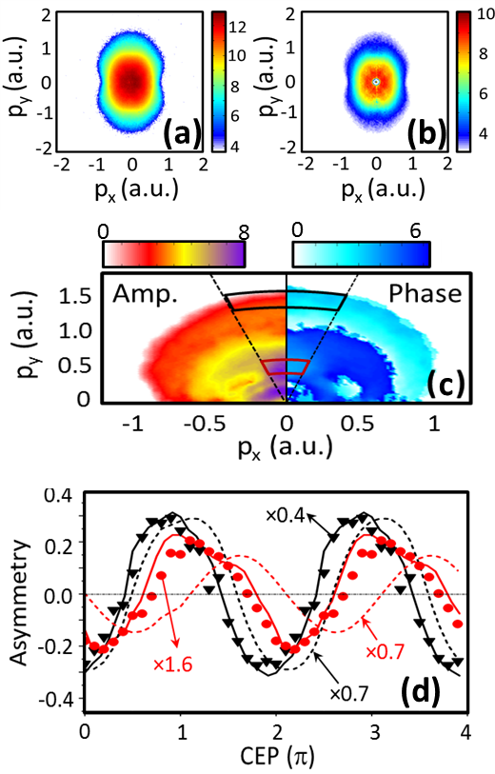
Fullerenes are nanometer size systems with interesting physical properties, including high polarizability, super-atomic molecular orbitals with macro-atom behavior, large photoionization cross sections, and efficient high-harmonic generation. The ionization and fragmentation of C₆₀ have been investigated extensively in the past. C₆₀ is very stable and is one of the few molecular systems for which the ionization energy is smaller than the lowest fragmentation threshold. Therefore it is an ideal system for probing electronic dynamics, and, when suitably excited, the electronic density oscillates on a nanometer scale. Moreover, in the experiments reported here, the pulse duration is short enough to avoid significant thermionic emission that occurs for longer pulse durations of hundreds of femtoseconds to nanoseconds.

We measured photoionization patterns of C₆₀ induced by a 4 fs, CEP-controlled pulse at 720 nm that is linearly or circularly polarized with the same field strength, corresponding to an intensity, I, of (6.5±0.5)×10¹³ W cm⁻² and (1.3±0.1)×10¹⁴W cm⁻², respectively [Li et al., 2014]. For these intense and ultrashort pulses, both the electronic wave packet dynamics and the ionization are induced by the same pulse. Since the pulse is ultrashort (less than two cycles), the motion of the nuclei can be considered negligible during the pulse and therefore purely electronic dynamics are controlled and probed. Furthermore, the angular distribution of the photoelectrons is synchronized with the transient electronic dynamics induced by the pulse. This is unlike multi-cycle pulses, for which the thermionic emission would lead to a more isotropic angular distribution. Figure 1 shows experimental data recorded for linear polarization. In particular, we show the recorded and inverted VMI image in Fig. 1(a) and (b) and derive from the CEP-dependent oscillation of the signal the CEP-dependent amplitude and phase depicted in Fig. 1(c). The emission up to 0.6 a.u. originates from direct electron emission, while higher momenta involve rescattering. The regions marked in red (direct) and black (rescattering) have been integrated and are shown in Fig. 1(d) as a function of CEP.
Figure 1: (a,b) Electron emission from C₆₀ recorded with the VMI (a) and inverted image (b). (c) The amplitude and phase of the asymmetry of the electron emission in polarization direction. (d) Integrated asymmetries in the direct (red) and rescattering region (black): measured (symbols), QD (solid lines) and MC (dashed lines) simulations.

Our interpretation of the angularly-resolved ionization patterns is supported by high level quantum dynamical (QD) and classical Monte Carlo (MC) simulations (shown as solid and dashed lines in Fig. 1(d)). For electrons with high momenta, rescattering is the dominant process. In this regime, both QD and MC simulations provide a good description of the process, where laser-field driven electron motion after ionization dominates. For low-momentum electrons, we find excellent agreement with the QD simulations, while the MC results exhibit a pronounced phase shift indicating that the direct emission is more complex. Based on the QD simulations, we interpret the results as follows: the direct electron angular distribution carries information on the coherently excited wave packet in the molecule. In particular, we find that for these electrons the maxima and minima of the photoionization-asymmetry parameter reflect the instantaneous localization of the coherent electronic wave packet. A manuscript containing these results has recently been submitted.

- Attosecond photoemission tailored by sub-wavelength nanofocussing in dielectrics
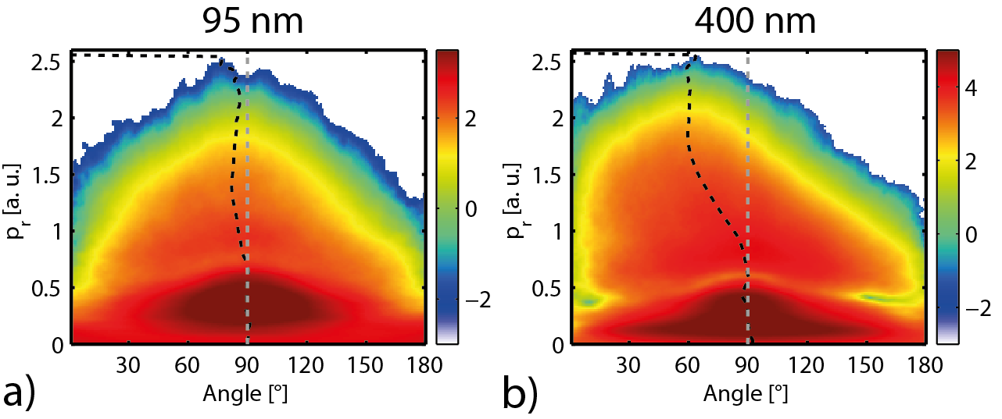
The possibility of full spatiotemporal control of near-fields opens up striking new perspectives in strong-field nanoscience. First, near-field enhancement and ellipticity profiles tailored via the nanostructure geometry can be exploited to manipulate electronic strong-field dynamics. Second, employing unsupported reproducible nanosystems, such as nanodroplets, nanojets, and gasphase nanoparticles, enables the detailed exploration and harnessing of the resulting attosecond near-field control even under high-intensity laser fields required for laser-based high-energy particle acceleration and XUV light generation via surface high harmonic emission. We addressed both aspects by investigating the nanofocussing induced directionality of near-field driven photoemission from isolated dielectric nanospheres. Exposing isolated nanospheres to few-cycle pulses with known carrier-envelope phase (CEP) offers a fundamental route to generate well-controlled near-fields, whose linear response structure is accurately described by the Mie solution.
Figure 2: a) Radial plot of the CEP dependent photoemission from 95 nm diameter SiO₂ sphere at a peak intensity of 3.7×10¹³ W/cm². b) Same plot for a diameter of 400 nm at 2.8x10¹³ W/cm².

In the experiments we utilized velocity-map imaging to study the angle-resolved electron photoemission from SiO₂ nanospheres with diameters d = 50 – 550 nm. The photoelectron dynamics was controlled by the CEP of 4 fs intense few-cycle laser fields at 720 nm central wavelength [Süßmann et al., 2014]. Strong near-field induced symmetry breaking of the photoemission is revealed by the pronounced asymmetry of the measured CEP-averaged angular-resolved photoelectron momentum maps in Fig. 2. For small, 95 nm diameter, nanoparticles (Fig. 2(a)) the photoemission peaks close to the laser polarization direction (dashed grey line). For particles with diameters approaching the laser wavelength, here 400 nm in Fig. 2(b), the electrons close to the cutoff show a pronounced asymmetry with respect to the laser propagation direction (right to left in Fig. 2). Comparing the angle at which the photoionization peaks close to the cutoff to Mie-theory calculations, we conclude, that the observed size-dependent directionality of the strong-field photoemission from nanospheres directly relates to the deformed near-field. Our results thus demonstrate feasibility of the real-space modification of phase-controlled strong-field phenomena via active near-field synthesis, where nanofocussing can be exploited systematically to shape the near-field. The analysis reveals the dominance of the radial field driven recollision dynamics for the directionality and phase dependence of the photoemission up to large sizes with substantial near-field ellipticity.

- Strong-field electron emission from metal nanoparticles

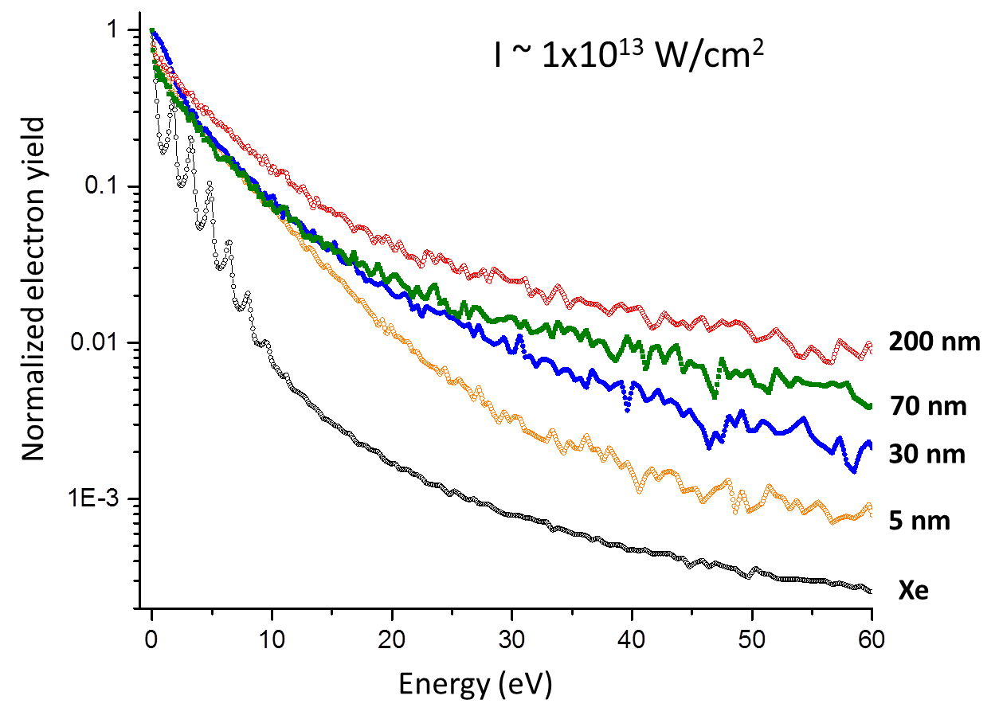
In summer 2013 we have successfully commissioned a new aerosol nanoparticle source at JRML. The source can be operated in conjunction with a velocity-map imaging setup dedicated for recording the electron or ion emission from isolated nanoparticles in strong fields. The new source is currently being used to measure the photoemission from gold nanoparticles with different diameters that are produced in-house by PhD student Jeff Powell, who now works under the joint supervision of Prof. Artem Rudenko and Prof. Chris Sorensen, a local expert in nanoparticle fabrication and characterization through light scattering. The main obstacle in studying metal nanoparticles as compared to SiO₂ is the density of the particles in the laser focus, which is significantly lower (by about a factor of 10-100). In order to clearly distinguish the sparse laser shots where a nanoparticle was ionized from those, where just background gas was ionized, the VMI was equipped with a single-shot CMOS camera (lend by Prof. Vinod Kumarappan). Using the event rate in these single-shot images permits to sort out the nanoparticle hits and achieve a reasonable signal-to-background ratio in the measurements. Our joint research currently goes in a few directions: studying the electron yield from gold nanoparticles as a function of size and potentially position within the focus and understanding how the dynamics evolves as a function of laser intensity.
Figure 3: Normalized electron yield from Au nanoparticles of different diameters as a function of kinetic energy. The data is compared to Xe under the same laser conditions.
Figure 3 shows preliminary data currently collected. The normalized electron yield from Au nanoparticles with different diameters is shown for the same laser conditions (about 25 fs pulse duration and intensity around 1×10¹³ W/cm²). Further data acquisition and analysis is underway.

- Damage threshold studies on gold nanowires
Ultrafast nanoscale circuitry relies on the ability to utilize the non-linear interaction of light with nanoscale materials in order to control (collective) electron motion on a sub-optical-cycle timescale. These non-linear regimes are reached for strong laser pulses with intensities typically just below the damage threshold of the materials. Such interactions give rise to (sub-optical cycle) electron emission and acceleration from isolated nanotips, nanospheres, and nanostructured surfaces. These interactions also can include the semi-metallization of dielectrics and metals, and drive currents across nanoscale junctions. In all of these cases, the highest laser intensity that can be applied to the material depends on the material composition and quality and the pulse duration. The exact reasons for damage of nanoscale materials are therefore often not well understood. We studied the melting of conducting, single-crystalline nanowires, which are one of the building blocks of nanoscale circuitry, under the illumination of femtosecond light fields with different intensities and pulse durations. Two types of nanowire arrangements are investigated: (1) free-standing Au nanowires that are grown on W needle electrodes and (2) Au nanowires attached to silica slides.
Some of our main experimental results are shown in Fig. 4 (further details and the theoretical modeling are contained in the paper [Summers et al., 2014]). The number of samples that were damaged at a given peak laser intensity is provided in a histogram representation. Perhaps the most dramatic aspect of these measurements is the very high intensities at which the nanowires are found to survive. With average damage thresholds ranging from a few TW/cm² to above 10 TW/cm² for the respective cases, it is suspected that Au nanowires survive well into the optical strong-field regime. In addition to this result, a clear distinction in optical damage threshold between the 32 fs and 108 fs cases can be seen for both wires grown on tungsten needles and on gold coated silica slides. The damage threshold for both cases was higher for 32 fs pulses than for 108 fs pulses. This corresponds to a factor of 2.4±0.7 for free-standing nanowires and a factor of 2.7±0.6 for the wires attached to fused silica substrates, where the uncertainty is due to the spread in the measured damage threshold. In contrast to this peak intensity picture the energy per pulse at which damage occurs varies only modestly between all four cases. By extrapolating our results to 5 fs pulses, we speculate that, peak intensities of 50 TW/cm² may be attained before melting occurs. We conclude that ultrashort light pulses permit studies in the non-linear regime, with many new opportunities for applications towards ultrafast light-driven nanoelectronics.
Figure 4: Measured optical damage threshold distribution as a function of intensity for (a)
108 fs pulses and nanowires on fused silica slides, (b) 32 fs pulses and nanowires on fused
silica slides, (c) 108 fs pulses and free standing nanowires on tungsten electrodes, and (d)
32 fs pulses and free standing nanowires on tungsten electrodes.

List of papers (published, submitted since April 1st, 2013)

- Optical damage threshold of Au nanowires in strong femtosecond laser fields, A.M. Summers, A.S. Ramm, G. Paneru, M.F. Kling, B.N. Flanders, C.A. Trallero-Herrero, Opt. Exp. 22, 4235-4246 (2014).

The JRML personnel acknowledges support by the U.S. Department of Energy under DE-FG02-86ER13491. M.F.K. acknowledges support by the U.S. Department of Energy under DE-SC0008146 and partial support by the DFG via the Cluster of Excellence: Munich Center for Advanced Photonics (MAP). The authors thank Kevin Carnes for critically reviewing the manuscript prior to submission, and Larry Weaver for much appreciated theoretical assistance. The authors also thank Prem S. Thapa from the Imaging and Analytical Microscopy Lab, University of Kansas, Lawrence, KS for his help in taking the SEM images of the nanowires.

- Attosecond controlled photoemission tailored by sub-wavelength nanofocussing, F. Süßmann, L. Seiffert, S. Zherebtsov, V. Mondes, J. Stierle, M. Arbeiter, J. Plenge, P. Rupp, C. Peltz, A. Kessel, S.A. Trushin, B. Ahn, D. Kim, C. Graf, E. Rühl, M.F. Kling, T. Fennel, submitted.
We acknowledge support from and fruitful discussions with Ferenc Krausz. We are grateful for support by the DFG via SPP1391. We acknowledge partial support via the Max Planck Society, the DFG Cluster of Excellence: Munich Center for Advanced Photonics (MAP), the BMBF via the project PhoNa (Photonische Nanomaterialien) and by the EU via the ERC grant ATTOCO and the training network ATTOFEL. M.F.K. acknowledges personal support by the DFG via Kl-1439/5 and by the U.S. Department of Energy under DE-SC0008146. T.F. acknowledges computing time provided by the north-german supercomputing center HLRN (project ID mvp00004) and financial support by the DFG via SFB652/3. B.A. and D. K. acknowledge support from National Research Foundation of Korea (NRF) funded by Ministry of Science, ICT & Future Planning via Global Research Laboratory Program [Grant No 2009-00439] and Max Planck POSTECH/KOREA Research Initiative Program [Grant No 2011-0031558].
- Coherent electronic wave packet motion in C₆₀ controlled by the waveform and polarization of few-cycle laser fields, H. Li, B. Mignolet, G. Wachter, S. Skruszewicz, S. Zherebtsov, F. Süßmann, A. Kessel, S.A. Trushin, Nora G. Kling, M. Kübel, B. Ahn, D. Kim, I. Ben-Itzhak, C.L. Cocke, T. Fennel, J. Tiggesbäumker, K.-H. Meiwes-Broer, C. Lemell, J. Burgdörfer, R.D. Levine, F. Remacle, M.F. Kling, submitted.
We are grateful to S. Karsch and F. Krausz for their support. We acknowledge support by the Max Planck Society and the DFG via SFB652/3 and the Cluster of Excellence: Munich Center for Advanced Photonics
(MAP). HL and MFK acknowledge support in the early stages of this project by the Chemical Sciences, Geosciences, and Biosciences Division, Office of Basic Energy Sciences, Office of Science, U.S. Department of Energy [grant DE-SC0008146]. JRML personnel were supported by the same funding agency [grant DE-FG02-86ER13491]. BA and DK acknowledge support from National Research Foundation of Korea (NRF) funded by Ministry of Science, ICT & Future Planning via Global Research Laboratory Program [grant 2009-00439] and Max Planck POSTECH/KOREA Research Initiative Program [grant 2011-0031558]. This work was supported by the FWF (Austria), SFB-041 ViCoM, SFB-049 Next Lite, and P21141-N16. HL and GW thank the International Max Planck Research School of Advanced Photon Science for financial support. Calculations were performed using the Vienna Scientic Cluster (VSC). BM and FR gratefully acknowledge support from Fonds National de la Recherche and from Fonds National de la Recherche Collective of Belgium [grant 2.4545]. FR and RDL gratefully acknowledge support from the Einstein Foundation (Berlin).

